BIOL 200
LECTURE 1
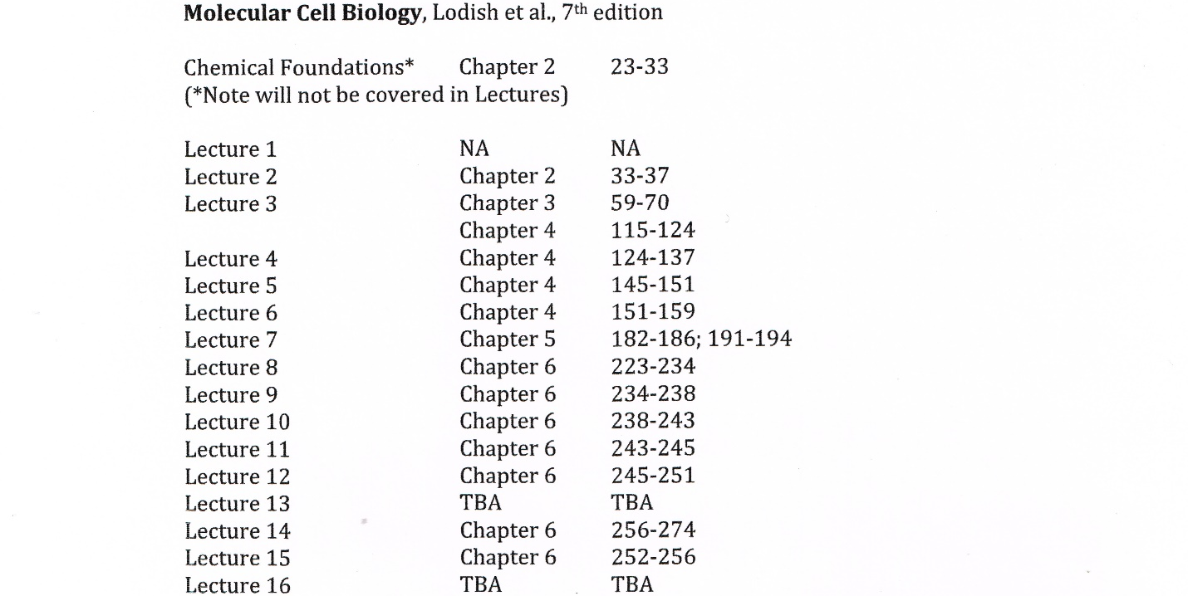
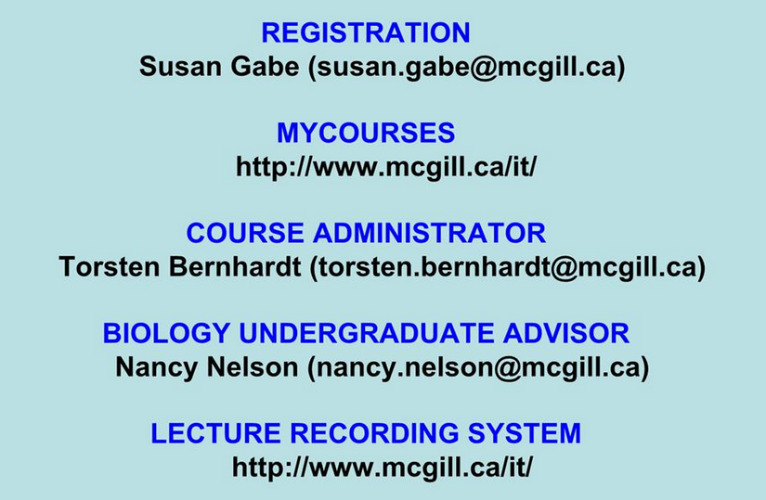
Exams and quizzes will be based on the lectures only
Review notes
Review recordings
Go to TA conferences
Arrange to see a TA in their office hours
Arrange to see a Prof in their office hours
IN THAT ORDER
Conference Schedule (in Stewart Biology Building)
Richa: Tues S4/106 4:30-5:30pm
Nitin: Fri S2/2 5-6pm
Mohana: Mon N5/1 4:30-5:30pm
Nicolas: Thurs S4/106 12-1pm
S4/106 (the TA conference room is in Stewart Biology Building)
The lobby is on the second floor near the second cup (kind of just a hall way)
Go up to 4th
Head into west block and go left down the cat walk into the south building (hence S)
Office hours (in Stewart Biology and Bellini Building)
Tom: Mon 1-2pm Stewart N4/1
Rick: Fri 1-2pm Stewart W5/17
Richa: Mon 4-5pm Stewart 5th floor lobby
Nitin: Thurs 4-5pm Bellini 235
Mohana: Wed 5-6pm Stewart 5th floor lobby
Nicolas: Mon 4-5pm Bellini 1st floor stairs
Midterm = 25%
October 15th 6-9pm (location TBA) THERE WILL BE AN ONLINE LECTURE ON OCT 15 NOT ON THE MIDTERM
Final = 65%
Date/location TBA
Quizzes = 10%
There are 6, 1 is dropped
THERE WILL BE NO LECTURE WHEN THERE ARE QUIZZES
There are 10 questions
You have 3 days to do them
You have 3 hours from the time you start
All work will be 70% multiple choice and 30% short answer
If something happens (fail or miss an exam) there are deferred exams in May 2015

LECTURE 2
Central Dogma: DNA –(Transcription)-> RNA –(Translation)-> Proteins
NO NEED TO KNOW HISTORY STUFF
Nucleic Acids
DNA = deoxyribonucleic acid, may be hundreds of millions of nucleotides long
RNA = ribonucleic acid, <100-1000 nucleotides long
Nucleotides (monomers) are the building blocks of nucleic acids (polymers)
Recognize the different parts
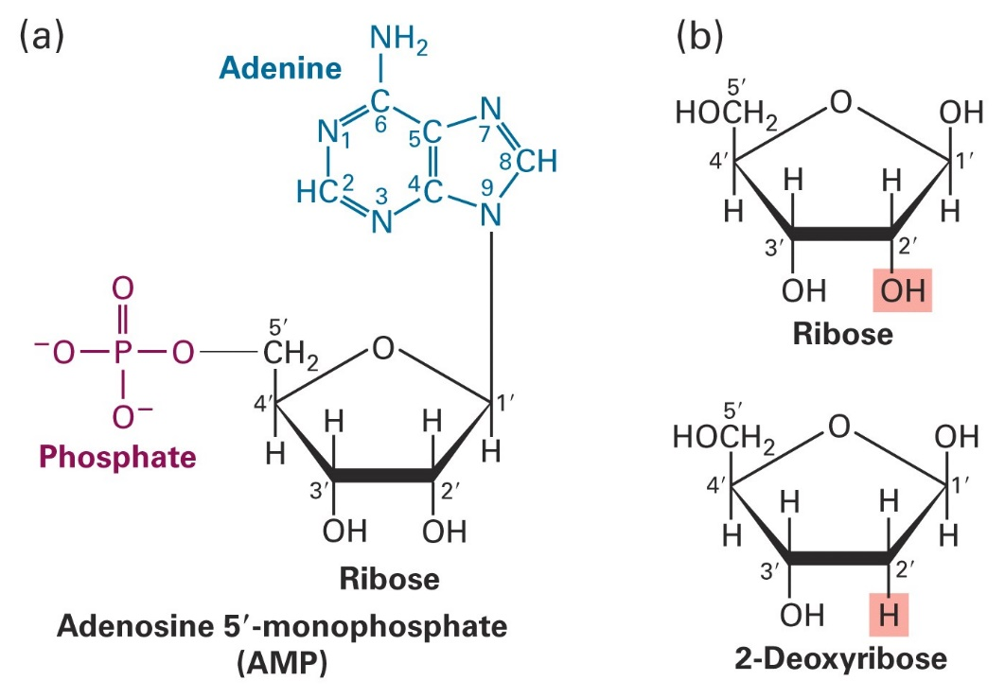
Pentose sugars
2-Deoxy ribose, in DNA
Ribose, in RNA and has an extra –OH on the 2’ C
Phosphate groups
Negatively charged in the intracellular environment
Attached on the 5’ carbon of the nucleic acid via a phosphoester bond
Bases
Nitrogenous bases are on the 1’ C
Be able to recognize the different bases GCATU
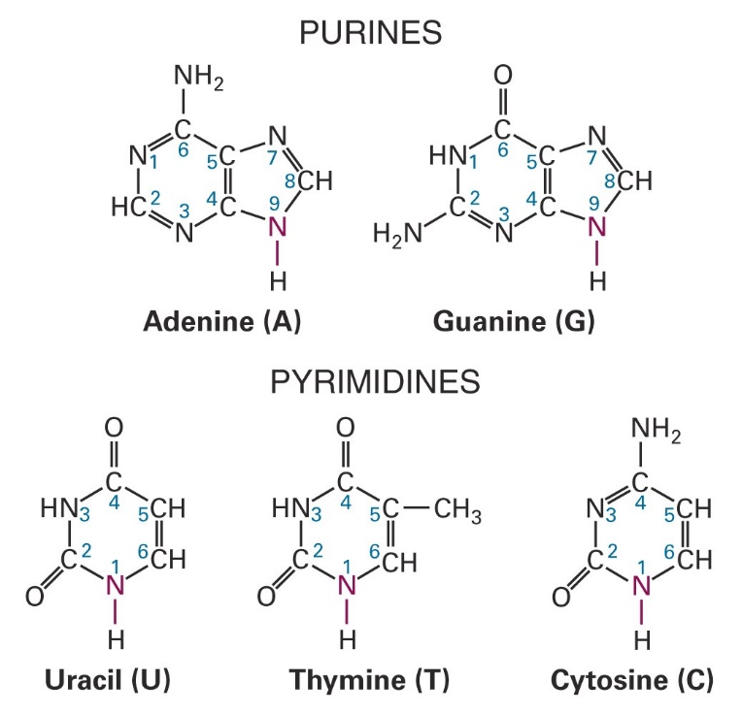
GCAT are in DNA
GCAU are in RNA
Pyrimidines always pair with Purines (C with G, A with T/U)
Pyrimidines have fused rings
The bigger word is the bigger group but the smaller molecule
Know table 2-3
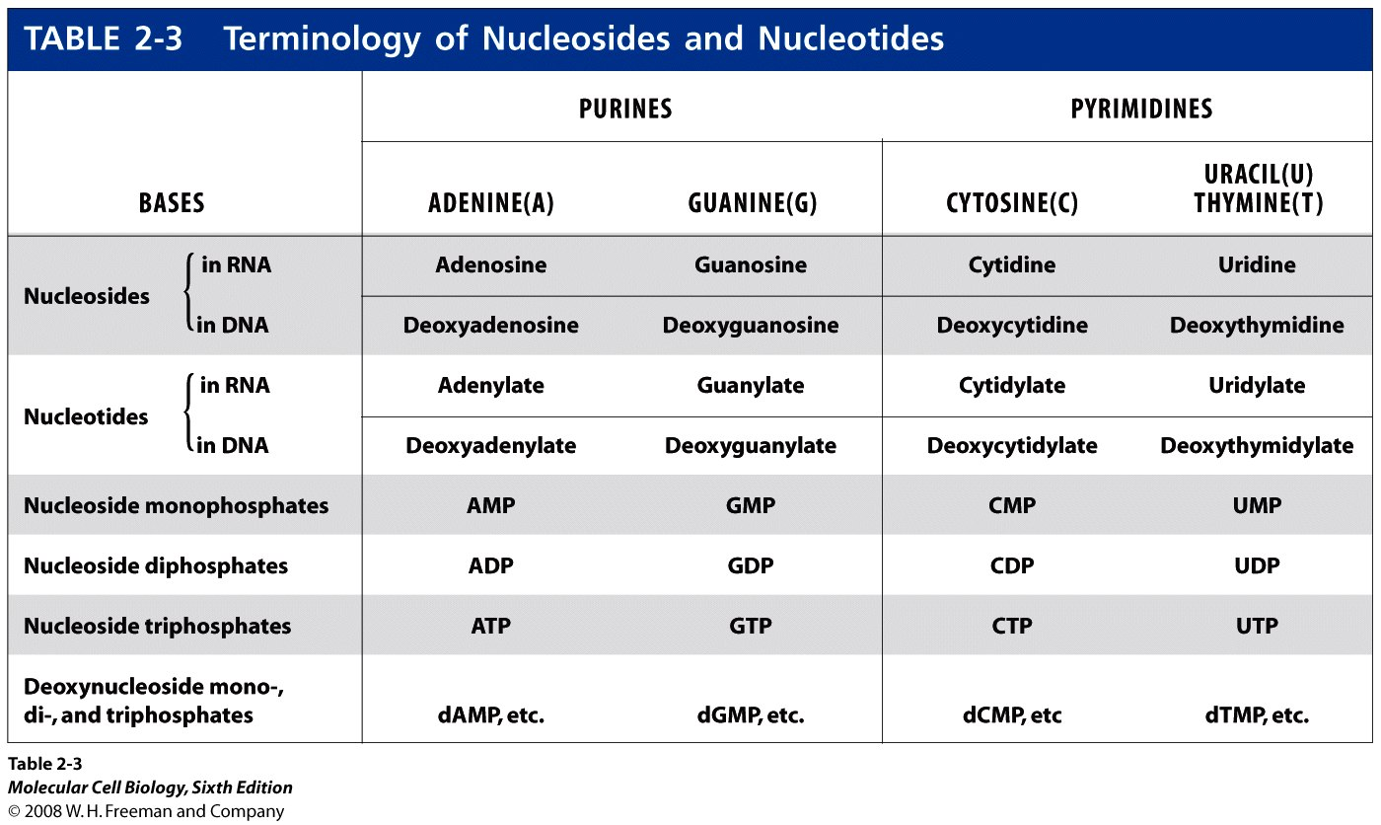
Note that Nucleosides have no phosphate, Nucleotides have one but it’s in the phosphate backbone
ie Nucleosides are the side group of the phosphate(s)
Also, in a nucleotide, the first phosphate is the alpha phosphate and so on with beta and gamma
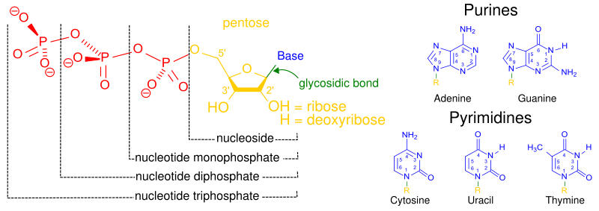
There’s an error in this picture as none shown are Nucleotides but nucleosides but it is a good image
Proteins
Protein Functions
Catalysis: catalyzing intra/extracellular reactions
Structural: providing structural rigidity
Transport: aiding in the flow of materials across membranes
Regulatory: acting as sensors/switches to control protein/gene activity
Signalling: transmitting external signals to the cell’s interior
Motor: motion
Proteins vary in size, shape, charge, hydrophobicity and reactivity
Shape plays a role in the function of proteins, if shape changes function changes with it
Recall denaturing (not outlined in this course yet but a good link)
Amino acids (monomers) are the building blocks of polypeptides
Amino acids can be D or L
D are uncommon and thus hard for bacteria, etc to destroy
L is the isomer used in the body
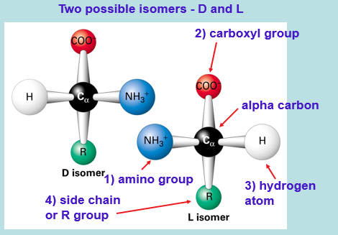
Be able to recognizes Amino acids groups
Know amino acid overarching groups
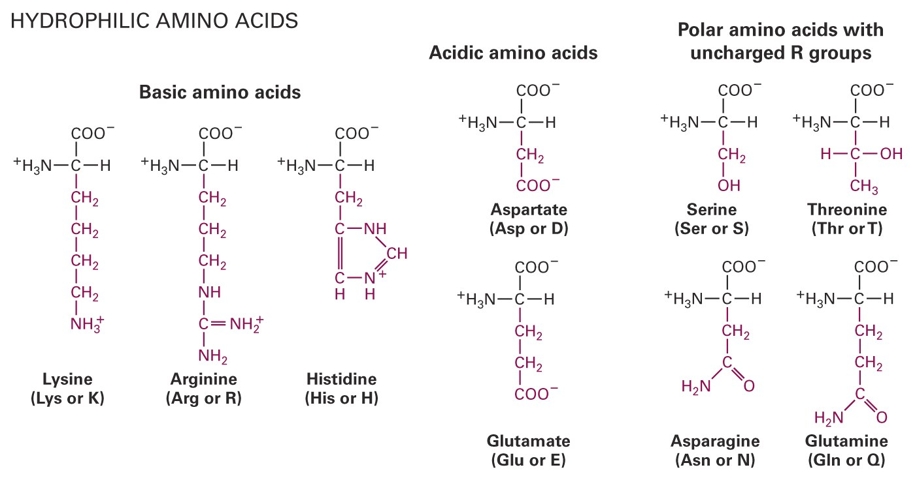
Polar and water soluble
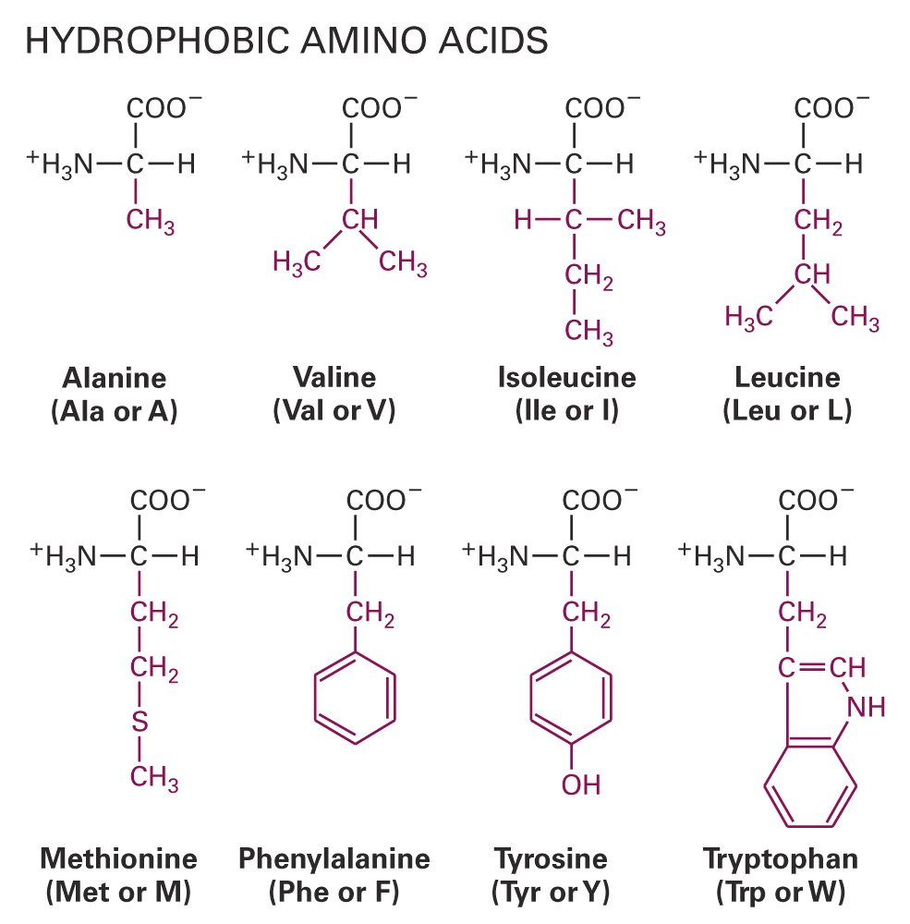Nonpolar and insoluble in water
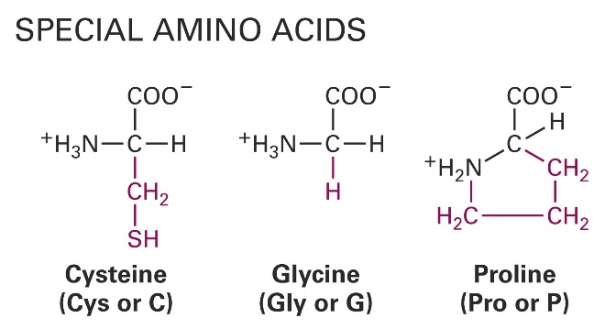
Cysteine has a sulfhydryl group that can form disulfide bonds (-s-s-) with other cysteines for
intra/inter-crosslinking
Stabilizing a folded structure
Glycine is symmetrical (achiral) and good for sharp turns and tight spaces
Proline has a rigid ring structure including the alpha carbon’s amino group and thus kinking chains
LECTURE 3
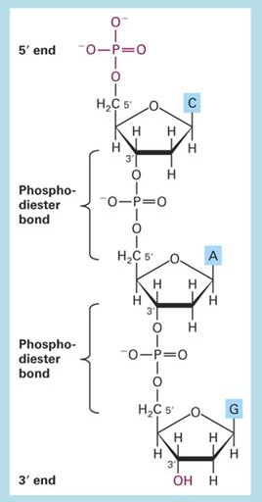
The back bone is made of repeating phosphate pentose unit
Thus no info is in the back bone
There is end bias
The free phosphate is always on the 5’ C of the terminal
sugar
3’ end has a free hydroxyl group on the 3’ C of the
terminal sugar
Links are via phosphodiester bonds
DNA and RNA synthesis goes from 5’ to 3’
so we name strand 5’ to 3’ (ex 5’-CAG-3’)

DNA forms a RIGHT HANDED double helix of 2 ANTIPARALLEL (one going reverse) polynucleotide strands
The backbone is located on the outside with inner nucleotides stabilizing the structure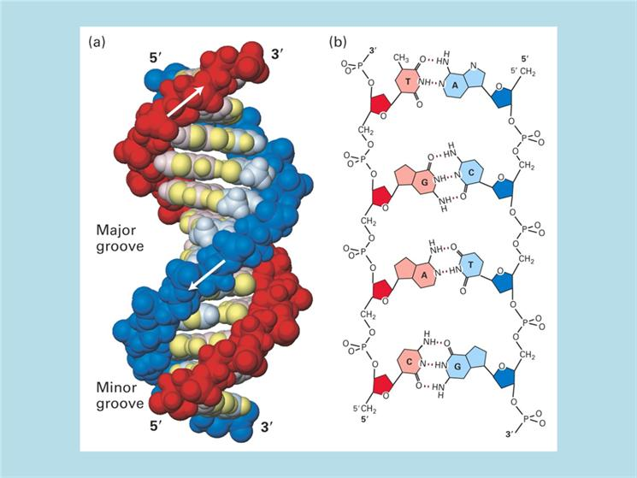
The grooves allow DNA binding protein to bind to the bases and “read” them
This occurs in both the major and minor groove
Note that A and T bond with 2 H-bonds, C and G with 3
This forms parallel Watson-Crick base pairs (bp)
Bases have base complementarity
This major/minor situation is only found in B DNA (most common)
B-DNA is unique in that it can bend length ways to become more compact
the tataa box sticks out
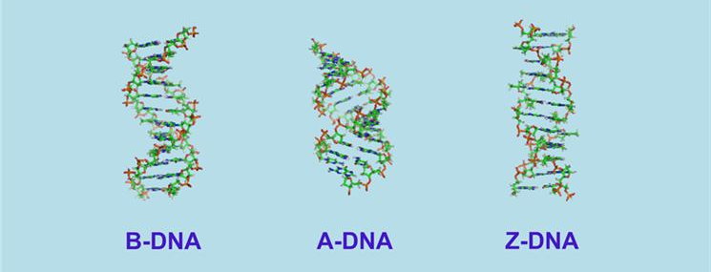
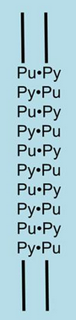
A-DNA (shorter/wider) can occur in
B-DNA in very low humidity (and dehydrated samples)
RNA-DNA helices and
RNA-RNA helices
Z-DNA
Short DNA molecules found in vitro (longer for the same bp)
Alternating purine/pyrimidine nucleotides
Forms a left handed helix
It is transiently formed shortly after transcription
Thus a tag for actively transcribed genes
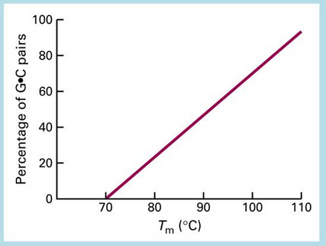
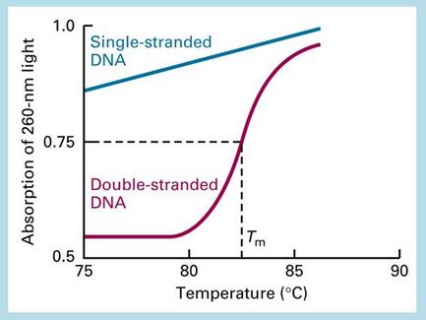

DNA denatures (and melts) with high temperatures
Useful for PCR
T_{m} is the temp when 50% of DNA is denatured
Note how T_{m} is only with double stranded DNA
T_{m} is a function of GC content (recall 3 H-bonds)
It’s directly proportional
We do DNA denaturing internally with enzymes
Note the curve
RNA primary structure is just code
Secondary structure, RNA folding onto itself short range
Hair pin, has a min number to make the turn
Stem-loop, has a large loop seperated by a double helical stem
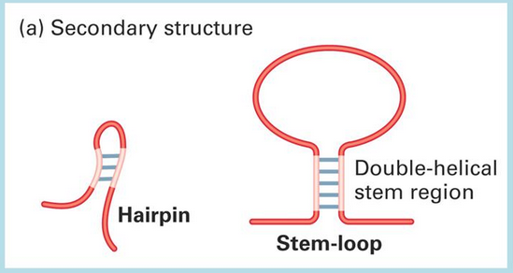
Tertiary, longer range folding on itself
The Pseudoknot forms an “s” shape
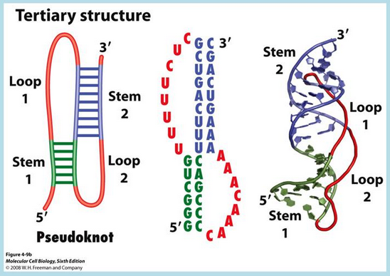
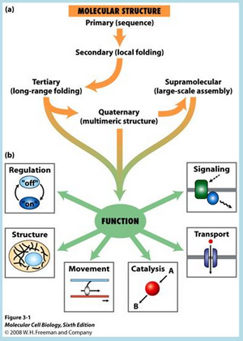
Proteins
Function is derived from 3D structure (AKA conformation)
Structure is derived from amino acid sequence
residue = amino acid at that particular position
Hierarchical structure of proteins:

Primary sequence given N to C
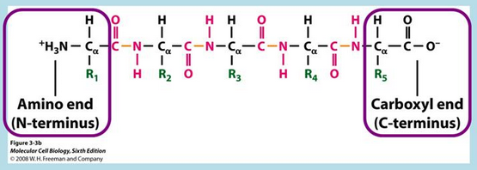
Secondary structure
α helix and β sheet
Folding of localized regions of a polypeptide chain
Noncovalent interactions (Recall different R group interactions) stabilize
No noncovalent interactions = random coil
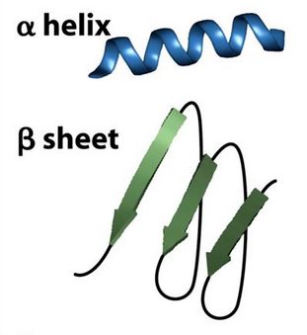
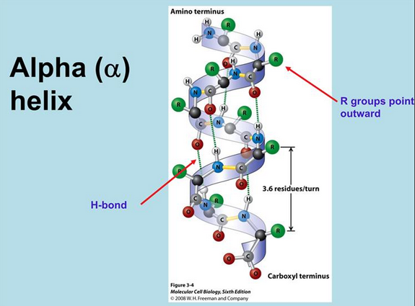
α helix
R groups out
H-bonds on N/N groups stabilize
3.6 residues per turn
Right handed helix

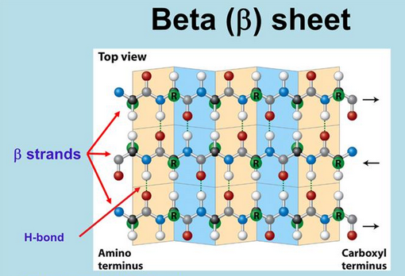
Β sheet
Laterally packed beta strands
Beta strands being 5-8 residues at near max extension (as a chain)
H-bonds between N/C groups in backbones stabilize
Can be parallel or antiparallel
Pleated
R-groups out
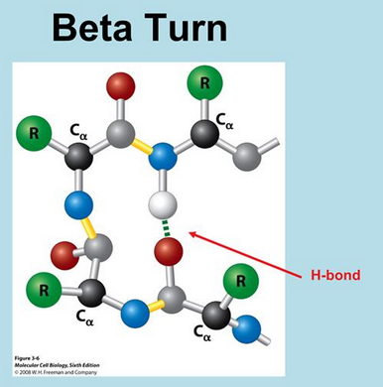
Beta turns are found at the edges of the sheets
Recall that glycine is good for sharp turns

Tertiary protein structure is often good to go
Note shortcut to function in the hierarchy diagram
Long range folding of the polypeptide chain
Stabilized by
hydrophobic interactions between nonpolar side chains
H-bonding between polar side chains
Disulfide bonds between cysteine residues
Procide a compact structure of alpha helices, beta sheets and turns
Quaternary means a few usually nearly identical proteins combining
Supramolecular
10-100s polypeptide chains of molecules plus some non-protein macromolecules
Thus they are macromolecular assemblies
Usually >1 megadalton in size
EX -> 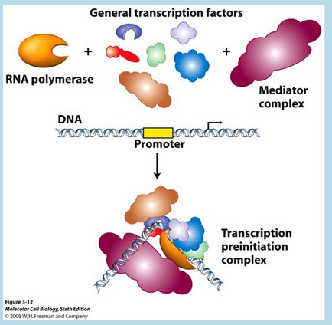
Motifs and Domains
“an area with a particular structural characteristic that allows it to perform its function”
The text tries to distinguish between motifs and domain but as far as we are concerned they are
interchangeable work
Combinations of secondary structures define motifs:
Note the 3 combos and the type of protein they are found
Also note the coil of 2 alpha helices in (a), the alternate name in (b), and the bonded zinc in (c)
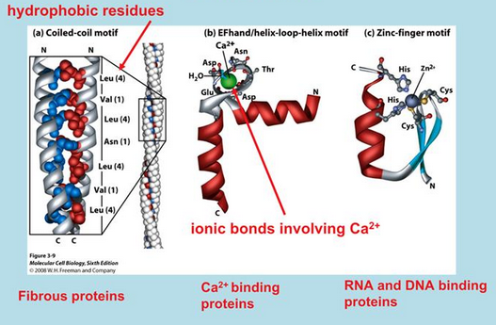
Many polypeptides are composites of different combos of motifs/domains
LECTURE 4
Transcription and translation: The prokaryotic model
This lecture is more of a reminder of the stuff we already know and is very packed
Central dogma
DNA
↓ Transcription
RNA (mRNA to be specific)
↓ Translation
Proteins
Transcription
Requires:
DNA template (or sense strand as opposed to the non-template or nonsense strand
to serve as the blue print for the RNA sequence
NOTE both strands have usable info (genes) just for different things
Ribonucleotides
to serve as monomers for RNA polymerization
RNA polymerase
to catalyze the synthesis of RNA
Naming parts:
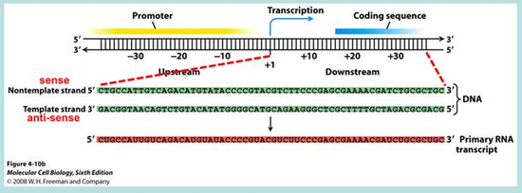
The promoter shows where to initiate transcription (it is found up stream)
Stages:
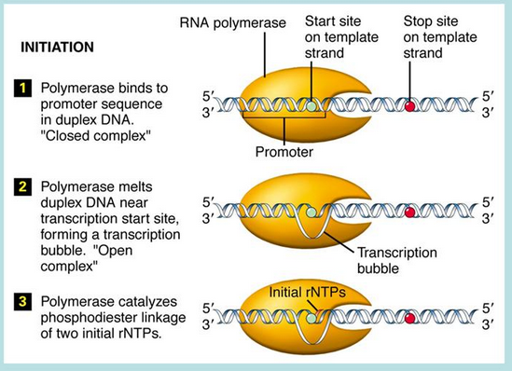
Note that rNTPs are complementary to the template strand
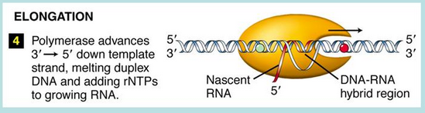
Nucleotide triphosphates (NTPs) lose 2 phosphates (the beta and gamma ones) in order to bond to the new chain (via the alpha phosphate forming a phosphodiester link with the free 3’ hydroxyl of the chain)
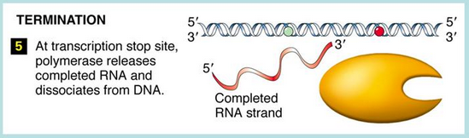
RNA polymerase and Initiation:
The holoenzyme consists of
the core enzyme, including beta subunits involved in elongation
a sigma factor, which has an essential role in selecting the transcription initiation site
holoenzyme scans
the sigma factor finds the promoter
by binding specific sequence motifs which are required for promoter
activity, ex the -10 and -35 regions (recall the TATA box?)
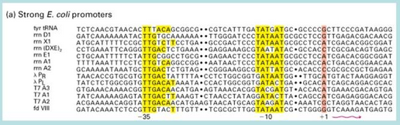
the holoenzyme binds to the promotor
This forms a “closed” complex
the sigma factor leaves
transcription begins
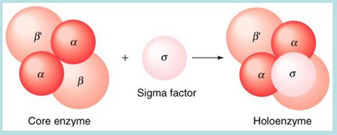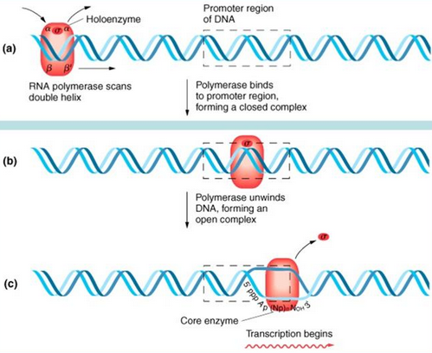
Translation
Components
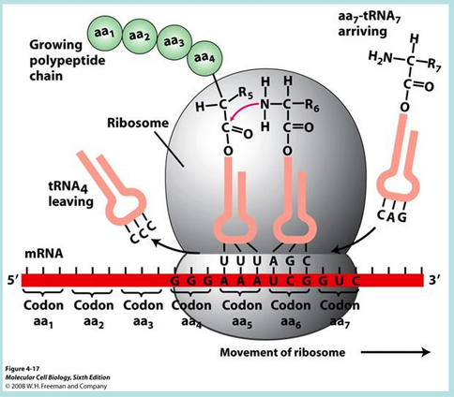
RNA has 3 roles in translation:
mRNA, messenger RNA, has genetic info in the form of codons (of 3 bases)
tRNA, transfer RNA, decipher codons with an anticodon and bind an associated amino acid
rRNA, ribosomal RNA, associates with proteins to form ribosomes
tRNA, transfer RNA, decipher codons with an anticodon and bind an associated amino acid
tRNA altered post transcription (with odd nucleotides and the CCA up top)
mostly just know it is a clover shape and changes would mostly make it unusable
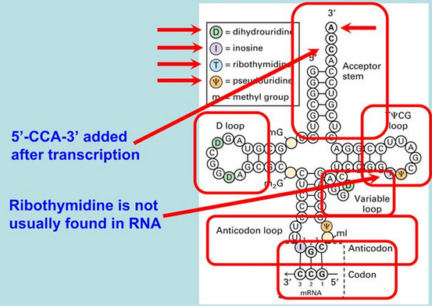
Aminoacyl-tRNA synthetase links amino acids to corresponding tRNAs
Via an ester bond
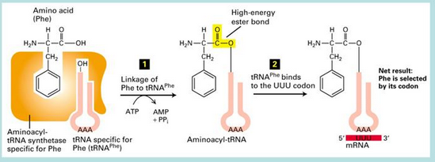
It is important to note that both anti codon and codon must be written 5’-3’
(thus don’t appear comp when written)
Also note the key components in forming aminoacyl-tRNA
The Genetic Code:
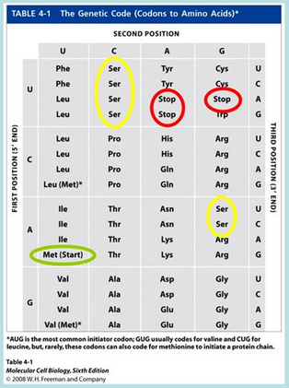
Meth is start most often, but there are others
Ser is a redundancy example (there 6 times)
Redundancy due to more codons than amino acids, and can’t have some codon for nothing
You would expect there to be 61 codons, (64-3 stop), but there are fewer in porkaryotes
coverage is assisted by WOBBLE
Wobble (non-standard base pairs)
3rd nucleotide in a codon
1st nucleotide in an anticodon
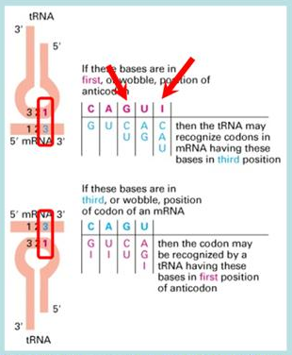
Thus the anticodon GAC can pair with the codon GUC or GUU
anticodon IAC with codon GUC or GUU or GUA
DON’T ASSUME TRANSLATION IS PERFECT, WOBBLE GIVES OPTIONS
rRNA, ribosomal RNA, associates with proteins to form ribosomes
Ribosomes are made of RNA and protein
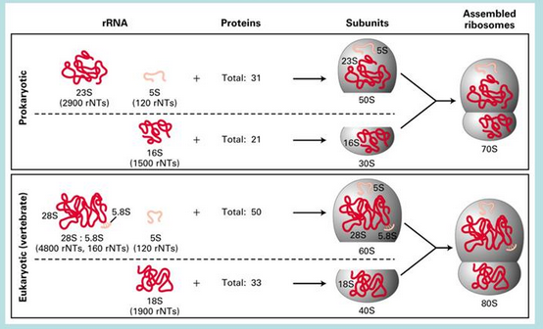
S in 23S, 5S etc refers to sedimentation coefficient
it just stuck don’t sweat the adding
Stages of translation (again the prokaryotic version)
Initiation
1) initiation factors (IFs) associate with the 30S subunit
this forms the preinitiation complex
2) IF1 and IF3 help
load mRNA and
initiate aminoacyl-tRNA formation of the 30S initiation complex
This complex binds at AUG (the initiation codon)
Note that with wobble multiple codons for AUG exist
the Shine-Dalgarno sequence (about 8 nu) signals the correct
3) IF1 and IF2-GTP (IF2 has GTP attached) facilitate the loading of the 50S subunit
this forms the 70S initiation complex
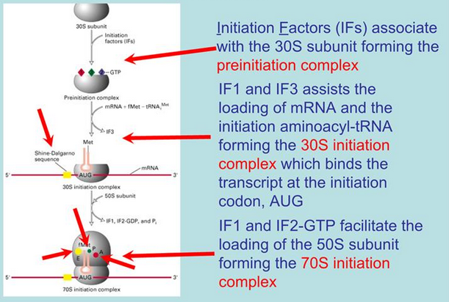
Elongation
Elongation Factors (EFs) allow the stepwise addition of amino acids
23S rRNA, a ribozyme, carries out the peptidyltransferase reaction
Termination
when the mRNA-ribosome-tRNA-peptidyl complex reaches a stop codon
Release factors (RFs) mediate the termination of protein synthesis
RF1 and 2 mimic tRNAs (matching stop codons) and because of this
RF3-GTP catalyzes the cleavage of the peptidyl-tRNA releasing the protein chain
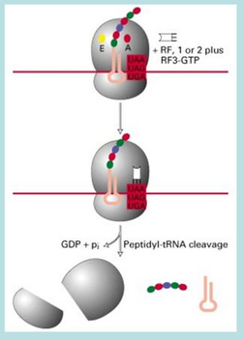
RECALL APE sites
Transcriptome = total of all RNA in a cell
Protiome = total of all protein in a cell

