GNG1106 Lab 1 (Pre-lab)
Compute the Area of a Triangle
Step 1: Problem identification and statement:
Compute the area of a triangle formed by three points on the x-y plane.
Step 2: Gathering of information and Input and Output description:
We wish to compute the area of the triangle using the three coordinates of three given points. We can use a certain formula using coordinate geometry, which calculates the area of a triangle using the three points given on the graph. Here is an example of a triangle formed by three points on the x-y plane:

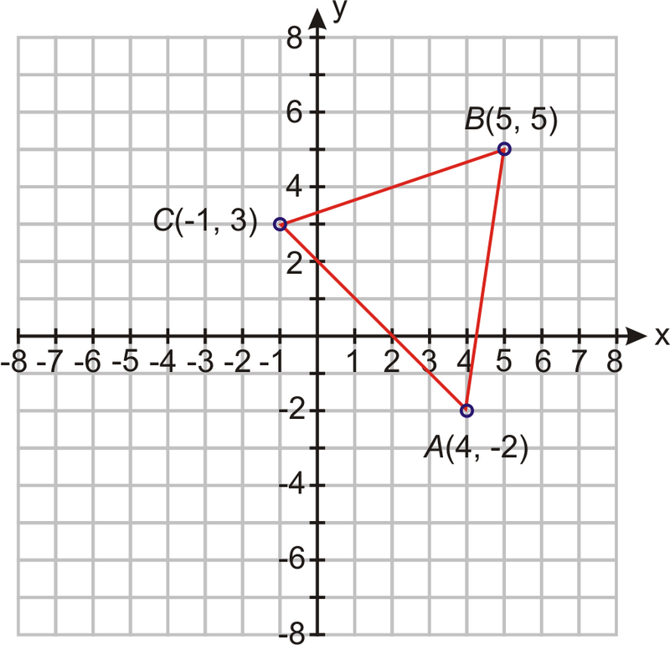
The formula for the area of a triangle (ABC) containing three coordinates on the x-y plane is:
where A_{x} and A_{y} are the x and y coordinates of the point A. (same for points B and C)

The I/O diagram for this problem is illustrated below.

Point A (A_{x}, A_{y})
Area of the triangle formed by the three points
Point B (B_{x}, B_{y})

Point C (C_{x}, C_{y})

Thus, the inputs are: point A (A_{x}, A_{y}), point B (B_{x}, B_{y}) and point C (C_{x}, C_{y}).
The outputs are: the Area of the triangle formed by the three points.

Step 3: Test Cases and Algorithm Design
For example, if we come back to the triangle illustrated in step 2:
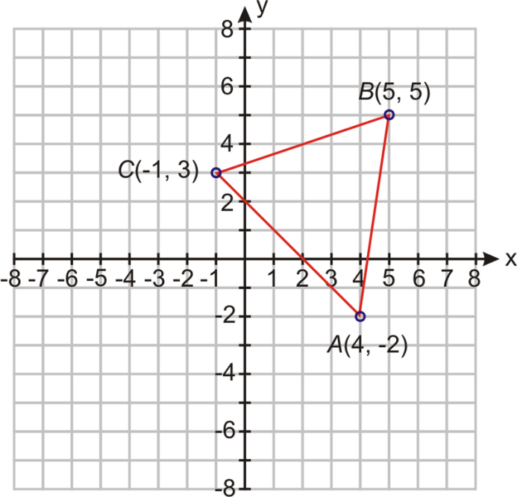
The exact coordinates for the x and y components of every point are the following:
x-coordinate of point A: 4
y-coordinate of point A: -2
x-coordinate of point B: 5
y-coordinate of point B: 5
x-coordinate of point B: -1
y-coordinate of point C: 3

Knowing that the formula of the area of the triangle is:

The area of this triangle is:
$area= \frac{4\left(5-3\right)+5\left(3-\left(-2\right)\right)-1(-2-5)}{2}$
$$area= \frac{4\left(2\right)+5\left(5\right)-1(-7)}{2}$$
$$area= \frac{40}{2}$$
$$area= 20.0$$

Test Cases:
The following table provides 4 test cases that can be used to test the algorithm and software during the lab. Here are a different set of coordinates for point A, B and C (both positive and negative).
Test Case | A | B | C | Area
1 | (12,-4) | (6,6) | (-5,3) | 64.0
2 | (15,0) | (13,8) | (-14,16) | 100.0
3 | (25,-10) | (0,15) | (25,-10) | 500.0
4 | (-7,33) | (49,24) | (65,-15) | 1020.0

Algorithm:
Assign values to A_{x} and A_{y}
Assign values to B_{x} and B_{y}
Assign values to C_{x} and C_{y}
Assign [Ax(By – Cy) + Bx(Cy – Ay) + Cx(Ay – By)]/ 2 to area
Print area
Step 4 and 5: to be done in Lab on Monday September 15th.

