SECTION 1 BUSINESS-DRIVEN INFORMATION SYSTEMS

Chapter 1 Information Systems and Business Strategy

“Why do we need to study information system?”
- Information Systems are everywhere in business.

Information Systems’ Role in Business:

Information Systems’ Impact on Business Operations:

- Businesses undertake enterprise-wide initiatives to achieve broad general business goals such as reducing costs. Information technology plays a critical role in deploying such initiatives by facilitating communication and increasing business intelligence.

- Understanding information systems must understand how business function and information system’s role in creating efficiency and effectiveness across the organization.

- Typical businesses operate by functional areas (often called Functional Silos). Each area undertakes a specific core business function. Functional areas are in fact “Interdependent”.

- Functional Organization – Each functional area has its own systems and communicates with every other functional area.
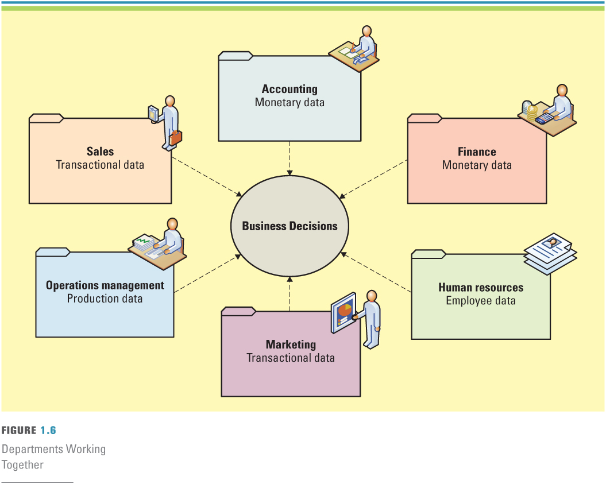
- For an organization to succeed, every department or functional area must work together to share common information and not be a silo. Information systems can enable departments to more efficiently and effectively perform their business operations.

- Must understand information systems including:

  - Information systems basics
  - Roles and responsibilities in information systems

Information Systems Basics:

- Information systems (IS) – any computer-based tool that people use to work with information and that supports the information and information-processing needs of an organization.
  - An information system can be an important “Enabler” of business success and innovation.

  - IS does not equal or represent business success and innovation, it is simply an enabler of business success and innovation

  - IS are most useful when they leverage the talents of people. IS in and of themselves are not useful unless the right people know how to use and manage them effectively.

- Information Technology (IT) – the acquisition, processing, storage, and dissemination of vocal, pictorial, textual, and numerical information by microelectronics-based combination of computing and telecommunications.

- Management Information Systems (MIS) – the function that plans for, develops, implements, and maintains IS hardware, software, and applications that people use to support the goals of an organization.

  - It is important to understand:

    - The difference between data, information, and knowledge
    - IS resources
    - Information cultures

Data, Information, and Knowledge:

- Data - raw facts that describe the characteristic of an event.
- Information - data converted into a meaningful and useful context.
- Knowledge - information that can be enacted upon i.e. “Actionable Information”.

- NOTE: People use Information Systems to transform Data into Information and transform Information into knowledge.

IS Resources:

- The plans and goals of the MIS department must align with the plans and goals of the organization. IS can enable an organization to increase efficiency in manufacturing, retain key customers, seek out new sources of supply, and introduce effective financial management.

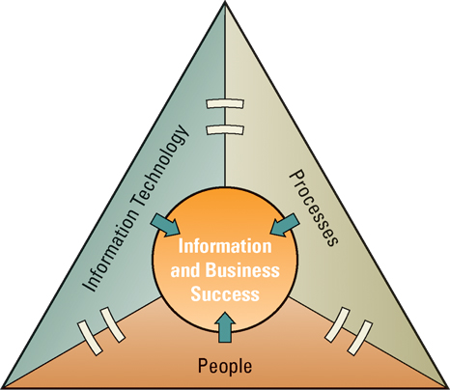

- KEY: People use processes to work with information systems to produce information.

- People, information, and information systems (in that order of priority) are inextricably linked. If one fails, they all fail.

Information Cultures:

- Culture influences the way people use information (their information behaviour) and reflects the importance that company leaders attribute to using information in achieving success and avoiding failure.

- Information-Functional Culture - Employees use information as a means of exercising influence or power over others. For example, a manager in sales refuses to share information with marketing. This causes marketing to need the sales manager’s input each time a new sales strategy is developed.

- Information-Sharing Culture - Employees across departments trust each other to use information (especially about problems and failures) to improve performance.

- Information-Inquiring Culture - Employees across departments search for information to better understand the future and align themselves with current trends and new directions.

- Information-Discovery Culture - Employees across departments are open to new insights about crisis and radical changes and seek ways to create competitive advantages.

  - KEY: Information-Discovery Culture will help an organization achieve the greatest success. Information-Functional Culture would hurt an organization.

  - Organizations that encourage their employees to share ideas and openly discuss challenges and opportunities on an enterprise-wide level have a competitive advantage over organizations that operate in functional silos.

Roles and Responsibilities in Information Systems

- Chief Information Officer (CIO) – An executive position that involves high-level strategic planning and management of information systems pertaining to the creation, storage, and use of information by a business.

  - Oversees all uses of IT and ensures the strategic alignment of IT with business goals and objectives.

  - CIO must have a deep understanding of both information systems and business; the need for in-depth IS knowledge enables the CIO to understand how systems can help business. Broad roles of a CIO include:

    - Manager – ensure delivery of all IS projects, on time and within budget
    - Leader – ensure the strategic vision of IS is on line with the strategic vision of organization
    - Communicator – advocate and communicate the IS strategy by building and maintaining strong executive relationships
- Chief Knowledge Officer (CKO) - Responsible for collecting, maintaining, and distributing the organization’s knowledge.

  - CKO designs processes and information systems that make it easy for people to reuse knowledge. CKO must continuously encourage employee contributions to keep the information system up-to-date.

- Chief Privacy Officer (CPO) – Responsible for ensuring the ethical and legal use of information within an organization.

  - CPOs are the newest senior executive position in IS. Many CPOs are lawyers by training, enabling them to understand the often complex legal issues surrounding the use of information and information technology.

- Chief Security Officer (CSO) – Responsible for ensuring the security of information systems, and developing strategies and technical safeguards against the attacks from hackers and viruses; CSOs’ main protective resources including data, hardware, software, and people.

- Chief Technology Officer (CTO) – Responsible for ensuring the throughput, speed, accuracy, availability, and reliability of an organization’s IT.

  - CTOs have direct responsibility for ensuring the efficiency of IT resources used in information systems throughout the organization. CTOs typically report to the CIOs.

- The ICT workers shortage is coming and outlined a few reasons for it on the demand:

  - IT know-how drives business change
  - Onshore demand for staff will continue to increase in areas where there are corporate cultures and security issues
  - Privacy and Security legislation creates further demand for IT personnel

The Skills Gap:

- One of the greatest challenges today is effective communication between business personnel and IT personnel. Unfortunately, a communication gap often exists between the two. IS personnel have their own vocabularies consisting of acronyms and technical terms. Business personnel have their own vocabularies based on their experience and expertise.

- Effective communication between business and IS personnel should be a two-way street, with each side making the effort to understand each other (including written and oral communication).

Improving Communication:

- For both sides to have effective communications, the business personnel must seek to achieve an increased level of understanding of IS, and the IS personnel must seek to achieve an increased level of understanding of the business.

- At the same time, an organization must develop strategies for integrating the IS personnel into the various business functions. IS personnel must understand the business if the organization is going to determine which technologies can benefit (or hurt) the business.

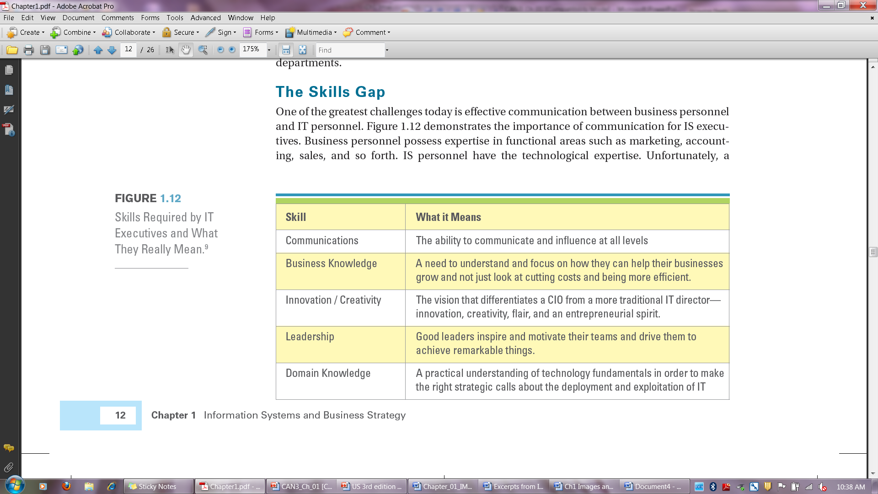

Identifying Competitive Advantages:

- To survive and thrive, an organization must create a competitive advantage.

- Competitive Advantage – a product or service that an organization’s customers place a greater value on than similar offerings from a competitor.

  - However, the competitive advantages are typically temporary because competitors often seek ways to duplicate the competitive advantage.

- First-mover Advantage – occurs when an organization can significantly impact its market share by being first to market with a competitive advantage.

- Organizations watch their competition through environmental scanning.

- Environmental Scanning – the acquisition and analysis of events and trends in the environment external to an organization.

  - Example: Frito-Lay, a premier provider of snack foods such as Cracker Jacks and Cheetos, does not just send its representatives into grocery stores to stock shelves—they carry handheld computers and record the product offerings, inventory, and even product locations of competitors. Frito-Lay uses this information to gain business intelligence on everything from how well competing products are selling to the strategic placement of its own products.

  - Organizations use three common tools to analyze and develop competitive advantages:

    - Michael Porter’s Five Forces Model
    - Michael Porter’s Three Generic Strategies
    - Value Chain Analysis

The Five Forces Model – Evaluating Business Segments:

Buyer Power:

  - Buyer Power – high when buyers have many choices of whom to buy from and low when their choices are few.

    - There are two situations in the supply chain where organizations need to be concerned about buyer power: i). in their relationships with customers; and ii) in their relationships with suppliers.

    - In the relationships with customers, organizations function as suppliers and thus prefer to reduce the buyer power of customers. Organization must make it more attractive for customers to buy from it instead of its competition.

      - Loyalty program – Rewards customers based on the amount of business they do with a particular organization

        - Frequent-flyer miles
        - Restaurant discounts such as Subway’s get your 12th sandwich free
        - Coffee clubs where you get your 10th cup of coffee free

      - Switching cost – Manipulating costs that make customers reluctant to switch to another product

    - In the relationships with suppliers, organizations function as buyers and thus prefer to increase their own buyer power with suppliers (and create competitive advantage). Organizations want to work with a large pool of suppliers to potentially supply the desired good or services.

Supplier Power:

  - Supplier power – high when buyers have few choices of whom to buy from and low when their choices are many.

    - There are two situations in the supply chain where organizations need to be concerned about supplier power: i). in their relationships with customers; and ii) in their relationships with suppliers.

    - In the relationships with customers, organizations function as suppliers and thus prefer want supplier power to be high. In the relationships with suppliers, organizations function as buyer and therefore prefer want supplier power to be low.
.
    - Organizations can create a competitive advantage by locating alternative supply sources (decreasing supplier power) through B2B marketplaces.

      - Business-to-Business (B2B) marketplace – an Internet-based service that brings together many buyers and sellers.
    - Two types of business-to-business (B2B) marketplaces:

      - Private exchange – a single buyer posts its needs and then opens the bidding to any supplier who would care to bid.

      - Reverse auction – an auction format in which increasingly lower bids are solicited from organizations willing to supply the desired product or service at an increasingly lower price.

Threat of Substitute Products and Services:

  - Threat of substitute products or services – high when there are many alternatives to a product or service and low when there are few alternatives from which to choose.

    - Organization can create a competitive advantage by using switching costs. Threat is reduced when Switching Costs are high. Switching costs are costs that can make customers reluctant to switch to another product or service.

    - A switching cost need not have an associated monetary cost. When businesses reduce or eliminate their switching costs, the consumer gains more power.

Threat of New Entrants:

  - Threat of new entrants – high when it is easy for new competitors to enter a market and low when there are significant entry barriers to entering a market.

    - Entry Barrier – a product or service feature that customers have come to expect from organizations in a particular industry and must be offered by an entering organization to compete and survive.

    - What is an industry that has a high entry barrier?
      - Energy – the organization has to have the infrastructure to support energy
      - Telecommunications – the organization has to invest in a telecommunications infrastructure prior to offering services
      - Banking – the bank must offer its customers an array of IT-enabled services including ATMs and online account services
    - What is an industry that has a low entry barrier?
      - Restaurants – simply lease a space, obtain license, and sell food
      - Catering – simply offer food and deliver
      - Movie Rental – simply buy the movies, pay the licensing fee, and offer the movies for rental (although if you want to be a Netflix the entry barrier is high because you have to have the facilities and systems to mimic their movie supply chain)

Rivalry Among Existing Competitor:

  - Rivalry among existing competitors – high when competition is fierce in a market and low when competition is more complacent.

    - Product Differentiation – Occurs when a company develops unique differences in its products or services with the intent to influence demand.

    - Communicating with suppliers over telecommunication networks rather than using paper-based systems makes the procurement process faster, cheaper, and more accurate. That equates to lower prices for customers and increased rivalry among existing competitors.

The Three Generic Strategies – Creating A Business Focus

- An organization can follow Porter’s three generic strategies for entering the new market: (1) broad cost leadership, (2) broad differentiation, (3) focused strategy.

  - Broad strategies reach a large market segment, while focused strategies target a niche market. A focused strategy concentrates on either cost leadership or differentiation.

    - Hyundai is following broad cost leadership strategy. Hyundai offers lower-cost vehicles, in each particular model stratification, that appeal to a large audience.

    - Audi is pursuing a broad differentiation strategy, with its A-series available at several price points. Audi’s differentiation is safety, and it prices its various Quattro models (higher than Hyundai) to reach a large, stratified audience.

    - Kia has more focused cost leadership strategy. Kia mainly offers low-cost vehicles in the lower levels of model stratification.

    - Tesla offers the most focused differentiation strategy of any in the industry.

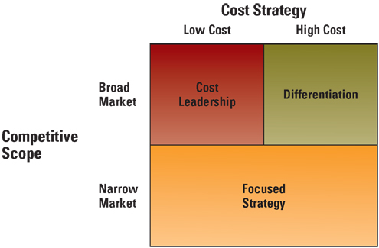

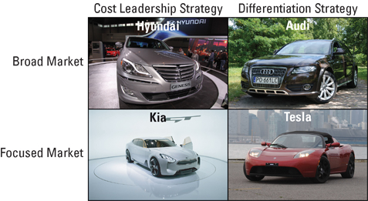

Value Chain Analysis – Targeting Business Processes

- Once an organization enters a new market using one of Porter’s three generic strategies, it must understand, accept, and successfully execute its business strategy. Every aspect of the organization contributes to the success (or failure) of the chosen strategy. The business processes of the organization and the value chain they create play an integral role in strategy execution.
Value Creation:

- Business Process – A standardized set of activities that accomplish a specific task, such as a specific process of a customer’s order.

  - To evaluate the effectiveness of its business processes, an organization can use Michael Porter’s value chain of approach.

  - Value Chain Analysis – Views a firm as a series of business processes that each add value to the product or service.

    - To create competitive advantage, the value chain must enable the organization to provide unique value to its customers. In addition to the firm’s own value-creating activities, the firm operates in a value system of vertical activities, including those of upstream suppliers and downstream channel members.

    - To achieve a competitive advantage, the firm must perform one or more value-creating activities in a way that creates more overall value than its competitors. Added value is created through lower costs or superior benefits to the consumer (differentiation).

    - Value Chain Groups – Within a company separate the company’s activities into two categories: 1) primary value activities and 2) support value activities:

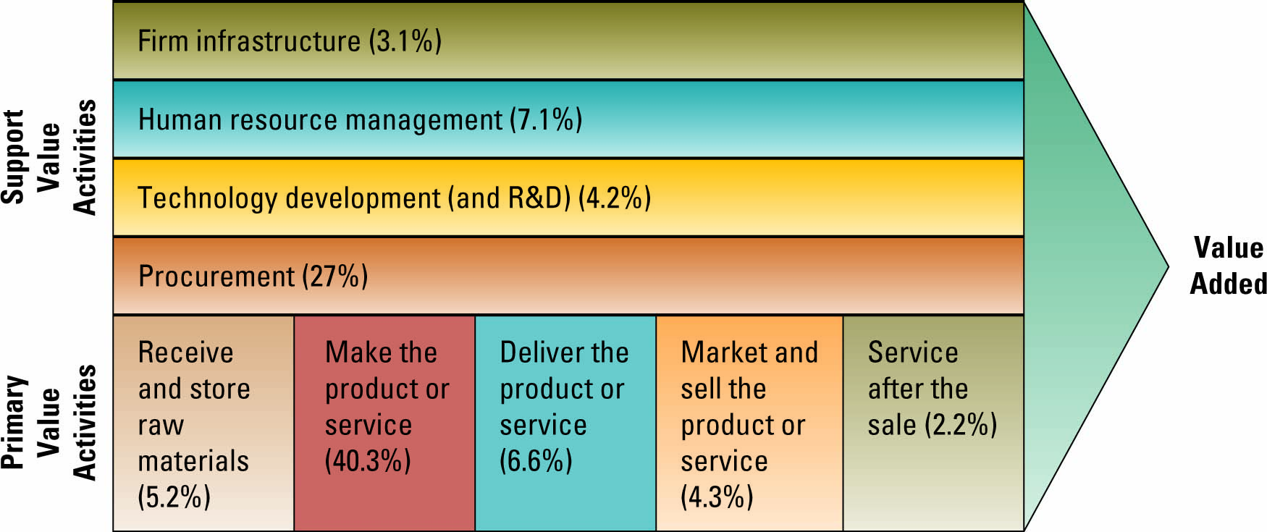

  - Organization should attempt to use information system to add value to both primary and support value activities.
- Value chain analysis is a highly useful tool in that it provides hard and fast numbers for evaluating the activities that add value to products and services. An organization can find additional value by analyzing and constructing its value chain in terms of Porter’s Five Forces.

  - Examples: If an organization wants to decrease its customers’ buyer power, it can construct its value chain activity of “service after sale” by offering high levels of quality customer service. This will increase the switching costs, and thereby decreasing their buyer power.

  - Analyzing and constructing its support value activities can help an organization decrease threat of new entrants. Analyzing and constructing its primary value activities can help an organization decrease the threat of substitute products or services.

- Implementation involves organization of the firm’s resources and motivation of the employees to achieve objectives. In a large company, the personnel implementing the strategy are usually different from those formulating the strategy. For this reason, proper communication of the strategy is critical.

- The competitive advantage is to:
  - Target high value-adding activities to further enhance their value
  - Target low value-adding activities to increase their value
  - Perform some combination of the two

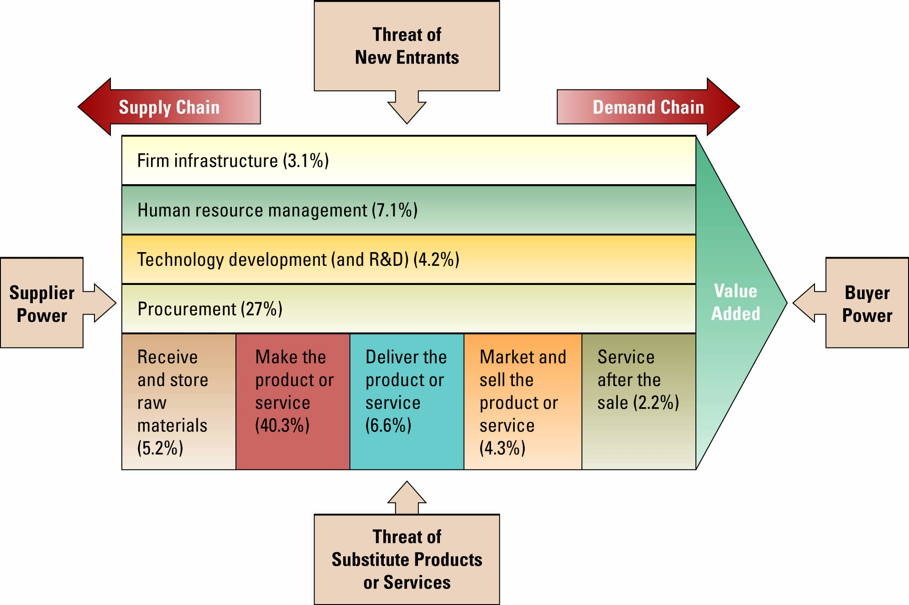
- Example: Information Systems can be used to redistribute Supplier Power. EDI is an information system whereby reduction of a manufacturing company’s raw materials inventory is electronically, and in real time, communicated to the supplier. When a reorder point is reached, inventory is sent automatically to the manufacturer and electronically invoiced. When both the manufacturer and the supplier invest in the technology to manage this highly efficient and effective system, both have a great deal to lose if the agreements fail and, thus, power is reduced.

Business-Driven Information Systems and Business Strategy:

- The Five Force Model is a framework that helps companies evaluate the relative attractiveness of entering or operating within an industry. It is a framework that can be used to assess the attractiveness of the industry in which a firm competes.

- The Three Generic Strategies are broad competitive approaches that organizations fall under. Knowing which broad competitive approach an organization is following can help that organization make informed decisions about how the company should compete with other firms.

- Value Chain Analysis is a systematic approach organizations can use to assess and improve the value of their business activities. Knowing what value each business activity offers a company can help an organization decide how to change or improve those activities to help it become more competitive.

