Open-Loop Motor Control

Open-Loop Motor Control
- 4 month old children don’t walk
- Just learning to crawl, interested in whether or not if provided with a tactile input it will simulate a normal Gait pattern
- Evidence of open-loop motor control (does not need sensory information to continue)
- Hardwired into the level of spinal cord

Sherrington
- Severed dorsal roots of monkeys and chimpanzees
- Dorsal root (sensory information gets into the spinal cord)
- Therefore, they could no longer process proprioceptive or somatic responses on one side of the body
- Monkey no longer used the side that didn’t receive neural inputs
- Sensory information is absolutely necessary in order to support a movement
- Closed-Loop Motor Control
- Huge flaw in the experiment: Should have severed dorsal root on both sides

Rothwall
- Studied patient that had Periferal Neuropothy (small sensory fibers die out due to poor circulation)
- Individual could still do basic tasks (i.e. button shirt) when his eyes are open or closed
- Performance gets worse as a function of time
- Sensory information is not absolutely required to support movement
- Open-Loop Motor Control
  - Supports rhythmical and ballistic (fast) actions

Mesencephalic (midbrain) cat supported on a treadmill
- Interested in central pattern generators [mechanisms that support rhythmic or stereotyped activity (i.e. walking)]
- Thought it did not require top-down cognitive control
- Performed a midbrain cut on a cat (prevents any efferent and afferent signals travelling to and from the brain and spinal cord
- Put cat on a treadmill and observed if it could walk
- Treadmill turned on a really slow speed, but eventually mechanical input makes the cat start to walk
- When cat had to ran, made the appropriate transition (speed of Gait pattern = speed of treadmill)
- There are groups of neurons known as central pattern generators in the spinal cord

Example of Central Pattern Generators
- Treadmill therapy may permit recovery of some function for the spinal cord injured
- Training is extensive
- Body weight is fully supported
- Anti-gravity muscle remain in state of complete paralysis

Example of Central Pattern Generators
- 4 neurons linked together
- 2 have direct link to alpha motor neuron (one to flexor, one to extensor)
- Input trigger excites input neurons, which excites other neuron +alpha motor neuron (flexor), which excites another neuron, and then the last neuron + extensor alpha motor neuron (cycle continues as long as treadmill is on)

Central Control of Rapid Goal-Directed Movements: Wadman et al (1979)
- Participants had to hold onto a lever and move it to a certain spot on a trackway
- Sometimes there was a magnetic lock on the level and could not make the ballistic response
- All actions associated with upper limb (goal directed) are characterized by a Triphasic pattern of EMG activation
  - 1) Primary agonist burst (i.e. triceps guiding limb to target)
  - 2) Antagonist burst (i.e. biceps slow down the limb)
  - 3) Secondary agonist burst (i.e. triceps prevent limbs from oscillating)
  - Occurs without any sensory inputs modifying it
- Results:
  - Unblocked: Had typical triphasic EMG
  - Blocked: EMG burst similar to the unblocked trial for 110ms after initial burst
  - Antagonist burst in blocked trials occurred at the same time as unblocked
  - Therefore, movements can be preprogrammed
  - Shows that motor command that comes from cortex goes down to spinal cord and even if its not complete, the signal had to run it’s course regardless
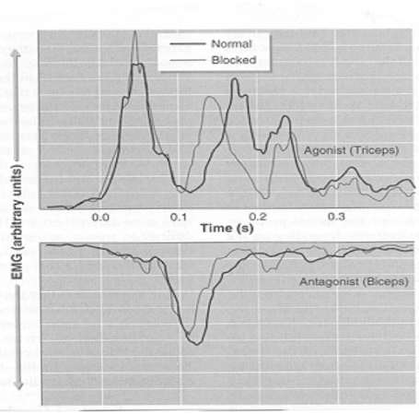
  - Triphasic EMG activity of agonist (top) and antagonist (bottom) musculature during a discrete aiming trial. The light gray lines represent movements that were blocked; however, antagonist EMG activity is still present.

