Closed-Loop Motor Control

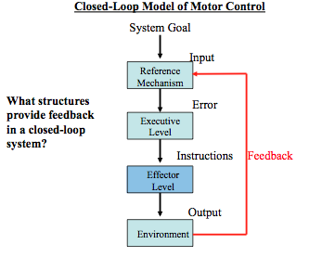
Closed-Loop Motor Control

- A way in which we control movement, which is based on sensory feedback (vision proprioception, vestibular system and mechanoreceptors)
- When you initiate a movement, if you detect any error your sensory systems will tell you to make a correction and that will be implemented
- Interchange between afferent and efferent pathways while you are making a response to make it as accurate and efficient as possible

Vision

- Identifying and interacting with objects
- Geniculostriate pathway: Visual stimulus Retina Thalamus (Lateral Geniculate Nucleus) V1 (major pathway of our visual information used for conscious control)
- V1 Inferior Temporal Cortex (ventral visual pathway, which supports perceptual judgements)
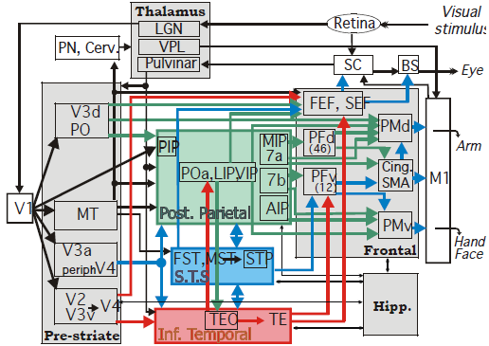
- V1 Posterior Parietal Cortex (dorsal visual pathway, which supports vision for action and control of static objects)
- Extrageniculate pathway
  - Bypasses geniculostriate pathway
  - Older (basic) visual pathway which supports vision for action on dynamic (unexpected) objects
  - Stimulus driven pathway and operates in the unconscious because it bypasses the primary visual cortex
  - Visual Stimulus Retina Superior Colliculus Pulvinar Posterior Parietal Cortex

Cornea: Transparent part of the front of the eye; provides optical power by refracting light
Iris: Coloured part of the eye; controls light levels similar to a camera aperture, adjusting the amount of light reaching photoreceptive layers at back of eye
Pupil: Opening in the centre of the eye; directly determines light level entering the eye
Lens: Focus light onto the retina (determined by its changing shape); up close image, contract cilliary muscles and stretch lens; distant image, relax cilliary muscles and make lens more circular
Retina: Photoreceptive layer at back of eye; converts light into electrical energy
Fovea: Centre part of retina; highest concentration of cones
Optic Nerve: Transmits electrical impulses from the retina to the brain
Optic Disc: Point of “connection” between retina and optic disc (an anatomic blind spot – cannot perceive visual information that lands on the optic disk)

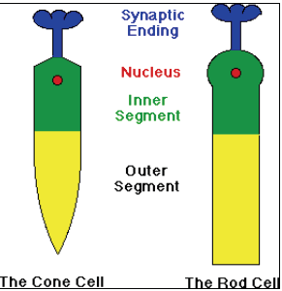
Retina
- Rods
  - Achromatic (only see thinks in black and white)
  - Equally dispersed about retina
  - Low spatial resolution
  - Respond to low light levels
  - Provides night vision
- Cones
  - Chromatic (colour vision)
  - Largely located in the centre of the retina at fovea centralis (so-called central vision)
  - High spatial resolution (because 1:1 mapping of cone cells to neurons)
  - Do not operate in low light levels, can’t see in the dark
  - The sharp tip in the cone cells allow for higher density

Cones
- Cells are specialized for different wavelengths/frequencies of colours (red, green, blue) and their densities vary from person to person
- People perceive colours differently as a function of their cone color ratio
- Most people have a stable representation of blue cones

Colorblindness
Two types: acquired and congenital
Congenital: cone mosaic may be comprised of blue and green or red and blue, etc, (thus, you are not able to process color (or certain colors) at the level of the eye)
Acquired: as a result of a stroke, a patient developed a form of colorblindness. This is a high level cortical deficit, as he was unable to process color at the level of the brain (color blindness sustained from a brain injury is called achromotopsia or color agnosia)
-This deficit occurs in about 1 of every 30 000 people

Binocular Vision
- We can see 210 degrees of visual field (approximately 140 degrees is binocular)
- Binocular Rivalry
  - Phenomenon in which a visual perception alternates between the different images presented to the eyes
  - Very small differences between the two eyes yield stereopsis
- Stereopsis
  - Disparity of images from the two eyes allow the estimation of depth
  - Without stereopsis depth estimation is severely impaired (lack 3D vision)
  - Remember “Magic Eye:” it is an example of an autostereogram
  - People who have one eye (enucleated) have a technique called motion paralayx (shaking head back and forth) which gives them a slightly different perception

Binocular Rivalry
- Sometimes brain processes information from right eye, other times from the left eye
- Damage to binocular vision leads to one image being produced with the lines crossing each other
- Allows you to see two different images depending on the time you are asked (i.e. either a seagull or a bunny, Necker Cube) eye shifts back and forth between
- Our ocular dominance is similar to a right hand dominance
- Most people are right eye dominate (90-95%) (2/3)
- Donut Test: Easy way to determine eye dominancy (eye that is closed and image stays aligned in donut shape is your dominant eye)
- Some people don’t have a dominant eye
- People with a strong dominant eye have a hard time seeing stereograms (need stereopsis)
- Cross dominance in baseball makes you good, right hand dominate left eye dominate

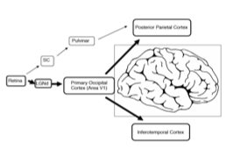
Processing Visual Information
Where does your brain process visual information?
- Depends on what you are doing with that visual information
- Duplex Model of Visual Control (Perception Action Model)
- Vision for Perception: Identify, determine size, shape or properties of an object
  - Compare one thing relative to another
  - “Allocentric frame of reference” (not precise)
- Vision for Action: Reach or point to an area in space to control action
  - Dorsal visual pathway
  - Absolute system (metrically precise, mm accuracy)
  - “Egocentric frame of reference”
  - Compare an object relative to yourself
- Dorsal Stream: From V1 to PPC
  - Stream of visual processing for action
- Ventral Stream: From V1 to inferotemporal cortex
  - Stream of visual processing for perception
Actions require precise visual information, perceptions do not.

Prosopagnosia
•Face blindness- people are unable to recognize faces
•Jane Goodall and Brad Pitt have this
•They see a face but separately, eyes, nose, mouth, they aren’t able to put all features together
•Congenital deficit or required deficit as a result of brain injury
•Region between V1 is Fusiform Face Region
o Part of brain that is involved in the processing of faces
o Lesion of ventral visual pathway

Case Study
- Patient DF
- House heated with propane (lived in rural area)
- Carbon monoxide was leaking into the house, DF passed out in the shower
- People thought she was completely blind afterwards
- Carbon monoxide poisoning impairing inferotemporal lobe (ventral stream) in the lateral occipital cortex: deficit is a form of object agnosia
- Said she could see tiny hairlike structures on a strawberry (5 months afterward)
- Specific visual impairment known as Visual Agnosia
- David Millner and Mel Goodell came up with the Duplex Model of Visual Control
- DF cannot identify different shapes or object features, but can reach out and grasp objects properly (can still use vision for action since PPC was unaffected)
- Can not copy a drawing, but can draw them from memory
- Simple mailing task with two conditions (perceptual and action)
- Can change orientation of slot
- Ask her to hold up the letter and try to line up the letter (but stopping before the slot), but she can not perform the task (just guesses, no idea when she has to use vision for perception)
- When asked to physically perform the action, she can easily put the object through the slot (vision for action)
- Tom James took a high resolution magnetic resolution imaging in DF vs healthy individuals why they saw simple images
  - Part of ventral visual pathway
  - Bilateral lesions to the lateral occipital cortex
  - Critical for using vision to make a perceptual judgment (if impaired = visual agnosia)
- DFcan see things and small little elements but is incapable of putting it all together. She cannot perform a visual guided action, only a memory. It is just her dorsal visual pathway therefore it runs in real time and info is only available in a moment-moment basis. As soon as ou lose contact with your environment you lose the the memory.
- Patient AT
- Impaired visuomotor processing
- Stroke to the posterior parietal cortex (dorsal stream) leads to a severe case of optic ataxia
- AT can recognize shapes, sizes and object features, but cannot reach out and grasp objects with visual control
- Bilateral lesions to PPC (dorsal pathway)
- AT’s impairment is restricted to right side of visual field

Face Blindness and Agnosia
- Ann had a stroke and it damaged her posterior parietal cortex causing the inability to use peripheral vision in the right visual field, same as optic ataxia
- PT/OT have individuals with optic ataxia perform movement with eyes closed and this accommodates their deficit
  - Dorsal visual pathway operates in a real-time motor control (needs to use vision)
  - Closing your eyes get rid of the real-time control so it shuts off this pathway and relies on their unimpaired ventral visual pathway and uses that remembered visual information to control movement
- Double dissociation between visual agnosia and optic ataxia: Patient AT and Patient DF
- Visual agnosia is much more severe that impacts your daily living
- People with optic ataxia can still drive their cars and show normative movements (can accommodate for their deficit much more readily than those with visual agnosia)
- DF can perform a task with eyes open, but is extremely impaired when her eyes are closed, since her ventral visual pathway is damaged (cannot perform visually-guided movements)

Double Step Paradigm
- Change position of target as the person is moving (moves either to the left or right)
- Target jump occurs during point of time known as saccadic suppression
- When your eyes move, period of maximum velocity means you can’t maintain a stable image on your retina (can’t see anything)
- Since target moves when you can’t see, participant can’t perceive the target moving (no conscious awareness) but their hand will move toward the new target location
- Due to extrageniculate pathway
- Provides evidence that PPC serves as an “automatic pilot”
- If target jump occurs after saccadic suppression, and participant is told to still move to the old target location, they always move their hand to the new target (since PPC is operating automatically)
- Individuals with optic ataxia can never make the corrective movement (they won’t see the target change, or modify their movement to the new target)
  - BUT will always move toward the old target since PPC is damaged and doesn’t function on autopilot

Summary
- Ventral visual pathway:
  - Offline Based on knowledge
  - Relative information
  - Allocentric frames of reference
  - Supports memory-guided movements
- Dorsal ventral pathway
  - Operates in real time
  - Absolutely and metrically precise information
  - Egocentric frames of reference
  - Does not support memory-guided movements
- Posterior Parietal Cortex
  - Use of vision is automatic and involuntary
  - Processes online visual information, not a top-down process, very simple
  - Responds only to position information; it is achromatic (not sensitive to color change)
  - PPC is the automatic pilot (so simple, it tells us where to go without thinking about it)

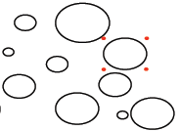
Masking Paradigm
-Stimulus is presented for 13 ms (it is an array of different sized circles, with the one with red dots surrounding the one to focus on)
-In the manipulated condition, the 4 red dots will persist for an additional 320 ms after the circles disappear
-In the perceptual condition, subject tells the experiment whether circle was big or small
-In the action condition, subject actually reaches out and points to the circle
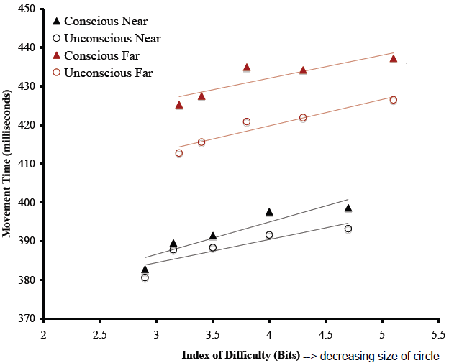
Results:
Perceptual task…
-Prime = control – people were 100% accurate in judging circle size
-Mast = experimental – only 56% accuracy (subject just guessing, could not actually perceive the size of the circle)
Action task
-Size of the circle decreased with each trial
-Filled triangles = controlled
-Open circles = masking (recall people cannot consciously report the size of circle)
-Found that movement time increased with decreasing object size
-Show that in neurologically intact people, there is a separation between perception and action (directly supporting the duplex model of control) – can act on something without being necessarily aware of what that something is
-Shows that the PPC does not need to be aware in order to act correctly (PPC operates below a level of conscious awareness)
  - Provides evidence of action blind sight in neurally intact individuals

Allocentric vs. Egocentric Frames of Visual Information
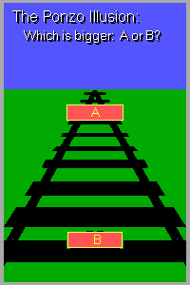
- When we make relative comparisons, we can trick the ventral visual pathway using pictorial illusions (allocentric)
- Ventral visual pathway thinks it’s looking at a convex image but it’s really a concave image (moving face)
- Box A and B are the exact same size, but because of relative cues, ventral visual pathway is tricked
- If the boxes were real, their motor movement will be the exact same regardless of which box they were asked to grasp (PPC and dorsal visual pathway does not care about relative cues, but only uses the precise size of the object to be grasped in egocentric frames of reference)
- Grip aperture scales in a direction consistent with the perceptual knowledge if they lose their vision halfway through the movement (memory-guided movement uses ventral visual pathway instead)
- Actions are immune to illusions, which process visual information using dorsal pathways are different from the ventral, which will get tricked

How Do We Intercept a Moving Object
- David Lee watched birds dive into the ocean and catch sardines (go up high, dive 3 meters below water). To get deep enough, (and not break their wings) they need to fold their wings into their bodies prior to entry
- Timing contact with a moving object must be an innate function (born with this ability)
- Time To Contact Theory (Optic Tau Theory)
  - Time to contact: Temporal prediction about when an approaching object will arrive
  - Innate theory occurs as a result of how the moving object casts a shadow on the back of the retina
  - Looming object casts an angle on the back of the retina (due to a shadow)
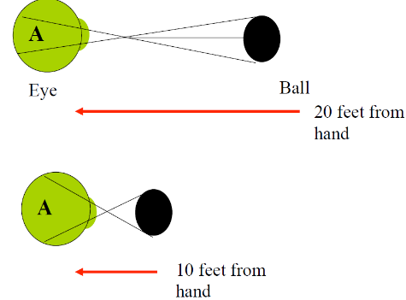
  - As it gets closer, the angle increases and tau decreases.
  - When tau reaches 0, it tells the performer they’re about to make contact with the object
  - Tau allows the system to predict when an object will be intercepted
  - Only works for objects moving in a straight line at a constant velocity

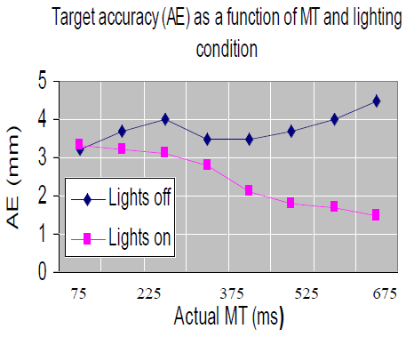
Time Required to Process Visual Feedback
Zelaznik et al (1983)
- Participants completed vision or no vision aiming movements
- Simple pointing task (20cm in front of them, 30cm, 40cm)
- Movements to be completed in 75 to 675ms with or without vision
- Then had them perform the movements with lights on/off
- At 75ms: No difference in error
- As the time to perform the task decreases, accuracy decreases when the lights are turned off
- Vision cannot be used to modify movement within 75ms
- Minimum threshold by which we can use vision for feedback control: 75-150ms (for static movements)
- For dynamic and unexpected, the minimum threshold is somewhere less than 75ms (because response regulated via extrageniculate pathway)

Vision and Whole-Body Actions
- Three sided room with stationary floor, the walls of the room could be moved forward or backward
- Subjects asked to maintain static posture while facing the front ball
- Experimental gradually moved the wall forward or backward (5-10cm)
- If slow enough, the participant had no conscious awareness that the room was moving
- But still a postural response
  - When wall moved forward, resulted in leaning backwards (in children and older adults, this perturbation resulted in a total loss of balance)
  - When wall moved backward, resulted in a dramatic forward lean
- Visual system maintains a constant relationship between head and fixation point, and since it is processed in real time, it is continually attempting to maintain this relation
- Vision is continuous used to modify a whole body movement (egocentric frame of reference)
- Conclusion: Visual information is a source of afferent information controlling balance

Balance
- The ability to control the relationship between our center of gravity and how it relates to our base of support
- Must keep COG within BOS or you will fall over.

Vestibular System
- We must get signals from peripheral NS to CNS. People with diabetes are not able to regulate glucose in the blood. Glucose is toxic for nerves and will lead to poly neuropathy, which is dying of nerves due to poor glucose regulation. It tends to be seen in older individuals and increases their risk for falls because balance regulation is lost.

Proprioception
Sensory signals (afferent kinesthesia) regarding position of body in space.
Proprioceptor Types: Vestibular, Muscle Receptors, Joint Receptors and Cutaneous Receptors

Vestibular System
- Three fluid-filled half circles termed semicircular canals
- Inside of canals are small structures called cilia which bend and relay information about the postural change
- Provide information regarding position of the head relative to the rest of the body
- Sensitive to each directional plane (x,y,z)
- Horizontal canal detects rotation of head around vertical axis (i.e. spinning)
- Anterior and posterior canals detect rotation in the sagittal plane (i.e. nodding) and in the frontal plane (i.e. completing a somersault)
- These three canals detect angular accelerations, but very little involvement in determining linear accelerations
- Otolith organs detect changes in gravity and acceleration
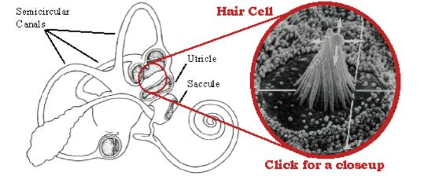
  - Utricle detect changes in horizontal movement and linear acceleration (e.g. walking) – Important for eye movements
  - Saccule detect changes in vertical movement (i.e. in an elevator) and linear acceleration (sensation of being in a plane) – Important for posture
- Girl in bike accident got vertigo from broken bony otolith organs in her semicircular canals. Physio shook her head a bunch of times and that’s how she got rid of the vertigo.
- Vestibular Ocular Reflex (VOR)
  - Mediated by the vestibular system
  - Head moves in one direction, vestibular system tells you this and sends specific outputs to ocular muscles, telling eyes to move in opposite direction
  - People with vestibular lesions are very impaired because they can’t regular VOR
  - Caloric Stimulation: Use cold water and flush ears, but rapid oscillation of eyes (water stops vestibular system from sending output, which means there is no connection about ocular muscles and position of head)
    - Develops Nystageous
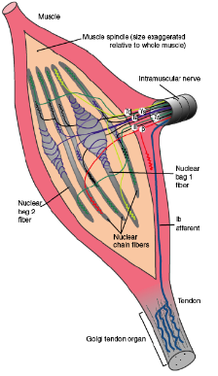
    - Alcohol disrupts fluid in semicircular and prevents cells from operating properly and impairs VOC
- Vestibular system function is disturbed by Menieres Disease:
  - Fluid of the semicircular canal is built up and starts to drain out the ear, constantly stimulating the hair cells and generating vertigo.

Muscle Spindles
- Cigar-shaped structures connected in parallel with muscle fibers
- Innervated by gamma motor neurons
- Provide information about stretch of the muscle
- Proprioception: Activation of intrafusal muscle spindles
- Spindles can’t store any information (muscle memory is a myth)
- Two types: Type 1a and Type II
  - Type 1a are REALLY sensitive to rapid (dynamic) stretch of the muscle (i.e. when the agonist first begins contraction, the antagonist muscle is being stretched) and are also velocity dependent
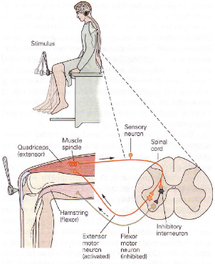
  - Type II are sensitive to sustained level of contraction of the agonist muscle (static stretch)
  - Both types respond to stretch of a muscle
- Provide system with information about limb position
- Red line: Limb position
- Green line: Type 1a activation (rasterplot)
- Blue line: Type II activation (rasterplot)

Monosynaptic Stretch Reflex
- Hammer strike on patella tendon results in stretch of the quadriceps muscles
- Muscle spindles of quadriceps send stretch information to the spinal cord
- Single synapse onto alpha motor neuron of quadriceps and contraction of that muscle
- The simplest of all stretch reflexes because it contains only one synapse (monosynaptic connection)
- Takes about 20-50ms: Too quick for the brain to be involved
- Simple test to see the basic level of health associated with CNS
- Hyper-reflexia:
  - Stroke that impaired entire left hemisphere (upper motor neuron injury)
  - Exaggerated response
  - Excitation associated with alpha-motor neuron is stuck on level of high excitability, which leads to an exaggerated response when synapsed with gamma motor neuron
- Hypo-reflexia:
  - Lower motor neuron injury
  - Impedes the ability of alpha-motor neuron
- Functionally significant (whether expected or unexpected): any actions will be counteracted with Type 1a or Type II muscle spindles

Muscle Spindles and Voluntary Control
- Participants asked to stand on platform which could move forward or backwards
- Platform translated backward: Thrown off posture and activation of posterior muscles (hamstrings and gastrocnemius) will happen to counteract
- In general, proximal muscles get activated before distal muscles
- BUT for postural control, there is a distal to proximal activation
- Called ankle strategy a.k.a. Distal-Proximal Control Strategy for postural control
- Evidence that within spindle cord, activation of alpha motor neurons has direct control over movement and cortex does not need to get involved whatsoever (mediated at the level of spinal cord)
- Hip strategy: Gymnast on balance beam and loses posture, attempts to fix posture by recruiting hip muscles
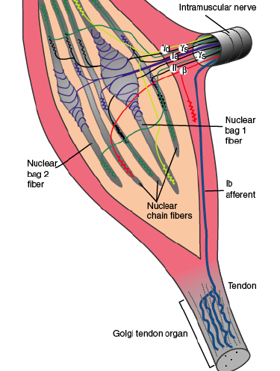
  - Older adults use this strategy, but not very effective since it is slow, so we give those exercises for their lower body.

Golgi Tendon Organ
- Located in junction between muscle and tendon
- Provide information about tension (force) in the muscle
- Prevents overstretch and rupture by inhibiting motor neuron drive (tendon actually separates from the bone)
- Sensory information works slightly different than muscle spindles (oligosynaptic connection involving an inhibitory interneuron)

Foam and Dome
Stand as still as possible keeping postural sway to a minimum for 30 seconds. Conditions:
- On flat ground eyes open
- On flat ground eyes closed
- On flat ground eyes open with dome on head
4-6 are the same just on a foam pad.
This tests our balance, somato sensory and vision, but not vestibular sense. (Multisensory integration)

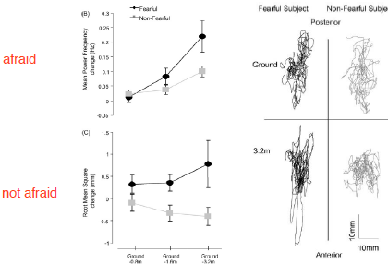
Cognitive Control of Balance
Carpenter want to see how people who were afraid of heights regulate balance at heights. Two groups: Afraid of heights and not afraid.
When non-stressed you sway less, not too worried about how close your COG is getting to end of BOS. If on the edge of a cliff gamma motor neurons fire a lot more to correct your COG often increasing activity in gamma motor neurons is called gamma motor drive!! On ground both groups are the same.
Not afraid group- balance remains similar- shift weight more backwards
Afraid- more sensitive to stretch but have worse balance at height.
Important because explicitly shows that when attentions is divided by fear and drawing on cognitive resources you don’t maintain balance as well.
Problem for older individuals at risk for falls. 1/5 falls after 65 will die

