Memory Systems
- Cognitive (somatic) memories (mediated by cortical structures) are stored different compared to motor memories (mediated by cerebellum)
- Memory: The capacity of individuals to retain and utilize information in various ways for various periods of time
  - Acquisition
  - Retention
  - Retrieval
- Comprised of three systems:
  - Short-term sensory store memory
  - Short-term memory (working memory)
  - Long-term

Short-term Sensory Store (STSS)
- Very brief duration
- Large capacity
- Veridical memory system (retains visual image exactly and precisely; takes live snapchats)
- Pre-categorical (no conscious awareness of what information is in the system)
- George Sperling (1960)
  - He presented a matrix of letters or numbers very quickly (10 ms flash)
  - Researchers used a whole-report technique where participants were asked to recall anything about the matrix
  - 0% recall accuracy when using the whole-report technique
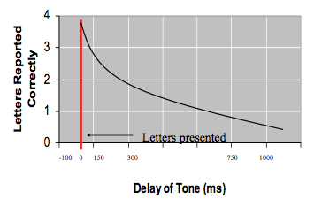
  - George used the same presentation, but using partial report technique (half-report)
  - He used a cue (tone) to tell participants which row to memorize that came before, during and after letters
  - High tone = only recall top row
  - Middle tone = only recall middle row
  - Low tone = only recall bottom row
  - When tone was concurrent with matrix, there was 100% recall accuracy
  - Delay of tone is a test for how long information can be maintained in the short-term sensory store
  - Showed the STSS can reliably store information for 300 ms, but becomes unreliable after 300 ms (accuracy is less than 50%)
  - Regardless of what row they were asked to recall, after 150 ms they have 75% accuracy (very large capacity and represents veridical memory), meaning they can recall any row as long as they are directed to that row within 150 ms

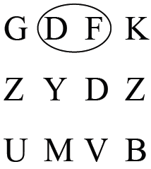
  - Ellipse over some letters (instead of tone) and are asked to recall those numbers, but 0% accuracy
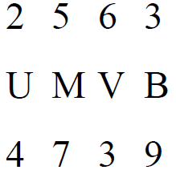
  - Ellipse erases the information that the STSS stored because it is in the same spatial location, which shows the veridical nature of the STSS
  - Instead of 3 rows of all letters and numbers, he dispersed them (2:1) and asked participants to just recall the row of all the letters
  - STSS cannot categorize stimuli since it is pre-categorical, and as a result one’s ability to recall this type of information is 0%

Short Term Memory (STM)
- Buffer between STSS and long-term memory (working memory that allows you to repeat and consolidate information and ultimately allow it to end up in your long-term memory)
- Brief duration (not as brief as the STSS)
- Limited capacity (7+/- 2 bits of information)
- Categorical (conscious and semantic)

Memory and Attention are Strongly Intertwined
  - Paying attention can be seen as holding in memory
  - The longer an item is attended to (held in memory), the higher the chance it will be remembered later
  - Attention is required for rehearsal
  - Theoretically keep information in your STM for as long as you are alive, as long as you rehearse the information (can’t rehearse = can’t retain)
  - Consolidated- Information has been shipped off to long-term memory

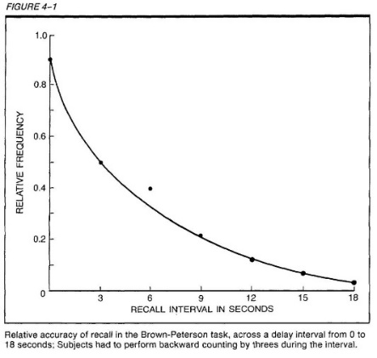
Brown-Peterson Task
- Specifically designed to measure the temporal duration of unrehearsed information can be retained in the short-term memory system
- Participants are flashed three letters, asked to recall it at some time later
- During the interval, there is a distractor task (counting backwards by 3’s) which prevents the information from being rehearsed
- The results typically show very low memory performance
- The reason is that rehearsal of the letters is prevented by the counting task
- Curved linear decrease in recall accuracy as a function of the length of the delay interval
- Unrehearsed info can reliably persist in short-term memory for about 3 seconds
- Trial effect- Needed a few trials to occur
  - In the fourth trial, instead of a trigram, they had to recall three numbers and accuracy shot back up
  - Decrease to recall accuracy as a function of increasing trials
  - Release from proactive interference
    - Previous information held impair your ability to hold new information that has previously been presented
    - Different somatic category releases you from this proactive interference
- Proactive Interference- The forgetting of currently learned material produced by interference from previously learned material (impairment being able to consolidate information, more robust than retroactive) ex. studying for two sciences vs science + art
- Retroactive Interference- Process in which an event learned during a retention interval leads to forgetting of a previously learned event

How Well We Retain Visual Information to Support Memory-Guided Movements
- How well we can retain information to support memory guided movements
- First condition = open condition
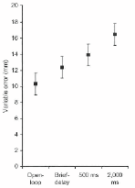
- Three brief delay conditions (0ms delay condition, 500ms and 2000ms)
- Participants are shown a target for 2sec
- Given auditory cue telling them to move
- Open – given auditory cue, as soon as they move, they cannot see their environment anymore, vision eluded at movement onset
- Brief delay condition
  - 0ms delay = lose vision of environment as soon as auditory tone goes off
  - 500ms delay = lose vision of environment prior to being told to move
  - 2000ms delay = lose vision of environment prior to being told to move
- Increase in variable error across trials (accuracy of pointing to a target)
- Results suggest that vision for action is different for visual memory of explicit tasks than vision for an implicit skill
- No period of time in which memory provides us with an accurate visual representation (There is no memory for vision that is as accurate as having vision during movement)
- Vision for movement, there is no accurate memory representation for vision and movement
- Visual information does not provide an accurate target representation for any period of visual delay

Proprioceptive Information to Support Memory-Guided Movements
- How long participants can store information related to target location in their proprioceptors
- Robots putting your finger on target than putting back to start position
- When a target is defined proprioceptively, the information is reliably there for up to 2000ms
- Visual information decays very quickly and provides an unstable representation of target location
  - Location of response mediated via extrinsic coordinates (outside the body) or egocentric code of reference (you relative to something else)
- Proprioceptive information decays more slowly
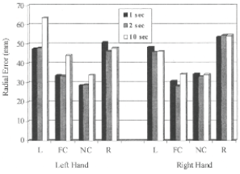
  - Location of response mediated via intrinsic coordinates (inside the body) or allocentric frames of references, which is the coding of a target relative to something other than the target

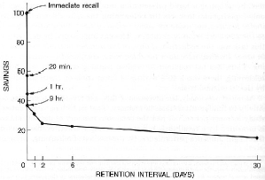
Typical Forgetting Curve (Forgetting Experiment)
- Ebbinghaus was interested in how much information people forget after learning a new motor skill
- Savings (how much information is remembered) vs Retention Interval (days)
- 20 minutes after learning task, only 60% recall accuracy (dramatic loss of information)
- 9 hours = 60% of information lost
- Plateau in recall accuracy (no diminishment in recall accuracy from 2 days to 30 days)
- Structure learning environment so that there is a accumulative practice during the day so it limits savings loss
- There is currently no theory that explains why we forget
- Forgetting seems to follow rather strict rules, but even these have not been fully explored
- It is postulated that very well-rehearsed knowledge will never be forgotten (Harry Barrick’s “permastore”) but you’re not able to access and retrieve it (only applicable to long term memory)
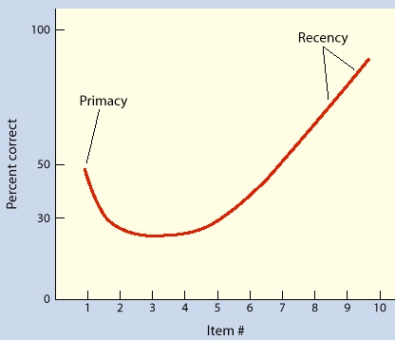

Typical Memory Recall Curve
- Robust primacy effect and robust recency accuracy
- Words in the middle do not show as good recall performance as primacy and recency
- First words in the list you rehearse (primacy)
- Last words you saw are fresh in memory and do not have time to decay (recency)
- People showing symptoms of a concussion do not show a primacy effect because it is a cognitively demanding task

Sleep and Memory Consolidation
- State dependent memory
  - Robert Kerr
  - Individuals who learned word list underwater or on the pool deck could recall the information the best when under the same circumstances (under the water or on the pool deck)
  - Environment influences ability to recall information
  - Optimized performance when heart rate is the same as when studying
- Sleep prevents forgetting and makes memories resistant to pro- and retroactive interference
- Especially if sleep closely follows learning
- Sleep allows for hippocampus-neocortical dialogue and information transfer
- With sleep hippocampus and neocortex synchronize their activity
- Sleep allows for the same brain waves to be developed in the temporal lobe and hippocampus, communicating directly together, supporting consolidation of memories

Sleep and Memory Types
- Slow-wave-sleep (SWS) represents very deep sleep and is the majority of the sleep cycle
- Random eye movement (REM) sleep predominates the second half of the sleep cycle
- SWS is important for consolidating explicit (somantic) memories (i.e. studying for physics exam) and at least 8 hours of sleep is needed
- REM sleep is important for consolidating implicit memory (i.e. studying for practical exam) and a nap is all that is needed
A study was done where people have to learn a list of words, one group does it in the morning, two groups do it at night. The two groups that do it at night are allowed 8 hours of uninterrupted sleep, the other group has their sleep interrupted every time they fall into slow wave sleep, a very deep sleep that is important for long term explicit memories. People who got a good sleep had a much better recall accuracy than those who didn't get slow wave sleep; both got same total amount of sleep, just one never got the deep slow wave.

Long Term Memory (LTM)
- Items practiced or rehearsed access LTM
- Has a limitless capacity
- Composed of three subsystems
- Individuals with cerebellum lesions have no difficulty with explicit memories but have an extreme difficulty learning new procedural memories

- Procedural (Implicit) Memory
  - Stores knowledge of “how to do” a skill or activity
  - We know “how to do” something, but not able to verbally describe it well (ex. Shooting a basketball, swimming)
  - Not mediated cortically, but at a level of the cerebellum

- Semantic (Explicit) Memory
  - General knowledge about the world developed from many experiences
  - Factual and conceptual (ex. The date Columbus discovered America)
  - Cortically mediated (top-down system involving frontal lobe)

- Episodic (Explicit) Memory
  - Knowledge about personally experienced events
  - Ex. Where we were when we heard about 9/11
  - Top-down memories, strong because they are personal to us

Henry Mallaison (1950s)
- Bicycle accident where bully pushed him and hit his head, which led to epilepsy
- Grand-Mal Seizure (impacted entire brain) occurring all the time
- Part of his brain causes seizure were removed: bilateral temporal lobe and the attached hippocampus
- Anterograde amnesia (could no longer form explicit memories or episodic information)
- Brenda Milner examined him and found that he could not form episodic memories but could form random semantic memories.
- Task: Get him to trace a star reflected in a mirror and come back two weeks later and perform the task again.
  - He had no memory of doing the task the first time
  - But his performance proved that he had learned a new procedural memory
  - Same as age-matched control
- Study shows that he didn’t damage the area of the brain that is associated with implicit memories.
- Study of HM + cerebellum lesions provide “double dissociation” which is paramount in proving a model (in this case distinct memory systems)

Clive Wearing
- Damage to bilateral temporal lobe, frontal lobe and hippocampus
- 10-30 second memory
- Indication of the important role of the temporal lobe and hippocampus associated with the consolidation of explicit long-term memories
- Bilateral lesions but most damage to left frontal lobe (creates emotional instability)
- Musical abilities are intact because not much damage to right cerebral hemisphere
- Anterograde and retrograde amnesia, but still okay with learning motor skills

Increasing LTM Potential
-Increase Movement Meaningfulness: when learning a new motor skill body-parts are coordinated in new ways, therefore movements are abstract and of little meaningfulness
A. Use of Imagery
-instead of a complex verbal instruction
-movement can be rehearsed through mental imagery
B. Verbal Label (only applies for early stage learners)
-provide a verbal label to the movement (e.g., release the football at the 11:30 position)
-label-movement association enhances correct recall of the movement
C. Intention To Remember
-when provided cues as to what information is to-be-recalled
-rehearsal to-be-recalled information improves integration into LTM
-e.g., test was done where people had to memorize words on a pool deck, and underwater. The people who had to recall the words in a different condition than where they memorized the words had a less accurate recall. This test shows the state dependent memory.
D. Subjective Organization
-grouping into smaller units
-e.g., learning a long dance routine of 25 mins is facilitated by learning routine in increments of 5 mins

