Attention

Attention

- “Focalization and limitation of information processing resources” – Schmidt & Wrisberg, 2005)
  - Presumes that attention has to occur at a conscious level (aware)
  - Attention and consciousness are not necessarily connected to each other
  - Neisser Experiment: Determining whether or not consciousness or attention are connected
    - Asked to memorize 25 words out of 100 (25 of those words were paired with a mild electrical stimulus
    - Done at beginning of fall semester and redone at the end of winter semester
    - 75 of the words were entirely new the second time around, but the 25 words that were paired with the electrical stimulus were included again
    - Measured galvanic skin response (GSR) which provides a measure of skin conductives (activation within autonomic nervous system which occurs below the activation of consciousness)
    - 25 words paired with stimulus elicited a very high GSR during the follow up session, suggesting that even though the participants weren’t consciously aware, their attentional system is working below the level of consciousness
- “Inattention blindness”
  - Awareness test (Dancing bear) COUNT NUMBER OF PASSES –Daniel simon
  - Focalization and limitation of processing resources
  - You are not aware of the bear because your intention spotlight is focused on something else
- “Change blindness”
  - We can detect stimulus if it represents an unexpected and dynamic change in our environment
  - If it’s a visually unexpected and dynamic stimulus, it excites neurons within our superior colliculus and involuntarily directs our eyes to the stimulus (hardwired feature in humans)
  - When changes occur gradually, we don’t attend to the change because we only have so much attention at any point in time and we don’t devout our attention to the things that we can’t see – big in advertisement
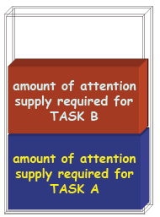

Attention as a Single Resource
- Processing Resources
  - Limited processing resource
  - Limited capacity/supply
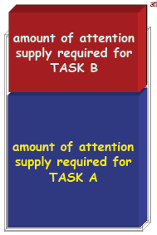
  - 2 tasks/processing activities can be performed if their attention demands do not exceed resource capacity
    - Ex: Driving a car and answering a cell phone
  - 2 tasks/processing activities will be dangerous if their attention demands exceed resource capacity
    - Ex: Driving a car during a snow storm and heavy traffic while talking on the phone

Attention for Control
- Information Processing
  - Limited capacity processing channel
  - Limitations in the number of activities that can pass through channel at the same time
  - Information processing channel allows for only one processing activity at a time
    - Broadbent proposed that If we have a bottleneck in processing, it occurs right at the stimulus identification stage
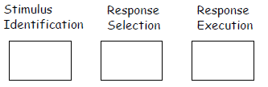
  - Serial vs. Parallel processing
    - Stimulus Identification
    - Response Selection
    - Response Execution
  - Each stage of processing takes time
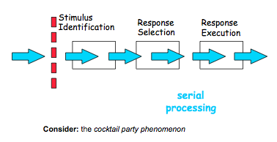

Welford’s Information Processing Channel
-One of the stages has a filter that limits the stimulus that can get into our processing channel, which occurs at the stimulus identification stage (dashed red dot line)
-When the filter occurs here it is referred to as the “early theory of attention”. This theory comes from Welford, and can be related to as a cocktail or "kegger" phenomenon
-Example: When talking to a friend in a large room where others are talking, you can only attend to you and your friends convo because you have a filter that will only attend to the stimulus coming from your friend, not from the party around you. Somewhere across the room someone says your name and you attend to that. Suggests that other information is leaking into your information processing channel unconsciously. Stimuli that is personal to you (name) can bypass filter and go through the channel

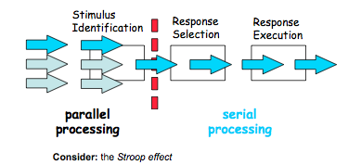
Broadbent and the Late Information Channel
- Bottleneck occurs between stimulus identification and response selection
- Can process multiple information
- But can only act at one pathway
- This was Broadbent’s Theory of Late Attention

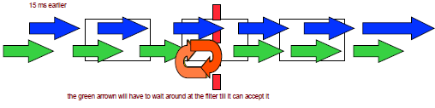
Psychological Refractory Period
- Delay in responding to the second of two stimuli presented in rapid succession
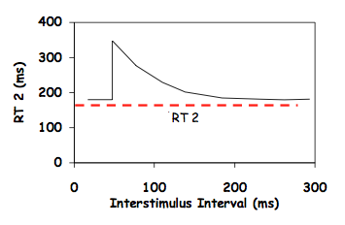
- Interference in selection and organization of response
- Good example of the Late Information Channel
- When red light and blue light come one independent of each other, we will have a 150 ms reaction time, but when we do the PRP, the first stimulus will be the same for 150 ms, but the second reaction will be elevated to 250 ms when you have to respond to the second stimulus in advance to a first one
- Therefore leads to an increased time for the second stimulus of two closely spaced stimuli
Stimulus 1 Reaction Time 1 (150 ms) Response 1
Stimulus 2 Reaction Time 2 (150 ms) Response 2
Stimulus 1 Stimulus 2 Response 1 (150 ms) Response 2 (250 ms)

Important Terms
Parallel Processing: A type of information processing that allows people to handle TWO or MORE streams of information at the same time
Serial Processing: A type of information processing that permits people to handle ONE stream of information at the same time
Double Stimulation Paradigm: A research design involving separate reaction to two different stimuli presented close together in time
Interstimulus Interval: The length of time separating two stimuli in a double-stimulation paradigm: often referred to as stimulus onset asynchrony (SOA)
Psychological Refractory Period: The delay in responding to the second of two closely spaced stimuli

Attentional Capacity and Instruction
A. Attention directed toward the initiation (and sometimes termination) of a movement is critical
B. Automate elementary components of a skill prior to integrating additional movement constraints
Leavitt (1979):
- Six age groups (6, 8, 10, 11, 14, 19) and difference in expertise (timbit to semi pro)
- Four conditions:
  - Skating only holding their stick (primary task)
  - Skating and identifying geometric figures (distractor task)
  - Skating and stickhandling (secondary task)
  - Skating, stickhandling and identifying figures
- Skating speed was examined in each age-group in each experimental conditions
- Results:
  - Skating impacted by stickhandling task up to 14 years of age
  - Thus, skating is attention demanding
  - Early in skill development, elements of movement that must become automated should be emphasized prior to introducing new attention demanding task
  - As the person develops, integrate secondary tasks because the primary task will not take up as much of their attentional resources

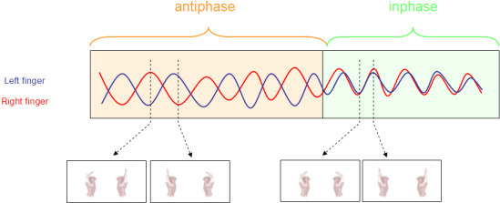
Coordination and Attention
- Bimanual coordination: simultaneous movement of the two hands
- Two hands seem to be “linked” together
- Timing structure of the two hands is the same
- Left side: Anti-phase coordination pattern (180 degrees out of phase)
- At 3.5 Hz: Transition from stable anti-coordination pattern to an unstable pattern
- Right side: In-phase coordination pattern (both sides are symmetrical)
- Low movement frequencies, we can adopt two independent temporal structures
- As we increase frequency past 4 Hz or movement every 250 ms, the attentional system cannot keep up so both sides fall in phase
- People without a corpus callosum have no difficulty performing high frequency anti-phase coordination
- With practice (musically) you can inhibit the corpus callosum to prevent confusion between hemispheres

Neuronal Correlates of Focuses versus Lapsed Attention
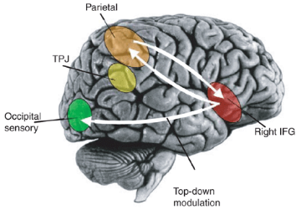
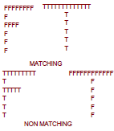
Why do we put Cheerios in the fridge and the milk in the cupboard? These action slips are due to poor or limited action control. Daniel Weismann used an fMRI and an experimental paradyme with diff stimuli to diff individuals while they were laying in fMRI. He manipulated the global and local features of stimuli. In the matching stimuli, an F was made of F's and the T was made with T's, The non-matching stimuli was the opposite. In trials they were asked to identify the global (what the total letter is) or local (what its made up of) feature. Global features tend to come to our attention first. When you had non matching global and local features it resulted in a significant increase in reaction time of the local feature. Long reaction times were taken as an indication of a slip of attention. He wanted to look at the cortical-structures that were or were not active. The inferior frontal gyrus (IFG) was important for the stimulus triggered orientation of attention. The middle frontal gyrus (MFG) maintained task goals in working memory. The anterior cingulate cortex (ACC) was thought to be responsible for conflict monitoring. On trials associated with very short reaction times found that these structures were very active. In contrast, they were very poorly active for long reaction times (attention slips). After participants did an attention slip, they were not aware it took them a prolonged timed period. The trial after an attention slip trial, you get a crazy activation of the right lobe attention center so you won't continue to make mistakes. These three structures can be referred to as our default attention network. When they aren't working at a high level, you will make a slip of attention. After a slip of attention, the IFG will activate the brain to ensure you don't commit further errors.

