Measurement, Interpretation and Evaluation of Motor Skill Performance

Measuring Motor Behaviour
There are three levels of analyses:
1) Performance Outcome
2) Describing the movement
3) Measuring activity of the central nervous system

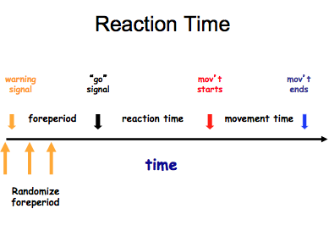
Performance Outcome
Measures of Time and Speed:
Performers who can accomplish an action in a given time are more efficient
I. Reaction Time/Response Latency:
- The speed at which you can detect stimulus
- Response programming
- Reaction Time tasks:
  - Simple Reaction Time (SRT)
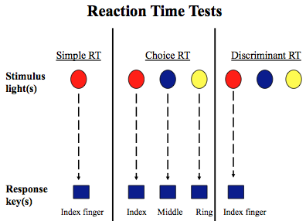
  - Choice Reaction Time (CRT)
  - Discriminant Reaction Time (DRT)
*Reaction Time + Movement Time = Total Response Time
* In order to get a pure measure of reaction time, you vary the foreperiod to prevent anticipation.
Simple RT: One stimulus, one response, leads to a pure measure of stimulus identification (around 210 ms), not high level control
Choice RT: Multiple stimuli, multiple responses, leads to a slower response because you have to identify and make a cognitive decision in terms of what colour turned on, and finally deciding the appropriate response (top-down cognitive control in frontal lobe) Damage to frontal lobe = longer choice reaction time, approx. 600 ms response time.
Discriminant RT: Multiple stimuli, only one response, have to inhibit other responses
-400 ms response time
-Top-down cognitive control in frontal lobe
-Can’t perform if there is damage to frontal lobe
Those with scitzophrenia, autism or frontal lobe lesions will have problems with inhibitory control and cannot inhibit a response. They will left their finger when any of the lights come on.
The number of errors made will provide an index of one’s inhibitory control.
Premotor Reaction Time:
- Period of time between the onset of the stimulus and the beginning of muscle activity
- Measured with an EMG (electromyography- measures electrical activity of a muscle)
- Measures time-frame required to receive and process information
- Provides an index of how long it takes the CNS to process and plan a response

Motor Reaction Time:
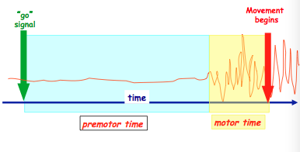
- Period of time between the onset of muscle activity and observable movement
- Time lag in muscle needed to overcome inertia of a limb
- Affects the “Electromechanical delay” within the limb

Fractionation of Reaction Time:
- Majority of Reaction Time interval is about 80% premotor, only 20% motor time
- EMG (electromyography) can be used to fractionate reaction time
- The go signal is a stimulus. The premotor time occurs during no waves, while the motor time is when there are waves until movement begins.
- Someone with Alzheimer’s Disease have a prolonged premotor time (CNS diseases)
- Someone with a Herniated Disc will have a prolonged motor time (musculoskeletal)

Simple Reaction Time Study:
- Pushing button on computer for 10 years
- First few years was 250ms
- After 10 years, his best reaction time was 199 ms
- Therefore, Maurice Green could not respond to the stimulus of the gun going off in 113 ms (false start)
- As well, the reaction time for a simple finger movement is 150-200 ms, so the reaction time for a multi-joint movement of a whole limb would be much higher
II. Movement Time: MT
- The interval between the initiation of a response (end of motor RT) to the completion of a movement

III. Total Response Time: TRT
- RT + MT

*Very different process underlie reaction time (CNS) and movement time (muscles)
*Training for RT will not improve MT; and vice versa

Describing the Movement
A. Qualitative Description
-verbal descriptions, time-lapse photography
-used a lot in rehab or coaching to show what they’re doing right or wrong
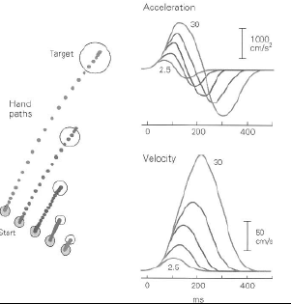
B. Movement Kinematics
-Branch of mechanics describing “pure” motion (how far, how fast)
-How far, how fast
i. Displacement: Spatial position of an effector (arm, leg, etc) during movement
ii. Velocity: Rate of change of an object position (ie arm) with respect to time
iii. Acceleration: Change in velocity of an object (ie arm) during movement
Kinematics of a Reaching Movement
- Participants had to point at an object at various distances
- Displacement of human limbs is not linear (slightly curved linear fashion)
- Moving in a linear fashion does not optimize efficiency and effectiveness of an object
- Velocity: Normal distribution (bell-shaped) but slightly positively skewed (right hand side is slightly longer than the left) which occurs when we make smooth movement (bell-shaped velocity profile)
- Ballistic movement (programmed fast) can’t be regulated by feedback structures but after peak velocity, the movement slows down so we can use feedback to modify it (requires processing time in the brain, resulting in a slightly longer time after peak velocity)
- The peak of velocity scales with the amplitude of the response (further you move, the higher the peak velocity)
- The motor system is sensitive to programming a response based on how far away the target is from the body
- Acceleration: Similar properties relative to velocity (smooth acceleration profiles) which shows explicit evidence of an optimized movement

Kinematics Experiment
-Patient has a lesion to the left parietal lobe and has a very severe type of apraxia
-Task was to slice a bagel in half
-Curved linear movement in the control
-Patient moves very linear and is primarily directed in the downward direction
-Wrist velocity vs Elbow Velocity: Should be a strong correlation between both in a normal individual but the patient’s velocities do not have a correlation
-Timing problem between the coordination of multiple effectors (the individual is moving them independently instead of in a coordinated manner)
-Eventually went to physiotherapy and worked on the timing and coordination of movement and eventually got the two velocities to be more coordinated

Measures of CNS Activity
A. Electromyography (EMG)
-electrical activity associated with muscle contraction
-provides info regarding the temporal (how many) and intensity characteristics of the movement
Phasic activation of the biceps and triceps when an individual is performing flexion/extension
- Demonstrates Reciprocal Innervation
- Tonic activation: What EMG looks like if you electrically (artificially) stimulate the muscle
  - All input arrives at the muscle at the exact same time, so all extrafusal muscles fire at the same time (synchronist)
- Phasic activation: What EMG looks like for voluntary contraction
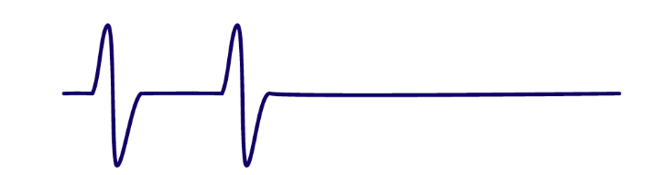
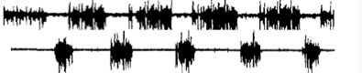
  - Different alpha motor neuron pools fire at different times, resulting in an asynchronistic non-overlapping pattern
Tonic activation
Phasic activation

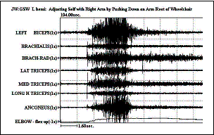
Clasp Knife Rigidity
- Evaluated with an EMG
- *Pocketknife video with leg*
- A clinical sign of an upper motor neuron injury
- Applies to all extrafusal muscle fibers
- Individual with a head injury (gunshot wound) have lack of reciprocal innervation (co-contraction) which impairs their ability to perform a sit-to-stand movement

Measure of Brain Activity
Provide measures of when and what brain regions activate during movement.
I. Electroencephalography (EEG) and Magnetoencephalography (MEG)
-Provides measures of when and what brain regions activate during movement (good temporal resolution at a ms level)
-Poor spatial resolution (only provides a rough idea of what part of the brain is active, not the precise area for a particular cognitive/cognitive-motor task)
-Higher level of activation = brighter colour
MRI (Magnetic Resonance Imaging)
- Structural scan
II. PET (Positron Emission Tomography)
- Inject or drink radiation isotope in hospital
- Isotopes are then picked up by the scan
- Shows metabolic processes of the brain
- Poor spatial resolution

fMRI (Functional Magnetic Resonance Imaging)
- Shows structure and function
- Great spatial resolution
- Really expensive technology
- Very poor temporal resolution
- Only takes pictures every 5-10 seconds

Transcranial Magnetic Stimulation (TMS) and Repetitive TMS (rTMS)

TMS
- Used to create virtual/artificial lesions
- Shows corticospinal activity with high temporal sensitivity (ms)
- Causes random activation associated with neurons with which single pulse contacts
- Figure of 8 coil attached to brain (over Broca’s area in left hemisphere)
- Singing is lateralized to right hemisphere, so for Frank, talking was interrupted but singing was not when Broca’s area is inhibited

Fadiga et al. (1998)
Wanted to measure excitability associated with motor imagery
- Excitation/inhibition in the corticospinal tract at the moment of stimulation
- Combine TMS with EMG in order to measure muscle activation
- Motor evoked potentials (MEPs) of muscle assessed to examine the “release” of action
- Task: Participants looked at screen and watched a bar get bigger and smaller (control)
- Participants saw the bar get bigger and smaller and had to think about flexing/relaxing their forearm in response to the bar changing sizes
- Control: When looking at the bar, MEP associated with the imagery task has no activation (muscle is below threshold stimulation)
- When looking at the bar and thinking about flexing/extending and the single TMS was fired, there was a large activation of the flexor muscle (bicep)
- Suggests that motor imagery and physical practice entail the same basic cortical areas
- TMS prevents inhibition of muscles

rTMS
- Same as TMS but continuous firing of random pulses in V1
- Individual LP was born without the ability to see
- NA and AM developed blindness as they aged
- LP felt pins and needles in fingertips (parathesia)
- NA and AM felt some but less than LP
- Shows neural plasticity since the brain has reorganized such that V1 is now responsible for haptic (touch) processing in LP in order to read brail more effectively

- rTMS can be used to either turn up or turn down the background activity of one hemisphere in order to re-establish the equilibrium between both hemispheres and therefore give the affected hemisphere the chance to rehabilitate
- Study: 3 groups
- One group thought they were getting rTMS but they really weren’t (placebo)
- Another group was getting 1 Hz of rTMS to the unaffected hemisphere (turn down the unaffected hemisphere)
- The last group was getting 5 Hz of rTMS to the affected hemisphere (turn up the affected hemisphere in order to re-establish equilibrium)
- Control: Nothing happened
- Group 2: After simple tapping task, activation returned to baseline
- Groups 2 and 3 outperformed the placebo group at each interval post-rTMS therapy
- Intervals that had 1 Hz over unaffected hemisphere had the best outcome in terms of improving their motor performance
- Turning down unaffected hemisphere = more effective

- rTMS can be used for patients with visual spatial neglect
- 15 days after treatment (5 Hz stimulus on parietal lobe for 5 minutes) the condition was almost non-existent

