The Nervous System

Pyramidal Tract
- Composed of a million fibers and allows for descending motor control
- Information from M1, SMA, PMA and parietal cortex enter the spinal cord via the pyramidal tract
- Interphase either directly or indirectly with alpha motor neurons
      - If connection is direct = monosynaptic connection
      - If connection is indirect = mediate by (a) interneuron (same level in spinal cord as alpha motor neuron it will synapse with) or (b) proprial spinal neuron (allows for the connection of a neuron from the pyramidal tract and alpha motor neuron at a different level in the spinal cord, connects different segments)
- Comprised of the corticobulbar tract and corticospinal tract

Corticobulbar Tract
- Corticobulbar fibers extend from the motor cortex (M1) to the “bulb” (the brain stem)
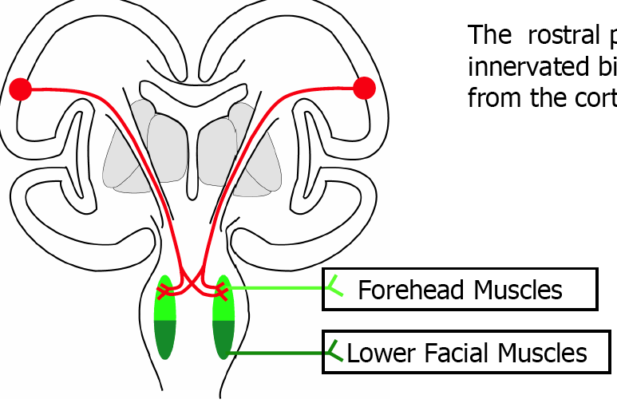
- Motor neuron activity organized by cerebral cortex
- Control facial musculature and muscles of mastication
- Contains upper and lower motor neurons (neuron on M1 and alpha motor neuron)
- Terminates at the brain stem (monosynaptic connection)
- Facial nucleus is divided into rostral (innervates forehead) and caudal (innervates mouth) parts
- Rostral part innervated bilaterally (both sides)
- Caudal part innervated from contralateral cortex
- Tumor on left upper motor neurons leads to asymmetrical innervation of lower facial musculature (paralysis on contralesional side)
- Lower motor neuronal injury (injury to alpha motor neuron) leads to complete paralysis on one full side of the face

Corticospinal Tract
Ventral Corticospinal Tract
- Originates from M1 (and SMA and PMA)
- Long axons descend “uncrossed” (ipsilateral connection) in ventral columns of the spinal cord, forming ventral corticospinal tract
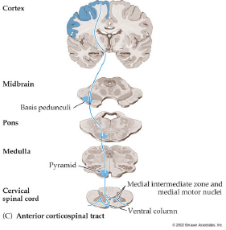
- Innervates axial musculature (muscles involved in gross body movements or trunk muscles)
- Make connections with propriospinal neurons (allow for communication of neural signals between segments of the spinal cord)
  - Send its projections to multiple alpha motor neurons at different levels in the spinal cord and they might go on to innervate different trunk muscles
- Not as evolved as lateral
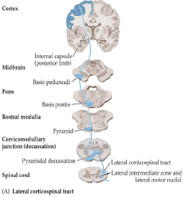
Designed to allow for communication and coordination of multiple muscles
Example: Bending at the hips
Lateral Corticospinal Tract
- Originate from M1 (also from SMA, PMA, and the Parietal Cortex)
- 75% of fibers cross at pyramidal decussation
- Monosynaptic connections (which is needed for precision grips)
- Goal-directed actions which allow for precise, single digit control
- Injury to head representation of hand region in M1 lose ability to perform precision grip since they lose the ability to control single digits (can still perform power grip through ipsilateral fibers containing 25% connection)
- Humans have the most descending motor neurons and they synapse on a single alpha motor neuron. We have a highly developed lateral corticospinal tract allowing us to use precision grip, compared to other animals.
- Synesthtesia is a neurological perceptual condition in which a person gets the five senses mixed up. For example they see tastes as colours. Affects 1% of population.

Important Differences Between Both Tracts
- Lateral corticospinal tract connects (synapses) with an alpha motor neuron
- Ventral corticospinal tract connects to propriospinal neurons, which ultimately synapse with alpha motor neurons
  - Propriospinal neurons allow coordination between multiple motor neurons

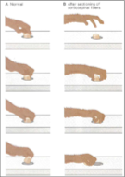
Ablation Study
- Selectively impairs the lateral corticospinal tract which in turn impairs fine coordination of individual fingers
- People with stroke often have difficulty performing daily living activities such as buttoning a shirt – they can only make a fist when manipulating objects
- Monkey takes 5 minutes to finally get a food reward item since it can only use a power grip
- This type of study in monkeys is a chronic (long term) deficit

Important Terms
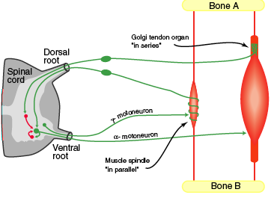
Innervation- the distribution of nerves to a part of the body
Innervation Ratio- The number of muscle fibers innervated by a single alpha motor neuron; can vary from a few to over a thousand (also includes intrafusal muscle fibers and gamma motor neurons)
-Movements that are more precise have a smaller innervation ratio
Extrafusal Fibers- Power producing muscle fibers external with respect to muscle spindles
Intrafusal Fibers- Muscle fibers inside the muscle spindles; innervated by a special system of fusi-motor neurons (Gamma motor neurons – monitored based on situation (high threat postural environment = high drive, which tells intrafusal muscle fibers to be on guard for any sort of stretch))

Motor Neurons and Motor Units
- Alpha motor neurons = a neuron innervating power-producing, extrafusal muscle fiber (Diameter of fiber (myelination) determines speed of muscle contraction, therefore alpha motor neurons are thicker than gamma motor neurons)
- Motor Unit = Alpha motor neuron and all of the muscles it innervates; a unit of force production in skeletal muscles
- Number of muscle fibers associated with a motor unit ranges from 10 (eye) to a thousand (back musculature)
- Motor unit pool = a bunch of alpha/gamma motor neurons and all of the extrafusal muscle fibers that they innervate
- Golgi tendon organ (GTO) = protective mechanism to prevent too much force to be developed in a muscle (sends information to spinal cord to prevent alpha motor neurons from firing); weight lifters learn how to ignore this

Fusi-Motor Neurons (Gamma Motor Neurons)
- Gamma motor neurons are small neurons innervating intrafusal fibers and changing sensitivity of muscle response to dynamic stretch
- Stretch = Space Recognition (where your limb is)
- Intrafusal fibers oriented in parallel with extrafusal fibers
- Polar connections between intrafusal and extrafusal fibers (run the entire length of a muscle, highly sensitive)
- Without them, we would have no idea where our feet are, for instance
- Peripheral neuropathy – pathway that connects intrafusal muscle fibers back to CNS that becomes damaged; patients cannot determine where parts of their body are without looking at them

Types of Motor Units
- Fast Twitch, fatigable (FF) (Fast Motor Unit)
  - Characterized by highest conduction velocity (100m/s)
  - Large fiber diameter (highly myelinated)
  - Innervate fast twitch muscle fibers (power lifters have tons)
- Fast Twitch, fatigue resistant (FR)
  - Characterized by medium conduction velocity (60m/s)
  - Medium fiber diameter
  - Innervates fast and/or slow twitch muscle fibers
- Slow Twitch, fatigue resistance (SR) (Slow Motor Unit)
  - Characterized by slow conduction velocity (40m/s)
  - Small fiber diameter
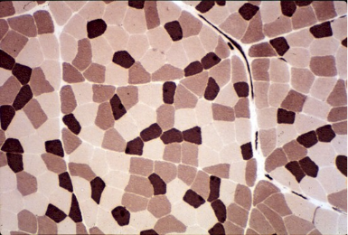
  - Innervates slow twitch muscle fibers
- Sprinter: 80% fast and 20% slow motor units
- Marathoner: 20% fast and 80% slow motor units
- Average person: 50% fast motor units and 50% slow motor units
- Couch potato: 60% fast and 40% slow motor units
- Spinal injury: 96% fast and 4% slow motor units (unable to sustain long movements)
- Dark spots in muscle biopsy represents slow twitch muscle fibers (due to oxygen binding to heme, which contains iron)
- Can training alter motor unit and muscle fiber types? Motor unit types can change as a result of de-training equaling to 100% fast fatiguing motor neurons. Motor unit types can be altered because they have a high plasticity
- What happens to motor unit types in elderly people? They are used to performing slow movements, which prevents their fast motor units (FF) from being active, leading to more falls or a reduced postural stability/support
- Koceja study found that with wobble board training for 6 weeks it lead to an increase in fast twitch (fatigue resistance) motor units, which ultimately improved their balance

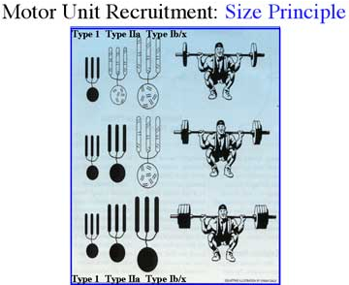
Henneman Principal (Size Principle)
- The recruitment of motor units within a muscle proceeds from small motor units to large ones
- Happens as a function of increasing force requirements
- Low force contraction, nearly all force produced by slowest motor units
- If contraction force is increased, larger motor neurons start to fire
- At the highest levels of force (maximal voluntary contraction), the largest motor units are recruited and all fibers are running

Concussions
- CTE linked to having many many concussions or blows to the head
- CDC estimates that between 50 000 and 300 000 concussions occur in sport every year
- There are two forms of sport concussion:
- Simple – this limits a players participating during the symptomatic period, but not intervention is required during the recovery period – athlete typically returns to play without further problems (although the athlete is more likely to become concussed again)
- Complex – continued symptoms during recover period (usually associated with episodes of loss of consciousness)
- Longer recover period
- More symptoms
- Difficult to determine whether the athlete should return to the sport
- In NCAA football, an athlete with previous concussion is 5.8 times more likely to sustain multiple concussions
- Athletes with multiple concussions recover much sower than athletes who have experienced a single concussion
- Athletes with multiple concussions show poorer memory recall than athletes with a single concussion when tested two days post concussion
- Athletes with multiple concussions show performance that is 7.7 times worse than single concussion athletes in a memory recall test
- Impact battery: simple neuropsychological battery given to athletes pre-season and two days after a concussion; measures how quickly one can perform different types of cognitive tasks
- Peirre Jollacher proposed that these tests were not sophisticated or precise enough to determine the extent of one’s concussion
- He proposed the EEG to measure brain activation
  - Interested in measuring event-related brain potential (ERP), our averaged electrical brain responses to time-locked stimuli
  - ERP measures of cognitive processing:
- Event related potentials are averaged electrical brain responses to time-locked stimuli
- N2pc = ERP component related to the focusing of visuospatial attention (how we orient visuospatial attention)
- P300 = measure of the stimulus classification processing speed
- Looked at three groups of athletes pre-season (athletes never been diagnosed with concussion, athletes diagnosed with one concussion, athletes diagnosed with multiple concussions; of those concussed had been nine months removed from their last concussive incident)
  - First component = impact test (quick classification of a stimulus in descending order)
    - Concussed athletes had the same relative performance relative to the control group who had never been concussed
  - Second component = determine the orientation of the differently colored stimulus (Jollacher measured the EPR)
    - No difference in the N2pc across the three groups, suggesting that concussed individuals had do difficulty with…
    - Amplitude of P300 decreased as a function of being concussed, suggesting that concussed athletes have some difficulty identifying and classifying information
  - This study shows that there is a long-term neurophysiological cost of being concussed, which cannot be determined with an impact test
  - Conclusions:
    - Equivalent neuropsychological test profiles of non-concussed, concussed, and multiple concussed athletes
    - No diff in N2pc in non-concussed, concussed + multiple concussed athletes
    - Suppressed P300 activity in multiple concussed athletes
    - The specificity of the long-term effect of concussion provides a framework to pin point the cognitive system impaired in multiple concussion (i.e. the ability to rapidly classify a stimulus)

Retinol Ganglion Cells
- The retina is the photo receptive layer at the back of the eye
- There are retinol ganglion cell asymmetries…
  - Asymmetry in the vertical axis – larger density of retinol ganglion cells in the center of the eye (central vision) whereas there are fewer RGCs as you move toward the peripherals (peripheral vision – lower resolution vision)
    - This density gives rise to cortical magnification – the number of neurons in V1 devoted to central vision is MUCH greater that devoted to peripheral vision
  - Upper and lower visual fields – there is a difference in the density of RGC in upper vs. lower hemi retina
    - This is an evolutionary based process as a result of what we do on a daily basis…
    - Information in lower visual field projects to the upper hemi retina
    - When we work, we are generally making movements in our lower visual field (therefore, the upper hemi retina has a greater density of RGCs, making the spatial resolution in the lower visual field more precise)
  - To test these asymmetries, use a simple behavioral pointing study – this is an indication of how we can link structure to function
  - “Putting your head in the clouds” = deviation of ocular gaze is a behavioral phenomena that seems to help in answering a complicated question (explanations for this have yet to be found)

Person Who Draws First Loses a Gunfight?
- Draw first = top-down decision that involves a lot of cortical activation
- Top-down decision is a slow process because it involves many different cortical regions
- Movement is therefore also slow (slow response time)
- Individual who sees opponent pulls gun from holster = stimulus driven response (reflexive)
- Don’t entail any top-down cognitive control because they use a very basic neural circuitry (very fast, mediated sub-cortically)
- Much faster than top-down cognitive control, which results in winning the gunfight
- Sitting across the table, you both have to reach out and hit a button
  - If the person starts to move then it speeds up your movement and allows you to move quicker than the person already initiating the response
    - Drawing a gun in the movie
  - Stimulus triggered actions are completed faster than intentional actions
  - Intentionally triggered actions require high level control- complicated system with lots of pathways and connections
  - Stimulus triggered actions do not entail high level control- mediated by the brain stem, fewer and less complication connections so they can be performed much quicker

SNARC Effect
- Spatial Numerical Association of Response Codes
- “Mental number line”
- Most people represent numbers left to right because of their strong analytical skills
- People who do it randomly tend to be more creative and have better visuospatial skills
- Research on how numbers influence movement:
- Participant stares at fixation cross. Numbers flash in either the left or right space and participant points to where the numbers were. When 1 and 2 were flashed in the left visual space, they had much shorter reaction times and movement times compared to 8 and 9 flashed in that same space. When 8 and 9 was flashed in the right visual space, they had much shorter reaction times and movement times compared to 1 and 2 flashed in that same space. When we move, we have this mental number line and when we get a stimulus congruent to it, the movement is optimized.
- Richard Sperry
- Won Nobel Prize in 1960s
- Cut or severed the connections of the corpus callosum
  - All activities controlled by “2 brains” that are connected
  - Can the 2 cerebral hemispheres operate independently?
  - By sectioning down the middle of the optic chiasm (limits what the animal sees in one eye to one cerebral hemisphere) and the corpus callosum, we can begin to test the dependence and independence of the cerebral hemispheres
  - There were no noticeable behavioral changes
  - Conclusion: in the split brain monkey, the two halves of the brain have separate memories and can perform independently (but the left brain cannot pass the information on how to perform a task to the right brain)
- Corpus callosum separation in a human (optic chiasm not severed):
  - Fixation cross: image flashed on right has direct access to left hemisphere (can name what it is b/c left hemisphere controls speech and language), image flashed on left has direct access to right cerebral hemisphere (unable to name what this image is b/c info cannot travel to the left hemisphere for speech production. Instead, he must draw the image and then use this drawing to demonstrate what he saw)
  - Mind is made of a constellation of semi-independent agents that can carry on activities beyond our conscious awareness

