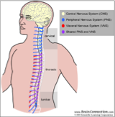
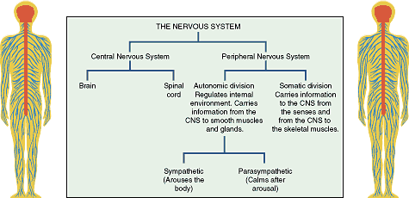
The Nervous System
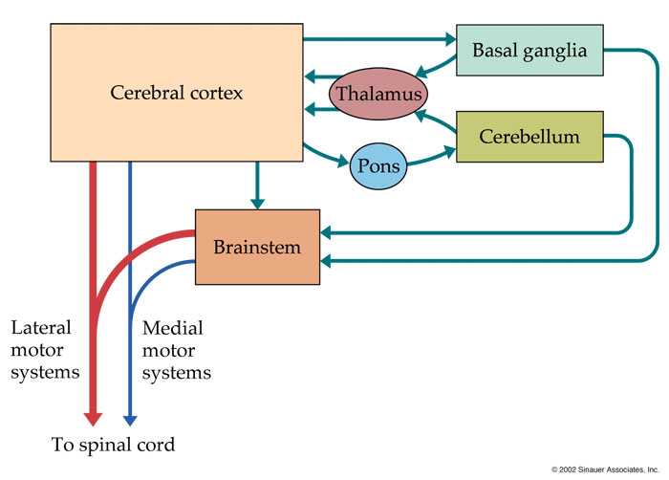

Hierarchical Organization
- Think of the Cerebral Cortex as the "big boss," it tells everyone else what to do and when to do it
- Think of the thalamus, basal ganglia, pons and cerebellum as being second in command
- The brainstem is third in command
- The spinal cord is a "slave" system to all the above
- -Brian sections and subcortical structures, sends and receives info to and from the spinal cord

Luigi Galvani (1737- 1798)
- “Animal electricity” practiced on frogs
- Investigated bioelectric energy and how it allows us to send signals
- Worked with spinally prepared frog by applying static electricity to sciatic nerve causing the limb of the frog to move

Neurons and the Neuromuscular System
- Average adult has 86 billion neurons
- A motor unit which consists of an alpha motor unit innervating three muscle fibres
- Alpha motor unit = Extrafusal muscle fibres
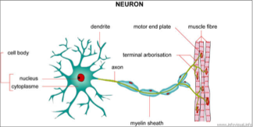
- Lower motor neuron disease = alpha motor unit disease
- Upper motor neuron disease = damage to neurons in cerebral cortex
-Myleinated faster AP
-Glial cells were though to support development and direction of new neurons
-Class of neurons motor neuron alpha neuron – is the enron that exists within the spinal cord, axon leaves the CNS (spinal cord) and goes to synapse with the extrafusal muscle fiber (allowing for contraction and movement)
-Axon is heavily mylinated

Speed of Nerve Conduction

- Helmholtz (1850s)
  - Interested in speed of nerve conduction
  - Used isolated muscle motor nerve of a frog
  - Measured time between electrical stimulation and muscle contraction
  - Estimated the speed of human nerve conduction
  - Measured reaction time in response to electrical stimulus to two points (For example, the foot and thigh)
  - Nerve Conduction velocity is very fast (30-90 m/s)
  - That speed is about 1/10 the speed of sound (speed of sound is 1238 km/h)
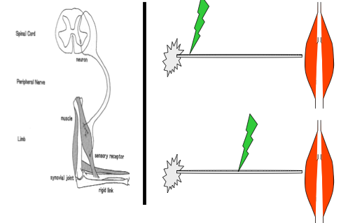

- Diseases of the Nerve
  - Disease of the nerve influences amplitude of nerve conduction
    - Ex: Amyotrophic Lateral Sclerosis (ALS) aka Lou Gehrig’s Disease
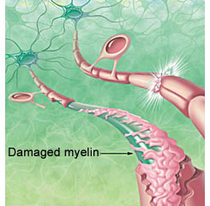
  - Disease of the myelin influences conduction speed
    - Ex: Multiple Sclerosis (MS)
    - Destroys the myelin patches along the CNS
    - Cortical lesions along multiple points in the CNS

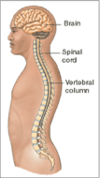
Types of Neurons

- Motor (efferent) neurons
  - Transmit motor commands down the spinal cord

- Sensory (afferent) neurons
  - Transmit signals to, and up, the spinal cord

-Blue is descending and red is ascending
-efferent descend in dorsal column
-Afferent ascend to ventral column
-Ventral route ganglion (front of spinal cord): Neurons leave through the front (counter intuitive)
-Information from muscles spindles gets into spinal cord and makes up ascending tract via dorsal column
-Efferent and afferent fibers are segregated or isolated in the spinal cord

Cerebral Cortex/Cerebrum
Contains two hemispheres made up of four lobes

Phrenology: The Past

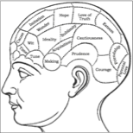
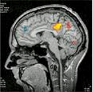
-Mental faculties in isolated in areas of the brain, they could localize thing such as courage (Victorian era hypothesis). NOT TRUE
1. Each part of the brain responsible for something different (Ex: One section of the brain is for courage, another for wit, ideality, etc)
2. An FMRI Scan of the brain showing activity level localizing certain motor functions specialized in different brain regions

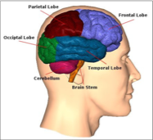
Occipital Lobe
- The center of our visual processing
- Contains primary visual cortex (V1) and the secondary visual areas

Primary Visual Cortex (V1):
- Found in occipital cortex (about the size of a credit card)
- Demonstrates cortical magnification (more neurons within our V1 that are devoted to central vision than neurons devoted to peripheral vision)
  - Allows high spatial resolution images
- Processes orientation of an object, perhaps colour, properties of a viewed object
- Lesions to V1 lead to cortical blind sight (or blindness)
  - Unable to perceive visual stimuli
  - Can use to vision to navigate through an environment and pick up an object in front of them, without even knowing there is an object there
  - Don’t need V1 for unexpected dynamic visual processing such as fly

Visual Area V2:
- Binocular vision (binocular disparity cells allow 3D images in mind, give depth)

Visual Area V3:
- Information that originates in V1 and passes through V3_{D} to parietal cortex supports vision for action
- Visual information from V1 passes through V3_{v} and travels to temporal lobe is the visual pathway for perceptions (judgment)

Visual Area V4:
- Works in conjunction with V1 but does more sophisticated processing (orientations or size properties of an object)
- Makes identification about simple geometric shapes
Visual Area V5:
- Important for movement because it uses visual information to detect motion (either self-motion or motion within external environment)
- Also known as Area MT

David Hubel

- Single cell recording of V1 in the awake cat
- Discovered binocular cells in V1
- Blobs = colour ensembles in cylindrical shapes
- Interblobs = Orientation sensitive
- They were looking at single cell neurons in an awake cat when the cat was seeing different things
- This allowed them to find binocular cells which help us see depth information
- Experiment where kittens were born and immediately a patch would be put on their eye for 6 weeks, and they never grew binocular cells

Parietal Lobe

- Contains primary somatosensory cortex (S1) at the front of the lobe, right parietal lobe is the seat of our visual spatial skills
- Responsible for the planning and control of movement
- Important because it is the part of the brain that integrates sensory with motor function
- IPL (inferior parietal lobe) is critical for planning a movement
  - Lesions to IPL lead to difficulty initiating a movement
- SPL (superior parietal lobe) is responsible for control of action (online/feedback control of action)
  - While limb is moving, can make corrections using feedback from the environment to ensure a successful response
  - People with lesions to SPL can initiate a movement, but might take multiple tries before being able to grasp something

- Stroke/lesion to right parietal lobe: Visual spatial neglect
  - High level disorder
  - Inability to shift their focus of attention from their right visual field and move it to their contralateral visual field
  - Leads to general spatial neglect in left side of visual array (information from each side crosses, hence affecting the opposite site)
  - They can see the image on both sides, but do not attend to it or neglect it
  - Important to diagnose
    - Tested using prism goggles (shifts attention to one side of the body, in this case the left side)
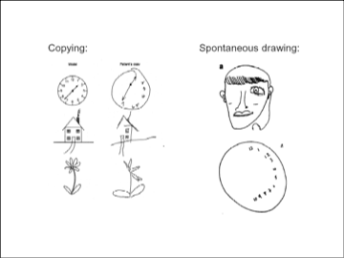
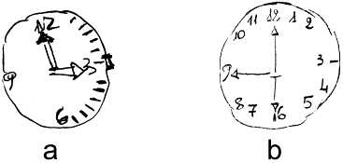

Clock drawing of a patient at Time 1 (a) and at Time 4 (b).

Someone with visual spatial neglect to the right parietal lobe.
- Anterior intraparietal region (AIP)
  - Provides critical information to perform grasping (aperture shaping)
- Parietal occipital area (PO)
  - Provides critical information to perform movement of a limb

Neglect and Blindsight

- Can use vision to act on something or touch something, even though they have no conscious awareness that they’re looking at an object
  - Can respond to vision without being aware
- Blindsight occurs when the part of the brain to see and process is damaged but the lobe for awareness is still active.
- Also known as cortical blindness, it is a low disorder

Temporal Lobe
- Function in visual object recognition
- Contains primary auditory cortex (primary function)
- Seat of our ability to recognize visual objects
- Location of the hippocampus (explicit and spatial memory and learning)
- Haptic (touch) information retained in structures located in temporal lobe
- Ability to comprehend speech is lateralized to the left hemisphere of the temporal cortex
- Hippocampus interacting with the temporal lobe plays a critical role in the formation of new explicit memories
  - Factual (cognitive) information, but not motor
  - Important in navigation (spatial memory) ex. Cab Drivers
  - Stress + lack of sleep impairs the hippocampus
  - Hippocampus means seahorse in french, looks like a sea horse
  - Amnesia arises when there are legions on the hippocampus
  - Anterograde amnesia occurs when we are unable to develop new explicit memories, but can still attain new motor memory skills
- A deficit to the temporal lobe can cause visual agnosia, which is when people lose their ability to recognize visual objects ex. Apple test

Frontal Lobe
- Functions in working memory (repetition), mental operation
- Contains primary and second motor areas
  - Primary Motor Cortex (M1) ( final common pathway to action)
  - Supplementary Motor Area (SMA)
  - Pre-Motor Area (PMA)
- “Seat of our consciousness” and emotional control
- All commands related to movements all end up in the frontal lobe before sent to CNS and spinal cord
- Lesions to M1 have profound movement difficulties such as a contralateral lesion in motor control, which if the right side of brain is damaged, the left side of the body will have problems in fine motor movements and can only power grip.

Subcortical Structures

Brain Stem
- Role in basic attention, arousal, and consciousness
- All information to and from our body passes through the brain stem on the way to or from the brain
- Regulates autonomous process (heart rate and respiration)
- Structures on brain stem that control functional movements
  - Superior colliculus (SC) makes saccades (goal-directed eye movement)

Cerebellum
- Involved in the coordination of voluntary motor movement, balance and equilibrium and muscle tone
- Involved in forming and retaining implicit (motor) memories
  - Head injury to cerebellum = inability to acquire new motor skills
- Lesions to cerebellum lead to cerebellar ataxia
  - Leads to motor deficit
- Critical for timing of movement
- Affects ability to coordinate firing multiple muscles at once
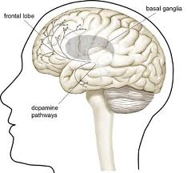
  - “Clock” that times when muscles should be active or inactive
- Stuttering may be because of a soft deficit to the cerebellum

Basal Ganglia
- Group of varied origin nuclei connected to the thalamus and cerebral cortex (frontal lobe)
- Play an important role in excitation of M1 neurons
- Striatum receives information from cortex, and outputs only to other basal ganglia nuclei
- Globus pallidus receives input from thalamus and outputs inhibitory input to movement related sensors
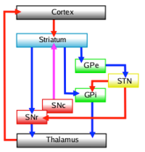
- Substantia nigra produces dopamine (neurotransmitter), which is lost as a result of a Parkinson’s disease
- Subthalamic nuclei is the source for the primary excitatory neurotransmitter
- Activates primary motor cortex which enables movement
- Direct pathway
  - Red line = excitatory input
  - Blue line = inhibitory input
  - Cortex Striatum excited Sustantia nigra and Globus pallidus inhibited Thalamus inhibited Excitation of motor areas on cortex Responsible for movement
- Parkinson’s Disease
  - Difficulty initiating a movement because basal ganglia do not allow access of primary motor cortex
  - Caused by damage to the basal ganglia pathway (constant inhibition of the thalamus prevents movement)
  - Leads to tremor
- Parkinsonian Gait
- Obsessive Compulsive Disorder
- Tourette’s (motor ticks)
- Hemiballismus (random, uncontrolled movements to one side of the body, result of CVA-cerebral vascular accident or stroke, such as a lesion to basal ganglia)

A study done by Amy Bastean, took people with frontal lesions and amnesia, who can’t develop new explicit memories (factual), and people with cerebellum lesions that were bilateral without amnesia. On day 1 participants came in and were given a list of 50 words that needed to be memorized (explicit). On day 2, they were asked to reiterate the words, but the people with amnesia could not, while the cerebellum lesions could do it fine. Therefore those with frontal lesions can’t remember explicit memories while those without can. Day 3 they had to do a motor task such as tracing a figure 8 in the reflection of a mirror which is an implicit memory. Day 4 they come back and those with cerebellum lesions could not learn the implicit motor task even though they knew they had practiced for hours. Those with frontal lesions showed a definite retention of the motor task, even though they did not remember they had practiced for hours. This study shows the separation between consciousness and the capability of learning. The frontal lobe shows they don’t need to remember a motor task in order to learn it. This study also shows a double dissociation in that the frontal lobe patients can’t remember explicit memories but can remember implicit memories while cerebellum can’t remember implicit memories while remember explicit memories.

Stroke
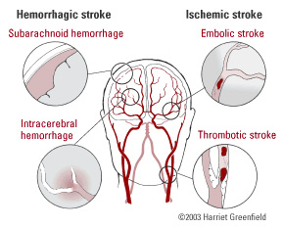
Hemorrhagic Stroke
- Rupture of arterial wall leading to bleeding within the brain
- Blood very toxic to neurons
- Blood spills over exposed neurons
- As neurons die, space is filled with cerebral spinal fluid (neurons do not regenerate, dark spot MRI)

Ischemic Stroke
- Blockage of artery to or within the brain
- Lack of oxygen (anoxia) leads to neuronal death
- Localized lesions may impair very specific types of cognitive and cognitive-motor functions

Primary Motor Cortex (M1)
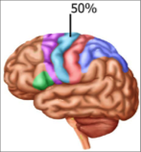
- Final common pathway to action (contains 50% of neurons that make up descending motor pathway)
- Right beside S1 (red)
- Direct control over how we move (movement can be directly produced only by a very specific region of the cortex- M1)
- Hitzig and Fritsch
  - Experimented with dog’s brains (stimulus = movement/twitch on opposite side of the body)
- Jackson (British physician)
  - Wife had intractable epilepsy with organized seizures
  - Would progress from fingertips, then arm, shoulder, etc.
  - Concluded there must be a systematic way in which the cerebral cortex was organized
- Penfield
  - The father of modern neurosurgery
  - Probed different parts of the brain and saw what would happen
  - Created map of human brain
  - Thought M1 was a relay station, or final common pathway to action (incorrect!)
- Fast electrical stimulation of (M1)
- Only the primary motor cortex elicit simple movements (twitch) when mild electrical stimulation. Premotor and supplementary cortex also have direct access to the spinal cord (40%), but will not cause twitching with stimulus. Posterior parietal cortex has about 10% access to fibers through spinal cord.
- The Human Homunculus
  - Face has the most sophisticated and complex movements, therefore has the greatest area on M1 and somatosensory cortex
    - M1 and somatosensory cortex adjacent to one another in cortical space which allows for efficient connections
    - Classic view, not 100% accurate
    - Contemporary View
      - Size = intensity of activation when activated
      - Different colours represent a different digit
      - Penfield thought it was a very strict region, but not the case
      - Neurons are intermingled/overlapped with each other (not one designated region for the hand, for instance)
      - Not strictly bordered by one another or segregated

Current Research
- Chiver and Hibeard had monkeys performing simple hand movements with small electrodes implanted into their primary motor cortex, while they measure the activation of the individual neurons.
- This was important because it shows that it is not a strict homunculus representation that pennfield thought it was.
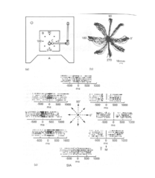
- Georgopoulos (monkey neuroscientist) disproved that M1 was just a relay station or final common pathway to action
- Light turns on, they must move the object towards the light (stimulus)
- Measured the activation of a single neuron by using a raster plot (simple way of depicting activation of a single neurons over time)
- Each tick is the depolarization (each row represents a single event or movement)
- Discovered that M1 neurons are tuned to the direction of a certain response
- The neuron in this case only fired at a very high frequency when moving toward the left side
- Showed that we are capable of moving robotic machinery from our brains neurons.

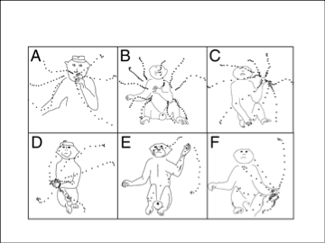
Prolonged M1 Electrical Stimulation

- Grazziano’s study applied electrical stimulation to M1 of a monkey and increased the intensity of the stimulation
- Panel A: Arm was put in a different starting point
- When stimulated to a specific location on M1 for 500 ms, the hand always moved toward the mouth (feeding behavior)
- Showed that sophisticated actions are maintained within M1
- Therefore, M1 is not just the final common pathway to action but the neurons exist directly on M1 and have movement specificity

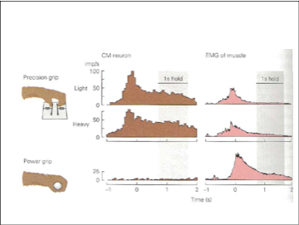
Corticomotorneuronal Activity
- Monkey preformed power grip (not a sophisticated action) or precision grip
- While both were performed, a single neuron was measured
- Histogram depicted frequency of neural activation
- While using a precision grip, huge activation of neuron
- While using a power grip, very little neural activity
- Group of neurons that are specialized and active just for a precision grip on M1

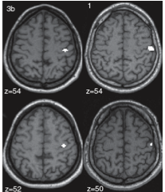
Dysmelia
- Incomplete development
- In 1960s, thalidomide was used during pregnancies to treat morning sickness
- Lead to undeveloped limbs in fetus
- Now used for cancer treatment
- White area neurons are devoted to the hand
- Bottom right small white area devoted to hand of an individual with dysmelia who only has two digits on the hand
- Plasticity- brain molds itself to fit the individual (someone with dysmelia needs a less sophisticated region on M1 for the affected limb that is not necessarily contra lateral)
  - Allows for improved motor recovery for people with injuries

Control/Kindled
- Normal motor map of a rat (left side)
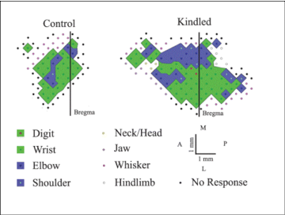
- Motor map has been changed significantly (expanded motor region) when a rat’s M1 has been kindled or exposed to prolonged electrical stimulation, eventually mimicking the brain of an epileptic person
- Penfield’s research could be wrong since he was working with individuals with prolonged epilepsy (prolonged electrical stimulation), causing kindling in the individuals brain and therefore a wrong representation on the Human Homunculus
- A kindled brain is not the same as a brain that has not been kindled and diffuse changes occur to a kindled rat’s brain, the majority occurring to M1 structures.
- This is important because it suggests that an epileptic brain is not the same as one without epilepsy

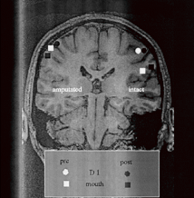
- MRI of a patient who had one of their limbs surgically removed
- Intact hemisphere (right hemisphere) projects to the left arm, which was still attached
- Amputated hemisphere projects to the right arm
- Cortical representation changed after amputation (mouth representation changed from pre-post- moved up toward where their thumb region used to be)
- Cortical plasticity because it changed to make up the lost arm
- People with phantom limbs will still sense tingling of them because the chin and hand region in the homunculus are so close
- Chin region infringe on thumb region, which shows that maybe Penfield’s original homunculus was inaccurate
  - The face should be rotated 180 degrees (in non-epileptic patients) from what was originally thought, so that the chin/mouth areas are adjacent to the thumb region
- Visual feedback of the phantom limb through a mirror box can reduce phantom limb pain, but as soon as hand is taken out of the box, pain reoccurs.
- This study represents the plasticity in the M1 and S1 cortex

Monkey See, Monkey Do

- In the frontal lobe, there is group of neurons classified as mirror neurons
- Important for our ability to learn through observation (bimotal)
- Babies can start to mimic facial expressions after 2-6 months in age
- Precursor for language development in humans
- Discovered by Rizzolatti (1986)
  - Ate at his desk in his lab, and when he reached for food, neurons in the frontal lobe of the monkey were activated
  - Recorded one single neuron’s activation whether a monkey watched another monkey eat, or watched a human eat, or when the tested monkey ate
- Autistic people have a reduced level to learn visually because of an underdeveloped mirror neuron system
- People with Down’s Syndrome are really good at learning new motor skills visually (mirror neuron system is overdeveloped), therefore we should over emphasize visual instructions for them.

Supplementary Motor Area (SMA)

- Output to corticospinal pathway as well as M1 projections
- Direct projections to spinal cord
- Projections terminate on hand and finger musculature
  - SMA neurons are in used for fine digit control
- Active for internally generated activities/movements
- Sequence-specific (some neurons fire only in relation to a specific movement sequence)
  - Certain neurons only fire when performing a certain sequence of movements
  - One finger tap leads to active SMA, but when moving fingers in a certain sequence, SMA is extremely active
- Activity increases in relation to movement complexity
- SMA activity for “real” or “imagined/motor imagery” movements
  - Using motor imagery can help you learn a task since the SMA is active, but is less efficient than actually performing the task
- In monkeys, damage to SMA produces deficits in bimanual coordination (using their hands together to perform something that is functional)
  - Will always produce similar tasks with both hands

Premotor Area (PMA)

- Sends fewer output to spinal cord than SMA
- Strong connections with reticular formation, red nuclei, and (indirectly) to cerebellum, therefore PMA is involved in visual motor control
- Triggered by external sensory events, and delayed (memory guided) action
- Avoid placing them in situations where they have to avoid obstacles
- PMA important for visually guided movements
  - Monkeys with PMA damage are unable to avoid obstacles
  - PMA damage in monkeys elicits perseveration behaviour
    - Keep doing the same behaviour over and over again (repetition)
    - Don’t realize that they’re doing it until you tell them (no conscious realization)
  - Single cell recordings show increased PMA activity 60 ms after visual stimuli presentation
    - Evidence of their significant role in visual processing from external stimulus

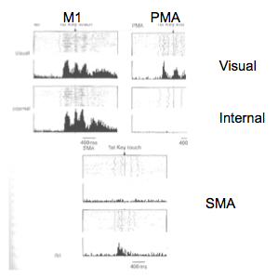
Raster plot (Visual vs. Internal)

- Monkeys had to perform a task and respond to a visual stimulus, or in the second monkey, it moved whenever it wanted to (internal)
- Measuring the activation of a single neuron
- M1 is active whether you’re visually told to move or internally move
- Neurons within the PMA are active for a visual monkey, but the exact same neuron demonstrates basically no activity during internal response
- Certain neurons within SMA are not active for a visual cue, but active for an internal cue

Cortical Plasticity

- “Use it or lose it”
- Neurons areas devoted to movement will start to disappear if not used
- Cortical density correlates to increased dendritic connections
- Study of cortical density when people learn how to juggle
- fMRI scan taken before they learned how to juggle
- Learned how to juggle for 3 months (20 mins/day)
- fMRI scan taken afterward showing their cortical density
  - Significant increase in cortical density in:
    - Bilateral V5/MT (motion processing)
    - Left intraparietal sulcus
- Told not to juggle for 6 months
- Another fMRI scan showing their cortical density was taken (significant decrease of cortical density)
  - Cortical volume returned to baseline

Cerebral Asymmetries
1. Two hemispheres of the cerebral cortex are linked by the corpus callosum (basically making two brains into one)
2. Left and right cerebral hemispheres have specialized functions
or cerebral asymmetries
-left hemisphere is lateralized for both speech production
and perception, as well as containing our movement
practice system (our ability to do a complicated task)
-right hemisphere is specialized for visual and spatial skills as well as haptic skills (touch)
Spontaneous Speech and language and praxis (functional movements) are lateralized to the left hemisphere, but automated speech can be lateralized to both hemispheres. People with downs syndrome are different because they have a right hemisphere specialization for speech perception and a left hemisphere specialization to produce speech. Therefore people with downs syndrome must shift their perceived speech in the right lobe and shift to their left lobe in order to produce speech. This is difficult for them as they have a less developed corpus collosum which is smaller and has fewer neurons.
- Aphasia – difficulty in speech or understanding language
- Broca (19th century, father of hemi-specialization) – People who had difficulty producing speech (moving articulating muscles) typically had a lesion in the left frontal hemisphere (Area now called Broca’s Area and lesions to it are called Broca’s Aphasia)
  - They can still understand language, know they have the disability
  - Coping with Broca’s Aphasia includes singing what they want to say because that is done with a different part of the brain
- Wernicke - People who had difficulty comprehending language typically had a lesion in the left temporal lobe (Area now called Wernicke Area and lesions to it are called Wernicke’s Aphasia)
  - People would speak in a “word salad”, which is a jumpled up speech because they have the lost the rules of their language.
  - Don’t know they have the disability

Cerebral Asymmetries
-Our two hemispheres are connected by a bunch of axons that have cortical-cortical connections known as arcuate fasiculus. Strokes cause this connection to get broken.
-Ex. in class where a man with transcortical sensory aphasia couldn’t talk properly, but still could count numbers. He only had a lesion to his articulate fasciulus on left parietal lobe and counting is automated and on both hemispheres so he could still count.
-Neurons in the left speech region of our brain are more complex than homologous right side: -more dendritic trees
-referred to as magno-pyramidal neurons that are distinct from other neurons because theyre much bigger and can communicate with more neurons
-left broca area has more neurons + signals because speech is a complex action

Apraxia
Apraxia: a disorder of learned, skilled purposeful movement not related muscle paralysis or comprehension deficits that is a high level movement disorder.
Ideational Apraxia: inability to evoke the appropriate action representation from long-term memory. Ex: they lost the memory on how to use a hammer, or keys
Ideomotor Apraxia: inability to transfer the appropriate innervatory patterns into action. They know what they want to do/how to do it, but can’t turn it into movement.
Conceptual Apraxia: know what they are doing and how they want to do it, but they select wrong objects for it. They will try and eat cereal with a knive.

Apraxia: CK
CK is a dense parietal lobe lesion. It occurred in a young woman that wanted to get birth control. She was tested for normal aphasia or apraxia and was fine. Until she tried to have a meal but she only tremored when trying to pick up the object. Although, she could make the movement of what she wanted to do without the object. We now refer to this as a somatosensory form of apraxia.

-Apraxia is an acquired neurological disorder; it can happen as a result of a head injury, but they can be referred to as a developmental coordinative disorder (DCV).
-Dyspraxia is different from apraxia in that one must develop the disorder. It impairs our ability in movement with timing and for rehab we must work on timing of actions. Dyspraxia will eventually resolve itself, but it is important to help its rehab so the victim does noes fall behind relative to their peers.
-Dyspraxia is different because it is a development, not acquired and is considered a “soft-deficit” to the brain.

