Proactiv Solution Advertising Campaign: The uses of celebrity endorsements and appeal to insecurities for the ideal type.

University of Ottawa
CMN 2173 A: Advertising and Society

Introduction
In modern society there are multiple advertising campaigns geared towards youth and young adults; especially within the ages of 15 to 25. Good campaigns specifically target the insecurities as well as, or the pop culture of the time to persuade the consumption of various products. This essay will analyze the advertising campaign of Proactiv Solution: “a three-step acne care system” as well as discuss the pros and cons of using celebrity endorsements. A close and in depth look into their success will also be discoursed including how they got to be as large as they are, why, and with whom. The advertising campaign promoted by Proactiv uses both celebrity influences and individual success stories to appeal to a greater demographic of people, whether they need Proactiv or not.
The campaign effectively attacks teenage and young adults’ insecurities to ensure sales. This essay will seek to identify the strategies of advertising, how marketers for Proactiv infuse a special meaning and the ‘ideal look’ for their product in order to showcase to their audience. It will recognize that advertising thrives on the myopia of the consumer population in hopes that their desires for the “ideal look” will drive them to ‘need’, in replacement of their ‘want’ for this product; specifically Proactiv Solution. Also, how their use in celebrity endorsers will motivate this ‘want’ or ‘need’ and persuade consumption.
Production Background
Proactiv is co-founded by two women, Dr. Kathy A. Fields, and Dr. Katie Rodan. Dr. Fields is a Stanford graduate as well as a board certified dermatologist; Dr. Rodan also studied at Stanford and still practices in medical, surgical, and cosmetic dermatology (Proactiv Website, Guthy-Renker). Their main goal is to educate their consumers about how to treat their skin concerns; they are committed to health of skin, this includes skin disease as well as cosmetic issues (CITE). Currently the agency producing the Proactiv advertising campaign is Eleven Inc.; they are responsible for many other advertising campaigns such as Apple, Visa and Virgin America. On Eleven’s website they introduce their Proactiv ad campaign as, ‘We play well with others’. Stating that,
“…[c]ollaboration is at the core of Eleven’s culture. We get off on it. Last year, for instance, we teamed with Guthy-Renker’s in-house broadcast unit to create an integrated ad campaign for Proactiv skin care. The campaign featured Katy Perry, Avril Lavigne, and Justin Bieber, and was the first pure brand effort in 15 years for Proactiv.”

San Francisco business times has presented Eleven Inc. on its annual list of “Best Places to Work in the Bay Area”. Eleven prides itself in having a unique representation of culture and pride themselves on the fact that “talented people want to work here, and the best tend to stay here.” (CITE). Eleven Inc. has been extremely successful in marketing and advertising for Proactiv; Stuart Elliot from the advertising section of the the New York Times writes often reguarding the ‘Be Proactiv’ campaign, saying “The campaign includes television commercials, magazine ads, billboards, signs and online ads, and they all resemble pitches for blue-chip brands in the skin care category. (CITE ME!)” Guthy-Renker aids Proactiv in creating a well-known source for product advertising, they believe in the direct form of advertising of “meaning and transformative products” revolving around cosmetics and fitness. For example, Susan Lucci’s Youthful Essence, and Anthony Robbin’s Ultimate Edge; they are viewed as “creating an extraordinary quality of life.”
Eleven Inc. aids in Proactiv’s solid attempt to market to consumers that are generally teenagers and young adults, faced with concerns regarding their skin and skin care treatment. Specifically the founders say, “to educate the public,” and “to educate doctors and consumers”. Their marketing demographic is particularly focused on younger consumers as they use teenage celebrities to endorse their products; however, they also maintain their status that states older to middle-aged people are still a main priority. Elliot also mentions how the Be Proactiv campaign was once advertised in the back of magazines such as ‘Seventeen’ but is now seen in magazines as reputable as ‘In Style’. Proactiv is in the field of beauty, cosmetics, health care, wellness, youthfulness, self-confidence, self-esteem and a happy life. How could this not be a success?
Production History
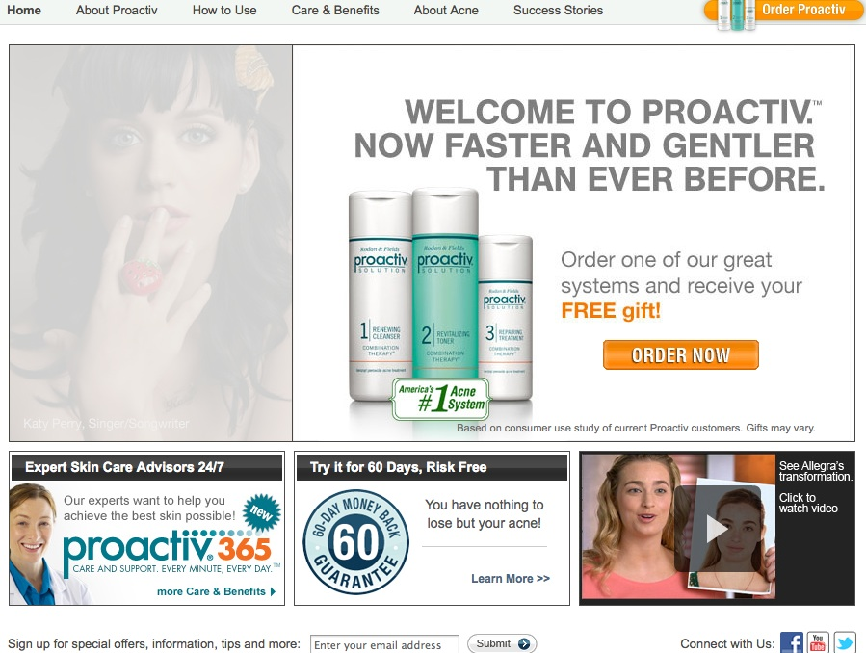

Their use of celebrities within their infomercials, commercials or TV ads differentiate by age; for example, the ad campaign featuring Julianne Hough depicts testimonials by middle aged to older demographic, those shown featuring Justin Bieber and testimonials by adolescents obviously target a younger age demographic. Celebrity spotlight actors include: Justin Bieber, Avril Lavigne, Katy Perry, Melisa Claire Egan, Julianne Hough, Chrishell Stause, Jennifer Love Hewitt, Caroline Wozniacki, Many Moore, and Jennifer Berry (Figure 1.0). “The pure chemistry between our products and high-profile celebrities is a refreshing truth in a time of deep consumer skepticism,” in analysis of this, one can understand that advertisers are choosing celebrities of greater popularity and larger media impact. Proactiv also uses celebrities with respectable track-records and credible sources, as well having an influential impact on the general population. Proactiv commercials are shot in primitive testimonial style, the previously mentioned commercial with Justin Bieber is a depiction of his leisure time (playing basketball and relaxing) along with his life as a celebrity and how he feels Proactiv has improved his life. As he answers, there is a sense that the material he was using was not rehearsed. These commercials strive to create an interpersonal connection between the consumer and the celebrity through the representation of problems, within skin care, and their link with their consumers who also have these problems. All of this while maintaining the attachment consumers share with the celebrities who endorse Proactiv. The next style employed is testimonial, which portrays classic before and after photos that illustrate the success stories of non-celebrity consumers (Figure 1.0). Lieberman, the chief executive of Lieberman productions who creates commercials for Guthy-Renker has a goal of reaching fresh eyes for their new campaign, growing from being a small company now reaching audiences of American Idol and Glee. Eleven Inc. deals with Proactiv’s print media, and Lieberman is in charge of direction of their television commercial ads. Print ads can be seen in many trendy magazines, such as Vogue, Allure, as well as website such as MTV.com and AOL. In addition, brand recognition and awareness of Proactiv is done through sales via Proactiv’s website, Proactiv’s phone numbers, and kiosks. They also promote their reputation as well as quality by offering it through 60-day free trials (Figure 1.0). By doing this they fully stand by their product and show consumers their confidence and pleased attitudes with the end results. Essentially, Proactiv moved from small time advertising, infomercials, and rarely seen magazine ads to being brand big time corperation owners recognized by famous celebrities, major magazines and pop culture. Proactiv moved from a retail kiosk, mail outs and risk free trials to commercials, testimonials and celebrity endorsements in order to advance in their use of advertising, showing more modern stance on spreading their product.
Figure 1.0
Figure 2
Analysis: Pros and Cons
The main positive factors associated with using celebrities are their reinforcement of product credibility; it establishes an appearance based on a “fresh face.” They employ the idea of a perfect individual – their celebrities. “Vicarious learning is a behavior modification concept through which consumers’ behaviors are influence by observing the actions and consequences of others” (Nord and Peter 1980). This is what Christiane Wong calls celebrity endorsement, she explains how organizations frequently endorse celebrities who possess ‘aspirational qualities’ and who can also be viewed participating in desirable activities, as well as achieving the desirable aspects of the product, which in the case if Proactiv is clear skin resulting in success. She continues to say, “the celebrities effectiveness stems from their symbolic aspirational reference group associations.”
“Initial studies used ‘source models’ to explain effects of celebrity endorses. In particular, the source credibility model and the source attractiveness model have been validated by many scholars. These models propose that celebrities owe their effectiveness to their credibility and attractiveness, which includes elements such as expertise, trustworthiness, familiarity, similarity and likeability of the source. This is similar to Tom et al’s suggestion that celebrities’ ability to influence consumers lies in their possession of various types of power (expert, reverent, legitimate, coercive, and reward power)” (Wong, 2009, p.2).
Proactiv employs this to the fullest extent, Julianne Hough is a role model of their product, she is a dancer, an actress and is ever present in the public’s eye, she is a very positive aspect of their product and something that they want promoted. She is considered the ‘ideal’ women, in beauty, success, talent, charm, and likeability. It creates a desire in the audience to want to find a connection with their idolized celebrity. Many find connectivity through similar relations that they have with their said celebrity; i.e. Proactive Solution; this reinforcing the products effectiveness, regardless if it is fully effective or not. The celebrity becomes the forefront for the product and instills a type of magic that the audience desperately wants to gain for themselves. The audience feels like they share something in common with the celebrity and it brings them one step closer to being just like them; acting like them, looking like them and maybe even achieving the same things they do. Essentially it becomes a fetish, and a must have commodity, and this is where Proactiv’s success is. It is an extremely effective method for Proactiv and is their main marketing strategy that is making them “America’s number one acne system” (Proactiv.com)
An obvious disadvantage of celebrity endorsement is if there is a scandal or a controversial situation in which the celebrity engages in, this immediately impacts the product and sales can be hurt as a result. Wong supports this with her analysis on Till and Shimp by using the principles of “classical conditioning” (Wong, 2009, p.4). It says, “that negative information about a spokesperson can damage product evaluation through the associative link between brand and celebrity” (Wong, 2009, p.4). For example, Lindsay Lohan was only featured once within a Proactiv commercial because she does not have a positive, and ‘ideal’ model face and reputation. She is in the tabloids shown in and out of jail, using drugs and alcohol and partaking in inappropriate and illegal activities. Wong used the example of Michael Jackson and PepiCo’s use of him as a celebrity endorser. They received negative feedback when he was involved in the molestation case (Wong, 2009, p.4). It is important to remember that no matter the outcome (Michael was innocent), this poor publicity is overall negative and hurts the company. Moreover, Proactiv has to be extremely careful with the celebrities that they choose to endorse their product; they cannot afford destroying their reputation by publicizing that they are supporting ill-behaved activities by poorly respected celebrities. Consequently, Proactiv’s reputation is riding on the celebrities’ actions within the Hollywood scene: what the celebrities endorse outside of Proactiv, what they participate in as leisure and work and how they present themselves in their genres or work and in everyday life. Wong details that “[r]esearch has shown that the effectiveness of endorsers is dependent on their congruity with the endorsed product” (Wong, 2009, p. 3). If the celebrity downward spirals, so does the product the celebrity is endorsing and if the celebrity attracts and reinforces the product optimistically, subsequently the product will as well, thus, Proactiv has chosen ideal and picture perfect celebrities that act as a catalyst to their product within the audience and within the cosmetic industry.
Additionally, another issue that can be a negative outcome for using celebrities is the Vampire Effect. Wong details this a potential pitfall:
“…if there is no congruency between the brand and the celebrity image, the audience will likely remember the celebrity, not the product. This has been termed the “vampire effect” (Evans 1998, as cited in Byrne, Whitehead and Breen 2003), which refers to the lifeblood of the product being sucked dry by the celebrity. The issue of fit is pertinent, and managers must carefully plan to ensure that the brand/product image fits with the characteristics of the target market and the celebrity image to ensure messages are effectively communicated” (Wong, 2009, p.3)

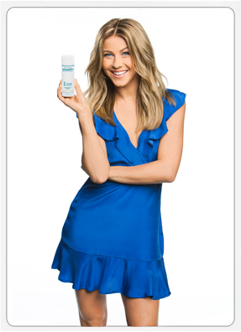
In analysis of Proactiv with the preceding information, they must be constantly on-guard for this problem. Will Justin Bieber be a larger face than the product, and if so, how to you manage it? So far it can be concluded that their celebrities do not outshine their product. The celebrities are, for most of the time, either holding the product, shown using the product, or talking about the positive attributes of the three-step acne system. (Figure 1.3)
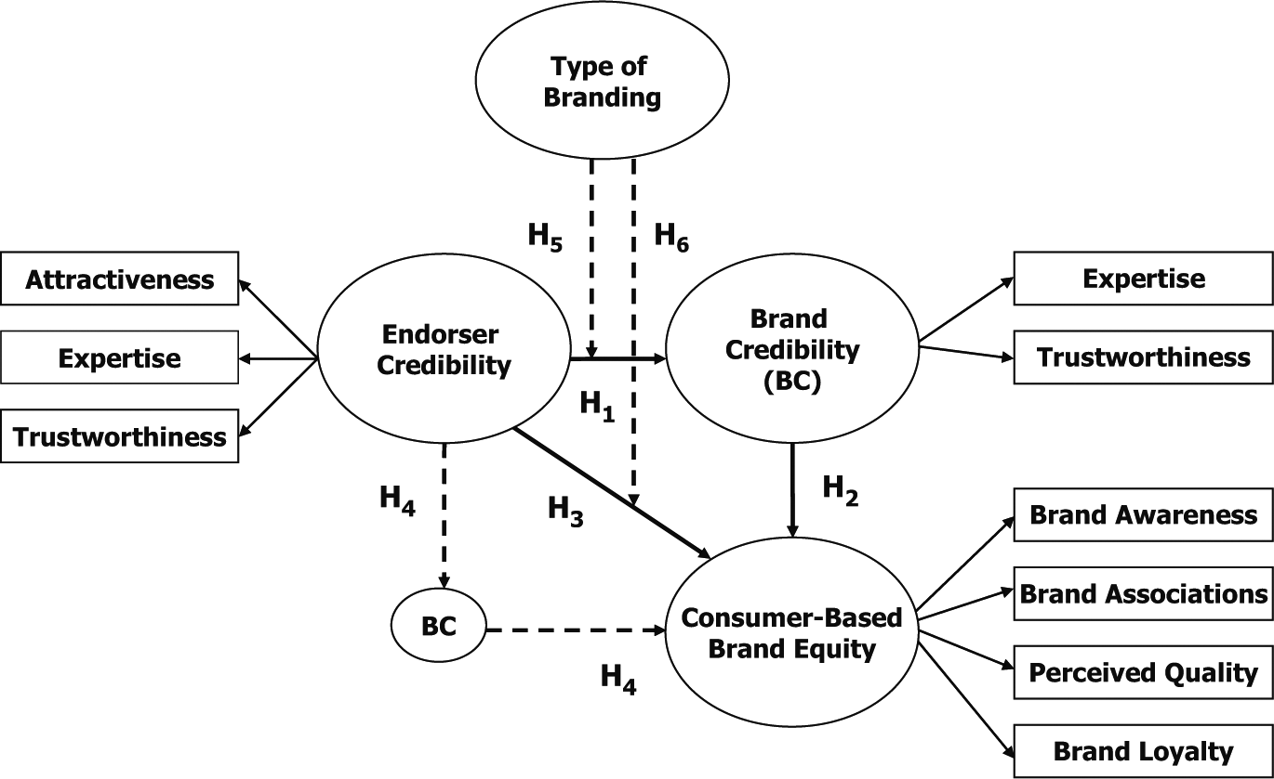
Another con of celebrity endorsement is “…celebrity greed and subsequent overexposure” (Wong, 2009, p.5). This can occur when an endorser is the face of multiple or too many products. Traditionally there has been exclusivity with celebrity use, minimizing any issues that may arise out of the celebrity promoting more than one product. For example, overexposure can decrease the audience’s trust for the celebrity (they are construed as a “sell out”) , it influences their perceptions on the loyalty of the celebrity and then consequently on the product and organization that has created the product, and further on the credibility of both. “Celebrity overexposure compromises the value of the celebrity in consumers’ eyes as it may accentuate the true nature of endorsement, which is more about the generous compensation rather than a celebrity’s liking for the brand” (Wong, 2009, p.5). Contrarily, if the celebrity ‘falls out’ of the Hollywood scene for whatever reason, the product’s public recognition ‘falls’ as well; meaning that when using celebrity endorsements, the product organization has to consistently be on-guard for celebrity status, public opinion of the celebrity, their actions, their creditability and if they are being overexposed or not. It is not easy, it is a tedious and continuous process that can ‘make or break’ a company’s image. Proactiv can be congratulated on their efforts to keep their celebrities ‘in check’ and to only use the high profile and positive role modela. McDonald and Hsu, detail that
Figure 3
Figure 4 (A.Spry, R.Pappu,T.B.Cornwell)
“[i]n the context of celebrity endorsement advertising, consumers might ask whether an endorser recommends a product because he/she actually believes the positive characterizes f the product (an internal attribution) or because he/she is paid for endorsing it (an external attribution). In particular, consensus is one of the attribution cues, which in an advertising context refers to the consumer’s perception of whether other individuals, including other endorsers, view the product similarly to the endorser. Thus, using multiple celebrities to endorse a product may create a consensus and help advertisers to positively affect consumer perception” (Chung-kue Hsu & Daniella McDonald, 2002, p 20).
Proactiv does this very well, they use the personal and private stories of the celebrities to try and capture the beliefs and insecurities of the audience they are targeting and implant the ‘fact’ that Proactiv is a reputable and astonishing product that heals all of one’s pains and insecurities. Celebrities put their private lives into the public spot light to show their ‘true insecurities’ to attack and make the consumers believe that it is a product that does truly work, and the success of Proactiv can only occur if consumers are willing to take a leap of faith and try the product. This is where the multiple celebrity use is an extremely effective method for getting loyal consumers. Herbert Blumer said “human beings act on things on the basis of the meanings that the things have for them” (CITE ME!!), and this is precisely what Proactiv is well accomplished at. Their consumers and future consumers are making their decisions based on their choice celebrity’s interpretation of the product and what it means to them. Julianne Hough says that “it takes the joy out of so many situations, posing for pictures, going on dates, to parties, it should be fun, but if acne is keeping you out of the picture, it’s time to do something about it” (YouTube). This immediately causes the viewer to question their life, their past experiences and photos and if they have acne problems, it even creates problems that ultimately don’t exist. This is how Proactiv gets their consumers; through life’s insecurities and the desire for the perfect face that leads to a popular and a care free life. Australasian Marketing Journal details that
“[a] significant interaction effect is found for purchase intention, suggesting that both attachment and the number of endorsements influence likelihood of purchase. When consumers are more attached to a celebrity and view that celebrity endorsing multiple brands, this negatively impacts their purchase intention. Yet, when consumers have a weak attachment, their purchase intention is increased with multiple endorsements” (Jasmina Ilicic & Cynthia M. Webster, 2011, p. 1).
Proactiv uses very popular and current celebrities that are known worldwide for their positive contributions to the Hollywood scene as well being a part of charity events. For example, Justin Bieber supports causes like AIDS Children, Creative Arts, Disaster Relief, Education, Healthcare, Human Rights, Literacy, Philanthropy, Poverty and Athletics. Avril Lavigne supports charities such as the Make A Noise Foundation, Amnesty International, AmericanCPR.org, Camp Will-a-Way, Music Clearing Minefields, US Campaign for Burma, Make-A-Wish Foundation and War Child (Looktothestars.org). Without these celebrities with respectable and moral resumes, Proactiv would most certainly not have had the same success rate. The choice of celebrities determines the success of the said endorsed product.

Ethnicities
In analysis of Proactiv’s celebrity use, it has been concluded that they do not use a wide-ranging variety of ethnicities, races, cultures, and styles. Proactiv’s use of celebrities is only white, heterosexual females, with the exception of Justin Bieber (Who is a white heterosexual male). With their use of personal stories or “Real Stories” (Proactiv.com) of real experiences of non-celebrities, they use the same, white, heterosexual, females; however, they do utilize more males and incorporate a few ethic persons. In their “top rated stories” section, out of eight stories presented, five have photos, and out of that five, all of them were female, and Caucasian. The others who did not display photos were girls; however, in analysis of their other categories, newest, featured stories, oldest, longest, photo stories and top rated stories, they were all the same people with an addition of one or two, and again, all girls. Moreover, Proactiv fails to be ethnically and gender neutral; which is a downfall for their campaign because it lessens the amount of people who can connect and relate to their product and people representing their product.
Interactionism
Interactionism is a concept that considers the dynamic relationship between text, media, producers, technologies and the interpretive audience. Goffman’s theory on “self presentation” generates interested in how the interaction rituals between people are shown across various mediums, we can see the way in which social interaction is shown within Proactiv and how they are using it to connect with the audience. For example; Proactiv can be seen to do this by how they connect with their audience in trying to show the “back” as Goffman puts it, of the celebrities in their commercials. The ‘back sphere’ is the area in which they withdraw social performance and drop their front; which is the capacity to control the way in which they present themselves by appearances, manner, and social settings. Katy Perry is an example that in a Proactiv commercial drops her front and is shown as vulnerable. She explains her difficulties with acne and acts in a way that creates pathos with the vewers. This as a result creates her character to be more relatable and allows for connectivity with the audience. Interactionism can also be viewed with the diction that Guthy-Renker directs for the celebrities. They use strong meaningful words, which still provide enough ambiguity and multi-utility for the diversity of society. For example, she specifically says:
“it takes a lot of guts to put it out there, to share my side of the story about acne because it’s one of those vulnerable moments but I think that a lot of people go through this. I really pride myself on relating to people and connecting to people with my songs and the lyrics. And I thought if I had the answer to something, it would just be natural to give it to someone that needed it” (Katy Perry –YouTube).
Their diction includes words like freedom, relief, popularity, and self esteem to attack the individual’s understanding of the product. They also use phrases like; “[p]roactiv gives you freedom and a new life, confidence and happiness.” And this is essentially the meaning in which they are instilling within their product. Freedom is shown as the notion of great skin, and without Proactiv this could not happen. The idea is that this acne product represents a life full of confidence and courage to take control and make things happen for oneself. The company uses the idea of perfection, something that is clearly unattainable, in order to market their idea of the freedom. Proactiv’s campaign commercials diction is a powerful through provoking tool that influences Proactiv’s audience to question their look, their life and consider using Proactiv to improve it, even if improvement is not needed. Proactiv is instilling not just a product to get rid of an unpleasant skin condition but a better life, even if, once again, that better life isn’t 100% necessary; however, media analysis shows that no advertising is good advertising unless it attacks the consumers and points out their flaws, and provides ways to heal and rid of these flaws. Proactiv campaigns are extremely optimistic and use upbeat tones, they show before and after photos to instill the products success, and they use hyperboles to attract attention. In observation, what they really do is promote individualism and a kind of narcissism to convey messages of consumption mainly my middle class citizens. They promote the importance of beauty and perfection and they do this by showing celebrities in their everyday life, being free of acne anxieties, and living worry free with a clear and beautiful face. It is instilling that anything but this clear skin is unacceptable and not desirable. All of the celebrities are shown discussing their discontent with their acne and how it enables their success and happiness. They show that once one has clear skin, that they are without worry and cares, thus, imposing the reality that if one does not have clear skin, they are not free, not happy and should seek a solution, and the solution is Proactiv. This is the narcissism of the perfect, ideal individual. Proactiv is also an expensive product, meaning that only middle to upper class individuals can afford it, secluding their audience to those with the income for it.
Consequently, interactionism deals with that Proactiv is very successful with doing, is placing their three-step acne solution into the lives of their audience. They air a commercial with Justin Bieber saying “it’s easy like 1-2-3 done!,” really putting pressure on the notion that Proactiv does not take a long time to use, it can be easily incorporated into anyone’s life and works. They do this all the while showing Justin Bieber hosting and concert and playing basketball with his friends, ideally, Proactiv is easy to use for not only the average person, but a busy celebrity like Justin Bieber, who manages to find time to play basketball with his friends. Although they do not end there, most of their celebrities endorsing commercials are followed by a “real story” of someone who tells their personal experience of Proactiv. They detail the confidence they receive, how their peers notice their skin improvements and how amazing they felt while using Proactiv and the results it gave them. Not only is their tactic to become interpersonal and put the product into the audiences’ life, but they flash “60-day trial” and “risk-free” across the screen. This is where the advertising takes full effect. When one sees this ad, they immediately believe they are getting a magic solution to all their ills, risk free, and only $19.95 if you “call now.” When the consumer views these commercials, they are instantly hit with a fantasy of popularity, beauty, hope and a better life. All of this from one commercial, for one simple product. Stimulus response can almost be seen here. After watching the commercial, many people are drawn to research more and analyze themselves. Even if a viewer has perfect skin, or skin that doesn’t need expensive cosmetics, these commercials are clever, in instilling insecurities that no one is free until they have and use this product. Justin Bieber again says, “I thought it was just for the hardcore cases, but it works for kids just like me.” This line here does more than just instill that the product works for more than one skin type, it illustrates that even if your skin is healthy and acne free, one should consume anyways because it will give you more than you have.

Conclusion
A full-proof and well organized advertising structure can absolutely be viewed as the reason why Proactiv is so successful. There is also the fact that the product is undoubtedly effective; however, without the smart and productive marketing strategies put forth by the company and their advertising partners, the success could virtually be cut in half. In spite of all the negative aspect Proactiv uses to promote their product, within their ideal look, they are indeed doing it well. They are not trying to demean anyone, but just trying to instill confidence within their consumers. In comparison to Axe Body Spray, they are not objectifying the person. We believe in the ad, and the notion of true beauty; Proactiv has created a well thought out and easily relatable ad. Celebrity endorsement has been used by several other companies since the success it had for Proactiv, this can place the company in a new spotlight of being a “trend setting”, something very difficult to do in the world of advertising.

