Lecture 11: Chapter 83:Principles of antimicrobial Therapy
some organism respond poorly to available drugs, effective drugs limited by toxicity & evolving microbial resistance
CLASSIFICATION OF BACTERIA: shape: spherical (cocci), spiral (spirochetes), rod (bacilli)
gram stain: gram+ (purple); gram- (pink); aerobic/anaerobic: req/don’t req O2 to grow/survive

CLASSIFICATION OF ANTIMICROBIAL DRUGS: Classification by susceptible organism(Look @ table)
Classifcation by mech of action: 7 major groups: selective toxicity:
1) drugs=inhibit bacterial wall synthesis/activate enzymes that disrupt cell wall (penicillins, cephalosporins)
2) ‘’ increase cell memb permeability(amphotericin B)
3) ‘’ lethal inhibition of bacterial protein synthesis (gentamicin)
4) ‘’ nonlethal inhibition of protein synt (Tetracyclines)
5) ‘’ inhibit bact synthesis of DNA/RNA or disrupt DNA function (rifampin, metronidazole, ciprofloxacin)
6) antimetabolites (disrupt vital biochem) (sulfonamides)
7) ‘’ suppress viral replication (acyclovir/zidovudine)
antibact drugs = bacteridical(lethal to bact) or bacteriostatic (slow bact growth but no cell death)
bacteria elimated via immune system+phagocytic cells

AQUIRED RESISTANCE TO ANTIMICROBIAL DRUGS: cause effective drugs to become useless; microbe= resistant not pt
Microbial mechanisms of drug resistance: reduction of drug []: microbes can decrease uptake to/ increase export from site of action of drug
Drug inactivation: microbes produce drug-metabolizing enzymes
Alteration of drug target mlcls: produce structural changes= drug doesn’t recognize etc.
Antag production produce antag interfere drug actions (rare)
Spontaneous mutation: random changes in microbe DNA increase in resist.
Conjugation: extrachromosomal DNA(plasmid/R factor) = transferred from one bacteria to another
mutation=random events, bugs reproduce rapidly
Relationship b/w Ab use/ Drug-resis microbes: how do Ab promote resistance: Ab not mutagenic, don’t chng bact DNA if resist organism= present, Ab will favour its survival by killing all other drug-senstive organisms remove competition for nutrient, promotes overgrowth of nrml flora (patho bacteria get R factor from flora)
more ab used, faster drug-resistant organisms will emerge/ broad spectrum Ab=more resistant
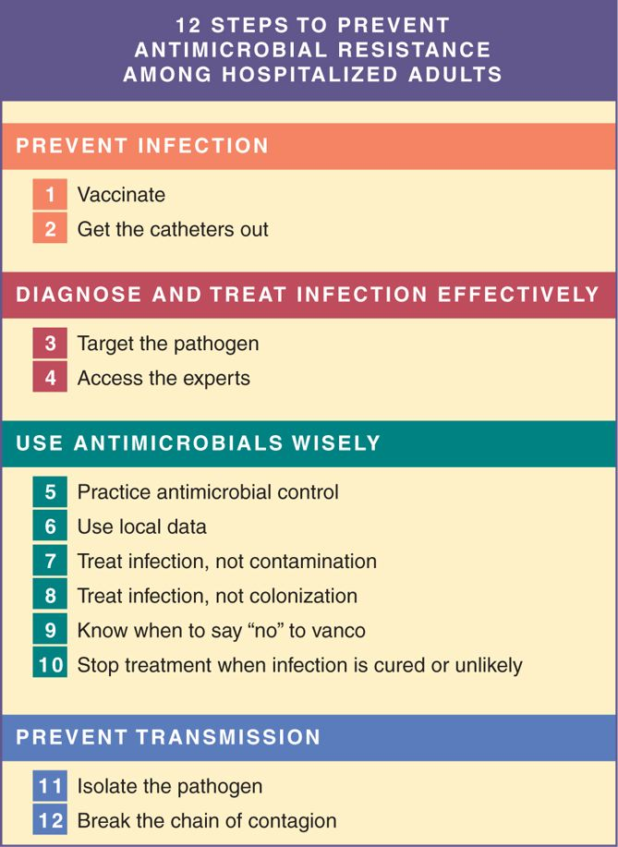
nosocomial infections: very difficult to Rx, resident organisms very drug resist
1) reduce need of anitmicro drugs, prevent infection
2) catheters out (IV, arterial, urinary tract, endotracheal)
3) determine identity/drug sensitivity of pathogen
4) access ID experts: srs infection, suprainfection, fail to respond, complexities
5) computer regiments, standard orders, MD edu, feedback evaluation
6) look @ time, locale, pt population, hospital unit
7) contamination false + results/ unneeded drugs use
use approved procedures to obtain/process all culture samples
8) unnecessary Rx/ misleading
9) drug of last resort for resist bact (vanocmycin)
10) if culture comes back (-) D/C pre-started Ab
11) contain/dispose of contagious body fluids
12) wash hands, don’t transfer bugs

SELECTION OF AB: several drugs effective
drug= first choice preferred greater efficacy, lower toxicity, narrow spectrum
alternatives if pt allergic/toxic, drugs can’t penetrate
empire therapy prior to completion of laboratory tests: broad spectrium agent used for intial treatment first, switch l8r
obtain samples of exudates and body fluids first
identifying the infecting organisms: match drug with bug: detect bug w/ gram-stain/microscope, polymerase chain rxn
determining drug susceptibility: disk-diffusion test (Kirby-bauer): widely used for testing drug sensitivity
agar plate inoculated w/ infecting organism and add disks w/ diff Ab (growth inhibit around one Ab)
measure dark bacteria-free zone (zone of inhibition= dead bugs) *EXAM*
serial dilution and gradient diffusion: provide MIC & MBC (minimum inhibitory/bactericidal concentration)
HOST FACTORS THAT MODIFY DRUG CHOICE. ADMIN, DOSAGE: Host defenses: immune (macrophages/neutrophils)
if impaired (AIDS, CA chemo) immune system not very effective
Site of infection (get Rx there): meningitis: inject directly in brain, infected abscesses- surgical drainage
Other factors: age: elderly= heightened sensitivity/toxicity= due to reduced metabolism/excretion
neonates need lower doses: poorly dvlped kidneys/liver
prego/lactation: previous allergic rxn: most common in penicillin; don’t re-expose
genetic factors: hemolysis w/ sulfonamides if deficient in G6PD; slow/rapid metabolizers of isoniazid

DOSAGE SIZE AND DURATION OF TREATMENT: don’t d/c Ab prematurely, even if symptoms subside
common cause of recurrent infection, drug resistance
THERAPY W/ AB COMBOS: Antimicro effects of Ab combos: initial Rx severe infection, enhanced action (endocarditis), mixed infections, prevention of resist (TB)
Disadvantages: toxicity/allergy/suprainfection); selection of resist bact, antagonism of 2 drugs, $$$

PROPHYLACTIC USE OF ANTIMICROBIAL DRUGS: surgery (cardiac, emergency C-section, “dirty” (ab performations, animal bites); dental/medical procedures that dislodge bacteria into blood
neutropenia (low WBC) (increase fungal infections); Ab used prophylactically

MISUSES OF ANTIMICROBIAL DRUGS: Attempted treatment of untreatable infection: majority of viral infections: no response to drugs (mumps, chicken pox, common cold); pts exposed to risks w/o receiving benefits
Treatment of Fever of unkown origin: fever =sign of infection, but also hepatitis, arthritis, CA
only exception: severe immunocompromise- infection lethal
improper dosage: dose too low=risk of SE w/o benefits; too high= risk of suprainfection/SEs
Rx w/o adequate bacteriologic information: req identity and drug sensitivity of bug; exception: life-threating situations

Chapter 84: Drugs= weaken bacterial cell wall I: PENICILLINS!
weaken cell wall take ups h2o/burstlysis; bactericidal
attach to PBPs inside, penetrate only gram + wall (gram- resist) (latter also have outer membrane)
Mamal cells= no cell wall: PCSs ineffective
penicillinases(beta-lactamses): enzymes cleaves beta-lactam ringrender penicillins inactive
gene transfer b/n bacteria via plasmids PCN resist
chemistry: properties of individual pens determined by R group
determines PBP affinity, penicillinase resistance, ability to penetrate gram-, stomach acid resistance, pharmacokinetic
classification: based on antimicrobial spectrum, 4 groups: narrow-spectrum=penicillinase sensitive, narrow= penicillinase resistant, broad-spectrum and extended-spectrum pens

PROPERTIES OF PENS: Antimicrl spectrum: active against gram + bact, gram – cocci, anaerobic bact & spirochetes
therapeutic uses: given PO, IM, IV; used for pneumonia, meningitis, endocarditis, tetanus, anthrax, syphilis; used prophylactically in sexual partners
penicillin allergy : general considerations: most common cause of drug allergy
severity range from minor rash to life-threatenng anaphylaxis
prior exposure/ no prior Rx: eat fungi or foods of animal origin
allergy to one PCN= allergy to all PCNs (& cephalosporins)
types of allergic rxns: classified as immediate (2-30min), accelerated (1-72h), late (days to weeks).
anaphylaxis (laryngeal edema, bronchoconstriction, hypotension) = immediate hypersensitivity rxn
mortality risk high, treatment is E (SQ, IM, IV) & resp support
if in doubt, check allergy via skin test (make sure E/ resp support ready!!)
box 84-1: methicillin-resistant staphylococcus aureus: gram +, on skin of asymptomatic carriers
abscesses, boils; can invade lungs/blood (bacteremia, fatal); most pts cured now/rate in hospitals decrease)
hospital assoc (85%): healthcare wrkers pts; multidrug resistant
risk facts: age, surgery/hospitalization/long-term care facility, dialysis, ICU, prolonged Ab Rx, indwelling catheter
community assoc (15%): less danger, easier to Rx; same effects/transmission, susceptible to more Ab
appear usu in young/healthy = no exposure to healthcare facilities

chapter 85: Drugs =weaken cell wall II: Cephalosporins, carbapenems, Vancomycin and others
inhibit cell wall synthesislysis/death
CEPHALOSPORINS: beta-lactam Ab similar structure/action to pens; deactivated by bacteria using B-lactamases
adverse effects: allergic rxns: most freq, severe/immediate rxns= rare
d/c ASAP if urticarial, rash, hypotension, diff breathing
can have x-reactivity to pens (don’t give ceph if history of bad rxn to pens)
therapeutic use: broad spectrum, bactericidial, high therapeutic index
3rd gen for many infections (mengingitis, nosocomial infections, gonorrhea, influenza, food poisoning, pneumonia)
drug selection: diff in generations: antimicro spectrum, adverse effects, pharmacokinetics

CARBAPENEMS: beta-lactam Ab, broad antimicro spectrum;
imipenem, meropeneum, ertapenem, doripenem; admin parenteral
broader spectrum than nearly all other Ab, resist to practically all B-lactamases
effective against gram +/- cocci/ grm + bacilli, anaerobes
OTHER INHIBITORS OF CELL WALL SYNTHESIS: Vancomycin: only for srs infections- toxic maybe
indications: CDI. MRSA
deosn’t interact with PCP, targets precursor mlcls for cell wall biosynthesis
SE: dose-related renal failure, ototoxicity, hearing impair= reversible
Box 85-1: Clostridium difficile infection (CDI) gram +, spore forming, anaerobic bacillus,
mild (ad discomfort, nausea, fever diarrhea)
severe (toxic megacolon, pseumembranous colitis, colon perforation, sepsis, death)
Rx: metronidazole/ vancomycin; preceded by use of Ab kill off nrml gut flora
acquired by ingest C. difficile spores, shed in feces (from commodes, bathtubs, rectal thermoms, via hands of HCP
spores of C. diff= hardy (drying, T chance, alcohol); remain in environ for wks
Rx: stop Ab that C. diff overgrowth, start metro/vanco

Chapter 86: Bacteriostatic inhibitors of protein synthesis: Tetracyclines, macrolides etc.
suppress bacterial growth/ replication but do not kill
TETRACYCLINES: broad-spectrum Ab; tetracycline, demeclocycline, doxycycline, minocycline (all similar)
Mech of action: suppress bacterial growth by preventing addition of a.a to peptide chain on ribos inhibit protein syn
cannot access cell interior; selectively toxic to bacteria, not host cells
microbial resist: results from reduced drug uptake, increased drug inactivation, decrease access of drug to ribos, increase elimination
Adverse effects: GI irritations, stain deciduous & permanent teeth?
Suprainfection b/c broad spectrum
c. difficile-life threatning diarrhea, fungi in mouth,pharynx, vagina/bowel, liver/kidney toxcity

MACROLIDES: inhibit bacterial protein synthesis; erythromycin (old), azithromycin, clarithryomycin, dirithromycin, troleandomycin (derivatives of erythromycin)
Antimicro spectrum: active against most gram+/- bacteria
advere effect: NVD, epigastric pain; risk of cardiac death, high [] prolong QT interval, ventricular dysrhyth

Chapter 87: Aminoglycosides: Bactericidal inhibitors of protein synthesis: narrow-spectrum, used against aerobic gram- bacilli, bactericidal
gentamicin, tobramycin, amikacin; 1st one: streptomycin used for tersina pestis (gram – bact, caused the Black Death
BASIC PHARMACOLOGY OF THE AMINOGLYCOSIDES:
adverse effects: ototoxicity: aminoglycosides accumulate in inner ear cellular injury impair hearing(ear ringing loss of high freq)/balance (headache, nausea, unsteadiness/dizziness/vertigo
nephrotoxicity:: symptoms: proteinuria, casts in urine, dilute urine, elevations in serum creatinine/ blood urea nitrogen; risk is high in elderly, preexisting kidney disease, pts taking other nephrotoxic

Chapter 88 Sulfonamides & Trimethoprim: Broad spectrum anitmicro
SULFONAMIDES: first available for systemic treatment of bacterial infections, used primarly for UTIs
mech of action: suppress bacterial growth by inhibiting synthesis of folic acid(needed for DNA/RNA/protein synthesis)
inhibits key step of para-aminobenzoic acid; sulfos = bacteriostatic, humans unaffected (folate from diet)
therapeutic uses: use limited b/c intro to other Ab= less toxic & dvlpmnt of sulfonamide resist.
adverse effects: hypersensitivity rxns: rash, drug fever, photosensitivity steven’s Johnson skin syndrome
hematologic effects: hemolytic anemia in pts = G6PD deficiency
red cell lysis: fever, pallor, jaundice; loss of WBC too
kernicterus: disorder in newborns caused by deposition of bilirubin in brain neurologic deficits & death
sulfo displace bilirubin from plasma proteins, cross BBB
contraindicated to infants <2mo or prego near term or breast-feeding
DDI: inhibit hepatic metabolism drug lvls increase

TRIMETHOPRIM: Mech of action: inhibit dihydrofolate reductase
suppress bacterial synthesis of DNA, RNA, proteins
bacterial resistance parallels sulfonamide inactivation
TRIMETHOPRIM/SULFAMETHOXAZOLE: inhibit sequential steps in folic acid synthesis
resistance less than to other drugs alone
Therapeutic uses: UTIs, pneumocystis pneumonia (PCP), given to AIDS pts,
GI infections, ear infections, chronic bronchitis, urethritis, pharyngitis, whopping cough, brucellosis, melioidosis, listeria, chancroid

Chapter 93: Antiviral agents I: Drugs for Non-HIV Viral infections: viruses intraceullar parasites: reproduce w/ host biochem, difficult to suppress viral replication w/o harming host
DRUGS FOR INFECTION WITH HERPES SIMPLEX VIRUSES AND VARICELLA-ZOSTER VIRUS: HSV causes infection of genitalia, mouth, face etc; VZV cause of varicella(chickenpox), herpes zoster(shingles) Rx: acycl/calacyc/famciclovir
Acyclovir: inhibits viral replication by suppressing synthesis of viral DNA
selectivity: virus activates drug
resistance: virus has mechanisms= interfere w/ activation (rare immunocompetent/common-transplant AIDS)
therapeutic uses: herpes simplex genitalis
mucocutaneous herpes simplex infections: oral acyclovir: Rx infections of gums/mouth, previous recurrences
IV acyclovir for immunocompromised pts (infection severe)
varicella-zoster infections: oral acyclovir= for herpes zoster(shingles)
VZV reactivation dormant decades in sensory nerve roots
also for varicella (chickenpox) in children/adol/adults; IV: immunocompromised

DRUGS FOR CYTOMEGALOVIRUS INFECTION: member of herpes group (herpes 1+2, VZS, Epstein-barr)
transmission= person to person via saliva, urine, blood, tears, breast milk, semen, organ transplant
after initial infection, virus= dormant for life (no detectable injury or illness),
immunocompromised = high risk morbidity/death
ganciclovir, galganciclovir, cidofovir, foscarnet, fomivirsen

DRUGS FOR HEPATITS: most common liver disorder, hep A,B,C,D,E,G
acute hep (<6mo): liver inflammation, jaundice, elevation of alanine aminotransferase; resolve w/o Rx
chronic: hep lead to cirrhosis, hepatocellular CA, liver failure Rx needed
Hepatitic C: transmission= exchange of blood/ sexual transmission; usu no symptoms/active infection/can transmit
chornic HCV : main liver transplant reason; liver failure, cancer, death
Rx: pegylated interferon alfa combined with ribarviron; no vaccine
interferon alfa: responses modest/ half relapse when Rx stopped
ribavirin(oral): Rx of choice, PREGO CAT X (tertagogenic/embyrolethal)
R/O prego, must take 2 nonhormonal contraceptives, contraindicated for man w/ pregnant partner
protease inhibitors: boceprevir, telaprevir: inhibit viral protease, virus cannot mature into infectious state;
combo w/ peginterferon alfa+ribavirin, $$$, many SE /DDIs

Hepatitis B: transmit: exchange of blood/semen; 50% dvlp acute hep (cleared by immune)
chronic infectionsbest Rx: prevention (children should have HBV vaccine before in school)
7 drugs: 2= alfa interferons, 5= nucleoside analogs (amivudine, adefovir, entecavir, telbivudine, tenofovir)
interferons more effective but $$$/less wel tolerated
lamivudine/adefovir = active against HIV promote resist HIV if co-infected w/ that virus
relapse=high after stopped Rx

DRUGS FOR INFLUENZA: resp tract infection, cause of morbidity/mortality
2 types: Influenza A: more infections than type B
contagious by cough/sneeze, symptoms begin 2-4 days postexposure, lasts 5-6 days
fever, cough, chills, sore throat, headache, myalgia(muscle pain); managed by vaccine& drugs
drugs 2 groups: adamantanes, neuraminidase inhibitors
influenza vaccines: types of influenza viruses: 2 vaccine types: inactivated influenza vaccine(injected IM) & live, attenuated influenza vaccine (intranasal spray)
protect beings 1-2 weeks after vaccination, lasts 6mo+ (flu seaseon from Nov-April)
adverse: rare, small risk of Guillain-Barre syndrome (severe paralysis);

neuraminidase inhibitors: active against influenza A/B, oseltamivir (PO), zanamivir (inhaled)
not alternative to vaccination
adamantanes: activity against influenza A only, adverse CNS effects common, resist dvlp rapidly(rim/amantadine)

DRUGS FOR RESP SYNCITAL VIRUS INFECTION: major cause of lower resp tract disease
usu in young, elderly, and ppl w/ disorders of resp/cardiac/immune
death rate is high in elderly, RSV= seasonal w/ most cases occurring in winter
2 antiviral drugs: ribavirin/palivizumab (not very effective)

Chapter 94: Antiviral Agents II: Drugs for HIV infections: causes AIDS, promotes immunodeficiency by killing CD4 T Lymphocytes; pts at risk of opportunistic infection(pneumocystis pneumonia, cytomegalovirus retinitis, diseeminated histoplasmosis TB) and certain CAs (kaposi’s sarcoma)
AIDS occurs years after HIV infection acquired; Rx: antiretroviral therapy
ART= $$$, complex, pose risk of longterm SE & DDIs

PATHOPHYSIO: Characterisitics of HIV: retrovirus (can’t self-replicate, obligate intracellular parasites)
to replicate must transcribe RNADNA (enzyme needed: RNA-dependent DNA polymerase aka reverse transcriptase)
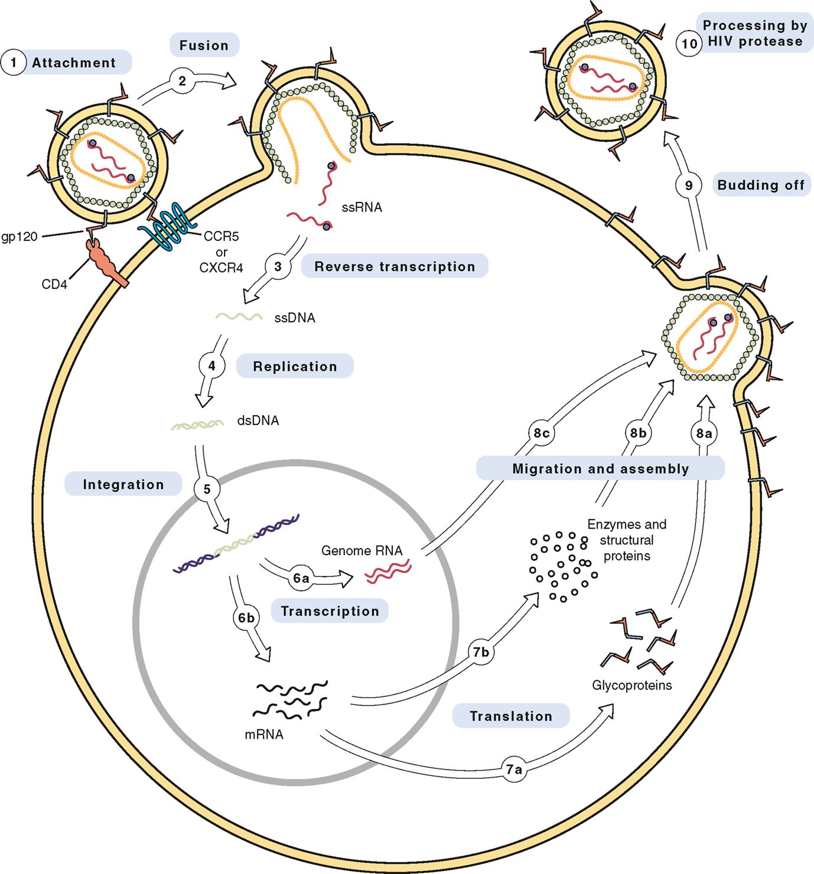
2 identical strangs of RNA, each has reverse transcriptase attached
surrounded by core proteins, shell surrounded by outer lipid bilayer env (has gp41+120 for attach to host cells)
replication cycle: 1) attachment of HIV to host
2) fusion of HIV/host membrane
3) reverse transcriptase RNADNA
4) replication of HIV DNA 2
5) integration of HIVhost DNA (integrase)
6) transcription of HIV DNA RNA
7) translation of RNA HIV gprot & enzymes & structural proteins
8) migration to cell surface and assemble into new virus
9) budding off from host cell (outer membrane of virus is host membrane)
10) protease gives HIV final maturation (cleavevs large polyproteins into smaller/functional forms)

mutation and drug resist: HIV reverse transcriptase can cause errors defective viral RNA
viable offspring are drug resist
transmission HIV: transmission can be contact w/ sex, transfusion, shared needles, accidental needle sticks/
transmit mom fetus; initially homosexual males, IV drug uders, hemophiliacs now eveyrone
triphasic clinical course of HIV infection: intial phase= HIV undergoes replication flu-like acute retoviral syndrome
resolves immune counterattacks HIV lvls fall
middle phase= prolonged clinical latency, asymptomatic but HIV continues to replicate CD4 T cells decline
latent phase= CD4 T cells drop below critical lvls oppurtunisitc infections/CA (AIDS occurs here),
CNS complications (tremor, ataxia, psychosis, mental slowness, memory loss, decrease cognition/[])

CLASSIFICATION OF ANTIRETROVIRAL DRUGS
nucleoside/nucleotide reverse transcriptase inhibitors mainstsys of Rx, (zidovudine, lamivudine)
relatives of natural building blocks of DNA, incorporate into growing DNA foil reverse transcriptase (step 3)
non-nucleoside reverse transcriptase inhibitors: differ from NRTIs by structure/ mech of action
not structurally related to nucleosides, bind to active center of reverse transcriptase direct inhibition
5 availabe: efavirenz, nevirapine, delavirdine, etravirine and rilpivirine; SE: rash, some teratogenic
protease inhibitors: SE: GI disturbances, fat maldistribution, hyperglycemia, diabetes, reduced BMD, increase bleeding, elevation in triglyceride
atanazavir, darunavir, fosamprenavir, indinavir, lopinavir/ritonavir, nelfinavir, ritonavir, saquinavir, and tipranavir
raltegavir, integrase strand transfer inhibitor: integrase needed for HIV replication, inhibiting integraseprevents insertion of HIV DNA stops HIV replication (elvitegravir)
enfuvirtide, HIV fusion inhibitor: (T-20) blocks entry of HIV into CD4 T cells, inconvenient(SQ injection x2 daily), $$$
maraviroc, CCR5 antagonist: interferes w/ entry of some strains of HIV into CD4 T cells

MANAGEMENT OF HIV INFECTION: most pts take multiple antiretroviral drugs(2 NRTIs combo w/ PI or NNRTI)
DDIs and SE risk is high, $$$, emergence for resist common
screening and diagnosis: tests detect anti-HIV Ab: results in minutes
cannot detect infection immediately following HIV exposure (Ab lvls too low to be measured in 1st few days/weeks) early detection: measure plasma HIV RNA
lab tests: viral load measures indicate the magnitude of HIV replication /predicts T cells destruction rate
CD4 T cell counts indicate how much dmg immune has already suffered
HIV drug resist: used to guide drug selection, nonadherence leads to drug- resist

Treatment of adult/adolescent pts: symptomatic HIV disease: should receive maximal antiretroviral therapy
ART contain 3-4 drugs enhance antiviral effects and reduce risk of resist, Rx til undetectable results of RNA
ART cannot cure HIV but d/c of ART rise in HIV RNA; Rx indefinitely

chronic asymptomatic HIV disease: early intervention benefits: reduction of viral load, slowed progression of AIDS, life prolonged?, risk of transmitting HIV reduced, decrease drug resist mutants, risk of TB, Kapsi’s sarcoma decrease
early intervention drawbacks: decrease quality of life, resist may dvlp sooner limits future options
symptom-free person exposed to drug SEs (including unknown long-term toxicities)
acute HIV disease: early Rx benefits: decrease HIV spread throughout body, slow progression of HIV, decrease resist
drawbacks: reduce quality of life (toxicity), blunting of early immune response to HIV, emergence of resist if Rx fails

treatment of infants and young children: common in dvlping country, young children= accelerated infection course
many dvlp symptoms by 1yo,(adults 10yrs), death by age 5-even with ART- immature immune systems
treatment of prego pts: mangemnt same as if u not prego
balance the benefits of treatment against the risk of Rx; interrupt Rx until after trimester (teratogenic mostly in 10-12w of prego), mother child transmission during delivery

post exposure prophylaxis: one time exposure to HIV carries small risk of infection
sources of exposure: vaginal/anal intercourse (unprotected), receptive oral intercourse, sharing contaminated needle, accidental needle sticks, splashed w/ blood and other body fluids
risk reduced by prophylactic ART, initiate ASAP (1-2h, no later than 72h)

