Lecture 7 Chapter 51 Drugs for Angina Pectoris
sudden pain beneath the sternum, left shoulder and arm “referred pain”
cause: O2 supply to heart is insufficient to meet O2 demand, occurs secondary to atherosclerosis of coronary arteries
2 drugs: cholesterol-lowering drugs and anti platelet drugs;
antianginal agents have 3 groups: organic nitrates, beta blockers and ca2+ channel blockers; 4th agent (ranolazine) can be combined with these drugs

DETERMINANTS OF CARDIAC O2 DEMAND AND O2 SUPPLY
O2 Demand: determinants of cardiac o2 demand are HR, myocardial contractility and intramyocardial wall tension
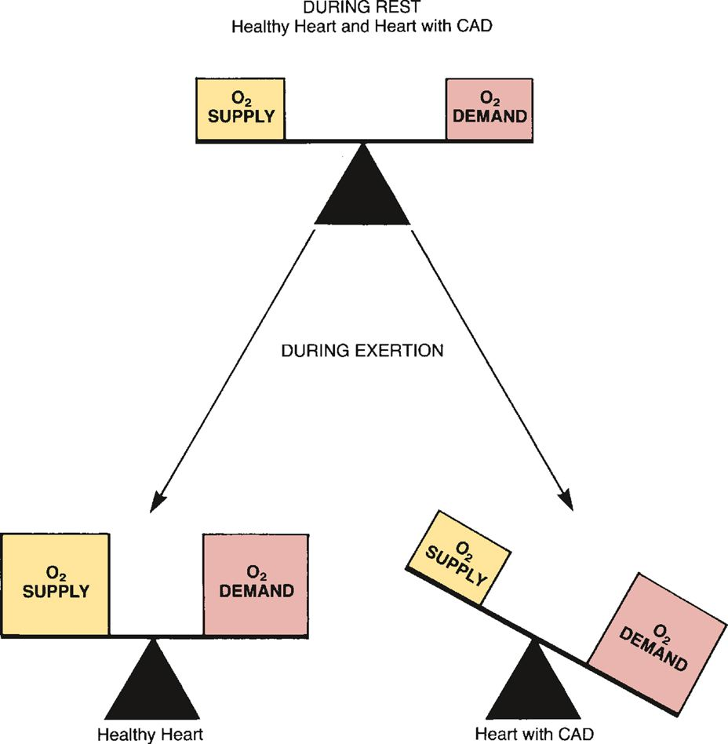
wall tension determined by cardiac preload/afterload
O2 supply: determined by myocardial blood flow

ANGINA PECTORIS: PATHO AND TREATMENT STRATEGY
3 forms: chronic stable angina, variant angina and unstable angina
Chronic stable angina (exertional angina)
Patho: triggered by increase in phys activity
cause of this: CAD (deposition of plaque in arterial wall)

Picture: arterioles are fully dilated during rest, so when exertion occurs no way to increase blood flow to satisfy O2 demand angina pain

TABLE 51-1 Mechanisms of Antianginal Action
Mechanism of Pain Relief
Drug Class | Stable Angina | Variant Angina
Nitrates | Decrease oxygen demand by dilating veins, which decreases preload | Increase oxygen supply by relaxing coronary vasospasm
Beta Blockers | Decrease oxygen demand by decreasing heart rate and contractility | Not used
Calcium Channel Blockers | Decrease oxygen demand by dilating arterioles, which decreases afterload (all calcium blockers), and by decreasing heart rate and contractility (verapamil and diltiazem) | Increase oxygen supply by relaxing coronary vasospasm
Ranolazine | Appears to decrease oxygen demand, possibly by helping the myocardium generate energy more efficiently | Not used
Nondrug Therapy: pts should avoid events that can cause angina (overexertion, heavy meals, emotional stress and exposure to cold; risk factors: smoking, obesity, hypertension, hyper lipidemia and a sedentary lifestyle
risk of MI= should receive antiplatelet drugs (Aspirin)

Variant Angina (prinzmetal’s angina, vasospastic angina)
Patho: caused by coronary artery spasm restrict blood flow to the myo
insufficient O2 to heart causes pain, symptoms occur at any time not just exertion(stable angina)

Unstable Angina
patho: this = medical emergency; symptoms from severe CAD complicated by vasospasm, platelet aggregation, and transient coronary thrombi/emboli (3x threat)
greater risk of death than stable angina but smaller risk of death than MI
treatment: maintain O2 supply and decrease O2 demand; pts should be hospitalized; acute management consists of anti-ischemic therapy combined with antiplatelet + anticoagulation therapy
anti-ischemic therapy consists of nitroglycerin (1st dose sublingual and follow w/ IV therapy), beta blocker, supplemental O2, Iv morphine sulfate, ACE inhibitor
antiplatelet therapy consists of aspirin (continue indefinitely), clopidogrel, abxiximab, eptifibatide/tirofiban (only for high-risk patients with continuing ischemia & only if angioplasty not planned)
anti coagulant therapy (remove blockage)

ORGANIC NITRATES: oldest drugs and most freq. used antianginal drugs, relieve angina by vasodilation
Nitroglycerin: effective, fast acting and inexpensive, drug of choice for relieving acute angina attacks
Vasodilator actions: acts directly on vascular smooth muscle to promote vasodilation
converts nitrate from nitroglycerin to its active form nitric oxide
mechanisms of antianginal effects
stable angina: decrease pain of exertional angina primarily by decreasing cardiac O2 demand
variant angina: nitro relaxes/prevents spasm in coronary arteries (increases O2 supply, not reduce O2 demand)
Adverse effects: well tolerated drug, headache (asprin), orthostatic hypotension (lie w/ feet elevated), and reflex tachycardia (b blocker, CCB)
Drug interact: this drug can intensify effects of other hypotensive agents, avoid alcohol
phosphodiesterase type 5 inhibitors used for erectile dysfunction, sildenafil, tadalafil and vardenafil can induce vasodilation
Tolerance: develops rapidly, pts dvlp cross-tolerance to all other nitrates and vice versa, dvlp 1 day, reverse by d/c
Preparations and routes of administration: sublingual or translingual spray take effect rapidly (1-5 min) and then fade in less than 1h, if pain does not go away in 5 minutes then call 911
transmucosally (b/n upper lip and gum/cheek and the gum) have rapid onset too but are long-acting, slowly dissolving over 3-5h
nitrates = rapid onset have two uses: termination of an ongoing angina attack and short-term prophylaxis prior to anticipated exertion
slow release oral capsules, transdermal patches and topical ointment effects begin slowly but lasts hours
long-acting nitrates used for sustained prophylaxis of anginal attacks, remove after 12-14h tolerance
IV nitroglycerin used in hospitals to treat unstable angina/chronic angina when symptoms cannot be otherwise ctrlled
Isosorbid Mononitrate and isosorbide dinitrate: same as nitroglycerin but differ by route of administration and time course of action
Amyl Nitrate: ultrashort-acting agent used to treat acute episodes of angina pectoris; intensifies sexual orgasm

BETA BLOCKERS [propranolol, metaprolol)
first-line drugs for chronic, stable angina, but not effective against vasospastic angina
exercise tolerance increased and freq. and intensity of angina attacks lowered
derease risk of death esp. in pts with a prior MI; SE: <3 failure, asthma, depression, mask hypoglycema
CA2+ CHANNEL BLOCKERS: verapamil, diltiazem and nifedipine; reduce peripheral resistance and relax coronary vasospasm
verapamil and diltiazem reduce HR and contractility, used to treat both stable and variant angina
adverse effects: hypotension and reflex tachycardia
RANOLAZINE: actions and therapeutic use: reduce # of angina episodes per week and increase exercise tolerance
smaller benefits in women than men, doesn’t reduce HR, BP or vascular resistance
has side effects and multiple drug interactions , dunno exact mechanism of action
de pointes (grapefruit juice HIV protease inhibitors, macrolide antibiotics, azole antifungal drugs, and some CCBs

REVASCULARIZATION THERAPY: CABG AND PCI
if drug therapy fails then surgical revascularization should be considered
CABG (coronary artery bypass and graft surgery) used to increase BF to ischemic areas of heart; chest, rib cage and pericardium are opened
one end of segment of healthy blood vessel from pt = grafted onto the aorta & other end connected to diseased coronary artery distal to the plaque
minimally invasive direct coronary artery bypass surgery = less invasive alternative to CABG, no bypass machine
performed on beating heart
PCI: percutaneous coronary intervention
two steps: balloon angioplasty followed by stenting; miniature catheter with deflated balloon inserted to artery (groin)aortaocculocoronary artery then inflated allows blood to flow stent (stainless steal mesh) implanted to help prevent restenosis

DRUGS USED TO PREVENT MYOCARDIAL INFARCTION AND DEATH
antiplatelet drugs: decrease platelet aggregation and thereby decrease the risk of thrombus formation in coron. arteries
aspirin, clopidogrel and prasurgrel are examples
cholesterol-lowering: elevated cholesterol = risk for coronary atherosclerosis
drugs that lower chol can slow progression of CAD, stabilize atherosclerotic plaques and cause plaque regression
all stable angina pts should receive this
ACE inhibitors: greatly reduce incidence of adverse outcomes, recommended for pts with CAD and those w/ diabetes

Chapter 52: anticoagulant, antiplateley and thrombolytic drugs
drugs suppress coagulation, inhibit platelet aggression and promote clot degradation, they all interfere with hemostasis so can cause risk of bleeding

COAGULATION: PHYSIO AND PATHOPHYSIO
Hemostasis: physio process by which bleeding is stopped; occurs in 2 stages: formation of platelet plug followed by reinforcement of the platelet plug w/ fibrin
Stage one: formation of a platelet plug: platelets come in contact with collagen on exposed surface of dmged BV
platelets then adhere to site of vessel injury
adhesion initates platelet activation massive palteley aggregation forms fibrinogen bridges b/n glycoprotein receptors on adjacent platelets; must be reinforced with fibrin to last
stage two: coagulation: production of fibrin produced by coagulation cascase by 2 pathways (extrinsic/intrinsic, many clotting factors
Keeping hemostasis under ctrl: antithrombin (protein tht forms complex with clotting factors inhibits their activity)
physio removal clots: plasmin used to degrade fibrin meshwork of clot; produced through activation of plasminogen
Thrombosis: thrombus = permanent blood clot formed in BV or w/n heart
thrombosis reflects pathologic functioning of hemostatic mechanisms
venous thrombus (where blood flow is slow due to lack of activity) has a long tail and can break off to form embolus (travels through vascular system and become lodged at faraway sites)
frequently lungs,brain; arteriol thrombus= localized injury b/c lack of perfusion
OVERVIEW OF DRUGS FOR TROMBOEMBOLIC DISORDERS **CHECK STUDY TIP SLIDES)
anticoag: disrupt coagulation cascase and suppress production of fibrin (also used = selective factor Xa inhibitirs –fondaparinux*; most effective against venous thrombosis, dipyridamole
antiplate: (aspirin and clopidogrel) inhibit platelet aggregation, most effective at preventing arterial thrombosis (tirofiban*)
thromb drugs (alteplase, streptokinase) promote lysis of fibrin and cause dissolution of thrombi (TPa-altepase*)

ANTICOAGULANTS Drugs that reduce formation of fibrin
warfarin: inhibits synthesis of clotting factors, including factor Xa and thrombin; all other anticoagulants inhibit activity of clotting factors
HEPARIN AND HEPARIN DERIVATIVES greatly enhance the activity of antithrombin (protein that inactivates two clotting factors: thrombin and factor Xa)
production of fibrin is reduced and clotting is suppressed
heparin (unfractionated) heparin (from lungs of cattle/intestines of pigs) rapid acting anticoag admin by injection (iv or SQ)
chemistry: mix of long polysaccharide chains, has many (-) charged groups highly polar, cannot cross membranes
mech of anticoag action: heparin suppresses coagulation by helping antithrombin inactivate clotting factors thrombin and factor X ultimately suppressing formation of fibrin
heparin useful for prohpylaxis of venous thrombosis, anticoag effects dvlp quickly whereas for warfarindoesn’t dvlp for days

pharmacokinetics
therapeutic uses: heparin preferred during pregnancy + when rapid onset is required
also used in open heart surgery and renal dialysis (heparin used to prevent coagulation in devices of extracorporeal circulation), prophylaxis
used to prevent postoperative venous thrombosis, and can be used for treating disseminated intravascular coagu. (disorder where fibrin clots form throughout vascular system and where bleeding can occur b/c fibrin production consumes clotting factor; also used as adjunct to thrombolytic therapy of acute MI
Adverse effects: hemorrhage: can occur @ any sight and can be fatal
look for signs of reduced BP, increased HR, bruises, petechiae, hematomas, red/black stools, cloudy urine, pelvin pain, headache/faintness and lumbar pain, withdraw heparin if bleeding starts
Heparin-induced Thrombocytopenia
potentially fatal immune-mediated disorder characterized by reduced platelet counts/ paradoxical thrombosis and MI
might require amputation in arm/leg; coronary thrombosis can be fatal (PE, stroke, MI, hematomas)
other adverse effects SQ admin can produce local irritation and hematoma. Vasospastic reactions that persistfor many hours may develop after 1> weeks of treatment
pts undergoing anesthesia using epidural/spinal catheter heprin cause spinal/epidural hematoma permanent paralysis

Warnings and contraindications: use with caution if pt hemophilla, dissecting aneurysm, peptic ulcer disease, severe hypertension or threatened abortion, and liver/kidney disease
contraindicated for pts with thrombocytopenia and uncontrollable bleeding
avoid using this immediately after surgey of eye, brain or spinal cord
Drug interactions: aspirin etc. that depress platelet function will weaken platelet aggregation (this is defense against hemorrhage)
Protamine sulfate for herparin OD protamine sulfate is antidote for heparin OD, occurs immediately and lasts 2h
Laboratory monitoring activated partial thromboplastin time tests of coagulation
goal: prevent thrombosis w/o spontaneous bleeding

Low-molecular-weight heparins: heparin preparations composed of mlcls that = shorter than those found in unfractioned heparin
are same effective but easier to use b/c they can be given on a fixed-dose schedule and don’t require aPTT monitoring
can be used at home, where as other one used in hospital
three used: enoxaparin, dalteparin and tinzaparin
risk increases with age and renal impairement for bleeding

WARFARIN: vitamin K antagonist (originally rat poison), antipsychotic drug; full psychosis remisison!!!!
similar to heparin; prevents thrombosis
warfarin has delayed onset so ont good for emergencies, but good for long-term prophylaxis
carries significant risk for hemorrhage
mech of action: suppresses coag by decreasing production of clotting factors = vitamin K-dependent clotting factors
pharmacokinetics: inactivated by the liver, although it can quickly inhibit clotting factor synthesis, noticeable anticoagulant effects are delayed b/c warfarin has no effect on clotting factors already in circulation
therapeutic use prevents venous thrombosis and assoc. pulmonary embolism, prevention of thromboembolism in pts with prosthetic heart valves and prevention of thromboembolism during atrial fibrillation
used to reduce risk of recurrent transient ischemic attacks and recurrent MI
monitoring treatment: anticoag effects of warfarin evaluated by monitoring prothrombin time (run @ home)
adverse effects: bleeding=major complication, and hemorrhage can occur @ any site
if there is emergency and procedure must be performed then injection of vit K can suppress bleeding
fetal hemorrhage and death have occurred and can cause gross malformation, CNS defects and optic atrophy
pregnancy cat X
Drug interactions: lots of drug interactions to the point where it can permit thrombosis or increase to the point of hemorrhage
drugs that interact: drugs that increase anticoag effects, drugs that promote bleeding and drugs that decrease anticoag effects
warfarin + heparin increases bleeding tendencies
aspirin + warfarin hemorrhagic disaster, drugs similar to aspirin (indomethacin, ibuprofen) and nonaspirin antiplatelet drugs (clopidogrel, dipyridamole, ticlopidine, abciximab) should be avoided/used w/ caution
induction/inhibition of hepatic metabolism + warfarin: phenobarbital, carbamazepine and rifampin powerful inducers of hepatic drugs metabolizing enzymes and = accelerate warfarin degradation and derease anticoagulation
- warfarin dosage must be increased
- intravaginal miconazole can intensify anticoag effects of warfarin
- cimetidine and disulfiram can inhibit warfarm metab and increase antocoag effects
warnings and contraindications: same with heparin, also contraindicated w/ Vit K deficiency, liver disease, alcoholism, prego and lactation
Vit K for warfarin OD: give orally or IV and SQ is less effective so avoid it
Iv is more effective but can cause anaphylactoid rxns,
dietary vit K can reduce anticoag effects of warfarin like mayo, canola oil, soybean oil, and green leafy veggies
diff b/n warfarin and heparin
TABLE 52-5 Summary of Contrasts Between Heparin and Warfarin
 | Heparin | Warfarin
Mechanism of action | Activates antithrombin, which then inactivates thrombin and factor Xa | Inhibits synthesis of vitamin K–dependent clotting factors, including prothrombin and factor X
Route | IV or subQ | PO
Onset | Rapid (minutes) | Slow (hours)
Duration | Brief (hours) | Prolonged (days)
Monitoring | aPTT | PT / INR
Antidote for overdose | Protamine | Vitamin K₁
DIRECT THROMBIN INHIBITORS: bivalirudin, lepirudin and argatroban administered by continuous IV infusion
desirudin admin SQ and dabigatran is admin PO
dabigatran has rapid onset, no need to monitor anticoag, few DDI, low risk bleeding and same dose can be given to all pts; it is direct, reversible inhibitor of thrombin.

RIVAROXABAN, A DIRECT FACTOR Xa INHIBITOR: oral anticoag = selective inhibition of factor Xa
rapid onset, fixed dosage, lower bleeding risk, few DDI and no need for INR monitoring
ANITHROMBIN: enodogenous cmpnd = suppresses coagulation (by inhibt thrombin and factor Xa)
used to prevent thrombosis in pts with inherited AT deficiency
two AT preparations : ATryn (made by recomb DNA) and Trombate III (made by extraction from human plasma)
ANTIPLATELET DRUGS: suppress platelet aggregation, prevents thrombosis in arteries, anticoag=thrombus in veins
TABLE 52-7 Properties of the Major Classes of Antiplatelet Drugs
 | Aspirin, a Cyclooxygenase Inhibitor | Adenosine Diphosphate Receptor Blockers | Glycoprotein IIb/IIIa Receptor Blockers
Representative drug | Aspirin | Clopidogrel [Plavix] | Tirofiban [Aggrastat]
Mechanism of antiplatelet action | Irreversibly inhibits cyclooxygenase, and thereby blocks synthesis of TXA₂ | Irreversibly blocks receptors for ADP | Reversibly blocks receptors for GP IIb/IIIa
Route | PO | PO | IV infusion
Duration of effects | Effects persist 7–10 days after the last dose | Effects persist 7–10 days after the last dose | Effects stop within 4 hr of stopping the infusion
Cost | $3/month | $87/month | $1000/course
Aspirin: mech of antiplatelet action: suppresses platelet aggregation by causing irreversible inhibition of cyclooxygenase (enzyme req by platelets to synthesize thromboxane A2)
indications for antiplatelet therapy w/ aspirin: ischemic stroke, transient ischemic attacks, chronic stable angina, unstable angina, coronary stenting, acute MI, previous MI and primary prevention of MI
adverse effects: can cause risk of GI bleeding and hemmorhagic stroke
enteric-coated or buffered aspirin may not reduce the risk of GI bleeding
dosing: should be low, high dose: increase risk of GI bleeding, stroke; take baby aspirn (81mg/day)

P2Y12 Adenosine Diphosphate Receptor Antagonists: block P2Y12 ADP receptors on platelet surgace and prevents ADP stimulated aggregration
4 antagonists available : 3 of them, clopidogrel, prasugrel and ticlopidine cause irreversible receptor blockacke and ticagrelor cause reversible
irreversible used for secondary prevention of atherotrombotic events in pts w/ acute coronary syndromes (unstable angina/MI)
reverse used for stroke prevention in pts @ risk, all 4 drugs taken orally and can cause srs bleeding
Glycoprotein IIb/IIIa receptor antagonists: “super aspirins” most effective antiplatelet drugs
abciximab, tirofiban and eptifibatide used
administered Iv, usually combine with aspirin and low-dose heparin
expensive, cause reversible blockade of platelet GP IIb/IIIa receptors thereby inhibits final step of aggregation

THROMBOLYTIC DRUGS: given to remove thrombi that already formed (plasminogenplasmin) **SEE TABLE**
alteplase, reteplase and tenecteplase used in US
streptokinase withdrawn from US; all carry risk of bleeding
these employed acutely and only for severe thrombotic disease. These AKA fibtinolytics
Alteplase (TPA): tissue plasminogen activator, identical to human tPa
first binds with plasminogen to form active complex then alteplase-plasminogen complex catalyzes conversion of other plasminogen mlcls into plasmin
4 indications: acute MI, acute ischemic stroke, and acute massive pulmonary embolism + DVT
bleeding= major complication of treatment, intracranial hemorrhage is major concern, brain herniation thru foramen magnum; timely intervention= w/ n 4-6h essential

Chapter 55 Drugs for Deficiency Anemias
anemia: decrease In number, size or hemoglobin content of erythrocytes
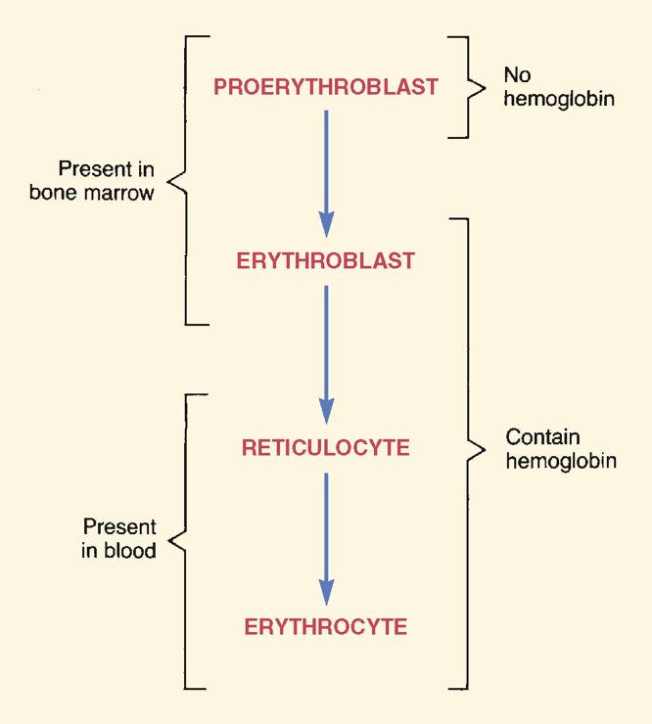
causes blood loss, hemolysis, bone marrow dysfunction and deficiencies of substances essential for RBC formation/maturation
bone marrow must be healthy, erythropoietin has to be present, iron must be available for Hb synthesis and vit B, folic acid etc. should be there too or else anemia
IRON DEFICIENCY: most common nutritional deficiency
biochem and physio iron: metabolic functions: 70-80% of iron is in Hb and 10% in myoglobin/iron-containing enzymes
fate in the body (2nd pic)
uptake and distribution: life cycle of iron beings w/ uptake of iron into mucosal cells of small intestine
cells absorb 2%-20% of dietary iron
following uptake, iron can either undergo storage in form of ferritin, or unerdgo binding to transferrin for distribution in the body
utrilization and storage: iron bound to transferrin has 4 fates
majority = taken up by cells of bone marrow to go with Hb
small amounts taken up by liver for storage, some iron in plasma taken up by muscle for production of myoglobin and other is taken up by tissues for production of iron-containing enzymes

after Hb is made, iron goes back to circulation as a component of Hb in RBCs, when RBC dies iron goes to plasma bound to transferrin and cycle again
Elimination: most excretion is via bowel; iron in ferritin lost as mucosal cells slough off and iron also enters bowel in bile
small amounts excreted in urine/sweat
blood loss=loss of Fe
Regulation of Body Iron Content: excessive Fe ctrlled by iron uptake: as body stores rises, uptake of iron declines and vice versa

Daily requirements: depends on rate of RBC production
for children: relatively high for growth, but adults is relatively low, women need more iron than men
Dietary sources: available in animals and plants especially the liver, egg yolk, brewer’s yeast and wheat germ
high iron foods: muscle meats, fish, fowl, cereal grains, beans and green leafy veggies
low iron foods: milk and non-green veggies

Iron deficiency: causes, consequences and diagnosis
Causes: iron deficiency results when = imbalance b/n iron uptake and iron demand
imbalance usually results from increased demand
causes of increased iron demand: blood volume expansion during prego, BV expansion dring infancy and early childhood and chronic blood loss from GI or uterine origin
if from iron uptake: usually caused by gastrectomy and sprue (disease of intestinal malabsorption)
Consequences: anemia (RBC become small and pale-microcytic and hypochromic-)
reduced O2 carrying capacity of blood results in fatgue, pallor of skin and mucous membranes
if tissue O2 is compromised tachycardia, dyspnea and angina may result
iron deficiency in young children can cause developmental problems; school-aged: can impair cognition
diagnosis: pale and small RBS , other tests for reduced blood lvls, decrease iron lvls, increase iron-binding capacity

Oral iron preparations I: iron salts: ferrous salts (absorbed more rapidly than ferric salts) and carbonyl iron used most often (gluconate/fumarate)
ferrous salts all equally effective,
ferrous sulfate = least expensive, used to traet iron deficiency anemia; preferred drug for preventing deficiency when iron needs cannot be met by diet alone
significant adverse effect of ferrous: nausea, pyrosis (heartburn), bloating, constipation and diarrhea
oral iron preps peptic ulcers, regional enteritis and ulcerative colitis
oral iron can cause dark green/black stools; large amounts of iron is toxic
children: early symptoms: vomiting diarrhea and shock then followed by gastric necrosis, hepatic failure, pulmonary edema and vasomotor collapse
if plasma lvl is high, lower with deferoxamine, oral drug (deferasirox) used for pts with chronic iron overload caused by blood transfusions

Oral prep II: Carbonyl iron: pure elemental iron in form of microparticles
good bioavailability, same effects as iron salts, less toxic and less risk for children to poisoning
Parenteral iron I: Iron dextran: rate of response is equal to oral iron, it is very dangerous
fatal anaphylactic rxns can occur; reserved for pts with clear diagnosis of iron deficiency where oral iron is ineffective
used also when blood loss is so great that oral can not be absorbed fast enough
injectable E and CPR should be used
Parenteral iron II: Na-Ferric Gluconate complex, iron sucrose & ferumoxytol: alternatives for iron dextran for parenteral iron therapy
risk of anyphylaxis is low, used to treat Fe deficient anemia in pts w/ chornic kidney disease undergoing hemodialysis

Guidelines for treating iron deficiency: assessment: cause of deficiency must be determined
routes of admin: oral, IV and IM; oral = preferred b/c it is safer and just as effective as others
duration of therapy: oral iron should be continued until Hb lvls = nrml (1-2 months)
therapeutic combos: anti-anemic agents combo should be avoided cause they can confuse interpretation of hematologic responses

VITAMIN B12 DEFICIENCY: causes anemia and injury to NS
vit B admin can reverse anemia, neurlogic dmg = longer to repair and never fully resolve sometimes
can also cause GI effects, impaired production of WBC and platelets and some psychiatric/neurological illnesses
Biochem/physio of Vit B12: metabolic function: vit B essential for synthesis of DNA, required for growth and division of all cells
vit B helps catalyze convers of folic acid to active form; active form participates in severeal rxns for DNA synthesis
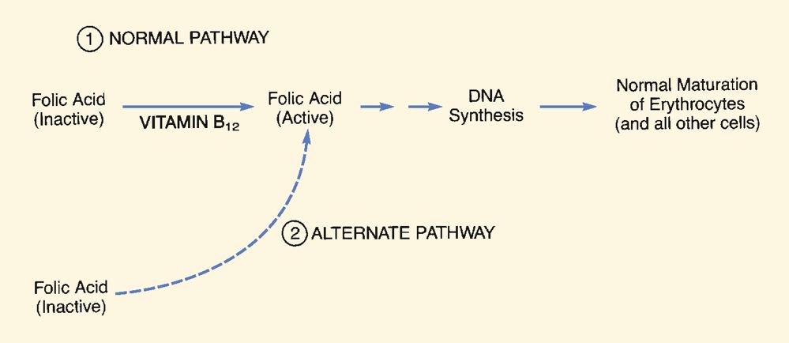
large amounts of folic acid can be activated by alternate pathway that = independent of Vit B (bypasses metabolic block caused by B12 deficiency)

Fate of Body and Daily requirements: need intrinsic factor for efficient absorption of B12
this causes vitB to go into liver and be stored, excertion takes place very slowly
years required for b12 deficiency to dvlp
dietary sources: consuming animal products (liver and diary products)
older ppl cannot absorb vit B in foods very well so need supplements

Vitamin b12 deficient causes, consequences and diagnosis
Causes: impaired absorption, rarely insufficient diet; impaired absorption occurs secondary to lack of intrisic factor
when caused by absensce of intrinsic factor called perniicious anemia (b/c back in the day, no effective therapy)
but today it can be managed
consequencecs:: megaloblastic anemia large numbers of megablasts (large erythroblasts) are in bone marrow and macrocytes (larged RBCs) appear in blood
anemia cause of death from b12 deficient; anemia produces peripheral and cerebral hypoxia
<3 failure/dysrhythmias most frequent cause of death
can cause neurologic dmg by demyelination of neurons (spinal cord and brain usually); early manisfestations: paresthesias of hands and feet and reduction in deep tendon reflexes
late-dvlping responses: loss of memory, mood changes, hallucinations and psychosis
vit B12 deficient leading to infection and spontaneous bleeding
diagnosis: measure of B12 content and schilling test (measures b12 absorption)

FOLIC ACID DEFICIENCY:
TABLE 55-4 Vitamin B₁₂ Deficiency Versus Folic Acid Deficiency
 | Vitamin B₁₂ Deficiency | Folic Acid Deficiency
Usual cause | Vitamin B₁₂ malabsorption from lack of intrinsic factor | Low dietary folic acid
Primary hematologic effect | Megaloblastic anemia | Megaloblastic anemia
Neurologic effect | Damage to brain and spinal cord | None*
Diagnosis | Low plasma vitamin B₁₂; low B₁₂ absorption (Schilling test) | Low plasma folic acid
Treatment (usual route) | Cyanocobalamin (IM) | Folic acid (PO)
Usual duration of therapy | Lifelong | Short term
Dietary sources of folic acid: present in all foods (liver, peas, lentils, oranges, whole-wheat prods, asparagus, beets, broccoli and spinach and grain products
Folic acid deficiency: causes, consequences and diagnosis
Causes: poor diet and malabsorption secondary to intestinal disease
alcoholism (acute or chronic) is most common cause
sprue: intestinal malabsorption syndrome that decreases folic acid uptake (doesn’t block absorption entirely)
doesn’t injure NS but same effects as b12 deficiency
folc acid deficiency early in prego can cause neural tube defects (spina bifida)
pts with megaloblastic anemia should know diff b/n folic acid/b12 deficiency as cause by comparing plasma lvls of folate and b12
Warning: large doses folic acid can correct hematologic consequences of b12 deficiency so it masks that b12 deficiency still exists
does not treat neurologic dmg so may allow dvlpmnt of irreversible dmg to NS **SEE STUDY TIPS**

Chapter 56: Hematopoeitic Growth Factors
hematopoiesis process which the body make RBCs, WBCs and platelets
regulated by hematopoietic growth factors (hormones that stimulate proliferation and differentiation of hematopoietic stem cells and enhance function of those cells
therapeutic applications: acceleration of neutrophil and platelet repopulation after cancer chemo, accerlation of bone marrow recovery after bone marrow transplant. And stimulation of erythrocyte production in pts w/ chronic renail failure.
TABLE 56-1 Nomenclature for Hematopoietic Growth Factors
Biologic Name | Generic Name
Erythropoietic Growth Factors  Erythropoietin | Epoetin alfa  Darbepoetin alfa (LA)  MPEG–epoetin beta (VLA)
Leukopoietic Growth Factors  Granulocyte colony-stimulating factor (G-CSF)  Granulocyte-macrophage colony-stimulating factor (GM-CSF) | Filgrastim  Pegfilgrastim  Sargramostim
Thrombopoietic Growth Factor  Interleukin-11 | Oprelvekin
ERYTHROPOIETIC GROWTH FACTORS: aka erythropoiesis stimulating agents, stimulate produc of RBCs
can cause risk of stroke, <3 failure, blood clots and MI; cancer pts shorten time to tumour progression and reduce overall survival
Epoetin Alfa (erythropoietin): admin IV or SQ
physio: natural erythropoietin = hormone produced by kidney; in response to anemia/hypoxia circulating RBC lvls increase
erythropoietin found in brain, bone marrow, liver, <3, kidney, uterus, tests and BV
actions of hormone: angiogenesis and maintenance of cellular integrity
therapeutic uses: elimantes need for blood transfusions (which needs hospitalization)
anemia of chronic renal failure, hiv infected pts, chemotherapy induced anmeia
anemia in pts facing surgery + predeposit blood
adverse effects/interactions: well tolerated, no srs allergic rxns; significant effect is hypertension, no drug interactions
other cardiovascular events: increases cardiac arrest, HF, thrombotic events (stroke/MI) and death
autoimmune pure RBC aplasia: no RBC precurser in bone marrow, rare
warnings!! Dosage should be @ lowest needed to gradually rise Hb lvls (>120gm/L)
ESAs can accelerate tumour progression and shorten life in certain cancer pts
preoperative pts use this to reduce need for RBC transufsion can increase risk of deep vein thrombosis for pts who were not given antocoagulant

Darbapoetin Alfa (erythropoietin, long acting) aka novel erythrocyte stimulation protein, long-acting analog of epoetin
cleared more slowly than epoetin (longer ½ life)
same adverse effetcs and monitoring and warnings as epoetin
Methoxy polyethylene glycol-epoetin Beta (very long acting)
acts on erythroid progenitor cells to stimulte production of RBVS, half liffe 6x darbapoetin and 27x of epoetin
can be given ½ a month; adverse effects, warnings and monitoring/admin is similar to other ESAs

LEUKOPOIETIC GROWTH FACTORS: stimulate prod of leukocytes: 3 preps filgrastim, pegfilgrastim and sargramostim
Filgrastim (granulocyte colony-stimulating factor) produced by recomb DNA, identical in structure/action to human granulocyte colony-stimulating factor (naturally occuring hormone)
used for elevation of neutrophil counts in cancer pts and treatment of severe chronic neutropenia
physio: acts on cells in bone marrow to increase neutrophils, enhances phagocytic and cytotoxic actions of neutrophils; fight against infection and cancer
therapeutic uses: pts undergoing myelosuppressive chemo: reduce risk of infection in pts going thru cancer chemo since anticancer drugs suppress production of neutrophils
severe chronic neutropenia: effective treatment for congenital neutropenia (kostmann’s syndrome) severe infections
pharacokinetics: IV//SQ, canot use orally cause detroy GI tract
adverse effects: no DDIs, bone pain and leukocytosis; can increase WBCs
Pegfilgrastim (long-acting) 17h half life, easier to use, expensive
Sarframostim (granulocyte macrophage colony stimulating factor): identical in strcture/actions to human kind; expensive, used for prolonging survival times for pts in whom bone marrow transplant = failed to take and reversing neutropenia in HIV pts caused by antiretroviral drugs increaseing neutrophil counts and reducing incidence/severity of infections in pts with aplastic anemia

THROMBOPOETIC GROWTH FACTOR: stimulate prod of thrombocytes (platelets); oprelvekin only one used, recomb DNA, identical in structure/action to human interluekin-11; given to pts undergoing myelosuppressive chemo ti minimize thrombocytopenia
adverse effects: fluid retention by kidney, dyspnea, cardiac dysrhythmias, severe allergic rxns, sudden death
DRUGS THAT MIMIC HEMATOPOIETIC GF/ENHANCE THEIR ACTIONS
Romiplostim and eltrombopag: similar to oprelvekin, incresae platelet production in pts with idiopathic thrombocytopenic purpura (characterized by low platelet counds secondary to immune-mediated platelet destruction and impaired platelet production
symptoms: easy bruising, superficial bleeding,
glucocorticoids, iv immunoglobulins inhibit production of antiplatelet ab

plerixafor: used in conjuction w/ G-CSF to incresae harvest of hematopoietic stem cells prior to bone marrow ablation w/ chemo in pts w/ multiple myeloma/non-hodgkin’s lymphoma

