Chapter 2: Business Process, Management, and Decision Making

Running Case
- Josie is trying to improve his grandparents’ coffee shop to compete with franchise coffee shop across the street. He found that free wifi will bring more younger customers. Then he found good router and the benefits of having wifi provided to customers.

- How Did This Stuff Get Here?
  - Hundreds – if not thousands – of different processes successfully interacted just to bring together a muffin, coffee, and you.
  - They had to work in such a way that all the companies and people covered their cost and earned a profit.
  - All this activities come through the interaction of business processes.
  - Understanding business processes is critical to understanding the information systems that support them. (Business processes are central to what every organization does.
- What Is a Business Process?
  - Business Process (Business System): series of tasks or steps designed to produce a product or service
  - Many organizations use ERP (Enterprise Resource Planning) to support their primary business processes.
  - Sales, purchasing and inventory management often consider part of an overall “supply chain” for an organization.
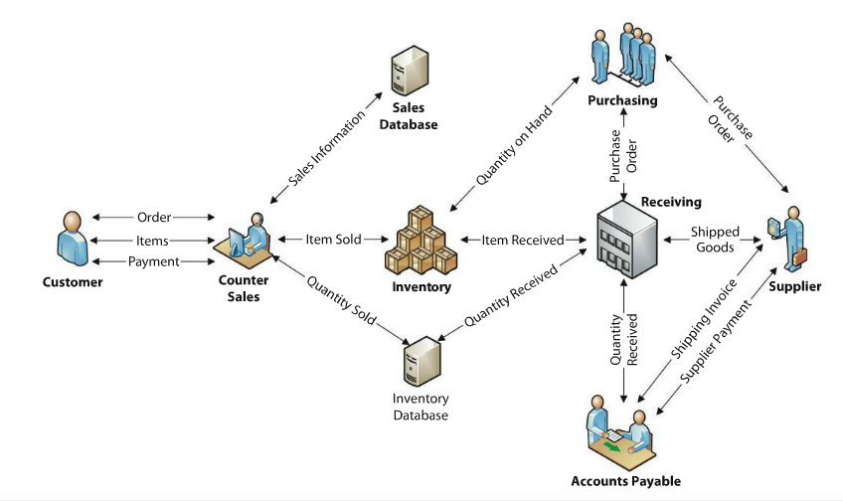
  - Figure 2-1 : Model of an Inventory Management Business Process.
(It does NOT show the causes)

  - Business Process: Management processes, manufacturing process, sales processes, and customer support process.
  - The goal of this process is to ensure that there is enough inventory to fulfill customers’ requests while, making sure there is not too much inventory.
  - Inventory management process works to balance the demands from customers with the inventory purchased from suppliers.
  - Inventory management system supports the process of collecting information. (Inventory database keeps track of what the customers have ordered and the current inventory.)
  - When good in stock hits some point (often called Reorder Point), the system advise the manager to order new supplies.
  - To order new inventory, the manager creates a Purchase Order which lists the items ordered and quantity desired.
  - Purchase order sent to suppliers => suppliers ships goods along with shipping invoice => They check the goods => Place it in inventory => update the database => Pay the invoice

  - DFD – Dataflow Diagram
  - Understanding, modeling, and redesigning business processes are a big part of what business analysts do.
  - System Analysis and Design: Modeling and designing activities.
    - Goal: to develop and understanding of how an organization works.
- What Are the Components of a Business Process?
  - Activities
    - Consist of purely manual activities, be automated or controlled by computers, or be a combined of manual and automated activities.
  - Resources
    - Items of value (Have value in the process
    - Ex.) milk, person working, cheque, customers’ money
  - Facilities
    - Structures used within the business process (It may be resources)
    - Ex.) Factories, equipment, trucks, etc. (In digital resources, it might include inventories and databases)
  - Information
    - To determine how to transform the inputs they receive into the outputs they produce.
  - Many businesses have different terms and definition
    - Ex.) Repository = facility, Business item = Information
  - These differences and inconsistencies can be problematic, therefore, software industry standards organization, Object Management Group(OMG), created a standard set of terms and graphical notations for documenting business processes.
  - Standard – Business Process Modeling Notation (BPMN) provides four graphical elements that can be used to document a process.

- What Is Information?
  - Data: recording facts or figures. (Ex. Individual Wages)
  - Information:
    - knowledge derived from data (Ex. Average wages)
    - Also known as data presented in a meaningful context.
(Ex. The Jeff’s hourly wage is less than half of average wage)
    - Processed data – Processed by summing, ordering averaging, grouping, comparing, or performing other similar operations.
  - The fundamental idea of definition is that we do something to data to produce information.
  - Bateson defines information as a difference that makes a difference.
  - Characteristics of Good Information
      - All information is not equal: some information is better than others.
    - Accurate
      - Based on correct and complete data, and it has been processed correctly as expected.
      - Cross-check the information you are receiving.
      - Keep in mind that over time, information may lose its level of accuracy.
    - Timely
      - Produce the information in time for its intended use.
      - The development of an IS, timliness will be part of the requirements you will request. (Need to give appropriate and realistic timeliness needs)
      - Save data and processing them after a couple hours later may be much easier, cheaper, and sufficient for you needs. (or it might become useless)
    - Relevant
      - Information should be relevant both to context and to subject.
      - CEO(Chief Executive Officer) need information that is summarized to an appropriate level for the position.
    - Just Barely Sufficient
      - The higher you rise in management, the more information you will be given, and more information you will need to ignore (because of time). Therefore, the information should be sufficient, but just barely so.
    - Worth Its Cost
      - Information is NOT free; the costs of developing operating, and maintaining the system, and the costs of your time and salary for reading and processing the information the system produces.
      - There must be an appropriate relationship between the cost of information and its value.
- What Is the Role of Information in Business Processes?
  - Any time a good is moved or a service is provided, data and information are always created.
  - Moving a physical good may have new place, new, ownership, and modification. (Different/New data)
  - We do not always collect these information but we have the potential to do so if we need to.
  - If we bring these two items (Information and Data), we can generate information.
  - Business process generates information by bringing together important items of data in a context. (It is important because it lets us know when we need to make payments, helps us to keep track of what we have delivered or not delivered, and keeps our inventory up to date.

  - Business Process Management
    - Over time, if we keep collecting data, the process itself will generate information that can be useful for management and strategic decisions.
    - Byproduct of every business process is information about how the process can be improved.
    - Business Process Management (BPM): a field of management that promotes the development of effective and efficient processes through continuous improvement and innovation.
    - The information about the process provides that ability to better manage the process itself. The organization use tools, such as lean value map steaming, and process mapping tools, such as ARIS, to support their work on business processes.
    - Information is an important part of effective management.
- How Do Information Systems Support Business Processes?
  - Information systems are used by the activities in a business process, but the particular relationship varies among the processes.
  - The systems analysts and designers determine the relationship of activities to information systems.
  - What Does It Mean to Automate a Process Activity?
    - The outermost components, hardware and people, are both actors; they can take actions.
    - The software and procedure components are both sets of instructions.
      - Software is instruction for hardware.
      - The procedure is instruction for people.
    - The data form the bridge between the computer side on the left and the human side on the right.
    - Automated system: work formerly done by people who followed procedures has been moved so that computers now do that work by following instructions in software. (Moving from right to left side)
  - An Information System to Support counter Sales
    - Cashier uses IS (cash register) to record sales and make appropriate changes to the inventory database.
    - The designers of this IS decided to fully automate it because the casher’s job is a low-skill-level position with high turnover.
    - Turnover: the rate at which new employees arrive and existing ones depart.

  - An Information System to Support Payment
    - IS that supports the payment activity is mostly manual system.
    - Accounts Payable clerk receive both the quantity received and the shipping invoice as PDF file => they compares the quantity => payment authorization.
    - The designers of this system chose to leave it as a manual system because processing exceptions is complicated.
  - An information System to Support Purchasing
    - Person doing the purchasing has a personal computer that is connected to the computer that hosts the database => her computer runs an inventory application (queries the database and identifies item that are low in stock) => application produces a report that she reads periodically => she decides which items to order from which suppliers
    - The designers of this IS decided to balance the work between the computer and the human.
    - The three different information systems at the restaurant support the needs of users in the company’s various business processes – counter sales, payments, and purchasing.
- How Do Information Systems Support Decision Making?
  - Making decisions is central to managing organizations.
  - Information systems support decision making by providing the information – the raw material – for many decisions.
  - Decisions Vary by Level
    - Decisions occur at three levels in organizations:
      - Operational Decisions: day-to-day activities.
        - Uses Transaction Processing Systems (TPS)
      - Managerial Decision: the allocation and utilization of resources.
        - Uses Management Information Systems (MIS)
      - Strategic Decisions: broader organizational issues
        - Uses Executive Information Systems (EIS)
    - In general, the decision time frame increases as we move from operational to managerial to strategic decisions.
  - Decisions Vary by Structure
    - Levels of IS with two decision processes:
      - Structured Decision: there is an understood and accepted method for making the decision.
        - Ex. Allocating furniture and equipment to employees, weather forecasting
      - Unstructured Decision: There is no agreed-upon decision-making method.
        - Ex. Predicting the future direction of the economy/stock, weather

  - Supporting Decision Making
    - The decision type and decision-making process are loosely related: the operational level tend to be structured and decisions at the strategic level tend to be unstructured.
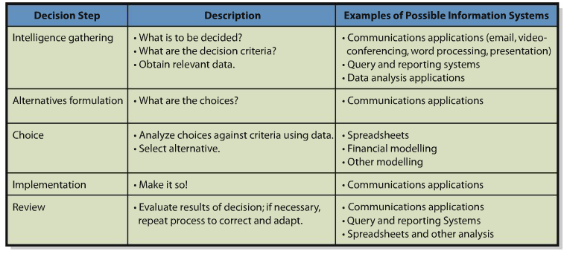
- What is Your Role?
  - The last component – people- which is the most important components.
  - Even if you have the perfect IS, if you do not know what to do with the information that it produces, you are simply wasting your time and money.

