Objectives:
- To define intentional and unintentional torts and where they are likely to arise in business activity
- To examine the standard of care required to preclude liability in negligence
- To assess the effect of apportionment on tort liability and its effect upon how damages are calculated

Introduction to Tort Law:
A tort is a civil wrong, other than a breach of contract, which causes harm to another person or to his or her property
Unlike a lawsuit in criminal court, a civil lawsuit seeks an award of compensation from the defendant for the wrong committed
Some conduct can be described as both a crime and a tort, and gives rise to two separate causes of action

Intentional Torts:
Knowingly and deliberately causing harm to another constitutes an intentional tort
Intentional torts may also be crimes, but in civil court a successful plaintiff receives an award of damages
Assault, battery, false imprisonment, defamation and trespass are examples of intentional torts

Assault and Battery:
An assault is a threat of violence or injury to another person, made intentionally
Battery involves unlawfully and intentionally touching or striking another person
Having acted in self defence may provide a defence against a claim of assault and battery, so long as the force used was not excessive
Another defence against battery is consent
False Imprisonment:
False imprisonment is the unlawful and intentional detention of another person without consent
The restraint need not be physical: an order from a security officer to stay on the premises based upon an allegation of theft is sufficient
A defence to a claim of false imprisonment is that the restraint was lawful rather than unlawful because a crime was committed

Defamation:
Defamation is intentional interference with a person’s reputation through the publishing of false statements about him or her
Libel is publication through the media
Accessibility to a foreign website will not, in itself, establish jurisdiction for a foreign court
Defences are truth, qualified and absolute privilege, fair comment and the plaintiff’s death
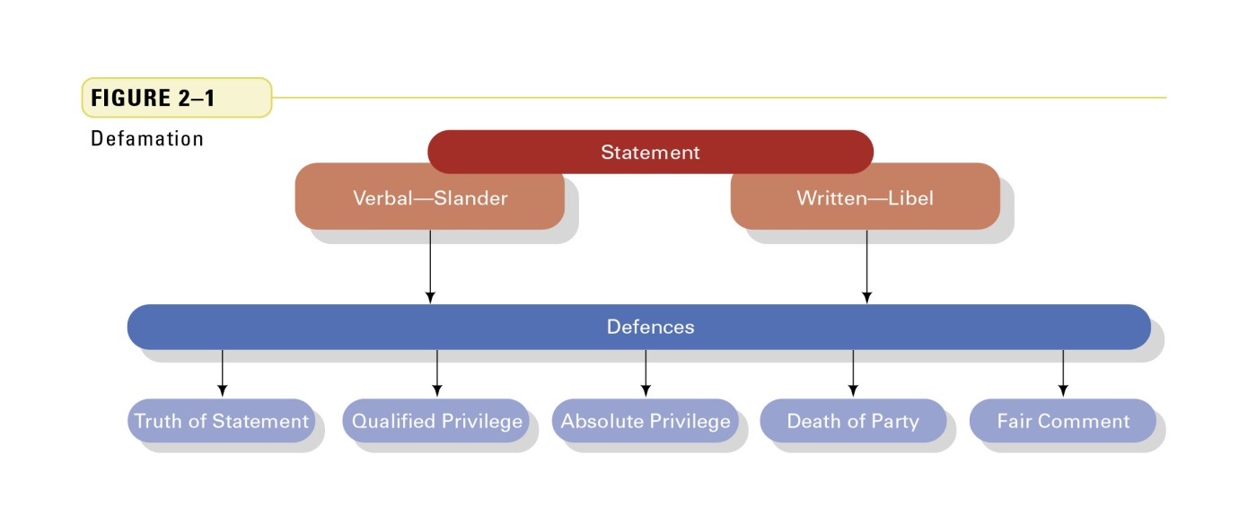
Trespass to Land and Goods:
Trespass is intentional interference, however slight, with a person’s right to exclusive possession of his or her property
It also occurs when someone who is on another’s land by invitation is asked to leave but refuses to go
Defences to a claim of trespass include being present on the property with permission or being present by accident (being pushed)

Nuisance:
Nuisance is activity by one occupier of property that unreasonably and substantially impairs a neighbour's use and enjoyment of his or her property
If the community as a whole will not be adversely affected, a court may issue an injunction; otherwise, it may award damages
Statutory nuisance with government land-use controls often replaces the tort of nuisance

Negligence: Duty of Care:
The unintentional tort of negligence occurs when someone carelessly or inadvertently causes harm to another person
A person’s right to act freely is counter-balanced by a duty, in the exercise of that freedom, to be careful not to injure one’s neighbor
Who is “a neighbour”? Anyone who reasonably and foresee ably could be affected by one’s acts

Negligence: Breach of Duty of Care:
The standard of care which one owes is determined by an application of the Reasonable Person Test:
“How would a reasonable person in the same circumstances as the defendant have behaved?”
If the defendant’s actions fall below the standard of care expected, the duty of care has been breached and the defendant may be liable for the plaintiff’s loss

Negligence: Causation and Remoteness:
The requirement of causation is addressed by asking the question “But for the conduct of the defendant, would the plaintiff’s injury not have occurred?”
The defence of remoteness then asks “Was it reasonably foreseeable and predictable that the defendant’s act would cause the plaintiff’s injury?”

Contributory Negligence and Willing Assumption of Risk:
The defence of contributory negligence determines the degree to which the plaintiff may be held responsible for his or her own harm
A court may apportion blame on a percentage basis, reducing damages accordingly
The defence of voluntary assumption of risk may negate a negligence claim if a plaintiff willingly participated in a dangerous sport

Other Unintentional Torts:
Occupier’s liability represents the duty of care owed by occupiers to people who enter onto their business or residential property
Most provinces and territories have enacted occupiers liability acts imposing the reasonable person standard of care on occupiers
Under the common law, varying standards of care are expected depending whether the entrant is a trespasser, licensee or invitee
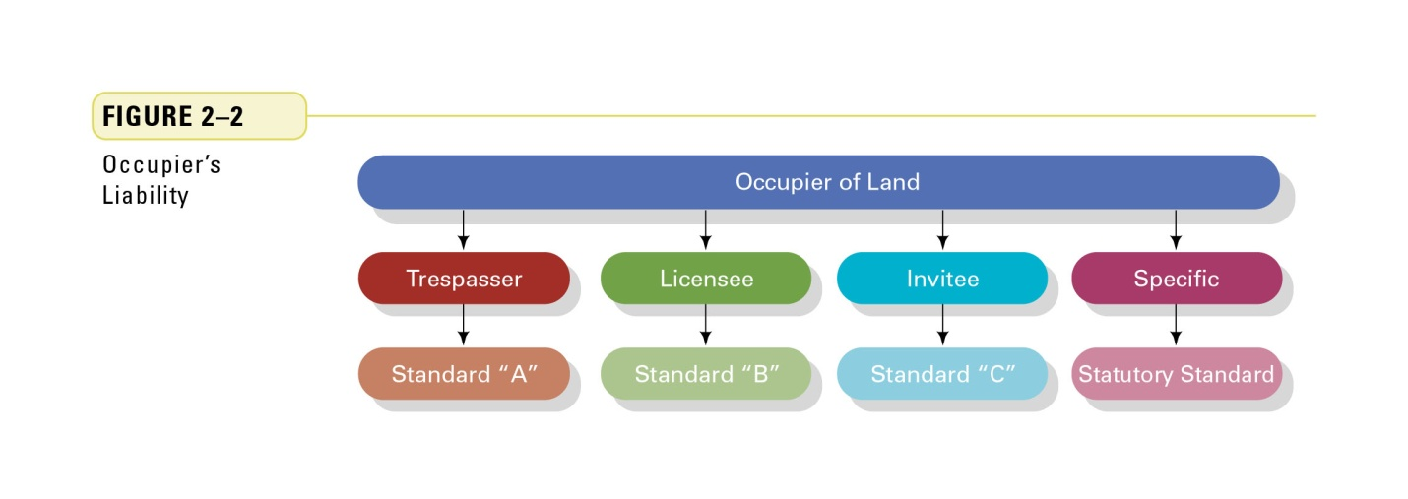
Other Unintentional Torts:
Vicarious liability arises when someone besides the individual who has committed a tort is liable, such as an employer or a partnership
Liability may be found if the tort occurred in the course of work being carried out for the benefit of an employer or partnership
For strict liability, the reasonableness standard is displaced by a strict responsibility for loss because the activity is inherently dangerous

Commercial Negligence:
Professional negligence arises when a professional is careless in the performance of a duty carried out for a client or patient
The standard of care expected of experts is established by the governing body of the relevant profession
It is described as the skill level of a reasonable person who is a qualified member of that profession

Negligent misstatements occur when an expert has been careless in the preparation of a financial statement or other report upon which a client or third party has relied
Foresee-ability determines the potential group of persons who may rely on the information
A defence of remoteness may arise from examining the intended use of the financial statement or report prepared by the expert

Manufacturer’s negligence places a very high standard of care upon manufacturers to ensure their products will not harm a consumer
The standard of care may require extensive testing, especially if the product will be used by children
Warnings of danger from improper handling and specific instructions for safe use may help a manufacturer avoid liability

Defences to Claims of Negligence:
A business or individual is not automatically liable for a client’s loss
An Act of God provides a defence if the loss is directly caused by a force of nature that no amount of care or skill could prevent
A waiver is a promise, usually in writing and brought to the attention of the person waiving the right, not to sue in the event that a contemplated injury occurs

A release precludes future legal action but offers compensation to the plaintiff as a settlement, without actually acknowledging liability for the loss
The Statute of Limitations requires plaintiffs to start their lawsuits within strict time periods before evidence is lost and memories fade
A lawful right to cause loss in the best interests of the public may exist for safety inspectors

TORT REMEDIES:
An award of damages is the remedy most commonly used to attempt to place the injured person in the position he or she was in prior to having suffered the injury or loss
The four types of damages include: special damages for specific losses usually established by receipts; general damages for the plaintiff’s pain and suffering; punitive damages to punish the defendant and deter others from egregious conduct; and nominal damages acknowledging a plaintiff’s right has been infringed

BUSINESS – RELATED TORTS:
Slander of goods or of title is a false statement by a competitor regarding the nature or quality of goods, or an allegation that goods are stolen or illegally imported
Fraudulent misrepresentation is a false statement that intends to deceive and induces the other person to enter a contract
Fraudulent conversion occurs when goods are acquired under false pretences such as by a cheque drawn on a non-existent bank account

RISK MANAGEMENT IN TORT LIABILITY:
Managers have a duty of care to attempt to foresee and preclude accidents
Workplace policies and procedures help minimize the risk
Inspection and quality control reduce the chance of defective products leaving the site
Open channels of communication with customers ensure quick recalls of products

SUMMARY:
Torts are civil wrongs that may be intentional or unintentional and are usually compensable by an award of damages
Carelessness rather than intent may cause the liability of individuals or groups such as professionals, manufacturers, occupiers, employers and partnerships
Liability may be apportioned according to the degree of fault on the part of the plaintiff

