1.1: THE COMPLEXITY OF THE MODERN MARKET
- A market economy is self-organizing
- “Self-interest, no benevolence, is the foundation of economic order.”
- Adam Smith (1723-1790)
- Responds to prices determined in open markets, collective outcome is coordinated.
- Main characteristics of market economy:
  - Self-interest: ppl pursue their own self-interest.
  - Incentives: ppl respond to incentives (ex. Buyer buys ↑when price↓)
  - Market Price and Quantity: determine free market
  - Institutions: all activities are governed by institutions created by government (ex. Private propriety, freedom of contract, rule of law)

1.2: SCARCITY, CHOICE AND OPPORTUNITY COST
- Economics is the study of the use of scare resources to satisfy unlimited human wants.
- Scarcity makes it necessary to choose, implies existence of cost.
- Opportunity cost OC measures the cost of obtaining a unit of one product in terms of the # of units of other products that could have been obtained instead.
- Production Possibilities boundary PPB shows all the combinations of goods that can be produced. Movement on curve requires reallocation of resources. Economic growth shifts the curve outward and makes it possible to produce more of ALL goods.
- FOUR economical problems that must be answered in all economies :
  - What is being produced and how? –resource allocation.
  - What is consumed and by whom? – who gets a lot, a little, and why
  - Why are resources sometimes idle? – macroeconomics
  - Is productive capacity growing? – macroeconomics

1.3: WHO MAKES THE CHOICES AND HOW?
- Circular flow of income and expenditure shows the interaction of (C&P) consumers and producers through goods and factor markets.
  - Individual consumers sell factor services to producers, earn income.
    - Decisions in effort to maximize their well-being or utility.
  - Producers sell g&s to individual consumers, earn income.
    - Decisions designed to maximize their profits.
- Modern economics are based on the specialization and division of labour, necessitates the exchange of g&s. Takes place in the markets and is facilitated by the use of money.
- Factors of Production (resources):
  - Land: all nature endowments (ex. Forest, minerals)
  - Labour: all mental and physical human resources.
  - Capital: all manufactured aids to production.
- Goods → tangible commodities Services → intangible commodities.

PRODUCTION (making g&s) →→→→→→ COMPSUMPTION (satisfy wants)
- The world economy is rapidly growing, driven by transportation and communication technology, transnational corporations like McDonalds.
- Markets used to consist of bartering (finding someone with double coincidence of wants)
- Money greatly facilitates s&t specialization and trade.

1.4: IS THERE AN ALT. TO THE MARKET ECONOMY?
- Types of economic systems:
  - Traditional: behaviour is based mostly on tradition
  - Command: most economic decisions are made by a central planning authority.
  - Free-market(market economy): most economic decisions are made by private households and firms (decentralized decision making)
  - Mixed: some economic decisions are made by firms and households and some by the government.
    - In practice, every economy is a mixed economy in the sense that it combines significant elements of all three systems in determining economic behaviour.
- The Great Debate: - Karl Marx disagreed with Adam Smith

- S.U & China followed Marx advice->Command econ.
- Government in the modern mixed economy:
  - Play an important role
  - Create and enforce imp. background institutions (private propriety)
  - Intervene to correct market failures
  - Redistribute income in the interest of equity.

2.1: POSITIVE AND NORMATIVE ADVICE
- Key to success of scientific inquiry lies in separating positive questions about the way the world works (matters of fact) from normative questions about how one would like the world to work.

2.2: ECONOMIC THEORIES
- Theories are designed to explain & predict what we see
  - Consists of a set of definitions of:
1. The variables to be employed

2. set of assumptions about how things behave

3. conditions under which the theory is meant to aply.
- Provide conditional predictions of the type “if one event occurs, then another will also occur.”
- ‘Model’ is used as a synonym for theory
- Organizes our thinking.

2.3: TESTING THEORIES
- Theories are tested by checking predictions vs. evidence.
- Use statistical analysis (distinction b/w correlation and causation)
- Discard some theories -> replace with demonstrably superior alternatives
- Most economic predictions involve casualty (requires adv. Statistical tech)

2.4: ECONOMIC DATA
- Index numbers express economic series in relative form.
- Value of index
in any given = Absolute value in given period x 100
period Absolute value in base period
- CPI : Consumer price index
- Graphed in three different ways:
1. Cross-sectional graphs : observations taken at same time.
2. Time-series graphs: observations on one variable taken over time.
3. Scatter diagrams: observations referred to specific points on two different variables

2.5: GRAPHING ECONOMIC THEORIES
- Functional relation can be expressed
1. In words
2. Schedule or table
3. Mathematically
4. Graphing
- Graph has positive slope of two variables both increase or both decrease.
- Graph has negative slope if one variable increases and other decreases.
- Marginal response (MR) of a variable gives the amount it changes in response to the change in the second variable.
  - When the var. is on the y-axis, its MR at ptA on the curve is measured by the slope of the tangent line.
- Some functions have max/min points, where the MR is zero.

3.1: DEMAND
- The amount of a product that consumers wish to purchase is quantity demanded.

- A flow expressed as so much per period of time.

- Determined by tastes, av. Household income, the product’s own price, price of other products, size of population, distribution of income among consumers, and expectations about the future.

Demand Curve:
Movement along the DC is caused by a change in the product’s price where as a shift in the DC is caused by a change in any of the other determinants of demand.
shifts…
- average income changes
- prices of other products change
- consumers’ tastes change
- the distribution of income changes
- population changes
- expectations about the future are revised

3.2: SUPPLY
What determines “quantity supplied”:
- the amount that some producers want to sell
- Flow expressed as so much per period of time
- Depends on the product’s own price, the cost of inputs, the $ of suppliers, gov. taxes or subsidies, the state of technology, prices of their products, and expectations about the future.
- Relationship b/w quantity supplied and price is rep. by a supply curve (show how much will be supplied at each market price)
-assumed to increase as the price of product increase, all other things held constant. Thus positively sloped!
Supply Curve: Shifts…
- the prices of inputs change
- technology changes
- the gov. imposes taxes or subsidies
- prices of other products change
- expectations about future are revised
- # of suppliers change
Movement along a SC is caused by a change in the product’s price where as a shift of the SC is caused by a change in any of the other determinants of supply.

THE DETERMINATION OF PRICE
Equilibrium price:
Price at which the quantity demanded equals the quantity supplied.
- At any price below the equilibrium -> excess demand occurs
- At any price above the equilibrium -> excess in supply occurs
Graphically, equilibrium occurs at the intersection point of both curves.
Price rises when there’s an excess in Demand; Price falls when there’s an excess of Supply.
-thus, the actual market price will be pushed toward the EP and once there won’t change until either the demand or supply curve shifts.

Comparative statics:
- determines the effects of a shift in either demand or supply.
LAWS OF DEMAND AND SUPPLY
- increase in demand raises both equilibrium price and equilibrium quantity; decrease in demand lowers both.
- increase in supply raises equilibrium quantity but lowers equilibrium price; decrease in supply lowers equilibrium quantity but raises equilibrium price.

4.1: PRICE ELASTICITY OF DEMAND
- Price elasticity of demand is a measure of the extent to which the Qd of a product responds to a change in its price. Represented by ‘n’, it is defined:
n= Percentage change in Quantity demanded
Percentage change in Price
- The % changes are usually calculated as the change ÷ by the average value. Elasticity is a positive number, and can vary from 0-infinity
- When E < 1, demand is inelastic. – the % in Qd is > change in price.
- The main determinant of PED is the availability of substitutes for the product. Any one of a group of close substitute will have a more elastic demand than will the group as a whole.
- Items that have few subs. In the short run tend to develop many subs. When the consumers and producers have time to adapt. ∴, demand is more elastic in the long run than in the short run.
- E and total expenditure are related in the following way:
- if E < 1, total expenditure is positively related with price; if E > 1, total expenditure is negatively related with price; if E = 1, total expenditure does not change as price changes.

4.2: PRICE ELASTICITY OF SUPPLY
- Elasticity of supply measures the extent to which the Qs of some product changes when the price of that product changes. Represented by ‘ns’, it is defined as:
ns = Percentage change in quantity supplied
Percentage change in price
- Supply tends to be more elastic in the long run than in the short run cuz it usually takes time for producers to alter their productive capacity in response to price changes.

4.3: AN IMPORTANT EXAMPLE WHERE ELASTICITY MATTERS
- Distribution of the burden of an excise tax b/w C&P depends on the relative elasticities of S&D for the product.
- Less elastic demand is relative to supply, the more of burden of an excess tax falls on the consumers. The more elastic demand is relative to supply, the more of the burden of an excise tax falls on producers.

4.4: OTHER DEMAND ELASTICITIES
- Income elasticity of demand is a measure of the extent to which the Qd of some product changes as income changes. Represented by the symbol ny,
ny= % change in quantity demanded
% change in income
- Cross elasticity of demand is a measure of the extent to which Qd of one product changes when the price of a different product changes. Represented by nxy,
nxy= % change in the quantity demanded of good X
% change in the price of good Y

5.1: THE INTERACTION AMONG MARKETS
- Partial-equilibrium analysis is appropriate when the (single) market being examined is small relative to the entire economy. Most common study in microeconomics
- General-equilibrium analysis is the study of all markets together.

5.2: GOVEERMENT-CONTROLLED PRICING
- Government price controls are policies that attempt to hold the price of some good or service at some disequilibrium value.
- At disequilibrium price, quantity exchanges is det. by the lesser of the quantity demanded or quantity supplied.
- A binding price floor is the set above the equilibrium price; excess supply
- A binding price ceiling is the set below the equilibrium price. Excess demand. Black markets.
- Seller’s preference and rationing (ie.coupons)

5.3: RENT CONTROLS: A CASE STUDY OF PRICE CEILINGS
- Rent control causes housing shortage that worsens over time. Sr is quite inelastic, and Sl is more elastic.

5.4: AN INTRODUCTION TO MARKET EFFICIENCY
- Demand curves show consumers’ willingness to pay for each unit of the product. For any given quantity, the area below the demand curve shows the overall value that consumers place on that quantity of the product.
- Supply curves show the lowest price producers are prepared to accept in order to produce and sell each unit of the product. This lowest acceptable price for each additional unit reflects the firm’s costs required to produce each additional unit.
- For any given quantity exchanged of a product, the area below the demand curve and above the supply curve (up to that quantity) shows economic surplus generated by the prod. and consumption of those units.
- Economic surplus in a market is maximized when quantity exchanged QE is determined by the intersection of the D&S curves. This outcome is said to be efficient.
- Policies that intervene in otherwise free and competitive markets – such as price floors, price ceilings, and production quotas – generally lead to a reduction in the total amount of economic surplus generated in the market. For this reason such policies are inefficient for society overall.

Learning Objectives:

The difference between marginal and total utility:
Marginal utility is the additional satisfaction obtained from the consumption of each additional item. As more items are consumed, the law of diminishing marginal utility states that the marginal utility for each additional item decreases.

Total utility is the sum of all marginal utilities for all items consumed. It is the total satisfaction received from the consumption of all goods.

Utility-maximization

Consumers adjust their expenditures so that the marginal utility per dollar spent is equal for all products.

Mux = Muy Mux = Px
Px Py Muy Py

Effects on price change

Substitution effect is the change in quantity demanded due to a change in relative prices, holding real income constant. Substitution effect is always negative because as P↓Q↑ or P↑Q↓: works in opposite way.
Income effect is the change in quantity demanded due to a change in purchasing power (change in purchasing power is caused by a change in relative prices, as P↓ it’s as if you have more money), holding new relative prices constant.

Consumer surplus

Difference between the total value of all items and the consumer’s total expenditure on the items. If the consumer values the product more than what they pay for it then consumer surplus occurs.

Consumer surplus = (max amount willing to pay) – (price you actually pay)

Total value is the area under the demand curve and to the left of the quantity purchased. Consumer surplus is the area under the demand curve and above the market price. Consumers buy items up until the marginal value of that unit equals the market price.

Paradox of Value

Confusion between the total value and marginal value. Mistake TU for MU!!

Ex. Water has a high total value but is so plentiful that its price is low and therefore generates a big consumer surplus. Diamonds have a smaller total value but because they are scarce they have a high price and therefore consumer surplus is not very big.

Indifference Curves (adds third decision (taste, preferences))

Eqt’n of line = ΔX(MUx) + ΔY(MUy)

Slope = ΔY/ΔX = - MUx/MUy = MRS

MRS: marginal rate of substitution

- All combinations of x and y that yield a given level of utility (ΔTU = 0)
- Any point above ID curve is preferred to any pt along the curve
- Any point on the curve is preferred to any pt below the curve
- Cannot cross
- Convex to origin because
- Infinite number of increasing outward

Budget Line

Eqt’n of line = PbQb + PpQp = Y
= expenditures = income

Slope of BL= - Px/Py = ratio of prices =OC= Marginal rate of Transformation

- Change in money income = BL shifts = proportional change in both prices

(with Y constant)
- Change in relative price = rotates

Total Utility Maximization
- Subject to constraints of BL (Y and prices)
- Attain highest indifference curve, given income and pries
- ID-curve tangent to BL
- MC = MB U given up = U gained
- MRT = MRS

Organization of Firms

Single proprietorship : single owner (unlimited liability, difficult to transfer

ownership)

Ordinary Partnership : Share profits, both have unlimited liability for each

other, harder to manage)

Limited Partnership : Shareholders only responsible for what they put in.

Limited Liable partnership: like LP but may be involved in business.

Corporation : own identity, owners not liable

State-owned corporation : own by government

Non-profit organization : revenue=cost

Firms are financed by
- Financial (work) capital : money firms raise to carry on business
- Equity Financing : GRANTING share of control of company for GIFT $

Dividend = return on capital

Share = share of control of company

K-gain = increase in market value of share

Undistributed profits = profits used to finance investment
- Debt Financing : BORROWING money

Debtor = borrower

Creditor = lender

Principle = original amount borrowed

Interest =rate on loan

Redemption Date = date to repay principle

Term = period b/w date of loan and redemption date

Difference between accounting and economic profits

Accounting profits = TR – explicit cost (ie. Labour, rent, capital)

= TR – sticker price

Economic profits = TR – (explicit + implicit cost (ie. OC time and capital))
= TR – TC

Relationship b/w TP, AP, MP and LDR

Total Product (TP) = total amount produced by a firm during a time period.

Average Product (AP) = TP divided by # of units of variable factor used.

Marginal Product (MP) = Δtotal output that results form using add. unit of v.f

Law of diminishing returns (LDR) = hypothesis that if ↑Q of a variable factor are applied to a given quantity of fixed factors, the MP of v.f. will eventually decrease

Costs in SR
TYPE OF COST | SYMBOL | DEFINITION

Total Costs

Total Fixed Costs

Total Variable Costs

Total Costs

Average Costs

Average Fixed Costs

Average Variable Costs

Average Costs

Marginal Costs

Marginal Fixed Costs

Marginal Variable Costs

Marginal Costs

- TC = TFC + TVC
- AC = AFC + AVC
- MC = 0 + MVC (MFC=O)

Short Run Cost Curves

Mother of All Curves = TP Father of All Curves = TC

AP and MP = brothers AC and MC = sisters

BASIC SHAPE:

AC = cup shaped (relatively steep)

AVC = saucer shaped (little flatter,

little lower, doesn’t include TPC)

MC = spoon shaped = spoon and handle

SHIFTS in SR Cost Curves:

Changes in Factor prices:

↑P_{inputs} shift up

Changes in Fixed prices :

↑plant size shift down and ↑capacity

**assuming revenue is constant

Profit maximization

Equate the marginal product per dollar spent on all factors

MP_{K} = MP_{L}

P_{K} P_{L}

If marginal product per dollar is not equal for all factors, there are possibilities that will reduce costs (for a given level of output)

Profit-maximizing firms

Must not only be technically efficient (least number of inputs) but also productively efficient (least cost)

Profit Maximization = Cost minimization = Efficiency

Relationship b/t Short Run and Long Run Cost Curves

LR: minimum cost of producing each level of output (productively efficient), given 1. Factor prices, and

2. when all factors can vary

SR: minimum cost (per unit cost) of producing each level of output,

1. given factor prices, and

2. When at least one variable is fixed

SHAPE OF LRAC – firm (shifts as industry expands)

Reasons

Increasing Returns to Scale = decreasing costs

- bulk discounts

- large fixed costs that remain constant as Q increases

Constant returns to Scale = Constant costs

Decreasing returns to scale = increasing costs

- middle management mush
- Alienation of workforce (raise average costs)

LRAC is the “envelope” of all SRAC curves

Each pt. on the LRAC curve has associated with it a SRAC, the pt of tangency being OPTIMAL level of the fixed factor

SRAC min = LRAC min

LR SUPPLY CURVE – industry

- joints all points of “demand induced shifts in SRS”
**demand shift causes supply shift**

- if small increase in demand and large increase in supply, LRS-curve will be downward sloping (shape determined by shifts in LRAC)

Economies of Scale of Firm vs. Decreasing Costs Industry

Very Long-Run = changes in technology

Technological change Productivity

When faced with increasing costs of inputs firms must -

Now viewed as endogenous – either substitution away (LR)

or innovate away (VLR)

Effect of Technological Change = LRAC shifts down (production cheaper)

ISOQUANTS (production decisions)

Comparable to indifference curve analysis

Three decision variables:
- Total Cost TC
- Price of Factors
- Output

ISOCOST = Equal Cost Line ISOQUANT = Equal Quantity Line

(like budget line) (indifference curve)

= all possible combination = all possible combinations

of factors available with of factors of production that

a given total costs. yield a given level of output

Condition for Profit Maximization (or Cost min.)

ISOCOST tangent to ISOQUANT

MP_{K} = MP_{L}

P_{K} P_{L}

A marker is said to have a competitive market structure when its firms have little or no market power. The more market power the firms have, the less competitive is the market structure.

Perfectly competitive market is a market where there is no need for individual firms to compete actively with one another because none has any power over the market. Can only affect profits by change their output quantity or own production cost.

Difference b/w AMEX and wheat farmers is the degree of market power.

Key Assumptions of the Theory of Perfect Competition
- Many Sellers: - one firm more or less does not affect industry supply

- Firm’s LRAC-min (MES) small relative to industry

- Industry supply is fairly constant
- Selling a homogeneous good:-perfect competition (No mkt power)
    - seller has no control over price bc many sellers selling
    - firm demand is horizontal (perfectly elastic)
    - identical goods are very rare, thus PC very rare
- Free Entry and Exit:- no “barriers to entry” (BTE)
    - entry/exit of new/old firm into industry is relatively cheap
    - LRAC min eventually attained

How to Derive a Competitive Firm’s Supply Curve
- Even though the D-curve for the entire industry may be neg. sloped, each firm in a PC market faces horizontal D-curve because variations in the firm’s output have no effect on price.

DEMAND CURVE

Competitive Industry Competitive Firm

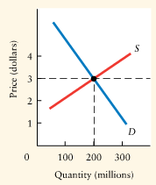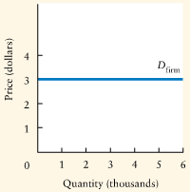

- TR = p*Q AR = TR/Q = p MR = ∆TR/∆Q
- If the mkt price is unaffected by variations in the firm’s output, the firm’s d-curve, its AR-curve, and its MR-curve all coincide in the same horizontal line.
- For a firm in PC, price = MR = AR.
- Revenues for a Price-Taking Firm

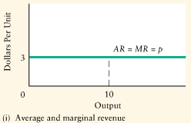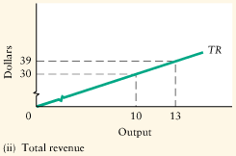

Determine Whether Competitive Firms are Making Profits or Losses in the Short Run

Four Steps to Eternal Bliss:
- MR = MC, to find Q1
- TR = P1*Q1
- TC = AC1*Q1
- Economic Profit = TR – TC = (P1 – AC1)*Q1

Normal Profit is when economic profit = 0

Economic Loss is when economic profit ≤ 0

Shut Down Point is when economic profit ≤ 0 BUT, TR = TVC
- Profit Maximization for a Competitive Firm
- 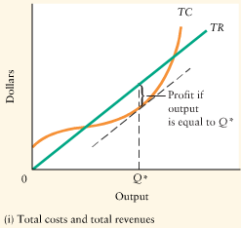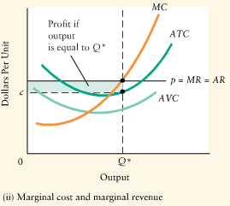

Short-Run Supply Curves

Competitive Firm
- Given by the portion of the MC-curve above its AVC-curve.
- For prices below AVC, the firm supplies zero units
- For prices above AVC, the firm supplies at a level of output equal to MC

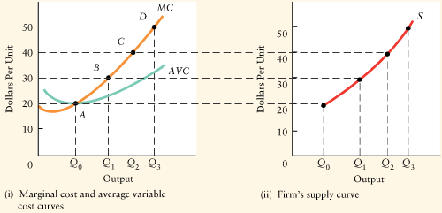

Competitive Industry
- The horizontal sum of the MC-curves of all firms in the industry

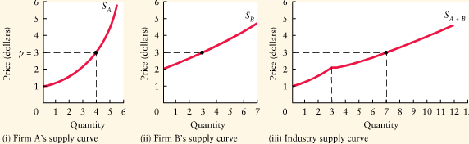

SR Equilibrium in a Competitive Market
- Industry in SR equilibrium, qdemanded = qsupplied, and each firm is maximizing profits given the market price.

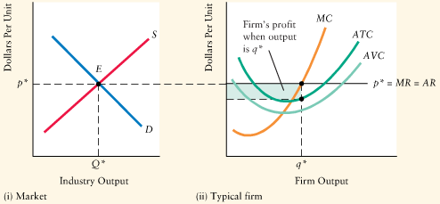

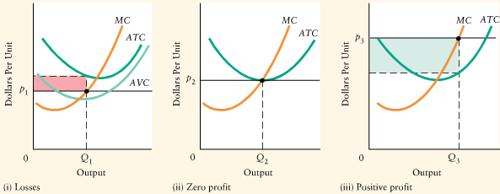

The Role played by Profits, Entry, and Exit in a Competitive Industry’s Long-run Equilibrium
- Profits in a competitive industry are signal for the entry of new firms; the industry will expand, pushing price down until profits fall to zero.

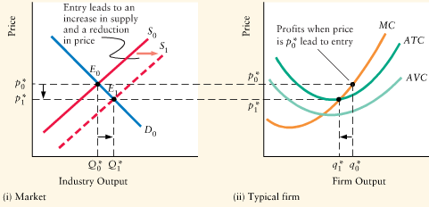
- Losses in a competitive industry are signal for the exit of firms; the industry will contract, driving the market price up until remaining firms are just covering their total costs (includes OC)

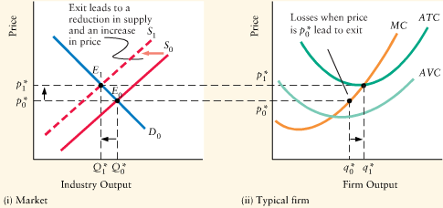

Sunk Costs and the Speed of Exit
- The longer it takes for firm’s capital to become obsolete or too costly to operate, the longer firms will remain in the industry while they are earning economic losses.
- If firm’s costs are mostly sunk costs, exit in loss-making indstries is slow.
- If firm’s fixed costs are mostly non-sunk costs, exit will be faster.

Long-Run Equilibrium
- The LRE of a comp. industry occurs when firms are earning zero profits
- CONDITIONS: 1. Market price = MC

2. p = SRAC min; must be making normal profits

3. p = LRAC min; each firm cannot lower costs in LR
- For a comp. firm to be maximizing its LR profits, it must produce at MES
- Each firm’s LRAC is the lowest cost attainable, given limits of tech & factor prices

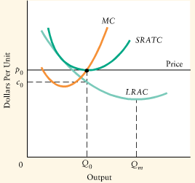

Changes in Technology
- Older firms, with higher costs, continue to exist;

The older firms continue operating as long as TR covers AVC.
- Price is eventually determined by ACmin of new plants;

Older firms find their R over AVC falls as newer firms force price down.
- Old plants ‘mothballed” when they are “economically obsolete”;

p<AVC, plant should be closed, even if not physically obsolete.

Declining Industries
- = industry in LR equilibrium suffers decreasing demand
- ex. Decrease in demand for glass beverage containers (to plastic)
- Response of firms: try to cut costs, no new equipment, LR losses
- Response of Government: subsidize inds to save jobs, delay decline. G should facilitate change with retraining a temporary income support.
- Unlike a perfect competitive firm, a monopolist faces a neg. slope d-curve
- The monopolist’s MR < selling price of output. Thus, MR is below d-curve
- Monopolist’s are PRICE-SETTERS
- Nothing guarantees that a monopolist will make positive profits in the SR, but if it suffers persistent losses, it will eventually go out of business.
- For a monopolist, there is no unique relationship b/w market price and quantity of output supplies. Therefore do not have a supply curve.
- A PC industry produces a level of output such that price=MC, monopolists produce a lower level of output, with price>MC
- A monopolist restricts output below the competitive level and thus reduces amount of economic surplus generated in the mkt. The monopolist ∴ creates an inefficient market outcome.
- If mono. profits are to persist in LR, entry of new firms mustbe prevented
- In competitive industries, profits attract entry erodes profits. In monopolized industries, positive profits can persist as long as there are effective entry barriers.

Short-run Assumptions:
- ONE seller ; FIRM = INDUSTRY (neg. d-curve)
- Selling an unique good
- Entry and Exit IMPOSSIBLE

Notes On Marginal Revenue:
- For monopoly, MR<price
    - To sell one more product, monopolist must drop price
    - - That lower price will apply to all quantity sold
    - - Thus extra unit will have a lower MR than the previous

- The monopolist will never produce where e<1
    - When TR ↓, e<1 and MR<0
    - Monopolists will not produce if MR is negative
- MR falls twice as steeply as AR
    - D=AR
    - P=a-bQ and TR=Q*P ∴ TR=aQ-bQ²
    - MR=dTR/dQ=a-2bQ

GRAPHS

RULE #1: Monopoly will NOT produce where e<1

RULE #2: A profit maximizing monopolist WILL produce output where it covers its day-to-day expenses.

RULE #3: Profit maximizing monopolist WILL produce output where MR=MC
Economic Profit: D-curve above AC

Normal Profit: D-curve tangent to AC
Economic LOSS: D-curve below AC

NON profit MAX does not imply a LOSS ex. BC hydro has option to product b/w Q1 and Q3, may want to decrease pollution by cutting back production, ∴ no carbon taxes, ∴ cut back on politicians on their backs

Trading off some profit for policy reasons

LongRUN equilibrium
GRAPH

BTE permits LR economic profits, act as a signal

-Natural BTE:
1 - Economies of Scale and Scope: Natural Monopoly = marker Demand conditions only allow one MES firm (tentacle industries: always cheaper to have one set rather than two)

2 – Startup Costs : new guy at cost disadvantage!

- Artificial BTE

- created by government (ex. Patents, franchises, charters, predatory pricing, red tape, environment regulations, licenses, etc)

EFFECT:
- Profits attract entry, BUT BTE permit LR economic profits

Cartels

= voluntary association of producers which agree to act as a monopoly to maximize joint profits (ex.DeBeers)
= sell less for more! (monopoly profit maximization result)
problems: 1. Enforcement Problem (incentive for cheating)
2. Restricting Entry (incentive for new entry)

CREATIVE DESTRUCTION:
= creative new ides destroy old, creating economic growth
- VLR new products/processes avoid BTE
- monopolies rarely persist, unless protected by G

PRICE DISCRIMINATION = MULTIPRICE MONOPOLY
= charges different prices for different units of the same product for reasons not associated with differences in cost (i.e. Charging higher price when costs haven’t risen)

Segment the market = one buyer (or dif. buyers), dif. p’s, same good

(ex. Milk (retail and wholesale), senior discounts, airlines)

hurdling price = high initial price for ppl who want the latest and greatest

CONDITIONS:
1. Monopoly power: P-taking firms cannot P discriminate
Firms must be able to segment the market

2. Consumer’s value of dif units of product varies (a)same (b) diff consumer

3. No Arbitrage: cannot buy at low p and sell for higher p

ADVANTAGE:

GRAPH

RESULTS:
- Higher Profits (than a single-price monopolist)
- Higher Output (than a s-p mon. If monopoly perfectly p-discriminates)

P=MC, ∴ all consumer surplus producer surplus (market is efficient)
- Normative Effects : Total surplus remains the same!
evaluation of this transfer is a value judgement

STRUCTURE OF THE CANADIAN ECONOMY

- large geography: high transportation costs and natural BTE
- small population: causes excess capacity (demand is low ∴ trade agreements to ↑ demand.
TWO market structures of IMP.Competition:
1. Monopolistic Competition = large # of small firms
2. Oligopoly = small # of large firms

Industrial Concentration Ratio:
= fraction of total mrkt sales controlled by given # of largest firms (eg.CR4)
problems: a) defining the “relevant market”
b) Tying competition to # of firms
General Rule:
higher CR the higher market power (↑CR ↑market power)
IMPERFECT COMPETITION:
= rivalrous behaviour with some market power to set p within a range

Ex. Monopolistic Competition (nonstrategic) and Oligopoly (strategic)

Assumptions:
1. Many Sellers 2. Differentiated product (eg. Life, cheerios, shreddies) 3. Entry & Exit not easy 4. P-setter within range

