PSY1101 – Keywords/Concepts
Midterm 1: Feb 9th (51 multiple choice Qs)
INTRODUCTION
Jan 9, 2011
Beginnings of Psych
- Psychological science: make observations and applying critical thinking
- Willhelm Wundt
  - Introduced psychological science
  - Reaction time experiments: Thought he could quantify mental processes based on you reaction time (by when you first RECOGNIZED the stimulus)
Big Questions in psych
- Nature-nuture issue The controversy over the relative contributions of biology and experience
  - Which one is more prominent in the development of psychological behaviours?
  - Today: science sees traits and behaviours coming from the interactions of BOTH nature and nurture
- Natural Selection
Psychology Subfields
- Basic research: pure science that aims to increase the basis of scientific knowledge
- Applied research: scientific study that aims to solve practical problems
- Counseling psychology: assists ppl with problems in living (school, work, marriage) and in achieving greater well-being
- Clinical psychology: studies, assesses, and treats ppl w/ psychological disorders
- Psychiatry: branch of medicine dealing w/ psychological disordersphysicians who provide medical treatment and psychological therapy
Structuralism
- Focuses on the structuralism of the mind structure of experiences
- E.B. Titchener
  - Brought psych. science to America
  - Introspection: to look inward (would train ppl to have an experience and meditate on that experience and all the details of said experience)
    - Must be objective to some extent, however people were having subjective experiences
    - Ex. something like height is objective, something like beauty is subjective
    - Doesn’t explain behaviour
- Introspection
Functionalism
- How the ability to plan far into the future helps humans survive…
- William James
  - Looked at our behaviours and what they might do for us (ex. anger is an emotion, however may cause an aggressive stance and gives a signal to the other person)
Behaviourism
- 1920-1960 Took over as the dominant psychological perspective
- Focus on the functions of behaviour in functionalism
- Psychology must focus on observable behaviour
- John Watson “father of behaviourism”
- Classical and Operant Conditioning (Pavlov…)
Psychoanalysis
- Freud
  - The unconscious mind.
  - Said the conscious life is “the tip of the iceberg”
  - Theorized we had a series of unresolved conflicts that are expressed through neuroticism and anxiety etc. psychoanalysis was developed to bring unconscious conflicts to the surface to be resolved in order to resolve the resulted behaviours
Humanistic Psychology
- Abraham Maslow & Carl Rogers
- Emphasized current enviro influences on our growth potential
- Highlighted need for love & acceptance
  - Physiological Safety Belongingness and love Esteem Self-actualization
Cognitive Psychology & Neuroscience
- Cognitive psych thoughts underlie all behaviours
- Focus on how we encode, process, store, and retrieve info
- Neuroscience study of the brain from a biological and physiological POV
- Cognitive Neuroscience

Levels of Analysis
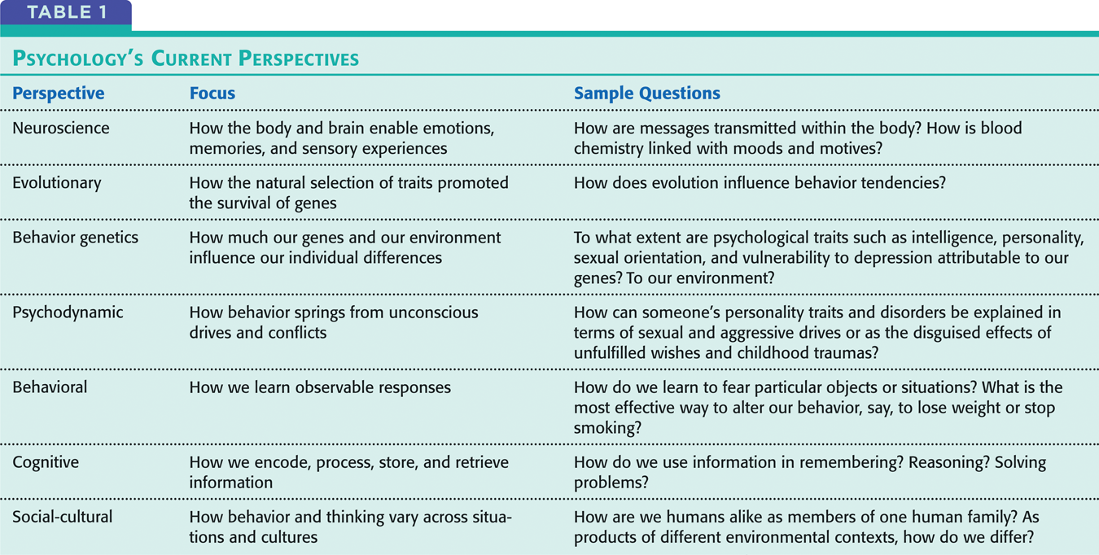

Biopsychosocial Approach
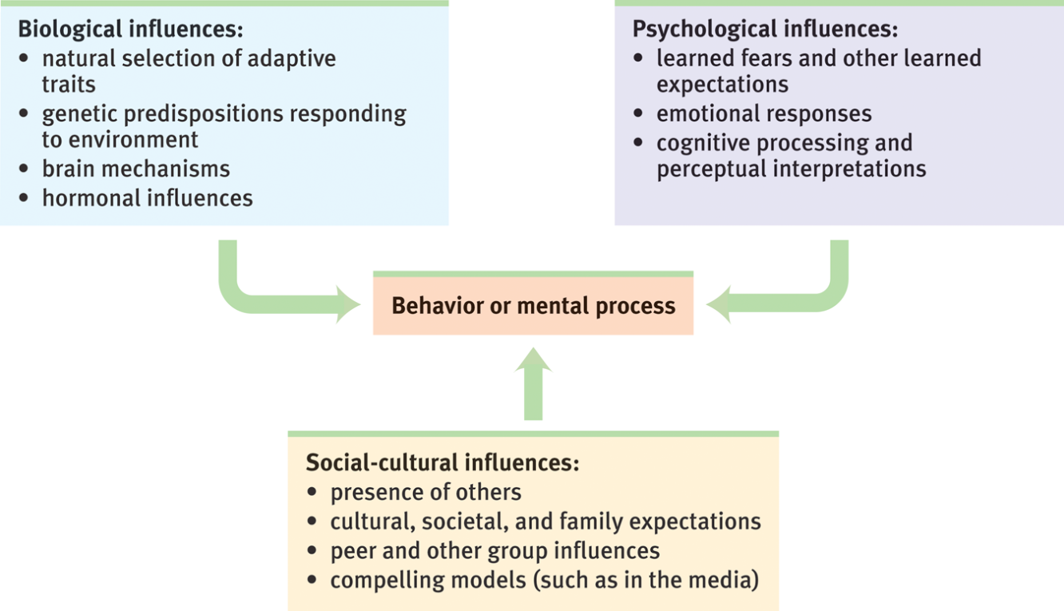

CHAPTER 1
Jan. 12, 2012
Critical Thinking
- Thinking that does not blindly accept arguments and conclusions examines assumptions, discerns hidden values, evaluates evidence, and assesses conclusions
Intuition
- Understanding or knowing without conscious recourse to thought, observation or reason
- Problems?
  - Does separation weaken or strengthen romantic attachment?
  - Hindsight Bias
    - The tendency to believe, after learning an outcome, that we could’ve foreseen it
    - “I-knew-it-all-along” phenomenon
  - Overconfidence
    - We tend to be overconfident when answering a factual question, we tend to be more confident than correct
    - Ex. Anagram: WREAT WATER
    - hindsight makes the answer seem obvious, and we become overconfident by thinking we could’ve solved it in a quick time (10 sec instead of the realistic 3 minutes it would have taken)
The Scientific Method: Theories
- Observations made to explain a theory
- Theories:
  - explain a variety of observations
  - explain through an organized set of principles
  - offer testable predictions which are implied by the theory (hypothesis)
  - Ex. Big Bang Theory, Theory of Evolution
Theory of Evolution through Natural Selection
- There is variation within any population of organisms
- There is competition for finite sources (mates, food, etc.)
- Certain traits increase a species “fitness” (survival + reproductive success)

EXAMPLES
Major Depressive Disorder: A cognitive theory
- Observations:
  - Frequent thoughts of worthlessness
  - Inappropriate feelings of guilt
  - Feelings of helplessness
- Cognitive theory principles
  - The way we think affects our feelings (“colours”, “sets the tone”)
  - Negative event occurs self-blame & overgeneralize (leads to ppl interpreting all things negatively)
  - Theory: low self-esteem underlies depression

Major Depressive Disorder: A Neurobiological Theory
- Neurochemical activity underlies all our experiences (inclu. feelings)
- Serotonin associated with positive mood
- Theory: Neurochemical imbalance (low serotonin) underlies depression
Testable Predictions
- Testable predictions that logically flow from the principles of the theory
- A good theory offers testable predictions
- Cognitive Theory of Depression
  - Low self-esteem underlies depression people suffering from depression should score lower on measures of self-esteem
- Neurobiological Theory of Depression
  - Neurochemical imbalance (low serotonin) underlies depression those suffering from depression should have lower levels of serotonin
- Hypothesis
  - Theory= general
  - Hypothesis = specific
  - If a Theory doesn’t lend itself to testable predictions, it’s not a scientific theory
How do you measure self-esteem?
- a researcher must define the operations they went through to measure the attribute or behaviour in questions
  - ex. if studying depression, you must describe exactly how you measured it
- Self-esteem
  - Measured by an individual’s responses to statements (scale of 1-7)
    - “I have good ideas”
    - “I am fun to be around”
- Operational Definitions
Operational Definitions
- Function 1: protects against experimenter bias
- Function 2: allows for replication
  - Same study, same procedure, different participants
  - Same study, slightly different procedure can original findings be extended to other circumstances?
Scientific Method
- Theories Hypotheses Research and observations
Observations
- Descriptive
  - The Case Study
  - Surveys
  - Naturalistic Observation
- Correlational: relationships between observations of different attributes
- Experimental: causal links where one attribute causes another

The Case Study
- Examine a single individual in depth
  - Ex. working with the language skills of a chimp (representative?)
  - Ex. people with brain damage from an accident test what they can no longer do (representative?)
The Survey
- Many cases, less in depth
- Ask people to report their behaviours or opinions
- Wording effects ex. “censorship” has a negative connotation vs. “restriction”
- Random Sampling
  - representative of the population (also un-biased)
  - Random if every person in the pop of interest has an equal chance of being included in the sample
  - Drawback: individual may not be representative of the population
Naturalistic Observation
- Unobtrusively observe and record behaviour in natural environments
Correlation
- Measures the relationship between 2 attributes or behaviours
- Often represented by scatterplots
- Direction of the relationship
  - +ve correlation as 1 attribute increases, the other increases
  - –ve correlation as 1 attribute increases, the other decreases
- Strength of relationship
  - Correlation of Coefficient (value is -1 to +1)
  - +ve correlation (0 to +1) +1 is perfect positive correlation
  - –ve correlation (-1 to 0) -1 is perfect negative correlation
- Illusory correlation: when we believe there is a relationship between two things, we are likely to notice and recall instances that support our belief
  - Perceiving order in random events When we notice random coincidences, we may forget they are random and see them as correlated
Jan 16, 2012
Experimentation
- Correlations will show us where a causal relationship possibly exists
- Breastfeeding and cognitive abilities
  - Breastfeeding could cause higher cognitive abilities
  - Later cognitive abilities could cause breastfeeding
  - A third factor causes them both (ex. socioeconomic status)
  - In this case, we know breast feeding came first, therefore the second hypothesis is not possible (temporal difference)
- 2 ways an experiment differs from a correlational research
  - 1) Manipulate the factor in the question (does breastfeeding later cause higher cognitive abilities?)
  - 2) Random assignment (asking how much mothers breast fed)
- Placebo (inert) effect
  - An improvement that is elicited by the expectation or anticipation of getting better
- Independent and dependent variables
- **a true experiment would require you to make your own groups manipulate the variable (ex. group 1 = 0 breast fed, group 2 = 2 months breast fed, group 3 = 6 months breast fed, etc.)
Statistics
- Data/Observations
  - Ex. # of hours students studied (40 students, show the amount of hrs each one studied)
Frequency distribution
- Frequency distribution table Shows the # of observations that fall into each category
- Frequency distribution graph
- Histogram
Measures of Central Tendency
- Measure of central tendency centre of the distribution of data
- Mean (most commonly reported measure of central tendency): arithmetic avg.
  - sum of all the scores/# of scores
- Median: midpoint of the data
  - Arrange data points in order from smallest to largest, take the data point in the middle
- Mode: the most frequently occurring score
Measures of Variation
- Calculate a single value that will represent the group
  - A value that best represents the degree to which the scores vary
  - The amount of difference amongst the scores
- Range: gap/distance between the lowest and highest scores (lowest score – highest score)
- Standard Deviation: represents the degree to which the scores vary
  - An estimation of the “avg” difference amongst scores
Normal Distribution
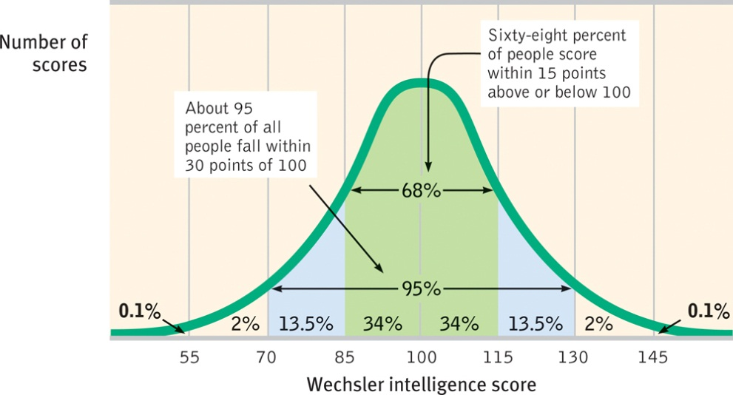
Statistical Significance
- Usually looking at differences between groups
- A statistical test will determine if the difference is significant
  - Taking into account the means (mean difference) & the standard deviation
- A difference is more likely to be found to be statistically significant if:
  - 1) the difference is reliable
    - Sample is representative, there is a low variability, many participants
  - 2) the difference is large
    - Statistical test will evaluate the prob of getting a diff that large, if it is less than 5% probability it is statistically significant, statistical significance DOES NOT mean practically significant
Culture
- The enduring behaviours, ideas, attitudes, and traditions shared by a group of ppl and passed on from one generation to the next
Ethics
- Experimentation on animals
  - Is it right to place the well-being of humans above animals?
  - Our compassion for animals varies (as our compassion for ppl) based on their perceived similarities to us
- Experimentation on humans
  - Ethical Principles
    - 1) obtain the informed consent of potential participants
    - 2) protect them from harm and discomfort
    - 3)treat info about individual participants confidentially
    - 4) fully explain the research afterward

CHAPTER 2
Jan 19, 2012
INFORMATION TRANSFER
Neurons
- Brain cells, or nerve cells
- Anatomy
  - Cell body (soma)
  - Dendrites
  - Axon
  - Terminal branches (buttons)
    - Synapse neurotransmitter is released by axon term. Into synaptic gap, binds to receptor, triggers opening of ion channels (NOT ACTION POTENTIAL)
  - Myelin sheath
    - Insulation
    - Action potential only occurs between the sections of myelin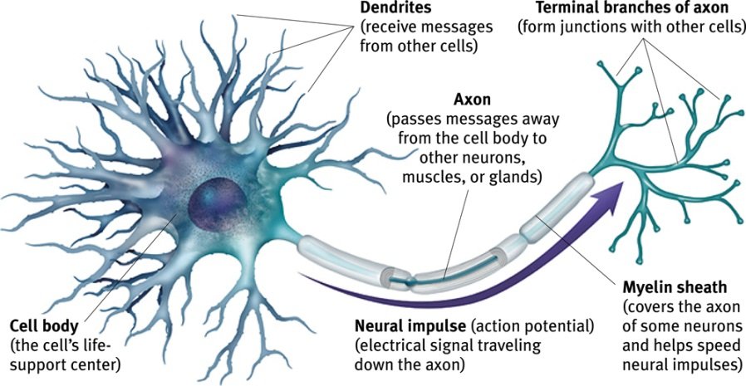

- 1st neuron = presynaptic neuron, 2nd neuron = post synaptic neuron
- Reuptake
- Dendrites/cell body receive signals from many neurons
  - Excitatory promotes depolarization
  - Inhibitory prevents depolarization
  - Summation + threshold ex. hot dinner plate
    - 1) plate is hot, DROP IT.
    - 2) you have a dinner party full of hungry guests, DON’T DROP IT
    - The one that is chosen depends on how hot it is (threshold)
Action Potential
- Electrical signal that travels down the axon
- Signal transmitted along the axon be diffusion of charged atoms
- This membrane is semi-permeable
  - Series of channel openings along the axon that allows the diffusion
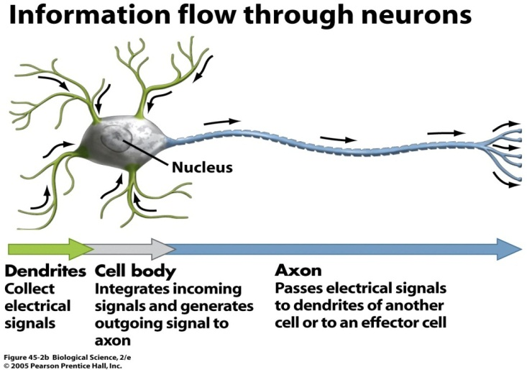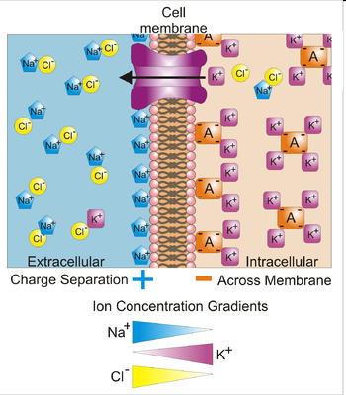
- Inside of the cell is –vely charged
- Outside of cell is +vely charged
  - Electrical potential
  - Resting membrane potential
- Attraction between –ve and +ve ions +ions only able to enter once the channels are open

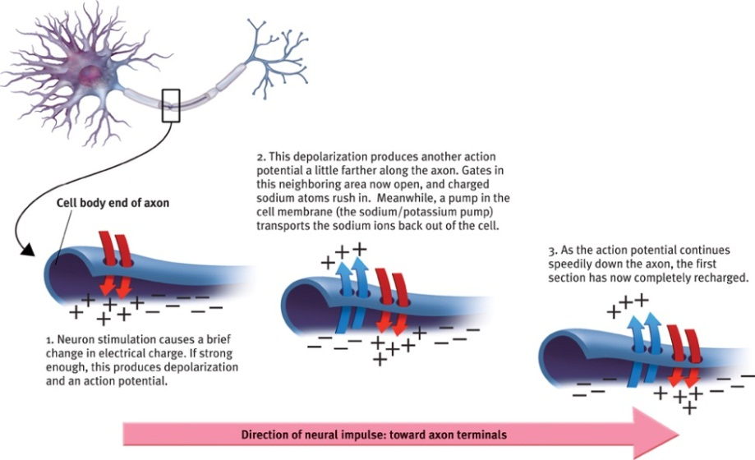
- Voltage-gated channels
  - 1st channel activated by a voltage change as soon as it gets to -55
  - Na+ ions enter, then diffuse across the axon and raises the electrical potential (open/closing channels along the way)
  - Depolarization (-ve to +ve) continues all down the axons until the terminal buttons are met
Neurotransmitters
- Ach: junction of motor neuron and muscle
  - Stimulates muscles to contract
  - If you had no Ach, you’d be paralyzed
- Motor neuron goes to muscles or glands, “inside out”
- Sensory neuron responsible for your different sense, “outside in”
- Interneurons part of the brain, in between motor and sensory neurons
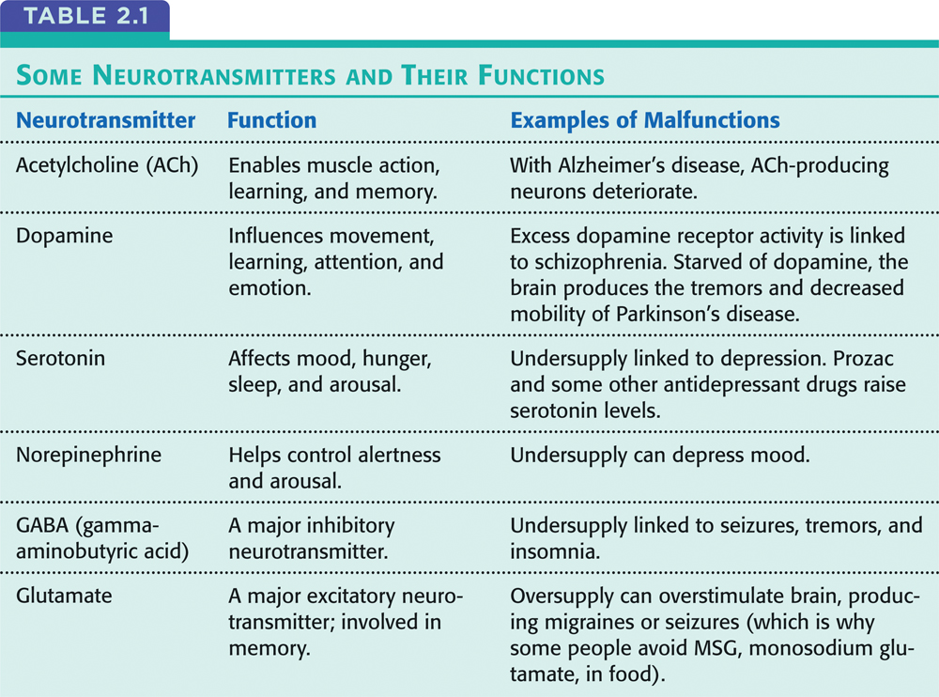
Acetylcholine Agonists & Antagonists
- Certain drugs are structurally similar to neurotransmitters
- Agonists: structural similarity or block reuptake
  - Ex. black widow spider venom cardiac muscles seize in reaction to the venom
  - Ex2. General anesthetics that is struct. similar to Ach blocks reception of Ach so your body doesn’t try to more when you’re unconscious)
- Antagonists: blocks the receptor
  - Bind to receptors but not similar enough to activate it
  - Ex. Butulinum toxin (botox) muscles become paralyzed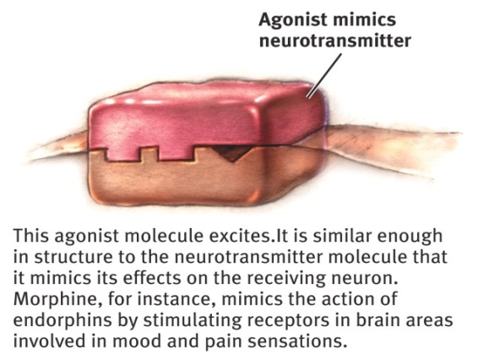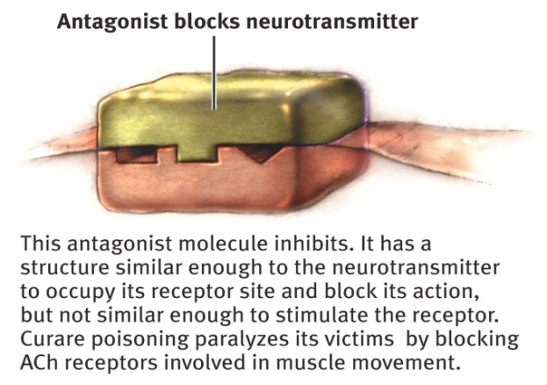

The Nervous System
- 2 major divisions
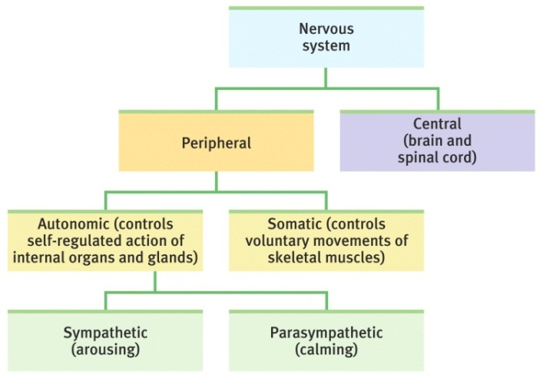
  - 1) the Central Nervous System (the brain & spinal cord)
  - 2) the Peripheral Nervous System (nerves, connect the brain to sensory organs, muscles and glands)
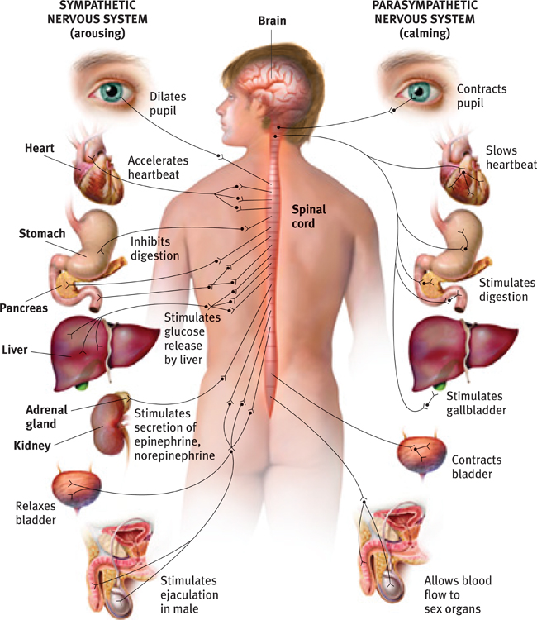
- Central Nervous system
  - Brain and spinal cord
  - Brain 40 billion neurons, 10, 000 connections each, 400 trillion synapses
- Peripheral Nervous system
  - Divided into the somatic and autonomic nervous system
  - Somatic: responsible for the voluntary control of skeletal muscles
  - Autonomic: controls (mostly) involuntary muscles (ex. heart, lungs, blood vessels, digestive system) as well as certain glands
    - Sympathetic fight-or-flight (expends energy)
    - Parasympathetic rest-and-digest (conserves energy)
Neural Networks
- Systems of neurons with a common purpose
- Some innate
  - Visual perception
  - Reflexes
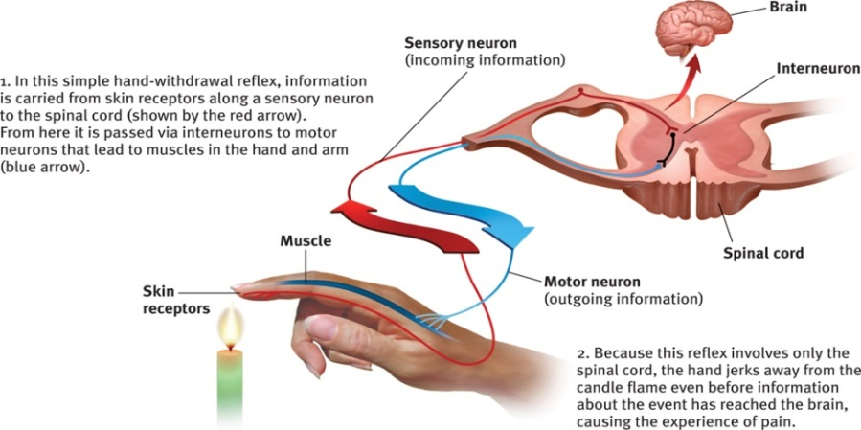
- Some Learned
  - Neurons that fire together, wire together
Spinal cord
- Connection between the brain and peripheral nervous system
  - Sensory neurons enter from sensory systems
  - Motor neurons from the brain exit
- Reflexes

CHAPTER 6: Sensation and Perception
Jan 30, 2012
Information Detection (sense organs, feature detection, sensation)
Information Processing (organization and interpretation, perception)
Vision
- The Stimulus Input
  - Light = 1 type of magnetic radiation
  - Electromagnetic radiation made up of photons (ex. sun = largest amount)
    - Different types: X-rays, ultraviolet radiation, infrared radiation, microwaves, radio waves, light
    - Packets of electromagnetic radiation oscillate (ebb+flow) degree of oscillation determines the wavelength
      - More oscillation = shorter wavelength
      - Wavelength determines whether or not out eyes can detect it
  - Visible spectrum only electromagnetic radiation our eyes can pick up
Wavelength and Amplitude
- Wavelength of light determines the hue that we will experience
  - Hue = colour
- Amplitude of the wavelength determines the brightness of the colour
  - Higher amplitude, brighter colour
  - Lower amplitude, duller colour
The eye
- detect and transduce electromagnetic radiation (light)
  - transduction is conversion of one form of energy into another
- cornea: bends the light in a certain direction
- pupil: hole in the iris, emotion/drugs/death can affect the dilation
- iris: coloured muscle that constricts (makes pupil smaller) or dilates (makes pupil bigger)
- lens: stretches to focus on certain points, if it does not focus properlycorrective lenses
- retina: very back surface of the eye
  - several layers of cells
  - photoreceptors rods and cones
  - bipolar cells
  - ganglion cells axons form the optic nerve
**inside of eye is hollow + filled w/ fluid
Rods and Cones
- 120 million rods, 6 million cones, 1 million ganglion cells
- Cones mostly in centre of retina (fovea), Rods mostly in periphery
- Cones are more sensitive to detail (better ratio of connections to ganglion cells)
- Only cones are sensitive to colour only absorb particular wavelengths of light
- Rods more sensitive overall need less light to activate them
Blind Spot
- Axons from the ganglion cells converge and leave the eye in the middle of the retina, near the fovea
- There’s a hole in your retina where there are no receptor cells
  - Brain has no direct information about a small area of your visual field
  - But it has indirect info
    - The other eye
    - Eye movements
    - Your brain fills in the info by making its best guess based on adjacent areas of the retina
Feature Detection
- Optic nerve carries information to the visual cortex
  - Thalamus
  - areas of the visual field have corresponding areas of the visual cortex
- Feature detection cells for each area of visual field
  - edges, lines, angles, movements, colours, depth
- Parallel processing
  - features extracted simultaneously
- Supercell clusters in association cortex
  - respond to complex patterns made by individual features
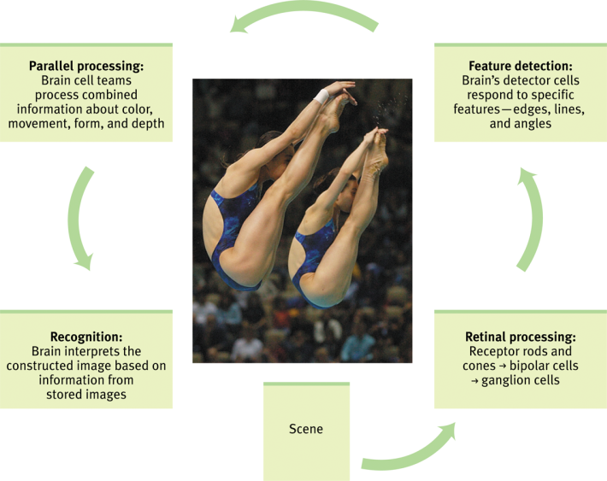
- **if you damage a specific section of the cortex, a specific section of your perception will be damaged woman lost her sense of motion detection freeze-frame coffee pouring instead of fluid movement
Visual Information Processing

Colour Vision
- Young-Helmholtz Trichromatic Theory: any colour created by combining light waves of 3 primary colours (red, green, blue)
  - Theorized the brain worked the same way
  - Hypothesized that the retina will have 3 diff types of colour sensitive cells
  - **light waves, NOT PAINT
- Colour blindness depending on the cones in your eye that you lose, your perception of colour is altered
  - Ex. missing red & green cones = red & green look the same
- Problems w/ trichromatic theory
  - 1)missing cones but perceiving yellow
  - 2) yellow seems pure
- After images you see the opponent colours
  - Ex. red + green, blue + yellow, black + white
  - Opponent process theory: opposing retinal processes enable colour vision
    - Ex. some cells are stimulated by green and inhibited by red (or vice versa)
Hearing/Audition
- Stimulus
  - Sound waves
  - Alternating series of compressed and expanded air
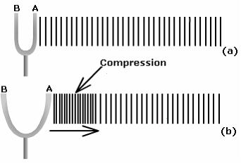
Sound Wave
- Sound can be represented as a 2D wave
- Frequency (Hertz) = # of wavelengths/sec
  - Longer wavelengthshorter frequency
  - Frequency determines pitch
- Amplitude determines loudness (the amount of pressure that waves exert in decibels)
  - Decibels: log scale that describes the magnitude of diff sounds relative to a reference magnitude
    - Every 10 decibels = x10 as loud as the threshold sound
      - Ex.20 decibels (10 + 10) = 10 x 10 = 100x as loud as a threshold stimulus
  - Reference magnitude: absolute threshold for sound -->smallest can be detected 50% of the time)
The Ear
- Transduce the sound wave energy into electrical energy
- Outer ear (pinna)
- Eardrum (tympanic membrane)
- Middle ear – 3 bones (ossicles)
  - Hammer (malleus)
  - Anvil (incus)
  - Stirrup (stapes)
- Cochlea
  - Oval window
  - Basilar membrane
  - Hair cells (receptor cells)
**the more hair cells stimulated, the louder the sound
Pitch
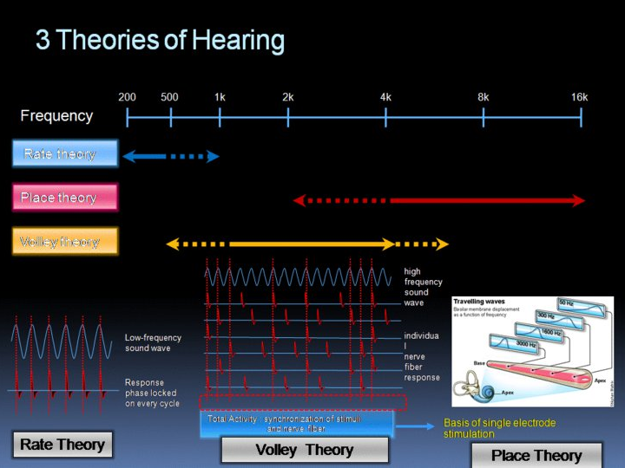
- Place theory: suggest there are diff spots along the basilar membrane sensitive to diff sound frequencies (pitch)
  - Research confirmed
  - Variations of pitch neatly localized on the membraine
  - Problem not as much precision at low pitches
- Frequency Theory: frequency of neural impulses = the frequency of the sound wave
  - Limitation can heat 20 Hz – 20,000 Hz, but neurons fire at max 1000 Hz
  - Middle frequencies still not represented
- Volley principle frequencies of adjacent hair cells added together

Sound Localization
- Left-Right Localization diff arrival times of stimulus at diff ears
- Diff in the magnitude of the sound wave at diff ears
  - Sound mag. weakens as it travels
  - Head dampens the sound (sound shadow)
- Shape of external ear
  - Diff shape at every angle changes the nature of the sounds in diff ways
  - Brain is able to recognize the effect that diff angles will have on the signal
Hearing loss
- 2 General kinds
  - 1) Conduction hearing loss damage to either the eardrum or bones of the middle ear
    - Infection, trauma
  - 2) Sensorineural hearing loss damage to hair cells of cochlea
    - Prolonged exposure to loud noises, age, genetics, infection, tumor
- Cochlea Implant
  - Microphone: pick up sound waves
  - Speech processor: filters the sound & preferentially selects frequencies that correspond to speech
  - Transmitter: send the info from the processor to the receiver
  - Receiver: accepts the info from the transmitter
  - Stimulator: sends electrical signal to electrodes
  - Electrodes: stimulate auditory nerve
Taste
- Basic taste sensations = sweet, sour, bitter, salty
- Research confirmed receptors for these 4 and another taste sensation


