Carleton University
School of Mathematics and Statistics
STAT2507 – Assignment 3

Shazeb Majeed Chaudhry
100845493

Question # 1
Descriptive Statistics: C1

Variable N N* Mean SE Mean StDev Minimum Q1 Median Q3
C1 10000 0 5.5152 0.0144 1.4357 3.0004 4.2998 5.5271 6.7449

Variable Maximum
C1 7.9989

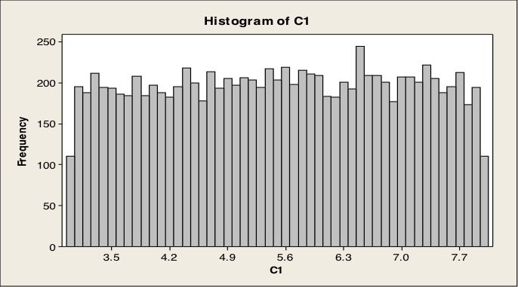
Question # 2

Variable N N* Mean SE Mean StDev Minimum Q1 Median Q3
C2 1000 0 5.088 0.160 5.064 0.007 1.535 3.524 7.186

Variable Maximum
C2 41.758

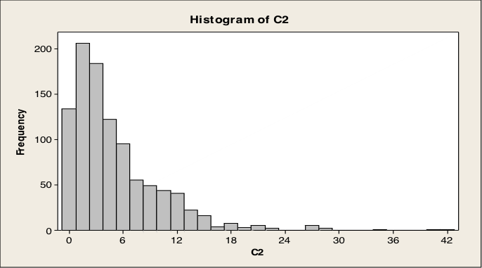

Question # 3
Descriptive Statistics: C3

Variable N N* Mean SE Mean StDev Minimum Q1 Median Q3
C3 10000 0 0.0052 0.0100 1.0035 -3.8273 -0.6623 -0.0018 0.6875

Variable Maximum
C3 3.7275

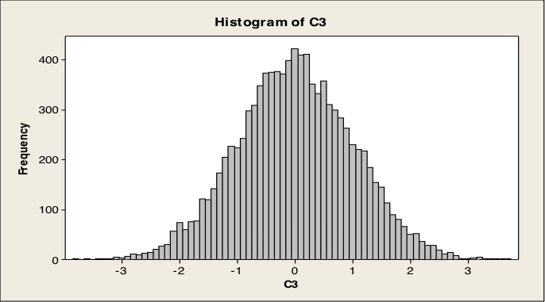

Descriptive Statistics: C4

Variable N N* Mean SE Mean StDev Minimum Q1 Median Q3
C4 10000 0 6.0291 0.0301 3.0106 -5.1333 3.9805 6.0277 8.0414

Variable Maximum
C4 16.882
Please Turn Over
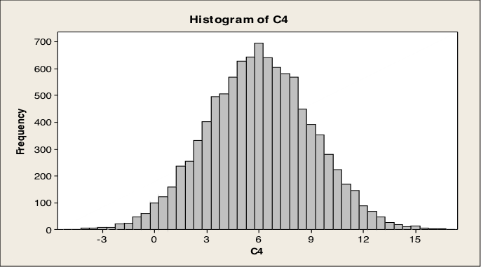

Descriptive Statistics: C5

Variable N N* Mean SE Mean StDev Minimum Q1 Median Q3
C5 10000 0 0.0097 0.0100 1.0035 -3.7111 -0.6732 0.0092 0.6805

Variable Maximum
C5 3.6276

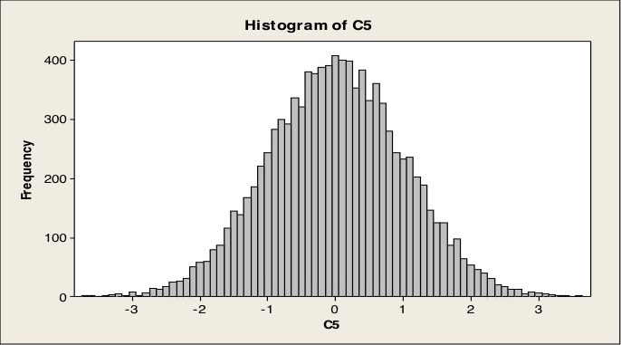
Question # 4
MTB > random 200 c1;
SUBC> normal 15 6.
MTB > random 200 c2;
SUBC> normal 5 1.
MTB > let c3 = 3*c1
MTB > let c4 = 2*c2
MTB > let c5 = 2*c1-10
MTB > let c6 = 3*c2+6
MTB > let c7 = c1+c2
MTB > let c8 = 2*c1+3*c3-2
MTB > desc c1-c8

Descriptive Statistics: C1, C2, C3, C4, C5, C6, C7, C8

Variable N N* Mean SE Mean StDev Minimum Q1 Median Q3
C1 200 0 15.354 0.419 5.926 2.968 11.137 14.691 19.131
C2 200 0 5.1603 0.0723 1.0225 2.1823 4.5359 5.0764 5.8440
C3 200 0 46.06 1.26 17.78 8.91 33.41 44.07 57.39
C4 200 0 10.321 0.145 2.045 4.365 9.072 10.153 11.688
C5 200 0 20.707 0.838 11.852 -4.063 12.275 19.382 28.263
C6 200 0 21.481 0.217 3.068 12.547 19.608 21.229 23.532
C7 200 0 20.514 0.430 6.087 8.216 16.120 19.458 24.385
C8 200 0 166.89 4.61 65.19 30.65 120.51 159.60 208.45

Variable Maximum
C1 32.894
C2 8.4134
C3 98.68
C4 16.827
C5 55.789
C6 31.240
C7 38.583
C8 359.84

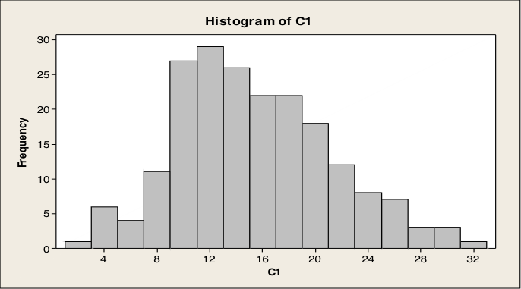
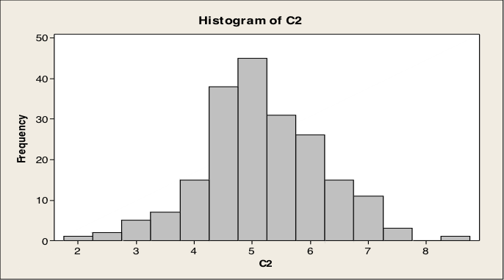
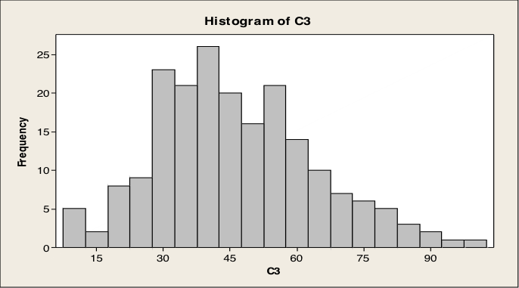
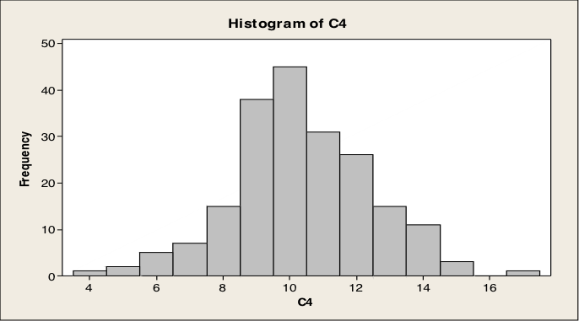
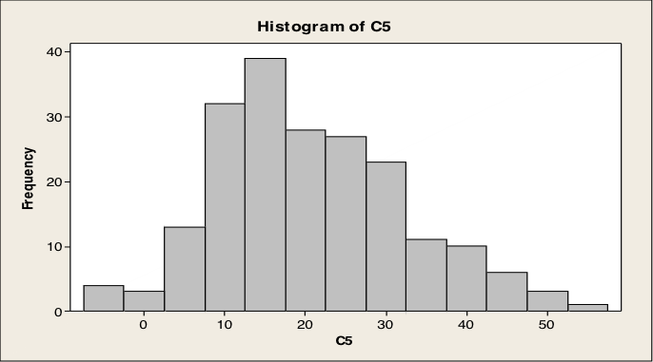
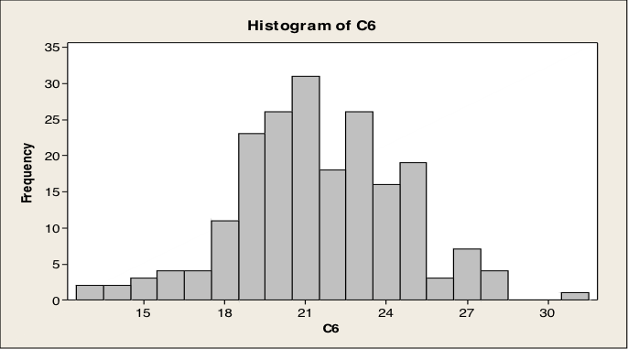
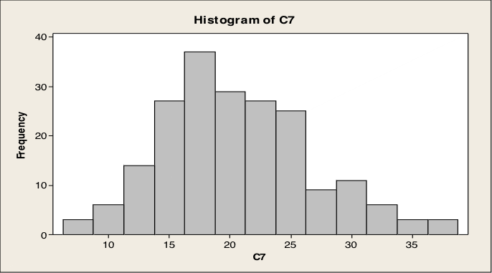
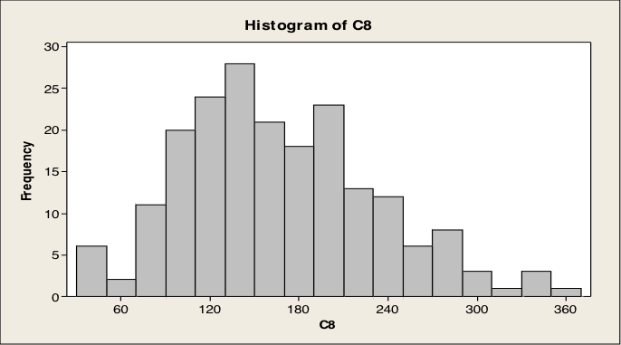

Question # 5
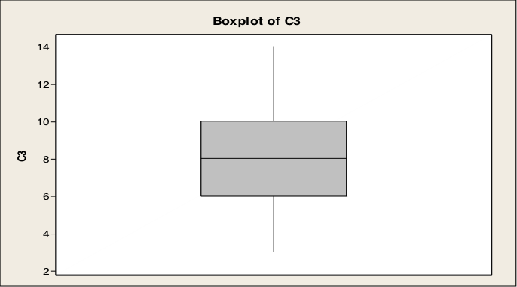
Descriptive Statistics: C3

Variable N N* Mean SE Mean StDev Minimum Q1 Median Q3
C3 100 0 8.030 0.291 2.911 3.000 6.000 8.000 10.000

Variable Maximum
C3 14.000

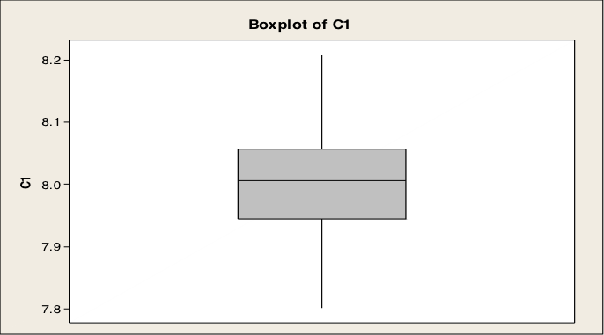

Descriptive Statistics: C1

Variable N N* Mean SE Mean StDev Minimum Q1 Median Q3
C1 100 0 7.9998 0.00821 0.0821 7.8020 7.9444 8.0061 8.0565

Variable Maximum
C1 8.2080

