- Organizations create and use teams, partnerships, and alliances to:
  - Undertake new initiatives
  - Address both minor and major problems
  - Capitalize on significant opportunities
- Organizations create teams, partnerships, and alliances both internally with employees and externally with other organizations
- It is getting harder and harder for any one individual to perform organizational activities in isolation
- Ask your students to list types of organizational activities that are performed by individuals
- Ans: For the most part, almost all organizational activities are performed in teams. For example, a customer service representative usually needs to talk with many coworkers to discover customer issues and problem resolution
- A marketing executive will need to work with sales representatives to determine what is “hot” in the market, what is selling, and what issues/complaints customers have before launching a new product
- The majority of work today is performed in groups and teams
- These teams can be departmental, interdepartmental, cross-functional, internal, and external
- 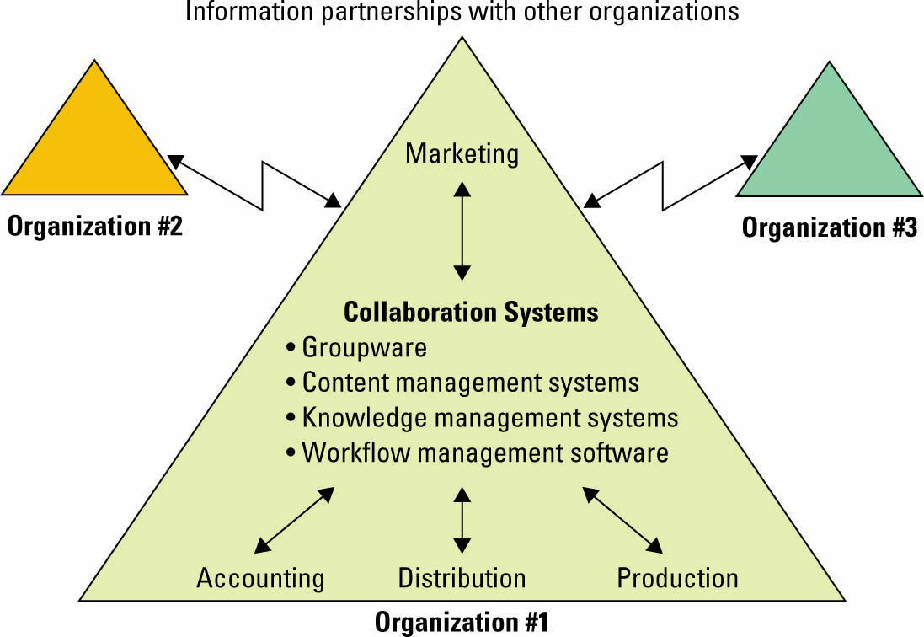
TEAM PARTNERSHIPS AND ALLIANCES
Information technology can make a business partnership easier to establish and manage
Information partnership – occurs when two or more organizations cooperate by integrating their IT systems, thereby providing customers with the best of what each can offer
The Internet has dramatically increased the ease and availability for IT-enabled organizational alliances and partnerships
- Organizations form alliances and partnerships with other organizations based on their core competency
  - Core competency – an organization’s key strength, a business function that it does better than any of its competitors
  - Core competency strategy – organization chooses to focus specifically on its core competency and forms partnerships with other organizations to handle nonstrategic business processes
- Collaboration system: An IT-based set of tools that supports the work of teams by facilitating the sharing and flow of information
- Collaboration solves specific business tasks such as telecommuting, online meetings, deploying applications, and remote project and sales management
- It is just as important for an organization to form teams, partnerships, and alliances with other organizations
- An organization that uses a core competency strategy will focus on its core competency and form partnerships with other organizations to handle nonstrategic business processes
- The most common example of this is outsourcing payroll or accounting functions
- Many organizations want to focus on the marketing and selling of a unique product or service. These organizations do not want to incur the expense of maintaining accounting or tax experts on staff, hence they will outsource these functions to a business partner
COLLABORATION
- Two categories of collaboration
  - Unstructured collaboration (information collaboration) - includes document exchange, shared whiteboards, discussion forums, and e-mail
  - Structured collaboration (process collaboration) - involves shared participation in business processes such as workflow in which knowledge is hardcoded as rules
- Content management system (CMS) – provides tools to manage the creation, storage, editing, and publication of information in a collaborative environment
- CMS marketplace includes:
- Document management system (DMS)
- Digital asset management system (DAM)
- Web content management system (WCM)
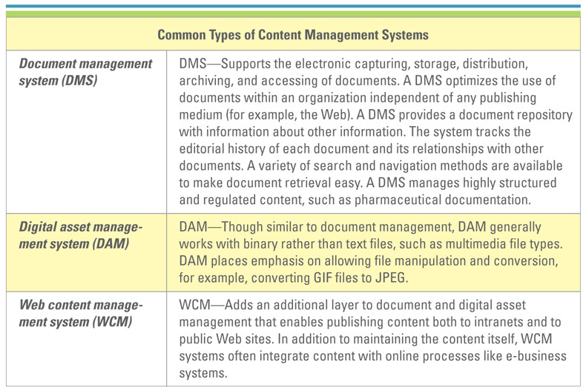
CONTENT MANAGEMENT SYSTEMS
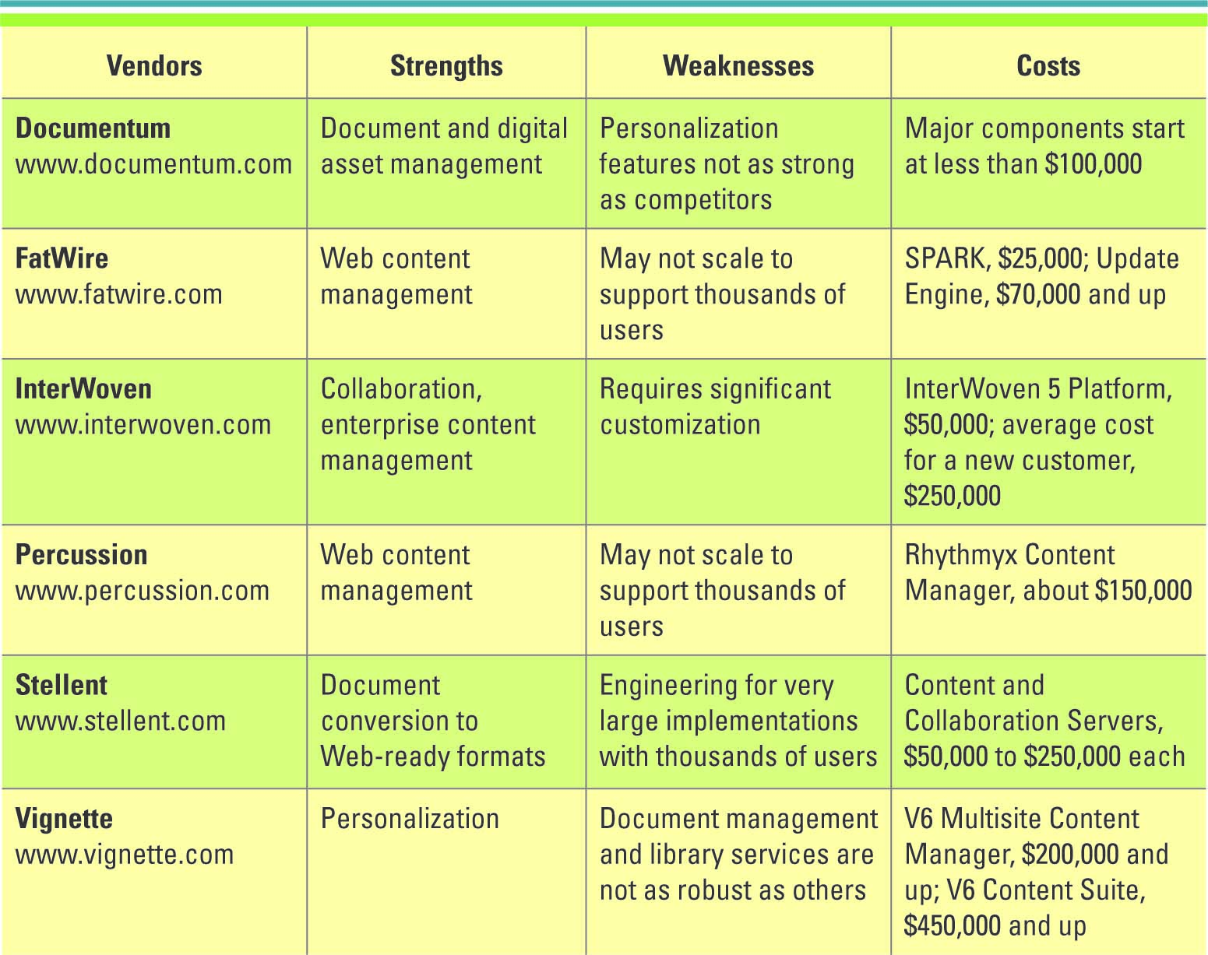
WORK FLOW MANAGEMENT SYSTEM
Work activities can be performed in series or in parallel and involve people and automated computer systems
Workflow – defines all the steps or business rules, from beginning to end, required for a business process
Workflow management system – facilitates the automation and management of business processes and controls the movement of work through the business proces
Messaging-based workflow system – sends work assignments through an e-mail system
Database-based workflow system – stores documents in a central location and automatically asks the team members to access the document when it is their turn to edit the document
- In addition to commercial off the shelf software (COTS), there are Open Source Solutions (OSS) solutions such as Wiki’s, Drupal
- Ask students whether they would consider Facebook and MySpace to be content management systems.
- Ask students what they would sites that facilitate blogging to be content management systems.
GROUPWARE SYSTEMS
Groupware – software that supports team interaction and dynamics including calendaring, scheduling, and videoconferencing
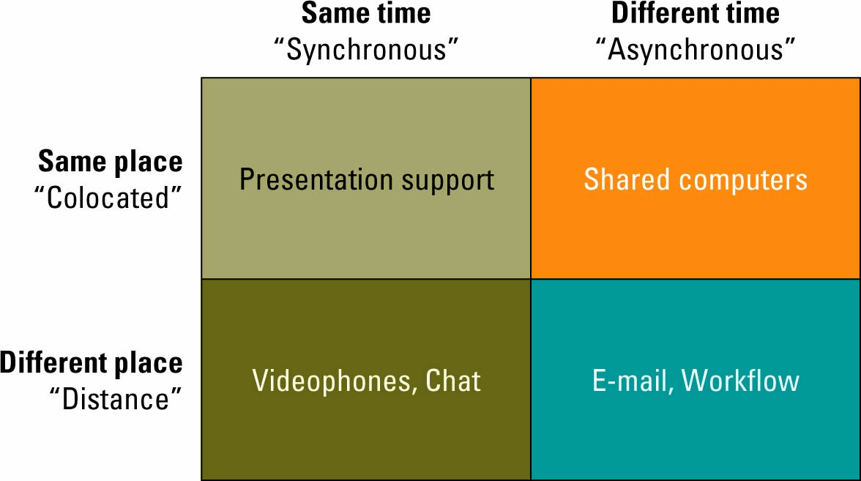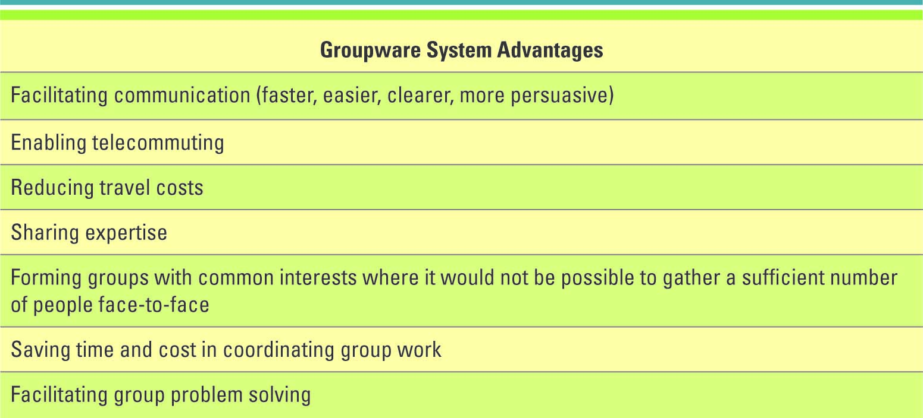Knowledge management (KM) – involves capturing, classifying, evaluating, retrieving, and sharing information assets in a way that provides context for effective decisions and actions
Knowledge management system (KMS) – supports the capturing, organization, and dissemination of knowledge (“know-how”) throughout an organization
Explicit and Tacit Knowledge
Intellectual and knowledge-based assets fall into two categories
  - Explicit knowledge – consists of anything that can be documented, archived, and codified, often with the help of IT
  - Tacit knowledge - knowledge contained in people’s heads
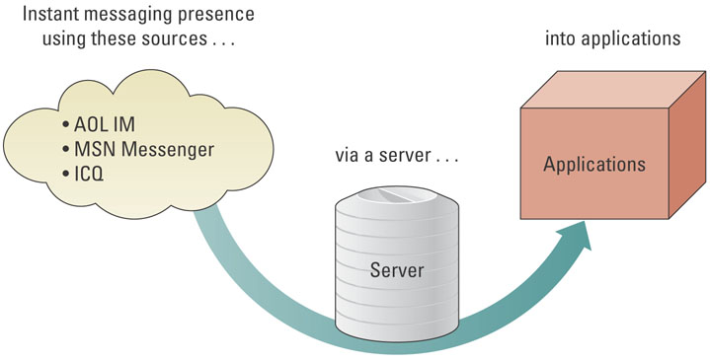
Email is the dominant collaboration application, but when real-time communication is required Instant Messaging can provide that service.
A common application of the integration of IM into business software is application sharing.
- For example, a team could be working on a budget using a spreadsheet that shared on-line, with all changes visible in real time to all team members.
- IM would provide communication among the team members allowing group discussion as well as side discussions.
KNOWLEDGE MANAGEMENT
The following are two best practices for transferring or recreating tacit knowledge
Shadowing – less experienced staff observe more experienced staff to learn how their more experienced counterparts approach their work
Joint problem solving – a novice and expert work together on a project
Knowledge management systems include:
Knowledge repositories (databases)
Expertise tools
E-learning applications
Discussion and chat technologies
Search and data-mining tools
KNOELDGE MANAGEMENT AND SOCIAL NETWORKING
Finding out how information flows through an organization
Social networking analysis (SNA) – a process of mapping a group’s contacts (whether personal or professional) to identify who knows whom and who works with whom
SNA provides a clear picture of how employees and divisions work together and can help identify key experts
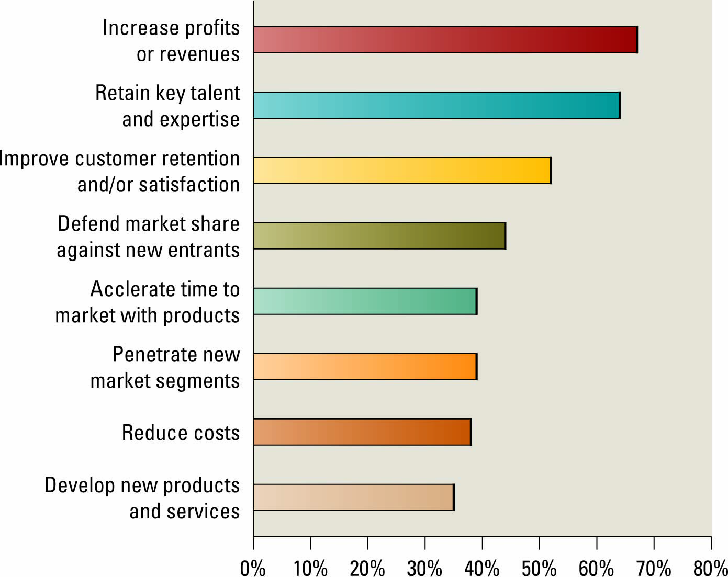Why is knowledge one of the real competitive advantages?
  - It is difficult to duplicate knowledge
  - It can take years to acquire
  - It is a personal asset
What if an organization could capture all of a persons knowledge using technology?
You would no longer need that person in the organization
ENTERPRISE PORTALS
- Enterprise Portals - Are single-point Web browser interfaces used within an organization to promote the gathering, sharing, and dissemination of information throughout an enterprise.
- Web browser interface facilitates navigation of the Enterprise Portal via:
  - Enterprise taxonomy or classification of information categories
  - Search engine
  - Hyperlinks to both internal and external resources
- Features
- Publishing facility
- Automatic indexing facility
- Subscription facility
- Intelligent agents
POTENTIAL OF ENTERPRISE PORTALS
Potential of Enterprise Portals
Facilitate knowledge creation, distribution, and use
Promote Collaboration
Portals must comprise three distinct areas to be effective
FACTORS EFFECTING ENTERPRISE PORTAL ADOPTION AND ENTERPRISE
Major factors affecting adoption and use of Enterprise Portals are not technical in nature
Lesson | Description
Lesson #1 | - In terms of information politics, the human struggle over an enterprise portal’s content and functionality can lead to resultant designs that favour certain stakeholder groups rather than address end-user needs.
Lesson #2 | - In terms of the system development process, a perceived slowness in changes to an enterprise portal’s design or information content can lead to user dissatisfaction.
FACTORS EFFECTING ENTERPRISE ADOPTION AND USE
Lesson | Description
Lesson #3A | - With respect to information sharing, the provision of protected, secure areas in an enterprise portal to pre-defined individuals or groups can lead to greater exchange of documents and ideas.
Lesson #3B | - With respect to information overload, the filtering of information within an enterprise portal can lead to greater user acceptance of the system.
Lesson #3C | - With respect to information access, providing quick and universal access to an enterprise portal can lead to heightened usage.
Lesson #3D | - With respect to information control, offering a means to tailor the display and presentation of information on an enterprise portal can increase user satisfaction with the system.
Lesson #3E | - With respect to attitude towards using an enterprise portal, a positive perception towards and awareness of an enterprise portal’s functionality can lead to greater user adoption.

Insights from Computer Supported Cooperative Work (CSCW) on adoption and use of Enterprise Portals
Ensure that everyone benefits
Create incentives for use
Promote multiple perspectives
Understand current work practice

