- Powerpoint on diversity and evolution tomorrow
- Homeostasis: State of biological balance
- Homeostasis is not just a static state:
- - this is the capacity to maintain a dynamic equilibrium within a tolerance range and it is achieved through a variety of automatic mechanisms that compensate for internal and external changes.

- Many Biological factors must remain within a tolerance range despite changes in the environment:
- - blood temperature
- - blood pH
- -sap composition
- - blood pressure
- -moiture level
- - level of glucose and calcium

- example of homeostatic mechanism in a small ecosystem (human body)
- PICTURE ON PHONE
- The blood glucose needs to be maintained in the levels
- The center of regulation is the pancreas

- Living things reproduce and devElop
- Reproduction is the ability to make another organism similar to itself:
- Unicellulars (Bacteria and Protists) simply split in two (binary fission);
- Multicellulars (Most Fungi, Plants and Animals) reproduce by pairing a sperm from one partner and an egg from the other partner:
- - The union leads to a zygotic cell (fertilized egg) and is followed by many cell divisions. This results in an immature stage, which grows and develops through various stages to become an adult.
- - An embryo develops into a specific organism because of the bleueprint inhirited from its parents:
  - This blueprint for an organism’s metabolism and organization is encoded in genes

- Genes are segments of long molecules of DNA:
- Genes can be passed on to the next generation;
- Unique collection of genes ensures unique characteristics of an individual;
- DNA can undergo mutations (changes) which may be passed on to the next generation which helps create a huge diversity of life.

- (ZYGOTE) -> FERTILIZED EGG
- - ONE CELL
- HUMAN HAS 46 CHROMOSOMES 23 FROM FATHER -> THE ZYGOTE WILL DEBLOCK AND CELL DEVISION WILL ADD A MASS OF CELLS
- CHALK BOARD PICTURE

- FIGURE 1.10
- Dna is located in the neuclei
- 23 molecules have dna

- double helix has a segment called genes -> one segment is one gene
- ex. gene 1 will be responsible for colour of hair etc.
- 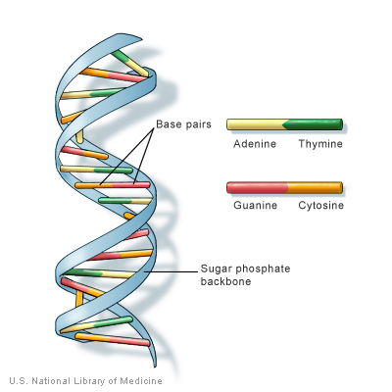

- Living things have adaptation
- Adaptations
- - modifications (in structure, function and behavior) that make organisims better able to function in a particular environment
- Evolution
- - the way in which populaions of organisms change over the course of many generations to become more suited to their enviorment
- - Natural selection: the natural environment selects organisms, so that only those who are able to modify are able to survive and reproduce -- fitness
- Species
- - group of indidivuals capable of interbreeding and producing fertile offspring
  - when two poplations become so different under modifications of the environment, they make two different species.

- explain how evolutions is a long process to adapt so that it can fit more to the new environment EXAM QUESTION
- A population of organisms is the product of evolution
and will constantly change
- Changes in
- the environment

Natural selection
- Following changes in the
environment;
- Way by which the natural
environment selects
the organisms:
those who are better adapted
are able to survive
and reproduce
- structure
- function
- behavior
New characters are brought about by genetic variation and mutations and can be passed on to the offspring.

Modifications of population through generations

better adaptation

Reproduction
survival

Madars textbook:

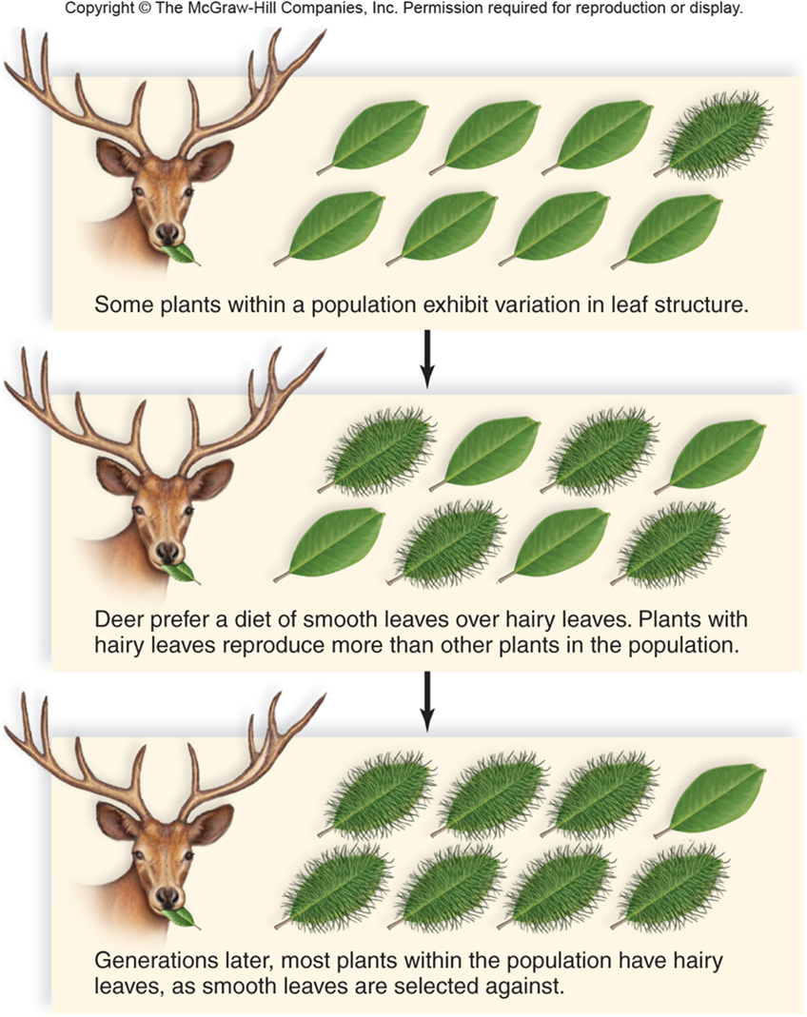

- Evolution is a long process. This generally takes pressure through years

- Form Fits Function
- Examples:
- 1. aerodynamically efficient shape of bird’s wing
  - with appropriate external contours;
  - with a skeleton contributing to flight: bones that are strong and at the same time have a light honeycomb structure
- Figure 1.7
- Form fits function in a gulls wing
- A) the shape of a birds wing and b) the structure of its bone make flight possible
- 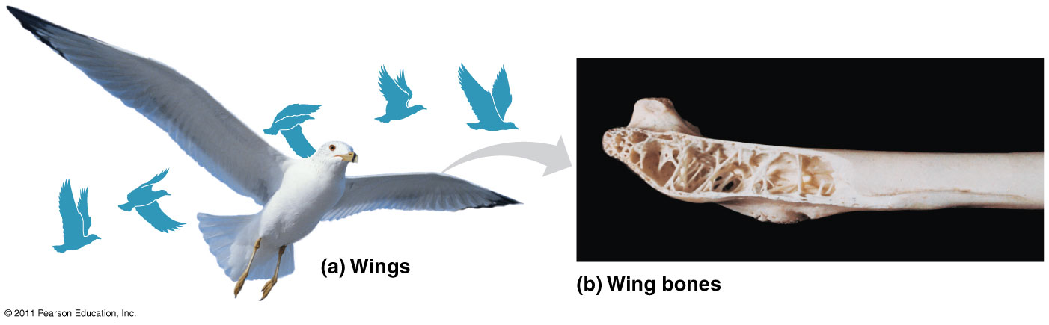

- The cells: basic units of structure and function
  - All cells are capable of reproduction
  - Cells are autonomous and capable of performing all activites of life (growth, metabolisim, homeostatis…)
  - All organisms are composed of cells (uni- or multicellular organisms)
- Two major kinds of cells
- Eukaryotic cells (figure 1.8)
- Complex structure
- Enclose many kinds of membrane-bounded organelles
- DNA associated with proteins (histones)
- True nucleus surrounded by a nuclear envelope
- - they have two nucleus, they call be found is all organisms but bacteria
- larger than prokaryotic cells
- 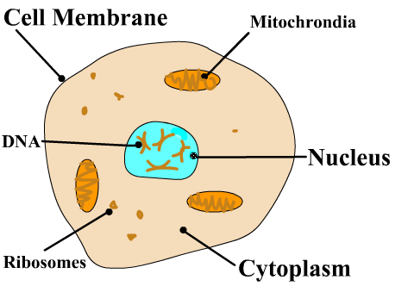
- Prokaryotic cells
- Simple structure
- Do not enclose many kinds of membrane-bounded organelles but have ribosomes
- DNA not associated with proteins
- Do not have a true nucleus (no nuclear envelope)
- PROKARYOTIC CELLS ARE BACTERIA
- 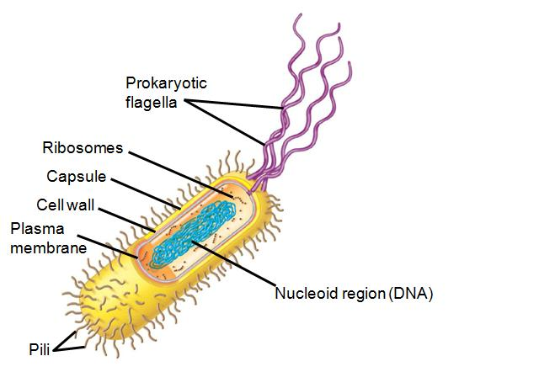

- Three domains of Life
- a) Domain bacteria
- - all are unicellular
- - autonomous, can survive alone and produce energy (2 μm)
- b) domain archaea
- - one cell can be separated from the other
- - produced energy
- - the live in harsh conditions
- - lives in 73 degrees , no oxygen (2 μm)

c) Domain Eukarya

each cell has two nucleus

kingdom plantae

kingdom fungi

kingdom animalia

protists

cells are put together to form specific tissues

their cells have a true nucleus
- complex organelles, much larger (100 μm)

- Classifying life figure 1.14
- PICTURE TAKEN

- 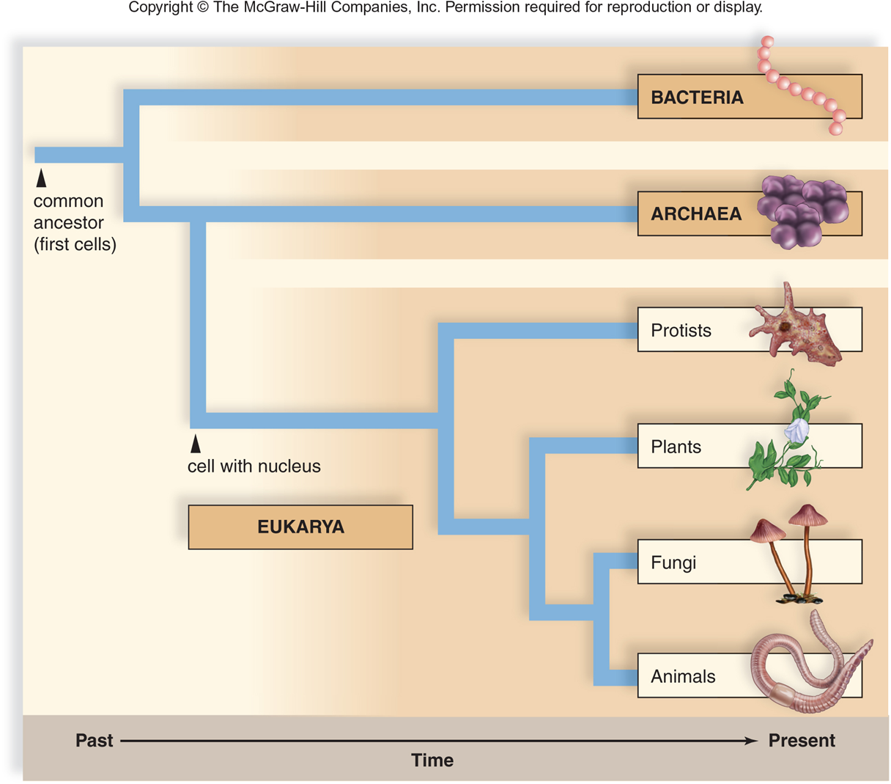

- 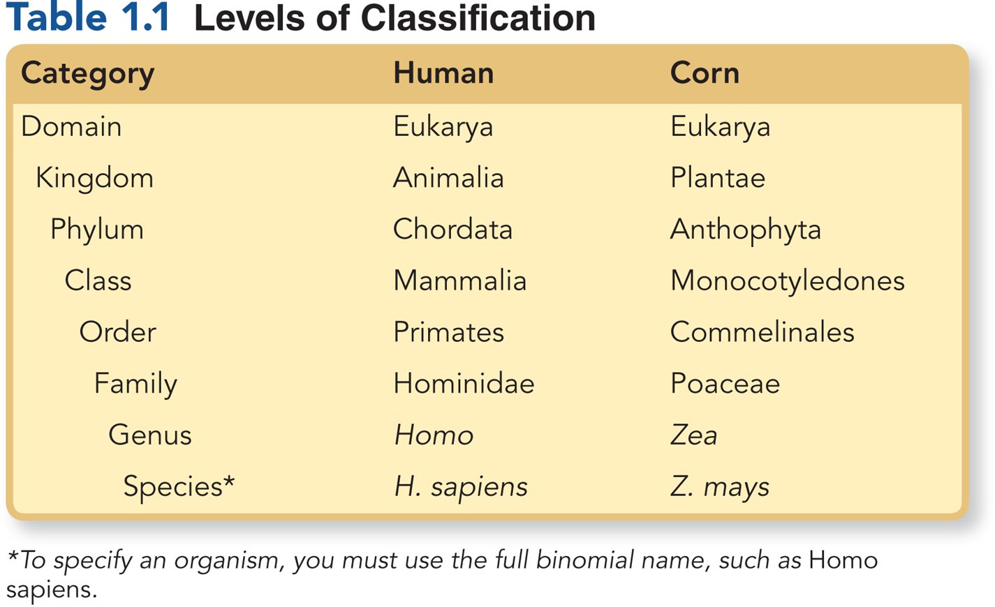

- Chemistry of life PowerPoint presentation (chapter 2)
- Why studying basic concepts of chemistry?
- To better know about phenomenons that occur at the level of organisms.
- We might want to know why opiates (such as morphine) and endorphins has similar effects:
- Endorphins: signaling molecules produced by the pituitary gland that bind to brain receptors, releiving pain and producing euphoria during times of stress (Ex.: intense exercise);
- Morphine: 1) affects pain perception and emotional state by mimicking the brain’s natural endorphins; releives pain and alter mood by weakly binding to specific receptor molecules on the surface of brain cells.

- Figure 2.18/2.16
- A molecular mimic
- - a morphine affects pain perception and emotional state by mimicking the brain’s natural endorphins
- PICTURE TAKEN

- We might want to know how muscles contract. To do so, we must take into account the interaction between actin and myosin molecules (which are proteins) within myofilaments. These are essential components of the muscles.
- - All organisms are composed of atoms and molecules: their organization is responsible for the unique properties of living things that cannot be found in nonliving things.

- Figure 5.15/5.14
- Contractile and motor proteins
- Function : movement
- Examples : motors proteins are responsible for the undulations of cilia and flagella. Actin and myosin proteins are responsible for the contraction of muscles
- PICTURE TAKEN

- 2.1) Matter and chemical elements
  - All organisms are composed of matter (any substance taking up space and having mass).
  - Energy doe snot have a mass but energy can be produced.
- Example:
- - Sheep wool is a matter;
- - Tree bark is a matter;
- - Phospholipid molecules in cell membranes are matter.
  - Matter only exists in three distinct states:
- - Solid, liquid and gas
  - All matter, living or nonliving, is composed of basic substances called elements:
- - An element is a substance that cannot be broken down to simpler substances with different properties (density, solubility, melting point, reactivity).
- - There are 92 naturally elements that serve as building blocks of matter (nitrogen, sulfur, phosphorus…).
  - Both Earth’crust and all organisms are composed of elements.
- but they differ as to which ones are common

- IMPORTANT
- Elements that are basic to life and make up about 95% of the body weight of organisms
- Elements | - Biological property
- C  - carbon | - Makes up the backbone of organic molecules; may bind to 4 atoms; responsible for the tridimensional shape of a molecule
- H  - hydrogen | - Takes part in more chemical reactions than any other elements
- N  - nitrogen | - Component of all proteins and nucleic acids
- O  - oxygen | - Essential for aerobic cellular respiration
- P  - phosphorus | - Component of nucleic acids, membrane lipids and some proteins
- S  - sulfur | - Component of many proteins

- LOOK AT POWER POWERPOINT CHEMISTRY OF LIFE SLIDE 5
- FIGURE 2.5/2.4 PICTURE TAKEN

- Periodic table rules
- The periodic table is a way to group the elements, and therefore atoms, according to their characteristics. Two rules are to be considered
- - Number of electric shells
- tells that an atom is in a particular period (horizontal row)
- - Number of electrons on the last shell
- tells that an atom is in a particular group (vertical column)

- Octet rule
The outer shell is most stable when it has eight electrons
- Noble gases have 8 electrons on their outer shell. They gain stability and do not ordinarily react with other atoms.

- Many atoms have less that 8 electrons on their outer shell. They are not stable and use the electrons in their outer shell to undergo reaction with other atoms, in such a way that after the reaction , each has a stable outer shell.
- According to their valence shell, they can give up, accept or share electrons to acquire 8 electrons in the outer shell.

- Figure 4.4 PICTURE TAKEN

- Molecular and chemical bondings between atoms
- Ionic Bonding
  - Strong attraction between a negatively charged ion and a positively charged ion
  - Bonding between Na+ and Cl- resulting in NaCl (sodium chloride)
- Ionic bonding
- Salts are solid substances that can separate and become ions in water

- Electron transfer and ionic bonding: attraction between positively charged atoms or ions.
- The lone valence elctron of a sodium is transferred to join the 7 valence elctrons of a chlorine atom
- PICTURE TAKEN

- Covalent bonding
  - Strong attraction that results when two atoms share electrons in such a way that each atom has an octet of electrons in the outer shell
  - Bonding between two atoms of hydrogen (H-H), of oxygen (O=) or between an atom of carbon and hydrogen (C-H): covalent bonding
- Organic molecule have a tridimensional form:
- - carbon is responsible for the backbone of a molecule;
- The tridimensional form is responsible for structure and function of all living matter:
- Ex.: - hormones have specific shape that can be recognized by their target cells (Ex.: growth hormone being recognized by children bone and muscle cells);
- - some receptors on WBCs have a specific shape allowing them to bind with HIV viruses: this receptor-virus complex allows the virus to be taken into the cell, reproduce into it and destroy it.

- Hydrogen bonding =involves two different molecules
- Weak attraction between the hydrogen (electropositive) of a molecule and the oxygen or nitrogen (electronegative) in another molecule represented by …
- Bonding between two molecules of water; Although a hydrogen bond is more easily broken that a covalent bond, many hydrogen bonds taken together are quite strong; Particularly important when two strands of DNA must join together.

- 2.4) chemical reactions
- a chemical reaction is the making of breaking of chemical bonds, leading to changed in the composition of matter.
- 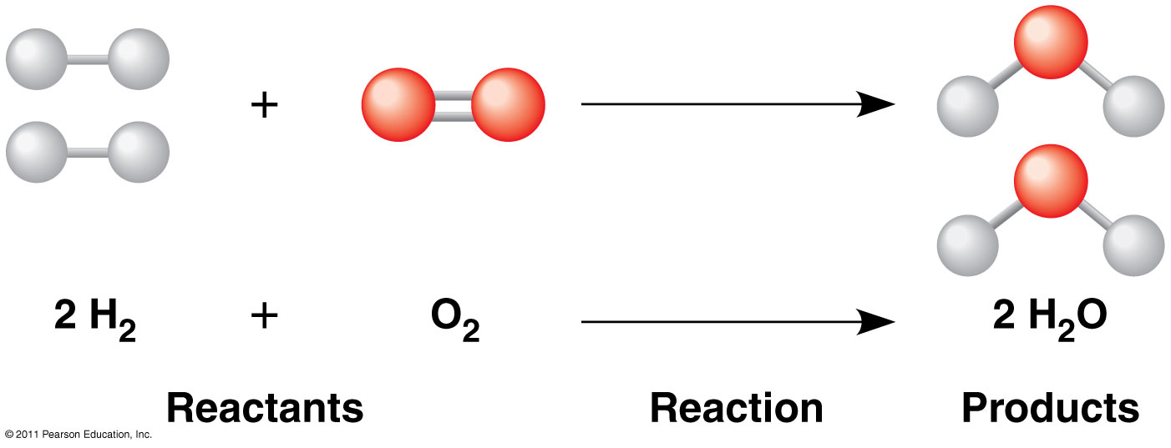

- chapter 3
- High heat capacity
- Explaination: hydrogen bondings absorb heta when thay are broken and release hate when thay are formed. This property is responsible for minimal change of air temperature
  - Water hold the atmosphere temperature as it absorbs heat from hot air, and as it releases heat in cold air.

- Hydrogen bonding –Broken absorb heat
- Consequence
- EXAM QUESTION:
- Some examples of important properties: heat capacity, evaporation and less density
- DESCRIBE ONE PROPERTY OF WATER BY PROVIDING TO TYPES OF INFORMATION:
- Physical or chemical explaination
- Consequence on living things.

- Chapter 4 slide – Carbon and molecular diversity
- Structure of organic molecules account for function of all cells in any type of organism
- Hemoglobin = protein = polymer of amino acids
- LOOK AT NOTEBOOK

- Organic molecules
- Distinction between inorganic molecules and organic molecules
- Inorganic molecules usually contain:
- Positive and negative ions
- Ionic bondings
- Small number of atoms
- (small molecules)
- Often associated with nonliving matter
- Co2 water oxygen, ammonia, nh3/nh4, o3

- Organic molecules usually contain:
- Carbon and hydrogen
- Covalent bondings
- Many atoms (molecules often quite large)
- Often associated with living matter

- Carbon atom
- What is there about carbon that makes organic molecules the same and also different?
- Carbon is small with a total of 6 electrons;
- In order to acquire 4 electrons in the outer shell (octet rule), it always shares electrons with:
- C H N O P S
- These are the elements that make up most of the weight of living things.
- Carbon can share with as many as 4 other elements and this spells diversity of biomolecules;
- Carbon can share electron with another carbon atom (C-C) and the result is carbon chains that can be quite long:
- When chains of carbon atoms are bonded exclusively to hydrogen, they are called hydrocarbons:
- The chain may be either linear or cyclic
- Figure 4.5 PICTURE TAKEN

- The carbon chain of an organic molecule
- is called: carbon skeleton (or backbone)and has:
- A functional group
  - Specific combination of bonded atoms that always react the same way; takes part in biochemical reactions

- A remainder of the molecule indicated by the letter R
  - Does not change as a biochemical reaction occurs; does not take part in the reaction)
- Look at chapter 4 for reference!

- Chaoter 5 structure and function of large biological molecules
- 5.1 polymers built from monomers
- 5.2 carbohydrates (sugrs -? Polymers of monosaccharides
- 5.3 Lipids -> polymers of fatty acids
- 5.4) Proteins -> Polymers of amino acids
- 5.5) Nucleic acids -> Polymers of nucleotides; ATP (nucleotide)

- Monomers
- These are small subunits which bond to one another and contribute to building up larger molecules.
- Ex.:
- glucose is a monomer of cellulose
- amino acids are monomers of proteins

- Polymers
- These are long and large molecules which are constructed by linking together a large number of small subunits.
- Ex:
- cellulose is a polymer of glucose
- proteins are polymers of amino acids

- These are molecules having many hydroxyle groups
- (-OH). They are divided into two groups:
- - those having aldehyde function (-CHO
- and coming from glyceraldehyde) or
- - those having a ketone function (-C=O and
- coming from dihydroxyacetone).
- - They are soluble in water (hydropohilic).
- - They are composed of :
- - simple sugars (monosaccharides)
- - double sugars (disaccharides)
- - long-chain sugars (polysaccharides)
- General molecular formula of glucids is: C_{n}(H₂)_{n}O_{n}

- Autotroph organisms (plants) and heterotroph organisms ( animals) are interconnected through carbohydrates
- Photosynthesis reaction
- 6CO₂ + 6H₂O C₆H₁₂O₆ + 6O₂
- Cellular respiration reaction
- C₆H₁₂O₆ + 6O₂ 6CO₂ + 6H₂O

- Disaccharides:
varied uses; made of two monosaccharides

- Maltose
  - Digestive role:
  - Comes from digestion of starch and leads to two glucose molecules
  - - glucose + glucose
- Sucrose
  - table sugar (used to sweeten food)
  - form in which sugar is transported in plants
  - - glucose + fructose
- Lactose
  - found in milk
  - - glucose + galactose

- EXAM QUESTION NAME 3 SIMPLE SUGAR OTHER THAN GLUCLOSE
- ALSO LOOK AT THIS DIAGRAM
- 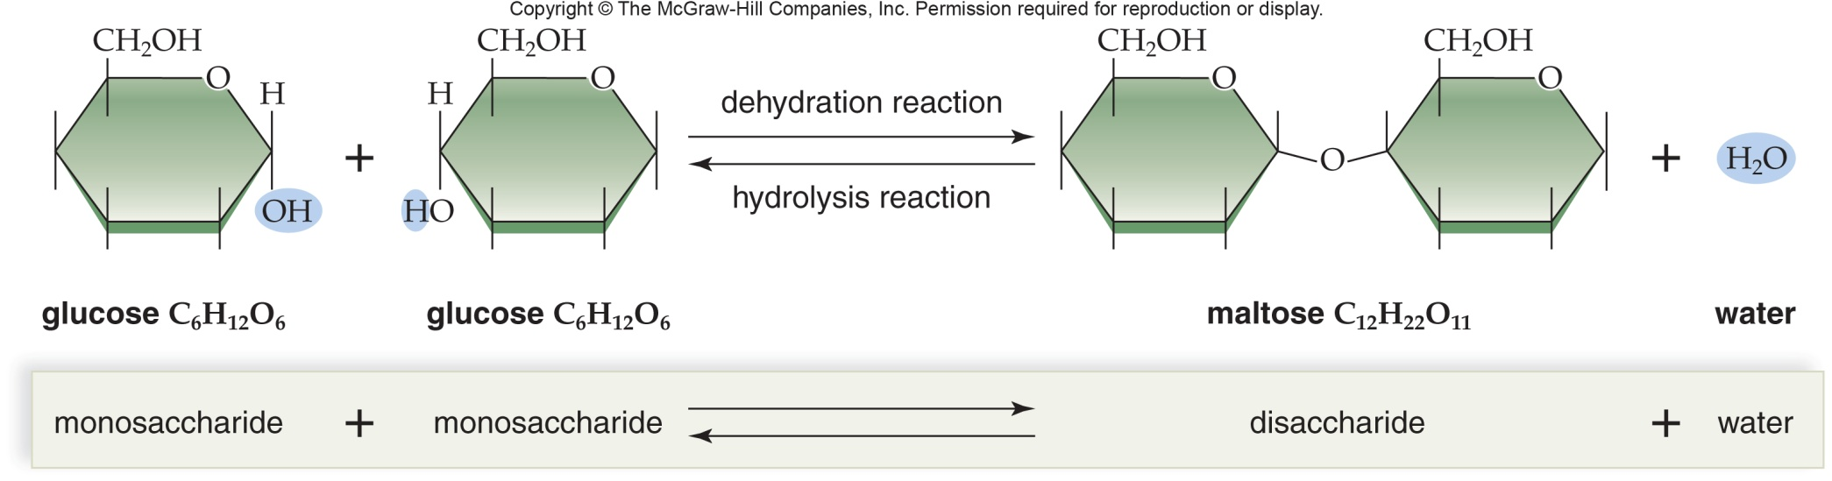
- Lipids
- Organic compounds that are insolube in water (hydrophobic)
- due to their long hydrocarbon chains but soluble in organic
- solvants such as benzene.

- Hydrophobic nature is due to fatty acids (long carbon chains):
- - Fatty acids often bind to glycerol.
- Important lipids are: - triglycerides (fats and oils),
- - phospholipids (in cell membranes),
- - steroids (cholesterol
- and sexual hormones),
- - waxes (in plants and animals)

- Steroids
- They have a skeleton of four fused carbon rings.
- Two major types of steroids:
- Cholesterol
- Essential component of animal cell’s plasma membrane (for physical stability);
- Precursor of several other steroids among which are sex hormones.
- Sex hormones
- Essential for regulation and reproduction
- Ex.:
- testosterone (in testes)
- estrogen (in ovaries)

- These two hormones differ only by a
- few atoms attached to the carbon skeleton
- and yet have their own profound
- effect on the body and behavior

- Cholesterol molecule from which other steroids are synthesized
- Cholesterol and sex hormones all ave 4 interconnected rings
- 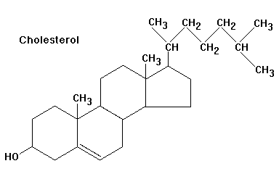

- EXAM QUESTIONS
- What molecles represents a disaccharide
- A) simples of sugars b) c) d)

- Shape of proteins and levels of complexity
- 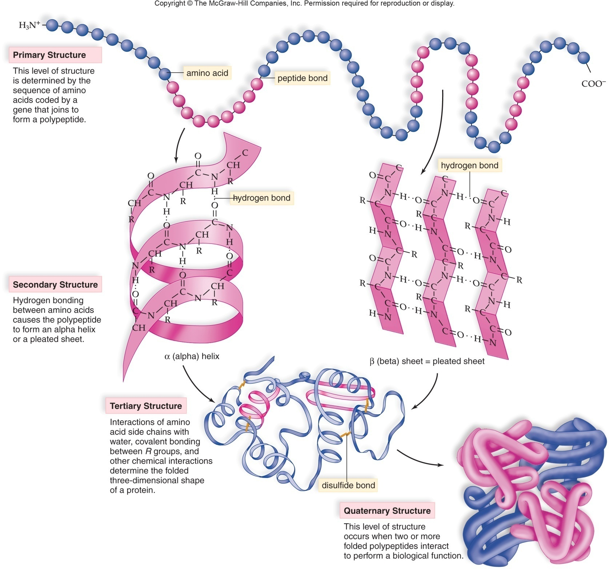look at figure 5.19 in the tenth edition textbook
- also page in notebook displays diagrams and explanations

- A single amino acid substitution in a protein causes a diseas called: sickle-cell Anemia

- TWO TYPES OF NEUCLEIC ACIDS
- DNA: DeoxyriboNucleic Acid (DNA)
- - is the genetic material that stores information regarding its own replication and the order in which amino acids are to be joined to make a protein.
- - during cell division, two daughter cells are produced: each one receives the same genetic material due to replication.
- RNA: RiboNucleic Acid (RNA)
- - is involved in protein synthesis and consequently the expression of genetic information.
- Types of RNA:
- - messenger RNA (mRNA)
- transfer RNA (tRNA)
- ribosomal RNA (rRNA)
- study DNA and RNA structure
- The differences between DNA and RNA

- DNA
- sugar = deoxyribose
- bases = A, G, C, T
- deoxyribonucleotide as basic subunit
- double stranded
- (2 strands)
- precursors: dATP, dGTP, dCTP, dTTP

- RNA
- sugar = ribose
- bases = A, G, C, U
- ribonucleotide as basic subunit
- single stranded
- (1 strand)
- precursors: ATP, GTP,CTP, UTP

- Exam Format: from ch. 1 -7.1 bonus marks on chapter 6: modications of cell structure

First part : multiple choice 25 choose 20 among 25 don’t answer more

True or false 18 questions choose 15

Matching

4 but choose 2 properties of molecules organ molecules

plasma membrane protein

different answers

two short answers

properties of water

evolutions
- Four questions
- Describe what homeostasis is with one example
- Diagram on the plasma membrane structure (label diagram)
- THIS DIAGRAM WILL BE ON THE EXAM TO LABEL
- 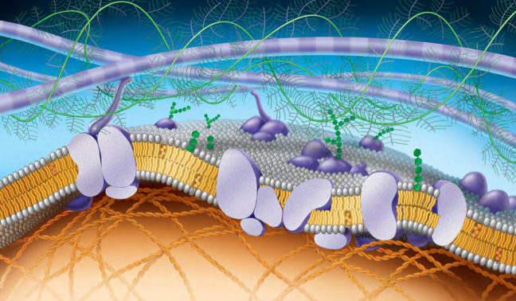
- see page 127 in 9th edition for labeling
- 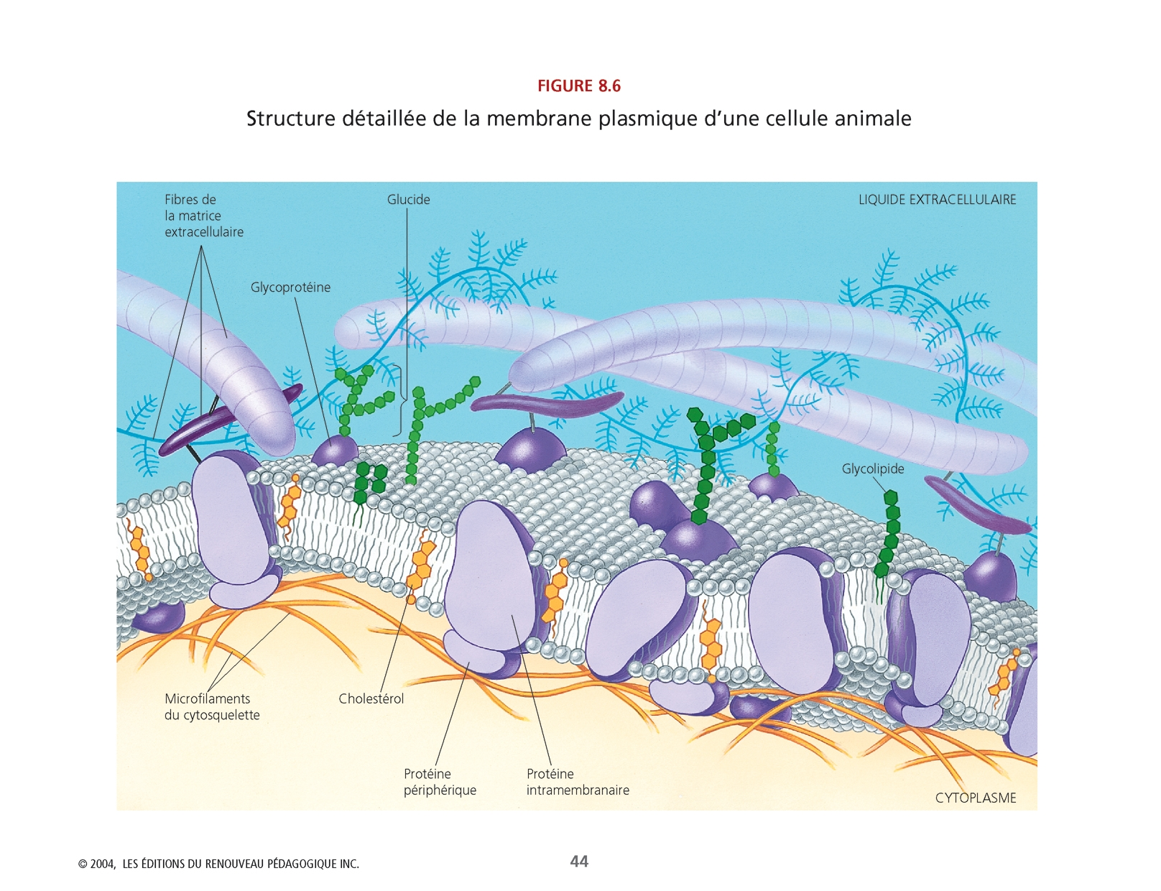

- FOR THE MATCHING THIS IS THE ANSWER
- Channel proteins
- Involved in the passage of molecules or ions through the membrane;
- Ex.: hydrogen
- Carrier proteins
- Combine with a substance and help it move across the membrane;
- Ex.: sodium and potassium
- Cell recognition proteins
- Glycoproteins help the body recognize foreign substances so that immune system may attack them;
- Ex.: pathogens
- Receptor proteins
- Have a shape that allows a specific molecule to bind to it. The binding causes the protein to change its shape and brings about a cellular response.
- Ex.: hormones
- Enzymatic proteins
- Carry out metabolic reactions directly
- Ex.: ATP metabolism.
- Junction proteins
- Form various type of junctions between animal cells
- Ex.: Signaling molecules

- LOOK AT THE PLANT CELL WALL SLIDE

- FOR CHAPTER 6 - a tour of the cell
- Why are cells so small and the disctintion between Prokaryotic cells Vs eukaryotic cell
- Matching the structure with the function on exam for this diagram

- 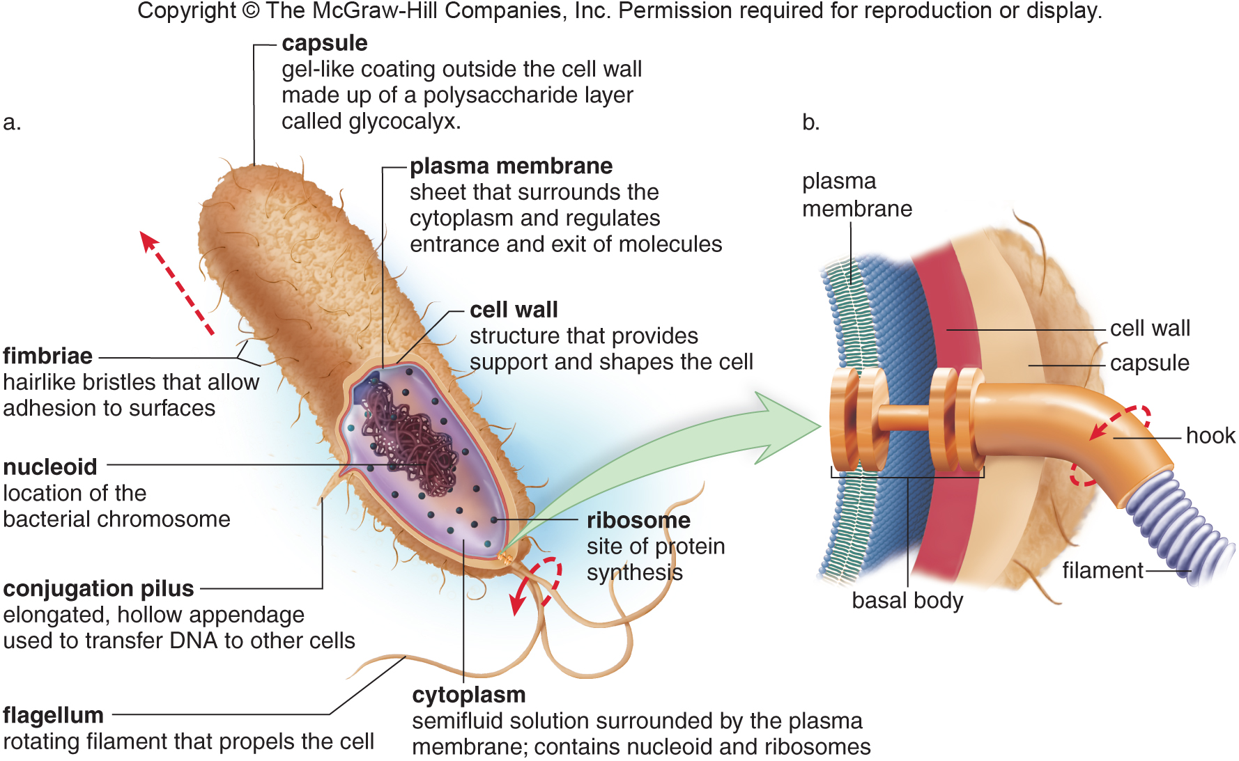
- make the distinction between prokaryotic cells animal and plant cells

- Next midterm chapters 19 virus structure, 16 dna structure and app, 17 proein synthesis, 12 cell division, 13 meiosis = july 30th Wednesday

- 9th edition
- Page 395 1,5,6,9
- Page 303 2, 3, 4, 5,7,10,13
- Chap.17 page 350, 1-6,8,10
- Chapter 12 page 244 1-3, 5-11
- Page 261 1-6,8,9

- Domains and kingdoms of Living world
- Living world:
- 1. Domain I Archaea
- 2. Domain II Bacteria
- 3. Domain III Eukaryotes

- Notes in notebook

