Sensory System

For homeostasis to function properly it is necessary for the body to detect changes in the external environment so it can react appropriately in order to maintain its internal environment.
The human body has several sensory systems that allow it to detect these external changes rapidly.
These systems include:
- The somatosensory (touch) system
- The visual system
- The auditory and vestibular system
- The olfactory (smell) system
- The gustatory (taste) system

Transduction of Environmental Information

It is how information from the external environment is turned into language the brain understands action potentials

Environmental stimuli (ES)
- It is energy like light, heat, touch, or sound
- This energy must be detected by sensory receptors which then convert the information into action potentials
- The stimuli comes in different forms and, therefore, will require different receptors to detect the stimulus and then convert it to action potentials
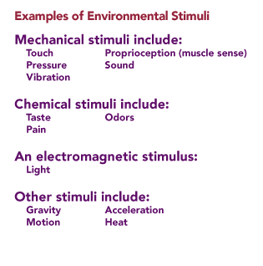
- Example:
  - A Mechanical stimulus will stretch the sensory receptors in the skin and open ion channels, causing a depolarization of the sensory neuron producing an action potential
  - A Chemical stimulus binds with a receptor, causing depolarization and then an action potential
  - A Light energy is absorbed by photoreceptors of the eye (rods and cones in the retina) and eventually produces action potentials
  - A Gravity and motion type of stimuli can also be detected by hair cells in the vestibular system, which convert this form of external stimulus to action potentials
- Some receptors can detect more than one type of stimulus
- Adequate stimulus – ES and most sensitive sensory receptor
  - The adequate stimulus for the rod and cone cells found in the retina of the eye is light
  - Example: If a pencil tip touches a point on your hand, it provides adequate stimulus for the activation of the cold receptor.
- Sensory receptors do respond to other forms of energy but not in an optimal way
- Example: the rod and cone cells of the eye also respond to pressure on the eyeball

Receptors (Generator) Potentials
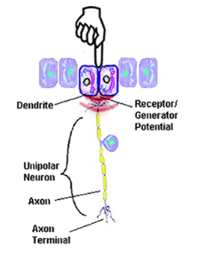
Once the sensory receptor is stimulated by an environmental stimulus, it will cause a change in ion permeability, leading to a local depolarization
This local depolarization is called a generator or receptor potential (RP)
- Since the receptor does not have voltage-gated ion channels necessary to fire an AP, the RP must spread to an area on the sensory neuron that does contain these channels
- This is usually at the first node of Ranvier on the axon
- The AP will then be generated and propagated along the axon and into the spinal cord
- In receptors with no axons (like hear cells in the inner ear), the depolarization has to spread to the synapse to result in the release of a neurotransmitter
- RPs are similar to EPSPs and IPSPs and share some of the same characteristic:
  - They are generally depolarizing but can by hyperpolarizing as well
  - They are caused by an increase in permeability to sodium ions or potassium ions in the cause of a hyperpolarizing stimulus
  - They are local and do not prorogate down the neuron like an AP but spread like an EPSP, decreasing with time and distance from the stimulus
  - They are proportional to the strength of the stimulus – the stronger the stimulus, the large the RP and the more likely to fire an AP
- Receptor Potential and Neural Coding
  - Neural coding informed the brain of the weight of an object in your hand
  - The heavier weight will trigger the receptors to produce a large RP
  - This large RP will trigger many APs on the sensory neurons axon
  - This burst of high-frequency AP will eventually reach the brain where you become consciously aware of the heavier weight in your hand

The Somatosensory System

The Somatosensory system detects and processes the sensations of touch, vibration, temperature, and pain (majority of which originate in the skin)
Detecting each sensation requires several different sensory receptors within the skin, each developed to detect its adequate stimulus
The receptors in the skin are collectively referred to as cutaneous receptors. They include the following:
- Hair Follicle Receptors – sensitive to fine touch and vibration
- Free Nerve Endings – respond to pain and temperature (hot and cold)
- Meissner’s corpuscles – detect low-frequency vibrations (between 30 and 40 cycles/sec) and touch
- Ruffini’s corpuscles – detect touch
- Pacinian corpuscle – detect high-frequency vibrations (250 to 300 cycles/sec) and touch

Receptive Field

This is an area on the surface of the skin where an adequate stimulus will activate a particular receptor to fire an AP in the neuron
Any stimulus applied outside the receptor field will not generate an AP
After AP have been generated in the sensory nerve, they must be propagated to a specific area of the brain so that the individual becomes consciously aware of the stimulus
These APs reach the brain via two spinal tracts:
- Spinothalamic (Anterolateral) Tract
- Tranmits information dealing with very basic sensations like pain, temperature and crude touch
- The information from the sensory neuron (first order neuron) enters the spinal cord where is synapses with a second order neuron
- The second order neuron crosses to the opposite or contralateral side of the spinal cord and ascends to a region of the brain called the thalamus
- The thalamus acts as a relay station for almost all sensory information (except smell)
- A second synapse with a third order neuron occurs here and then travels to the somatosensory cortex
- Note: Important to realize that sensory information from the right side of the body goes to the left side of the brain
- Dorsal Column, Medial Lemniscal System
- Transmit information associated with the more advanced sensations of fine detailed touch, proprioception (muscle sense), and vibration
- The information from the sensory neuron (first order neuron) enters the spinal cord and immediately travels up the spinal cord because crossing to the contralateral side (unlike the spinothalamic system)
- In the upper spinal cord, the sensory neuron synapses with a second order neuron which then crosses to the opposite side of the spinal cord
- From here it continues to the thalamus where it synapses again onto a third order neuron that then travels to the somatosensory cortex

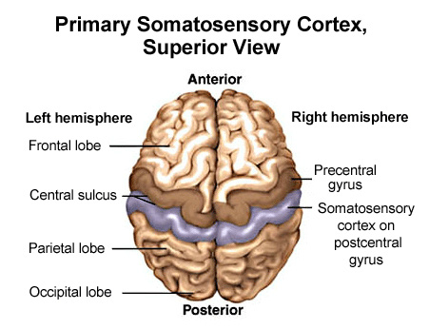
Primary Somatosensory Cortex

Once the sensory information has reached the brain, it travels to the primary somatosensory cortex, which is located in the parietal lobe on the postcentral gyrus behind the central sulcus
- The Somatosenory Homunculus
- Arranged in a very specific manner
- The sensory information arriving at this cortex is not randomly scattered around on the surface; rather, it is geographically preserved
- It is as if the entire body were projected onto the surface of the brain like a map
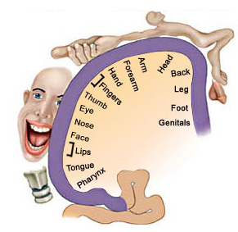
- All the sensory information for the foot is located in one area-that of the leg just next to it and the hip next to the leg, and so on-for the entire body
- This topographical representation of the body on the surface of the cortex is called the somatosensory homunculus
- Some of the areas of the human body take up more space in the somatosensory homunculus
- Areas dealing with the hand, tongue, and lips, receive more sensory information and require more of the brain to process that information
- The hands, tongue, and lips are the most sensitive parts of the body; they contain many more sensory receptors than any other part

The Visual System

The visual system detects light, converts it into APs, and sends these to the primary visual areas for processing
Once processed, we become aware of our visual world and are able to distinguish and recognize features in our external environment

The visual system consists of:
- Eye contains photoreceptors that convert the light to APs
- Visual Pathway transmits the APs
- Primary Visual Area in the occipital lobe of the brain (which processes the incoming signals)

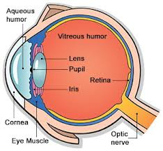
- The Eye
- After passing through the cornea, the amount of light is regulated by the iris, which can constrict with bright light or dilate in low light
- The lens flips the light (upside down and backwards) and focuses it onto the retina at the back of the eye
- The retina contains photoreceptors called rods and cones
- The rods and cones actually point toward the back of the head
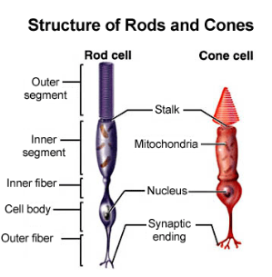
- The center of your vision is focused onto a part of the retina called the fovea. This area has the highest [ ] of cone cells
- The Photoreceptors of the Eye – Rod Cells and Cone Cells
- Rods
- Are extremely sensitive to light and therefore functions best under low light conditions
- They contain one type of photopigment (a chemical sensitive to light), and do not detect color
- Rods are located mostly in the region of the retina outside and around the fovea
- Cones
- Functions best under bright light and are ideal for detecting detail
- There are three different types of cone cells, each with a different photopigment and each sensitive to one primary color
- The cones are principally located in the region of the fovea where they are found in large [ ]
- Rods and cones do not have axons and therefore do not generate APs
- Generate RPs that cause the release of an inhibitory neurotransmitter from their synaptic ending
- Other Cells of the Retina
- The retina contains a pigment layer at the very back of the eye that absorbs excess light
- Other cells in the retine include:
- Bipolar cells
- Ganglion cells
- Horizontal cells
- Amacrine cells
- These other cells are responsible for the integration of information from the rods and cones and the production of APs

- Transduction of Light to Action Potentials
- The visual system works “backwards”
- When depolarized, the rod and cone cells release an inhibitory neurotransmitter, shutting off the biopolar cells
- When light strikes the retina, it does not excite and depolarize the rod and cone cells
- The light actually hyperpolarizes these cells and shuts them off
- Since these cells release an inhibitory neurotransmitter when depolarized in the dark, they inhibit the bipolar cells
- When light strikes the photoreceptors, they hyperpolarize, shut off, and stop releasing inhibitory neurotransmitter
- The bipolar cells, which can depolarize spontaneously (by themselves), now become activated
- Eventually, the depolarization of the bipolar cells may lead to an AP in the ganglion cells
- How Light is Transformed into APs
- In the dark, Na⁺ are flowing into the photoreceptors, producing a depolarization
- This leads to the release of the inhibitory neurotransmitter
- When light strikes the rod and cone cells, it closes these Na⁺ channels
- With less Na⁺ coming in and K⁺ leaking out, the cell hyperpolarizes
- With the rods and cones hyperpolarized, no inhibitory neurotransmitter is released and the bipolar cell depolarizes
- Types of Eye Movements
- Saccades
- Rapid, jerky movements of the eye
- Used to rapidly move the eye to the object of interest
- Example: Gazing around a room while holding your head still or reading these words on your computer
- Smooth Pursuit
- Smooth movement of the eyes that is made to keep a moving object of interest focused on the fovea
- Example: following the light of a bird through the sky while keeping your head still
- Vestibular Ocular Reflex (VOR)
- Eye movements that are made when you focus your attention on an object and then move your head back and forth or shake it up and down
- Example: Staring at someone with whom you are disagreeing or agreeing
- Vergences
- Eye movements that are made when an object of interest is approaching or moving away from you
- When the object is moving away, the eyes diverge, when the object moves closer, the eyes converge
- Example: Staring at a pencil while moving it away from and towards your face

The Auditory System

The auditory system converts sound waves from the external environment into APs that travel to the auditory system of the brain
Detect sound frequencies ranging from 20 waves per second (or Hz) to 20,000 Hz
Most acute hearing occurs in the range of 1,000 to 3,000 Hz

Structure
- The external or out ear contains the ear or aucile and the external auditory canal
- Middle ear consists of the eardrum (or tympanic membrane), the ear ossicles (which are made up of three bones – the malleus, incus, and stapes), and the Eustachian tube
- Inner ear consists of the vestibular apparatus, which is involved with the sense of balance, and the cochlea for the processing of sound
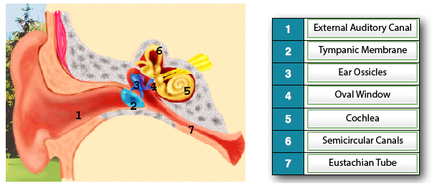

Structure of the Cochlea
- Cochlea resembles the shell of a typical garden snail
- Divided into three compartments: scala vestibule (vestibular duct), Cochlear duct, and a scala tympani
- Separating the cochlear duct and the tympanic duct is the basilar membrane, which contains the organ of Corti
- The organ of corti is where the sound waves are converted to APs by special hair cells
- These hair cells are embedded in the tectorial membrane

Sound
- Sound is not created until this wave of air pressure hits parts of the ear (or microphone) and turns it into electrical information (APs in the CNS) that is then interpreted as sound
- Frequency and Intensity of Sound Waves
- The frequency of a sound wave is the number of waves (or cycles) per unit time, while the intensity (or loudness) is expressed by the height (or amplitude) of the sound wave
- Transfer and Amplification of Sound Vibrations
- The airwaves created by a falling tree travel through the air and reach the outer ear
- These waves are funneled into the external auditory canal and strike the tympanic membrane, causing it to flex back and forth
- The levering action of the ear ossicles amplifies the pressure waves that strike the tympanic membrane
- The ear ossicles cause the oval winder to vibrate; this is a small membrane-covered opening directly underneath the stapes (one of the ear ossicles)
- Since the ear ossicles amplify the vibrations of the tympanic membrane and since the oval winder is much smaller than this membrane, the waves are amplified 15 to 20 times their original amount
- Fluid inside the cochlea, called perilymph, then transmits the waves to the hair cells embedded in the basilar membrane, which detect the vibrations and turn them into APs in the auditory nerve
- Transduction to Sound to Action Potentials
- We hear different frequencies of sound because of the vibration of the basilar membrane (basement membrane)
- The pressure waves in the fluid created by vibrations of the oval window produce a traveling wave on the basement membrane, which reaches a peak at different regions of the membrane
- This happens because the membrane is not consistent along its length
- Basilar (Basement) Membrane
- Not uniform shape and tension also varies along its length, being
“tight” at the base and “loose” at the top
- Depending on the part of the membrane that is vibrating, only certain hair cells will be activated by certain sounds: low frequencies will stimulate hair cells at the apex (top) of the cochlea, and high frequencies will stimulate hair cells on the membrane near the oval window
- The length stiffness of the hair cells also differ slightly along the length of the membrane

- Basilar Membrane and Brain
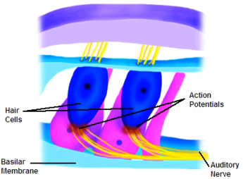
- When the basilar membrane vibrates, the hair cells are bent, causing ion channels to open and depolarization of the cells
- The depolarization causes the release of a neurotransmitter from the hair cells, exciting neurons of the auditory nerve which then fire APs
- The louder the sound, the stronger the vibration of the basilar membrane, the more bent the hair cells, the more neurotransmitter released, and the higher the frequency of APs produced
- These signals flow to the auditory cortex located in the temporal lobe of the brain

The Vestibular System

Vestibular system is located next to the cochlea and is responsible for maintaining balance, equilibrium, and postural reflexes
It performs these functions by detecting linear and rotational motion and the position of your head relative to the rest of the body
The vestibular apparatus is also responsible for one of the types of eye movements we looked at earlier called the vestibular ocular reflex (VOR)

Structure of the Vestibular Apparatus
- The Semicircular Canals
- Detect only rotational or angular acceleration/deceleration of the head
- Three and each one will detect movement in each plane of motion
- Filled with a fluid called endolymph
- At the end of each canal is a swelling called the ampula, and inside the the ampula is a sensory region call the crista ampullaris
- The crista ampullaris contains the sensory hair cells, which are fixed at their base, while their cilia are embedded in a gelatinous materal called the cupula
- When the head is rotated to the left, the endolymph inside the canals lags behind and seemingly moves to the right
- The endolymph hits the cupula and bends the hair cells embedded in it
- When hair cells are bent in a particular direction, they will depolarize and fire APs, sending signals to the brain
- When bent in the opposite direction, they will hyperpolarize, sending no signals to the brain

- Otolith organs
- Which detect linear accelerations and decelerations and the position of your head when it is tilted
- Two and one is for detecting linear acceleration in the vertical plane (up and down) which is the utricle and another for accelerations on the horizontal plane which is the saccule
- The utricle detects horizontal accelerations and decelerations
- Both organs at together to detect head tilts
- Each Otolith organ contains many hair cells that are anchored at their base and have their cilia embedded in a gelatinous membrane
- The gelatinous membrane has Otolith crystals embedded in it to give weight and inertia during movements
- When the body is at rest, there is a regular series of APs being produced in the vestibular nerve:
- The body accelerates in either the vertical or horizontal plane, the Otolith crystals initially lag behind and seem to move in the opposite direction, to the acceleration
- This bends cilia of the hair cells in the opposite direction, causing them to increase the frequency of APs in the vestibular nerve (the faster the acceleration, the higher the AP frequency)
- When the body is moving at constant velocity (neither accelerating nor decelerating), the hair cells return to their “resting state” as do the frequency of APS
- When the body begins to decelerate, the hair cells bend in the other direction, which causes the frequency of APs to decrease further from the resting state (the more rapid deceleration, the lower the AP frequency

The Hair Cell
- When the hair cells are at rest, they release a small resting level of neurotransmitter from their base onto the sensory nerve, which fires APs
- When the smaller stereocilia bend toward the large kinoclilium (during an acceleration, for example), the hair cell releases more neurotransmitter, causing more APs in the sensory nerve
- When the stereocilia bend away from the kinocilium (during a deceleration, for example), the hair cell releases less neurotransmitter resulting in fewer APs

