Storm Energy
- Sun – The Source of Atomosphere Heat
- Solar energy is absorbed at 3 different heights:
- Top (thermosphere) – absorption of non-visible light
- Middle (stratopause) – absorption Of ultraviolet by good ozone
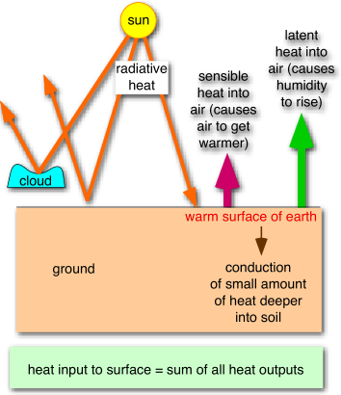
- Bottom (earth surface) – light shines through lower atmosphere with little direct heating of air, but heats the ground instead. Then the warm ground heats air in troposphere (the bottom 11km), ad powers storms.
- Surface Heat Budget
- Some solar energy reflects back into space: some intercepted by clouds → scattered back to space; some reflected from ground
- Some absorbed by the ground → warms the surface
- Absorbed sunlight at ground changes into:
Sensible Heat (warms the air): temp increases
The two heat sources that fuel storms
Latent Heat (evaporates water from lakes, vegetation, etc): humidity increases
- Both temperature and humidity are important
- Daily Cycle
- Solar heating during day – input (like charging a battery)
- Infrared radiation (IR) cooling at night – loss (like discharge)
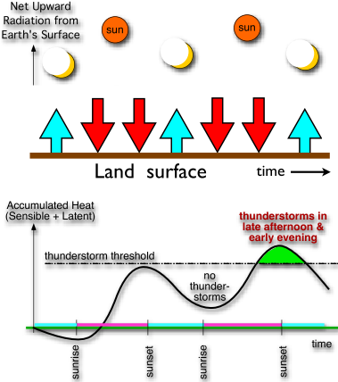
- Greatest accumulation of heat, near sunset every day (at end of each charging cycle)
- Late afternoon and early evening – most likely time of day for Tstrom formation.
- Moist Air – the Fuel for Storms
- Storms have special organization and capability to:
Draw in humid air, then to cause it to condense and release its heat into the storm, result in precipitation and violent winds
- Humidity: is the amount of water vapour in the air.
Mixing ratio = the amount of water vapour divided by the amount of all other gases
- Saturation – an EQ between evaporation & condensation:
Mixing Ratio at EQ is called saturation mixing ratio
Saturation value is maximum humidity that air can hold
Saturation value is important in controlling atmospheric humidity.
Warmer air can hold more water vapour at EQ than colder air
Air that contains this max amount = saturated
Air holding less = unsaturated
- Adiabatic Cooling:
When air rises, it cools. Cooler air can hold less water as vapour. Therefore, some vapour must condense into liquid droplets. But condensation releases latent heat.
Storms strengthen when latent heat change to sensible heat.
If the saturation humidity value becomes smaller than the actual humidity, then condensation occurs.
Condensation – releases sensible heat into storms, reduces the humidity down to the EQ (saturation) value & produces or increases liquid cloud drops, which can grow to become rain drops
Condensation in Tstorms releases latent heat. Latent heat warms the Tstorm air, making it buoyant and causing the air to rise. This is what drives the violent updrafts in thunderstorms.
Rainfall = precipitation: Strong storms → heavy precipitation
Strong radar reflectivity (large dBZ)
Heavy rainfall rate (RR) – measured by increase of depth of water in raingauge
Average warming rate – the average temperature change ΔT over time interval Δt is:
ΔT/ Δt = a * RR (a=0.338k/mm)

Thunderstorms
- Thick clouds with lightning & thunder
- Cloud top near top of troposphere (10-15km)
- Cloud base near ground (altitude ~ 1km)
- Looks like anvil or mushroom
- Strong updrafts & downdrafts (turbulent)
- If very strong updrafts then dome of clouds overshoot above the anvil (100s km in diameter)
- Main updrafts (stem of mushroom is 15km diameter)
- Storm energy from temperature & humidity
- Thunderstorm Cells:
- Cumulonimbus (thunderstorms) are made of large cells that evolve during 15-30mins
- Most thunderstorms contain 2 or more cells, and are called multicell thunderstorms
- Sometimes a very large, rotating single-cell thunderstorm forms, called supercell storm – they can cause tornadoes, large hail, frequent lightning, heavy rain, strong winds: strongest.
Three-stage model of thunderstorm – Airmass thunderstorm
- The Cumulus Stage
- Inside cloud and outside cloud temperature is different in same altitude.
- Air in the updraft is warmer than surrounding air: buoyant
- If it rises high enough, condensation occurs; condensation releases latent heat (warms the air within the cloud).
- The thunderstorm begins as a typical cumulus cloud – warm, moist, unstable low-level air is heated to buoyancy.
- The Mature Stage
- After 15-30 minutes reaching the cumulus stage, precipitation begins.
- A strong, deep updraft (20-40mph) may lift air as high as the tropopause, whose stability caps the upward motion and causes an anvil to begin forming.
- Precipitation particles rise in the updraft and then spread into parts of the cloud lacking strong updrafts. As they fall, they begin to drag the surrounding air downward with them, initiating a downdraft.
- Cools the lower-level air by: Contact between rain and air & amount of the precipitation evaporate in the surrounding air from the cloud base.
- Sink faster: the cooling increases the air’s density in the downdraft.
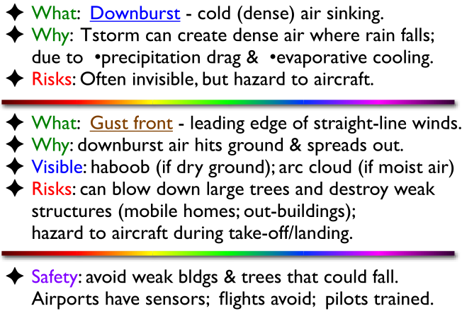
- Gust front: the boundary between cold outflow and the warm ascending air.
- Downburst: rain-cooled air that, after reaching ground level, spreads out in all directions producing strong wind; microburst: shorter-lived downburst, small diameter downbursts
Speeds of 20 to 90km/h
Horizontal wind speeds near ground of up to 250km/h

- Dissipating stage
- Weak downdrafts, light precipitation, and temperatures colder than those at the same level outside the cloud characterize the lower regions of the cloud in this stage.
- Thunder and lightning diminish
Supercell Thunderstorm: the most violent & longest lived
- Often the whole Supercell Thunderstorm rotates as Mesocyclone, and can spawn tornadoes
- Observing and Monitoring using Remote Sensors: Radar – sees the precipitation inside the storm; namely, in the up- & downdraft stem of the mushroom cloud, satellite
Thunderstorm Frequencies
- Form @ warm, moist, unstable air, low-level, and some lifting mechanism.
- Lifting the surface air from this new position will make the rising parcel even warmer and more unstable than the environmental air, providing the lift to initiate deep convection and leading to thunderstorm formation.
- U.S., maximum occurs in the southeastern states.
- The Florida peninsula is well situated for thunderstorm development.
- Colorado southward to New Mexico and Arizona.
- Thunderstorms are more common in lower latitudes (where cool ocean water and a persistent inversion).
- Occur most frequently in the warmest months of the yr and hrs of the day; most common in the tropics, particularly over land in the vincity of the intertropical convergence zone.
Induction – the approach of a charged object.
Electric discharge current – the spark is a momentary flow of charged particles between oppositely charged objects
Properties of Thunderstorm Electricity
- The air (excellent electric insulator) prevents electric currents from flowing between the charge centers.
- Charges increase beyond certain values, or if the charge centers move close to one another, or if the atmosphere’s conductivity increases (precipitation substantially improves conductivity), a brief electric discharge current flows through the air.
- -ve charge in the central and lower cloud levels, upper regions are +ve.
- The most intense –ve chage is at the -15°C level: active precipitation region.
- Cloud base: generally negative but due to the vicinity of precipitation, positive charge often occurs.
How does charge separation occur in a thunderstorm?
- Convective Hypothesis:
- The general configuration of positive charge aloft and negative charge at lower levels in thunderclouds.
- Fails to account for the fact that negative charge seems to collect at the -15°C level
- In fair weather, the lower atmosphere and the ground posses a slight surplus of positive charge.
- Convective currents within a vigorous thundercloud sweep some of this low level positive charge to upper cloud regions.
- This positive charge center aloft attracts negative ions from the upper atmosphere to the cloud boundaries
- The downward-moving negative charges encounter downdrafts on the periphery of the cloud, which carry them to middle and lower levels of the cloud.
- Precipitation Hypothesis:
- The smaller particles acquire positive charges at cold temperatures. Also, the fact that lightning often occurs at the onset of precipitation is evidence in support of a hypothesis that links precipitation and lightning.
- Graupel particles and ice crystals collide within the cloud. The collision causes electric charges to become separated. The ice crystals acquire a positive charge, while the graupel becomes equally but negatively charged.
- Updrafts carry the lighter, positively charged particles higher in the cloud than the negatively charged graupel.
The Turbulent Atmosphere
- Air motions = winds : blow in more warm, humid air = positive feedback = longer-lasting storms
- Forecasting the Winds: combining Newton’s Law, definition of acceleration gives forecast method called prognostic equation: v_{new} = v_{old} + [(F/m) * Δt] (CI)
- Air parcel = hypothetical blob of air about the size of a city block
- Air parcel movement = wind: so equation CI is a forecast equation for the wind. It tells how winds will increase or decrease or change direction, depending on the forces that act on air parcel.
- Buoyancy force – cause up and downdraft
- Pressure-gradient force (PGF) – horizontal PGF = horizontal winds
- Warm air rises – updrafts; cold air sinks – downdrafts
- The buoyancy of an air parcel depends on the difference between the parcel temperature and the temperature of the surrounding air
- Warmer air is less dense; colder air is more dense
- Pressure-gradient force is caused by the difference between two pressures across a distance.
- Air warms in the core, the air expands – less dense than cool air, hence it takes up more space. This causes pressure at the top of the core to be greater than surrounding pressures. The horizontal pressure gradient at the top of the hurricane creates outward spiraling winds. These winds remove air molecules from the core.
- Horizontal change in temperature → horizontal changes in pressure that increase with height → pressure gradient increasing at higher altitudes → drives faster winds at higher altitudes
This type of pressure-gradient force drives the violent winds in hurricanes.
- Continuity links vertical and horizontal winds into circulations: buoyancy in the vertical, or by horizontal pressure gradients
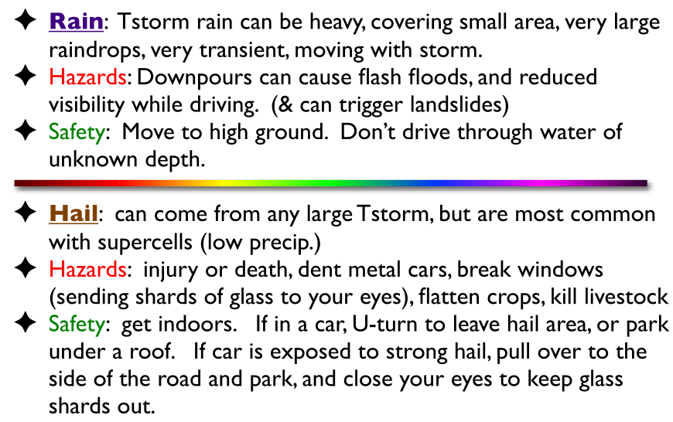
The Lightning Flash
- Sound travels slower than light
- Count the numbers of seconds between when you see the lightning and hear the thunder, divide the number by 3 to estimate the range in km to the lightning.
- 30/30 Rule: if 30 secs or less between when see flash and hear bang, then move indoors and stay there until 30 minutes after last lightning or thunder
- Safe places: fully enclosed metal vehicle with windows, and substantial permanent building, but don’t use hard-wired telephones.
- If stuck outdoors, avoid unsafe areas: small structures, huts, rain shelters, nearby metallic objects (pole, fence), trees, water, open fields, hill tops, etc.
- Cloud-to-ground (CG):
- To make a spark in air, you need 3 billion volts/km
- Lightning from the anvil travels a longer distance, which can happen only if more volts.
- In Canada, over 90% of positive CG has single stroke.
- Negative CG can have > 10 strokes, but mode is about 2 strokes/flash
- A buildup of negative charge near the cloud base induces a strong positive charge on the ground, particularly on tall objects.
- Negative strikes: are more numerous, come from cloud base
- Positive strikes: are less frequent, come from the anvil, are often much stronger, are the primary cause of natural wildfires, 10 to 25% of Canadian CG lightning is positive.
- Stepped leader: a flood of electrons rushes earthward in a series of segments.
- Return stroke: carries the main flow of electricity, a positive current from the ground to the cloud.
- Charge buildup → Stepped leader → Return stroke → (multiple) Lightning flash
- In-cloud:
- The upper level’s positive charge attract with another cloud’s negative charge at the lower level.
Thunder: is sound made by a lightning bolt.
- Caused by (air heated by), expanding and colliding with unheated air.
Multicell Thunderstorms:
- Caused by:
- General environmental heat, moisture, instability
- Lifting by gust front
- Colliding downdrfts from nearby cells
- Creates daughter cells
- Can produce variety of severe weather: hail, damaging winds, torrential rain, and tornadoes.
Frontal and Squall Line Thunderstorms:
- Thunderstorms may form at the front due to frontal lifting and then move forward faster than the front, generating daughter cells as they go
- Wave motions caused by air flowing over the front may induce a region of rising air downstream. If air is unstable, this lift may be sufficient to initiate thunderstorm formation.
- Wind shear
- Strong lifting
- Rotation
- Can produce variety of severe weather: hail, damaging winds, torrential rain, and tornadoes.
Mesoscale convective complexes (MCC):
- Generate most of the precipitation during the growing season in many agricultural regions of the Midwest.
- Can produce variety of severe weather: hail, damaging winds, torrential rain, and tornadoes.
- Larger associations of thunderstorms than squall lines; multicell and squall line mixed.
- Tend to form within regions of deep and extensive warn, humid air.
- Cyclonic convergence at low levels and divergence aloft.
Supercell Thunderstorms:
- The most intense thunderstorms: severe thunderstorm.
- Capable of producing hail 3/4 inch or more in diameter; winds of 50 knots or more.
- Heavy downpours, flash flooding and frequent lightning occur.
- The one of exceptional size and intensity that persists in the mature state for considerably longer than most thunderstorms.
- (Intense updrafts) Bounded weak echo regions (BWER): the moisture particles pass through the strongest supercell updrafts so rapidly there is not time for them to grow to be strong radar target.
- (rotation) Mesocyclones: inflowing warm, moist surface air spirals cyclonically as it is drawn toward the updraft, where a small-scale, counterclockwise turning, low pressure center called a mesocyclone form.
- Wind shear
- Produce most tornadoes
- Intense, large, single cell thunderstorms

Tornadoes
- Recognizing Tornadoes
- Tornadoes are violently-rotating columns of air, in contact with the ground.
- Many different types of tornadoes exist.
- The most violent tornadoes come from supercell thunderstorms
- Most tornadoes are made visible by cloud-water droplets (the funnel cloud) and/or dust and debris from the ground (the debris cloud). Some tornadoes are invisible.
- In N. America most thunderstorms move from SW toward NE
- Recognizing a supercell rotation:
- Striation around the mesocyclone
- A rotating wall cloud – tornadoes come from wall clouds in supercells
- Speeds and Disaster Scales
- Most move at speeds near middle of that range
- Rotational (tangential) speeds around tornado center are much faster than translation speeds. These rational winds cause the damage.
- Enhanced Fujita Scale: determined by amount of damage buildings
- TORRO Scale: determined by wind speed
- Tornado Safety
- Tornadoes are short lived
- Indoors: below ground, in a basement or storm cellar, get out of mobile homes
- Outdoors: get into a ditch or hole, place your body below line of fire of fast moving debris
- In car: drive away from tornado on best convenient road, preferably to right or left of translation direction of tornado, do not hid under highway bridge or overpass
- Tornado Risk:
- U.S.: Oklahoma, the center of Tornado Alley; Canada: Ontario
- Tornado Outbreaks:
- 6 tornadoes in one day and one region, or many tornadoes during about a week.
- Outbreaks occur almost every year in N. America
- Tornado Evolution
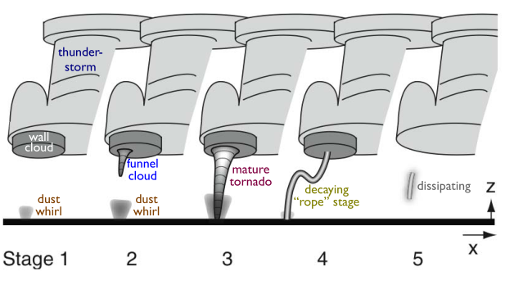
- Forecasting Tornadoes is Very Difficult
Watch:
- 6 to 12 hr forecast
- A broad region within which tornadoes are favorable or likely later in day
Warning:
- Tornado actually detected now, by either: Doppler radar – sees tornado vortex signature or TVS, or Human spotter or other gov. official actually sees a tornado
- Tells: where tornado is, where it is moving, warnings to specific towns or countries tornado sirens activated.
- Warning come only 15mins or less prior to a tornado hitting you, so you must immidately terminate normal activities and go to tornado shelter or other area of refuge.
- Observing: in field, weather radar observation (hook echo ), Fujita scale of tornado intensity.
- Suction vortices – within a tornado cloud. It is a smaller-scale swirls are thought to cause much of the damage in severe tornadoes.
- Produced from supercell thunderstorm and others (squall line and cold frontal thunderstorms).
- Form @ warm, moist conditionally unstable air; cold, dry air aloft; cappng inversion; rotation (mesocyclone); occur often in Southern U.S.
- (A) The thunderstorm and mesocyclone → (B) wall cloud → (C) tornado
- A. the mesocyclone is wider, shorter, and rotating more slowly than in later stages.
- B. the mesocyclone is stretched vertically and narrowed horizontally, with the result that rotation around its core becomes much faster as it conserves its angular momentum.
- The rotating mesocyclone and wall cloud are regions of intense low pressure. Air below the cloud base rushes into this cyclone, and, conserving angular momentum, it accelerates to great speeds. As its pressure decreases to match that of its surroundings, the air expands and cools. The cooling may lead to condensation, making the air visible as a funnel cloud.
- Wall cloud: is an isolated lowering of cloud base
- Waterspouts: develop where waters are warm.
- They are common off the coast of Florida, far north Canada (Great Lakes and Cape Breton).
- Forecasting:
- Watches: Tornado possible
- Warnings: Tornado imminent or reported
- Improvement: improved radar (WSR – 88D)
- Safety:
- Outside: abandon car, lie in low pot
- Inside: abandon mobile home, go to lowest interior locale.

Hurricanes
- Hurricanes & typhoons are tropical cyclones with surface winds turning counterclockwise and spiraling in
- Eye = center of hurricane (low pressure at sea level)
- Are made of thunderstorms: eye wall = ring of thunderstorms around the eye; spiral bands = bands of Tstorms extending out from the eye wall
- Persist if central pressure in eye remains low (to create wind, waves, and to suck in fuel of warm humid air, and the hurricane remains over the warm ocean
- Weaken and die if hurricanes cannot generate sufficient fuel of warm, humid air. This happens when hurricanes move over: colder water or in land.
- Heavy condensation and precipitation from thunderstorms in the eye wall cause the hurricane core (eye + eye wall) to become very warm relative to its surroundings. The warm core creates high pressure at the core top, and low pressure at the core bottom.
- Results in Vertical Circulation – strong updrafts in the eye-wall thunderstorms. Outflow at hurricane top away from core. Weak downward motion in the eye and outside the hurricane. Inflow at hurricane bottom toward core.
- Cycles back into base of eye-wall Tstorms as a complete circulation.
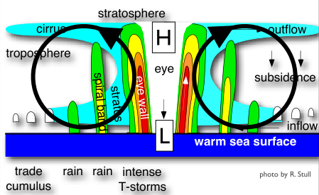
- Hurricane Katrina, New Orleans, 2005:
- Katrina lost strength crossing Florida, but after reaching the warm waters of the Gulf of Mexico, the storm grew rapidly, with wind speeds reaching 280km/h and its size nearly doubling.
- Katrina remains the costliest natural disaster in U.S. history The storm, the evacuation difficulties, the levee failures, the flooding, the destruction, and the deaths had all been accurately predicted for many years
- As levees are built higher and the city sinks lower, a bowl has been created, with lake and river water levels higher than city land levels.
- Results: an increasingly elevated Mississippi River. High lake levels. Much destroyed marshland between Gulf of Mexico and the city. Globally rising sea level. And more hurricanes.
- Suggestions: reduce the size of the city. Rebuild only on ground above sea level. Make New Orleans into an island. Restore marshlands between the Gulf of Mexico and the city. Raise ground level in the city. Construct huge levees and floodgates. Build bigger water-pumping system.
- Hurricane Hazel, Southern Ontario, 1954:
- First identified as a tropical storm, Hazel gained strength rapidly and reached hurricane status later that day.
- Haiti → the resort town of Long Beach in North Carolina (U.S.)
- Hurricane Hazel I joined together with Hazel II that was coming from the west. They combined forces. They headed directly toward Toronto.
- “the intensity of this storm has decreased to the point where it should no longer be classified as a hurricane. This weakening storm will continue northward, passing east of Toronto before midnight. The main rainfall associated with it should end shortly thereafter, with occasional light rain occurring throughout the night. Winds will increase slightly to 45 to 50mph until midnight, and then slowly decrease throughout the remainder of the night.”
- Hurricanes are large tropical cyclones. They are heat engines that convert the heat energy of the tropical ocean into the mechanical energy of winds and waves.
- Requirement:
- Seawater should be at least 27°C in the upper 60 meters of the ocean.
- Air must be warm, humid, and unstable enough to sustain convection.
- Upper-level winds should be weak and preferably blowing in the same direction the developing storm is moving
- The storm must be sufficiently far from the equator so that the Coriolis effect is strong enough to deflect surface winds.
- Aspects:
- Latent heat released by condensation of water vapour inside a hurricane is its main energy source
- Hurricanes that move onto land weaken rapidly
- Weather fronts are not associated with hurricanes
- The weaker the high-altitude winds, the stronger a hurricane can become
- Hurricane centers are warmer than their surroundings
- Hurricane winds weaken with height
- Air in the center of the eye sinks downward
- Development:
- Tropical disturbance: a low pressure zone that draws in a poorly organized cluster of thunderstorms with weak surface winds
- Tropical depression: as surface winds strengthen and flow more efficiently around and into the center of the growing storm.
- Maturity:
- Rainfall is most intense in spiraling bands of clouds surrounding the eye
- Winds strongest along the eye wall
- The general wind flow patter is convergent toward the center at low levels, rising in convective clouds and divergent at upper levels.
- The heat from the ocean causes the air rising in the eye wall to be warmer than the surrounding environment.
- As the air continues to rise, latent heat is released in staggering quantities. Once they reach the tropopause, winds diverge and lose energy to outer space by long-wavelength radiation. The cooled air begins to sink.
- To sustain the hurricane, air must flow into the system at a higher temperature than it exits the system.
Category 1 – Minimal
Category 2 – Moderate
Category 3 – Extensive
Category 4 – Extreme
Category 5 - Catastrophic
- The Saffir-Simpson scale based on three parameters: wind speed, barometric pressure, and storm surge elevation.
- Some hurricanes undergo a transformation process known as post-tropical transition and unexpectedly gain strength. (ex. Hazel)
- Storm surges: is an offshore rise of water associated with a low pressure weather system, typically tropical cyclones and strong extratropical cyclones. Storm surges are caused primarily by high winds pushing on the ocean's surface. The wind causes the water to pile up higher than the ordinary sea level.
The atmosphere drives an ocean disaster. Strong winds drag ocean water, raises sea level and causes water to pile up against shore – coastal flooding.
- Northern Atlantic Ocean Hurricanes:
- Large, mobile, and long lasting
- Storms reaching Canada are most often weakened and have lost their hurricane status when they come to shore.
- Exception: Luis – category 3on the Avalon Peninsula of Newfoundland.
- A total of 33 cyclones classified as hurricanes have made landfall in Canada.
- Hurricanes form when sea-surface temperatures are warmest, and in late summer in North Atlantic Ocean (mid-August and late October).
- 위험할 수 있는 주 – Ontario, Quebec, New Brunswick, Nova Scotia, Prince Edward Island, and Newfoundland : hurricanes are rare in Canada
- Cape Verde – Type Hurricanes
- Type tropical cyclones are blown across the Atlantic Ocean by the trade winds between 5°N and 20°N latitude.
- Galveston, Texas, September 1900 (category 4):
- The deadliest natural disaster in the history of the U.S.
- Paths of Cape Verde-type hurricanes are influenced by the size and position of a high-pressure zone, the Bermuda High.
- Juan, September 2003
- Caribbean Sea – And Gulf of Mexico – Type Hurricanes
- Occurs at the Intertropical Convergence Zone (ITCZ) – the convergence zone occurs where the trade winds meet near the equator.
- Where the airflows converge, a low-pressure area can form with thunderstorms, a large core, and rising moist air.
- Mitch, October 1998 (category 5):
- Was heading to Cuba but turned to Central America. (Honduras → Nicaragua)
- Second deadliest hurricane in the America.
- Hurricanes are frequent when: El Nino is absent, Warmer sea surface, Wetter summer
- Hurricanes are fewer when: El Nino is present, Cooler sea surface, Drier summer

