Eosc 114
Landslide

Vulnerability to landslides is increased
- increasing population density
- use of marginal land
- rapid land-use change
- global warming

The world's most devastating landslide disasters typically involve numerous fatalities due to both direct and indirect consequences.

1. Mass movement(mass wasting): downslope motion of soil and/or rock materials under the influence of gravity.
Landslide is general term for mass movements.
It occurs when gravitational force pulling the slope material down exceeds the slope material's internal resistance to
shear or failure. Moves downslope by sliding or shearing along a weak failure plane or a number of failure planes.

2. Gravity.
- main force responsible for landslides.

- Gp : acts perpendicular to the slope. Helps hold an object or slope materials in place on the slope.
- Gt : that acts tangential to the slope surface or parallel to and down the slope. Pulls an object or slope materials in the down-slope direction, causing a shear stress.

3. Shear strength
- internal resistance of body against shear stress.
- includes frictional resistance and cohesion.
- affected by
- 1. the type of soil or rock
- 2. the condition of the geologic materials (how eroded are they)
- 3. the presence of weak surfaces ( joints and faults)
- 4. por water pressure within the slope.

3a. The factor of safety

Compact -> stable.

Two factors determine the resistance to failure.
1. the weight of the material itself acting perpendicular to the slope, Gp which helps to hold the slope materials in place.
Another term for this is normal stress, σn.
2. factors that adds to the spaces between grains (primarily water pressure), which decrease the strength of the material. We
will represent this factor simply as pore water pressure, μ.

Unit B. Landslide Causes and Triggers.

1. Discerning a cause vs trigger.
Cause: a factor that makes slopes susceptible to movement without actually initiating a landslide
Trigger: Initiates movement by driving the Fs < 1.0.

- exmaples of trigger
- earthquakes
- volcanic eruptions
- intense, short-period rainfall
- mining and quarrying
- irrigation
- vegetation removal
- excavation of a slope at its toe
- loading of the slope at its crest
- and, loud noises or vibrations

- Factors that decrease slope stability when the Fs<1.0 or when shear strength is greater than shear stress are considered causes.

Trigger frequency is how often an event occurs that sets off a landslide (can be natural, human induced, or combination)

2. Slope stability and erosion.

Erosion: transport of material away from its source. Removing material at the base of slope can cause slope failure in one of two ways:
a. the driving mass becomes than the resisting mass.
b. the slope steepness at the base of the slope increases such that shear stress becomes greater than shear strength.

-Among many different agents, water is most common.

2. Slope stability and erosion.

Rapid Erosion: Large storms, either through heavy rainfall events or large pounding waves can cause rapid erosion and undercut coastal slopes, triggering large landslides.

3. Slope stability and vegetation.

- Affect the shear strength of the materials comprising the slope. Plant roots increase soil cohesion and strength by helping to bind loose materials.
- Roots decrease surface erosion and help to absorb excess water.
- More vege, more stable.

4. Slope stability and water content
Water plays an important role in either causing or hindering mass wasting and landslides:
- An excess water within a slope increases its mass, increase shear stress
- affect fluid pressure. it can build in such a way that water can support the weight of the overlying rock mass. This case happens when grains are cemented together and excess water sets the grains apart. When this occurs, friction decrease, and shear strength also decrease -> slope failure.
- Water increase the weathering of rocks when it flows into narrowest rock fractures. When water goes through, it freeze/thaw cycles, it can expand in volume by 9%.
- In sediment (loose rocks, sand, slit and clay), water helps or hinders cohesion.

5. Slope stability and seasonal precipitation
-Landslides occur more frequently after periods of heavy rainfall of water affecting the erosion rates.
-West coast of Canada: landslides are more common in the winter, when precipitation is high and spring when snows melt.
-More the intense and abundant of precipitation, more landslides.

6. Slope stability and volcanic activity
Deposition of loose volcanic ash on hillside accelerates erosion, and mud or debris flows triggered rainfalls. Volcanic eruption have triggered some of the largest historic landslides.

6a. Nevado del Ruiz, Colombia 1985
5389m. This volcano is covered with 25 squar kms of snow and ice.
Located in the Andes mountains of South America.
two and a half hours after the eruption, snow and ice melted and lahar traveled 100km.
killed 23000 ppl and 5000 injured. 5000 homes destroyed along the Chinchina, Guali, and Lagunilas Rivers.

6b. Mount St. Helens, Washington
1980 eruption, triggered by a massive 2.8 rockslide, triggered by ongoing volcanic activity.
rapid melting of snow and ice from the eruption induced mud flows.

7. Slope stability and earthquakes

Earthquake> M 4.0 trigger landslides in susceptible slopes.
Earthquake often dislodge loose rock resting on steep slopes trigger rockfalls.
due to earthquake, increase in the shear stress and decrease in the shear strength

8. Slope stability and anthropogenic activity
Ways in which humans can increase the likelihood of a landslide
- Excavation of a slope at its toe
- Loading of a slope at its crest (i and ii are commonly done during construction)
- Deforestation for constructing and development, including clear-cut logging on slopes
- Irrigation
- Mining
- Water leakage from utilities (iv, v, and vi can affect landslide probabilities by chaning groundwater flow and surface water drainage)
- Artificial vibration

10. Case Study: UBC's towers beach
- The erosion of the headlands of Point Grey and subsequent recession of the cliffs that bound UBC has been a concern since 1960
- univerisity is build on unconsolidated sands and silts.
- two berms(artificial beaches) have been constructed to curtail coastal erosion and allow downwasted material to accumulate at the base.
11. Case Study: The Vaiont Dam
- In 1956, SADE, installed.
- Landslide on October 9, 1963. 260 m^3 of rock collapsed.

Part C. Landslide classification

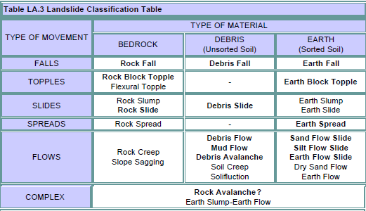

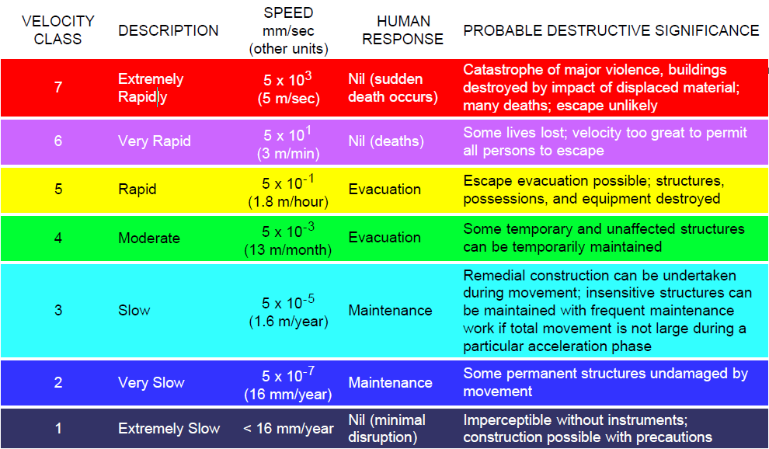

2. Falls
- sudden, vertical movement.
- occur on steep slopes with loose rock

3. Topples
- require forward rotation of material about a pivot point below the center of gravity of the unit

4. Slides

-involve large volumes of rock or soil material moving as an initally coherent mass on a sliding surface

- Rotational slides
- Translational slides

5a. Lateral Spreads
- occur where occur where there is slow to rapid extensional movement of rock or soil.
- usually related to the sudden liquefaction of a weak soil layer.
- in areas where loose soils are saturated with water, seismic shaking can cause liquefaction, the sudden lss of strength in the soil transforming.

5b. Sensitive Clays and Spreads
- Sensitive clays(quick clays): young marine clays deposited with a House of Cards-like structure.
- during earthquake, this structure may collapse and liquefy
- Canada's Quick Clays: The St. Lawrence River valleys are lined with thick beds of sensitive marine clays, known as Leda clay.

6. Flows, creep, and long run-out debris flows.

a. Flows occur where there is large volume of water present in a mixture of soil and debris. Flows flow with mixture.
b. Rock or soil creep
- type of flow where soil and upper bedrock zons move downslope extremely slow.
c. Debris flow
- rapid flow of fully saturated debris
Debris flows are common in BC coastal mountains because of heavy rain falls on steep slopes

d. Debris avalanche

7. Complex landslides
- formed by combination of two or more landslide types.
- example: long-runout debris: starts with rock fall that turns into debris flows
- Struzstorms: dry rock avalanche that travel a hot with only small vertical drop
- mass movement of dry rock debris
- avalanche volume > about 10^6 cub meters
- Ratio of fall height to run out length <0.6
- Mobility of sturzstorms increases with avalanche volume
- found on many solar system bodies
- flow like a fluid

D. Landslide mitigation

1. Landslide mitigation

1a. avoid
- An often used method of avoiding the problem is relocating a facility, structure, or route of a planned new road or rail line, to avoid areas along which landslide hazards may be a problem.

1b. prevention
- usually done by reducing the driving forces or by increasing resisting forces

1c.protection
- works towards minimizing the hazard presented (e.g. using rock fall nets)

2. Landslide frequency in B.C.
- In canada, about 5 ppl/yr die from landslide
- 365 deaths reported since 1855 from western canada
- annual landslide costs range from 50 milion to 1 bilion $
- landslide frequency in western Canada(BC, western Alberta) is 0.01 to 0.04 events/yr with return period of 25 to 100 yrs
- the return period for similar sized events can be calculated as
- why western canada?
-western Canada's mountainous terrain leads to higher shear stress which drives down the Fs
-complex geology
-frequent earthquakes

3. Anthropogenic affects
People heighten landslide natural disasters by
- Developing on steeper slopes
- removing vegetation
- excavation and slope loading
- altering water drainage
- altering climate

4. Case Study: the Frank Slide
- April 1903
- 82 million tonnes of limestone crashed from Turtle Mountain to town of Frank
- 76 pple dead.
- complex landslide.

5. Case Study: The Sea-to-sky corridor, Mount Garibaldi and Rubble Creek Landslides
Steep slopes, unstable and weak rock, frequent triggers like volcanic and seismic activity are prime cause for landslides
all three are present on the slopes of Mount Garibaldi which lies ~60km north of Vancouver along Howe Sound.

6. Case study: Lions Bay
- between Vancouver and Squamish along Hiway 99
-February 11, 1983, debris flow.
-killed 2 teenagers

7.Case study: Lions Bay Retention Dam
-built to protect towns.
purpose:
a. To remove debris from the flow mass.
b. to prevent more debris from begin incorporated into the flow mass
c. to decrease the flow's velocity and erosive capabilities.
d. to prevent debris from overtopping the channel

8. Living with Landslides
-identify landslide-prone areas
-if the slope is unstable enough, must either employ techniques to prevent a landslide, or move out if too expensive

some useful ways of engineering an unstable slope or reducing the harmful affects
-excavation
-grading
-pumping or draining water from the interior of the mass
-installing surface drainage devices
-plant veges
-build retaining walls
-reinforce the slide mass by using netting, blots, soil nails, or shotcrete
-inject cement, silicate, or an acrylamide-based slurry into drilled holes to increase stability and lower porosity of unstable rock

damage and loss reduced by
-identify high risk areas
-put in place effective warning and response procedures
-proper land-use management
-employ effective mitigation techniques

The least expensive option is to avoid development on landslide-prone slopes in
the first place.

