Lesson 3: Volcanoes
Unit A
1. Formation of magma/lava
Magma: melting pre-existing rock in Earth’s interior
*Melted rock= less dense than solid rock
For magma to rise through crust:
- < dense than crust
- Runny (low viscosity)
- Hot enough (liquid)
- Composition+ Temperature
Magma erupt+ cools = lava
Common Elements in crust:
-O (45%), Si (27%), Al (8%), Fe (5.8%), CA, Mg, Na, K, Ti, H, P, Mn
[Highlight=Major composition]
2. Composition of magma/lava
Magma cools and crystallizes minerals
=Naturally occurring element/compound
Ordered internal structure
Characteristic chemical composition,
Crystal form
Physical properties
=Most minerals out of magmasilicate minerals
(feldspar, quartz, micas, hornblende, pyroxene, olivine)
=Size of crystals duration of magma to cool
Intrusive rocks=slow underground cooling in crustal magma chambers (big)
Extrusive rocks (fine-grained) =quick surface cooling small (hard to see)
3. Volcanic Products
a) Lava Flows:
-magma w/ low gas content (< few percent) erupts effusively at surface
1. pahoehoe: ropy-textured
2. ‘a’a: rubble-y flow top consisting of broken fragments of lava
b) Volcanic glass:
-magma erupts + cools very quickly = no crystallization
-solidification glass (not crystalline/ may contain tiny crystals)
1. Obsidian=massive
2. Pumice = contain vesicles (bubbles)
c) Pyroclastic material:
-Fragments of all sizes erupted explosively
1. Ash: <2mm
2. Lapilli: 2-64mm
3. Blocks and bombs: >64mm
*many pieces of pumice pumice lapilli
-erupt as: ballistic, flows, fall deposits
d) Gaseous Products:
-Gas compoundsout of magma during eruption + form vesicles in rocks
-H₂O=most common
-CO₂ =colorless, odorless + denser than air=accumulate in low areas
-SO₂
-H₂S=rotten egg smell
-HCl
Sour taste + stinging nose/throat
4a. Factors influencing explosivity of magmas
*gas content (vary from 1 -10 %)
-Primary gas: H₂O and CO₂
-Magma rises to surface
Dissolved gases (compressed at depth) expand + try to escape
Gas bubbles form + grow + explode
-higher gas content= more explosive = hazardous

- Viscosity: resistance to flow
-high gas content + high viscosity = most explosive volcano
-Factors:
1. Chemical Composition: More SiO₂ = higher viscosity = resist flow
2. Temperature: Cools Si-O bonds form (polymerize) = more viscous
-Table of Viscosity (m)
* Higher m-value (log of the viscosity) = more viscous + explosive
- Same temperature magma w/ higher SiO₂ content = more viscous
- Same content lower temperature (1/T, T=temperature)
4b. Explosivity, viscosity and chemical composition of magmas
- Mafic magmas
  - Lowest SiO₂ content
  - Exist at high temperature
  - Lowest viscosity
  - Low gas contents
  - Erupt effusively
  - Form dark mafic rocks= basalts
- Felsic magmas
  - Lower temperature
  - High viscosity
  - Erupt explosively
  - Lighter colored felsic rocks = rhyolites
  - Gas content>Mafic
5. Anatomy of an explosive eruption
1. High silica forms in the crust by melting of pre-existing rock Gas is dissolved in this magma due to high pressure underground
2. Magma rises towards surface b/c less than solid rock
3. Dissolved gas expands + forms bubbles in magma = vesiculation
4. B/c magma cools as it rises, viscosity increases (SiO₂ bond are forming) bubbles trapped in magma +pressure builds within the bubbles as it rises
5. Bubbles are 75%, close enough that they touch walls between are thin = gas pressure overcomes viscosity of the magma
6. Eruption + fragments of magma pyroclasts
* Magma = mafic included bubbles escape from rising magma = less explosive eruptions
6. Volcanoes
- Mass of material that forms on surface in response to eruptions
- Hills or mountains
- Within volcano= crater
Steep-walled, bowl-shaped depression surrounding the volcanic vent
6a. Mafic volcanic landforms: Shield and cinder
Mafic lavas= very fluid + travel long distances from a vent
= flow downhill 30 km/hr
= travel 10 ~ 100 km’s from vent
- Shield Volcano
- Tens of km high + over 100 km across
- Formed from repeated eruption of basaltic lava flows
  - Small eruptive centers cinder cones (present on the flanks)
- EX: Hawaiian Volcanoes (Mauna Loa, Mauna Kea, Kilauea)
- Mauna Loa: largest active volcano + 28,000 above sea floor
- Cinder Cone
- Conical hill formed from accumulation of pyroclastic material (cinders = 4-32mm) around a vent
- 10-100’s m high + 100s m across
- 1 or more lava flows in the vent
- Mafic magma but andesitic cinder cones exist
6b. Intermediate to felsic volcanic landforms: stratovolcanoes
Intermediate to felsic magma:
- When erupts= ash columns (> 40 km)
- Ash stratospheretravel around the world= air-fall ash
- EX: Mt. St. Helens on May 18, 1980
- Takes place at composite volcanoes and calderas
- Composite volcano / Stratovolcano
- Composed of alternating layers of lava flows and pyroclastic layers w/ domes + tabular intrusions (dykes + sills)
- Tall (Several km high + >10 km across)+ conical + steep slopes
- Erupt full range of silica contents
- Mafic/ Some intermediate eruption= flows
- Magma w/ higher silica = erupt explosively as pyroclastic material ( bombs, flows, falls)
- Lava Dome
- Pile of viscous lava that forms over a vent
- Mushroom shape (Lava = viscous + do not travel far)
- May stand alone or erupt in the center/flank of existing volcano
  - EX: Mt. St. Helens: Dome in crater Dacitic= intermediate w/ more SiO₂ rich than andesite
6c. Felsic Volcanic Landform: Calderas
- Dominantly felsic
- Large depressions in the crust caused by voluminous eruption of explosive, felsic pyroclastic material
- ~ 100s of km across + km’s deep
- So much magma is erupted existing crust founders into the void (left by evacuated magma chamber
* Different from crater!! (Depression above volcanic vent, only meters across, erupted material around the vent)
1) Sequence
a) Formation and accumulation of a very large body of felsic magma in a near-surface magma chamber. This magma is buoyant + domes the overlying crust= radial and ring fractures.
b) Gas pressure in the felsic magma chamber increases to the point that explosive fragmentation occurs. Pyroclastic material erupts through fractures in the overlying crust in the form of pyroclastic flows, and produces a deposit known as an ash flow tuff sheet. This tuff sheet blankets the countryside for many kilometers out from the caldera, and some of the tuff sheet is deposited in the center of the caldera.
c) So much magma erupts that the roof of the caldera collapses back into the void left by the evacuated magma, producing a very large closed depression in the surface.
- Most explosive volcanoes (Large amount of energy on landscape)
- Infrequent eruptions
- EX: Crater Lake, Oregon (6700 years) destroyed composite cone, Mt. Mazama
- EX: Yellowstone, Wyoming + Long Valley, CA (1 million years)
6d. Volcanic landform: Summary
7. Summary

VISCOSITY + | VOLATILES + | VOLUME = | VOLCANIC LANDFORM
Low | Low | Large | Shield Volcanoes
Low | Low | Very Large | Flood Basalts
Low/Medium | Medium/High | Small | Scoria Cones
Medium/High | Medium/High | Large | Stratovolcanoes
High | Low | Small | Lava Domes
High | High | Very Large | Calderas

Unit B: What Threats Do Volcanoes Pose?
- World population increases, more people are living closer to active volcanoes

1a. Lava Flows
a) Mafic lava flows:
-flow + spread laterally out of stream canyon valley floor
- Erupt at 1200 ~ 1400 C
- Not explosive
-Able to run away/avoid particular valley
*Infrastructure damage (Road + buildings)
b) Fire Fountains:
- Small explosive explosion
- Basaltic lava containing lots of gas
- Partially liquid drops falls to the group coalesce to re-form lava flow
1b. pyroclastic material (tephra)
-form from high-silica magma (mafic + intermediate-composition pyroclasts possible)
-Mafic pyroclasts = scoria
a) Ash particles: smallest pyroclasts (< 2mm diameter)
-pressure in gas bubbles > strength of viscous magma form from fragmentation of frothy magma
* Ash Columns Stratosphere = previously mentioned (pg. 4)
-Ash chokes vehicles + airplane engines
- Respiratory ailments
- Bury buildings / cause collapse / cover land
b) Lapilli:
- Pyroclasts 2 – 64 mm
- Associate w/ large eruption columns
- Fragments of pumice pumice fall deposit
c) Bombs and blocks
- > 64 mm = largest
- Ejected as ballistic projectiles
- Land near volcanic vent
1c. Pyroclastic flows:
- Turbulent mixtures of hot gas + pyroclastic fragments emplaced laterally from vent
- Consist of ash, lapilli, crystals, lithic fragments
- Density currents (300-400 km/hr)
- Largest pyroclastic flows travel 10’s of km from source
- Temperature: 500 ~ 700 C
- Confined to low areas in topography (stream valleys radiating from a volcanic cone)
- EX: Mount Pelée (1902) destroyed towns
a) Origination
1. Collapse of eruption column
2. Sudden collapse of part of an erupting volcanic dome
3. Small pyroclastic eruption builds up and overspills the crater rim
= high-speed flow of pyroclastic materials
4. Failure of one side of volcanic edifice lateral blast of pyroclastic material flows down slope
-Most lethal eruptive products
- Flow mostly along channels, ridges, valley but also jump the banks (high speed > tens of km)
*Immediate vicinity all dead

1d. Lahar (volcanic mud/debris flows)
- Destructive mixtures of water, ash, rock fragments (all sizes) and debris
- Travel down slope at 50 km/hr
- Follow stream valleys
- Hot emplace b/c of association w/ pyroclastic eruptions
- Cooled lahars occur long after volcanic activity
- Destructive path: Roads, bridges, houses, livestock, people
*travel long distance + between times of volcanic activity
- Some eruption micro-weather system
= gaseous product steam into atmosphere = rain
= rain on pyroclastic material accumulated on steep slopes = lahars
=EX: Herculaneum after Mt. Vesuvius
=EX: Mt. Rainier (WA) large lahars
- Great height = extensive glacial cap, frequent earthquakes, hot-spring
- Unstable = dangerous volcano
- Heavily populated = hazardous
- Massive Avalanche + rapidly melted ice = floods + lahars
1e. Toxic gasses
- Released during or between active eruptions
- Most common = H₂O and CO₂
- Others = Sulfur dioxide, Hydrogen sulfide, hydrogen chloride
- 1 ~10 % gas
- SO₂ + H₂O dilute sulfuric acid = acid rain
- Destroy crops, leach heavy metals from steel structures, nails, and paint, contaminate cisterns of drinking water
- CO₂ Denser than air + accumulate in low areas
- Asphyxiate living things
- EX: Lake Nyos in Cameroon, W. Africa
-Crater in middle of dormant volcano
- 1986 Release of CO₂ = asphyxiated people + livestock w/o warning
1f. Volcanic Landslide
- (sector collapse) down slope failure of a portion of a volcanic edifice
- Eruptive products altered to clay minerals by hydrothermal fluids
- Clay = low shear strength
- Water + Clay Failure under gravity = Volcanic landslides mudflows + debris flows
- Landslide that ensues can be classified as debris avalanche
- Triggered by volcanic activity, earthquakes, rapid melting of snow + ice, heavy rainfall
- Mt. St. Helens, 1980 5.1 earthquake = landslide
Depressurized near-surface magma body + precipitated a eruption = lateral blast, vertical ash column and pyroclastic flows

2. Volcanic Explosivity Index
1) Volume of eruption products
2) Eruption plume or cloud height
3) Duration of eruption
4) Qualitative observations (range: non-explosive gentle cataclysmic mega colossal
- VEI range from 0 ~ 8
- Comparison scale

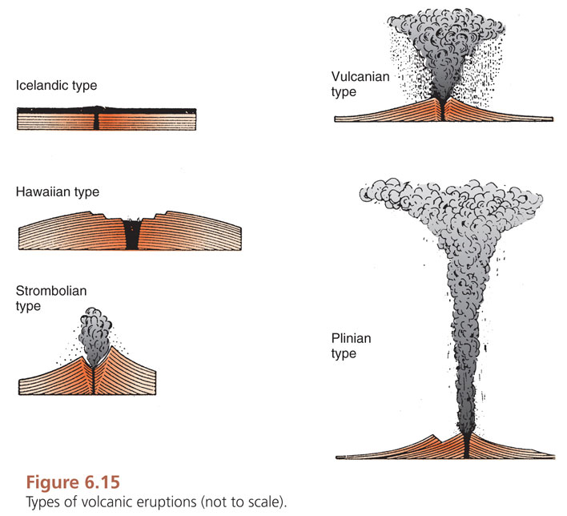

- Eruption of Lake Toba (73,000 BP) VEI 8
- Recent: Krakatau (1883) VEI 6
- Mt. St. Helens (1980) VEI 5
- Mt. Pinatubo (1991) VEI 6
- NO VEI 7 since Tambora Caldera (1815)
3. Summary of Volcanic hazards
-hazards from the Cascades volcanoes for B.C + Pacific NW
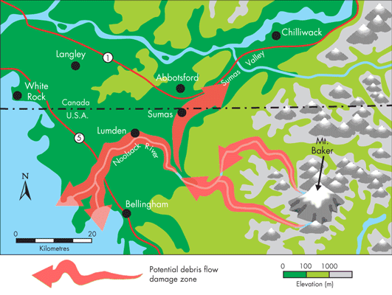
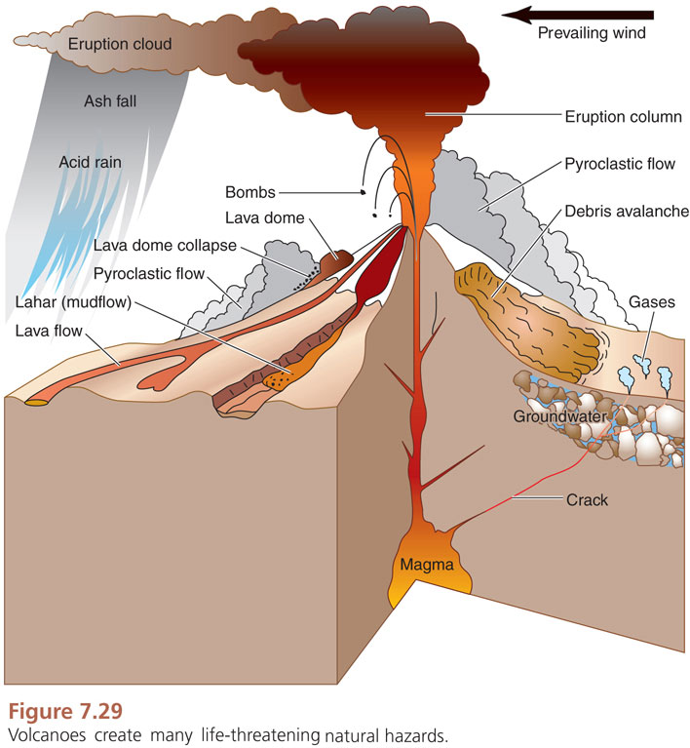

Lahars down Noolsack Sumas

Unit C: Preventing Destruction from Eruptions
1. Facets of Eruption prediction
a) Collect existing (baseline) geologic data
- Types of products erupted
- Distribution and area covered
- % of magmas of different silica content erupted in the pas
- Analyses of chemical components of eruptive products
- Frequency of eruption in the past
- Radiometric dating techniques potassium – argon and argon - argon
b) Develop a monitoring scheme
- Should start before eruption starts
- Reality = hard and not start until volcano show imminent signs
c) Create geologic and volcanic hazards map
- Zones of likely eruptive activity + specific hazards
2. Observe and measure
a) Increased seismic activity
b) Ground deformation – changes in shape of volcano
c) Increased gas emissions
d) Visible signs of volcanic activity – new eruptive material
e) Increased heat flow
3. Volcano monitoring strategy
-To detect + measure changes caused by magma movement beneath volcano
- Rising magma will:
1. Trigger swarms of earthquakes and other seismic events
2. Cause swelling or subsidence of a volcano’s summit or flanks
3. Lead to release of volcanic gasses from ground + vents
- Scientists able to anticipate eruption days to weeks ahead of time
- Detect remotely occurrence of certain volcanic events (explosive eruptions + lahars)
3a. Volcano monitoring techniques: Increased seismic activity
1. Seismic monitoring:
- Most useful technique = prediction
- increased seismic activity eruptions / precursor activity
- Location + frequency + types of earthquakes are important
- Buoyant magma rises fractures overlying rock through the curst
= concentrations of earthquakes
- Pre-eruption earthquakes:
a) Swarms dozens ~100s of event
b) M < 5
c) Increasing in freq. / intensity as an eruption is imminent
Closer to eruption location + shallower as eruption is near
= Sustained with M = 2- 6
- EX: Mt. St. Helens = detected increased freq. of earthquakes + trend to shallower quakes foci with time
2. Acoustic flow monitors (AFM)
- Special type of seismometer optimized to detect + record high freq. (10 – 250 hz)
- These vibrations = lahars > earthquake (0.5 – 10 Hz)
- Solar powered
- Buried in the ground adjacent to stream valleys radiating out from a volcano
- Signal to station alert people downstream to get to higher ground
3b. VMT: Ground deformation
- Volcano changes shape when magma / gas moves into a reservoir beneath/ within volcanic edifice
EX: Helens developed a pronounced bulge on its north flank
- Crypto dome of dacitic magma emplaced close to surface (under pressure from gas trapped inside the existing stratovolcano
1. Direct measurements of horizontal displacement:
- taping distance btw two metal stakes/ measuring increase in width of cracks growing on volcano
- Use= hazardous to field personnel
Present within / on an active volcano
-EX: St. Helens – dome growth eruptions within 24 hours
2. Tilt meters
- Sensitive instruments record changes in tilt of surface
- Place around flanks
- Predict eruptions at Hawaiian shield volcano (Kilauea)
- Record inflation of volcano prior to explosion
- Prior: tilting outward from central crater as the volcano inflates with magma in interior
3. Global Positioning System (GPS)
- Pinpoint horizontal + vertical movement of targets on a volcano (repeated measures)
- Placing GPS at known locations around volcano/ direct measurements
- Safe with fixed receiver
- Loss of expensive equipment
4. InSAR (satellite radar interferometry)
- Safer but expensive measurement
- Ground deformation measurement
- Satellites using radar wave elevation of large areas of crust of active volcanoes
- Areas of uplift are identified by deformation fringes colored irregularly shaped rings
- EX: 2001 central Oregon Cascade Range uplift over 5 years
3c. VMT: Increased gas emissions
- Increased gas emissions reflect change in:
- Magma supply rate
- Type of magma erupting
- Underground fracture system routing gas towards surface
- Volcanoes record 2 – 3 orders change in SO₂ emissions during / prior to eruption
1) Direct collection of gas
- Possible, but may be uncomfortable during active volcano
2) Correlation Spectrometer (COSPEC)
- Estimate SO₂ emissions in eruption plume from afar
- Little danger
- Measures amount of solar ultraviolet light absorbed by SO₂ + comparison w/ standard
- Amount of absorption proportional to concentration of SO₂
3d. VMT: Visible signs of volcanic activity – new eruptive material
Visual Observation: Changes or Differences
1) Still Photography and Video footage document changes to active volc.
2) LIDAR (light detection and ranging) images calculate the volume of new material over time
- EX: Mt. St. Helens dome
3e. VMT: Increased Heat Flow
- Indicate presence of new magma at surface
- Fracturing of crust due to magma upwelling
- Increased activity at hot spring / fumaroles
1) Direct observations:
- Of glowing magma/cracks in volcano
- Optical pyrometer (hand-held) determine temp. of glowing lava
2) Aerial remote sensing of infrared spectra:
-record anomalously hot areas
3) Forward looking infrared (FLIR):
- Satellites/ Airplanes
- EX: dome growth at Mt. St. Helens
4. Predicting eruptions: Communicating with public
GREEN | Volcano is in typical background, non-eruptive state  or, after a change from a higher level,  volcanic activity has ceased and volcano has returned to non-eruptive background state.
YELLOW | Volcano is exhibiting signs of elevated unrest above known background level  or, after a change from a higher level,  volcanic activity has decreased significantly but continues to be closely monitored for possible renewed increase.
ORANGE | Volcano is exhibiting heightened or escalating unrest with increased potential of eruption, timeframe uncertain,  OR  eruption is underway with no or minor volcanic-ash emissions (ash-plume height specified, if possible).
RED | Eruption is imminent with significant emission of volcanic ash into the atmosphere likely  OR  eruption is underway or suspected with significant emission of volcanic ash into the atmosphere (ash-plume height specified, if possible).

5. Difficulty of Prediction:
- installation and upkeep of real-time seismic network
- installation and upkeep of real-time GPS network
- gas emission sampling (COSPEC)
- regular ground measurements (e.g., crack widths)
- chemical analyses of eruptive deposits
- daily observations
* MUST include all in following order
- Cannot determine exact time of eruption
- Not enough time to evacuate all local populace
- Just increase chance of prediction
- EX: Mt. St. Helens – became hard to predict (dome formation)

Unit D: Where are violent volcanoes found?
1a. Review of plate boundaries
-Three types of plate boundaries:
1) Divergent margins:
- Two plates spread apart due to upwelling of the upper mantle + injection of magma
- Located in ocean basins = mid-ocean ridges / continental rift zone
- EX: East African Rift
2) Convergent margin:
- Two plates collide one subduct into the mantle beneath the other
- Ocean-ocean collision + ocean-continent collision
- Volcanic arcs form in these settings
- Continent-continent too heavy = mountain chains
-EX: India + Asia = Himalayan
- Magmatism is rare in Continent-Continent collision zones
3) Transform fault:
- Two plates slide laterally past one another
- Magmatism is also rare
1b. Chemical composition of upper mantle + crust
- Upper mantle: ultramafic
- Rocks <45 weight % SiO₂ and high in MgO + FeO
- Oceanic crust is mafic
- Igneous rocks w/ 45 -52% SiO₂ and less MgO and FeO + more CaO and Al₂O₃ than upper
- Continental crust: Wide range of igneous rocks w/ SiO₂
- Mafic ~ intermediate felsic 45% to > 68%
- SiO₂ rich
- Higher buoyancy
* Melting temperature of a rock/magma is inversely proportional to SiO₂ content
2. Distribution of Active volcanoes
Sub-aerial active volcanoes (above ground level):
- Associated with convergent plate margins
- Many are found along margins of Pacific Ocean basin
Pacific Ring of Fire
- Divergent:
- 15% of sub-aerial volcanoes
- More submarine volcanoes mid-ocean ridge
- Most volcanoes occur
- Additional sub-aerial volcanoes are found within oceanic + continental plates and not along plate boundary
= hotspot volcanoes
3a. Hotspot settings: Oceanic
- Located where hot, buoyant mantle material (mantle plume) rises into upper mantle
Initiates melting
- Originate at core-mantle boundary + fixed in the mantle
- When induces melting mafic magma is produced
- Magma rises to surface through mafic crust w/ little interaction b/c melting temp of magma + crust are similar
- Typically shield volcanoes + small cinder cones erupts mafic magma
= dark-colored, low in viscosity, and low in SiO₂ = basalts
- Hawaiian-Emperor chain of volcanoes Pacific Plate moving NW direction over mantle plume
3b. Hotspot Settings: Continental
- Higher silica content of continental crust + resulting interactions of mantle-derived magmas w/ that of continental crust
- Rising mantle plume induce melting in upper mantle/lithosphere near base of continental plate
= mafic rises through crust melts crust (higher silica content)
- Mafic magmas can produce large volumes of felsic melt
* Giant Calderas (most explosive)
** Rhyolites
- Yellowstone caldera, NW Wyoming, USA (Yellowstone hotspot chain)

4a. Convergent margin settings: Ocean-ocean convergence
- Oceanic lithosphere is subducted.
- Lithosphere dehydrates + water is introduced into overlying asthenosphere (upper mantle)
- Water induces melting of mantle (lower melting temp)
Form mafic magma
< Dense than surrounding mantle mafic magma rises
- Overlying rising mafic is oceanic: mafic magma has limited interaction
- Intermediate magmas may form
- Magmas produced in oceanic arcs are mostly mafic + some intermediate
** Volcanoes in oceanic arcs composite volcanoes
= Rocks form basalts and andesites
- EX: western Aleutian arc (ocean-ocean plate convergence)
4b. Convergent margin settings: Ocean-continent convergence
- Mafic magma forms in the mantle (same as previous mechanism)
- Water introduced by the subducted slab lowevers melting temp of mantle
- Mafic magmas rise through continental crust interact with to produce intermediate and felsic magmas
- Interactions include melting of continental crust (produce felsic magma)
Changing (differentiating) composition of mafic magma to more SiO₂-rich
*Composite volcanoes = eruption of magmas w/ range of silica contents
** basalt, andesite, rhyolite
** MORE EXPLOSIVE = HAZARDOUS
- EX: Garibaldi-Cascade arc (Cascade Range volcanoes) subduction of Juan de Fuca plate under NA plate
- Active over 4000 years

