GEG3321 – Final Study Notes
LECTURE 1 - Introduction
Socio-Ecological Systems (SES)
Ecological System
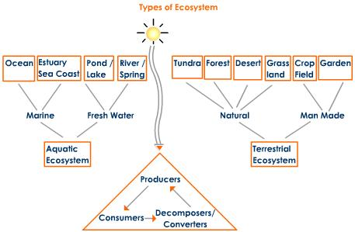
Social System
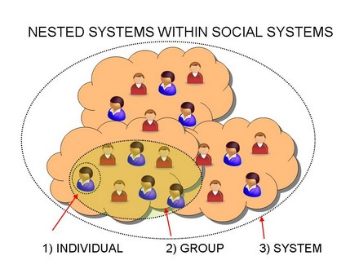

Elements of SESs
Social | Ecological
- Culture and traditions | - Climate
- Knowledge and experience | - Air
- Religion values and ideologies | - Water
- Technology | - Soil
- Institutional framework | - Wildlife
- Power dynamics | - Forests
- Economics | - Minerals
- Governance | - Micro-organisms
- Health | - Pests
- Education and literacy | - Livestock

- We can no longer look at ecosystems without considering the ‘social’ system everything is connected
Ostrom: Challenges of Achieving Sustainability in SESs
- There is no one optimal way of doing things (panacea ‘cure-all’ trap)
  - Tragedy of the commons
- We must accept rather than reject complexity
- Multi-disciplinary frameworks are essential
- We need to consider issues at multiple scales
- Important to use consistent analytical frameworks
  - Consistency needed for comparison
- We need institutional diversity
- Since change is constant we can’t just solve problems, we need to come up with solutions that can adapt as things change
- Social factors in our personal system impact how we interact/manage environmental systems

SES
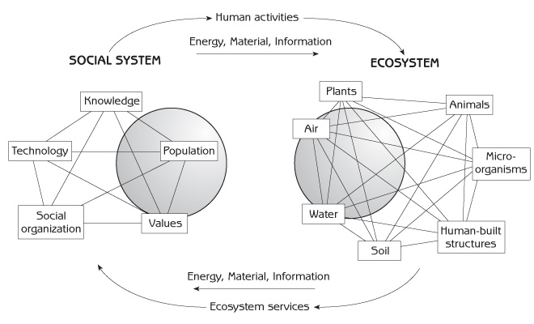
Environmental Thought
Deep Ecology | Shallow Ecology
- Goal is to change dominant paradigms  - Cultural shift in thinking and doing  - Nature has intrinsic value  - Nature needs protection for humans | - Changing consumptive behaviour but not consumption  - Focus on fixes (technology – i.e. band aids) to reduce impact  - Humans have the right to use natural resources  - Humans are part of nature (top of food chain)
- DE – idea is to get rid of consumption
- SE – more mainstream, still believe is sustainability/environmentalism, looking to find solutions
LECTURE 2 – Ecosystem Services and Ecosystem Change
Part 1
Three Pillars of Sustainable Developments
- Environmental sustainability
- Economic sustainability
- Socio-political sustainability

Sustainable Development – History
Our Common Future, a report published by the World Commission on Environment and Development (WCED) in 1987 (Bruntland Report)
- Sustainable Development – “development which meets the needs of the present without compromising the ability of future generations to meet their own needs”
UN Conference on Environment and Development – Rio de Janeiro, Brazil, also referred to as the Rio Summit and the Earth Summit
- Matthews and Hammill (2009: 1119) note that main problem since the Rio Summit has been “in designing the move from theory to practice. Here the tenacious grip of technological, political and other constraints becomes clear.”
Barriers of Sustainable Development
“Uptake of sustainable development has also been hampered by development being defined primarily as economic growth. This has been the framework used by developed countries in attaining their unprecedented levels of wealth, and it should be no surprise that major developing economies are following the same course. The problem with such an approach is that natural resources are in imminent peril of being exhausted (whether in terms of supply [e.g., oil reserves] or quality [e.g., air or water pollution])”.
Early Concepts of Sustainable Development
Steady-state economy
- A steady state economy is an economy of relatively stable size. It features stable population and stable consumption that remain at or below carrying capacity.
Carrying capacity
- The carrying capacity of a biological species in an environment is the maximum population size of the species that the environment can sustain indefinitely, given the food, habitat, water and other necessities available in the environment. In population biology, carrying capacity is defined as the environment's maximal load.
Limits to growth
- The Limits to Growth is a 1972 book modeling the consequences of a rapidly growing world population and finite resource supplies. The book outlines the idea that there are ecological limits to economic growth
Common Principles of Sustainable Development
Commitment to equity and fairness, in that priority should be given to the improving the conditions of the world’s poorest and decisions should account for the rights of future generations.
Emphasizes the precautionary principle, i.e., “where there are threats of serious or irreversible damage, lack of full scientific certainty shall not be used as a reason for postponing cost-effective measures to prevent environmental degradation” (Rio Declaration on Environment and Development, Principle 15
Embodies integration, and understanding and acting on the complex interconnections that exist between the environment, economy, and society. This is not a balancing act or a playing of one issue off against the other, but recognizing the interdependent nature of these three pillars.
Millennium Ecosystem Assessment
What is the MEA?
- Largest assessment ever undertaken of the health of ecosystems
  - Prepared by 1360 experts from 95 countries; extensive peer review
  - Consensus of the world’s scientists
- Designed to meet needs of decision-makers among government, business, civil society
  - Information requested through 4 international conventions
What is the Message?
‘The MEA contains a stark warning. While living standards improved of the past two centuries, human activity is putting such strain on nature that we are undermining the Earth’s capacity to support current and future generations. We are living beyond our means: recent gains in quality of life have come at considerable cost to the natural systems on which we all depend. If we act now, we can avoid irreversible damage to ecosystems and human well-being. But this will require a change in the way we think about and use natural resources”

What is an Integrated Assessment?
What is happening?
- current state and trend report
Why is it happening?
- what are the different drivers
What will happen if we don’t act now?
- extrapolate into the future
What can we do and what are we doing about it?
- how can we change the future, how can we influence the future
Differences between a Review and an Assessment
 | Review | Assessment
Audience | Scientists | Decision-makers
Authors | One person or small group | Large multidisciplinary group of experts
Gap identification | Basic research | Problem driven
Uncertainty statements | Only to set agenda | Prevalence
Judgement Statements | Bias towards agenda | Unbiased (not an advocacy piece)
Topic coverage | Little synthesis (is narrow) | Broad – historical, current, future. Knowledge synthesis

Science Assessment
A social process designed to bring the findings of science to bear on the needs of decision-makers.
A scientific assessment applies the judgment of experts to existing knowledge to provide scientifically credible answers to policy relevant questions
Criteria for a Successful Assessment
- Political Legitimacy
- Scientific Credibility
- Saliency – Focus on User Needs
Ecosystem Services
“The benefits people obtain from ecosystems”
Provisioning: goods produced or provided by ecosystems
Regulating: benefits obtains from regulation of ecosystem processes

Cultural: non-material benefits from ecosystems

MA
- Multi-scale assessment
- 18 assessments were approved
- Self-funded except for a few grants
- Drew information from 15 other sub-global assessments that met the criteria
Why a Multi-scale Assessment?
Rationale
- Characteristic scale of processes
- Greater resolution at smaller scales
- Independent validation of conclusions
- Response options matched to the scale where decision-making takes place
Core Questions
- What is the rate and scale of ecosystem change?
- What are the consequences of ecosystem change for the services provided by ecosystems and for human-well-being?
- How might ecosystems and their services change over the next 50 years?
- What options exist to conserve ecosystems and enhance their contributions to human well-being?
Main Findings
- Humans have radically altered ecosystems in last 50 years
  - The MA focused on population growth in last 50 years. From MA Synthesis: “Between 1960 and 2000, the demand for ecosystem services grew significantly as world population doubled to 6 billion people ...”
  - Global economic activity increased nearly seven-fold between 1950 and 2000. Gross World Product expected to increase 3 to 6-fold between 2000 and 2050 in MA scenarios.
  - Cultivated systems cover 24% of the terrestrial surface; more land was converted to cropland in the 30 years after 1950 than in the 150 years between 1700 and 1850. Cultivated systems (areas where at least 30% of the landscape is in croplands, shifting cultivation, confined livestock production, or freshwater aquaculture) now cover one quarter of Earth’s terrestrial surface.
  - “Humans are fundamentally, and to a significant extent irreversibly, changing the diversity of life on Earth, and most of these changes represent a loss of biodiversity“
Scale of Change
- 20% of the world’s coral reefs were lost and more than 20% degraded
- 35% of mangrove area has been lost in the last several decades
- Amount of water in reservoirs quadrupled since 1960
- Approximately 60% (15 out of 24) of the ecosystem services evaluated in this assessment (including 70% of regulating and cultural services) are being degraded or used unsustainably

- Changes have brought gains but at growing costs that threaten achievement of development goals.
- Degradation of many ecosystem services
- Increased risk of abrupt changes in ecosystems
- Growing harm to poor people
- Food production more than doubled (an increase of over 160%) from 1961 to 2003
- are increasing the likelihood of nonlinear changes in ecosystems (including accelerating, abrupt, and potentially irreversible changes)
- economic and health costs of degradation can be substantial
- Poor people are most dependent on ecosystem services and most vulnerable to degradation of the services

- Degradation of ecosystems could grow worse but can be reversed.
- MA Scenarios
  - Global Orchestration Globally connected society that focuses on global trade and economic liberalization and takes a reactive approach to ecosystem problems but that also takes strong steps to reduce poverty and inequality and to invest in public goods such as infrastructure and education.
Global, Reactive Environmental Policies
    - Lower population
    - Lower habitat loss
    - Higher economic growth
    - Higher GHG emissions

  - Order from Strength Regionalized and fragmented world, concerned with security and protection, emphasizing primarily regional markets, paying little attention to public goods, and taking a reactive approach to ecosystem problems.
Regional, Reactive Environmental Policies
- Worst across the board (except GHG/Climate due to slower economic growth)
- Slower economic growth than Global Orchestration

  - Adapting Mosaic Regional watershed-scale ecosystems are the focus of political and economic activity. Local institutions are strengthened and local ecosystem management strategies are common; societies develop a strongly proactive approach to the management of ecosystems.
Regional, Proactive Environmental Policies
- Best GHG
- Best Nitrogen
- Best Water
- Slower economic growth than Global Orchestration
- Reliability of ecosystem services decreased, risks increased
- New problems emerge from technologies

  - TechnoGarden Globally connected world relying strongly on environmentally sound technology, using highly managed, often engineered, ecosystems to deliver ecosystem services, and taking a proactive approach to the management of ecosystems in an effort to avoid problems.
Global, Proactive Environmental Policies
- Best GHG
- Best Nitrogen
- Best Water
- Slower economic growth than Global Orchestration
- Reliability of ecosystem services decreased, risks increased
- New problems emerge from technologies

- Actions needed – significant and not underway
  - Investments in public goods (e.g. education) and poverty reduction
  - Elimination of trade barriers and distorting subsidies
  - Use of active adaptive management
  - Investment in education
  - Investment in new technologies
  - Payments for ecosystem services

- Workable solutions will require significant changes in policy
Promising Options: Change the Economic Incentives
- Problem can’t be solved so long as ecosystem services are treated as free and limitless
    - Measure ecosystem service values
    - Incorporate into cost-benefit analyses
- Agricultural and fisheries production subsidies cause ecosystem service degradation.
    - Annual subsidy to agricultural in industrialized countries: $324 billion annually (1/3 of global value)
    - Annual subsidy to fisheries in industrialized countries $6.2 billion (20% of global value)
    - Opportunity to shift subsidies to payments for ecosystem services
- Shift subsidies from agricultural and fisheries to payment for ecosystem services
- Market mechanisms may sometimes be useful
- Development planning and national development strategies could benefit from the incorporation of ecosystem services
- Technologies (ex: sustainable agriculture intensification)
- Individual behaviour – public education
Part 2
Planetary Boundaries
- “Estimating a safe operating space for humanity with respect to the functioning of the Earth System”.
- “What are the non-negotiable planetary preconditions that humanity needs to respect in order to avoid the risk of catastrophic environmental change at continental to global scales”?
Resilience Earth System


Reduced Resilience – Our precarious predicament
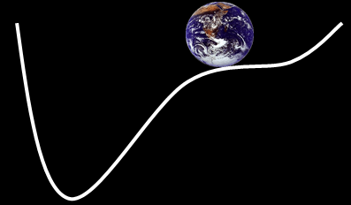
- If we transgress the boundaries too much the Earth will no longer stay stable. There could be major change
- Consequences are unknown
Key Steps
- Identification of key Earth System processes
- Quantification of these processes including boundary levels that should not be transgressed
- Characterizing unacceptable change (i.e. transgression of boundaries) that risks humanity transitioning from the Holocene (stable environment) to the Anthropocene (unknown future)
Climate Change
- Climate change is a statistically significant variation in either the mean state of the climate or in its variability, persisting for an extended period (typically decades or longer) (natural & human induced)
Ocean Acidification
- Oceans currently remove roughly 25% of CO₂ emissions
- Ocean acidification = the addition of CO₂ to the ocean which decreases pH (increases acidity), decreases carbonate ion concentration, and decreases saturation states of biologically important calcium carbonate minerals.
- Impacts marine organisms to produce calcium carbonate (CaCO₃) required for the production of shells (corals, mollusks)
Stratosphere Depletion
- Stratospheric ozone filters ultraviolet radiation from the sun
- Ozone-depleting substances (CFC’s, polar stratospheric clouds) cause thinning of the ozone and negatively impact marine organisms and human health
- Suggested threshold <5% decrease in column ozone levels for any latitude with respect to a 1964-1980 baseline
Nitrogen and Phosphorous Cycles
- Eutrophication due to human-induced influxes of nitrogen and phosphorus
  - (industrial fixation of atmospheric N₂ to ammonia, agricultural fixation, biomass burning, fertilization of crops)
- Phosphorous inflow to the oceans is a key driver of global-scale ocean anoxic events (OAE)
- Suggested threshold for nitrogen set at approximately 25% of its current value (35Mt N/year)
- Suggest threshold for phosphorous is <10X natural background rate
Global Freshwater Use
- 97% of the water on the Earth is salt water, and only 3% is fresh water of which slightly over two thirds is frozen in glaciers and polar ice cap
- 25% of the world’s river basins run dry before reaching the oceans due to use of freshwater resources in the basins
- Impacts include loss of soil moisture due to land degradation and deforestation, use and shifts in runoff volumes, impacts on climate regulation.
Land Use Change
- Land-use change is driven by agricultural expansion
  - Local food, maize craze…
- Almost at threshold

Biodiversity Loss
- Biodiversity is the degree of variation of life forms within a given ecosystem, biome, or an entire planet – it is often seen as a measure of ecosystem health
- Current and projected rates of biodiversity loss constitute the sixth major extinction event in the history of life on earth (i.e. 1st human-induced)
LECTURE 3 – Climate Change Science: Biophysical
Part 1
What is Weather?
- All natural phenomena within the atmosphere at a given time (hours to days)
What is Climate?
- The average and variations of weather over a long period of time (~30 years)
Modern Climate Systems
Two main components affecting climate change:
- Atmospheric circulation (air currents)
- Ocean circulation (the great ocean conveyor)
Greenhouse Effect
- Atmosphere and Greenhouse Effect
  - The Earth’s atmosphere keeps it around 30°C warmer than it would otherwise be.
    - -18°C vs. +14°C
Past Climate Systems
How do we know about climate systems in the past?
- Early human records (ex: rock paintings)
- Geomorphology (ex: river deltas)
- Geological record (ex: fossil records)
- Ice cores

What Causes Climate Change?
- Changes in:
  - Sun’s output
  - Earth’s orbit
  - Volcanic eruptions
  - Greenhouse gases
What are some Current Impacts of Climate Change?
- Rise in:
  - Global surface temperature, ocean temperature, global sea level, ocean acidity, drought, etc.
- Decrease in:
  - Snow, Arctic sea ice, glaciers, cold
- Declining snow pack in mountainous areas = increased drought
How do we Measure/ Model Future Climate Change
- Grided climate data

  - GCM – Global Circulation Model (Global Climate Model)
    - GCM’s are complex, mathematical computer models which use past (1961-1990 baseline) meteorological averages to simulate projected future climate data. Climate change scenarios are generated using monthly global climate data and are often forced with a variety of potential climate futures (SRES-special report on emission scenarios).

  - SRES – Special Report on Emission Scenarios
    - There are 40 different scenarios, each making different assumptions for future greenhouse gas pollution, land-use and other driving forces.

- Issues with grid cells:
  - Elevation is not taken into consideration
  - Lose precision (mixed pixel problem)
  - Cells are too large

SRES Scenarios
- Four storylines/families (A1, A2, B1, B2)
- Six scenario groups – one each for A2, B1, B2, and three for A1
  - (A1F1 – fossil fuel intensive, A1B – balanced, A1T – predominantly non-fossil)
Primary Drivers
- Demographic change (population and population structure)
- Social and economic development
- Rate and direction of technological change
A1 Storyline
- The A1 scenarios are of a more integrated world.
- The A1 family of scenarios is characterized by:
  - Rapid economic growth.
  - A global population that reaches 9 billion in 2050 and then gradually declines.
  - The quick spread of new and efficient technologies.
  - A convergent world - income and way of life converge between regions. Extensive social and cultural interactions worldwide.
A2 Storyline
- The A2 scenarios are of a more divided world.
- The A2 family of scenarios is characterized by:
  - A world of independently operating, self-reliant nations.
  - Continuously increasing population.
  - Regionally oriented economic development.
  - Slower and more fragmented technological changes and improvements to per capita income.

B1 Storyline
- The B1 scenarios are of a world more integrated, and more ecologically friendly.
- The B1 scenarios are characterized by:
  - Rapid economic growth as in A1, but with rapid changes towards a service and information economy.
  - Population rising to 9 billion in 2050 and then declining as in A1.
  - Reductions in material intensity and the introduction of clean and resource efficient technologies.
  - An emphasis on global solutions to economic, social and environmental stability.
B2 Storyline
- The B2 scenarios are of a world more divided, but more ecologically friendly.
- The B2 scenarios are characterized by:
  - Continuously increasing population, but at a slower rate than in A2.
  - Emphasis on local rather than global solutions to economic, social and environmental stability.
  - Intermediate levels of economic development.
  - Less rapid and more fragmented technological change than in A1 and B1.
Approaches to Modeling climate Change Impacts
- Analogues (past)
- GCM scenarios (future)
- Demand-side Modeling (current)
Analogues
An analogue approach uses past climate data which is representative of future change along with past performance data allowing conclusions to be made about possible future impacts

Analogue – Strengths and Weaknesses
- Strengths
  - “Real-world” conditions represented including supply side and demand side adaptations
  - Opportunity to examine wider range of indicators (i.e. economic)
- Weaknesses
  - Assessment for a short period of time (1 year and 3 year)
  - Analogues selection based on temperature
  - No long-range scenarios (i.e. 2100)
Comparing Analogue with GCM
- Model does not account for human change (decisions, technologies, etc.)
- Analogue = better at predicting human behaviour
Part 2
Adaptation
“Adjustment in ecological, social, or economic systems in response to actual or expected stimuli and their effects or impacts. This term refers to changes in processes, practices, or structure to moderate or offset potential dangers or to take advantage of opportunities associated with change in climate”
Adaptive Capacity
“the potential or ability of a system, region, or community to adapt to the effects or impacts of climate change”
Coping Range
- Akin to a systems adaptive capacity
- Different for each system
- Is not static
- Adaptations can increase coping range

Determinants of Adaptive Capacity
- Economic resources
- Technology
- Information and skills
- Infrastructure
- Institutions\equity
- Developing countries have lower adaptive capacity and a higher reliance on climate resources
Adaptation in Polar Regions – Canadian Arctic
- a developing region in a developed country

Sea Ice Changes
- increased shipping
- marine mammals changing migratory patterns
- intensifying sovereignty debates
- increased federal attention and investment\increase military presence
- proposed development of offshore drilling\changing cruise patterns
LECTURE 4 – Climate Change Mitigation
Kyoto Protocol
- Adopted in 1997, entered into force in 2005
- 192 countries are party to the protocol
- Kyoto falls under the UNFCCC (an overall framework for intergovernmental efforts to tackle the challenge posed by climate change)
- Kyoto sets defined targets for reducing GHG emissions and is legally binding
- Kyoto is more specific and more rigid than UNFCC
- Done by 2012 from the 1990 level
Details of Kyoto
- Countries must meet their targets nationally or by participating in:
  - Emission trading system
  - Clean development mechanism
- CER – certified emissions reduction mechanism a country participating in Kyoto offers to one who isn’t under Kyoto to implement something that reduces emissions (Annex 1/B country takes credit for this)
  - Joint implementation
Mitigation
- An anthropogenic intervention to reduce the sources or enhance the sinks of greenhouse gases
Adaptation
- Adjustment in natural or human systems to a new or changing environment
The Lag Effect
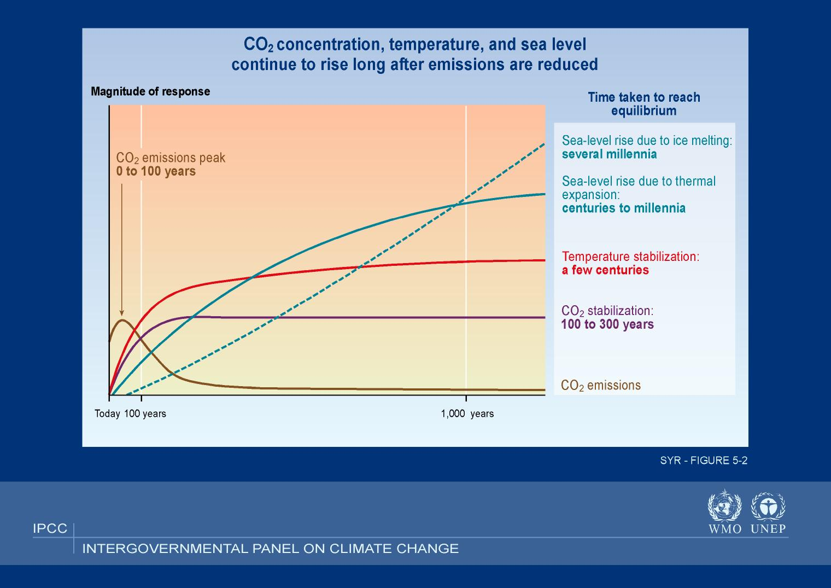
Types of Mitigation
- Lifestyle changes
- Industry Activities
- Infrastructure Change
- Management of Ecosystems
- Economic Incentives
Lifestyle Changes (Source)
- Transportation Alternatives
- Consumption Patterns
- Building Occupant Behaviour
Industry Activities (Source)
- Technology Change (more energy efficient processes)
- Material Use Change (recycling, substitution)
- Improve carbon capture and storage
- Participation in regulated/volunteer economic incentive programs
Infrastructure Change (Source and Sink)
- Green Building Code
  - ENERGY EFFICIENT REQUIREMENTS
  - GREEN WALLS/ROOFS
- Transportation Network Planning
- Improve ‘green’ power options
Ecosystem Management (Sink)
- Forest management:
  - Aforestation
  - reforestation
- Protected Area Management
- General Land Management
Economic Incentives (Source and Sink)
- Carbon Tax (put $ value on a tonne of carbon – reduce C emissions of pay tax)
- Carbon Offsets (paying for something that offsets C emissions ex tree planting)
- Payment for Ecosystem Services (pay land owners to keep land natural)
- Emission Trading System (Kyoto)
  - Cap and trade – setting a cap on emissions. If cap is exceeded, must purchase credits from another industry who has emitted less than their cap. If not, significant fines are applied
Emissions Trading
Setting a cap on emissions, letting the market decide the price
LECTURE 5 – No Class
LECTURE 6 – Cecelia Lee – not important for exam
LECTURE 7 – No Class Thanksgiving
LECTURE 8 – Climate Change Refugees Video
- How long is man going to survive?
- Thoughts of worry for climate conflicts and climate wars
- Migration will be necessary as sea levels rise and threats of major weather events increase where will these people go?
- More weather extremes, more often, in more places
- Climate change is a present issue
- “the last call for humanity”
LECTURE 9 – UN Conference Presentations
LECTURE 10 – UN Conference Negotiations
LECTURE 11 – Resilience Thinking and Political Ecology
Resilience Thinking – A New Paradigm
- Current approaches to sustainable natural resource management are failing us. They are too often modeled on average conditions and expectations of incremental growth, ignore major disturbances, and seek to optimize some components of a system in isolation of others. This approach fails to acknowledge how the world actually works

- Resilience thinking is about understanding and engaging with a changing world. By understanding how and why the system as a whole is changing, we are better placed to build capacity to work with change, as opposed to being a victim of it

- It involves … embracing change versus rejecting it
- It is about … understanding that we are all part of a system
- It is appreciating … the complexity and adaptability of a system
- It requires … explanation of how systems operate and function over time and space
- Resilience: “courage to come back”
- New way of thinking about the world
- Things are constantly changing
- Often think about optimizing
- Understanding and engaging with a changing world
- Different scales (not just local, or global)
- Look at different scales and the inter-connectedness
Defining Resilience
- Derived from latin word resilio, meaning ‘to jump or leap back’
- Resilience involves:
  - the ability to recover from or adjust easily to misfortune or change;
  - undergoing change while retaining the same structure, function and feedbacks;
  - the capacity to both withstand shocks and surprises and to rebuild if damaged.
Disciplines understand and apply the concept of resilience differently
- Ecologist (natural functions) - measure of how much disturbance (i.e. storms, fire, pollutants) an ecosystem can handle without shifting into an qualitatively different state
- Sociologist (social systems) - ability of human communities to withstand and recover from stresses such as environmental change or social, economic or political upheaval
Key Concepts
- Vulnerability
  - Resilient systems are forgiving of external shocks and surprises. They have the capacity to buffer perturbations, to renew and reorganize after change, and to learn and adapt in a dynamic world
  - Vulnerability is the flip side of resilience: when a social or ecological system loses resilience it becomes vulnerable to change that previously could be absorbed
- Resilience – the capacity of a system to absorb disturbance and reorganize while undergoing change so as to still retain essentially the same function, structure, identity, and feedbacks.

- Transformation – is the capacity to create a fundamentally new system when ecological, economic, or social (including political) conditions make the existing system untenable.

- Adaptability – is the capacity of actors in a system to influence resilience or facilitate transformation
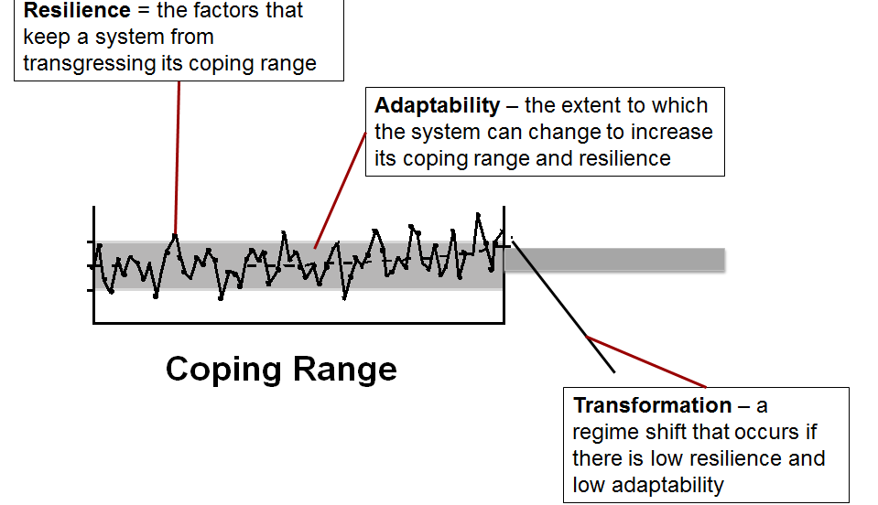
Resilience Factors
- Human capital
- Social economy
- Demographics and culture
- Technology
- Values and religion
- Governance
- Institutions
- Policy
- Geography
- Investments
Multiple Domains, Regime Shifts
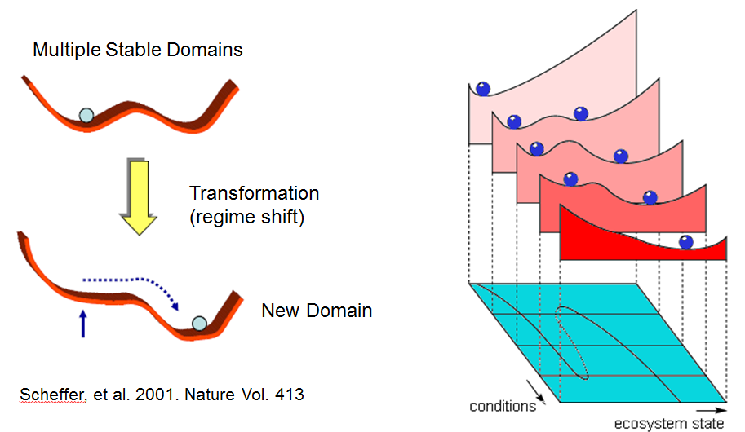
Adaptive Cycles and Regime Shifts
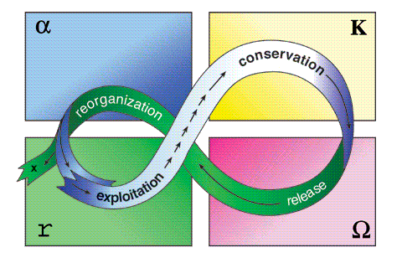
Path Dependency
- The Cowpath: the path is a creation by the cows themselves - they follow it or depart from it according to their whims or their needs. From daily use, the path undergoes change. A cow is under no obligation to stay in the narrow path she helped make, but she often profits by staying with it and she is often disadvantaged if she strays since she wouldn’t know where the path was or where it leads.
- Path dependence explains how the set of decisions one faces for any given circumstance is limited by the decisions one has made in the past, even though past circumstances may no longer be relevant.
- Sub-optimal or inefficient technologies can become locked in as industry standards, and in instances where there are significant network effects, these inefficiencies may persist for extended periods of time
- VCR vs. Betamax
- QWERTY Keyboard
- get on a path and keep following it
- explains set of decisions one faces
Path Creation
- The path dependency revolution is now slowly giving way to another revolution: the path creation revolution.
- The idea of path dependency neglects the role of human agency while accepting the impersonal forces of history. The theory explains novelty as the cumulative result of small and impersonal historical incidents.
- Path dependency neglects the important role played by conscious human agents in the development of the historical path actually followed
- Path creation theory combines the notions of cumulative causation, history as an endogenous variable, and increasing returns (all basic concepts of path dependency) with human agents’ mindful deviations and real time influences to explain phenomena in the making.
- Path creation reminds us of the significance of human agency in economic processes.
- …It involves entrepreneurs and innovation and leads to transformation
- “we” make transformation occur
- a positive approach (holder of your own destiny)
- humans are agents of their own change
Innovation
- “Innovation is the way of transforming the resources of an enterprise through the creativity of people into new resources and wealth”
- Innovation differs from invention or renovation in being a substantial positive change rather than a modest incremental change.
- It is creating a “new path”
- way of transforming resources
- human agencies
- positive change
- ex.: internet, agriculture, printing press, vaccinations, dental hygiene, wheel
LECTURE 12 – Governance
Adaptive Management
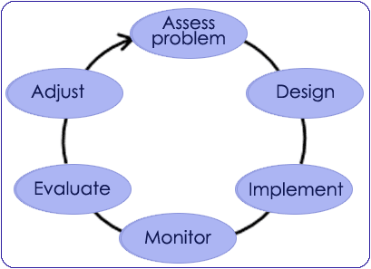
Adaptive Management – is a clearly articulated approach to environmental management that treats policies or management prescriptions as experiments to test hypotheses, monitors the outcomes in order to refine those hypotheses, and subsequently adapts policies and actions as new knowledge and understanding are gained.

- Expect the unexpected, and learn from it
- Designs policies and management practices to benefit from unexpected events
- Sustains resilience and support learning
- Articulates policy and management interventions as experiments
- Allows for adjustments to changing events, decisions, and circumstances
- Question-orientated, experimental approach
- Encourages generalizations or even vagueness concerning future system states (i.e. transformation) (too much direction stifles creativity)
- Manage in a way that is dynamic
- Often loose, vague, not prescriptive

Active Adaptive Management
- Managers implement more than one policy or management practices as concurrent experiments to determine which best meets specified objectives
- Management programs themselves are designed as experiments to test hypotheses about their effects on particular resource or environmental systems being managed
- Design of management and policies recognize the unexpected and also benefit from the unexpected.
- Prospective (system is additional disturbed under controlled environment) vs. Retrospective (use of historic data)
- Decide what to do, do it and see what happens
- Multiple experiments
- Prospective – pushes a system (ex: ecological) to its limits and then study it
Passive Adaptive Management
- Active adaptive management is not always possible or feasible.
- Passive adaptive management involves the use of historic data available at the time to construct a single best estimate or model for response. Policy or management decision is based on assuming that the model is correct.
- New knowledge is gained through the monitoring process and adjustments are made
- Passive adaptive management is less resource intensive than active adaptive management but the learning happens much more slowly
- Single experiment, slower
- Retrospective – looks at history – may be too dangerous to push a system to its threshold
Adaptive Management Process

Adaptive Co-Management: Definitions
- Management is the right to regulate internal use patterns and transform the resource by making improvements
- Adaptive co-management merges the principles and practices of adaptive management and co-management
- Co-management, the sharing of power and responsibility between the government and local resource users
Adaptive Co-management: Key Concepts
- The idea is that an agency with jurisdiction over an area (usually a state agency) might develop a partnership with other relevant stakeholders (primarily including local residents and resource users) which specifies and guarantees their respective functions, rights and responsibilities with regard to the (area)
- Co-management can be looked upon as a continuum from the simple exchange of information to formal partnership
- Co-management presupposes that parties have, to some extent, agreed on an arrangement, but the actual arrangement often evolves; it is a process rather than a fixed state
- Provides linkages between stakeholders and facilitates risk-sharing and conflict resolution
- Works through cycles (practice, learning, experiment, etc.)
- Adaptive management between groups
- Co-management happens a lot in North America (Aboriginals)
Adaptive Co-Management Process
- defining the social-ecological system under focus;

- mapping the essential management tasks and problems to be solved;

- clarifying the participants in the problem-solving processes;

- analyzing linkages in the system, in particular across levels of organization and across geographical space;

- evaluating capacity-building needs for enhancing the skills and capabilities of people and institutions at various levels; and

- prescribing ways to improve policy making and problem-solving.

- Institutional capacity
  - To implement policy
  - Identify adaptive measures
- We have been using the same institutional framework that we have always used --. Have to evaluate institutions
Adaptive Co-management Continuum
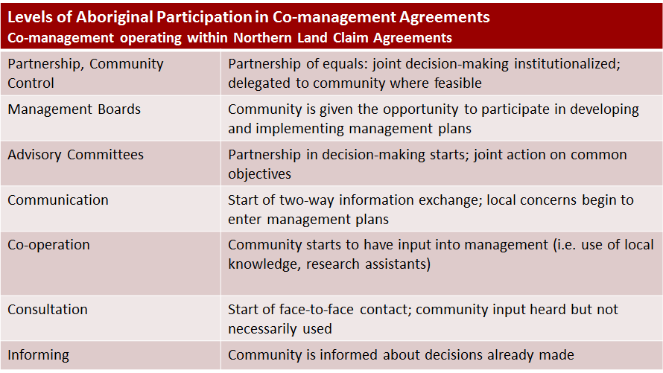
- Least amount of co-management at the bottom to most at the top
Adaptive Co-Management Case Study
- Red Lake – Walleye (boom-bust fishery)
  - 1989 - lakes yielded 1 million pounds of walleye to commercial fishing by the Red Lake Band of Chippewa and 180,000 pounds to sport anglers
  - 1996 – lakes yielded less than 15,000 pounds
  - 1998 – Red Lake Tribal Council suspended subsistence fishing
  - 1999 – Minnesota Department of Natural Resources closed walleye harvest in state waters and proposed a 10-year recovery plan
Public Participation and Social Learning
- Participatory approaches are characterized by inclusive definitions of stakeholders, early and ongoing participation, citizen control over decision-making, and use of multiple involvement techniques, including interactive mechanisms
- Social learning emphasizes collective learning by groups, organizations, and communities as a means of adaption to and driving social-ecological change.
- Highly participatory approaches provide the conditions for social learning
- Creates situations for social learning
Public Participation Techniques
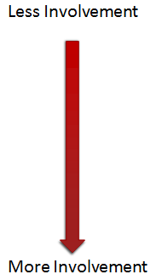
- Passive Information
- Advertisements
- Websites
- Active Information
- Briefings
- Panels
- Public Input
- Meetings
- Public hearings
- Problem Solving
- Advisory committees
- Workshops
Advantages of Public Participation Techniques
- Strengthen democratic process
- Improves decision making
- Access to rich local and traditional knowledge
- Brings alternative ethical perspectives
- Broadens the range of solutions
- Enhances sense of public ownership and engagement
- Increases accountability
Disadvantages of Public Participation Techniques
- Can enhance conflict vs. reducing them
- Requires a high degree of trust, goodwill and mutual respect among parties
- Cognitive conflict / education and understanding of the issues and science
- Can sometimes reinforce the status quo
- Power imbalances can impact decision making abilities
- Costs can be high
- Takes longer
Effective Ways to Engage the Public
- Personalize, strength of social network
- Goal: try to attract people that either don’t care or feel the opposite
LECTURE 13 – Traditional Knowledge
Commonalities

- Cultural history linked to the land
- Notion of common territory
- Lack of political control over own affairs;
- Exclusion from decision-making;
- Non-recognition of rights almost always marginalized
- …Working towards right to self-determination
- Loss of cultural diversity as Aboriginal populations are lost…also, loss of ecological knowledge

How Many Indigenous Peoples Are There?

- ~300 million worldwide
- Best indicator: language
- 70-80% of World’s cultural diversity
- Inhabit areas of high biological diversity
- Linked biological and cultural diversity
International Indigenous Movement

- 1960s – North America, Australia, Scandinavia
- 1970s – Latin America
- 1980s – Asia and parts of the Pacific
- 1990s – Africa and Russia
- Focused on reviving indigenous populations
- Respecting rights, showing that the knowledge is important
Resource Wars

- Native Peoples are often involved at the forefront of battles around resources and environment (e.g. Oka, Ipperwash, Caledonia)
- Native rights now tied to international environmental movement
- “The era of resource wars is just beginning. At stake is not only the issue of ownership, but the value of resources and who has the right to manage and consume them” –Cultural Survival
- Lands are often threatened by resource development projects

The Politics of Stereotypes

- Between ‘Primitive Polluters’ and the ‘Ecologically Noble Savages’
- Stereotypes carry political weight
- Inaccuracies limit self-development
- Indigenous-Environment Relationship
- Dynamic
- Holistic
- More sustainable
- Qualitatively different from modern approach
- False ideals/expectations about indigenous people
  - Western view: “Ecological Saints”
  - Asian view: “Primitive Polluters”

Indigenous Knowledge

- Dichotomy:
  - Aboriginal view
  - Eurocentric view
- … must start with Indigenous people and their understanding of the world

What is Traditional Knowledge?

- Historical evolve over time
- Worldview (way people conceptualize the universe)
- Holistic
- Relationships
- System – components, processes and cycles
- Spiritual element
- Traditional Ecological Knowledge (TEK):

  - “The cumulative body of knowledge, practice and belief, evolving by adaptive processes and handed down through generations by cultural transmission, about the relationship of living beings (including humans) with one another and with their environment”

- Traditional Knowledge (TK)
  - more holistic term commonly used across Canada
- Indigenous Knowledge (IK)
  - Holistic term commonly used across the globe

Knowledge-Practice-Belief Complex
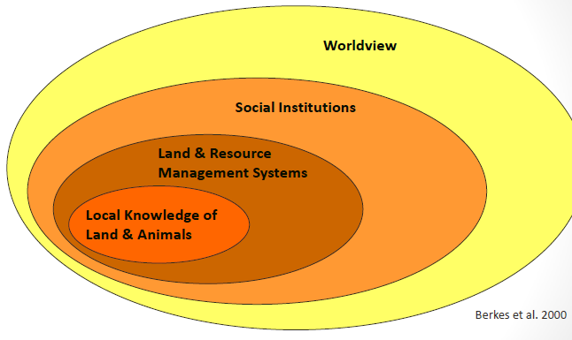
Traditional Knowledge & Western Science
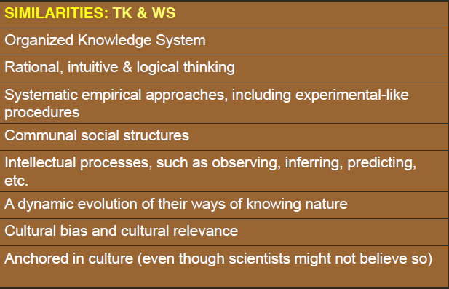
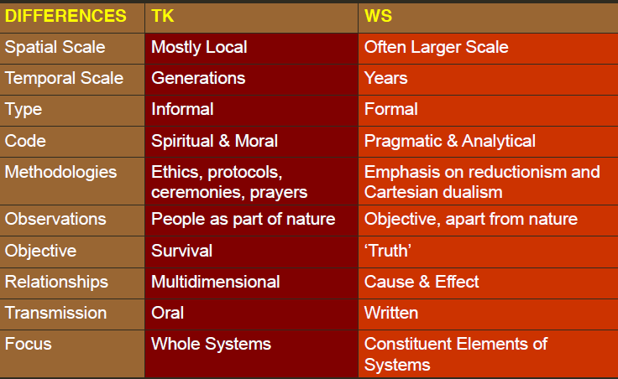

Knowledge Integration for Environmental Management
- Environmental Impact Assessment
  - E.g. Mitigating development project impacts
  - E.g. Proposed Mackenzie Gas Pipeline, NWT
- Resource Development
  - e.g. IBAs, Monitoring Agencies
- Natural Resource Management
  - e.g. Co-management
- Conservation
  - e.g. Protected areas designation

Knowledge Integration for Environmental Management

- Critiques
- Skepticism about credibility and reliability of TK
- Differing interpretations of what "significant" impacts means
- Implies that TK conforms to Western concepts of ‘knowledge’
- Ignores State-Aboriginal power relations – TK as ‘data’
- Concentrates power in administrative centers
- Political decision-making processes require restructuring to effectively incorporate TK
- Different interpretations between the Western world and the Aboriginal ways
- Need to take into account both world views

Two Row Wampum

"This symbolizes the agreement under which the Haudenosaunee (Iroquois) welcomed the white peoples to their lands. We will NOT be like father and son, but like brothers. These TWO
ROWS will symbolize vessels, travelling down the same river together. One will be for the Original People, their laws, their customs, and the other for the European people and their laws
and customs. We will each travel the river together, but each in our own boat. And neither of us will try to steer the other's vessel.'"

- i.e. coexisting without disrupting each other’s affairs

Key Messages

- Eurocentric/Western Knowledge Systems and Indigenous Knowledge Systems are based on different worldviews
- Indigenous knowledge is relevant and important for understanding and addressing issues in social-ecological systems
- Particularly in context of rapid environmental change
- Combining IK and WK is not straightforward
- Requires partnerships with knowledge-holders, open-mindedness, flexibility

