GEG2320 – FINAL STUDY NOTES
READINGS
Chapter 1 – Systems, Science and Study
- Scale or level of geographic detail is an essential property of any GIS project
- Geographic problems can be distinguished on the basis of intent, or purpose
- Normative use (of GIS): GIS that focuses on design
- Positive use (of GIS): uses that advance science
  - Ex: new location for retailers = normative (focus on design) but to predict how consumers will respond to new locations must analyze and model the actual patterns of behaviour they exhibit = positive
- Geographic problems can be distinguished by their time scale
- Spatial: any space, not only the space of the Earth’s surface
- Geospatial: a subset of spatial applied specifically to the Earth’s surface and near surface
- Information systems help us to manage what we know (organize, store, access, retrieve, manipulate, synthesize, apply, etc)
- Data: consist of numbers, text, or symbols that are in some sense neutral and almost context-free
- Codifiable knowledge: it can be written down and transferred with relative ease to others
- Tacit: implicit/ understood knowledge
- Knowledge about how the world works is more valuable than knowledge about how it looks because it can be used to predict
- Ideographic geography: focuses on the description of form and emphasizes the unique characteristics of places
- Nomotheic geography: seeks to discover general processes
- Many geographic problems involve multiple goals and objectives MULTICRITERIA DECISION MAKING
- GIS relies heavily on the internet and the limited-access intranets of corporations, agencies and military
Chapter 2 – A Gallery of Applications
- GIS is fundamentally about solving real-world problems
- 5 Ms of GIS
  - Mapping
  - Measurement
  - Monitoring
  - Modeling
  - Management
Chapter 3 – Representing Geography
- Representations help us assemble far more knowledge about the Earth than is possible on our own
- Tobler’s First law of Geography: Everything is related to everything else, but near things are more related than distant things
- Data in digital form are easy to transform, process and analyze
  - GIS allows us to measure accurately and quickly, to overlay and combine, and to change scale, zoom, and pan with respect to map sheet boundaries
- Geographic representations is concerned with the Earth’s surface or near surface at scales from the architectural to the global
- The key GIs representation issues are what to represent and how to represent it
- One of the most important criteria for the usefulness of a representation is its accuracy
- Many plans for the real world can be tested first on models or representations
- Geographic data link place, time, and attributes
- Geographic attributes are classified as nominal, ordinal, interval, ratio and cyclic
  - Nominal – serves on to identify or distinguish one entity from another
    - Ex: numbers on driver’s license
  - Ordinal – values have a natural order
    - Ex: Canada rates its agricultural land by classes of soil quality (class 1 = best, class 2 = not so good, etc.)
  - Interval – if the difference between the values makes sense
    - Ex: the Celsius scale is interval because it makes sense to say that 30 and 20 are as different as 20 and 10
  - Ratio – if the ratios between values makes sense
    - Ex: weight is a ratio because it makes sense to say that a person of 100kg is twice as heavy as a person of 50kg
  - Cyclic – examples: flow of direction on a map, or compass direction, or longitude, or month of the year
- The world is infinitely complex, but computer systems are finite. Representations must somehow limit the amount of detail captured
- The 2 fundamental ways of representing geography are discrete objects and continuous fields
  - Discrete objects view: represents the geographic world as objects with well-defined boundaries in otherwise empty space (can count these)
  - Continuous field view: represents the real world as a finite number of variables, each one defined at every possible position
- Raster and vector are two methods of representing geographic data in digital computers
  - Raster representations – divide the world into arrays of cells and assign attributes to the cells
  - Vector representations – all lines are connected by precisely straight lines
- 10 rules of generalization
  - Simplification
  - Smoothing
  - Aggregation
  - Amalgamation
  - Merging
  - Refinements
  - Exaggeration
  - Enhancement
  - Displacement
- Weeding: the process of simplifying a line or an area by reducing the number of points in its representation
Chapter 4 – The nature of Geographic Data
- Maps are inherently incomplete
- Our behaviour in geographic space often reflects past patterns of behavior
- Spatial autocorrelation is multidirectional (i.e. looks at past, present and future)
- Spatial autocorrelation measures attempt to deal simultaneously with similarities in location of spatial objects and their attributes
  - Positive spatial autocorrelation – features that are similar in location and similar in attribute
  - Negative spatial autocorrelation – features that are close together in space tend to be more dissimilar in attributes than features that are further apart
  - Zero autocorrelation – attributes are independent of location
- Geographic data are only as good as the sampling scheme used to create them
- Stratified sampling designs accommodate the unequal abundance of different phenomena on the Earth’s surface

Technical box 4.1
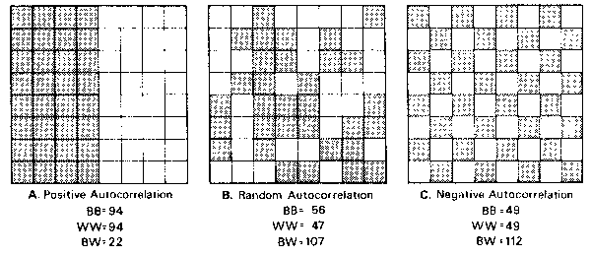
Technical box 4.3
- Isopleth and choropleth maps
  - Isopleth maps are used to visualize phenomena that are conceptualized as fields and measured on interval or ratio scales
    - Isoline: connects points with equal attribute values (ex: contour lines)
    - Isohyets: points of equal precipitation
    - Isochrones: points of equal travel time
    - Isodapanes: points of equal transport cost
  - Choropleth maps are constructed from values describing the properties of non-overlapping areas, such as countries or census tracts
    - Each area = coloured, shaded or cross-hatched to symbolize value
    - 2 types of values:
      - Spatially extensive: those whose values are true only of entire areas (ex: total population)
      - Spatially intensive: those that could potentially be true of every part of an area, if the area were homogeneous (ex: densities, rates or proportions)
Technical box 4.6
- Measuring lengths is dependent upon the tools used and the distances measured. The smaller the interval, the more accurate then length of what is being measured will be.

Chapter 5 - Georeferencing
- Time is an optional element in geographic information, but location is essential
- To be most useful georeferences should stay constant through time
- Metric georeferences are much more useful because they allow maps to be made and distances to be calculated
- Many commonly used place names have meanings that vary between people and with the context in which they are used
- The meaning of certain place names can become lost through time
- Postal addresses work well for Georeferencing dwellings and offices, but not natural features
- Linear referencing systems identify location on a network by measuring distance from a defined point of reference along a defined path in the network
- Linear referencing systems are widely used in managing transportation infrastructure and in dealing with emergencies
- Earth is often represented as an ellipsoid
- Lines of latitude and longitude are equally far apart only at the equator, toward the poles, lines of longitude converge
- Conformal property – ensures that the shapes of small features on Earth’s surface are preserved on the projection
- Equal area property – ensure that areas measured on the map are always in the same proportion to areas measured on the Earth’s surface
- Three major projection classes:
  - Cylindrical projections – wrap sphere with paper and unroll it
  - Azimuthal or planar projections – touch the Earth with a sheet of flat paper
  - Conic projections – wrap a sheet of paper around the Earth in a cone shape
- When longitude is assigned to x and latitude to y, a very odd-looking Earth results
- Universal Transverse Mercator (UTM) coordinates are in meters, making it easy to make accurate calculations of short distances between points
- Geocoding: converting street addresses to latitude and longitude or universal coordinate systems
Chapter 6 – Uncertainty
- It is impossible to make a perfect representation of the world, so uncertainty is inevitable
- Uncertainty accounts for the differences between the contents of a dataset and the phenomena that the data are supposed to represent
- Many terms to describe uncertainty:
  - Vagueness (definitions), fuzziness, imprecision, inaccuracy, etc.
- Conceptual view of uncertainty:
Real world – U1 Conception – U2 Representation – U3 Analysis
- Uncertainty can exist both in the positions of boundaries of a zone and in its attributes
- Many English language terms used to convey geographic information are inherently ambiguous
- A geographic database is a collection of measurements of phenomena on or near the Earth’s surface
- Errors in land cover maps can occur in the locations of boundaries of areas, as well as in the classification of areas
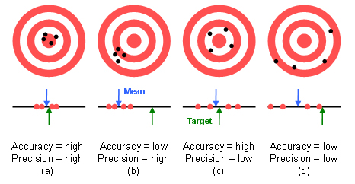
- Inappropriate inference from aggregate data about the characteristic of individuals is termed ecological fallacy
- Relationships typically grow stronger when based on larger geographic units
Chapter 8 – Geographic Data Modeling
- A data model is a set of constructs for describing and representing selected aspects of the real world in a computer
- A layer is a collection of geographic entities of the same geometric type (ex: points, lines, polygons). Grouped layers may combine layers of different geometric types
- Raster data model: uses an array of cells, or pixels, to represent real-world objects (commonly associated with field conceptual data)
- Vector data model is closely linked with discrete object view
- Features are vector objects of type point, polyline, or polygon
- TINs = triangulated irregular networks

Chapter 9 – GIS Data Collection
- Data collection workflow:
  - Planning Preparation Digitizing/Transfer Editing/ Improvement Evaluating
- Primary geographic data capture involves the direct measurement of objects
  - Primary raster data capture = remote sensing
  - Remote sensing is the measurement of physical, chemical and biological properties of objects without direct contact
  - 3 key aspects of resolution: spatial, spectral and temporal
  - 2 main branches of vector data capture: ground surveying and GPS
  - Ground surveying is based on the principle that the 3-D location of any point can be determined by measuring angles and distances from other known points
- Secondary geographic data capture is the process of creating raster and vector files and databases from maps, photographs and other hard-copy documents
- Human error is commonly introduced in the digitizing process
  - Errors are: overshoots and undershoots, omissions of one or more lines, omission of attribute data and sliver polygons
- Web 2.0 technologies have enabled citizens to collect data very rapidly, across a wide variety of thematic and geographic areas that represent a wide spectrum of viewpoints
Box 9.2
- Citizen-centric data collection
  - E-Flora BC project – public is encouraged to participate in reporting occurrences of invasive plant species accessible through the web
Chapter 10 – Creating and Maintaining Geographic Databases
- A database is an integrated set of data on a particular subject
- DBMS = database management systems
  - Relational databases are made up of tables
  - Each geographic class (layer) is stored as a table
  - Database tables can be joined together to create new views of the database
- SQL = standard query language (or structured)
- Edits must be stored in a file system or database
- The mechanism for managing edits to a file or database is called a transaction

Chapter 11 – The GeoWeb
- 6 component part of GIS
  - Hardware, software, data, users, procedures and network
- In distributed GIS the 6 component parts may be at different locations
- 4 locations of significance to distributed GIS:
  - Location of the user and the interface from which the user obtains GIS-created information, U
  - Location of the data being assessed by the user, D
  - Location where the data is processed, P
  - Area that is the focus of the GIS project, or the subject location, S
- In distributed geography the user location and the subject location can be the same
Chapter 12 – Cartography and Map Production
- Maps are both storage and communication mechanisms
- Principles of map design
  - Purpose
  - Reality
  - Available data
  - Map scale
  - Audience
  - Conditions of use
  - Technical limits
Chapter 14 – Spatial Data Analysis
- Spatial analysis can reveal things that might otherwise be invisible – it can make what is implicit explicit
- Spatial analysis is the crux of GIS, the means of adding value to the geographic data and of turning data into useful information
- Spatial analysis is a set of methods whose results change when the locations of the objects being analyzed change
- Location – identifying where something exists or happens
- Join – a fundamental operation in databases that is used to combine the contents of two tables using a common key
- Point in polygon operation – used to determine whether a point lies inside or outside a polygon
- Distance – the separation of places on the Earth’s surface
- A GIS will almost always underestimate the true length of a geographic line
- Buffering is possible in both raster and vector formats
- Point patterns can be identified as clustered, dispersed or random
  - Clustered – some locations are more likely than others, and the presence of one point may attract others to its vicinity
  - Dispersed – the presence of one point may make others less likely in its vicinity
  - Random – points are located independently, and all locations are equally likely
- First-order processes involve points being located independently, but many still result in clusters because of varying point density
- Second-order processes involve interactions between points, leading to clusters when the interactions are attractive in nature and to dispersion when they are competitive or repulsive
- IDW = inverse-distance weighting: (using Tobler’s law) estimates unknown measurements as weighted averages over the known measurements of nearby points, giving the greatest weight to the nearest points
- IDW provides a simple way of guessing the values of a continuous field at locations where no measurement is available
- Kriging responds both to the proximity of sample points and to their direction
Chapter 16 – Spatial Modeling with GIS
- An analog model is a scaled physical representation of some aspect of reality
- Any model leaves its user uncertain to some degree about what the real world will do
- Models allow planners to experiment with what-if scenarios
- Models can be used for dynamic simulation, providing decision maker with dramatic visualizations of alternative futures
LECTURES
LECTURE 1 – Intro to Geomatics
Main Disciplines of Geomatic
- Geographic Information Systems (GIS)
- Remote sensing (satellite imagery)
- Global Positioning Systems (GPS)
- Cadastral surveying (land boundaries, etc.)
Cartography
- Definition: multidisciplinary field: surveying, GPS, etc
- Geomatics from a geographers perspective (remote sensing, photography, GIS, etc)
- The Geomatics approach
  - Carried out by
    - Data
    - Assesses uncertainty
    - Modifies/analyze data
    - Visualize/display data
Remote Sensing
- Definition: science collecting information about Earth without being in contact with such entity
- Source of layers to GIS – “feeder”
Remote Sensing – Active vs. Passive
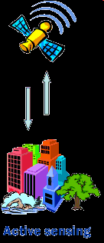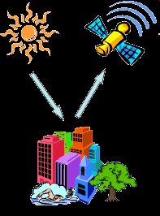
Active Passive
- Active remote sensing is when something is emitted from a starting point like sonar in order to bounce off an object and return information back about that object or the space around it to the source containing the data needing to be acquired. Passive remote sensing is when no source is emitted to return information; instead the data is collected ‘passively’ through visual observation for example

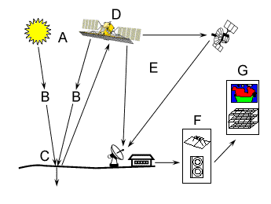
Cartography
- Definition: production of maps with primary goal for representing/depicting spatial distribution of given entities on a planetary body
  - Emphasis on SPATIAL DISTRIBUTIONS
- Coordinate systems
- Not a “feeder”
GPS
- Definition: network of satellites that calculate 3D position, x, y, z, in a continuous and instantaneous fashion
- Revolutionized transportation, environmental management, weather prognosis, etc.
- Source of layers – “feeder” collect data and records coordinates
Pythagorean Theorem Triangulation
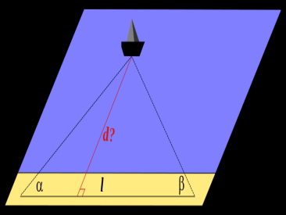
Characteristics of Maps
- Reductions
Map Scale – defined dimensional relation between reality and a map
Ex: 1:50 000 1cm = 50 000 cm

- Transformations
- Projection – transformation of a spherical surface to 2D map

- Abstractions
- Simplification of reality (only info chosen to fit the purpose of the map is displayed)
Mercator Projection
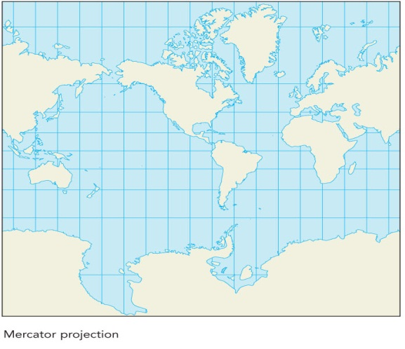
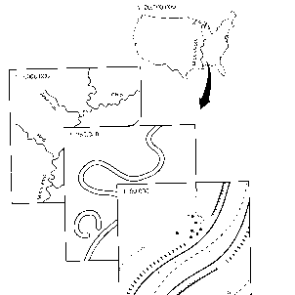
Map Categories
- Map Scale
- Small Scale
  - “bird’s-eye view” of a large area.
- Large Scale
  - “close-up view” of a small area.

- There are no set international standards of the cut-offs
- 1:50,000 cutoff between small & large scale

- Function
- General reference maps
    - Usually large-scale
    - Ex: mining, tourism, etc.
- Thematic maps or special purpose maps
    - Shows theme
    - Distribution of an attribute for relation among attributes
- Charts
- To be worked on”
  - Nautical
  - Aeronautical
Hypothesis/Prediction
- Definition of hypothesis: supposition about data expressed in a manner to make it subject to tests
- Definition of prediction: tentative proposition which is to be subjected to verification through investigation (educated guess)
Spatial is Special
- Spatial refers to any space
- Geographic/Geospatial refers to Earth’s surface (coordinates)
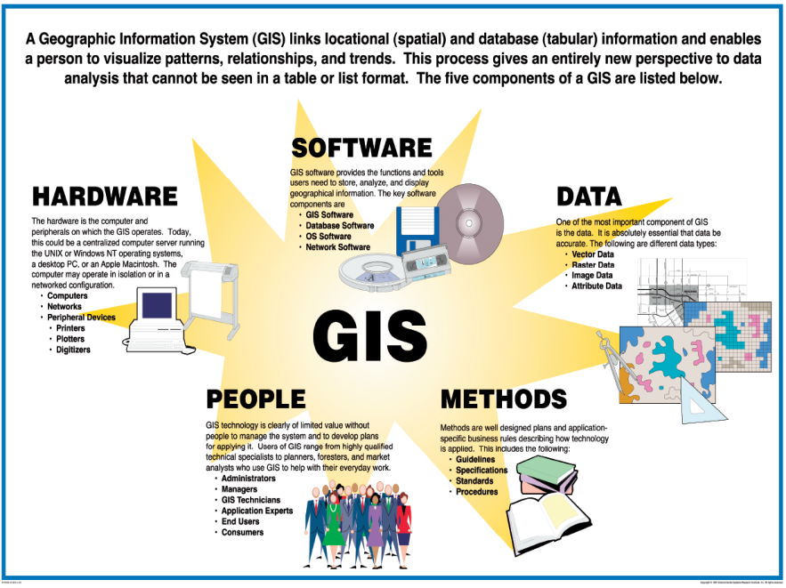
Data: raw or unprocessed information
Knowledge: info allows us to create knowledge (knowledge can help us make predictions)

LECTURE 2 – Representing Geography
Geographic Representations: 2 Key Questions
- Why create representations, computer or otherwise?
- We live and interact with such a small % of our earth – we don’t know much about the part of the world we don’t interact with. What we need to sustain our lifestyle is increasingly more in the parts of the world that we do not interact with. Helps us assemble far more knowledge about the world than we know. We can also figure out missing pieces. Plans can be tested by computer models.
- What do we represent and how to represent it?
- how – depends on the accuracy we require (generalization and scale dependent – determines what and how we represent)
The Fundamental Problems
- The world is infinitely complex, but computer systems are finite.
Geographic Data Link
- Place (locations)
- Time
- Attribute(s)
Ex: I saw a large whale (attribute) 25m from the shore (place) an hour ago (time)
What are Attributes?
- Things about a place.
  - Identify
  - Describe
  - Measure
  - Classify
- description of place in time
  - Ex: street name
Type of Attribute
- Nominal
- Ordinal
- Interval
- Ratio
Types of attributes: Nominal
- Serves only to distinguish one entity from another.
- Observations of kind / Categorization
  - Cannot apply math to nominal attributes
    - Ex: place names, colours, binary systems, male/female, etc.
Types of attributes: Ordinal
- Values have a natural orders.
- Ranked data, greater/less than, ordered along a scale
  - ex: big, medium, small; low, medium and high-income
  - Cannot apply math
  - Can have median, but not average
Types of attributes: Interval
- Algebraic meaning
- Arbitrary zero but no natural origin
  - If the differences between values ‘makes sense’
  - Ex: Celsius scale
  - Can do math

Types of attributes: Ratio
- A difference between two interval measures
  - Elapsed time (t_{o}-t₁)
- True origin
  - Ex: weight
GIS Special type of attribute: Cyclic
- Directional or Periodic
  - Compass
  - 0 degrees = 360 degrees
View of the Geographic World: Discrete (or categorical) objects
- Objects in “empty” space
- Can be counted
- Limitations…
  - Ex: humans – occupy volume in space
  - Represents the world as objects having well defined boundaries in ‘empty’ space.
  - Object: instance of a generally recognized category that CAN BE COUNTED
  - Discrete view is not the best way to represent the infinitely complex world ex: mountain is really continuous growth from the ground, not a discrete object.
View of the Geographic World: Continuous fields
- World defined at every location
- No “empty world”
  - Represents the real world as a FINITE # of variables – key defined at every location
  - Ex: population density, magnetic field

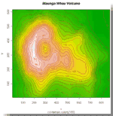
Continuous vs. Discrete Fields
Continuous

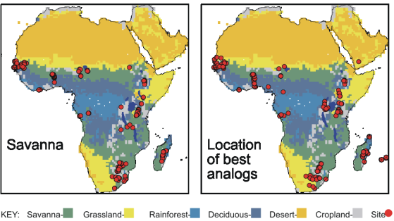

Discrete/Categorical

Raster data model
- Ways to represent data in a way a computer can ‘understand’.
- An array of numbers that is either 0 or 1 – binary system
- Leads to large data storage requirements
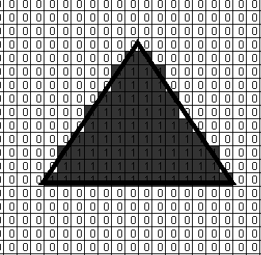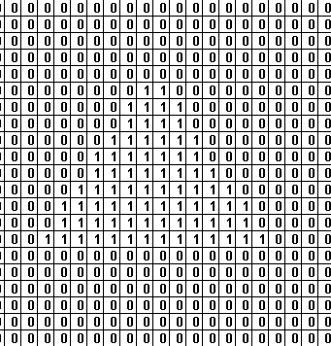
Mixed Pixel Problem
- What if the boundary of the two land uses share a pixel? A: the pixel is given the value of the land use that covers the most space: “the largest share rule”
Vector Data Model
- Captured as points connected by straight lines
Polygon Representation
- Mathematical representation
- Doesn’t have to encode for inside area, just applied by dots
Vector Model Topology
- Arcs
- Nodes
- Vertices
  - Arcs – a series of connected points (x,y) with a defined start and end point.
  - Nodes the beginning and terminal points that define an arc.
  - Arcs are joined only at nodes.
  - Points in-between two nodes are called vertices.
Vector Components
- POINTS: have no dimension but its coordinates allow for accurate representation of a phenomena
- LINES: have 1 dimension (length).
- POLYGON (AREA): length, area. Area is captured by a series of points (vertices).
  - POLYLINE: No area… ex: path of migratory bird
  - To capture an area object in vector form, we only need the locations of points that form the vertices.
- So, Vector is more memory efficient AND accurate
Discrete Objects
Object | GIS Rep. | Example | Dimension
Areal | Polygon |  | 2
Linear | Line |  | 1
Incidental | Point |  | 0

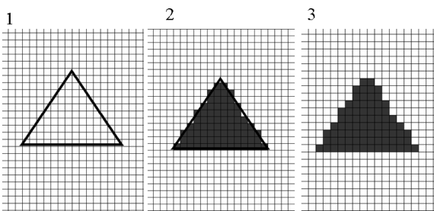
Raster version does not accurately represent the vector version of the triangle
- Vector
  - Rivers – more accurate for shorelines
  - Roads – curves in roads that raster cant represent
  - Buildings – discrete objects
  - Railroads – lines, branching, network.
  - Political boundaries – imposed, not necessarily real but important for taxation and management etc..
  - Range boundaries – vector.
  - Soil type or soil units
- Raster
  - Crime Density – number of crimes per unit area
  - Pollution concentration – pollution of some sort or chemical everywhere.
  - Temperature – always present everywhere.
  - Commuting times – distance surface or time surface
  - Geology – rock units, types, - everywhere that’s all right.
- Some techniques that can only ‘handle’ certain type of data (raster or vector)
Few Rules
- Font style
Human phenomena: ex. City of Ottawa
Physical phenomena: ex. St-Lawrence River
- Physical phenomena should be italicized, but human phenomena can be left in normal font

- Font size
- The name has priority – avoid obstacles
- A larger city must have a larger font:
  - Ottawa
  - Casselman

- Colour
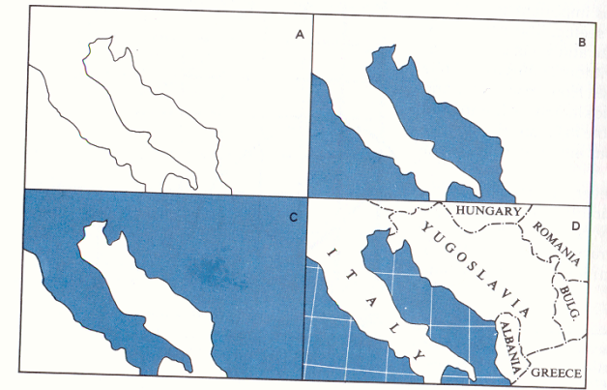
- Water should be blue, terrain a shade of brown, etc.
- Grid is an elegant way to enhance map

- Labelling Feature
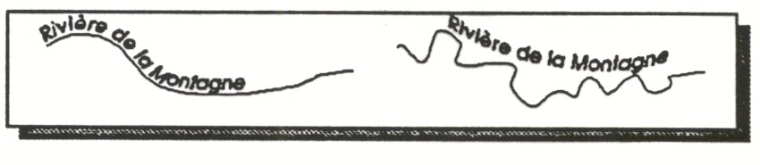
- Positioning Labels
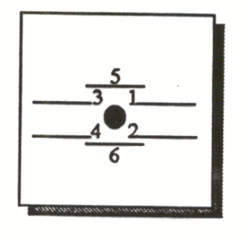
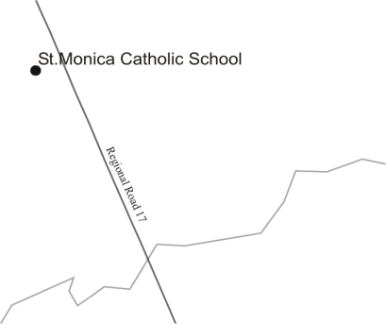 NO 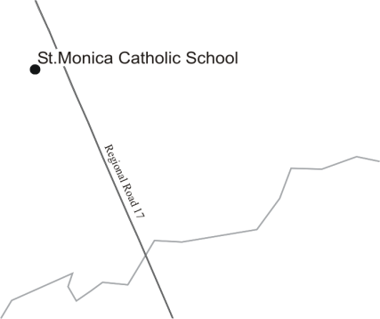YES

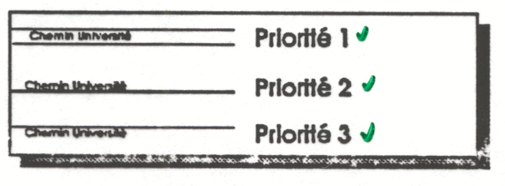
LECTURE 3 – Georeferencing & Cartographic Projections
Georeferencing
- Define the existence of an object in the physical space
  - Establishing location of an object in terms of map projections or coordinate systems (adds to the georef definition)
  - We georef to make sense of data
Requirement of Georeferencing
- That it be unique
- That its meaning be shared
- Temporally persistent
- Unique – only one location is associated with a given reference ex: London, UK vs. London, Ont.
- Meaning be shared – to be understood more easily
- Ex: 60 University Ottawa, Ont. Can K#X #X# to most Canadians this indicates that it is some place within a University in Ottawa, Ont. Canada
- Persistent through time – cannot have a georef change through time often. Ex: road names
Georeferencing: Simple and Metric
- Simple: names/text
- Metric:
- E.g.:
  - Latitude and longitude
  - UTM
- Unique = simple georeferencing
- Some georeferences are nominal – ex: london, mount everest
- Metric: geometric system
- Provide opportunity for infinitely fine level of precision
- Can perform computation with this system
Georeferencing system: examples
- Place Names
- Postal Addresses
- Postal Codes (FSA)
- Linear Referencing
- Cadaster
- Longitude and Latitude
- Projections and coordinate systems
- GPS (Global Positioning System)
Geoid vs. Elipsoid
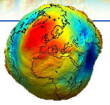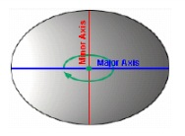
Geographic Coordinates
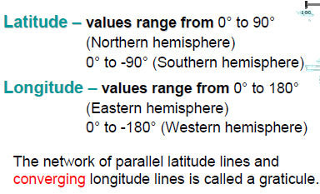
*** Projected coordinate system is always based on geographic coordinate system – this leads to distortion; pay the price in distortion but gain the ability to perform math***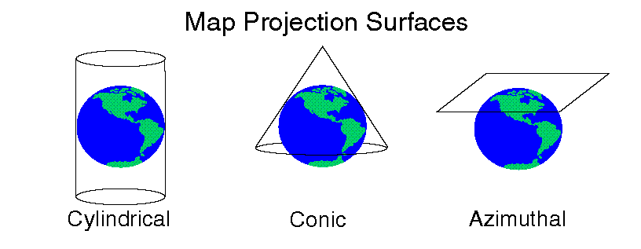
Which map projection?
What is the purpose and final use of a project?
- Thematic map = equal-area
- Presentation maps (not for analysis) = conformal
- Navigation = Mercator, azimuthal, equidistant
- Extent = a city or a continent?
- Location = polar, mid-latitude or equatorial region?
- Predominant extent = east-west or north-south extent?
- Mercator – often used, most accurate at equator
- Conic = often used for the poles, most accurate at top, distortion occurs more as moved out into concentric circles
Projections and Distortions
- GCS to PCS = always involves SOME distortion
- 4 spatial properties are affected by distortion: shape, area, distance, direction
- No map can preserve all four spatial properties
- Tangent: when a projection touches the hypothetical globe. Interject that with a secant – no distortion occurs at the point of contact. The further we move away from the points of contact; distortion will increase in between the two as you move away from them.
A map is said to be….if….
- Conformal if it preserves local shapes
- Equal-Area if the size of the feature on the map is relative to its actual size on Earth
- Equidistance if it preserves distances from all locations
- Azimuthal if directions or bearings are preserved from all locations to one other point (Also called planar)
LECTURE 4 – Cartographic Principles and Map Design
Objectives of Map Design
- Primary goals
- Secondary goals
GIS Processing Transformations

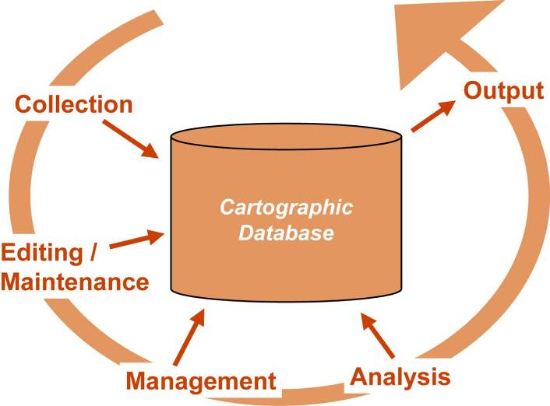

Limitations of Paper Maps

Map Types
- Two main types of maps:
- General reference maps
- Thematic maps
Design Process: 4 stages
- Graphic conception
- Specific graph plan
- And 4. Implementation specification and design prototype

Perceptual Considerations
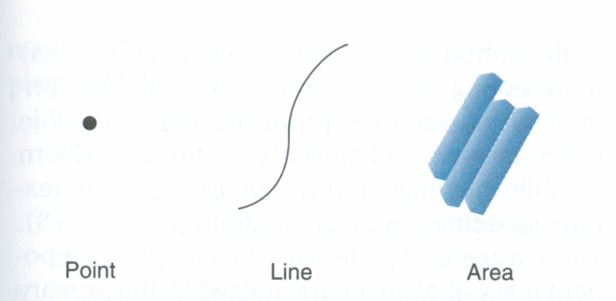
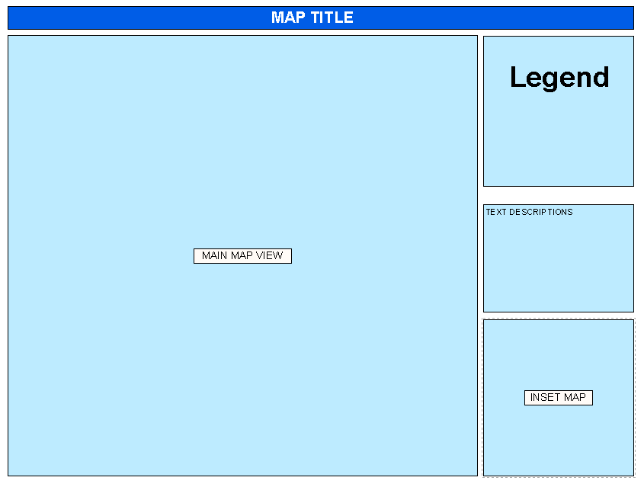
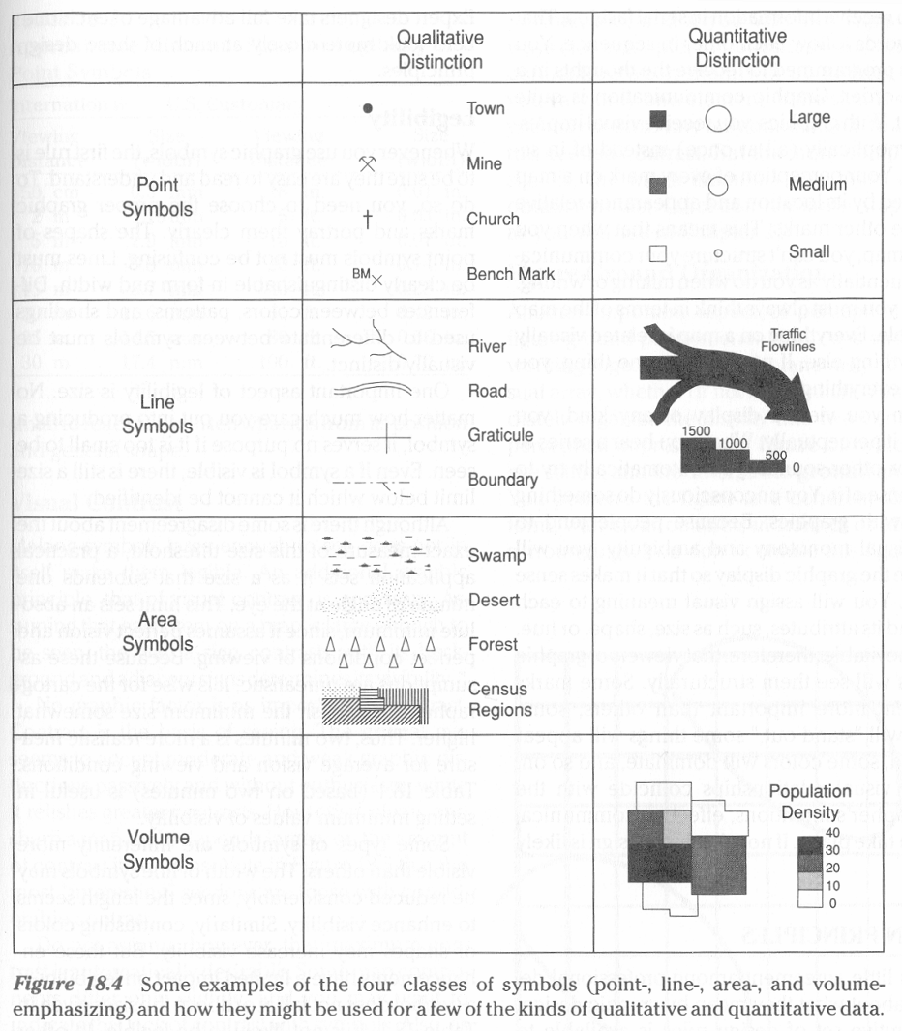

- To make point, line and area marks on the map appear more or less distinctive we alter:
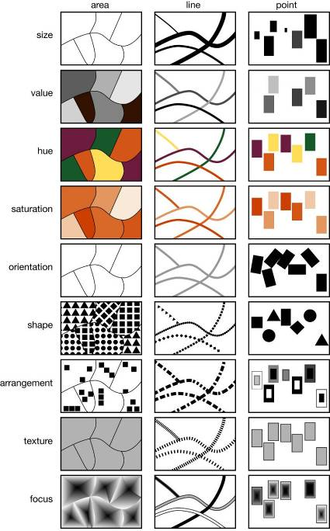

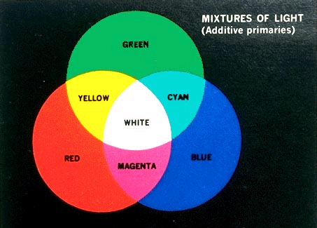
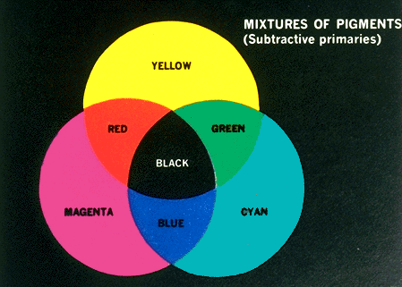
Perceptual Considerations: Visual Variables
- Value
- Hue
- Saturation

Colours, Absorption, Reflection, and Appearance
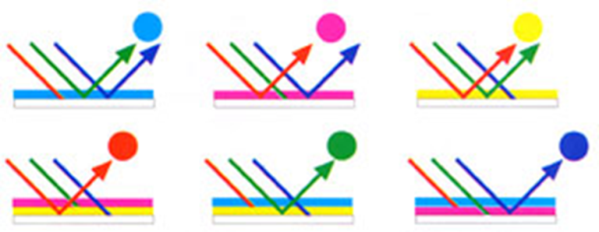
Perception of graphic complexes
- Graphics provide a “synoptic” visual impression
- Some map problems
Design Principles
- Legibility
- Visual Contrast
- Figure vs. Ground Organization
- Hierarchical Organization

Design Principles: Legibility
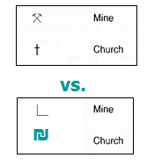
Design Principles: Visual Contrast
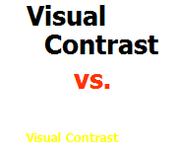

Design Principles: Figure vs. Ground
Controls on the discrimination of figure vs. ground:
  - Closed forms: island, countries. Small surrounded area tends to be perceived as figure
  - User familiarity: fixation on well-known shapes
  - Good contour: continuity tend to enhance figure-ground differentiation (graticule & drop shadow raise figure)
  - Detail: markings on land define figure
  - Size: smaller areas emerge as figure, larger as ground
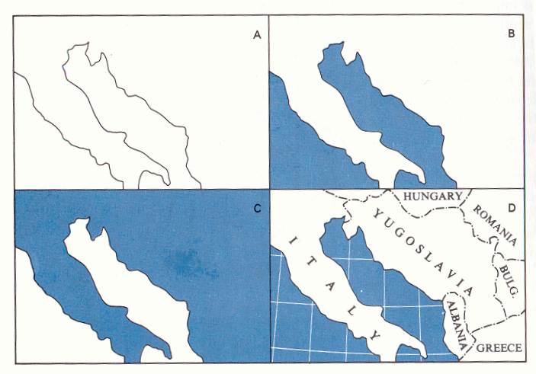
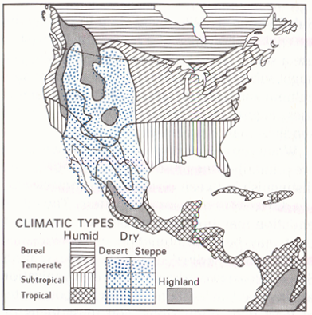
Hierarchical Organization
When considering initial designs keep visual hierarchy in mind
- Area symbols

Visual Balance
- Visual/geometric center
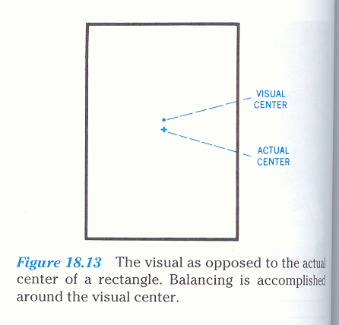
- Shape of Map Layout
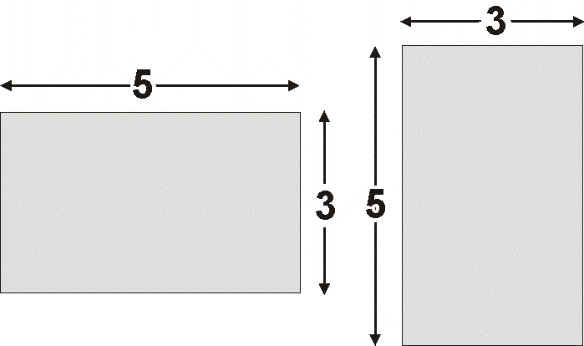

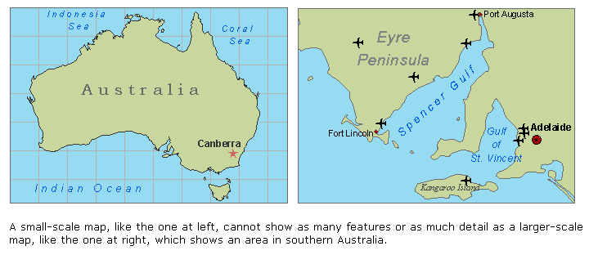

Cartographic generalization: example of bad generalization
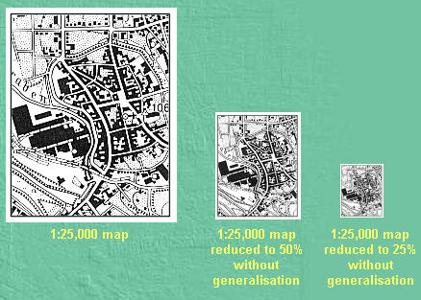
Cartographic generalization: example of GOOD generalization
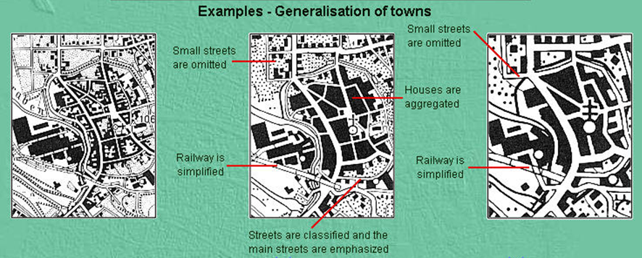

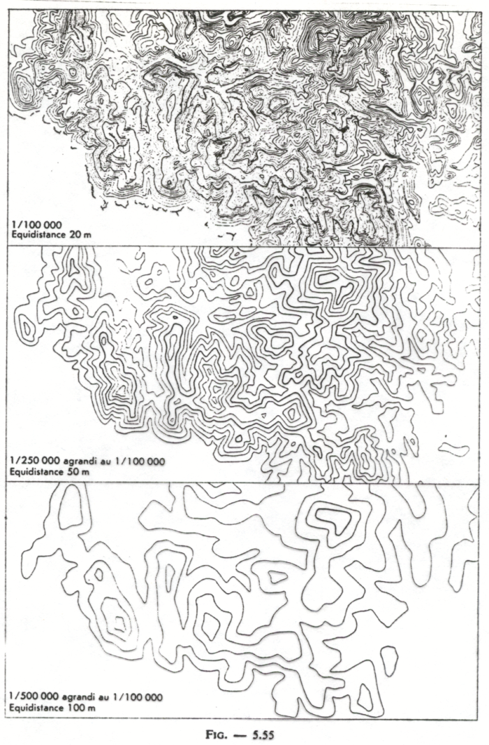
Map Composition
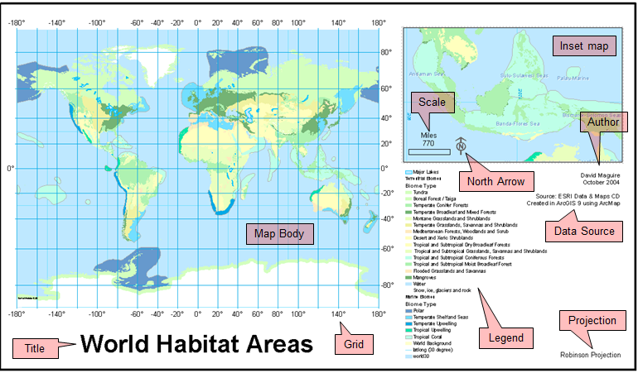
- Title
- Legend (key)
- Inset/overview map
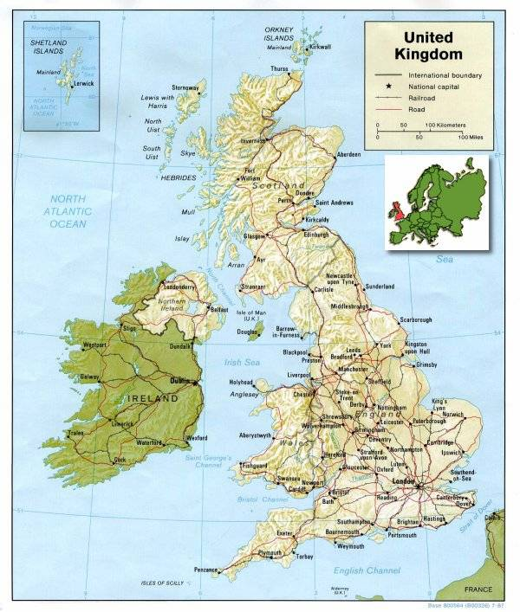
- Direction indicators
- Scale
- Borders
- Metadata
Type Form
- Natural features (hydrography, landforms, etc..)
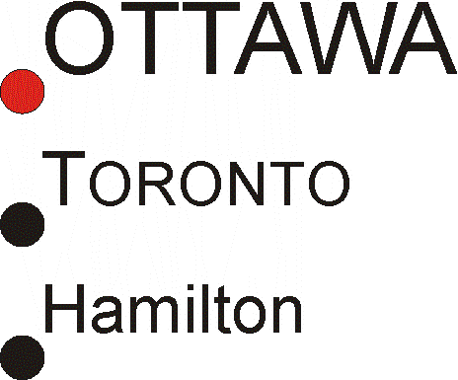
  - Italic
- IMPORTANT names and titles
  - UPPERCASE
- Medium importance
  - UPPERCASE
- Less important
  - Lowercase

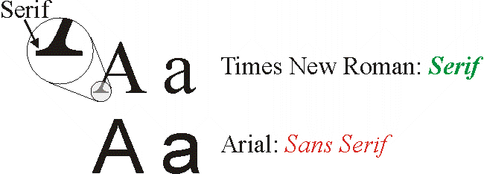
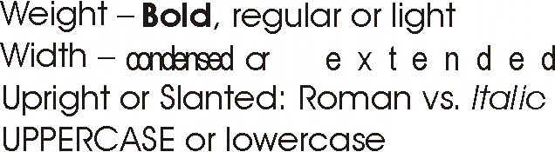
Type color & spacing
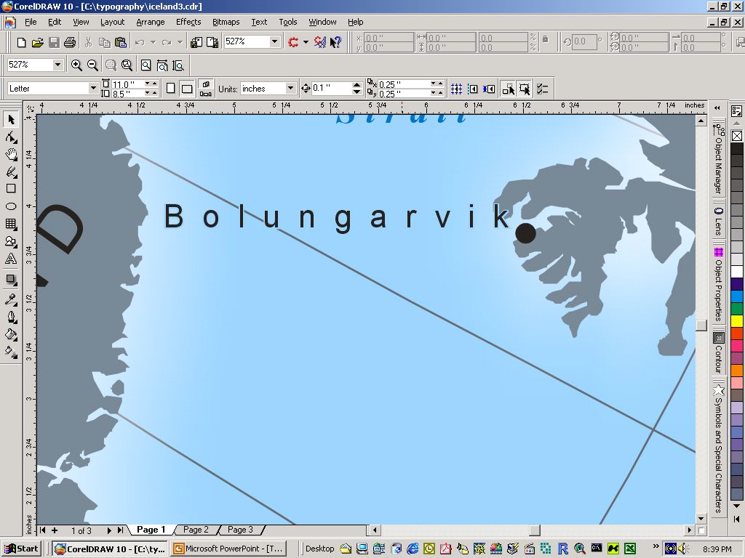
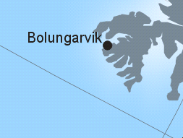 vs. 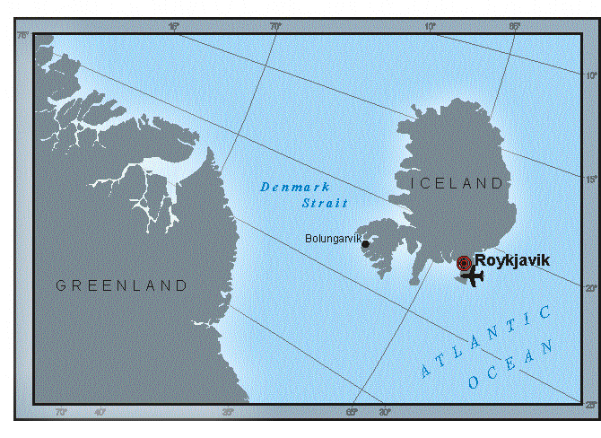

Lettering Place Features (Points)

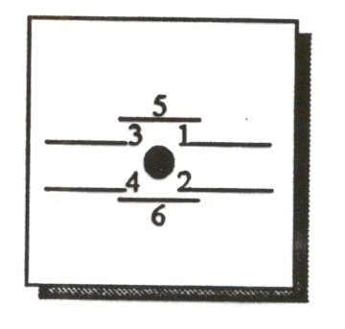
Respecting curvature
Labeling Linear Features
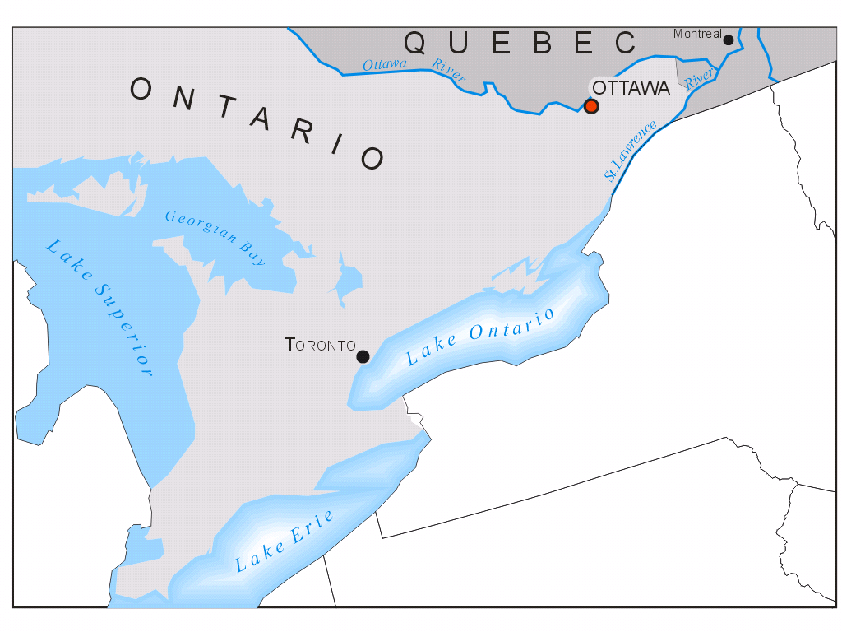
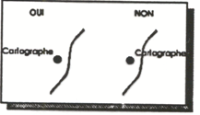
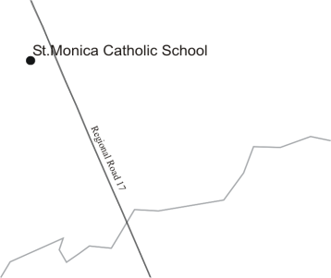NO vs. 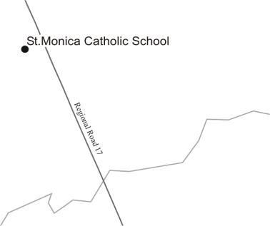YES

Labeling Areal Features
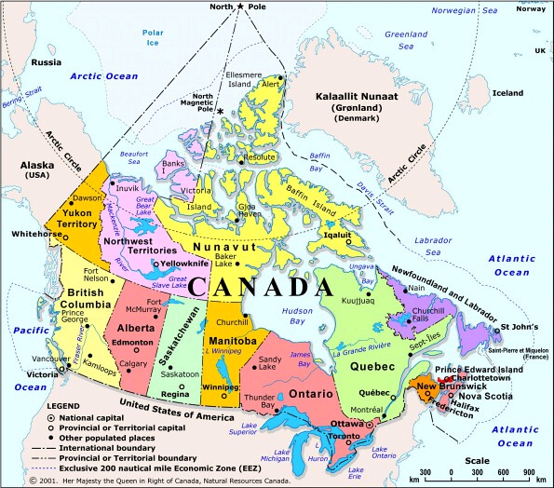
Remember: the bare minimum…
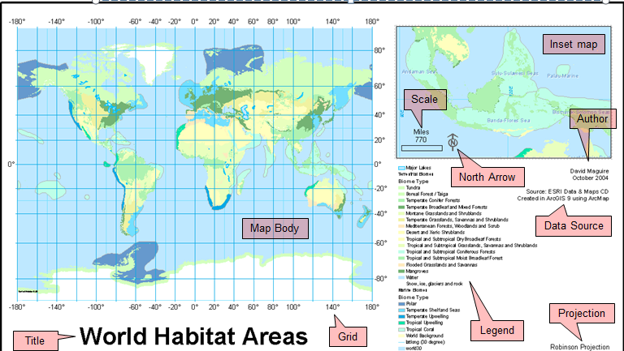
Conclusions
- Cartography is both an art and a science
- Like any other art maps are rarely good on the first iteration
- Maps are fundamental to presenting geographic data
- Map is the main thing
- Scale map to the data
- Modern advances in cartography (GIS) make it easy to produce good and bad maps
  - Remember that maps require many basic elements: do not automatically accept the standard ArcMAP output as being sufficient
LECTURE 5 – Managing Attribute Data

LECTURE 6 – NO CLASS

LECTURE 7 – Spatial Queries

LECTURE 8 – Uncertainty and Spatial Analysis
Uncertainty
- Inevitable!
- Is any representation a complete one?
- We must live with it.
- Impossible to make a perfect representation of the world
- Maps are inherently uncertain, therefore there is no complete representations
- Impossible to capture everything at any scale (especially in a digital representation)
- Uncertainty is acknowledging the problems and dealing with them as they arise
Sources of Uncertainty
Imperfections, hence errors and uncertainty, in:
- Measurements (Interval/Ratio)
- Definitions/Specifications (Nominal/Ordinal)
- Position (Spatial/Scale)
- Different measuring instruments can be used causing inaccuracy (ex: can’t measure the exact number of people in a city)
  - Some people are more accurate than others
- Def/spec – ex: what is a house?
  - Imperfect classification
- Position – spatial/scale
  - Can’t accurately position every feature
Sources of uncertainty
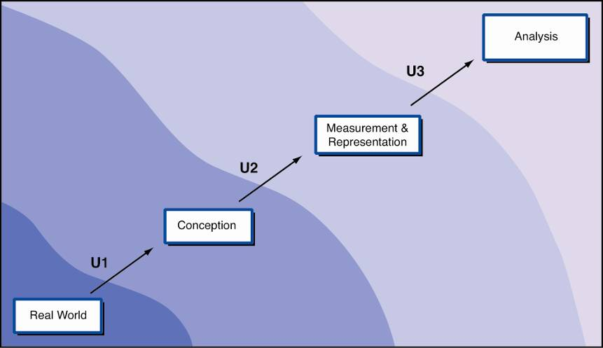
- U – filters: distort the complexity that the world is perceived – cumulative
- Lots of uncertainty – always acknowledge uncertainty
U1: Uncertainty in conception
- Conceiving geographic phenomena
- Units of analysis
- Conception makes a difference in how information is represented and analyzed
- Units of analysis – categories chosen are often vague (ex: what defines prime agricultural land?)
Uncertainty: Ambiguity
- Ambiguous linguistics
- Ambiguity also arises in the conception of indicators
- example: what does HIGH unemployment mean? What does dry soil mean? What does a dense forest mean?
- Introduces ambiguity right away
- High income levels are suggestive of high spending levels
- Indirect indicator examples: multiple car ownership (could be considered to have higher income – suggestive of higher spending levels)
Ambiguity: definition errors
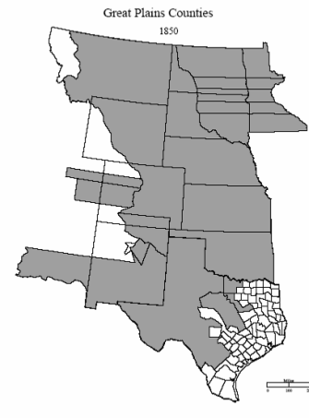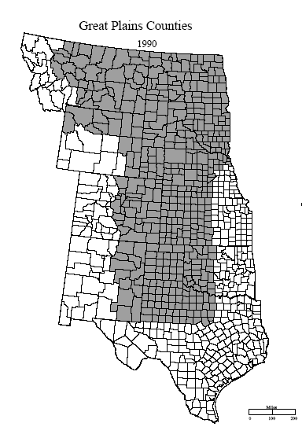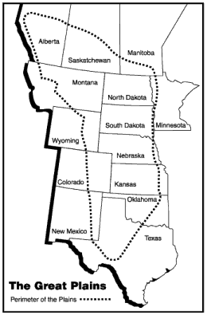
- Q: what are the boundaries of the great plains?
- What do we use to define the great plains? Agriculture, borders? Culture? etc.
Fuzzy Approaches to Uncertainty
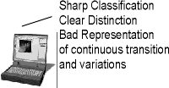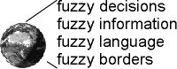
- In fuzzy logic partial truth: MAYBE
- We need it to deal with datasets that are not precisely defined.
- Ex: there is a range between 0 and 1.
Fuzzy approaches
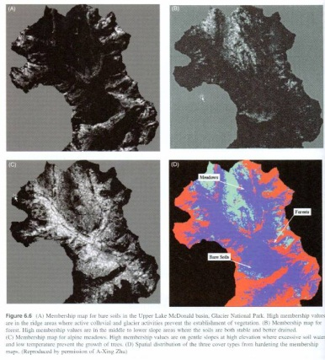
- Hardening = process of converting each pixel to the class with the highest value

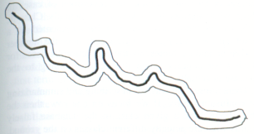
U2: Uncertainty in measurement
- Representational models filter reality differently:
  - Vector (discrete) representations
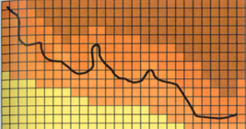
  - Raster (field) representations

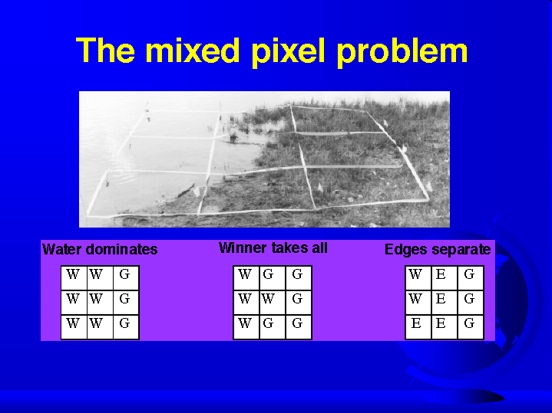

Precision vs. accuracy
These terms are often used interchangeably, but do not mean the same thing!
Precise measurements
- accuracy: how close a measurement is to the real value
Accuracy = how close a measurement is to the real value

Accurate (but imprecise) Accurate & precise
Reporting Measurements
- Excess precision should be removed by rounding
  - ‘14.43 m’ implies an accuracy of +/- 0.01 m
  - ‘14.4 m’ implies an accuracy of +/- 0.1 m
  - ‘14 m’ implies an accuracy of +/- 1 m
  - If a number is known to be exactly an integer or whole number, then it is shown with no decimal point
Blunder
- Blunder = human error (mistake)
Precision with blunder Accuracy with blunder
- Should include it but not ignore it
Positional errors: scale influences accuracy
Positional accuracy of features on a paper map is roughly 0.5 mm on the map
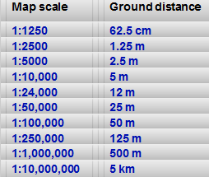
Positional errors
- Positional Errors (X, Y, Z axes)
  - Also errors from interpolation, georeferencing, etc.
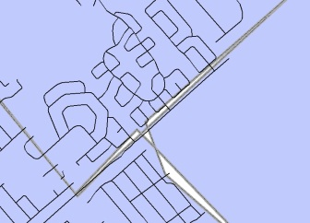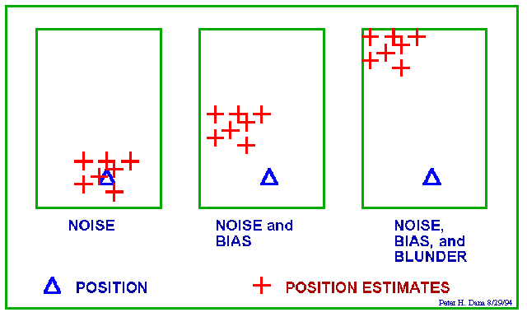
Digitizing GPS
U3: Uncertainty of analysis Ecological Fallacy
“Inappropriate inference from aggregate data about the characteristics of individuals is termed the ecological fallacy”
  - Personal error due to subconscious want to hear certain information
Fallacy of composition: Opposite to Ecological Fallacy
“Something is true of the whole from the fact that it is true of some part of the whole.”
Ecological Fallacy: example
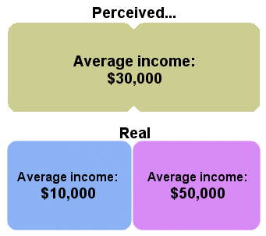
Modifiable Areal Unit Problem (MAUP)
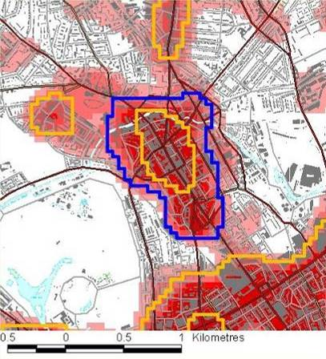
Different ways of defining a town center
- Summary values are very much influenced by the choice of the district boundaries
- Boundaries are often very arbitrary and not necessarily explained fully
- In this instance number and sizes of the data is important in …the zones
What is Spatial Analysis?
- A GIS analysis involves visualizing and combining geographic data to derive new information.
Implicit Explicit
Data Information Knowledge
- Analysis – takes the smaller parts, tries to understand them to explain the greater picture (greater than the sum of it’s parts)
- After knowledge decision making
- Spatial analysis doesn’t necessarily just apply to geographical space (ex: spatial analysis of neurons)
What is Spatial Analysis?
A set of methods whose results change when the locations of the objects being analyzed change.
GIS Analysis: few caveats
- does not solve problems
- does not always produce desirable results the first time
- may simply produce more questions
Spatial Analysis can be simple or complex
- Clusters on a map (simple)
- Dispersal of pollution (complex)
The Snow map: 19th century GIS analysis
- John Snow maps cholera in wells

The analytical process
- Define the problem
- Define the criteria
- Identify the data you need
- Plan the analysis
- Prepare the data for analysis
- Execute the analysis
- Examine and present the results
Spatial Analysis techniques: buffers
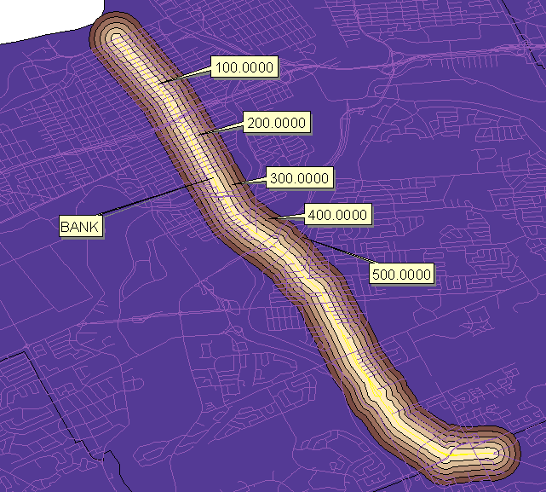
- Buffer: zone of interest (inclusion or exclusion)
- Crime within 300 meters of Bank st.
Buffering around a point
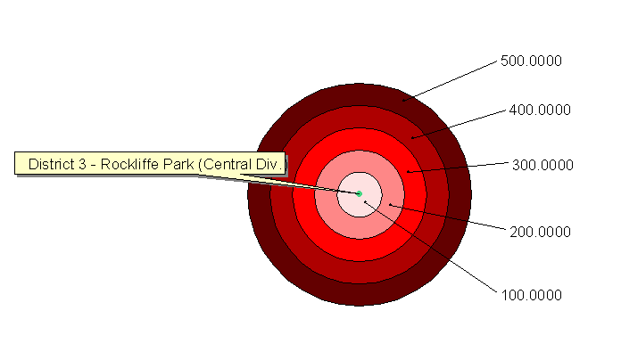
- Are crimes closer to Bank st. or are they more prevalent as one moves away from Bank st.?

Spatial Analysis techniques: Cluster detection
- What kind of pattern is displayed?
  - Random?
  - Clustered?
  - Dispersed?
- First order vs. Second order
Spatial Interpolation
- Making a reasonable estimate of the value of a continuous field at places where the field has not actually been measured.
- Interpellation only makes sense with continuous view
Tobler’s First Law of Geography
“Everything is related to everything else, but near things are more related than distant things”
Definition of Spatial Autocorrelation
- Positive SA 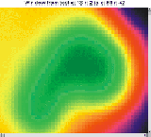
- Zero SA 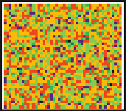
Spatial Autocorrelation is scale dependent
- Left: looks uniformly dispersed
- Right when the scale is adjusted we see a cluster of points

Irregularity vs. Regularity
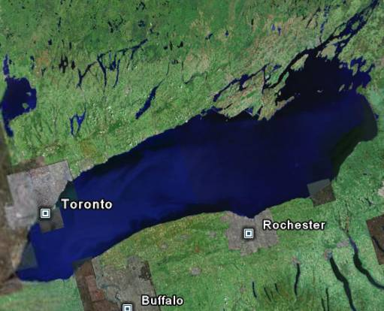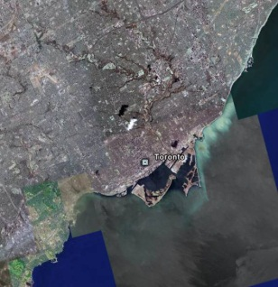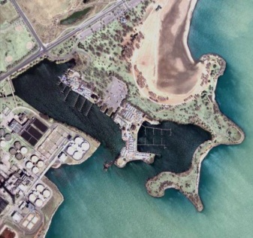
Measuring Spatial Autocorrelation: Moran's Index (a.k.a. Moran’s I)
- Value ranges from –1 to +1
  - Values close to –1 have negative SA
  - Values close to +1 have positive SA
  - Values close to 0 show random patterns
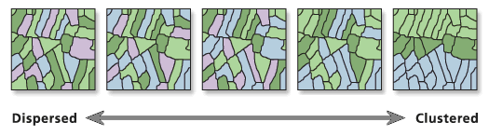
Spatial analysis techniques: Spatial Interpolation
- Thiessen’s polygons
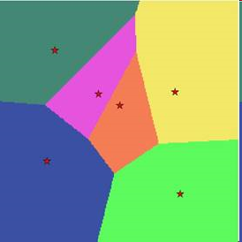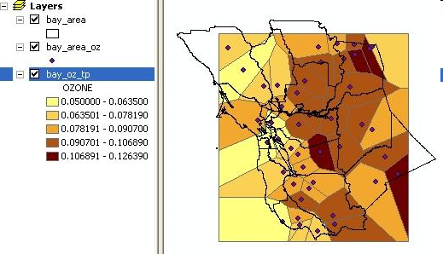

Spatial analysis techniques: Triangulated Irregular Network (TIN)
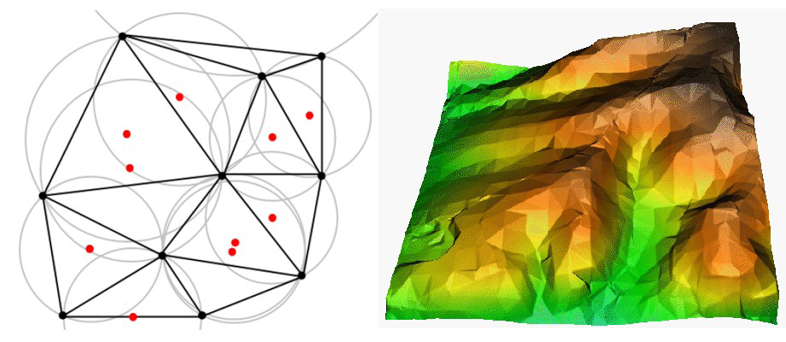
Spatial analysis techniques: Inverse-Distance Weighting (IDW)
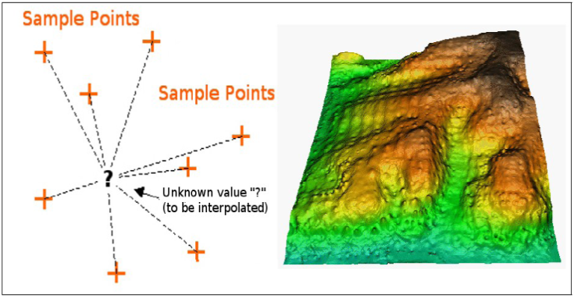
- Estimates unknown measurements with weighted averages…more weight to those points that are closer.
- Quality decreases if data points are distributed unevenly
- The max and min value interpolated by this model is limited by the max and min of the data points
Spatial analysis techniques: Kriging
- Keeps the properties of the surface in mind
- Semivariogram: a model within Kriging
Interpolation: words of caution
- No universal technique
- Follow a 3-step procedure:
  - Evaluate sample data
  - Apply interpolation suitable for sample data and results
  - Compare the results and assess
LECTURE 9 – NO LECTURE
LECTURE 10 – Spatial Modeling
Relationship of GIS Professionals
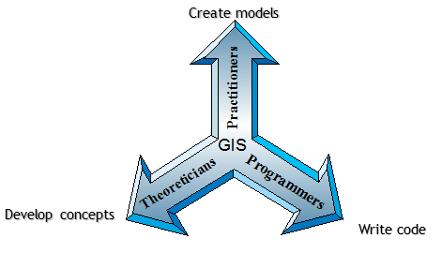
GIS for Exploration
- GIS allows scientists to challenge existing observational hypotheses through detailed measurement, analysis, and geographic visualization of patterns that, without the ability of the GIS to deconstruct or aggregate, may yield false or misleading conclusions
  - Holistic
- Allows one to take large chunks of earth’s surface and ‘play with it’
- Whole system must be considered when analysis phenomena
- Reductionist approach – taking things apart and analysis them => more holistic approach needed (Systems thinking)
- Example holistic model – systems thinking;
LOBLAWS
- Owners make money
- Place where people go to feed themselves
- Location of transportation (in and out)
- Place to meet someone
- Place to get a job
Loblaws is many things

What is a model?
- Data model: raster, vector, TIN, etc.
- (Simulation) Model
  - Representation of one or more processes or phenomena that occur in the real world
- Representation of the world
- Modeling = simplifying
- Simulation model --> produce some kind of result that will later be interpreted
Why Model?
- Repeat testing of a hypothesis with different data
- Automation
- Easier reproduction
- Simplification of workflow
- Avoiding manual steps
- Develop model to test hypothesis
- Can easily share datasets which simplifies workflow
- More efficiency with avoidance of manual steps
Understanding the Modeling Process
Knowing …
- what one is modeling …
- what types of data are to be used…
- what desired outcome or resulting model is to look like …
- Should keep in mind what exactly is being modeled
What is the model supposed to do?
- Is my model going to help me quantify an existing pattern so I can better understand it?
- Is my model attempting to examine multiple relationships from different maps?
- Am I making a model to show how things change through time?
- Is my model designed to predict something?
- Am I attempting to find the best places, routes, or scenarios for some form of activity?
Main Purpose: Analyze Geographically Referenced Data
Most done as formal models
- Human or physical environment, to…
- Aggregate or disaggregate mapped data
- Predict new distributions
- Define locations of selected activities
- Describe results of patterns of one variable on itself or on other variables
Understanding the Modeling Process
- Divide-and-Conquer approach to model building
GIS Analysis: its primary function
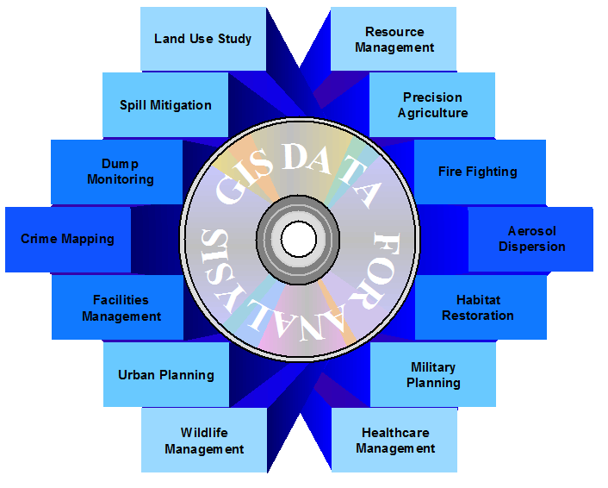
- Analysis is the most important thing in GIS
Geoprocessing
- What is geoprocessing?
- We have performed geoprocessing often
- A model is a collection of geoprocessing operations that automatically execute in sequence GOOD WORKING DEF OF MODEL
- Creating new data from existing data
- Model can be easily modified to produce different results
GIS as Toolkit
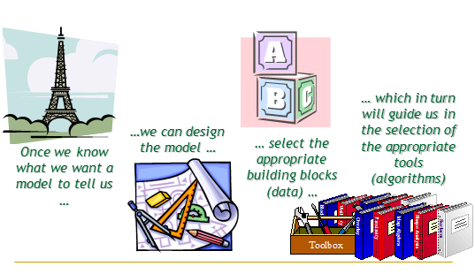
GIS as the Right Tool
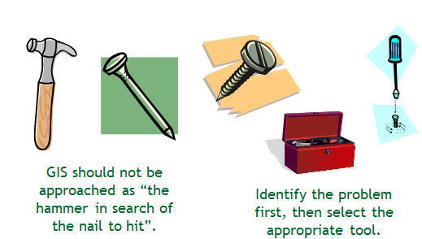
- Identify the problem FIRST!
… knowing all the commands of ArcGIS will not make you any more a GIS modeling expert than will knowing all the options within a word processor make you a best-selling writer …
How do we model?
- ArcGIS has a drag-and-drop interface to ArcToolbox called ModelBuilder allowing you to develop a flow chart of your GIS workflow.
- ArcGIS allows for custom scripting that can be added to ArcToolbox, introducing greater functionality.
  - We won’t be doing this in this course.
ModelBuilder
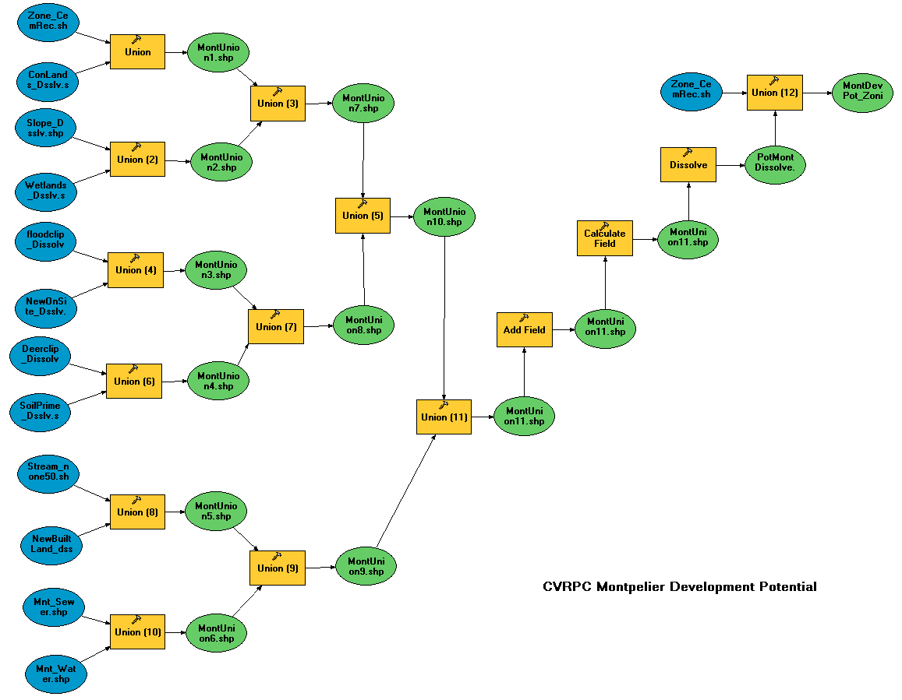
LECTURE 11 – Internet GIS
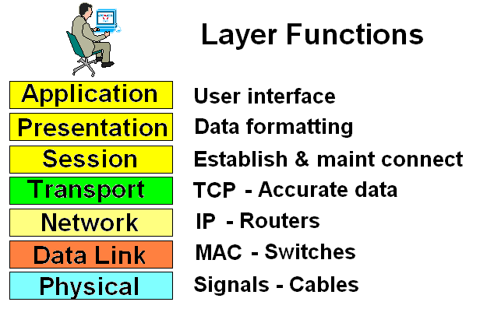
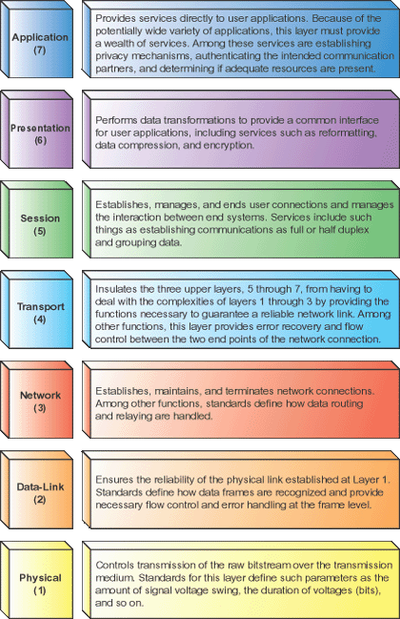

What is internet GIS?
- First, let’s define “desktop” GIS
  - Proprietary
  - Open Source
- closed, isolated, and centralized system
- Only accessible by the users that have physical access to the computer
- Open source: the language of the program for example is open to modification. (i.e. someone can completely re-write the program) – greater amount of customization
- Internet GIS
  - What is internet?
  - Web?
  - “…the use of and reliance upon the web as means to disseminate spatial information, perform analysis, and communicate results.” (Peng, 2001)
- Needed network that could survive war
- Before 1990s internet used by a small number of people (elite users)
- Web: Application that runs and operates on top of the internet
- Internet needs the web to share information
- Web does not require installation of programs/data web is the platform
Distributed GIS
- First, let’s define “centralized” in the context of environmental management.
  - Data incompatible
  - Not standardized
  - Difficult to find
  - Duplicated
  - Inadequately shared with the public
- - Ex centralized: to make appropriate decision, we need access to information. Data is scattered through different agencies. Need to create one giant database = access to all information from one central location. Problem: moment it’s in the system, it’s already outdated.
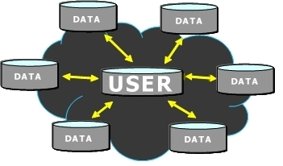
Distributed GIS is…
- an information architecture that streamlines data exchange
i.e. “spread out”
- Cloud = internet
- Everyone that owns data becomes a host
- Yellow arrows = processes, applications, etc.
- Information is shared over the internet using an outlined approach (same way)
- Idea of distributed GIS (spread out) opposite of centralized
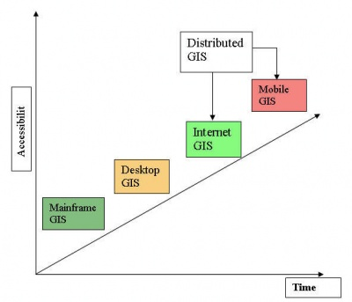

- Mainframe GIS (huge historical computer systems) (1st generation GIS)
- Desktop GIS – installed on many computers more people have access to GIS (2nd generation GIS)
- Distributed GIS (3rd generation GIS)

Why do we need Distributed GIS?
- Platform-independent
- Real-time accessibility
- Data ownership
- Monitoring
- Access can be opened/closed/protected
- Forces you to put things in a certain standard
- Can close access temporarily to update it
Basic components of Distributed GIS
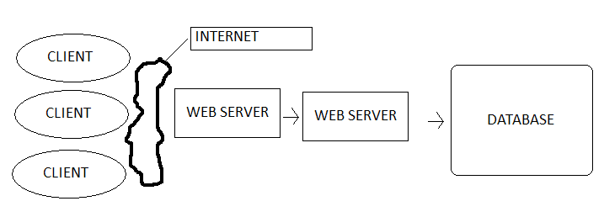
A Sample WMS request with MapServer
http://131.2.32.39/york/MapServer/WMSServer?SERVICE=WMS&VERSION=1.1.1&Request=GetMap&FORMAT=png&LAYERS=WELLS
Address, get me the Map, format in png, this particular layer
Web Mapping Services (WMS)
- A protocol for delivering map images created by a map server from a GIS database.
- GeoServer, MapServer, ArcGIS Server
- Returned as JPEG, PNG, TIFF

Anatomy of a WMS request
- open ArcGIS
- paste request (get capabilities)
- read by their WMS server
- gives response as image
- displays on the computer
Web Feature Service (WFS)
- get or query features based on spatial and non-spatial constraints
- create a new feature instance
- delete a feature instance
- update a feature instance
Who maintains these standards?
- Open Geospatial Consortium (1994) open to public, anyone can edit it
- About 30 standards, including WMS/WMF and KML
- Government of Canada uses these
The future of GIS and information sharing
- The internet as platform
  - Each computer becomes an informational node
  - Web 2.0
- Towards the geospatial web

- Analytical nodes increase the computing power to greater than any super system that exists
- Web 2.0 = modern web; allows for interaction (ex: facebook)
- Implies the convergence of spatial and non-spatial data in a standard format
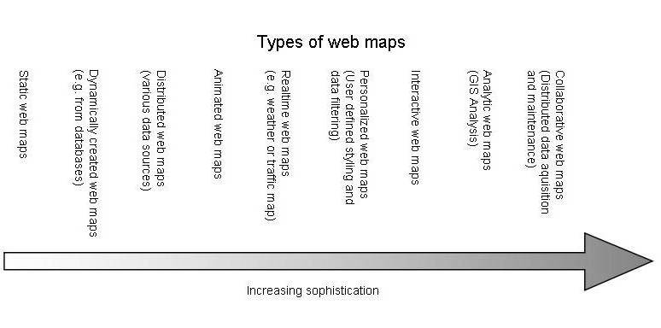
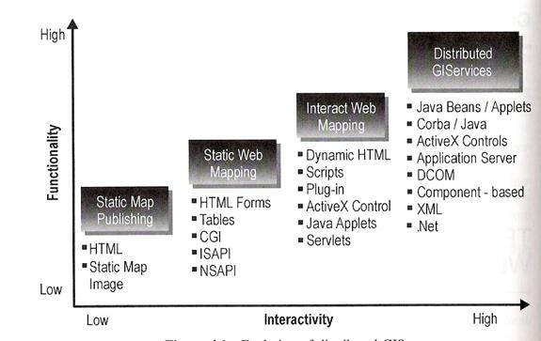
- Notice that there is high functionality and high interactivity is distributed GIServices
- Adaptations and improvements over time
What is Participatory GIS?
Is defined as the use of GIS to broaden public involvement in policymaking as well as to the value of GIS to promote the goals of nongovernmental organizations, grassroots groups and community based organizations.
It can be thought of as applied GIS, which incorporates values such as trust, transparency, inclusiveness, and empowerment. PGIS is not a distinct technology; it is a set of technologies that synergistically work towards the aforementioned values.
What is Participatory GIS?
- A subset of spatial analysis and participatory democracy
  - Not merely an implementation of technological tools
  - Citizen involvement and requires a community network
  - 4th generation GIS?
  - Bottom-up approach vs top-down
- Form of critical GIS (thinks critically of the broader usage)
- Recognized that technology alone is not enough to represent all knowledge
- Comes from people give data get something useful (to better): bottom-up approach
- Collect data analyzed put into report communicated back to people: top-down approach
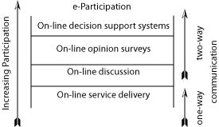
- Local knowledge plays a tremendous role in supporting knowledge
Critical GIS?
- Elitism and Accessibility
  - Empowering and disempowering users
  - Marginalization
  - Reinforcement of Western epistemology
- Alienation by Experts
  - Spatial problems are increasingly complex and imperceptible
  - May threaten the “participatory”
- Simultaneous empowers and disempowers
- Gives computer literate individuals an advantage; marginalizes those that aren’t. Also, those that have no access to computers or GIS, such as Aboriginals are marginalized…i.e. heavily caters to Western world
SHORT ESSAYS. Note: There is no limit, however, be as concise as possible.

- Name at least 4 disciplines/technologies that comprise geomatics.
- GIS
- Remote Sensing
- GPS
- Cadastral surveying

- List three ways of representing vector graphics. Briefly explained their properties/characteristics and give one example for each way (i.e. what can we represent using each?)
- Points, 0 dimensions, (x, y) coordinates
- Lines, 1 dimension (length), path of migratory bird
- Polygons, 2 dimensions (length and area), building

- Explain the difference between “active” and “passive” remote sensing instrumentation.
- Active remote sensing is when something is emitted from a starting point like sonar in order to bounce off an object and return information back about that object or the space around it to the source containing the data needing to be acquired. Passive remote sensing is when no source is emitted to return information; instead the data is collected ‘passively’ through visual observation for example

- What do we mean by “cartographic generalization”? What is an advantage of generalizing? What is a drawback?
- Cartographic generalization is the assumption that all maps represent the same attributes, or contain the same information about different places. The drawback of cartographic representation is that not all maps require the display of the same type of information, and displaying unnecessary information takes away from the map and it can become confusing to interpret or understand.

- In your own words, define “georeferencing”. Name one requirement that is must adhere to.
- Georeferencing defines the existence of an object in physical space. Establishing location of an object in terms of map projections or coordinate systems
- Must be UNIQUE, SHARED (meaning) and PERSISTENT (through time)
  - Ex: postal code, street names
6. Consider the following example: “first, second, third.” This would be an example of _________ data:
- ordinal
- nominal
- ternary
- none of the above

7. This ratio could easily be considered as “small scale”:
- 1 : 125 000
- 1 : 10 000 000
- 1 : 500
- 1 : 50 000

8. A geoid is :
- A representation of shapes and features visible on a sphere.
- Any surface where reduction of dimension occurs (ex. from 3D to 2D).
- A surface of equal gravity formed by the oceans at rest and by an imaginary extension of this surface under the continents.
- A perfect sphere which must always be projected prior to use.

9. Projections must be done because:
- It allows visualizations of the entire planet at once.
- It is impossible to unfold a globe.
- Computer monitors are flat.
- All of the above.

10. The system of latitude and longitude is also referred to as:
- UTM
- Geographic coordinates
- Cartesian coordinates
- Linear projection

QUIZ 2
Multiple-choice questions
1. The following Boolean operator does not exist:
- OR
- NOT
- WITH
- AND
- They are all Boolean.

2. The primary goal(s) of a map is to:
- share information and illustrate results
- highlight patterns and processes
- correctly project spatial information
- a) and b)
- b) and c)

3. In the context of cartographical design, “figure” means:
- main theme on the map
- what we notice first on a map
- amorphous ground underneath the relief
- none of the above

4. Metadata is important because:
- allows for faster searching of data
- it provides useful information about the quality of the data
- contains author contact info, instruments used, software version, etc.
- all of the above

5. The Modifiable Areal Unit Problem (MAUP) tells us that:
- user should always be able to modify the areal extent of the map
- aggregate data is useless in GIS
- the results are influenced by the density of points used to organize the data
- the results are influenced by the sizes of the zones used to organize the data

Fill-in the blanks
6. “Uniform pattern” means that points are located independently and all locations are equally likely.
7. In fuzzy logic, class memberships can vary (e.g. from 0 to 1). We refer to this as hardening.
8. When a measurement is close the real value it is considered accurate.
True or False
9. Places on a shoreline of an ocean or other large body of water must have their names/labels entirely on water: TRUE or FALSE
10. GIS modeling can be used to help quantify an existing pattern: TRUE or FALSE
BONUS QUESTION
11. Spatial autocorrelation that has dissimilar values appearing in close association is said to be NEGATIVE (- 1 on Moran’s index).

