Working capital / owner equitin account is same as retained earnings ( SEE KNIGHTS IMPORT).. the capital investment = added to the R/E T part AND AND THE STATEMENT OF CASHFLOWS
- USE EXPENSES FOR AMRT
- For calculating % and differences for B
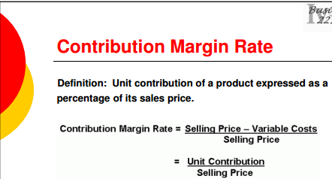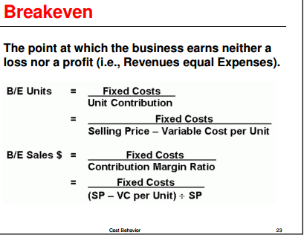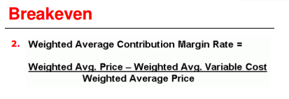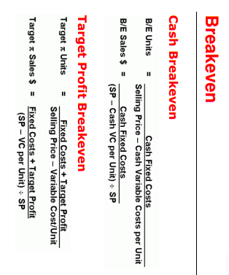
CAN USE WEIGHTED AVG TOO
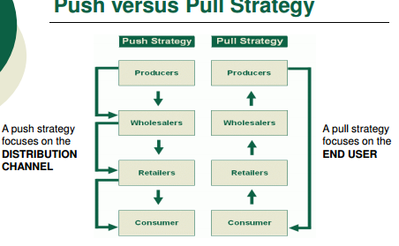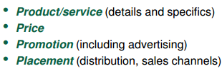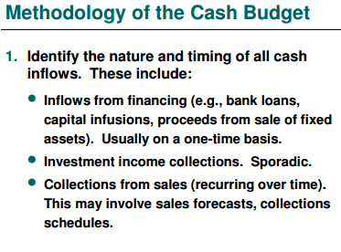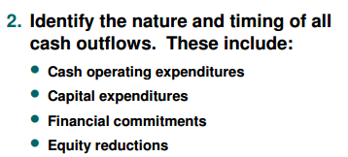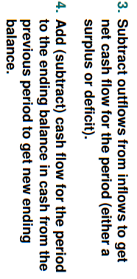
- SCF: SCF ANALYSIS : 1) ops? 2) uses and sources( major) 3) MATCH ( SUSTAINABLE???)
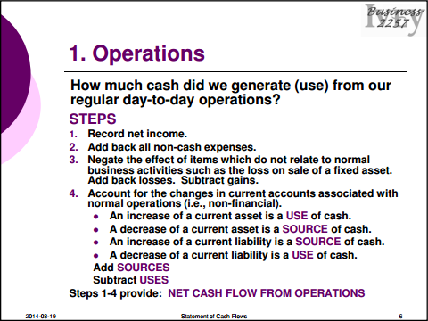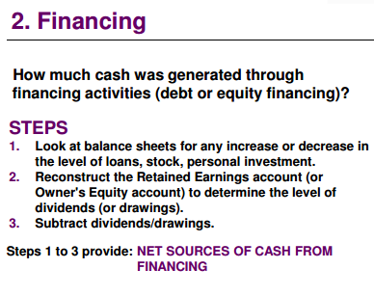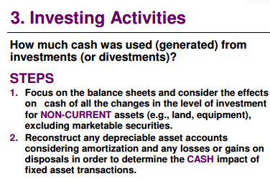
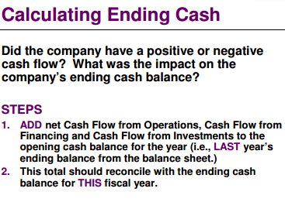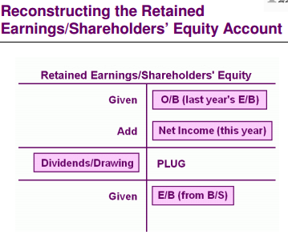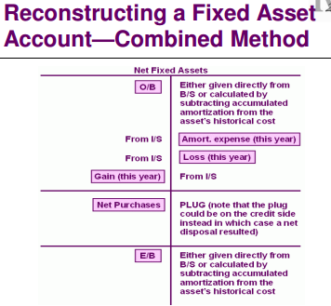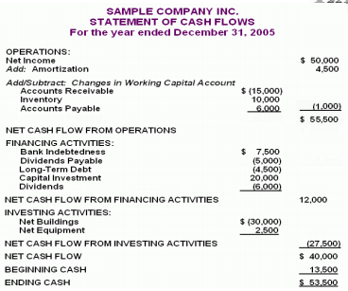
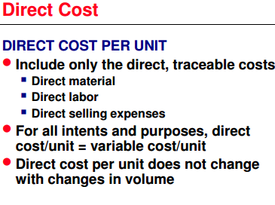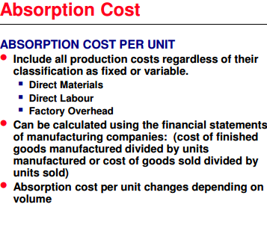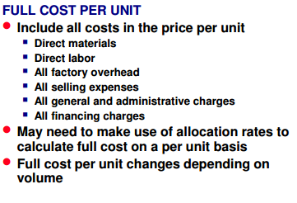
- Case and framework
- Role,decision goals
- Industry( KSF), consumer, competitive
- Sizeup(capabilities.. SCF,analyze,ratios,analyze (seeabove)
- Differential! MUST decide..
- IS AND BS
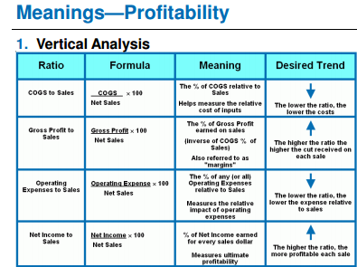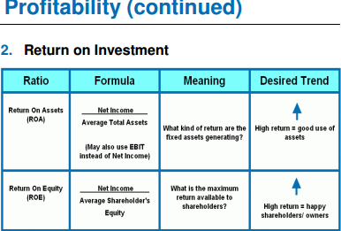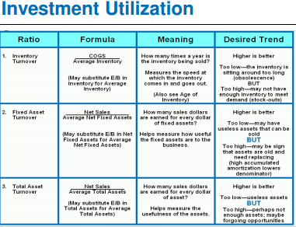
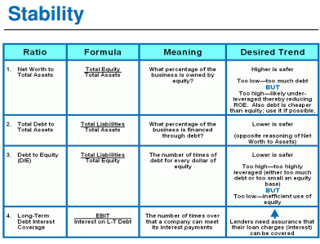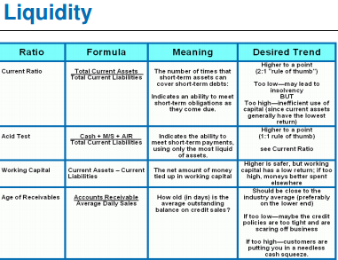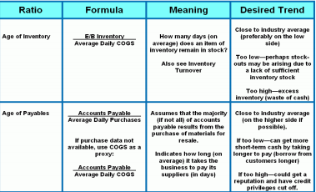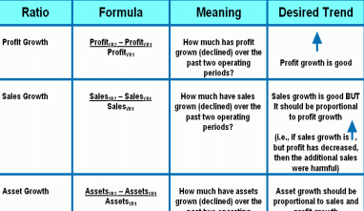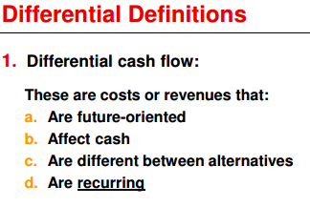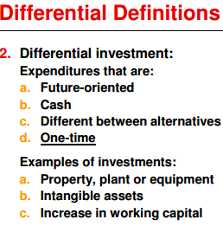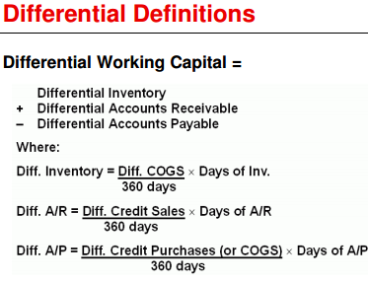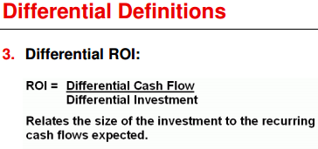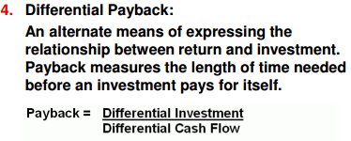
Working capital / owner equitin account is same as retained earnings ( SEE KNIGHTS IMPORT).. the capital investment = added to the R/E T part AND AND THE STATEMENT OF CASHFLOWS
- USE EXPENSES FOR AMRT
- For calculating % and differences for B/S… y2-y1/y1
- Subunit eval = per product.. subtract its variable costs! Use fixed cost if LONG TERM DECISION
- Margin of safety ( projectedsales-B/E sales)/ projected

Projected Income StatementProcess:
1. Estimate sales forecast
2. Estimate expense levels using vertical
analysis, management policy, and/or past
income statements
3. Apply tax rate

