Chapter 2: Personality and Learning
1) Personality: The relatively stable set of psychological characteristics that influences the way an individual interacts with his or her environment and how he or she feels, thinks, and behaves.
Consists of a number of dimensions and traits that are determined by genetic predisposition and by one’s long term learning history.
Three Approaches:
Dispositional: Traits influences behaviour (we are predisposed to behave in certain ways)
Situational: Environment (characteristics of orgs – rewards& punishment) influences behaviour
Interactionist: Both traits (dispositions) and environment (situations) influence behaviour
Weak situations: roles are loosely defined, there are few rules and weak reinforcement and punishment contingencies. *Personality will have the most impact in this situation.
Strong situations: the roles, rules, and contingencies are more defined.
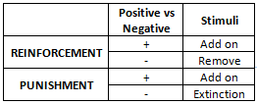
Trait activation theory: traits lead to certain behaviours only when the situation makes the need for the trait salient. (when the situation calls for a particular personality characteristic).
The Big Five:
-Provides a framework for classifying personality characteristics into five dimensions.
Openness to experience: Curious and original vs. Dull, unimaginative
Conscientiousness: Dependable, responsible vs. Careless, impulsive
Extraversion: Extravert: Sociable, talkative, outgoing vs. Introvert: Withdrawn, shy
Agreeableness: Tolerant, cooperative vs. Cold, rude
Neurotic (emotionally stability): Stable, confident vs. Depressed, anxious
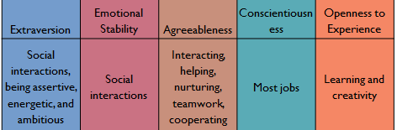
Locus of Control: External Control (Fate, Luck, Other ppl) vs
Internal Control (Initiative, personal action, free will) usually leads to a better-harder worker
-High internals are most satisfied-committed with-to their jobs, earn more money.
Self-Monitoring: The extent to which people observe and regulate how they appear and behave in social settings and relationships.
High Self-monitors: observe the thoughts, actions, and feelings of people around and control the images they project.
Self-Esteem: The degree to which a person has a positive self-evaluation.
High self-esteem: favorable self-images
Low Self-esteem: Unfavorable self-images & uncertain about their opinions, attitude & behaviors . React badly to negative feedback.
Behavioural Plasticity Theory: Ppl with low self-esteem tend to be more susceptible (more pliable) to external and social influences than those who have high self-esteem. (Interactionist approach example)
Positive and Negative Affectivity: emotional dispositions that predict people’s general emotional tendencies.
Positive affectivity: Propensity to view the world, including oneself and other people in a positive light.
Negative affectivity: Propensity to view the world, including oneself and other people in a positive light.
-Higher PA leads to higher job satisfactions & performance. More creative.
-Higher NA leads to lower job satisfaction & performance. Higher stress & counterproductive work.
Proactive Behaviour: Taking initiative to improve current circumstances or creating new ones.
Proactive Personality: A Stable disposition that reflects a tendency to take personal initiative across a range of activities and situations to effect positive change in ones environment. Proactive individuals look for opportunity, show initiative, take action rather than be passive, and be shaped by the environment.
General Self-Efficacy: a general trait that refers to ones belief in his or her ability to perform successfully in a variety of challenging situations. (motivational trait)
-Developed over the lifespan as repeated successes and failures are experiences.
-Someone how has had a lot of failure probably has a low GSE.
Core Self-Evaluations: A broad personality concept that consists of more specific traits that reflect the evaluations people hold about themselves and their self-worth.
-Individuals hold evaluations about themselves and their self-worth, competence and capability.
-These four traits are: self-esteem, GSE, locus of control and neuroticism (emotional stability)
2) Learning: Practice and experience lead to a relatively permanent change in behavior.
What we learn in Organizations?
Practical Skills: job specific, knowledge & technical
Intrapersonal skills: problem solving, critical thinking, risk taking, learning about alternative work processes
Interpersonal skills: interactive skills such as communicating, teamwork, conflict resolution
Cultural awareness: learning social norms, understanding company goals& expectations, business operations & priorities
Operant Conditioning (or Learning) Theory (Skinner):
Behaviour of rats confined in a box. When the lever if pulled, a pellet would appear. At first the rats ignored the lever but overtime, the rats gradually acquired the lever pulling response as a means of obtaining food. The subject learned to operate on the environment to achieve a certain consequence.
Reinforcement: the process by which stimuli strengthen behaviours
-Positive: Application or addition of stimuli that increases or maintains the probability of some behaviour
(kid gets cookie for doing chore)
-Negative: increases or maintains the probability of some behaviour by removing a stimuli
(nagging goes away when job is done)
Punishment : the process by which stimuli decreases behaviours
Positive: Add on stimuli Negative: extinction of a stimuli
Extinction: The gradual dissipation of behaviour following the termination of reinforcement. Ignoring a behaviour ex: The guy that made jokes wasn’t getting responses anymore, so he stopped.
Errors Involving Reinforcement:
-Failure of making reinforcements contingent on specific behaviours
-Failure of understanding diversity in preferences for reinforces (ex: giving time off to a workaholic as a reward)
-Neglecting Important sources of reinforcement:
-Performance Feedback: Providing qualitative or qualitative info on past performance for the purpose of changing or maintaining performance in specific ways
-Social Recognition: Informal acknowledgement attention, praise, approval, or genuine appreciation for work well done from one individual or group to another.
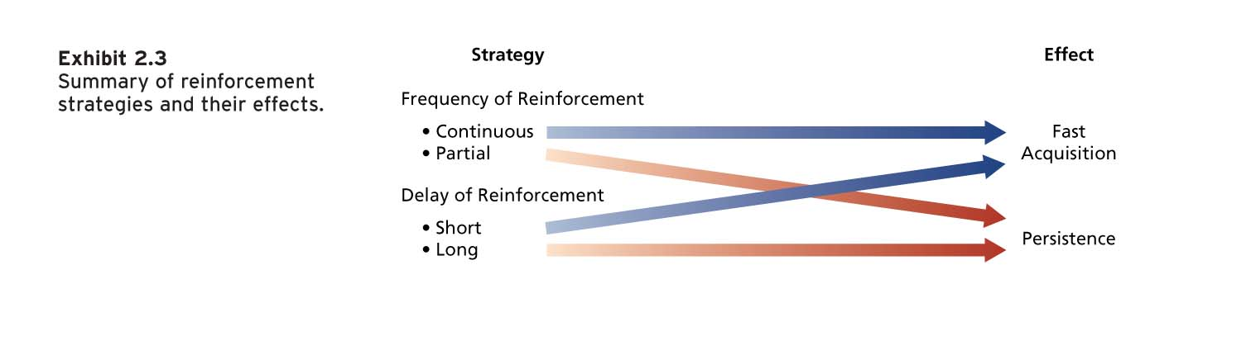
Reinforcement Strategies:
Immediate Reinforcement: To obtain fast acquisition of some response, continuous and immediate reinforcement should be used. It should be applied every time the behaviour of interest occurs and without delay.
-Facilitates fast learning
Partial reinforcement: Compliment occasionally and later in the day. Facilitates persistent learning

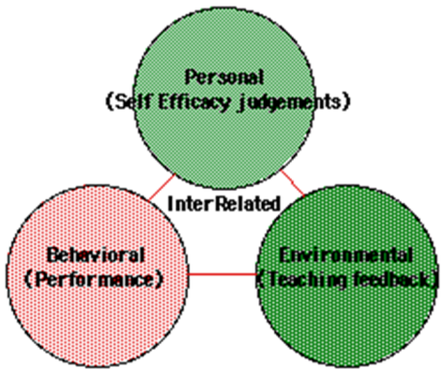
Social Cognitive Theory (Bandura):
Social Cognitive Theory: Emphasizes the role of cognitive processes in learning and in the regulation of peoples behaviours. People learn by observing the behaviour of others.
-Observational Learning: The process of observing and imitation the behaviour of others
-Self Efficacy Beliefs: Beliefs people have about their ability to successfully person a specific task
-Self-Regulation: The use of learning principles to regulate one’s own behaviour
Chapter 3: Perception and attribution
Perception: The process of receiving information from our senses and
interpreting it to provide order and meaning to the environment.
Components of Perception:
- Perceiver: influenced by experience, motivational state & emotional state
Perceptual defence: the tendency for the perceptual system to defend the perceiver against unpleasant emotions (when we see what we want to see, hear what we want to hear, our perceptual system is working to ensure we are not faced with threatening things)
- Situation: Situational Context. Can blur the characteristics of the target, or make some of them more salient.
- Receiver (target): ambiguous. The target cannot always use all the info given by the perceiver.
Social Identity Theory: People form perceptions of themselves based on their personal characteristics and memberships in social categories.
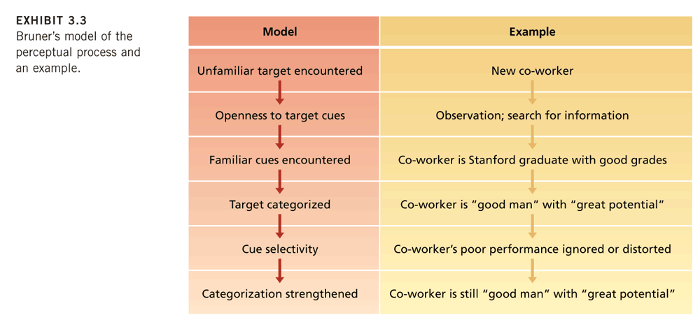
Perceptual Process:
Perceptual Tendencies:
Selectivity: don’t use all cues + give special emphasis to some
Constancy: the same way over time and across situations
Consistency: select, ignore, and distort cues to form a homogenous picture
Perception Biases:
Primacy effects: tendency for a perceiver to rely on early cues or first impressions. Often has a lasting impact. Form of selectivity.
Recency effects: tendency for a perceiver to rely on recent cues or last impressions
Central Traits: personal characteristics of a target person that are of particular interest to a perceiver.
Implicit personality theories: personal theories that people have about which personality characteristics go together.
ex: expecting hard working people to also be honest
Projection: The tendency for perceivers to attribute their own thoughts and feelings to others. People often assumer others are like themselves.
Stereotyping: tendency to generalize about people in a certain social category and ignore the variations among them
Three specific aspects to stereotyping:
  - We distinguish some category of people
  - We assume that the individuals in this category have certain traits
  - We perceive that everyone in this category possesses these traits
    - Stereotypes: race, age, gender, ethnic background, social class, education and occupation
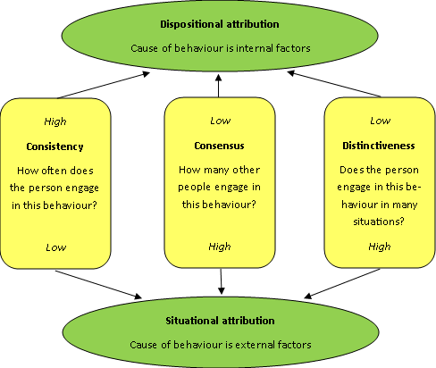
Attribution: the process by which we assign causes or motives to explain people’s behaviour. (Dispositional or situational)
Dispositional Attribution: explanations for behaviour based on an actor’s personality or intellect
Situational Attributions: Explanations for behaviours based on an actor’s external situation or environment.
The Attribution Process:
Fundamental Attribution Error: The tendency to overemphasize dispositional explanations for behaviour at the expense of situational explanations.
Actor Observer Effect: The propensity for actors and observers to view the causes of the actors behaviour differently.
Self-Serving bias: The tendency to take credit for successful outcomes and to deny responsibility for failures
Workforce diversity: differences among recruits and employees in characteristics such as gender, race, age, religion, cultural background, physical ability, or sexual orientation.
Workplaces are changing, becoming more diverse.
Valuing Diversity: Improved recruiting, Improved marketing, Improved competitiveness in global markets, Resource-Acquisition, Improved Creativity, Improved Problem-Solving, System Flexibility
Managing Workplace Diversity:
-Select enough minority members to get them beyond token status.
-Encourage teamwork that brings minority and majority members together.
-Ensure that those making career decisions about employees have accurate information about them.
-Train people to be aware of stereotypes.
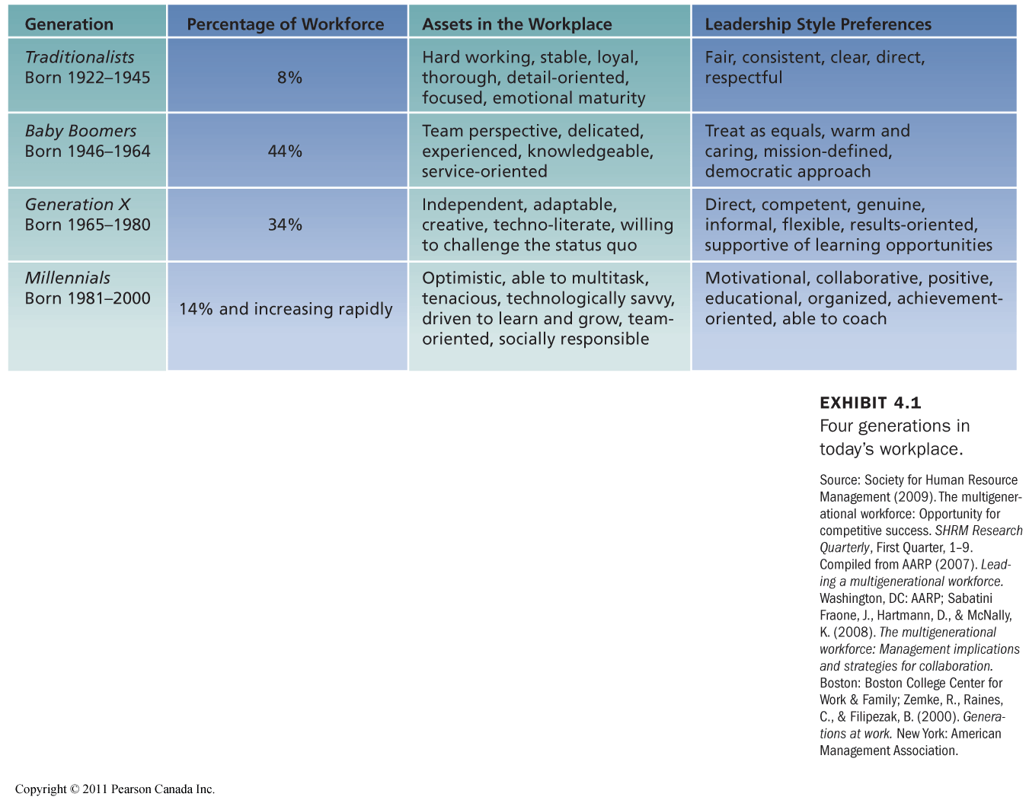
Chapter 4: Values, Attitudes and Work Behaviour
Values: A broad tendency to prefer certain states of affairs over others.
-Values have to do with what we consider good and bad. -Values are motivational.
-People tend to hold values structured around such factors as achievement, power, autonomy, conformity, tradition, and social welfare.
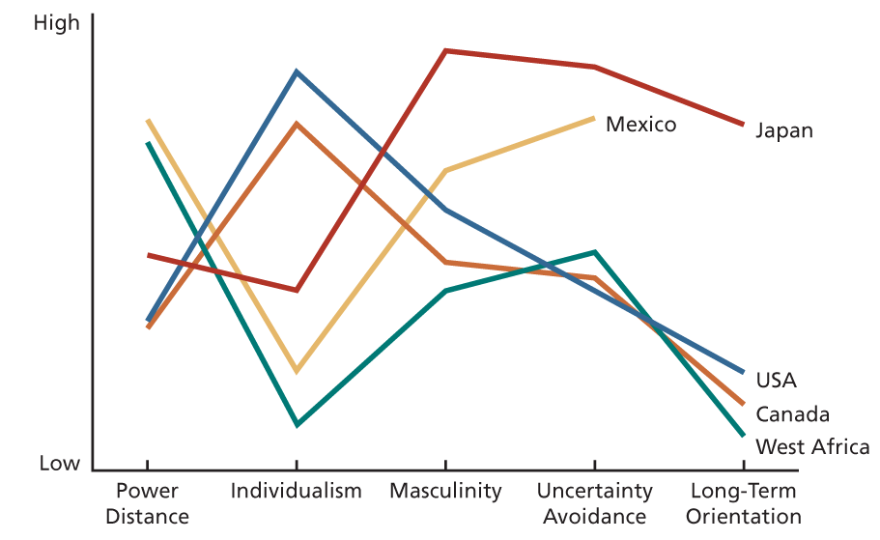
Hofstede’s Study: Discovered 5 basic dimensions along which work-related values differentiated across cultures:
1-Power Distance: The extent to which an unequal distribution of power is accepted by society members
2- Uncertainty Avoidance: The extent to which people are uncomfortable with uncertain ambiguous situations
3- Masculinity/Feminity: Masculine cultures clearly differentiate gender roles, support the dominance of men and stress economic performance. Feminine cultures accept fluid gender roles, stress sexual equality, and quality of life.
4- Individualism Vs. Collectivism: Individualistic societies stress independence, individual initiative, and privacy.
Collective cultures favour interdependence and loyalty to family or clan. Collectivism: Should give rewards to groups instead of individuals
5- Long-term/short-term orientation: Cultures with a long-term orientation stress persistence, perseverance, thrift, and close attention to status differences. Truth depends on the situation, so adapt, flexible. Cultures with a short-term orientation stress personal steadiness and stability, face-saving, and social niceties, establish absolute truth, respect of tradition, focus on quick results
Attitudes: A fairly stable evaluative tendency to respond consistently to some specific object, situation, person, or category of people.
(Belief + Value) Attitude Behaviour
-Organizations often attempt to change employee attitudes.
Job Satisfaction: A collection of attitudes that workers have about their jobs.
Facet Satisfaction: the tendency for an employee to be more or less satisfied with various facets of the job. (I love my job but hate my boss)
Overall Satisfaction: An overall or summary indicator of a person’s attitude toward his or her job that cuts across various facts. (On the whole, I really like my job, although some aspects could be better)
Job Descriptive Index (JDI): Evaluates five facets of satisfaction.
What determines Job Satisfaction?
1- Discrepancy Discrepancy theory: Job satisfaction stems from the discrepancy between the job outcomes wanted and the outcomes that are perceived to be obtained
2- Fairness
-Distributive Fairness: Fairness that occurs when people receive the outcomes they think that they deserve from their jobs.
Equity Theory: Job satisfaction stems from a comparison of the inputs one invests in a job and the outcome one receives in comparisons with the inputs and outcomes of another person or group.
Inputs: Anything that people give up, offer, or trade to their organization in exchange of outcomes.
Outcomes: Factors that an organization distributes to employees in exchange of their inputs.
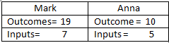
Ways to restore equity:
-Change your inputs or outcomes. (Working less because you’re underpaid) -Change Referent inputs or outcome
-Change perception of your inputs and outcome -Be persuaded to think differently -leave job
Q: Equity
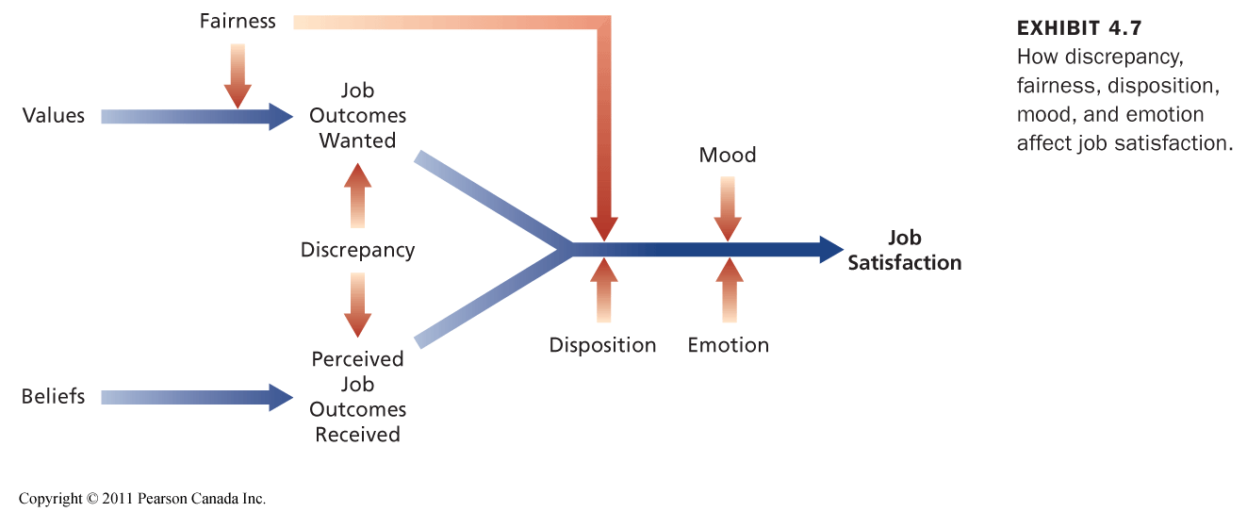
a) anna should be experiencing inequity
B) mark should be experiencing equity
c) mark and anna should b experiencing equity
d) mark and anna should be experiencing job satisfaction
-Procedural Fairness: Fairness that occurs when the process used to determine work outcomes is seen as reasonable
-Interaction Fairness: Fairness that occurs when people feel they have received respectful and informative communication about an outcome.
3- Disposition: How your personality contributes to your feelings of job satisfaction
Some people are predisposed by virtue of their personalities to be more or less satisfied despite changes in discrepancy or fairness.
4- Mood and Emotion
Emotions: Intense, Often short lived feelings caused by a particular event
Mood: Less intense, Longer lived and more diffuse feelings
Active Event Theory (Weiss and Cropanzano): How emotions and moods affect job satisfaction
Emotional Contagion: Tendency for moods and emotions to be spread between people or throughout a group
Emotional Regulation: Requirement for people to conform to certain display rules in their job behaviour in spite of their true mood or emotions.
Key Contributors to Job Satisfaction:
-Mentaly challenging work -Adequate Compensation
-Career Opportunities -People
Concequences of Job Satisfaction:
-Absense from work -Turnover (Quitting)
-Perfomance
-Customer Satisfaction and Profit
-Organizational Citizenship Behaviour: Voluntary,
informal behaviour that contributes to organizational effectiveness.
Organizational Commitment: An attitude that reflects the strength of the linkage between an employee and an organization
- Affective Commitment: Based on identification and involvement with an organization. People stay at their job because they want to.
- Continuance Commitment: Based on the costs that would be incurred in leaving an organization. People stay because they have to.
- Normative Commitment: Commitment based of ideology or a feeling of obligation to and organization. People stay because they think they should.
Q: Getting an education will allow me to get a better job: belief, attitude, value, behaviour
Q: I have a positive view towards education: attitude, belief, value, behaviour
Q: What job satisfaction facet is more likely to stimulate high performance? Pay, content of work, supervision, people, promotion
Q: If you experience interactional unfairness at work, how will this affect your satisfaction at work?
a) you will be dissatisfied with the system
b) you will be dissatisfied with your coworkers
c) you will be dissatisfied with your boss
d) you will be dissatisfied with yourself
e) you will be dissatisfied with your friends
Q: Job satisfaction research has pointed to the influence of dispositional factors because…
a) Job satisfaction is stable over time, regardless of current employer
b) Adolescence dispositional measures correlate with job satisfaction
c) Optimists with realistic thinking processes are more likely to be satisfied
d) All of the above
Chapter 5: Theories of Work Motivation
Motivation: The extent to which persistent effort is directed toward a goal.
The basic characteristics of motivation: Effort, Persistence, Direction, Goals
Intrinsic VS Extrinsic Motivation:
Intrinsic: Stems from the direct relationship between the worker and the task, it is usually self-applied. Ex: Feelings of achievement, accomplishment, challenge
Extrinsic: Stems from the work environment external to the task, usually applied by others. Ex: Pay & fringe benefits
Self-Determinant Theory: Theory of motivation that considers whether people’s motivation is autonomous or controlled. (Deci & Ryan)
-Autonomous Motivation: Self-motivated by intrinsic factors
-Controlled Motivation: Motivated to obtain a desired consequence or extrinsic reward

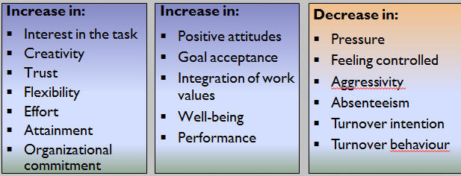
Autonomous motivation leads to :

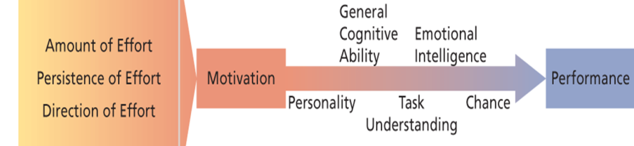
Motivation and Performance:
Performance: The extent to which an organizational member contributes to achieving the objectives of the organization
-General Cognitive Ability: A person’s basic information-processing capacities and cognitive resources
-Emotional Intelligence: The ability to understand and manage one’s own and other’s feelings and emotions.
Meyer & Salovey, 1990.
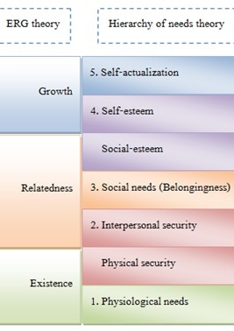
Need Theories of Work Motivation: Specify the kinds of needs people have and the conditions under which they will be motivated to satisfy these needs in a way that contributes to performance.
- Needs are physiological and psychological wants or desires
- Can be satisfied by acquiring certain incentives or achieving particular goals
NEEDS BEHAVIOUR INCENTIVES AND GOALS
McClelland’s Theory Of needs: A non-hierarchical need theory of motivation that
outlines the conditions under which certain needs result in particular patterns of
motivation.
- Need for Achievement: Strong desire to perform challenging tasks well
- Need for Affiliation: Strong desire to establish and maintain friendly,
compatible interpersonal relationships
- Need for Power: Strong desire to influence others, making a significant
impact or impression
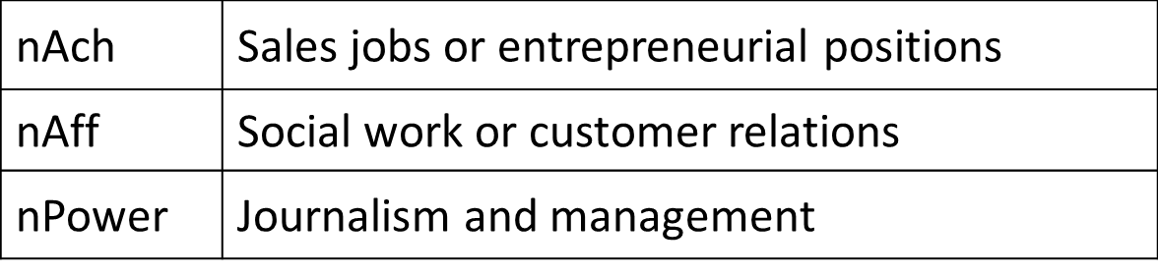
Process Theories of Work Motivation:
-Expectancy Theory (Vroom): Motivation is determined by the outcomes that people expect to occur as a result of their actions on the job
Expectancy: The probability that a particular first –level outcome can be achieved;
Valence: The expected value of work outcomes (to which extent they are attractive or un-attractive);
Instrumentality: The probability that a particular first-level outcome will be followed by a particular second-level outcome.
Force: The effort directed toward a first-level outcome.
Managerial Implications:
Boost Expectancies: Ensure that employees expect to be able to achieve first-level outcomes.
Clarify Reward Contingencies: Employees should be convinced that first-level outcomes are clearly instrumental in
  - obtaining positive second-level outcomes and
  - avoiding negative outcomes.
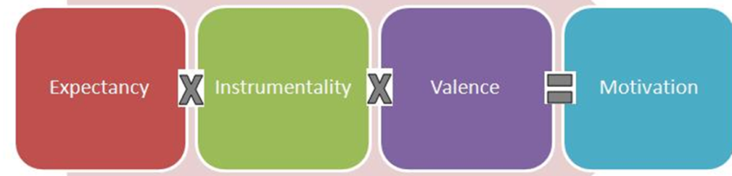
Appreciate Diverse Needs: Analyze the diverse preferences of employees and attempt to design individualized “motivational packages”.
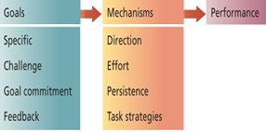
-Equity Theory (adams): A Process theory that states that motivation stems from a comparison of the inputs one invests in a job and the outcomes ones receives in comparison with the inputs and outcomes of another person or group.
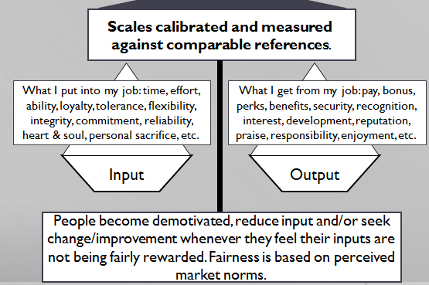
-Goal Setting Theory (Locke and Latham): A process theory that states that goals are motivational when they are specific, challenging, when organizational members are committed to them, and when feedback about progress toward goal attainment is provided.
Managerial Implications:
Set specific and challenging goals and provide ongoing feedback.
- Enhancing Goal Commitment
  - Participation
  - Rewards not necessary
  - Management support

Performance-prove goal o: Preference to obtain favourable judgments about the outcome of one’s performance
Performance-avoid goal o: Preference to avoid negative judgments about the outcome of one’s performance
Distal Goal: Long term or end goal
Proximal Goal: Short term or sub goal
Chapter 6: Motivation in Practice
Money as Motivator:
Money: pay + various fringe benefits
How effective is pay as a motivator?
  - Pay can satisfy a variety of needs.
  - In that case, pay should be highly valent.
  - When it is made contingent on performance
Production Jobs:
Piece-Rate: Workers are paid a certain amount of money or each item produced. (Increases production)
Potential problems: Lowered quality, Differential opportunity, Reduced cooperation, Incompatible job design, Restriction of productivity
White Collar Jobs:
Merit Pay Plans: Systems that attempt to link pay to performance on white collar jobs
Potential problems: Low discrimination, Small increases, Pay secrecy

Pay to Moitvate TeamWork:
- Profit Sharing: return of company profit to employees in cash bonuses or retirement supplements
- Employee Stock Ownership Plans (ESOPs): allows employees to own shares of company
- Gainsharing: group pay incentive based of productivity or performance improvements
- Skill-based Pay: system in which people are paid according to the number of job skills they have acquired
Job Design as a Motivator:
The goal of job design is to
- identify the characteristics that make some tasks more motivating than others and
- capture these characteristics in the design of jobs.
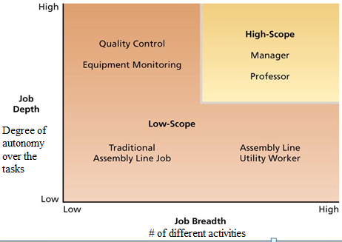
Types of Job design:
- Scientific Management: Until 1960s, Taylor’s principles of Scientific Management were the prevailing philosophy of job design
  - Job simplification
  - Extreme division of labour and specialization.
  - Careful standardization and regulation of work activities and rest pauses.
  - Motivational strategies: close supervision and piece-rate pay.
- Job Scope:
To Increase Job Score: Job rotation, stretch assignments
- Job Characteristic Model
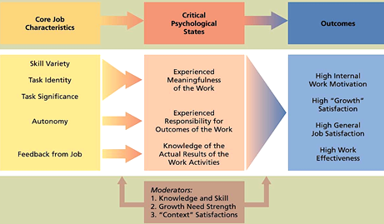
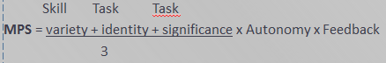
- Job Enrichment: designing jobs to enhance intrinsic motivation, job involvement and the quality of working life
- Work Design

