Biomechanics
Chapter 1 – What is Biomechanics?

Kinesiology: broadly defined is the study of the science of movement, its anatomical, physiological, mechanical, psychological and sociological aspects

Biomechanics: the science involving the study of biological systems from a mechanical perspective
- Application of mechanical principles in the study of living organisms

- Combines bio = life and mechanics = the study of action of forces
- Biomechanics uses the tools of mechanics, the branch of physics involving the analysis of the action of force, to study the anatomical and functional aspects of living organisms
- Biomechanics is the study of the effects and control of forces that act on and are produced by living bodies

Mechanics: the physical science, which deals with the state of rest or motion of bodies under the action of forces

- Two major sub branches of mechanics: Statics and Dynamics

Statics: is the study of systems that are in a constant state of motion

Dynamics: is the study of systems in which acceleration is present
- Dynamics further divides into Kinematics and Kinetics
- Dynamics is ∑ (sum of) F (forces that cause motion) = m (resistance to motion) a (motion)
- ∑F = ma ( Newton’s second law) refer to slide 9

Kinematics: the study of the description of motion, including considerations of space and time (appearance of motion)

Kinetics: the study of the action of forces, resulting in motion

Kinesiology: the study of human movement (all aspects)

- Analysis of human movement can be either Qualitative or Quantitative

Quantitative: involving the use of numbers
Qualitative: a description of quality without the use of numbers

Biomechanics
Chapter 2 – Anatomical Foundations

Forms of Motion

- Most human movement is general motion

General Motion: a combination of translation and rotation simultaneously

Linear Motion: along a line that may be straight or curved with all parts of the body moving in the same direction at the same speed
- Also referred to as translation

Translation: linear motion – the body moves as a unit
- Ex. A sleeping passenger on a smooth airplane flight is being translated through the air

Rectilinear: along a straight line
Curvilinear: along a curved line

Angular Motion: is rotation around a central imaginary line or point
- Known as axis of rotation

Axis of rotation: imaginary line perpendicular to the plane of rotation and passing through the center of rotation
- Ex. When a gymnast performs a giant circle on the bar, the entire body rotates, with the axis of rotation passing through the center of the bar

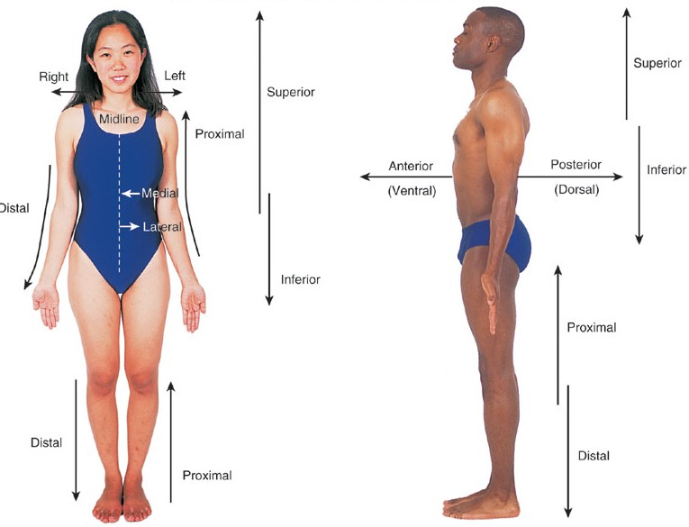
Directional Terms

Normal Planes of Motion

Frontal Plane: plane in which lateral movement of the body and body segments occur (cuts the body into front and back)
- Body moves side to side
- Jumping jacks, cartwheel

Sagittal Plane: the plane in which forward and backward movements of the body and body segments occur (cuts the body into left and right halves)
- Body movements are forward and backward
- Cycling
- Most activity occurs in the sagittal plane

Horizontal/Transverse Plane: plane in which horizontal body and body segment movements occur when the body is in an erect standing position (cuts the body into top and bottom)
- The body twists
- Diving

Joint Movements

Sagittal Plane Movements

- 5 primary movements occur in the sagittal plane
  - flexion
  - extension
  - hyperextension
  - dorsifexion
  - plantar flexion

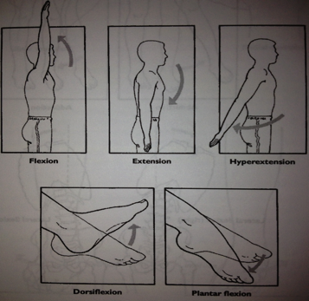
Flexion: is defined as a position that is made possible by the joint angle decreasing, (anything that brings you down in terms of knee is flexion/ bringing you back up is extension)

Extension: is defined as the movement that returns the body segment to anatomical position from a position of flexion

Hyperextension: is the rotation beyond anatomical position in the direction opposite of flexion

Dorsifexion: motion bringing the top of the foot toward the lower leg

Plantar flexion: motion bringing the ball of the foot downward (pointing your toes)

Frontal Plane Movements

- 7 movements occur in the frontal plane
  - abduction
  - adduction
  - lateral flexion (right and left)
  - elevation and depression of scapula
  - eversion and inversion of the foot
  - ulnar deviation
  - radial deviation

- the 2 major frontal plane movements are adduction and adduction

Abduction: body segment moves away from the midline (hips/shoulders)

Adduction: body segment moves closer to the midline (hips/shoulders)

Lateral flexion: sideways rotation of the trunk

Elevation and depression of the shoulder: refers to the up and down movements of the shoulder

Radial deviation: rotation of the wrist towards the thumb

Ulnar deviation: rotation of the wrist towards the pinky finger

Eversion of the foot: outward rotation of the sole of the foot

Inversion of the foot: inward rotation of the sole of the foot

- Abduction and adduction of the entire foot is referred to as pronation (outward rotation) and supination (inward rotation)

Transverse Plane Movements

- 4 movements occur in the transverse plane
  - right and left rotation
  - medial and lateral rotation
  - supination and pronation
  - horizontal abduction and adduction

Left and right rotation: used to describe transverse movement of the head, neck and trunk

Medial and lateral rotation: used to describe the movements towards the body or away from the body

Supination and pronation: rotational movement of the forearm either pronation (inward rotation) and supination (outward rotation)

Horizontal abduction and adduction – movements in the transverse plane from anterior to lateral or lateral to anterior

- Circumduction is another movement involving a circular movement of a body segment (drawing a circle in the air)

Kinematic and Kinetic Framework

Forms of Motion

- Most human movement is general motion; a complex combination of linear and angular motion
- Linear and angular motion are pure forms of motion

Translation: movement from one place to another where all points move through the same distance

- 2 types
  - Linear Motion – travels in a straight line
  - Curvilinear Motion – travels in a curved line

Rotation: angular motion about an axis, all point through the same angle
- It is rotation around a central imaginary line known as the axis of rotation

General Motion: a combination of translation and rotation

Description of Motion

- Kinematics

Position: a spatial reference system used to standardize the measurements taken

- Typically use a standard Cartesian System

Cartesian Coordinate System

- Reference frame created from 3 perpendicular axes (x,y,z) with arbitrary origin (0,0,0,)
- Movements are primarily in a single plane
- Can be analyzed using a 2 dimensional coordinate system (x, y)
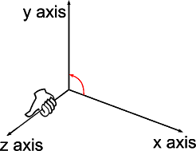
- X = horizontal direction
- Y= vertical direction
- When movement occurs, there is a change in the x,y coordinates over time
- We use the ground most often as the origin so that everything stays positive

** review slides/notes

Three Graphs that Describe Motion

- Review graphs from notes
- Note* - changes of a coordinate over time = velocity
- Peak height = x vs y or y vs time
- Horizontal velocity = x vs time
- Vertical velocity = y vs time

Mechanical Systems

- Before determining the nature of movement the mechanical system of interest must be identified
- Look at objects (football), whole body and body segments (leg)
- At a joint** look at a body segment that is adjacent to it ex. Knee – look at the thigh and calf

- For gross motor movement description and analysis, the human body is modeled as a hinged, linked series of rigid bodies

** Model- represent mathematically as a basis for measurement

- Symmetric = both limbs mirror images (moving body as a whole)
- Non-symmetric = limbs are independent (body moves independently)

Examples of Models

- 6 segment symmetric
  - forearms and hands are a single link
  - trunk and head are a single link
- 12 segment non-symmetric
  - forearms and hands are a single link

** review notes

Kinematic Analysis of Human Movement

- Requires knowledge of the specific biomechanical purpose of the movement and the ability to detect the cause of errors through movement patterns
- Can be qualitative or quantitative
- Does not include force
- We need to know what it is we want to do
- We are describing motion

** see notes in audio notes re: viewing angle

- Kinematic analysis is useful when
  - Performance outcome is as a result of changed movement pattern
  - Analyst can distinguish the cause of a problem from symptoms of the problem or an unrelated movement of idiosyncrasy

- Tools used for measuring kinematic qualities
  - Usually done with high def video
  - Standard video 30 pics per second
  - How many cameras will you need to capture your view?
  - You can also use infrared marker
  - Gait analysis
  - Goniometer (only give relative angle)

Kinetic Framework

Kinetics: the study of forces

Scalars: are any values that just have magnitude
- Mass, volume, length and speed
- There is no direction

Vectors: magnitude and direction
- Vectors are illustrated with arrows
- Both magnitude and direction are important
- Kinetic vector qualities:
  - Force, weight, pressure and torque
- Kinematic vector qualities
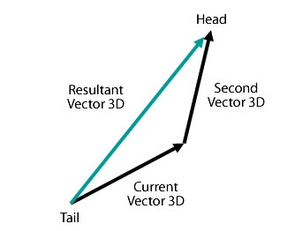
  - Displacement, velocity and acceleration

Adding Vectors

- Resultant Vectors - tip to tail composition
- Always add tip to tail
- Adding 2 vectors together – you will find the results

- Resolving Vectors – splitting vectors into 2 vectors that are perpendicular to each other
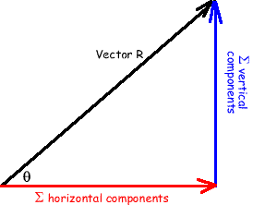
- Taking the result and finding the direction
- What portion is vertical and what portion is horizontal

- 1 cm = 10N
- 30N = 3 cm
- 45N – 4.5 cm

Trigonometry Solutions to Vector Problems

**Review trig sheet notes

SOH CAH TOA

Inertia

Inertia: tendency for a body to resist a change in its state of motion

- Although inertia does not have any units of measurements, the amount of inertia a body possess is directly proportional to its mass
- The more massive an object is, the more it tends to maintain its current state of motion

Mass

Mass: quantity of matter contained in an object
- Mass is a scaler – it has magnitude
- Symbol – m
- Units – kg

Force

Force: a push or pull acting on an object
- The produce of mass and acceleration
- Characterized by magnitude, direction and point of application to a given body
- The action of force causes a body’s mass to accelerate
- Symbol: F
- Units: N ( newtons)

- Formula: F = ma

- The units of force are units of mass multiplied by units of acceleration

- Internal Forces
  - Muscle force
  - Joint force – ligament forces and bone on bone forces

- External Forces
  - Gravity (weight)
  - Ground reaction force
  - Friction

- All forces come in pairs
- The force exerted by one object on another is matched by an equal and oppositely directed force by the second object on the first

Net Force

Net force: force resulting for the vector addition of two or more forces
Units – Newton (N)
Symbol - ∑ F = sum of forces

- When all acting forces are balanced or cancel each other out the net force is = 0 and the body remains in its original state of motion
- It remains motionless or motion with a constant velocity
- When net force is present – the body moves in the direction of the net force and with acceleration that is proportionate to the magnitude of the net force

Weight

Weight: force due to gravity

- The amount of gravitational attraction between an object and earth
- The direction of weight is downward
- Point of application: centre of gravity
- Units: Newton
- Symbol = F_{g}

- Wt = ma (weight = force)

- NOTE = 1kg = 2.2 lbs

Center of Gravity

Center of Gravity: the point about which body’s weight is equally balanced no matter how the body is positioned

- The location of the center of mass determines the way in which the body responds to external forces
- Where all the weight of a body is considered to be concentrated at a single point and acts downward from that point

Torque

Torque: rotary effect of a force (also called momentum of force)

- Torque is that which causes or attempts to cause the body change in the rotational motion of a body
- Direction: clockwise or counterclockwise around axis of interest ( at joint use joint movement terms such as flexion or extension)

- Formula: Torque = F d⊥ (force x momentum arm)

- Symbol: T
- Units: Newton meters

Moment Arm

Moment Arm: Perpendicular distance from line of action of the force to the location of the axis of interest (typically at centre of gravity of system or at a joint)

- Symbol: d⊥
- Units: meters (m)

Free Body Diagram: a sketch that shows a defined system in isolation with all of the force vectors acting on the systems

Impulse

Impulse: the integrity of force over time

- The area of force vs. the time curve
- Units: Newton seconds (N.s)

Pressure: defined as force per unit of area over which force acts

- Formula: P = F
A

Impulse: the integration of force over time
- impulse is important in injury mechanics

Magnitude: the area under force vs time curve ( if force is constant impulse=Ft)
- units = Newton seconds (N.s)

Tools for measuring Kinetic Quantities

EMG: electromyography
- Studies neuromuscular function
- Estimate of muscle activation

Force Plates
- To measure ground reaction force
- Employed in gait research
- Hand grip dynamometer
- Fish scale

Newton’s Law of Motion

Law 1

Every object in a state of uniform motion tends to remain in that state of motion unless an external force is applied to it.

Law 2

The relationship between an object's mass m, its acceleration a, and the applied force F is F = ma. Acceleration and force are vectors (as indicated by their symbols being displayed in slant bold font); in this law the direction of the force vector is the same as the direction of the acceleration vector.

Law 3

For every action there is an equal and opposite reaction.

NOTE:

Force, weight pressure and torque = Kinetic Vectors

Displacement, velocity and acceleration = Kinematic Velocity

Linear Kinematics

Kinematics: the form pattern or sequence of movement with respect to time
- The appearance of motion
- Kinematics spans both qualitative and quantitative forms of analysis

Linear Kinematics: involves the shape, form, pattern and sequencing of linear movement through time

Distance and Displacement

Distance: is measured along a path of motion
- Ex. The distance a skater travels on the ice may be measured from the track left on the ice
- Units – length (m)
- Distance is a scalar quantity

Displacement: change in location, or the directed distance from initial to final location
- Ex. The skaters displacement is measured in a straight line from start to finish (see class pic)
- Units – length (m)
- Displacement is a vector quantity

Speed and Velocity

- Speed and velocity parallel distance and displacement

Speed: the distance covered divided by the time it takes to cover it

- Formula: speed = distance travelled (length)
change in time

- Speed is a scalar quantity

Velocity: is the change in position (displacement) that occurs during a given time

- Formula: Velocity = change in position (displacement) =
change in time

- V= Δ position
Δ time

- V = displacement = d
change in time Δt

- Velocity is a vector quantity
- Units: m/s

Acceleration

Acceleration: is the rate of change in liner velocity

- It means speeding up or increasing in velocity

- Formula: a = change in velocity = Δ v₂ - Δ v₁
Change in time Δ t

- Acceleration may be positive, negative or equal to zero based on the direction of motion and the direction of the change in velocity
- When acceleration is zero = velocity is constant

Force of Gravity

- The force of gravity produces a constant acceleration on bodies near the surface of the earth equal to approximately 9.81m/s²
- Acceleration of gravity is = 9.91m/s2
- Acceleration remains constant regardless of shape, size or weight of the projectile

Projectile Motion

What is a projectile: a body in free fall that is subject only to the forces of gravity and air (an airplane is not a projectile because it has engines and lift due to the design of the wings)

- Vertical projectile motion is influenced by gravity and air
- Horizontal projectile motion is influenced by air resistance
- Air resistance is small and often neglected
- ** If you neglect air resistance – the horizontal speed of a projectile remains constant throughout the trajectory

Apex: the highest point in the trajectory of a projectile

- as something goes through the sir it takes off at some angle, it goes up and reaches the apex and then comes back down
- during this: the vertical velocity decrease on the way up
- at the top it is = 0
- and increases on the way down
- at the peak/apex vertical velocity = 0

- if you have two balls – one is dropped and one is projected horizontally for the same height
- both balls will land at the same time since gravity affects their vertical velocities equally and has no effect on horizontal velocity
- neglecting air resistance: the horizontal speed of a projectile remains constant throughout the trajectory

Trajectory: the flight path of the center of gravity of a projectile

3 factors that influence trajectory ( projectile’s motion)
- angle of projection (projection angle)
- projection speed
- relative height of projection

Projection angle: the direction of the instantaneous velocity at take off with respect to the horizontal
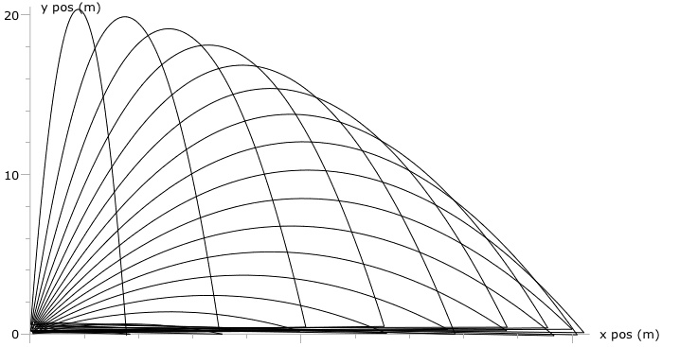
- diagram shows the same object taking off at different angles
- 45 degrees goes the farthest
- 90 degrees goes the highest

- if the projection angle is vertical – the trajectory is also vertical

- if the projection angle is oblique at some angle between 0 and 90, the trajectory is parabolic ( curved – R and L halves are mirrored)

- if the projection angle is horizontal at a angle of 0 the trajectory will be half of a parabola
Projection Speed: the magnitude of projection velocity

- the projection speed determines the length or size of the projectile trajectory

Range: the horizontal displacement of a projectile at landing

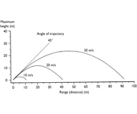
- the faster a ball is going, the greater the magnitude -the farther it will go

Relative Projection Height: the difference between height at release and height at landing
- when relative projection height is zero, the angle of projection that produces the maximum horizontal displacement is 45°
- as relative projection height increases – the optimum angle of projection decreases
- as relative projection height decreases – the optimum angle increses

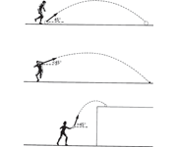
optimum range at a projection angle of 45 degrees

optimum range at a projection angle < 45 degrees

optimum range at a projection angle > 45 degrees

Factors Influencing Selected Variables of projectile Motion

VARIABLE | FACTORS OF INFLUENCE
Flight Time | Initial vertical velocity *  Relative projection height
Horizontal | Horizontal velocity *  Initial vertical velocity * = flight time  Relative projection height = flight time
Peak Height | Initial vertical velocity *

** initial vertical and horizontal velocities are determined from the projection speed and angle by resolving the initial velocity into two components

**a projectile’s flight time is increased by increasing the vertical component of projection velocity or by increasing the relative projection height

Analyzing Projectile Motion

Initial velocity: vector quantity incorporating both angle and speed of projection
( direction and magnitude)

- velocity is a vector quantity
- the vertical speed of a projectile is constantly changing because of gravitational acceleration

Formulas for Constant Acceleration

V₂ = v₁ + at

d = v₁t + ½ at²

v₂² = v₁² + 2ad

where:

d= displacement
v = velocity
a = acceleration
t = time

Horizontal projectile motion

- no acceleration which means the a_{h} = 0

Formulas

V_{h2} = v_{h1} (constant)

d_{h} = v_{h1}t

Formulas for Vertical Projectile Motion

Vertical acceleration due to gravity: a_{y} = -9.81m/s₂

V_{y2} = v_{y1} -9.81t

d_{y} = v_{y1} – 4.91^{t2}

-therefore at apex (v_{y2} = 0 at t_{a})

t_{a} = v_{y1}/9.81 dv = v_{y1}t_{a}-4.91t_{a}²
= v_{y1}²/2g

** review problem questions in notes

Angular Kinematics

- an angle is composed of 2 sides that intersect at a vertex

Angular Motion: is rotation about an axis

- most human movement involves rotation of a body segment around a joint

Axis of Rotation: is a line oriented perpendicular to the plane in which it rotates

Angular Kinematics Human Perspective

Joint Motion | Plane of Motion | Axis of Rotation
Flexion/Extension | Sagittal | Mediolateral
Abduction/Adduction | Frontal | Anteroposterior
Medial/Lateral Rotation | Transverse | Longitudinal

- two types of angles
  - relative - joint
  - absolute - segment

Relative Angles

Relative Angle: angle at a joint formed between the longitudinal axes of adjacent body segments
- also known as joint angle
- ex. The relative angle of the knee is the angle formed between the longitudinal axis of the thigh and the longitudinal axis of the lower leg
- joint angles are relative in human motion
- in a joint angle you need all 3 points to define an angle
- all joint angles are at 0° when fully extended

Absolute Angles

Absolute Angle: angular orientation of a body segment with respect to a fixed line of reference
- also known as segment angle
- reference lines are usually vertical or horizontal
- absolute angles should be measured I the same direction from a single reference ( wither horizontal or vertical)
- the absolute angle of the trunk with respect to vertical is often a quantity of interest in studies of lifting as related to lower back pain

Relative vs Absolute Angles

RELATIVE ANGLES | ABSOLUTE ANGLES
Ankle angle | Upper arm angle
Knee angle | Trunk angle
Hip angle | Thigh angle
Elbow angle | Calf angle

- absolute angles all have a horizontal angle joined with them
- relative angles have 3 points

Tools for Measuring Angles

- relative angles – gonimeter used for direct measurement of relative joint angles
  - protractor with arms
- absolute angles – inclinometer is a gravitational based instrument that identifies the absolute angle of orientation of a body segment ( it is a challenge to position the inclinometer accurately)

Notes:

- If a muscle is getting shorter it is concentric
- If a muscle is getting longer it is eccentric
- You would use joint angular velocity to determine if it is eccentric or concentric
- When the angle or angular velocity of interest is of a joint (between two different segments) then you are measuring RELATIVE angle/angular velocity
- When the angle or angular velocity of interest is of a segment (a segment with respect to the space around it) then you are measuring an ABSOLUTE angle/angular velocity

Angular Kinematic Measures

Instant Center: the center of rotation at a given joint angle or at a given instant in time during a dynamic movement
- The location of a joint centre changes as the position of the joint changes
- Joints are not perfectly round
- As they rotate the axis that they rotate around changes

Angular Distance and Angular Displacement

Angular Distance: is measured as the sum of all angular changes undergone by a rotating body
- The pendulum swinging there and back – see pic below

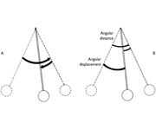
angular distance and angular displacement
counterclockwise direction = +
clockwise direction = -

Angular Displacement: is the change in the angular position or orientation of a line segment
- Change in angular position
- Vector quantity
- Measured in degrees, radians or revolutions
- Displacement is start to finish
- Angle has to be in radians if you are going to use calculators

Units of measure

- Degree = 360°
- Revolution = complete circle = 1 revolution
- Radians = complete circle - 2π radians
  - 360° = 2π radians
  - 1 radian = 57.3
  - π radian = ½ circle

Radian: angle at the center of the circle that results in an arc equal in length to the radius of the circle

- to convert:
  - angle in degree = angle in radian × 180°
π

Angle(rad) = arc length(m)/radius(m)

Units of Angular Measurement

90 degrees | 180 degrees | 270 degrees | 360 degrees
π/2 radians | π radians | 3π/2 radians | 2π radians
¼ revolution | ½ revolution | ¾ revolution | 1 revolution

Direction of Angular Motion

- defined in terms of direction of rotation around the axis of rotation
- often counterclockwise is defined as a positive rotation

Right Hand Rule: is the procedure for identifying the direction of an angular vector
- fingers curl in the direction of motion
- thumb indicates the direction of vector

Rotation | Angular Velocity (ω) | Angular Acceleration (σ)
Counter Clockwise | increasing | up
Counter Clockwise | decreasing | down
Clockwise | increasing | down
Clockwise | decreasing | up

Angular Speed and Velocity

Angular Speed: is defined as the angular distance covered by the time interval over which the motion occurred
- it is a scalar quantity

Formulas

Angular speed = angular distance σ = ϕ
change in time Δt

Angular Velocity: rate of change in the angular position of a line segment

Angular velocity = angular displacement ω = Δθ
change in time Δt

Units = degs/rads/revs and rpm

Angular Acceleration = change in angular velocity α = Δω
change in time Δt

Units = degs/s², rads/s² and rev/^{s2}

- as with linear relationships, average(instantaneous) values are determined by the length of time interval selected
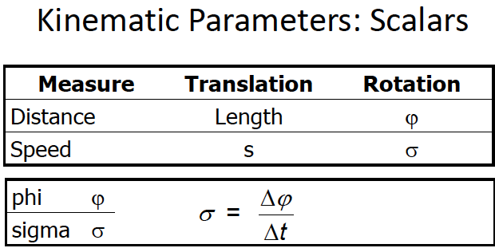
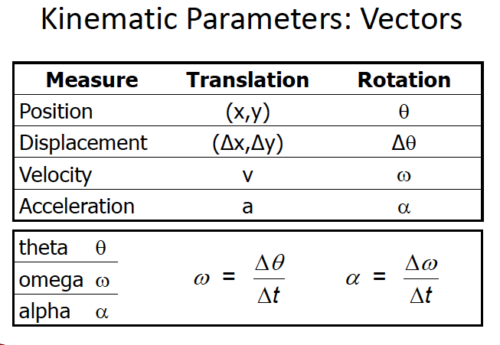

Linear and Angular Displacement

Radius of Rotation: distance from the axis of rotation to a point of interest on a rotating body

- the larger the radius of rotation(r) the greater the linear distance (s) travelled by a point on a rotating body
- s = rφ (φ = angular distance)

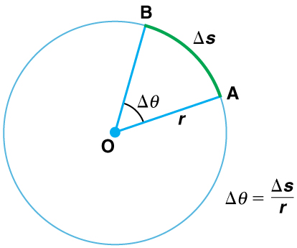

- although every part of an object moving about an axis had the same angular distance, each part of the object has a different linear distance

Linear vs Angular Velocity

- rate of change of displacement ( linear or angular)
- Linear (tangential) velocity – v
- r = radius
- ω = angular velocity

Linear vs Angular Acceleration

- the acceleration of a body in angular motion can be resolved into teo perpendicular linear acceleration components
  - tangential acceleration (a_{t})
  - radial acceleration (a_{r})

Tangential Acceleration: component of acceleration of a body in angular motion directed along a tangent to the path of motion: represent a change in linear speed

- represents rate of change in linear speed

a_{t} = v₂ – v₁ a_{t} = ra
Δt
Radial Acceleration: component of acceleration of a body in angular motion directed toward the centre of curvature
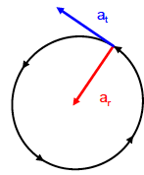
- represents rate of change in direction

a_{r} = v² a_{r} = rω² r

