ECON 201 Microeconomics
Chapter 1
What is ECONOMY; “the one who manages the household”. How society manages its scarce resources
Ten Principles of Economics;
Group 1: How People Make Decisions
- People Face Trade Offs: All Decisions involve tradeoffs.
Society Tradeoff- efficiency vs equality
Efficiency; when society gets the most from scarce resources.
Equity; When prosperity is distributes uniformly among societies member
- The Cost of Something is What You Give Up to Get It: making decisions requires comparing the costs and benefits of alternative choices.
The opportunity cost of any item is whatever must be given up to obtain it. It is the relevant cost for decision making
- Rational People Think at the Margin:
Rational People: systematically and purposefully do the best they can to achieve their objectives.
Marginal Changes: What is the marginal cost and what are the benefits…incremental adjustments to an existing plan
ex. Student considers additional year he compares the fees and the forgone wages to the extra income he could earn with the extra year of education.
When Marginal Benefit outweighs Marginal Cost=GO FOR IT
- People Respond to Incentives: Rational people respond to incentives
Incentive: Something that induces a person to act (reward/punishment)
ex. Gas prices increase then gas guzzling cars sales decrease.
Group 2: How People Interact
- Trade Can Make Everyone Better Off: Rather than being self-sufficient, people can specialize in producing one good or service and exchange it for other goods
Countries can benefit with trade and specialization (Better prices for goods they produce) Question: Plaid—value village---sewers, fabric makers, truck drivers, button makers, thread makers, sewing machine makers dye bankers…Millions around the world behind one thing. Interconnected---Colour, pattern, size, price, quality---country
- Markets Are Usually a Good Way to Organize Economic Activity; Buyers and sellers make up a Market. “Organize economic activity” means determining: what to sell, how to produce, how much of each product, who gets them
Market Economy allocates resources through the decentralized decisions of many households and firms as they interact in markets.
Modern Mixed Economy: let the market work itself out but also government has say
- Government Can Sometimes Improve Market Outcomes:
When… Market Failure: When market fails to allocate societies resources efficiency
Causes: Externalities-when the production or consumption of a good affects bystanders (pollution) Market Power- A single buyer or seller has substantial influence on market price (monopoly)
How the Economy as a Whole Works (Based more on Macro Econ)
- A Countries Standard of Living Depends On its Ability to Produce Goods and Services:
Productivity; the quantity of goods and services produced from each hour of a workers time
- Prices Rise When The Government Prints Too Much Money:
Inflation; an increase in the overall level of prices in the economy
What Causes Inflation?
- Society Faces a Short Run Tradeoff Between Inflation and Unemployment: this provides a key role in the analysis of the business cycle.
Business Cycle; irregular and unpredictable fluctuations in economic activity as measured by the production of goods and services or the number of people employed.

Study/Reading Tips:
- Summarize Don’t Highlight; Keep mind engaged, summarize whole chapter and paragraphs
- Test Yourself; Quick Quizzes throughout the textbook, Aplia, Nelson.com
- Review Questions; @ the end of each chapter there are a series of questions to answer, do them. Practice Practice Practice.
- Group Study
- Teach Someone Else; ensures that you know what you are talking about
Chapter 2: Thinking like an Economist
Economist as Scientist
- Economists try to address their topic or issue with a scientific approach using the Scientific Method.
  - Scientific Method; involves observations, theory, more observations… They cannot use experimentation as it is hard in economics
  - Assumption simplifies the world and makes it easier to understand and assumptions are based on scientific thinking.
- Economic Models are used to learn about the world and use diagrams, equations and graphs.
  - Very basic and are built on assumptions
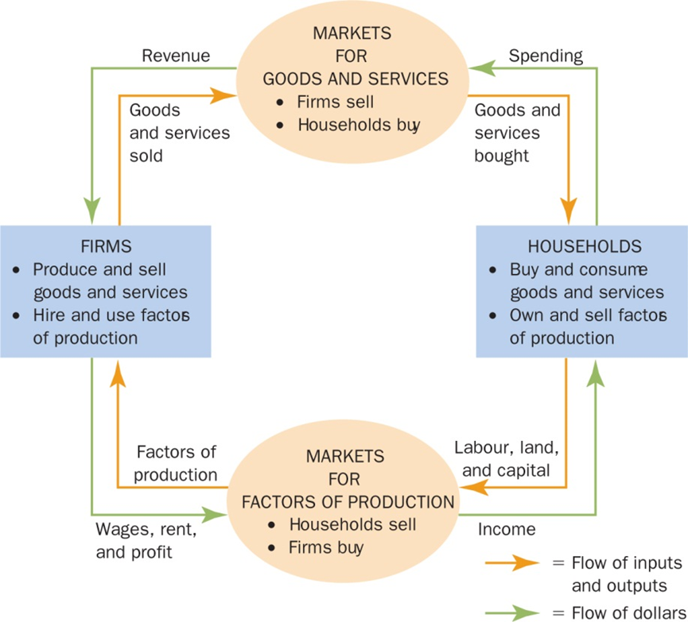
- Circular Flow Diagram: visual model of the economy that shows how dollars flow through markets among households and firms.

In this model, the economy is simplified to include only two types of decision makers—households and firms. Firms produce goods and services using inputs, such as labour, land (natural resources), and capital (buildings and machines). These inputs are called the factors of production. Households own the factors of production and consume all the goods and services that the firms produce.

- Product Possibility Frontier (PPF): A graph that shows combinations of output that the economy can possibly produce given available factors of production and the technology of it.
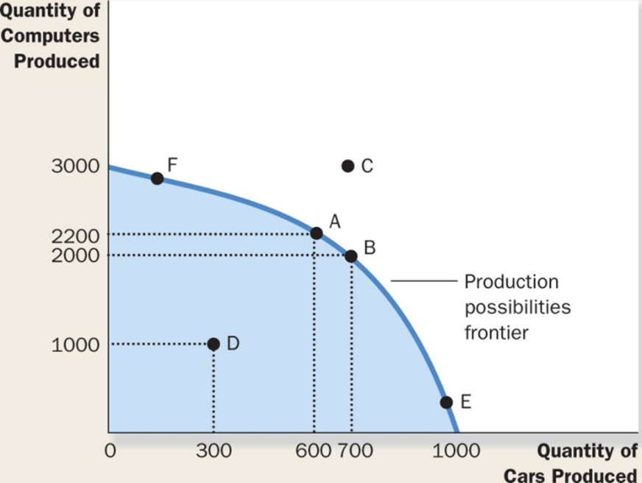

Point A, B, E and F are the most efficient possibilities for production
Point D is a possibility but it is under produced thus not efficient
Point C is not possible because there are not enough hours to support it

PPF: shows a tradeoff, more of one product means less of another… negative slope
Opportunity Cost: Notes example. 2500 you want 4000 what is the opportunity cost? Opportunity cost to get extra1500 wheat is 150 computers.
What is the opportunity cost of 1 wheat? 100tons
Slope of linear line y=a+bx where a=vertical intercept b=slope
b=rise/run = 5000-0/0-500=-10
a=5,000/y=5,000-10x
wheat=5000-10comp
“-“ is the trade off, negative slope = negative number
“10” represents the opportunity cost of 1 computer
What is oc of 1 ton of wheat= 1/10
Lower opportunity cost of x axis when slope is not as steep
a>b
1/a>1/b

The PPF could be a straight line or bow shaped
It depends on what happens to the opportunity cost as economy shifts resources from one industry to another.
OC remains constant as a straight line, Oc rises as in bow shaped

Why might PPF be bow shaped? When different workers have different skills, different opportunity costs of producing one good in terms of another. Also when others resources are in the mix.
The PPF shows all combinations of two goods that an economy can possibly produce given its resources and technologies. The PPF illustrates the concepts of tradeoff and opportunity cost, efficiency, unemployment and economic growth. Bow shape means increasing opportunity cost.

Microeconomics; how households and firms make decisions and how they interact in markets.
Macroeconomics; the study of the economy wide phenomena, including inflation, unemployment and economic growth.

The Economist as Policy Advisor
- As Scientists economists make Positive Statements which attempt to describe the world as a whole
- As policy advisors economists make normative statements which attempt

