Gene Structure

Pre-Reading:

Pre-Reading Outcomes
Start codon's are the message that starts a certain protein being synthesized. For all proteins this is the nucleotide sequence "AUG" and this codes for the amino acid methionine.The stop codons are the messages that tells the cell that the protein is made and that they should stop adding more amino acids to the polypeptide. The stop codons do not have amino acids, they are UAA, UAG and UGA.

Note:

Bacterial Transcription initiates after the Promoter Sequence
- Template strand (bottom) runs 3' to 5' (left to right), this strand is being used to create the mRNA
- The coding strand (top) is antiparallel to the template strand and runs 5' to 3'
- The purple arrows are the sites of mutations that destroy the function of the promoters
- The other arrows (green and black) indicate the places where polymerase actually touches the double stranded DNA, shown by black dots
- The two regions -35 and -10 sequence, the sequence is specified (TAT and ATA), this means in all prokaryote promoters these will be the bases you will most commonly find at those positions
- Promoters have particular sequences at particular places, this means that promoters have direction
- Promoters are double stranded DNA, that attracts association with polymerase and they direct polymerase
- Promoter causes DNA to open up, transcription starts by complementary base pairing until we get to the end at which the polymerase stops transcribing
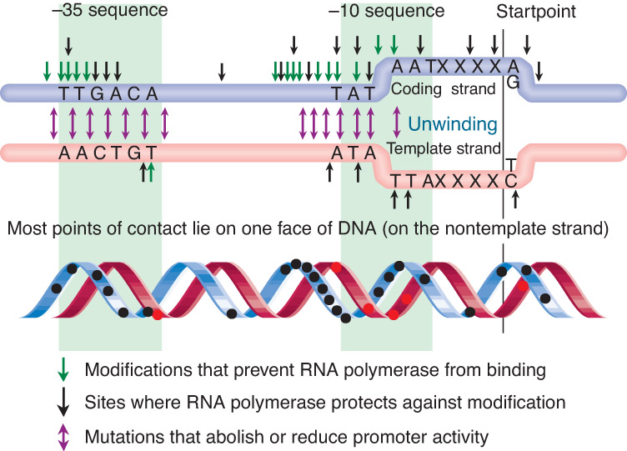

Bacterial Transcription terminates after a Hairpin Loop
- Terminator sequence present at the area where transcription is supposed to stop
- The mRNA goes right past the terminator sequence but copies the terminator sequence
- mRNA then base pairs with itself and where the terminator sequence is present it makes a little loop there (hairpin loop)
- At the end of the mRNA there are a series of U's which means that on the DNA there is a series of A's, there are just a few of those but thenanother promoter starts and then a terminator and then A's, etc
- A-U base pairs have only two hydrogen bonds, thus, they are relatively weak which is enough to destabilize the polymerase and it falls off
- The loop signals the polymerase to stop transcribing
- This is one of the transcription stop mechanism in prokaryotes
- The transcription terminating sequence is found in DNA but is understood as RNA

The Template for a given Gene is either one strand or the other
- The direction the polymerase is going tells you which strand is the template
- The promoter determines which way the polymerase goes (promoter on right then top strand is the template, left then bottom strand)
- Depending which side of the gene the promoter is on determines which way the polymerase goes
- In circular DNA (E.coli, mitochondria, chloroplast) some genes are found on the outside strand while others are found on the inside strand
- There is no such thing as one template strand
- The start codon is the same in both prokaryotes and eukaryotes
- Sequence is from 3' to 5' respectively, TAC, in the template DNA
- Start codon's start translation

Ribosomes have two subunits, each containing rRNA and Proteins

Translation initiation is stabilized by "SD box" mRNA sequence pairing with rRNA
- The small subunits of ribosome's (rRNA) associate with the message (mRNA) by complementary base pairing
- This occurs in a region called the SD box
- A docking sequence that helps the small subunits of the ribosome dock onto the mRNA
- The region between the 5' end and the start codon is not translated
- Translation begins at the start codon
- The region that is not translated is known as the untranslated region (UTR)
- The region between the start of the message and the start codon is called the 5' UTR
- One of the functions of the 5' UTR is to house the SD box to allow translation to initiate
- SD box signals are coded in the DNA but are understood as RNA
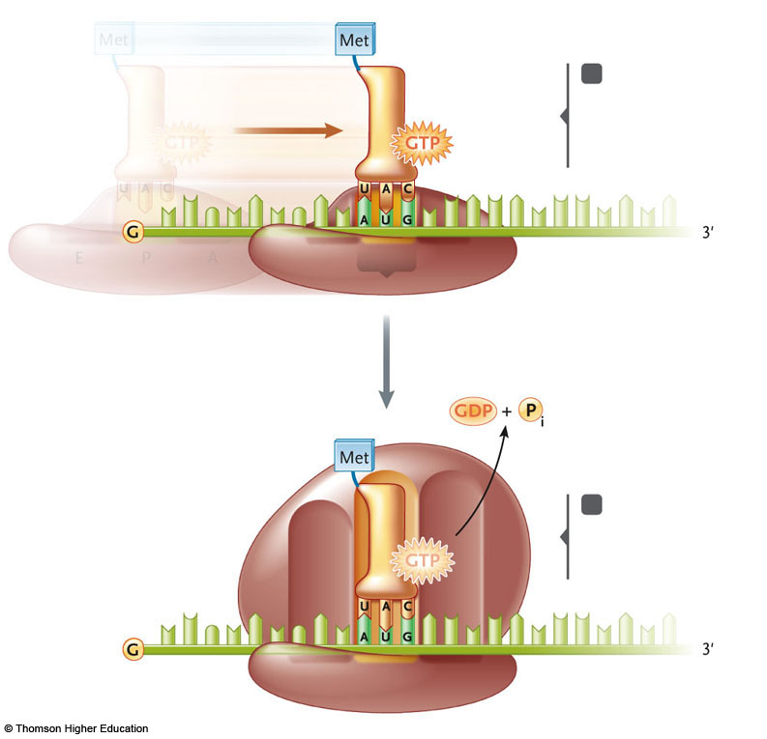

A Protein Release Factor terminates translation
- When ribosomes approach a stop codon, there is no tRNA that recognizes stop codons except the ones that do which are mutants, there is no normal tRNA that recognizes stop codons
- When ribosome gets to the stop codon it asks for a tRNA but there aren't any, thus, it stutters for a moment allowing a protein release factor to enter that site and signal the end of translation
- A release factor is what recognizes stop codons
- Stop codons are found in DNA but are understood by RNA
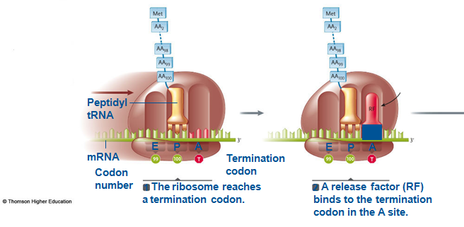

- In eukaryotic cell transcription occurs in the nucleus, then the message gets out of the nucleus before translation, the message is protected from ribosome's until it leaves the nucleus, there are no ribosome's inside the nucleus
- In prokaryotic cells ribosome's have immediate access to messages, sometimes the messages aren't even fully transcribed before they are translated
- In prokaryotes, transcription and translation occur at the same time
- The oldest ribosome is the on e that has had the most opportunity to translate the message, the longest message, the one with the longest polypeptide chain

Lecture Outcomes
- The mechanism by which each signal is interpreted or understood by the cell is not found in the DNA itself, the DNA just codes for the signal but it is understood by the RNA, thus, allowing the proteins or RNA to execute that specific signal.
- The relationship between the DNA sequence of signals and their function
- Promoters have particular sequences at particular places, this means that promoters have direction and they are double stranded DNA, that attracts association with polymerase and they direct polymerase.
- See Pre-Reading Outcome(s)

