UNIT 1: Basic cell processes: integration and coordination

Chapter 1: Introduction to Physiology

- physiology: study of normal functioning of a living organism and its component parts (including all its chemical and physical processes)
  - also known as knowledge of nature
- many complex systems possess emergent properties
  - emergent properties: properties that cannot be predicted to exist based only on knowledge of system’s individual components
  - emergent properties result from complex, nonlinear interactions of the different components
- focus of physiology: integration of function across many levels of organization
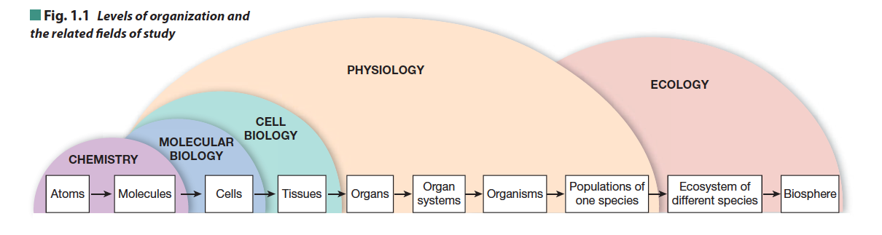
- levels of organization:
- there are 10 physiological organ systems in human body
  - integumentary system forms protective boundary that separates body’s internal environment from external environment
    - includes skin
  - musculoskeletal system provides support and body movement
    - includes skeletal muscles, bone
  - respiratory (pulmonary) system exchanges gases between internal and external environments
    - includes lungs, airways
  - digestive (gastrointestinal) system takes up nutrients and water and eliminates wastes
    - includes stomach, intestine, liver, pancreas
  - urinary (renal) system removes excess water and waste material
    - includes kidneys, bladder
  - reproductive system produces eggs or sperm
    - includes ovaries and uterus, testes
  - circulatory (cardiovascular) system distributes material by pumping blood through vessels
    - includes heart, blood vessels, blood
- nervous and endocrine systems 00> coordinate body functions
- Nervous includes brain, spinal cord
    - Endocrine includes thyroid gland, adrenal gland
  - immune system includes but not limited to anatomical structures known as lymphatic system
    - protect internal environment from foreign substances by intercepting material that enters through intestines and lungs or through break in skin
- function is the WHY of the system or event
- mechanisms the HOW of a system
- mechanistic approach to physiology examines process
- translational research approach that uses insights and results gained from basic biomedical research on mechanisms to develop treatments and strategies for preventing human diseases
- Homeostasis: concept of relatively stable internal environment
  - Homeo similar
  - Stasis condition not a state that is static and unchanging
- for multicellular animals, a watery internal environment that surrounds the cell called extracellular fluid is the internal environment of the body
- extracellular fluid (ECF) serves as transition between an organism’s external environment and intracellular fluid (ICF) inside cells
- most cells of multicellular animals do not tolerate much change
- to maintain homeostasis, body must maintain mass balance
- law of mass balance: if the amount of a substance in body is to remain constant, any gain must be offset by an equal loss
- amount of substance in body is called body’s load
- law of mass balance equation: total amount of substance X in the body = intake+ production – excretion- metabolism
- body has two options for output to maintain mass balance
  - to excrete material Excretion: elimination of material from the body usually through urine, feces, lungs, skin
    - any foreign substance in the body is called xenobiotic
  - to convert substance to a different substance through metabolism
    - metabolite: any product created in a metabolic pathway
- clearance: rate at which the substance disappears from the blood
  - kidney and liver are two primary organs that clear solutes from the body
  - clearance also takes place in tissues other than liver and kidneys
- homeostasis refers to the stability of the extracellular fluid compartment (ECF)
- in state of homeostasis, composition of both body compartments is relatively stable condition is a dynamic steady state
- modifier dynamic indicates that materials are constantly moving back and forth between two compartments
- in a steady state, there is no net movement of materials between compartments
- steady state is not the same as equilibrium
- equilibrium: implies that composition of body compartments is identical
- ECF and ICF exist in state of disequilibrium
- There are two basic patterns of control mechanisms: local control and long-distance reflex control
- All control systems have three components:
  - an input signal
  - a controller/ integrating center integrates incoming info and initiates appropriate response
  - output signal
- simplest form of control is local control (restricted to tissue or cell involved)
- example of local control:
  - when oxygen concentration in a tissue decreases
  - cells lining small blood vessels that bring blood to areas sense lower oxygen concentration and respond by secreting chemical signals
  - signal molecule diffuses to nearby muscles in blood vessel wall, telling them to relax
  - relaxation of muscles widens blood vessel which increases blood flow into tissue and brings more oxygen to area
- reflex control: any long-distance pathway that uses nervous system, endocrine system or both
- physiological reflex can be broken down into two parts: a response loop and a feedback loop
- response loop:
  - has three primary components: an input signal, integrating center, an output signal
  - input side of response loop starts with stimulus change that occurs when regulated variable moves out of its desirable range
  - specialized sensor monitors variable
  - if sensor is activated by stimulus, it send an input signal to integrating center
  - integrating center evaluates information coming from sensor and initiates an output signal
  - output signal directs a target to carry out a response
- feedback loop:
  - where the response “feeds back” to influence input portion of pathway
- negative feedback loops are homeostatic
- designed to keep system at or near a set point so that the regulated variable is relatively stable
- negative feedback: a pathway in which the response opposes or removes the signal
- negative feedback loops stabilize the regulated variable and aid system in maintaining homeostasis
- negative feedback loops can restore the normal state but cannot prevent the initial disturbance
- positive feedback loops are NOT homeostatic
- response reinforces stimulus rather than decreasing or removing I
- response sends regulated variable even farther from its normal value
- this type of feedback requires some intervention or event outside loop to stop response
- negative feedback loops can stabilize a function and maintain it within a normal range but are unable t prevent change that triggered reflex
- few reflexes have evolved that enable the body to predict that a change is about to occur and start response loop in anticipation of change
  - these anticipatory responses are called feed forward control
- regulated variables that change predictably and create repeating patterns or cycles of change are known as biological rhythms or biorhythms
- biological rhythms reflect changes in set point of regulated variable
- some variability in set points is associated with changing environmental conditions rather than biological rhythms
- adaptation of physiological processes to a given set of environmental conditions is known as acclimatization when it occurs naturally
- if process takes place artificially in a lab setting, it is called acclimation
- altered variable is the independent variable
- essential feature of any experiment is an experimental control
- control group is usually duplicate of experiment group except that independent variable is not changed from its initial value
Results of human experiments can be difficult to interpret
- variability: human pop’n have genetic and environmental variability
- one way to reduce variability within a test population, is to do a crossover study
- Placebo effect: tell someone the advantages and the person will have the exact effect although it is an inactive substance
- Nocebo effect: you warn people that a drug they are taking may have specific adverse side effects, those people will report higher incidence of side effects that a group that is not warned
- Best way to control for placebo and nocebo effects is to do a blind study
- Blind study: subjects do not know whether they are receiving the treatment or the placebo
- Double- blind studies: a third party not involved in experiment is only one who knows which group is receiving experimental treatment and which group is receiving control treatment
- Double- blind crossover study: control group in first half become experimental group in second half and vice versa; no one involved knows who is taking active treatment
- refer to chapter summary

Chapter 3: Compartmentation: Cells and Tissues
- body is divided into three major body cavities:
  - cranial cavity referred to as skull
    - contains the brain
  - thoracic cavity called thorax
    - is bounded by spine and ribs on top and sides, with muscular diaphragm forming the floor
    - contains the heart
  - abdominopelvic cavity
    - abdomen and pelvis form one continuous cavity
    - tissue lining called peritoneum lines abdomen and surrounds organs within it
    - kidneys lie outside abdominal cavity, between peritoneum and muscles and bones of back
    - pelvis contains reproductive organs, urinary bladder, and terminal portion of large intestine
- cavities are separated from one another by bones and tissues and are lined with tissue membranes
- interior of any hollow organ is called its lumen may be wholly or partially filled with air or fluid
- the body can be divided into two main fluid compartments:
- 1) extracellular fluid (ECF)
- 2) intracellular fluid (ICF)
- extracellular fluid subdivides into plasma (fluid portion of blood) and interstitial fluid (surrounds most cells of body)
- dividing wall between ECF and ICF is cell membrane
- functions of cell membrane include:
  - physical isolation separates intracellular fluid inside cell from surrounding extracellular fluid
  - regulation of exchange with the environment controls entry of ions and nutrients into cell, elimination of cellular wastes and release of products from cell
  - communication between the cell and its environment contains proteins that enable cell to recognize and respond to molecules or to changes in its external environment
  - structural support proteins in cell membrane hold cytoskeleton, cell’s interior structural scaffolding, inplace to maintain cell shape
    - membrane proteins create specialized junctions between adjacent cells or between cells and extracellular matrix
    - secretion process by which a cell releases a substance into extracellular space
    - cell-cell an cell-matrix junctions stabilize structure of tissues
- the more metabolically active a membrane is, the more proteins it contains
- three main types of lipids make up cell membrane: phospholipids, sphingolipids, and cholesterol
  - phospholipids made of glycerol backbone with two fatty acid chains extending to one side and a phosphate group extending to the other
    - glycerol-phosphate head of molecule is polar and hydrophilic
    - fatty acid tail is nonpolar and hydrophobic
    - phospholipids orient themselves so that polar head of molecules interact with water molecules while nonpolar fatty acid tails hide by putting polar head between themselves and water
    - arrangement can be seen in three structures: micelle, liposome, phospholipid bilayer of cell membrane
      - micelles small droplets with single layer of phospholipids arranged so that interior of micelle is filled with hydrophobic fatty acid tails
      - are important in digestion and absorption of fats in digestive tract
      - liposomes larger spheres with bilayer phospholipid walls
      - leaves hollow center with aqueous core that can be filled with water soluble molecules
- sphingolipids have fatty acid tails but heads may be either phospholipids or glycolipids
    - are slightly longer than phospholipids

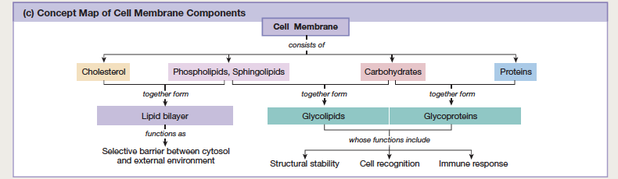

- cholesterol mostly hydrophobic, insert themselves between hydrophilic heads of phospholipids
    - helps make membranes impermeable to small water-soluble molecules and keeps membranes flexible
- membrane proteins may be loosely or tightly bound to membrane
  - Integral proteins :
    - Tightly bound to membrane
    - Only way to remove it is by disrupting membrane structure with detergents or other harsh methods that destroy membrane’s integrity
    - Include transmembrane proteins and lipid- anchored proteins
- Peripheral proteins:
- Attached to other membrane proteins by noncovalent interactions
- Can be separated from membrane by chemical methods that do not disrupt integrity of membrane
- Include enzymes and some structural binding proteins that anchor cytoskeleton to membrane
- Transmembrane proteins:
- Also called membrane- spanning proteins because protein’s chains extend all the way across cell membrane
- When protein crosses membrane more than once, loops of amino acid chain protrude into cytoplasm an extracellular fluid
- Carbohydrates may attach to extracellular loops and phosphate groups may attach to intracellular loops
- Phosphorylation of proteins regulatory method cells use to alter protein function
- Membrane carbohydrates attach to lipids and proteins
- Most membrane carbohydrates are sugars attached to membrane proteins (glycoproteins) or to membrane lipids (glycolipids)
- Found on external surface of cell where they form a protective layer known as glycocalyx
- Differentiation only selected genes activate, transforming cell into specialized unit
- Outer boundary = cell membrane
  - Controls movement of material between cell interior and outside by opening and closing gates made of protein
  - Cells must communicate and cooperate with oterh cells to keep body functioning in coordinated fashion
  - Cell is divided into cytoplasns and nucleus
    - Cytoplasm consists of fluid portion (called cytosol), insoluble particles (called inclusions)
    - Insoluble protein fibers and membrane= bound structures known as organelles
- cytoplasm includes all material inside cell except nucleus
- it has four components:
  - cytosol semi gelatinous fluid separated from extracellular fluid by cell membrane
    - contains dissolved nutrients, proteins, ions, waste products
  - inclusions particles of insoluble materials
    - some are stored nutrients; others are responsible for specific cell functions structures are sometimes called membranous organelles
    - do not have boundary membranes; are in direct contact with cytosol
    - movement of material between inclusions and cytosol does not require transport across membrane
    - nutrients are stored as glycogen granules and lipid droplets
  - cytoskeleton insoluble protein fibers form cell’s internal support
  - organelles membrane bounded compartments that play specific rols in overall function of cell
- ribosomes small, dense granules of RNA and protein that manufacture proteins under direction of cell’s DNA
- ribosomes attached to cytosolic surface of organelles are called fixed ribosomes
- those suspended free are called free ribosomes
- there are three sizes of cytoplasmic protein fibers; classified by diameter and protein composition
- thinnest: actin fibers (also called microfilaments)
- intermediate filaments may be made of diff types of proteins
- largest: hollow microtubules made of protein called tubulin
- insoluble protein fibers have two purposes: structural support and movement
- centrosome cell’s microtubule organizing center assembles tubulin monomers into microtubules
- centrosome contains two centrioles direct movement of DNA strands during cell division
- cytoskeleton 3D scaffolding of actin microfilaments, intermediate filaments, and microtubules that extends throughout cytoplasm
  - some protein fibers are permanent but most are synthesized or disassembled according to cell’s needs
  - has 5 functions
    - cell shape
    - internal organization
    - intracellular transport
    - assembly of cells into tissues
    - movement
- motor proteins proteins that convert stored energy into direct movement
- three groups of motor proteins associated with cytoskeleton
- all groups use energy stored in ATP to propel along cytoskeleton fibers
  - myosins bind to actin fibers and play role in muscle contraction
  - kinesins assist movement of vesicles along microtubules
  - dyneins assist movement of vesicles along microtubules; associate with microtubule bundles of cilia and flagella to help create whip like motion
- endoplasmic reticulum three major functions: synthesis, storage, transport of biomolecules
  - rough ER main site of protein synthesis
  - smooth ER main site for synthesis of fatty acids, steroid, lipids
- golgi apparatus receives proteins made on rough ER, modifies them, packages them into vesicles
- membrane bound cytoplasmic vesicles are of two kinds:
  - secretory vesicles contain proteins that will be released from the cell
  - storage vesicles contents never leave cytoplasm
    - ie: lysosomes act as digestive system of cell
    - ie: peroxisomes degrade long chain fatty acids and potentially toxic foreign molecules
- communication between nucleus and cytosol occurs through nuclear pore complexes
Tissues of the body
- cells in tissues are held together by specialized connections called cell junctions
- refer to figure 3.7 – pg 77
- Histology: the study of tissue structure and function
  - There are four primary tissue types in human body: epithelial, connective, muscle, neural/ nerve
- extracellular matrix: extracellular material that is synthesized and secreted by cells of a tissue
- matrix always has two basic components: proteoglycans and insoluble protein fibers
  - proteoglycans: are glycoproteins proteins that are covalently bound to polysaccharide chains
  - insoluble protein fibers (ie: collagen, fibronectin, laminin) provide strength and anchor cells to matrix
- cells communicate by attaching between extracellular matrix and proteins in cell membrane or cytoskeleton
- during growth, cells form cell-cell adhesions
  - cell adhesion molecules (CAMs) membrane spanning proteins responsible for cell junctions and transient cell adhesions
- stronger cell junctions can be grouped into three categories: communicating junctions, occluding junctions, anchoring junctions
- animals have three types of junctions :
  - gaps junctions: allow direct and rapid cell to cell communication through cytoplasmic bridges between adjoining cells
    - cylindrical proteins called connexins interlock to create passageways that look like hollow rivets with narrow channels through centers.
    - Allow chemical and electrical signals to pass
- tight junctions: occluding junctions that restrict movement of material between cells they link
- cell membranes of adjacent cells partly fuse together with help of proteins called claudins and occludins
- anchoring junctions (desmosome): attach cells to each other or to extracellular matrix
- cell to cell anchoring junctions are created by CAMs called cadherins
- movement of materials between cells is known as paracellular pathway
- adherens junctions link actin fibers in adjacent cells together
- dosmosomes attach to intermediate filaments of cytoskeleton
- two type of cell-matric anchoring junctions:
  - hemidesmosomes: strong junctions that anchor intermediate fibers of cytoskeleton to fibrous matrix proteins
Type 1: Epithelial tissue
- protect internal environment of body and regulate exchange of materials between internal and external environments
- tissues cover exposed surfaces such as skin, line internal passageways
- any substance that enters or leaves internal environment of body must cross an epithelium
- some epithelia act as a barrier to keep water in body and invaders (bacteria) out
- others control movement of materials between external environment and extracellular fluid
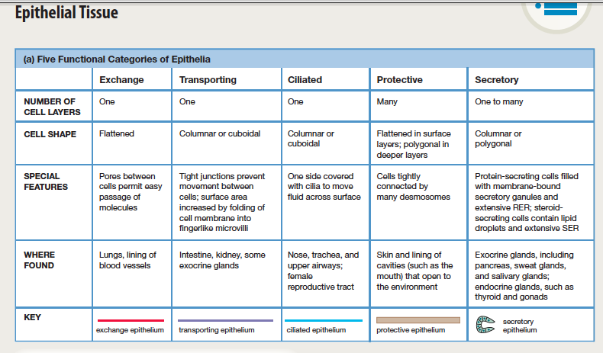

- extracellular matrix lying between epithelial cells and underlying tissues basal lamina
- Basement membrane composed of network of collagen and laminin filaments embedded in proteoglycans
- Protein filaments hold epithelial cells to underlying cell layers
- Leaky epithelium all dissolved molecules except for large protenis can pass from blood to interstitial fluid by traveling through gaps between adjacent epithelial cells
- Tight epithelium adjacent cells are bound to each other by tight junctions that create a barrier, preventing substances from traveling between adjacent cells
- Epithelial tissues can be divided into two types
  - Sheets of tissue that lie on surface of body or that line inside of tubes and hollow organs
  - Secretory epithelia that synthesize and release substances into extracellular space
- classification recognizes two types of layering:
  - simple one cell thick
  - stratified multiple cell layers
- three cell shapes:
  - squamous
  - cuboidal
  - columnar
- five functional types of epithelia:
  - exchange permit rapid exchange of materials
    - lines blood vessels and lungs two major sites of gas exchange
    - squamous epithelium lining heart and blood vessels is called endothelium
  - transporting are selective about what can cross them and are found mainly in intestinal tract and kidney
    - regulate exchange of nongaseous material (ions and nutrients) between internal and external environments
    - can be identified by:
      - cell shape are much thicker than cells of exchange epithelia and act as barrier and entry point
      - membrane modification apical membrane (surface of epithelial cell that faces lumen) has projections called microvilli that increase surface area available for transport
        - basolateral membrane (side of epithelial cell facing extracellular fluid) may have folds that increase cell’s surface area
- cell junctions cells of transporting epithelia are attached to adjacent cells by tight to very tight junctions
        - to cross epithelium, material must move into an epithelial cell on one side of tissue and out of cell on other side
- cell organelles properties of transporting epithelia differ depending on where in body epithelia are located
  - ciliated located in airways of respiratory systems and in female reproductive tract
    - are non transporting tissues that line respiratory system and parts of female reproductive tract
    - injury to cilia or other epithelial cells can stop ciliary movement
    - loss of ciliary function (when mucus that traps bacteria can no longer be swept out of lungs by cilia) contributes to higher incidence of respiratory infection in smokers
  - protective found on surface of body and inside openings of body cavities
    - prevent exchange between internal and external environments and protect areas subject to mechanical or chemical stresses
  - secretory synthesize and release secretory products into external environment or into blood
    - are composed of cells that produce substance and secrete it into extracellular space
    - cells may be scattered among other epithelial cells or may group together to form multicellular gland
    - there are two types of secretory glands: exocrine and endocrine
    - exocrine glands release their secretions to body’s external environment; exocrine secretion leaves body
      - most exocrine glands release their products through open tubes known as ducts (ie: sweat glands, mammary glands, salivary glands, liver, pancreas)
      - produce two types of secretions:
        - serous secretions watery, many contain enzymes (tears, sweat, digestive enzyme)
        - mucous secretions sticky solutions that contain glycoproteins and proteoglycans; act as lubricant for food to be swallowed, as a trap for foreign particles and microorganisms inhaled, protective barrier between epithelium and environment
        - exocrine glands remain connected to parent epithelium by duct that transports secretion to its destination
- endocrine glands ductless and release their secretions called hormones into body’s extracellular compartment
  - pancreas, thyroid gland, gonads, pituitary gland
  - endocrine glands lose connecting cells and secrete their hormones into bloodstream
  - refer to Figure 3.10

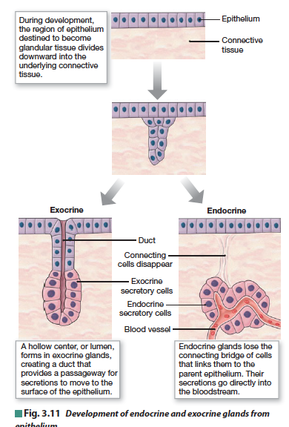

Type 2: Connective Tissue
- provide structural support and sometimes a physical barrier that helps defend body from foreign invaders (ie: bacteria)
- distinguishing characteristic: presence of extensive extracellular matrix containing scattered cells that secrete and modify matrix
- include blood, support tissues for skin and internal organs, cartilage, bone

structure of connective tissue:
- extracellular matrix: ground substance of proteoglycans and water
- consistency: highly variable, depending on type of connective tissue
- one extreme: watery matrix of blood
- other extreme: hardened matrix of bone
- lie embedded in extracellular matrix:
  - fixed remain in one place
    - responsible for local maintenance, tissue repair, energy storage
  - mobile can move from place to place
    - responsible for defense
- cells that are actively breaking down matrix are identified by –clast
- cells that are not growing, not secreting matrix components or breaking down matrix are identified by –cyte meaning cell
- connective tissue cells produce matrix fibers
  - four types of fiber proteins are present
    - collagen found almost everywhere connective tissue is found
      - individual collagen molecules pack together to form collagen fibers
      - amount and arrangement of collagen fibers help determine mechanical properties of different types of connective tissues
    - elastin
      - cotled, wavy protein that returns to its original length after being stretched called elastance
      - elastin combines with fibers of fibrillin to form filaments and sheets of elastic fibers
    - fibrillin
    - fibronectin
      - connects cells to extracellular matrix at focal adhesions
      - also play role in wound healing and in blood clotting
- types of connective tissue:
  - loose connective tissues
  - dense connective tissues
    - tendons attach skeletal muscles to bones
    - ligaments connect one bone to another
      - have limited ability to stretch because they contain elastic fibers and collagen fibers
  - adipose tissue
    - made up of adipocytes (fat cells)
    - brown fat is composed of adipose cells that contain multiple lipid droplets rather than a single one
  - cartilage
    - flexible, notable for lack of blood supply
    - nutrients and oxygen must reach cells of cartilage by diffusion
  - bone
    - is calcified because it contains mineral deposits
    - minerals give bone strength and rigidity
- blood
- characterized by watery extracellular matrix called plasma
- plasma consists of dilute solution of ions and dissolved organic molecules
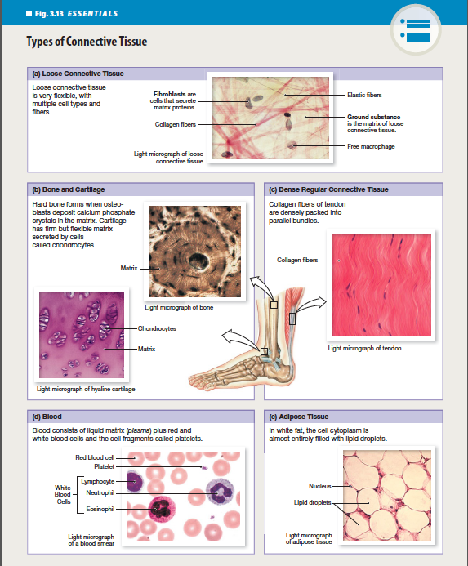

- excitable tissues muscle and neural
  - ability to generate and propagate electrical signals called action potentials
  - both have tissue types minimal extracellular matric, limited to supportive layer called external lamina
Type 3: muscle tissue:
  - has ability to contract and produce force and movement
  - body contains three types of muscle tissue:
    - cardiac muscle in heart
    - smooth muscle, which makes up most internal organs
    - skeletal muscle most attach to bones and are responsible for gross movement of body
Type 4: neural tissue:
  - has two types of cells
    - neurons
      - carry information in form of chemical and electrical signals from one part of body to another
      - are concentrated in brain and spinal cord
      - glial cells
      - are support cells for neurons
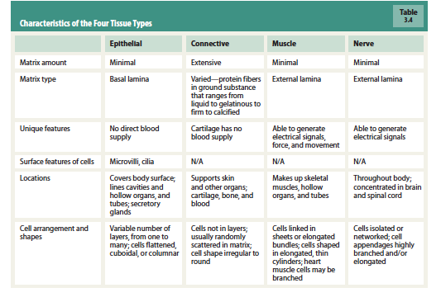
- cell birth, growth, death continue through life
- cell death occurs two ways (one messy and one tidy)
- necrosis:
  - cells die from physical trauma, toxins, lack of oxygen when their blood supply is cut off
  - necrotic cells swell, their organelles deteriorate and rupture
  - cell contents released this way include digestive enzymes that damage adjacent cells and trigger an inflammatory response
    - can be seen when there is a red area around a scab
- apoptosis
  - programmed cell death/ cell suicide
  - do not disrupt neighbors when they die
  - some signals keep apoptosis from occurring, other tell cell to self destruct
  - when signal is sent out, chromatin in nucleus condenses, cell pulls away from neighbors
  - it shrinks, then break into membrane bound blebs that are eaten by neighbor cells
- all cells are derived from single cell formed at conception
- cell reproduce themselves by undergoing cell division known as mitosis
- any totipotent cell has potential to become functioning organism
- begin to specialize and become pluripotent
- as cells specialize and mature, lose ability to undergo mitosis and reproduce themselves
- undifferentiated stem cells in tissue that retain ability to divide and develop into cell types of tissue are mutlipotent
- groups of tissues that carry out related functions may form structures called organs (ie; skin)
- refer to chapter summary

Chapter 6: communication, integration, and homeostasis

Cell- to-cell communication
- are only two basic types of physiological signals: electrical and chemical
- Electrical signals: are changes in cell’s membrane potential
- Chemical signals: are molecules secreted by cells into extracellular fluid
  - Responsible for most communication in body
- cells that respond to electrical or chemical signals are called target cells
- use four basic methods of cell-to-cell communication:
  - local communication
    - 1) gap junctions allow direct cytoplasmic transfer of electrical and chemical signals between adjacent cells
    - 2) contact-dependent signals occur when surface molecules on another cell’s membrane; occurs in immune system and during growth and development
    - 3) chemicals that diffuse through extracellular fluid to act on cells close by
- long-distance communication
- 4) uses combination of chemical and electrical signals carried by nerve cells and chemical signals transported in blood
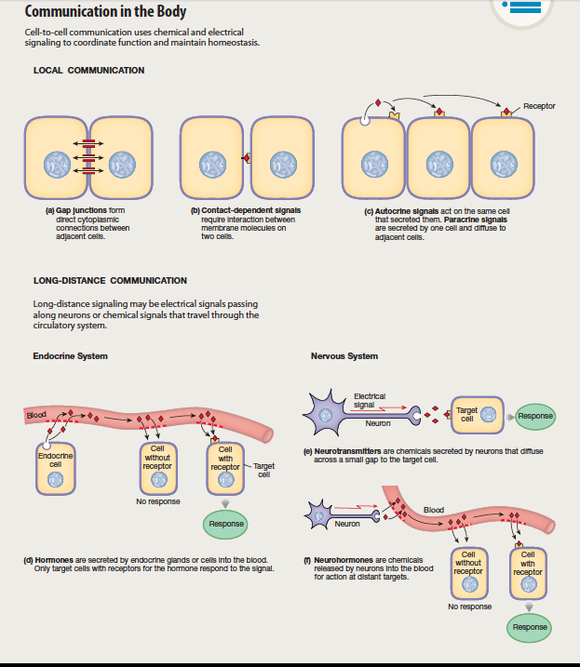

- Cell adhesion molecules (CAMs) act as receptors in cell to cell signaling
- Paracrine signal: chemical acts on neighbouring cell(s) eg: histamine
- Autocrine signal: chemical acts on same cell(s)
- Most long distance communication takes place through nervous and endocrine system
- Endocrine system communicates by using hormones
- Hormones: chemical signals that are secreted into blood and distributed all over body by circulation
- Nervous system uses combo of chemical and electrical signals
- Neurocrine: electrical signal travels along nerve cell until it reaches very end of cell, then it is translated into chemical signal secreted by neuron
- Neurotransmitter: when a neurocrine molecule diffuses from neuron across a narrow extracellular space to target cell and has rapid effect
- Neuromodulator: when neurocrine acts more slowly as an autocrine or paracrine signal
- Neurohormone: when neurocrine released by neuron diffuses into blood for distribution
- Cytokines control cell development, cell differentiation, immune response
- In development and differentiation, cytokines function as autocrine or paracrine signals
- Cytokines are made on demand
Signal pathways
- chemical signals are released from cells into extracellular compartment as paracrine, autocrine molecules and hormones
- they travel through blood by cells do not respond to every signal
- a cell can respond to a chemical signal only if cell has appropriate receptor proteins for that signal
- all signal molecules have the following features:
  - signal molecule is ligand that binds to protein receptor; ligand is known as first messenger because it brings info to target cell
  - ligand- receptor binding activates receptor
  - receptor activates one or more intracellular signal molecule
  - last signal molecule initiates synthesis of target protein or modifies existing target proteins to create response
- most pathways include:
  - signal molecule binds to membrane receptor protein which activates intracellular signal molecules which can alter target proteins which create a response
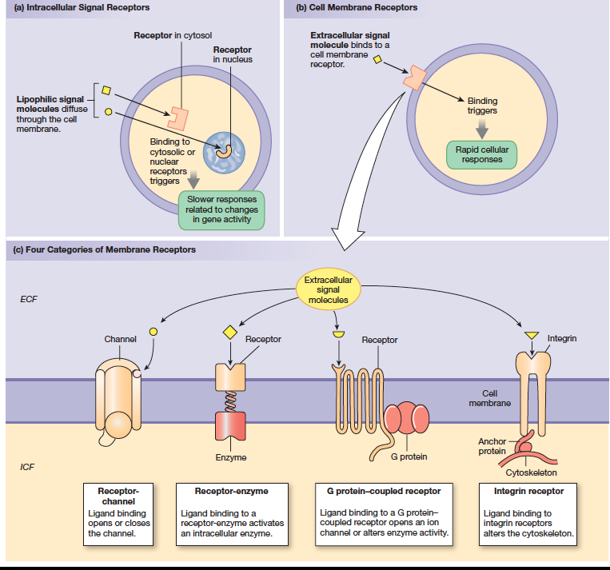

- signal transduction: transmission of info from one side of a membrane to the other side using membrane proteins
- extracellular molecule is first messenger; intracellular molecule is second messenger system
- membrane proteins act as transducers (convert signal from one form to another)
- basic pattern of biological signal transduction pathway:
  - extracellular signal molecule (first messenger) binds to and activates membrane receptor
  - activated membrane receptor turns on its associated protein and starts intracellular cascade of second messengers
  - last second messenger in cascade acts on intracellular targets to create response
- proteins modified by calcium binding and phosphorylation control:
  - metabolic enzymes
  - motor proteins for muscle contraction and cytoskeletal movement
  - proteins that regulate gene activity and protein synthesis
  - membrane transport and receptor proteins
- signaling cascade starts when stimulus (signal molecule) converts inactive molecule A (receptor) to active form
- active A converts inactive molecule B into active B
- active B converts inactive molecule C into active C and so on until a substrate is converted into product at final step
- signal amplification: turns one signal molecule into multiple second messenger molecules; process begins when first messenger ligand combines with receptor
- receptor-ligand complex turns on amplifier enzyme
- receptor-enzymes:
  - have two regions: receptor region on extracellular side of cell membrane & enzyme region on cytoplasmic side
  - enzyme of receptor- enzymes are protein kinases- tyrosine kinase or guanylyl cyclase
- G protein- couples receptors (GPCR) are large family membrane-spanning proteins that cross phospholipid bilayer seven times
- Cytoplasmic tail of receptor protein is linked to three part membrane transducer molecule known as G protein
- Inactive G binds to GDP to form GTP which activates G protein
- When G proteins are activated, 1) open an ion channel in membrane or 2) alter enzyme activity on cytoplasmic side of membrane
- First identified signal transduction pathway G protein- coupled adenylyl cyclase- cAMP system
- Adenylyl cyclase is amplified enzyme that converts ATP to second messenger molecule cyclic AMP
- Cyclic AMP activates protein kinase A (PKA) which phosphorylates other intracellular proteins
- Refer to figure 6.8
- One ligand may have multiple receptors
- Agonists: ligands that turn receptors on
- Antagonists: ligands that block receptor activity
- Down- regulation: decrease in receptor number
  - Cell can physically remove receptors from membrane through endocytosis
  - More easily reversible way to decrease cell response is desensitization achieved by binding chemical modulator to receptor protein
- up-regulation:
  - target cell inserts more receptors into its membrane
- all reflex pathways response loops have three primary components:
  - input signal
  - integration of signal
  - output signal
- stimulus sensor or receptor input signal integrating center output signal target response
  - stimulus disturbance or change that sets pathway in motion
  - sensor continuously monitors its environment for particular variable
  - integrating center compares input signal with setpoint or desired value of variable
    - if variable has moved out of acceptable range, integrating center initiates an output signal
- output signal an electrical and/or chemical signal that travels to target
- target/ effector is cell or tissue that carries out appropriate response to bring variable back within normal limits
- central receptors: located in brain or are closely linked to brain
- peripheral receptors: reside elsewhere in body and include skin receptors and internal receptors
- there are two levels of response:
  - cellular response: take place in target cell
  - systematic response: describes what those specific cellular events mean to organism as a whole
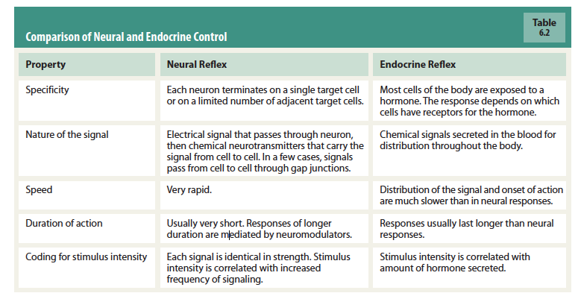

- refer to chapter summary

