ADM2337 NOTES

LECTURE 1

- HRM: the process of managing human capital to achieve an organization’s objectives.

- HRM and business strategy: HRM can help company improve employment costs and forecasting labour trends, design new ways to acquire and utilize employees.

- HRM responsibilities
- HR planning
- Recruitment/ selection
- Orientation/training
- Performance management
- Compensation and benefits.

- Competitive challenges
- Responding strategically to changes in the mareketplace.
Example of organizational responses:

Six sigma (six step), reengineering, downsizing, outsourcing.

Need to be effective at change management- for proactive and reactive change.

- Competing, recruiting, and staffing globally
- Corporate social responsibility
- Advancing HRM with technology
~big data enabled through cloud computing
~ collaborative software
~internet and social media
~from “touch labour” to “ knowledge workers”
- Containing costs while retaining top talent and maximizing productivity
~Downsizing
~Furioughing
~Outsourcing
~ Off shoring
~Employee leasing
~Productivity enhancements

- Responding to demographic and workforce diversity challenges
~Immigration
~Age and generational differences
~Gender
- Adapting to educational and cultural shifts affecting the workforce
~ Education of workforce- widening skills gap
~More diversity in culture values – needs to be reflected in policies
~Increase in employee rights and privacy

Chapter 2

-Strategic planning
~Procedures for making decisions abt the organization’s long-term goals and strategies
Human resources planning
Process of anticipating and providing for the movement of people into, within, and out of an organization.

Strategy Formulation
What is required and necessary in support of human resources?

Step 1: mission, vision, & values
Mission
The basic purpose of the organization

Strategic vision

~ a statement abt where the company is going. Futuristic

Core values
Enduring beliefs and principles that the company uses as a foundation for decisions.

Steps 2&3: SWOT analysis

Strengths
Weaknesses
Opportunity
Therstd

Step 2 External
Environmental scanning:

~economic factors
~technological changes

Forecasting : a critical element of planning
1 forecasting the demand for labour
2 forecasting the supply of labour
3.balancing supply and demand considerations

Quantitative approach: trend analysis
Forecasting labour demand based on an organizational index:

Plot historical trend
Calculate productivity ratio
Multiply productivity ratio by business factor to determine HR demand.

Qualitative approach : management forecasts

Forecasting the supply of employees:
•Staffing Tables
•Markov Analysis
•Skill Inventories & management
•Replacement Charts
•Succession Planning

Determine Human capital readiness

Gap analysis:
Demand for employee
Supply of employee =GAP

Step 5: Strategy implementation

Talking action: reconciling supply and demand
- a labour surplus exists when the internal supply of employee exceeds the organization’s demand.
- A labour shortage exists when the internal supply of human resources cannot meet the organization’s needs.

Labour surplus…..

A labour suplus exists when the internal supply of employees exceeds the organization’s demand
- employers may respond with:
- hiring freeze

Labour shortage….

A labour shortage exists the internal supply of human resources cannot meet the organization’s needs.

Employers may respond with:
1.overtime
2. Hiring temporary employees
3. External recruitment
4. Transfer

Step 6: evaluation and assessment
Evaluation and Assessment Issues
–Benchmarking: The process of comparing the organization’s processes and practices to those of other companies.

–Human capital metrics
•Assess aspects of the workforce.
–HR metrics
•Assess the performance of the HR function itself.

Lecture 2 chapter 3

- Multiple legal jurisdictions for employment/ labour law
~ provincial/ territorial employment laws govern 90% of Canadian workers.
~ Federal laws govern 10% of workers- the federal civil service, crown corporations and agencies, transportation, banking and communications.

- Legal framework for employment law in Canada
~Constitutional law : charter of right and freedom
~ Legislated Acts of parliament
~Regulations: aid in the interpretation of laws – regulatory bodies human rights commissions, ministries of labour
~Common law :
- Major forms of employment legislation

- Employment/labour standards legislation
~ Establish minimum employee entitlements
Wages, paid holidays and vacation, parental leaves
- EX: Ontario –

- Human right: the Charter of right and freedom (1982) . Guarantees fundamental freedoms to all Canadians
~ section 15 guarantees the right to : equal protection and equal benefit of the law without discrimination, and in particular.

- Human right and discrimination
~ every employer is affected by HR legislation
~Broad application; supersedes other contracts.: federal employees

- Systemic vs. Intentional
~ Systemic: employment criteria that have the effect of discriminating on prohibited grounds but are nit used with the intent to discriminate.

~Intentional 故意的: deliberate use of race, religion or other prohibited criteria in employment devisions.

- Reasonable accommodation: adjustments in job content and working conditions that an employer may be expected to make in order to accommodate a person protected by human right provisions.
- Undue hardship: human rights legislation mandates employers must accommodate to the point of “undue hardship”.

“Undue hardship” refers to the point where the financial cost or health .

- BFOR/BFOQ: a justified business reason for discriminating against a member of a protected class.

EX: a social service organization serving people who are deaf, deafened or hard of hearing may be allowed to prefer a community liaison officer who has a hearing disability.

-Harassment 骚扰: unwelcome behavior that demeans, humiliates, or emhattasses a person and that a reasonable person should have known would be unwelcome…….e.g BULLYING:
~ Employer’s responsibility to protect employees from harassment.

D.F Sexual harassment: unwelcome sexual advances, requests for sexual favours, and other physical and verbal contact of a sexual nature in the workplace.

-Harassment policies: to reduce liability and encourage a respectful workplace employer should:
1. Establish sound anti-harassment policies-respectful workplace and climate

- Employment equity:1. Federal employment equity act (1995) 2.based on charter of rights and freedoms 3. More proactive approach needed.
- Employment equity designate groups: woman, visible minorities, people with disabilities, aboriginal
- THE employment equity act:
~ Organizations regulated under the Canada labour code: prepare an EE plan.
~ Federal contractors program:
- The Implementation of Employment Equity in Organizations

- Step 1: Senior Management Commitment and Assignment of Accountable Senior Staff

- Step 2: Data Collection and Analysis
•Stock data
•Flow data
•Self Identification Form

Step 3: Employment Systems review
•Systemic discrimination
•Special measures
•Reasonable accommodation

Step 4: Establishment of a Work plan

Step 5: Implementation

Step 6: Evaluation, Monitoring and Revision

- Pay equity: It is illegal to discriminate on the basis of job content.
~ Based on 2 principles: 1. Pay equity 2. pay equality.

- Diversity management
~ Broader/ more inclusive than employment equity.
~ a set of activities designed to : 1. Integrate all employees in a multicultural workforce. 2. Use diversity to enhance the organization’s effectiveness.

Business reasons for diversity management?
* Better utilization of talent *increased marketplace understanding *enhance creativity

CHAPTER 4

-Job analysis
~Process for obtaining info about jobs by determining the tasks. Duties and activities

Job Description
•A statement of the tasks, duties, and responsibilities of a job to be performed

Job Specification
•A statement of the needed knowledge, skills, and abilities of the person who is to perform the job

-Methods of Collecting Job Analysis Information
~Interviews (individual, group, supervisory)
~Questionnaires
~Observation
~Participant Diary/Log

-NOC
~Reference tool for writing job descriptions and specifications
~Compiled by the federal government
~Contains comprehensive, standardized descriptions of about 30,000 occupations and the requirements for each.

(O*NET ONLINE ) job research

-Approaches to job analysis
Position Analysis Questionnaire nquestionnaire used to collect quantifiable data concerning the duties and responsibilities of various jobs nvery structured job analysis questionnaire which contains 194 items

~CRITICAL INCIDENT METHOD

~TASK INVENTORY ANALYSIS

- Competency based job analysis
~¨Traditional job descriptions (with their lists of specific duties) may actually backfire if a high-performance work system is your goal
~ ¨Describing a job in terms of the measurable, observable behavioral competencies an employee must exhibit to do a job well

-PAQ
~ ¨Information input
~¨Mental processes
~¨Work output (physical activities and tools)
~¨Relationships with others
~¨Job context (physical and social environment)
~¨Other job characteristics (pace and structure)

-Products of job analyses

~Job Title
•Indicates job duties and organizational level

~Job Identification Section
•Distinguishes job from all other jobs

~Job Duties, or Essential Functions, Section
•Indicate responsibilities entailed and results to be accomplished

~Job Specification Section
•Skills required to perform the job and physical demands of the job

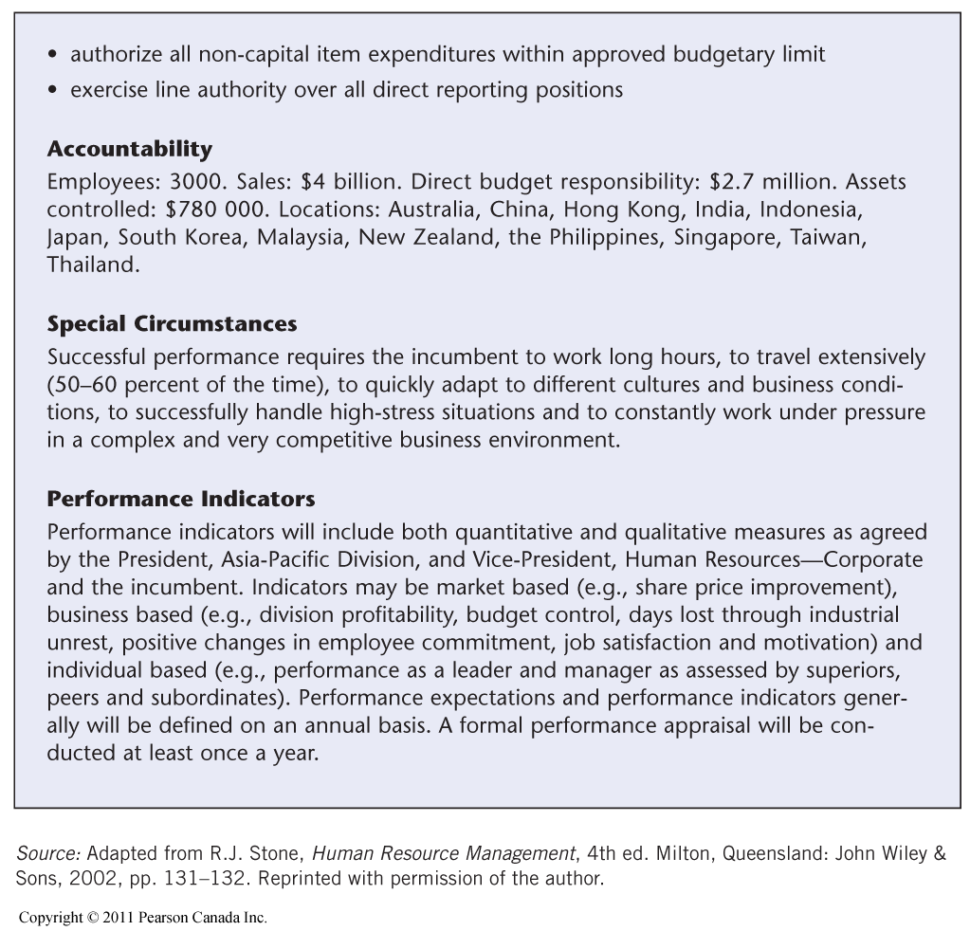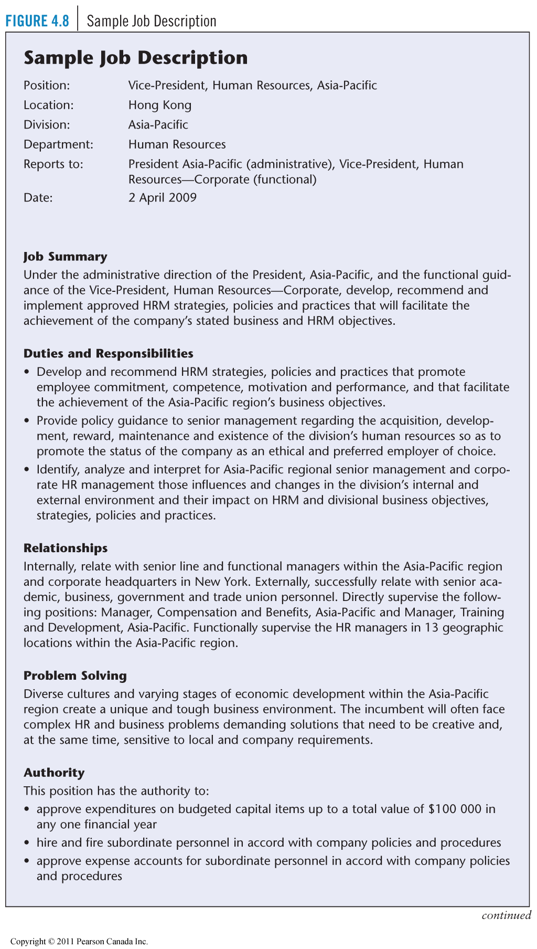

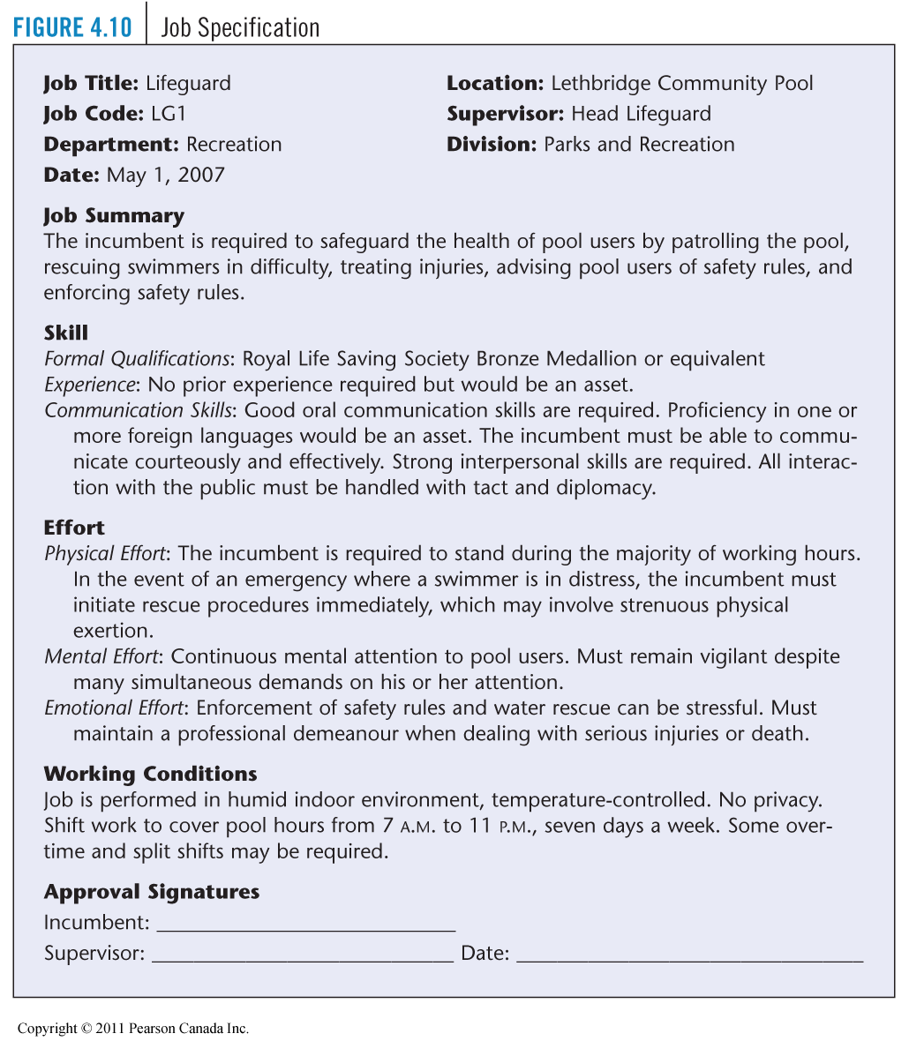

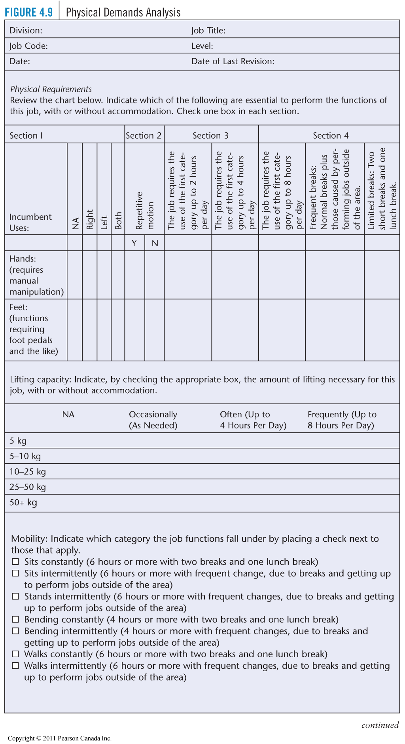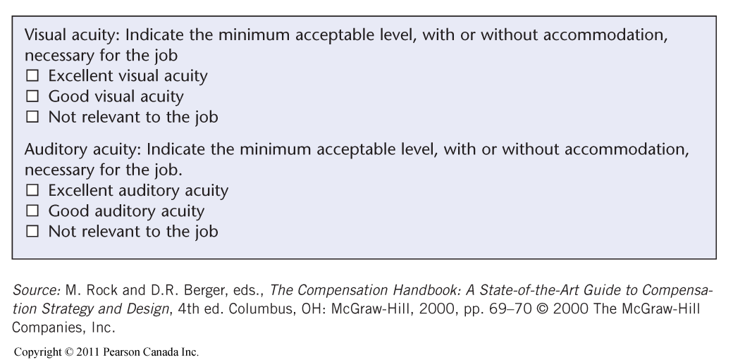

- Problems with Job Descriptions
- 1.If they are poorly written, using vague rather than specific terms, they provide little guidance to the jobholder.
- 2.They are sometimes not updated as job duties or specifications change.
- 3.They may violate the law by containing specifications
not related to job success.
- 4.They can limit the scope of activities of the jobholder, reducing organizational flexibility.

- Poorly written, little guidance
- Not updated in time
- Contain not job-related requirement
- Reduce flexibility

- Job design:
~ •An outgrowth of job analysis that improves jobs through technological and human considerations to enhance organization efficiency and employee job satisfaction.

Basis for Job Design

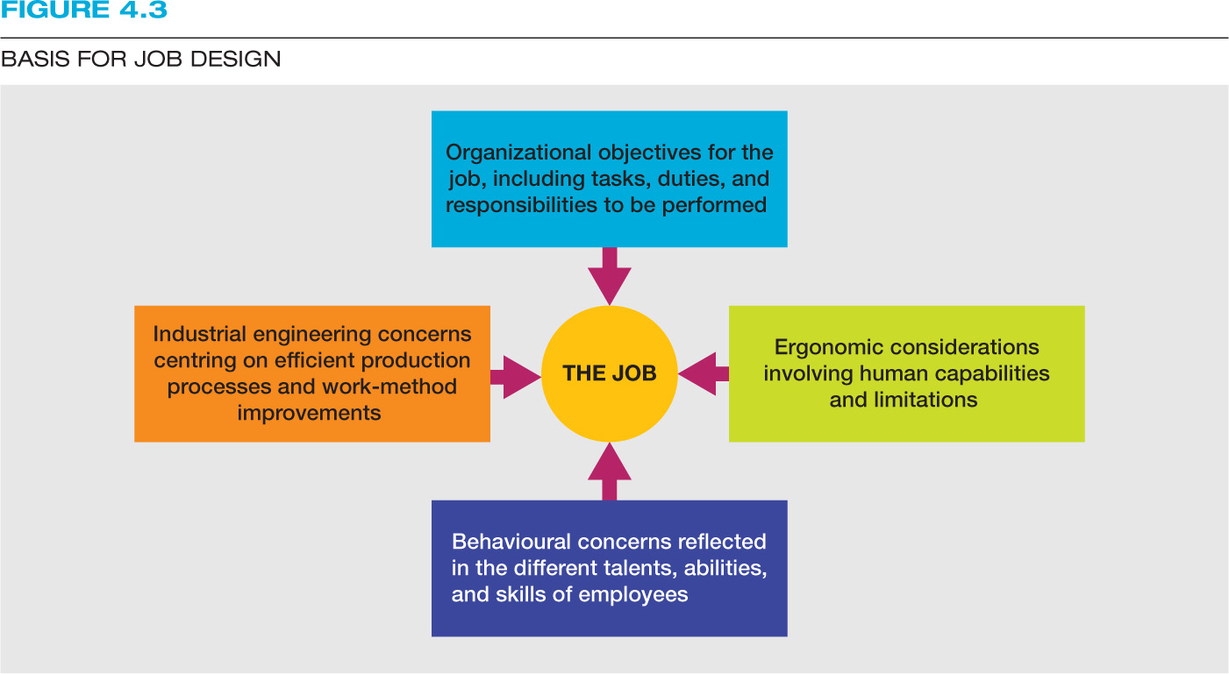

Chapter 5: recruitment
- The strategic aspects:
- Why is recruitment strategically important to the org?
-Human talent is critical to high org, performance

- Who Should Do the Recruiting?
•HR recruiters or generalists (large firms)
•Managers and/or Supervisors (smaller firms)
•Work Teams

•Recruiting Process Outsourcing (RPO)
–The practice of outsourcing an organization’s recruiting function to an outside firm.
- Internal recruitment:
ADV:
Company can capitalize on investment made
- Readily available
- Get up to speed faster
- Less uncertainty about their performance
- No advertisement costs
- Through HRIS, job posting, and bidding

DISADE:
-Discontent of unsuccessful candidates and time consuming.
-Dissatisfaction with insider as new boss
-Inbreeding
-Existing talent pool is limited
-May gain info from rivals.

- Internal recruitment methods:
- Job posting
- Performance appraisals (9-box Gird) GE.
- Skill inventories and replacement charts.

- External recruitment:
ADV:
- Larger, more diverse pool
- Assists in EE goals
- Acquisition of new skill/ deduced need for training
- Elimination of employee rivalry and competition.
- External recruitment methods:
- The internal, social networking and mobile recruiting (passive job seekers, beware the digital divide)
- Advertising
- Walk-ins and unsolicited 主动提供的 applications and resumes.
- Open houses and job fairs.
- Employee referrals.
- Re-recruiting.
- Executive search firms. (“Headhunters”)
- Private employment agencies and temporary agencies.
- Public employment agency
- Educational institution: career center
- Professional associations
- Labor unions
- Employee leasing – by professional employer organizations (PEO’S)

- Improve effectiveness of recruiting:
Surveys:
-Managers’ satisfaction- quality, time
-New hires/ candidates

Realistic job previews
-Inform the applicants about al aspects of the job, including less desirable aspects.
-RJP’S – better job satisfaction, lower turnover.

Metrics
-Provides feedback on the effectiveness of the recruiting strategy.

- Metrics- quality- of –fill:
•Quality of Hire = (PR + HP + HR) / N
–PR = Average job performance rating of new hires
–HP = % of new hires reaching acceptable productivity with acceptable time frame
–HR = % of new hires retained after one year
–N = number of indicators

- Metrics: costs of recruitment
SC/H=AC+AF+RB+NC/H
SC = source cost
AC = advertising costs, total monthly expenditure (example: $32,000)
AF = agency fees, total for the month (example: $21,000)
RB = referral bonuses, total paid (example: $2,600)
NC = no-cost hires, walk-ins, nonprofit agencies, etc. (example: $0)
H = total hires (example: 119)
Cost to hire one employee = $467.23

- Career Management: Developing Talent over Time
-Career development: a dynamic process that matches individual and organizational needs.

- Identify career opportunity + requirements
•Begin with a competency analysis
•Identify job progressions and career paths
•Track career stages

- Recognize Different Career Paths

•Promotion: a change of assigned to a job at a higher level in the organization.
•Transfer
•Consider Dual Career Paths for Employees
•Consider the Boundary less Career
•Help Employees Progress beyond Career Plateaus

- Career Development Initiatives

•Career Planning Workbooks and Workshops
•Career Counseling
•Mentoring
•Networking
•Career Self-Management Training

mid-term
- 1-6 chapter
- 7 questions, select 6.
- All short answer. (No multiple choice)

Chapter 6.

- The process of choosing among qualified individual who have been recruited to fill existing or projected job opening.
- Initial applicant screening:
- Typically preformed by HR
- Candidates not meeting essential selection criteria are eliminated first.
- Candidates who most closely match the job specifications are given further consideration
- Use of technology-increasingly popular to improve the initial screening process

- Employment interviews:
- Type of questions: traditional/general –getting to know you questions, icebreakers, understanding your personality questions. –Success depends on your responses as well as on the rapport you build with the interview.
- Situational
- The interviewer gives you a hypothetical situation and asks how you would react.
- Success depends on the appropriateness of your anticipated.
- Phone interview tips: keep paper and pens, a copy of your resume, and a list of the jobs you have recently applied for neat the phone. Be conscious of your tone of voice and try to avoid ling pauses.
- Skype interview tips: dress professionally and prepare your surroundings, as employers will be paying attention to the details that are available. –Practice the process with someone in advance.
- Panel interview tips: focus primarily on the person who asked you the questions; however, you also need to make.
- Groups interview tips: try to stand out from the crowd without stealing the spotlight and overpowering the group. –Be conscious of how you are interacting with the other members of the group.
- Stress interview tips: try to stay focused and calm.
- Case interviews: the employer wants to see how you approach a problem and how you break down a complex situation into logical components.

- Guidelines for employment interviewers:
- Interviewer training: practice makes perfect, beware of perceptual biases.
- Employment equity: are your question legal? All jurisdictions forbid direct questions about race, sex, age, colour, religion, and national origin.
- Post-interview screening:
- Reference checks
- Background check
- Credit check
- Pre-employment tests
Standardized measure of behavior used to measure a person’s KSAOs relative to other individuals, might have legal problems
- Job knowledge test
- Work sample test: part of the work (以上两个用来测量能力)
- Assessment center test: process to evaluate candidate as they participate in a series of situation (manager)
- In-basket exercise: 对case做决定并安排重要程度
- Leaderless group discuss: initiative主动性, leadership skills, group work
- Role-playing: customer meeting
- Behavioral interview: “这种情况下你会怎么做”
- Cognitive ability test 认知能力测试: mental capacity, intelligence, reasoning ability, verbal fluency; specific
- Bio data test: biographical 传记的, use past behavior predict future behavior
- Personality and interest inventory
- Extroversion 外向
- Agreeable
- Conscientious 勤奋的
- Neuroticism 敏感的
- Openness to experience: insightful, creative, curious

- Obtaining Reliable and Valid Information
- Reliability: The degree to which interviews, tests, and other selection procedures yield comparable data over time

- Validity: The degree to which a test or selection procedure measures a person’s attributes

Chapter 7

- Conducting the needs assessment
~organization analysis
~Task analysis
~Person analysis

- Designing the training program
- Instructional objectives: represent the desired outcomes of a training program. Should be SMART:
- After completing training, participants should be able to: successfully resolve a basic customer inquiry 2 minutes. Use active listening techniques to respond to a customer inquiry. Follow the standard telephone script, without error.

