BIOL 1001 Learning Objectives for the Second Midterm

Natural Selection

Instructor materials Lecture 5a and 5b. Pages 55-58

- Argue how population thinking as opposed to typological thinking coincides with Darwinian, as opposed to Lamarckian, Evolution [Comprehension]

Typological Thinking; the idea that species are unchanging types and that variations within species are unimportant or even misleading
Population Thinking; variation among individuals in a population was the key to understanding the nature of the species
Darwinian Evolution; Changes happen in populations as opposed to individuals.
- Individuals change in response to changes in the environment.
- Individuals with changed traits have increased reproductive fitness.
- Those individuals with higher fitness, their alleles become more frequent in the population
This is because desirable traits, those that increase fitness populate the gene pool – the allele frequencies change – within populations and hence populations not individuals change.
Lamarckian Evolution; important evolutionary changes occur in individuals
- Individuals change in response to changes in the environment.
- Changed traits, as result of (1), are passed onto offspring
- Acquire features as required become larger and more complex. Species change throughout time by the inheritance of acquired characters

Population thinking coincides with Darwinian Evolution in the sense;
Variation amongst individuals is looked at through the population. The changes within individual members can cause changes to populations, in fact population change not individuals, thus making the variations amongst individuals important. In contrast Typological thinking argues species remain unchanged.
Population thinking and Lamarckian Evolution;

- Identify the 4 major p-prims that interfere with the intellectual absorption of the concept of natural selection [Comprehension]

P-prims: “phenomenological primitives”; Highly automatic, intuitive, and shallow processing components that are used for cognition AKA “folksy knowledge”, common knowledge, intuition, common sense, time-tested explanations that work… Yet they are incorrect

Observations | Inference | Fallacy
First: For all species, populations have the capacity to increase exponentially considering the number of individuals born or produced

Second: Resources (food, space, nest sites, etc.) are finite

Third: Despite this over-production, and because of resources limitations, most populations remain relatively stable over long periods

 | leads to a struggle for existence among individuals of a population…  …with only a fraction of their offspring surviving [ Mayr’s 1st inference] | Fallacy A: Somebody is in charge; Anthropomorphic Thinking – “a higher being/force orchestrating change”  Example; Everyone know that the theory of natural selection does not invoke Mother Nature, but people still have an indistinct notion that there is a natural force at the helm
Fourth: Members of a population vary extensively in their characteristics no two individuals are exactly alike (typological) |  | Fallacy B: The needs of an organism will generate evolutionary solutions – evolve traits as needed; Teleological Thinking – Lamarckian Thinking - When we need something we “make” it
Fifth: It is obvious that much of the variability we see is heritable  Children resemble their parents and siblings resemble each other |  | Fallacy C: The process drives towards complexity and perfection; Progressive Thinking - We are the end-point
 | Individuals whose inherited traits give a high probability of surviving & reproducing …  …are likely to leave more offspring than other individuals [ Mayr’s 2nd inference] | Fallacy D: An entire population transforms uniformly as it adapts; Typological Thinking – Humans categorize items into groups, and we are inclined do so with organisms
 | AND SO, the gene pool changes accordingly [Mayr’s 3rd inference]

Fallacy A: Somebody is in charge; Anthropomorphic Thinking – “a higher being/force orchestrating change”
Example; Everyone know that the theory of natural selection does not invoke Mother Nature, but people still have an indistinct notion that there is a natural force at the helm
Fallacy B: The needs of an organism will generate evolutionary solutions – evolve traits as needed; Teleological Thinking – Lamarckian Thinking - When we need something we “make” it
Fallacy C: The process drives towards complexity and perfection; Progressive Thinking - We are the end-point
Fallacy D: An entire population transforms uniformly as it adapts; Typological Thinking – Humans categorize items into groups, and we are inclined do so with organisms

“When employing explanations using natural selection, I won’t resort to…
(a) … invoking Mother Nature or some other entity as orchestrating change; Anthropomorphic Thinking
(b) … arguing that because a species “needs” some adaptation it will be so; Teleological Thinking
(c) … explaining patterns by thinking of progress towards perfection; Progressive Thinking
(d) … ignoring the fact that members of populations are variable. Typological Thinking

Given a piece of text or other information that contains faulty thinking about natural selection, identify which p-prim is involved [Application]

- Explain why evolution is not progressive (e.g. not moving towards “perfection”), and why natural selection is non-random. [Comprehension]

Evolution is not goal oriented, and not progressive. Adaptations do not occur because organisms “will” or “want” them to, they happen at random (remember, acclimation means to change in response to environment, where as adaptation means to change with respect to alleles). Progressive means to move forewords, in the case of natural selection it would imply to become more complex (traits), however this is not the case. As already mentioned, changes at the DNA level (allele) happen randomly; If this mutation is a good mutation it helps increase chances of survival) that the organism sees an increased reproductive fitness, which in turn results in the frequency of that particular allele increasing. Over time complex traits amongst populations may be lost or gained, there is no pre determined or absolute value about this tendency.

- Explain categories of constraints on evolution by natural selection [Comprehension]and be able to assign such categories to examples [Application]

Polygenetic Inertia; unchanged evolutionary history
Nonadaptive Traits; Vestigial traits exist for the simple reason “our ancestors had them so do we...” they do not increase reproductive fitness.
Historical Constraints: Imperfect Structures traits evolve from pre existing traits. Evolution can only act upon existing structures and or functions. Structures despite that change would make them better are impervious to change.
Genetic Constraints; evolution can ONLY happen upon existing alleles.
Genetic Correlation: Pleiotrophy; Genetic variations can affect an array of traits.
Imperfect Solutions; as evolution acts upon populations, only those mutations that increase fitness are passed along and as a result diseases )ex. Sickle cell)
Tradeoffs Constraints; selection acts upon many traits at one and thus every adaptation is a comprise
Example: bigger body may lead to a alpha individual but at the same time will the individual require more food to survive.

- Describe how an organism’s phenotype represents a compromise or “trade-off” between the adaptive value of multiple traits [Knowledge, Comprehension]

Tradeoffs Constraints; selection acts upon many traits at one and thus every adaptation is a comprise
Example: bigger body may lead to a alpha individual but at the same time will the individual require more food to survive.

Other forces leading to Allele Frequency Changes Microevolution

Instructor materials Lectures 7 and 8 and textbook pages 65, 73-76 (drift), 77-78 (flow), 78-80 (mutation), 80-83 (non-random mating)

- Define,describe, and distinguish amongthe agents of microevolutionary change: mutation, gene flow, genetic drift (including small population events--founder effect and genetic bottleneck), and natural selection, as well as non-random mating. [Knowledge, Comprehension]

Word | Definition
Mutation | Mutations cause random changes in genes with respect to fitness, restores genetic diversity by creating new alleles. Most mutations are bad as most organisms are already well adapted to their surroundings and thus mutations result in products that do not work as well as the already existing alleles deleterious alleles (alleles that lower fitness). Deleterious alleles are eliminated through purifying selection.  1 in every 10000 gametes is mutated. 1 in every 5000 individual will carry a gene mutation. 100+ mutations per generation.
Point mutations | change a nucleotide base, that often prescribes a different amino acid, changing the protein product
Chromosomal mutations | Mutations in the chromosomal duplications usually resulting in deleterious alleles (alleles that lower fitness) in turn diseases/syndromes . Mostly bad.
Gene Flow | Gene flow is the transfer of alleles between populations (Immigration in, Emigration out) happens when individuals migrate from one population to another and breed. It increases similarities of allele frequencies between source and new population. It tends to equalize allele frequencies between source and recipient populations. Gene flow is random with respect to fitness, it can reduce or increase reproductive fitness, but movement of alleles between populations always tends to reduce genetic differences between them.
Genetic Drift | Change in allele frequency due to chance, random (sampling error; occurs in meiosis and subsequent fertilization of all sexual species), does not lead to adaptation (as the changes are not influenced by environment, but merely by chance, as a result contrary to natural Selection genes that lessen reproductive fitness may increase in frequency) and is undirected. From one generation to the next. Leads to fixation/lost genes.
Genetic Drift; Small Population Effects | GD is prominent in small populations as the results are seen more quickly. The small population can have so few copies of “x” alleles that loss of a few individuals removes those variations from the gene pool entirely leading to “lost” alleles.  In large populations the random changes in allelic traits generally cancel out statistically. Losses of individuals by random means will not selectively remove any single expressed trait or nonphenotypic allele.
Genetic Drift; Founder Effects | Few individuals initially part of larger population become isolated and may form a new population. However these are generally small population with little genetic variability to begin with and as a result are susceptible to Small population Effects. In the first generation, all the flowers are there, but for some reason, all the red flowers grew far away from the rest of the flowers. Now, in the main patch of flowers, we can have pink, white, and red flowers, because all the alleles are there, but in the red flower patch, there is only one color, because that patch only has red alleles.
Genetic Drift; Genetic Bottleneck Effect | Population bottlenecks occur when a population’s size is reduced for at least one generation. Because genetic drift acts more quickly to reduce genetic variation in small populations, undergoing a bottleneck can reduce a population’s genetic variation by a lot, even if the bottleneck doesn’t last for very many generations. Reduced genetic variation means that the population may not be able to adapt to new selection pressures, such as climatic change or a shift in available resources, because the genetic variation that selection would act on may have already drifted out of the population.
Natural Selection | Change in allele frequencies over time. Directed by environment Favoured alleles increase fitness and leads to adaptation
Non-Random Mating  -inbreeding  -assortative & -sexual | In order for two different species to interbreed, they must be closely related.. Non-Random mating doesn’t change allele frequencies, but it does alter genotype frequencies. Sometimes it affects both allele and genotype frequencies (sexual selection) but sometimes it only affects genotype frequencies (assortative mating, inbreeding). Can change genotypic frequencies but not evolutionary changes.
Inbreeding | Breeding within ones family/relatives. (a) Inbreeding increases homozygosity, and (b) Inbreeding does not cause evolution; allele frequencies do not change (although genotype frequencies are not in equilibrium). Can change genotypic frequencies but not evolutionary changes.
Assortative Mating | Choosing mates based on particular phenotypic (visible) traits. Can change genotypic frequencies but not evolutionary changes.
Positive Assortative Mating (disruptive selection & Inbreeding) | Choosing mates that share similar phenotypic (visible) traits as themselves (or family).
Negative Assortative Mating ( | Choosing mates that have different phenotypic (visible) traits as themselves.
Sexual Mating | Individuals within populations differ in their ability to attract mates, favouring individuals that have traits that enhance ability to attract mates (ex. Looks). Genetic adaptations related to reproduction are favoured. Females have more of a preference to choose as their investment is greater (fundamental asymmetry of sex).
Directional Selection | Allele frequency moves towards a particular trait  Reduction of genetic variability... favoured alleles move towards 10. Frequency to become “fixed”, while the others reach a frequency of 0.0 or “lost.”
Stabilizing Selection | Reduction of allele variation within population; variation in a trait.  Bell curve become squished
Disruptive Selection | Selection favours the extreme trait values over the average trait values, eliminating average traits as opposed to extreme (normal). In this case the variance increases as the population is divided into two distinct groups. Disruptive selection plays an important role in speciation.
Balancing Selection | any pattern of selection where no single allele has a universal advantage (it may at times have a temporary advantage)

- Explain how the significance of drift is largely dependent upon population size [Knowledge, Comprehension]

Genetic Drift is the change in allele frequency due to chance, random (sampling error; occurs in meiosis and subsequent fertilization of all sexual species), does not lead to adaptation (as the changes are not influenced by environment, but merely by chance) and is un-directed. From one generation to the next. It leads to fixation/lost alleles. In smaller populations drift leads to the loss of heterozygosity, decreases genetic variability and increases genetic differences within populations.

It is more pronounced in smaller populations. In smaller populations the sampling error is large.

As allele frequencies fluctuate up and down sooner or later one allele will hit a frequency of 0 and become “lost” while the other will hit 1 and become “fixed” at that locus. In a small population due to a few changes (such as accidental deaths) over 1 generation, an entire allele can be lost, where as in a larger population the same number of deaths over 1 generation, the frequency of the allele might just decrease. Given enough time, even in large populations alleles can be lost and or become fixed.

- Identify, given a scenario, the outcome of a small population event. [Comprehension, Analysis]
- Connect the significance of the Lenski experiment for the interaction of mutation and natural selection [Comprehension]

Lenski Experiment (February 24, 1988) looked at Bacterium Escherichia coli. To this date Lenski lab in Michigan has watched population change in lineages of over 50,000 generations (close to 60,000) . E. coli used reproduced asexually and thus mutation was the only clause of genetic variation. Both selection and genetic drift occurred. Every 10000 generation, a portion of the culture was frozen as a timekeeping fossil. It was latter thawed and compared to a “mutated” variant of the bacteria using a colour indicator to differentiate the two generations. The one that multiplied the fastest was said to have a higher fitness rate. Thus this concluded (a) mutation is the ultimate cause of genetic variation, as it is the only process hereby which new alleles are created. (b) Without mutation evolution would stop, this is because while genetic drift and natural selection eliminate alleles, mutation creates new alleles restoring genetic diversity. It provides something for genetic drift and natural selection to act upon. Stopping mutation would prevent new alleles from being formed but natural selection would still act on all existing alleles and cause evolution as the fittest individuals reproduce the most. Eventually less successful alleles will disappear until only one allele for each gene is left (as a result of selection and random genetic drift); once that has happened no evolution occurs anymore. Without mutations no fitness increase would have been observed in the E. Coli. (c) Mutation alone is negligible in changing allele frequencies at particular genes as the mutations upon genes are so very little. However combined with natural selection it becomes important as it is the basis of new alleles, alleles that could increase fitness.
NOTE: There is a ‘famous’ moment in about generation 33,000 when a mutation allowed one of the 12 populations to metabolize (i.e. use as food) citrate. The citrate had been in the nutrient broth all along and it was there to neutralize ions, and couldn’t be used as food by the original populations. This new strain was wildly successful with highly elevated fitness, and it has remained successful ever since, chomping away on citrate, which its ancestors could never do

- Explain the phenomenon of inbreeding and its consequences for zygosity [Knowledge, Comprehension]

Two fundamental points of inbreeding; (a) Inbreeding increases homozygosity, effectively taking alleles from heterozygotes and (statistically) packaging them into homozygotes and (b) Inbreeding does not cause evolution; allele frequencies do not change (although genotype frequencies are not in equilibrium). It is mating among relatives and as a result genotype frequencies change but not allele frequencies. This is because no new alleles are introduced into the family. Inbreeding increases the likelihood of homozygosity in each generation. That means less genetic variability and a greater likelihood that hidden recessive alleles (that might be bad) will show up in a homozygous state. As the homozygosity increases a decrease in fitness is observed, this is referred to as inbreeding depression. Inbreeding depression results from (a) Many recessive alleles represent a ‘loss-of-function’ mutations. Most mutations produce less effective or dangerously defective proteins, however these are generally harmless in heterozygotes. Due to inbreeding homozygosity increases causing for decrease in fitness, an increase in (bad) syndromes and diseases (handicapped and mental disorders). (b) Many genes (especially disease-fighters) are under selection for heterozygosity; the more allele types, the greater the disease-fighting arsenal. Essentially individuals who are heterozygotes have a stronger chance to fight diseases, such as sickle cell Malaria. With inbreeding allele frequencies (and types) decrease as the same alleles are passed down over and over. As a result homozygosity increases and fitness declines.
With continued inbreeding, recessive, delirious genes surface. This is due to the increase in homozygosity (stemming from the inbreeding). As a result, these individuals are unable to manufacture offspring (due to assortative and sexual mating) and thus inbreeding increases the rate at which purifying selection eliminated delirious genes... It doesn’t on its own change allele frequencies, but, by disproportionately creating homozygotes, it exposes recessive alleles to natural selection It facilitates and even accelerates purifying selection

- Explain the phenomenon of assortative mating and its consequences for independence of gene pools [Knowledge, Comprehension]
Assortative Mating is choosing mates based on particular phenotypic (visible) traits. This process can change genotypic frequencies but not evolutionary changes. Positive Assortative Mating (disruptive selection) is choosing mates that share similar phenotypic (visible) traits as themselves (or family). This causes an increase in the number of homozygous genotypes (AA and aa) and a corresponding decrease in the number of heterozygous (Aa) ones in a population. Increased homozygosity results in lower fitness. Negative Assortative mating is choosing mates that have different phenotypic (visible) traits as themselves. As a result of this a progressive increase in the frequency of heterozygous genotypes (Aa) and a corresponding decrease in homozygous (AA and aa) is seen.

Sexual Selection

Instructor materials Lecture 9 and textbook pages 83-88, 223-224

- Explain how sexual selection is a special case of natural selection [Knowledge, Comprehension]
Sexual selection is a subset of natural selection where the selective forces are the reproductive features and behaviours of conspecifics. It acts on an organism's ability to obtain (often by any means necessary!) or successfully copulate with a mate. Sexual selection is often powerful enough to produce features that are harmful to the individual’s survival. For example, extravagant and colourful tail feathers or fins are likely to attract predators as well as interested members of the opposite sex. “eggs (female) are expensive, sperm (male) is cheap.” It is responsible for phenotypic differences between males and females.
- Connect sexual selection patterns with the foundation of disparity in reproductive investment [Comprehension]
“eggs (female) are expensive, sperm (male) is cheap.” It is responsible for phenotypic differences between males and females.

Disparity in reproductive investment;
Difference in gamete sizes (sperm is tiny compared to the egg)
Parental involvement (female invests a lot of time)
Difference in resources donated to mates

Sexual Selection Patterns;
Males; fitness is characterized through how many mates they have
Females; fitness is characterized through mates quality.

Sexual Selection Theory;
- As female’s investment in offspring’s are greater they have a right to be choosy with whom to mate. As a result males, as their investment is so little should be willing to mate with any female.
  - Investment includes size of gametes
  - Parental care; time invested
  - resources provided directly to mates
- If Male to females are equal, than males will compete for mates (male to male competition) as they want MANY offspring’s. However a female can’t have many offspring (at extreme most 10) therefore males will want to take many mates in order to increase their fitness.
- Male fitness is limited by how many mates they have. Alleles that increase male’s attractiveness in the eyes of females should increase rapidly in population (as these individuals will copulate more). Hence sexual selection should act more strongly upon males than females.
As a result of males having lower parental investments/ donations where as females have high parental investments/ donations, the reproductive rate of males is very high compared to females. Males can sire an almost unlimited amount of kids (sperm) resulting in very high sexual activities where as females have lower sexual activities as they invest a lot of time for the sake of one child (for a male it may only take a few seconds to ejaculate and impregnate the female, she than has to carry the baby to term, give birth, nurse and raise it). Thus females have a right to be choosy with whom to mate, where as males have to compete for their mate. And hence the male’s fitness is characterized by how many mates he has where as the females’ fitness is characterized via the mates quality.

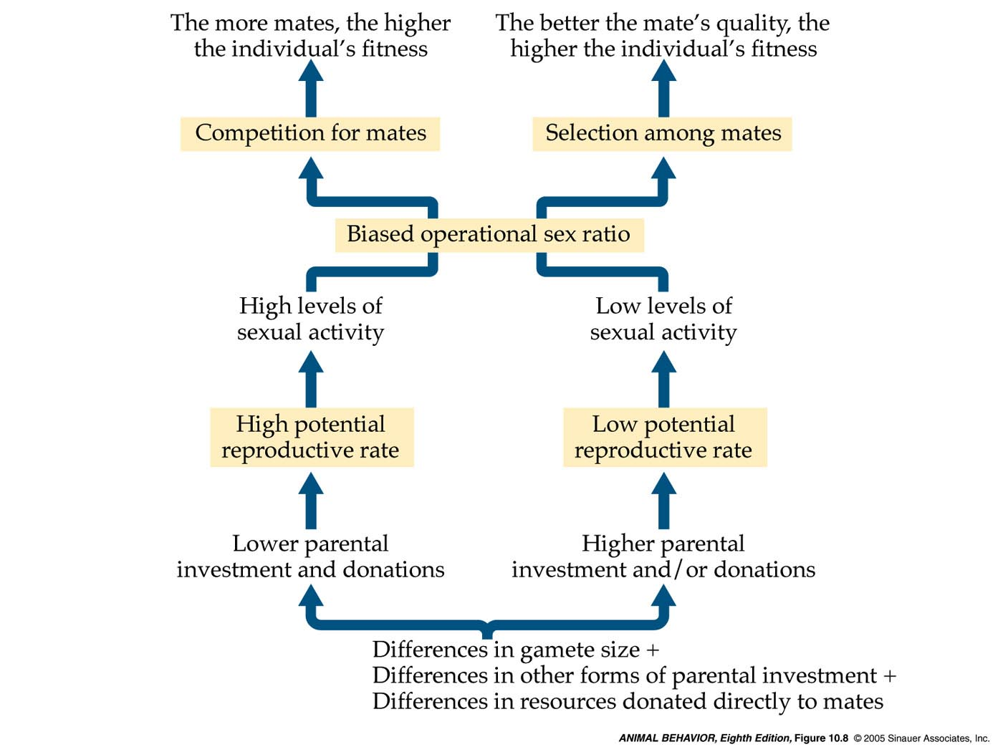

Natural (Sexual) Selection
- Organisms overproduce
- Yet populations generally stay stable
- The availability of females is finite (resources changes to availability of females)
1st inference: Struggle for reproductive success (existence changes to reproductive success)
- Individuals in a population vary in their sexual behaviours and adornments (how they vary is elaborated upon)
- Much variability is heritable
2nd inference: Those with favourable sexual traits tend to leave more offspring (favourable traits changes to favourable sexual traits)
3rd inference: The gene pool will change

- Explain why sexual selection is often strongest in males [Comprehension]
Sexual selection is a subset of natural selection where the selective forces are the reproductive features and behaviours of conspecifics. Females’ fitness is limited by time and recourses where as males’ fitness is dependent upon his access to mates. Males have to compete for mates within populations as their invest is so little. As female’s investment in offspring’s are greater they have a right to be choosy with whom to mate. A way females choose mates is based upon the heritable traits that look favourable (tall, white etc. in humans). As a result males, as their investment is so little should be willing to mate with any female. If males to females are equal, than males will have to compete for mates. However a female can’t have many offspring as the investment is so great (a lot of time) therefore males will want to take many mates in order to increase their fitness. Females use the “good allele” method to choose their mates –those who look healthy will probably sire healthy offspring. As a result alleles that increase male’s attractiveness in the eyes of females should increase rapidly in population (as these individuals will copulate more). Hence sexual selection should act more strongly upon males than females. More generally, sexual selection acts more strongly on the sex making a lower investment in reproduction as they will have to be “chosen.”

- Distinguish male and female Bateman-Trivers graphs [Comprehension]
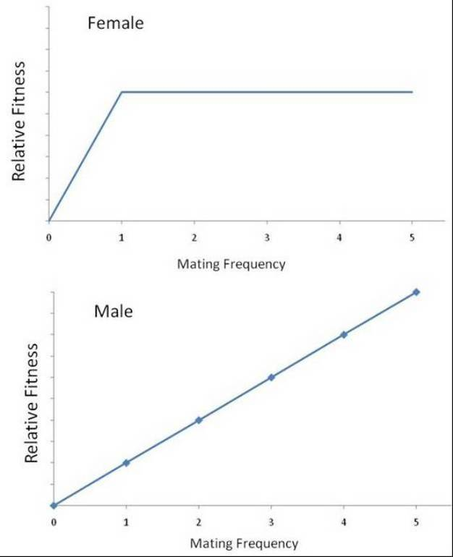
- Distinguish between the two major categories of sexual selection, mate choice (intersexual selection) and competition (intrasexual selection) [Knowledge, Comprehension]
Competition (intrasexual selection); male to male competition to impress female.
Selective force (stressor); conspecifics (members of the same species) males.
Mate choice (intersexual selection); actually being selected by the female – the relationship between genders
“Behaviors between sexes in which the choosing sex (usually the female) selects a partner from the other sex (usually the male)”
Commonly make choices based on;
- Physical characteristics signaling the genetic quality of the male such as colour, adornments, displays, performance, etc. which don’t seem adaptive for survival.
- Resources or parental care provided my males
- both
Selective force (stressor); conspecifics (members of the same species) females.

- Describe the “good genes (alleles)” hypothesis, and give examples of male traits or behaviours to explain this hypothesis. [Knowledge, Comprehension]
Good Allele based choice is basically the female wanting a partner who is healthy and well fed. This is indicative through his physical characteristics signaling the genetic quality of the male such as colour and size. Such as the colourful feathers of a bird, especially red and yellow and orange. Carotenoids (presence is indicated by the brightness of the mentioned colours) protect tissues and stimulate the immune system to fight disease. Carotenoids come from carotenoid rich plants and thus, the presence of it indicates a healthy and well fed male.
Anthropomorphic view; “I’m healthy and well fed because I have good genes. Mate with me”

- Describe the “good resources” hypothesis (e.g. paternal care, nuptial gifts) and give examples of male traits or behaviours to explain this hypothesis. [Knowledge, Comprehension]
Good resources translate into good parenting or good opportunities for parenting.
In populations where male to male competition is not the only determent of whom the female mates with, she may consider;
- Physical characteristics signaling the genetic quality of the male such as colour, adornments, displays, performance, etc. which don’t seem adaptive for survival.
- Resources or parental care provided my males
- Both

Good resources; includes (but not limited to) A nest site, A territory from which other competitors are excluded etc. (anything of utility for achieving fitness).
Parental Care; Males help raise young/ provide parental care for them.
Example; Kiwis – The female produces a giant egg (15% of her body weight) But males take over the incubation and other parenting responsibilities. These arrangements help balance out the fundamental asymmetry in reproductive investment between the sexes
Example; Birds who have complex songs are preferred over birds whose songs are average. These males bring more food to their offspring, which grow bigger (‘good resources’).They are less like to suffer from inbreeding or excessive homozygosity (‘good genes’) as they will be preferred by many and will not have to “settle.”

- Define sexual size dimorphism and connect it to sexual selection [Knowledge, Comprehension]
Sexual Dimorphism is the phenotypic difference between genders. Sexual size dimorphism looks specifically at size difference between sexes. That sex which competes for the attention of its mate is usually bigger in size (typically it is the male that is bigger). Size is indicative of a well fed and healthy partner, and as a result those who are bigger in size have more reproductive success. (Good Allele)

- Define sexual cannibalism [Knowledge) and connect cannibalism to the concept of fitness [Comprehension]
Sexual cannibalism; is a special case of sexual selection in which the female kills and consumes the male during or after copulation.
Example; Chinese Mantis, some spiders and insects.
Chinese mantis; one study: 63% percent of the diet of the female Chinese Mantis is the male partner
Some males, by allowing themselves to be consumed, can increase the amount of time they spend transferring sperm to the female, and so fertilize more eggs and thus increase their fitness at the same time Females get nourishment for her (and his) offspring (good recourse).

- Express how sexual selection (reproduction) and ‘ecological selection’ (survival) can constitute a case of stabilizing selection [Comprehension]
In ecological selection Genetic adaptations related to survival are favoured where as in sexual selection Genetic adaptations related to reproduction are favoured. In reproductive processes, traits that are favoured increase fitness without too much of a trade off.
Example, an increase in size will allow a bird to overpower weaker males, get more food and be well fed and healthy. However if the male is too big he will require a lot of food and have to expend a lot more energy. This can result in poor health if there are not enough resources (food). Due to this extremes such as too big or too small in size will be selected against as the trade off is too much as compared to the payoff. As both sexual and ecological selection select against extreme ends due to the trade off being greater than the payoff, they constitute to a stabilizing selection

