11.1: Galvanic Cells
- Electric current is a flow of electrons in a circuit.
- Electrochemistry is the study of the processes involved in converting chemical energy to electrical energy, and vice versa.
- A galvanic cell also called voltaic cell is a device that converts chemical energy to electrical energy.
- A galvanic cell prevents direct redox reaction, instead, electrons flow from one reactant to the other through an external circuit.
- An example of a galvanic cell is called the Daniell cell which contains:
- One half of the cell consists a piece of zinc placed in zinc sulfate solution
- The other half consists of a piece of copper placed in copper sulfate.
- A porous barrier or semi-permeable membrane separating the two half cells. It stops the copper ions from coming into direct contact with the zinc electrode.
- In a Daniell cell, the pieces of metallic zinc and copper act as the electrodes.
- Electrodes are conductors that carry electrons into and out of a cell.
- The zinc sulfate and copper sulfate act as the electrolytes.
- Electrolytes are substances that conduct electricity when dissolved in water.
- The redox reaction takes place in a galvanic cell when an external circuit, such as a metal wire, connects the electrodes.
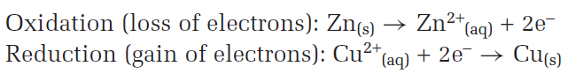
- Anode is the electrode at which oxidation occurs.
- Anode is positively charged
- Cathode is the electrode at which reduction occurs.
- Cathode is positively charged.
- In this example, zinc is the anode and copper electrode is the cathode.
- In galvanic cells, electrons flow through the external circuit from the negative electrode to the positive electrode.
- Each half-cell contains a solution of a neutral compound; in this case, these solutions are zinc sulfate and copper sulfate.
- In order to maintain electrical neutrality in the half cells, negative ions migrate toward the anode and positive ions migrate toward the cathode.
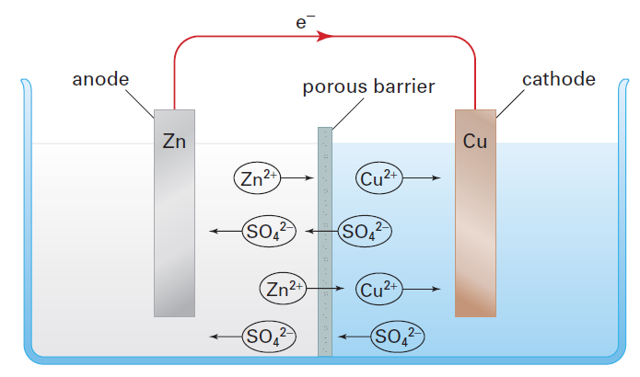
- A device called the salt bridge can replace the porous barrier.
- A salt bridge contains an electrolyte solution that does not interfere in the reaction.
- The bridge allows ion migration to maintain electrical neutrality.
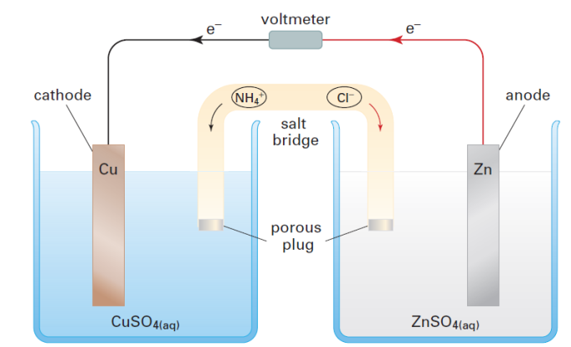
- Suppose the salt bridge of a Daniell cell contains ammonium chloride solution, NH₄Cl.
- As positive zinc ions are produced at the anode, negative chloride ion migrates from the salt bridge into the half-cell that contains the anode.
- As positive copper ions are removed from solution at the cathode, positive ammonium ions migrate from the salt bridge into the half-cell that contains the cathode.
- Other electrolytes, such as sodium sulfate or potassium nitrate, could be chosen for the salt bridge.

- The galvanic cell notation is a shorthand method for representing galvanic cells.
- The galvanic cell notation for a Daniell cell is as follows.
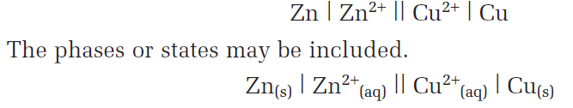
- In the shorthand representation, the anode is always shown on the left and the cathode on the right.
- Each single vertical line, |, represents a phase boundary between the electrode and the solution.
- The double vertical line, ||, represents the porous barrier or salt bridge between the half cells.
- Spectator ions are omitted.

- Some redox reactions involve substances that cannot act as electrodes, such as gases or dissolved electrolytes.
- Galvanic cells that involve such redox reactions use inert electrodes.
- An inert electrode is an electrode made from a material that is neither a reactant nor a product of the cell reaction.
- The reduction half-reaction does not include a solid conductor of electrons, so an inert platinum electrode is used in this half-cell.
- The platinum electrode is chemically unchanged.

For example:
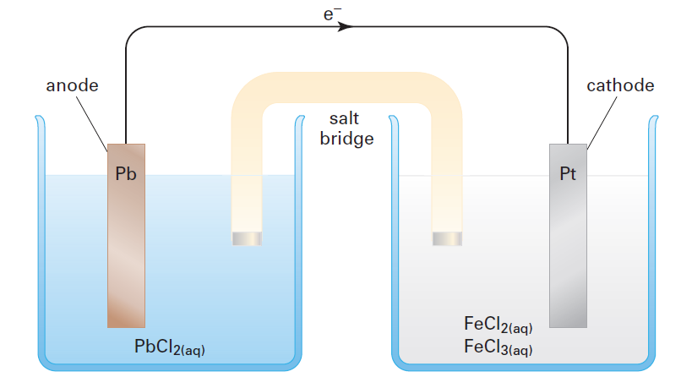
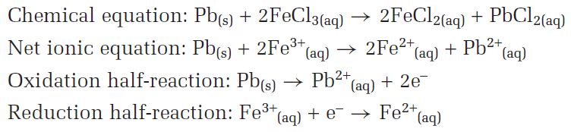
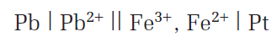
- Refer to pg509 for calculations

- The chemical changes in galvanic cell are accompanied by changes in potential energy.
- Electrons spontaneously flow from a position of higher potential energy at the anode to a position of lower potential energy at the cathode.
- The moving electron can do work, such as lighting a bulb or turning a motor.
- Electric potential, E, is the difference between the potential energy at the anode and the potential energy at the cathode.
- Electric potential is measured as volt, v.
- Electric potential is also known as cell voltage or cell potential.
- The cell potential is measured by a device called the voltmeter.
- One cannot generate electricity by connecting two copper electrodes into a lemon.

- A dry cell is a galvanic cell with the electrolyte contained in a paste thickened with starch.
- A battery is defined as a set of galvanic cells connected in series.
- A disposable battery is known as a primary battery.
- A rechargeable battery is known as a secondary battery.

11.2: Standard Cell Potentials
- The table of standard half-cell potentials allows you to calculate cell potentials, rather than building the cells and measuring their potentials.
- Reduction potential is the half-cell potential for a reduction half-reaction.
- The most easily reduced molecules and ions are near the top of the list.
- The tables of standard reduction potential are only true when ions and molecules are in their standard states.
- Aqueous molecules and ions have a standard concentration of 1mol/L.
- Each half-cell reduction potential is given relative to the reduction potential of the standard hydrogen electrode which has been assigned a value of zero.
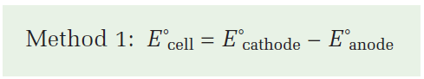
- The subtraction of the reduction potential for a half-reaction is equivalent to the addition of the potential for the reverse half-reaction.
- The reverse of a reduction is an oxidation.
- The half-cell potential for an oxidation half-reaction is called an oxidation potential.
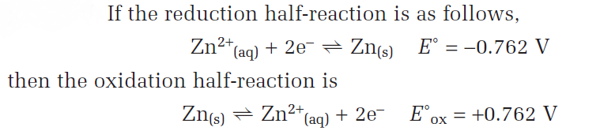
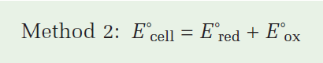
- One does not need to consider the amounts of reactants or products present, or the reaction stoichiometry, when calculating a standard cell potential.
- Refer to pg519 for calculations.

11.3: Electrolytic Cells
- For galvanic cells, the cell potential is positive, thus the overall reaction is spontaneous.
- A galvanic cell converts chemical energy to electrical energy.
- An electrolytic cell converts electrical energy to chemical energy.
- Electrolysis is the process that takes place in an electrolytic cell.
- The overall reaction in an electrolytic cell is non-spontaneous, and requires energy to occur.
- Similar to a galvanic cell, an electrolytic cell includes electrodes, at least one electrolyte, and an external circuit.
- Unlike galvanic cell, electrolytic cell requires an external source of electricity, sometimes called the external voltage.
- An electrolytic cell may or may not include a porous barrier.

- The electrolytic cell shown below decomposes sodium chloride into its elements.
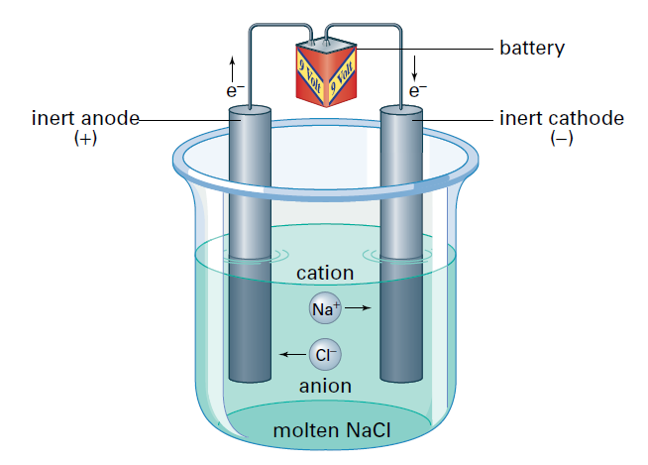
- The cell consists of a single container with two inert electrodes dipping into liquid sodium chloride.
- The ions in molten sodium chloride have the freedom of movement, thus molten sodium chloride is the electrolyte of this cell.
- The external source of electricity forces electron onto one electrode.
- As a result, this electrode becomes negative relative to the other electrode.
- The positive sodium ions move towards the negative electrode, where they gain electrons and are reduced to the element sodium liquid.
- The negative chloride ions move toward the positive electrode, where they lose electrons and are oxidized to the element chlorine, a gas.
- Just as in a galvanic cell, reduction occurs at the cathode, and oxidation occurs at the anode.
- In a galvanic cell, the cathode is positive and anode is negative.
- In an electrolytic cell, the cathode is negative and anode is positive.
- Refer to pg525 for calculations

- When electrolyzing an aqueous solution, there are two compounds present: water and the dissolved electrolyte.
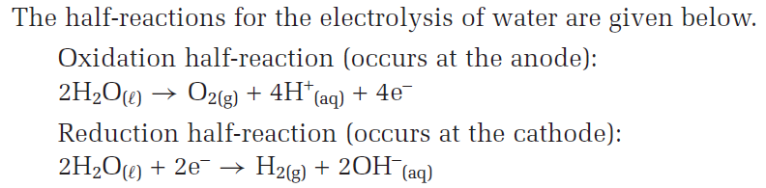
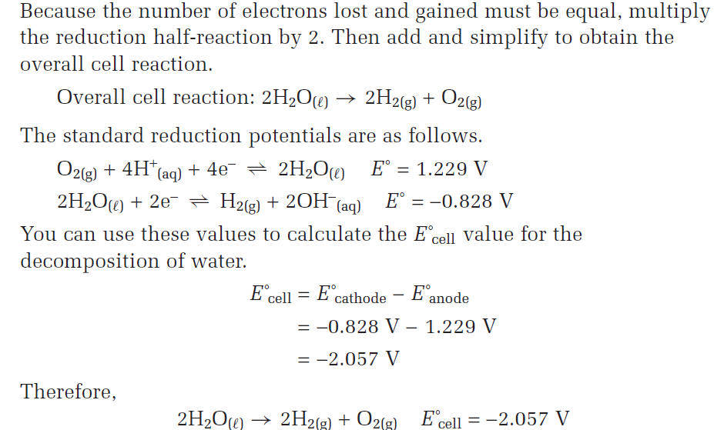

- Electrolytic cells are used for non-spontaneous redox reactions, so all electrolytic cells have negative cell potentials.
- The reduction potential values for the non-standard conditions in pure water are given in a separate table.
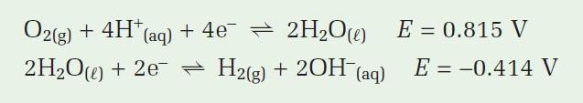
- Using the half-cell potential, E_{cell ,} the calculated cell potential is -1.229V.
- Therefore, the calculated value of the external voltage needed is 1.229.
- In practice, the external voltage needed for an electrolytic cell is always greater than the calculated value.
- The excess voltage required is called the overvoltage.
- Pure water is a very poor electrical conductor. To increase the conductivity, an electrolyte that does not interfere in the reaction is added to the water.
- By adding an external electrical supply, with a voltage greater than the voltage of the Daniell cell, you can push electrons in the opposite direction, thus reversing the chemical reaction.
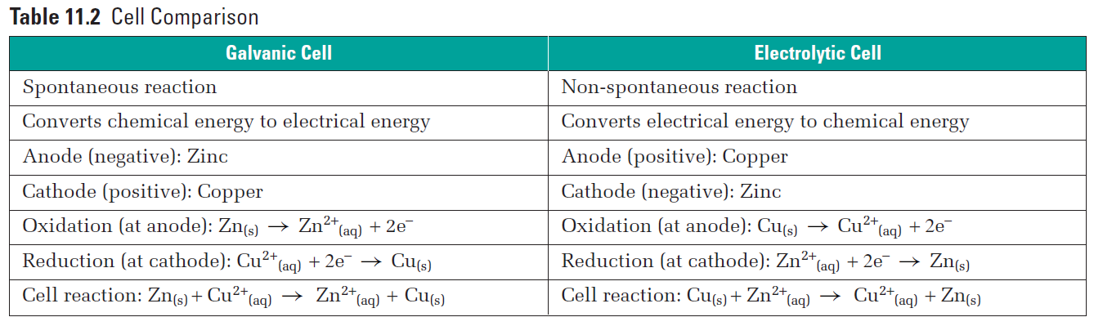
- In the galvanic cell, the zinc anode gradually dissolves. The copper cathode grows as more copper is deposited onto it.
- In the electrolytic cell, the copper anode gradually dissolves. The zinc cathode grows as more zinc is deposited onto it.
- The process in which a metal is deposited, or plated, onto the cathode in an electrolytic cell is known as electroplating.

- To predict the products of an electrolysis involving an aqueous solution, one must examine all possible half-reactions and their reduction potential.
- Then one must find the overall reaction that requires the lowest external voltage.
- Refer to pg529 for calculations.

- Galvanic cells have positive standard cell potentials, and that these cells use spontaneous chemical reactions to produce electricity.
- Electrolytic cells have negative standard cell potentials, and that these cells use electricity to perform, non-spontaneous chemical reactions.
- Refer to pg534 for calculations.

- One of the most common secondary (rechargeable) batteries is found in car engines.

11.4: Faraday’s Law
- The flow of electrons through an external circuit is called the electric current, measured using ampere.
- The quantity of electricity also known as electric charge is the product of the current flow and the time for which it flows.
- The electric charge is measured in a unit called coulomb.
- The charge on a mole of electrons is known as one faraday (1F).
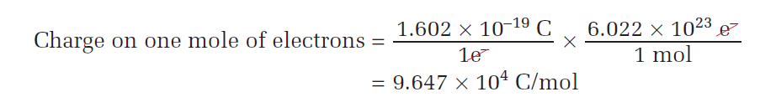
- A rounded value of 96 500 C/mol is often used in calculations. (Three significant digits).
- Refer to pg539 for calculations

- Faraday’s law states that the amount of a substance produced or consumed in an electrolysis reaction is directly proportional to the quantity of electricity that flows through the circuit.

- Extraction is a process by which a metal is obtained from an ore.
- The process of purifying a material is known as refining.

