CHAPTER 15
DATA PROCESSING AND FUNDAMENTAL DATA ANALYSIS

Overview of the Data Analysis Procedure
- Validation and editing (quality control)
- Coding
- Data entry
- Logical cleaning of data
- Tabulation and statistical analysis

Step One: Validation and Editing
Validation: Process of ascertaining that interviews actually were conducted as specified. (E.g. interviewer fraud or failure to follow key instructions)
- Was the person actually interviewed?
- Did the person qualify according to the screening questions?
- Was the interview conducted in the required manner?
- Did the interviewer cover the entire survey?

Editing: Process of ascertaining that questionnaires were filled out properly and completely.
- Did the interviewer fail to ask certain questions or fail to record answers for certain questions?
- Were skip patterns followed?
  - Skip Pattern: Sequence in which later questions are asked based on a respondent’s answer to an earlier question or questions.
- Did the interviewer paraphrase respondent’s answers to open-ended questions or copy them verbatim? Did the interviewer probe?

Step Two: Coding
Process of grouping and assigning numeric codes to the various responses to a question.

Coding Process:
- List responses
- Consolidate responses
- Set codes
- Enter codes
  - Read responses to individual open-ended questions on questionnaires
  - Match individual responses with the consolidated list if response categories and determine the appropriate numeric code for each response
  - Write the numeric code in the appropriate place on the questionnaire for the response to the particular question or enter the appropriate code in the database electronically

Automated Coding Systems: Algorithms are based on semiotics and show great promise for speeding up the coding process, reducing its cost and increasing its objectivity. (E.g. TextSmart module of SPSS)

Step Three: Data Entry
Process of converting information to an electronic format.

Intelligent Entry Systems: Form of data entry in which the information being entered into the data entry device is checked for internal logic. These systems can be programmed to avoid certain types of errors at the point of data entry, such as invalid or wild codes and violation of skip patterns

Scanning: Form of data entry in which responses on questionnaires are read in automatically by the data entry device. (E.g. Scantron)
Step Four: Logical Cleaning of Data
Logical or Machine Cleaning: Final computerized error check of data. This may be done through error check routines and/or marginal reports.
- Error Check Routines: Computer programs that accept instructions from the user to check for logical errors in the data.
- Marginal Report: Computer-generated table of the frequencies of the responses to each question, used to monitor entry of valid codes and correct use of skip patterns.

Step Five: Tabulation and Statistical Analysis
One-Way Frequency Tables: Table showing the number of respondents choosing each answer to the survey question.
In most instances, it is the first summary of survey results seen by the research analyst. In addition to frequencies, these tables typically indicate the percentage of those responding who gave each possible response to a question. There are three options for the base used for the percentages:
- Total respondents
- Number of people asked the particular question
- Number of people answering the question (i.e. 2 – people who answered don’t know)

Cross Tabulations: Examination of the responses to one question relative to the responses to one or more other questions.
- Put the independent variable in the columns, dependent variable in the rows

(See examples on next page)
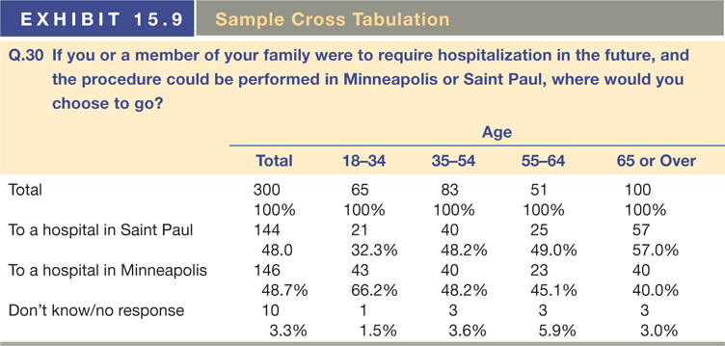

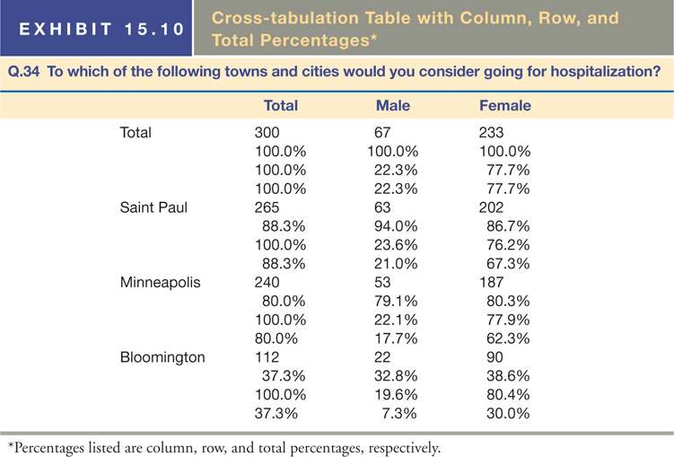

- A common way of setting up cross-tabulation tables is to use columns to represent factors such as demographics and lifestyle characteristics, which are expected to be predictors of the state of mind, behaviour, or intentions data, shown as rows of the table.
- Cross tabulations provide a powerful and easily understood approach to the summarization and analysis of survey research results.
- However, it is easy to become swamped by the sheer volume of computer printouts if a careful tabulation plan has not been developed.
- Some tips:
  - Make hypotheses.
  - Look for what is not there.
  - Scrutinize for the obvious.
  - Keep your mind open.
  - Trust the data.
  - Watch the “n”.

Graphical Representations of Data

Line Charts
- Good for demonstrating linear relationships
- Particularly useful for presenting a given measurement taken at several points over time

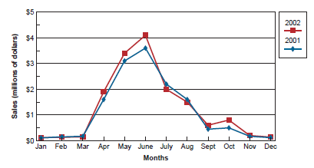

Pie Charts
- Good for special relationships among data points
- Should total to 100%
- 3D pie charts are harder to read

Bar Charts
- Good for side by side relationships / comparisons
- Comparisons are easier than with pie charts
- Most flexible of the graphs
- Use zero origins
- Use Multiple graphs for 3 variables
- Avoid 3D bar charts – hard to read
- Four types of bar charts:
  - Plain Bar Chart
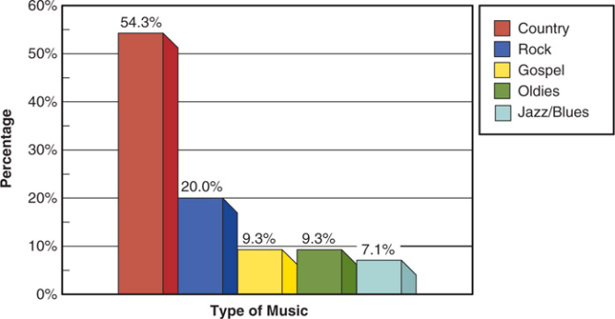

  - Clustered Bar Chart: Shows the results of cross tabulations
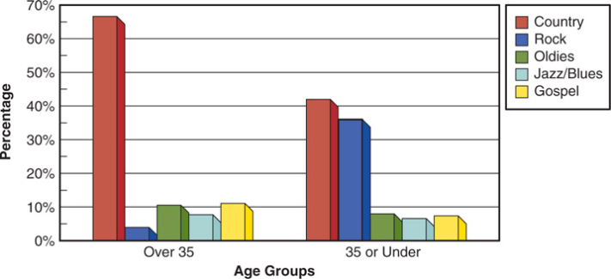

  - Stacked Bar Chart: Also show the results of cross tabulations
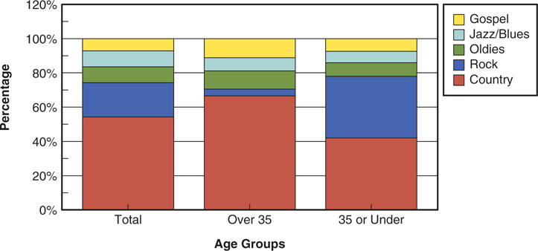

  - Multiple-row, 3D Bar Chart: Also show the results of cross tabulations
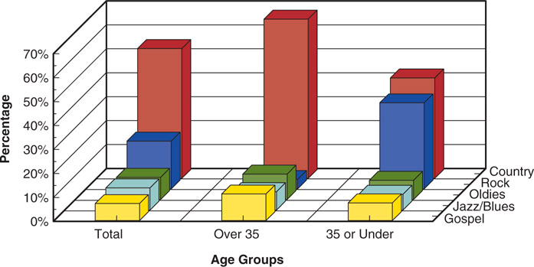

Lying with Graphs

More Honest:

Descriptive Statistics
Descriptive statistics are the most efficient means of summarizing the characteristics of large sets of data. In a statistical analysis, the analyst calculates one number or a few numbers that reveal something about the characteristics of large sets of data.

Measures of Central Tendency
- Mean: The sum of the values for all observations of a variable divided by the number of observations.

- Median: Value below which 50 percent of the observations fall – midpoint.

- Mode: The value that occurs most frequently.

Measures of Dispersion
These indicate how spread out the data is
- Variance: The sums of the squared deviations from the mean divided by the number of observations minus one. It is the same formula as standard deviation with the squaring.

- Range: The maximum value for a variable minus the minimum value for that variable.

- Standard Deviation: Measure of dispersion calculated by subtracting the mean of the series from each value in a series, squaring each result, summing the results, dividing the sum by the number of items minus 1, and taking the square root of this value.

$$S=\sqrt{\frac{\sum_{i=1}^{n}{\left(X_{i}-\overline{X}\right)}}{n-1}}$$

S = sample standard deviation n = sample size
X_{i} = value of the ith observation $\overline{X}$ = sample mean

