CHAPTER 14
SAMPLE SIZE DETERMINATION

Determining Sample Size for Probability Samples
As a general rule, the larger the sample is, the smaller the sampling error. However, large samples cost more money, and the resources available for a project are always limited. Although the cost of increasing sample size tends to rise on a linear basis (double the sample size, almost double the cost), sampling error decreases at a rate equal to the square root of the relative increase in sample size. If sample size is quadrupled, data collection cost is almost quadrupled, but the level of sampling error is reduced by only 50%.

Budget Available: What sample size can we afford once other project costs are deducted? This also includes time.

Rule of Thumb: Is there some convention we can apply? What might make an adequate sample size based on past experience?

Number of Subgroups Analyzed: In any sample size determination problem, consideration must be given to the number and anticipated size of various subgroups of the total sample that must be analyzed. The larger the number of subgroups to be analyzed, the larger the required total sample size.

Traditional Statistical Methods: Variance, heterogeneity in the population, standard deviation, sampling error and confidence intervals play a key role in determining sample size.
Determining Sample Size for Probability Samples
Judgement: Best guess of “experts”. Draw on your experience to determine sample size.

Conventional: What have others done? See what the sample size has been for similar studies.

The Normal Distribution
General Properties
- Many variables encountered by marketing have probability distributions that are close to the normal distribution
- Useful approximation of many other discrete probability distributions
- Useful for a number of theoretical reasons – including the central limit theorem
- Central Limit Theorem: The idea that a distribution of a large number of sample means or sample proportions will approximate a normal distribution - regardless of the distribution of the population from which they were drawn.

Characteristics of a Normal Distribution
- The continuous distribution that is bell shaped and symmetrical about the mean
- The mean, median, and mode are equal
- There is only one mode
- About 68% of the observations are within one standard deviation plus/minus of the mean, 96% within two standard deviations, and 99+% within three standard deviations
- The total area under the normal curve is equal to 1
- The area of a region under the normal distribution curve between any two values of a variable equals the probability of observing a value in that range when an observation is randomly selected from the distribution
- Proportional property of the normal distribution: The area between the mean and a given number of standard deviations from the mean is the same for all normal distributions.

Standard Normal Distribution: Normal distribution with a mean of zero and a standard deviation of one.
A simple transformation formula, based on the proportional property of the normal distribution, is used to transform an X value from any normal distribution to its equivalent value Z from a standard normal distribution:

$$Z=\frac{Value of the variable-Mean of the variable}{Standard deviation of the variable}$$

Or

$$Z=\frac{X-μ}{σ}$$

Standard Deviation: The measure of dispersion calculated by subtracting the mean of the series from each value in a series, squaring each result, summing the results, dividing the sum by the number of observations minus 1 and finally taking the square root of this value.

$$S=\sqrt{\frac{\sum{{\left(X-\overline{X}\right)}^{2}}}{n-1}}$$

Population and Sample Distributions
Population Distribution: The frequency distribution of all the elements of a population.

Sample Distribution: The frequency distribution of all the elements of an individual sample.

Sampling Distribution of the Mean
It is the theoretical frequency distribution of the means of all possible samples of a given size drawn from a particular population; it is normally distributed. It is computed in the following way because the variance (or dispersion) within a particular distribution of a sample means will be smaller if it is based on larger samples.

Standard Error of the Mean

Where
$S_{\overline{X}}$ = Standard error of the mean
σ = Population standard deviation
$\sqrt{n}$ = Square root of the sample size

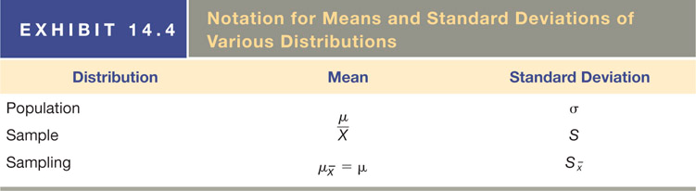

Basic Concepts
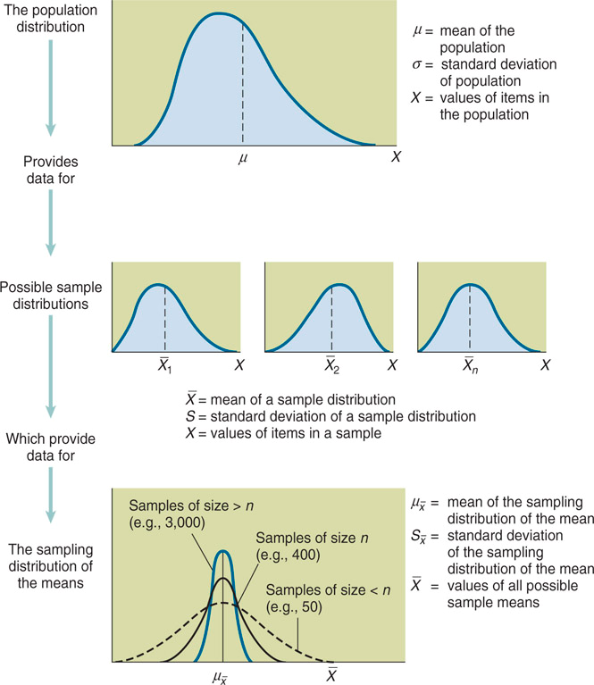

- The sampling distribution of the mean for simple random samples that are large (30+ observations) has the following characteristics:
  - The distribution is a normal distribution
  - The distribution has a mean equal to the population mean
  - The distribution has a standard deviation (the standard error of the mean) equal to the population standard deviation divided by the square root of the sample size:
$$σ_{\overline{X}}=\frac{σ}{\sqrt{n}}$$

Point and Interval Estimates
- Point Estimate: The particular estimate of a population value. (E.g. Sample Mean). The distance between the point estimate and the true population value is the sampling error.
- Interval Estimate: The interval or range of values within which the true population value is estimated to fall.
  - Confidence Level: Probability that a particular interval will include the true population value; also called confidence coefficient.
  - Confidence Interval: The interval that, at the specified confidence level, includes the true population value.
    - 95% Confidence Interval:

$$\overline{X}±1.96σ_{\overline{X}}$$

- 68.26% Confidence interval:

Sampling Distribution of the Proportion: The relative frequency distribution of the sample proportions of many random samples of a given size drawn from a particular population; it is normally distributed.
- It approximates a normal distribution
- The mean proportion for all possible samples is equal to the population proportion
- The standard error of a sampling distribution of the proportion can be computed with the following formula:
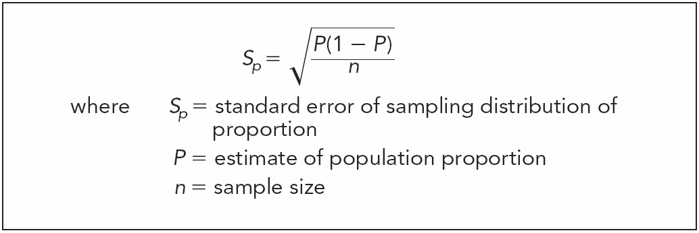

Determining Sample Size
Calculating Sample Size for Problems Involving Estimating Means

$$n=\frac{Z^{2}σ^{2}}{E^{2}}$$
Where
n = Sample size
Z = Level of confidence expressed in standard errors
σ = Population standard deviation
E = Acceptable amount of sampling error

- Three pieces of information need to compute the sample size required:
- The acceptable or allowable level of sampling error E
- The acceptable level of confidence Z. In other words, how confident does the researcher want to be that the specified confidence interval includes the population mean?
- An estimate of the population standard deviation σ
- Allowable Sampling Error: Amount of sampling error the researcher is willing to accept, E.
    - In exploratory studies, one may be interested in developed a basic sense of whether attitudes toward one’s product are generally positive or negative. Precision might not be critical.
    - In a product concept test, one would need a much more precise estimate of sales for a new product before making the potentially costly and risky decision to introduce that product in the marketplace.
- Acceptable Level of Confidence: How confident does the researcher want to be that an interval includes the population mean, Z.
- Population Standard Deviation: Standard deviation of a variable for the entire population, σ.
  - Four methods to estimate population standard deviation:
- Use results from a prior survey
- Conduct a pilot survey
- Use secondary data
- Use judgement

Calculating Sample Size for Problems Involving Estimating Proportions

$$n= \frac{Z^{2}\left[P(1-P)\right]}{E^{2}}$$
Where
Z = Level of confidence expressed in standard errors
P = Estimate of population proportion
E = Acceptable amount of sampling error
Population Size and Sample Size
- Independence Assumption: Assumption that sample elements are drawn independently of one another. This assumption is justified when the sample is small relative to the population.
  - However, it is not appropriate when the sample is relatively large (5% or more of the population).
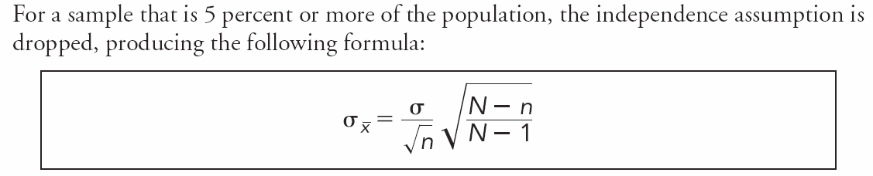
- The part circled in red is referred to as the finite population correction factor.
- This makes the revised sample size:

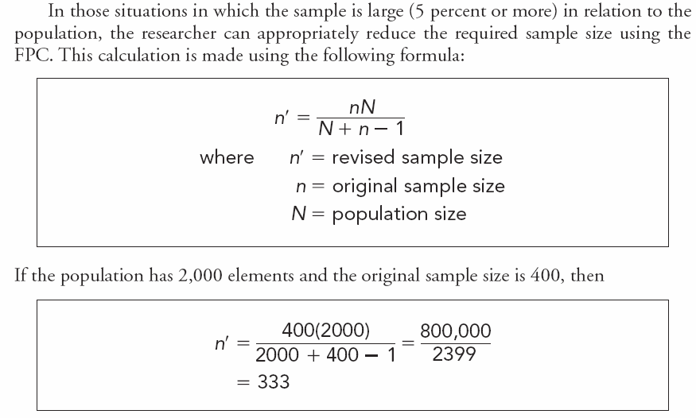

  - The key is not the size of the sample in relation to the size of the population but whether the sample selected is truly representative of the population.

Determining How Many Sample Units are Needed: You need to contact more than n, since it’s unlikely that everyone you contact will agree to answer the questionnaire. If you determine that you need 800 respondents and a typical response rate for your type of survey is 30%, then you would actually have to contact 2,667 people to get 800 completed surveys.

Statistical Power
The probability of not making a type II error.

Sampling Issues to Consider
- Time to Generate the Sample
- Scope of the Research
- Budget Available
- Experience with Sampling
- Level of Accuracy Desired
- Your Knowledge of the Population
- There Are Only 2 Options for Reducing Sample Size
  - Option 1: Use a confidence level lower than 95% if the decision is not critical
  - Option 2: Be willing to accept more sampling error (i.e., less precision, broader range)

