CHAPTER 13
BASIC SAMPLING ISSUES

Concept of Sampling
Sampling: The process of obtaining information from a subset of a larger group. A user of marketing research then takes the results from the sample and makes estimates of the characteristics of the larger group.

Population: The entire group of people about whom information is needed; also called the universe or population of interest. The target population can be thought of as a “target market”.

Sample versus Census
Census: Data collection from or about every member of the population of interest. It is also called canvassing the population by asking everyone a set of questions. It is very expensive and time-consuming, and sometimes the researcher may not obtain a complete and accurate list of the entire population or some may not be willing to participate.

Sample: A subset of all the members of a population of interest. Information is obtained from or about a sample and used to make estimates about various characteristics of the total population. Ideally, the sample from or about which information is obtained is a representative cross section of the total population.

Developing a Sampling Plan
- Define the population of interest: Specify the characteristics of those individuals or things from whom or about whom information is needed to meet the research objectives
- Often specified in terms of geographic area, demographic characteristics, product or service usage characteristics and/or awareness measures.
- Those who are excluded must also be properly defined
  - Includes security questions for those working in advertising (possible competitors)

- Choose a data-collection method: Determine how you collect the sample - such as mail, Internet, telephone, mall intercept, etc.

- Identify a sampling frame: List of the members or elements of the population from which units to be sampled are to be selected or a specified procedure for generating such a list.
- There is seldom a perfect correspondence between the sample frame and the population of interest.
  - E.g. Telephone books

- Select a sampling method: Determine how you will get the sample list through probability or non-probability methods. It depends on the objectives of the study, the financial resources available, time limitations and the nature of the problem under investigation.
- Probability samples: Samples in which every element of the population has a known, nonzero likelihood of selection.
  - Largely developed by George Gallup in the 1950’s for his mother-in-law’s campaign, based on Bernoulli’s theories
  - Famous frame errors: ‘Dewey Wins!’
  - Some methods more ‘efficient’ than others – i.e., for the same size sample (i.e., same cost) they produce a smaller standard error of the estimate
  - Researchers can be sure of obtaining information from a representative cross section of the population of interest
  - Sampling error can be computed
  - Survey results can be projected to the total population
- Nonprobability samples: Samples in which specific elements from the population have been selected in a non-random manner
  - Nonrandomness: Population elements are selected on the basis of convenience – easy or inexpensive to reach.
  - Purposeful nonrandomness: Systematically excluding or over representing certain subsets of the population.
  - Less expensive than probability samples of the same size
  - Less time-consuming in terms of sample design
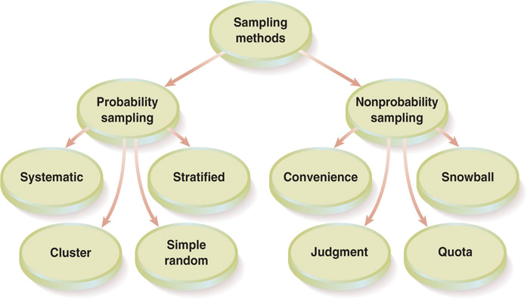

- Determine the sample size: What is the level of accuracy you want to achieve; the time and money you have to do the survey, and the data collection method?
- Nonprobability: What are the available budget, rules of thumb, and number of subgroups to be analyzed in the determination of sample size?
- Probability: Use formulas to determine sample size required, given targets of acceptable error and levels of confidence

- Develop operational procedures for selecting sample elements: This is the plan of how to go about actually choosing and interviewing the respondents. Must be clear, detailed and unambiguous.

- Execute the operational sampling plan: Field workers must be trained to execute the sampling plan properly.

Sampling & Nonsampling Errors
Population parameter: A value that accurately portrays or typifies a factor of a complete population, such as average age or income. The accuracy of sample results is affected by two general types of error: sampling error and nonsampling (measurement) error.
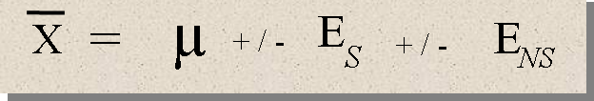
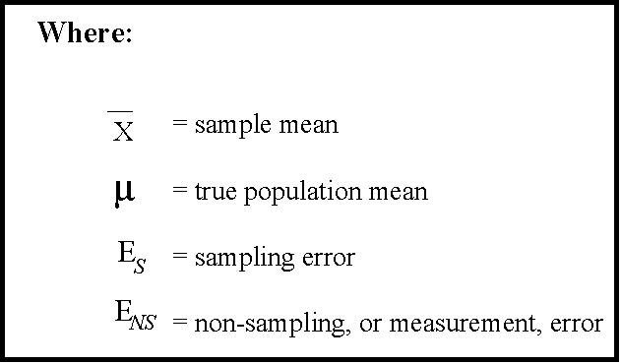

Sampling error: Error that occurs because the sample selected is not perfectly representative of the population.
- Administrative error: Flaws in the design or execution of the sample
- Random sampling error: Due to chance and cannot be avoided. Can be reduced by increasing the sample size

Nonsampling error: All factors other than sampling error that may cause inaccuracy and bias in the survey results.

Probability Sampling Methods
Simple Random Sampling: A sample selected by assigning a number to every element of the population and then using some method for randomly selecting elements to be in the sample such as random digit dialing or tables of random numbers.
- Sampling error: Extent to which a sample value can be expected to differ from a population value



Systematic Sampling: A sample in which the entire population is numbered and elements are selected using a skip interval – every “nth” name is selected. Simpler, cheaper and less time-consuming than the simple random sampling method.


Stratified Sampling: Probability sample that is forced to be more representative through simple random sampling of mutually exclusive and exhaustive subsets.
  - E.g. Male or female
- The population is divided on the basis of factors related to the characteristic of interest in the population.
- Pros: Potential for greater statistical efficiency (smaller sampling error) and can be a smaller sample than the simple random one.
- Cons: Information to stratify may not always be available, the division must yield significant differences in regards to the measurement of interest and the potential value of the information must warrant the time and costs associated with stratification.

Three steps in implementing a properly stratified sample:
1. Identify important demographic or classification factors (that correlate with the behaviour of interest)
2. Determine what proportions of the population fall into the various subgroups under each stratum
- Proportional allocation: Sampling in which the number of elements selected from a stratum is directly proportional to the size of the stratum relative to the size of the population. (proportion of stratum size/population size)
- Disproportional or optimal allocation: Sampling in which the number of elements taken from a given stratum is proportional to the relative size of the stratum and the standard deviation of the characteristic under consideration. This provides the cheapest, most efficient samples and provides the most precise estimates of sample size. Relatively more elements are drawn from those strata having larger standard deviations (more variation).
3. Select separate simple random samples from each stratum

Cluster Sampling: A sample in which the sampling units are selected from a number of small geographic areas to reduce data collection costs.
- Sampling frame specifies groups or clusters of the population, not individual elements
- Most popular type of cluster sample is area sample – clusters are city blocks or neighbourhoods
- If the sample consists of all the elements in the selected subsets, it’s called a one-stage cluster sample. If the sample of elements is chosen in some probabilistic manner from the selected subsets, the sample is a two-stage cluster sample.
- Multistage area sampling: Geographic areas selected for national or regional survey in random progressively smaller population units, such as counties, then residential blocks, then homes.

- Cons:
  - Lack of heterogeneity from the clusters to the rest of the population. They might all be similar inside but different from others.
  - Less efficient than other types of probability samples
  - Cheaper than either stratified or simple random, saves on cost and travel

Nonprobability Sampling Methods
Units of the sample are selected on the basis of personal judgment or convenience.

Convenience Samples: A sample based on using people who are easily accessible – such as mall intercepts or other high traffic locations. The sample may represent an efficient and effective means of obtaining the required information, especially in an exploratory situation.

Judgement Samples: A sample in which the selection criteria are based on the researcher’s personal judgment about the representativeness of the population under study. The researcher selects who should be in the study.

Quota Samples: A sample in which quotas, based on demographic or classification factors selected by the researcher, are established for population subgroups.
- 2 differences from stratified sampling: not a probability method, no knowledge of correlation between quota factor and DV
- E.g. Owners of different breeds of dogs or marketing majors in a sample of JMSB students

Snowball Samples:
A sample in which additional respondents are selected based on referrals from initial respondents. It is good for low-incidence, hard-to-find respondents.
- E.g. Canadians running an ecommerce business out of their home, injecting drug users, commercial sex workers.
- Dramatic reduction in search costs
- Sample might become biased – might not be a good cross-section of the population
- Respondents might be reluctant to give referrals

Internet Sampling
Convenience Samples – Although that may change in the future as better e-mail sampling frames become available

Pros
- Target respondents can complete the survey at their convenience.
- Data collection is inexpensive.
- Survey software can facilitate the data collection process.
- The survey can be completed quickly.

Cons
- Sample might not be representative of the population.
- You cannot always be sure who is completing the survey.
- Maintaining respondent confidentially can be a challenge.
- Data security issues can be difficult to manage.

