CHAPTER 9
PRIMARY DATA COLLECTION: EXPERIMENTATION AND TEST MARKETS

Experiment
Research approach in which one variable is manipulated (also called the independent, treatment, or explanatory variable) and the effect on another variable is observed
- Holding other variables constant to rule out 3rd variables – may need to use deception
- Participants’ Equivalence on Dependent Variables
  - Random assignment, matching, within Ss designs

Demonstrating Causation
Causual Research: Research designed to determine whether a change in one variable likely caused an observed change in another
Must show:
- Concomitant Variation: A & B must vary together in some predictable fashion (statistical relationship)
- Appropriate Time Order of Occurrence: A occurs before B
- Elimination of Other Possible Causal Factors: Ruling out things such as effect of changes in the competition, the economy, etc.

One-Way Analysis of Variance (Teacher Notes)

Between Subjects Designs
Simple Designs (One-way ANOVA)
- Contrasts

Factorial Designs (Univariate ANOVA)
- Contrasts
- Interactions
- Mediation/Moderation

Within Subjects Designs
Repeated Measures

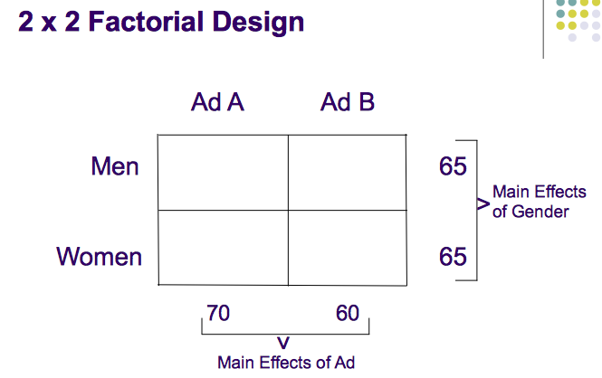

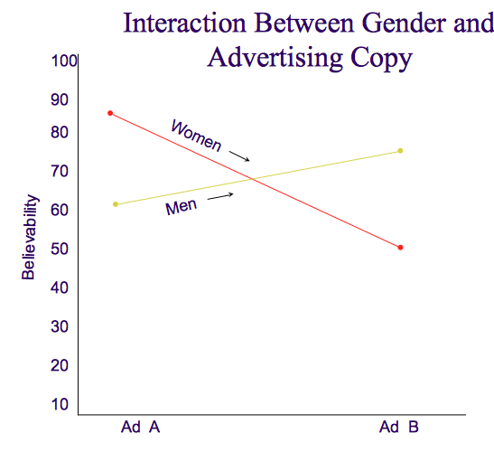

Examples in Marketing (Teacher Notes)
Crayola.com Example
- Dependent variable: Web site visits
- Independent variables: Invitation email characteristics
  - Subject line heading
    - “Help us help you”
    - “Crayola.com Survey” (+7.4%)
  - Customization
    - “Greetings”
    - “Hi NAME” (+2.7%)
    - “NAME” (+3.4%)
  - Incentive
    - None
    - $25 at Amazon (+5.2%)
    - $100 product drawing (+8.4%)

Product Testing Candy Bars Examples (Teacher Notes)
- Dependent variables: Product liking, purchase likelihood
- Independent variables:
  - Nut type: Hazelnuts, walnuts, peanuts
  - Chocolate cover: Milk chocolate, bitter chocolate
  - Filling: Caramel filling at 10%, 15%, 20%

Experimental Setting
Laboratory Experiments: Controlled setting
Pros:
- Ability to control extraneous causal factors (temperature, light, humidity, etc.)
- Easy to eliminate other possible causal factors
- Focus on concomitant variation and appropriate time order of occurrence
- Greater internal validity

Cons:
- Lower external validity

Field Experiments: Actual environments, such as a marketplace
Pros:
- Solve the problem of realism of the environment
- Greater external validity

Cons:
- No control over spurious factors that might influence the dependent variable (such as actions of competitors, the weather, the economy, societal trends, and political climate)
- Lower internal validity

Validity
Internal Validity: Extent to which competing explanations for the experimental results observed can be ruled out
- Increased Experimenter control
  - Hold other factors constant or measure them to account for them in the analysis

External Validity: Extent to which causal relationships measured in an experiment can be generalized to outside persons, settings, markets, and times.
- Are the experimental conditions realistic?
- Can the results be generalized to other shoppers, products, contexts?
- E.g., effect of credit card insignia on tipping (J. Applied Psychology)

Experimental Notation
“X” = Independent Variable: Indicates the exposure of an individual or a group to an experimental treatment (the factor whose effects we want to measure and compare). This variable is something the researcher can change and manipulate (such as prices and new packages). It is hoped that the change in the independent variable will cause a change in the dependent variable.

“O” = Dependent Variable:
Indicates a variable the researcher cannot change directly. It is hoped that changing the independent variable will cause changes in the dependent variable (sales of the product). Thus the dependent variable is “dependent” on what the researcher does with the independent variable.

Different time periods are represented by the horizontal arrangement on the X’s and O’s.
e.g.
O₁ X O₂

The X’s and O’s can be arranged vertically to show simultaneous exposure and measurement of different test units
e.g.
X₁ O₁
X₂ O₂

Extraneous Variables (Threats to validity)
History: Intervention, between the beginning and end of an experiment, of outside variables that might change the dependent variable. Could events outside of the experimental situation, but occurring at the same time, account for the effect observed?
e.g. The actions of a competitor during the experiment, the weather, etc.

Maturation: Changes in subjects occurring during the experiment that aren’t related to the experiment but which might affect subjects’ response to the treatment factor. The longer the experiment runs, the more likely it is that maturation will present problems for interpreting the results. Did the subjects go through developmental changes due to passage of time that could account for the results?
e.g. Getting older, wiser, hungrier, tired, etc. (usually anything that will change consumption habits)

Instrument Variation: Changes in measurement instruments (e.g., interviews or observers) that might affect measurements. Did the way responses were measured change over the course of the experiment?
e.g. Measurement on same subject taken by two different interviewers (with different measurement methods) or the measurement taken by one interviewer at two different points in time (where he changes).

Selection Bias: Systematic differences between the test group and the control group (or population to which the researcher would like to project the experimental results) due to a biased selection process. Equality of groups can be ensured though randomization (not too good for small samples sizes) or purposeful matching (screening questions, etc. Matching is not always possible, however).

Mortality: Loss of test units or subjects during the course of an experiment which might result in a non-representativeness. No way to know whether the lost units would have responded to the treatment variable in the same way as the others. Results would lack external validity.
e.g. All subjects under 25 years old drop-out. This is likely to give a biased picture

Testing Effects: An effect that is a by-product of the research process itself. There are 2 forms:
- Main (Direct) Testing Effect: Possible effects of earlier observations on later observations.
e.g. Taking a test for the second time and doing better
- Interactive (Indirect) Testing Effect: Possible effects of a prior measurement on a subject’s response to a later measurement
e.g. The measurement taken before the independent variable occurred also affects the dependent variable

Regression to the Mean: Tendency of subjects with extreme behavior to move toward the average for that behavior during the course of the experiment. Are the extreme responses the result of random error?
e.g. Is the extreme behaviour due to extreme people (like heavy users) or chance?

Controlling Extraneous Variables
Randomization: The random assignment of subjects to treatment conditions (i.e. test or control) to ensure equal representation of subject characteristics.

Physical Control: Holding constant the value or level of extraneous variables throughout the course of an experiment.
e.g. Using matching to make sure there are no important differences between characteristics of respondents in the test and control groups

Design Control: Use of the experimental design to control extraneous causal factors.

Statistical Control: Adjusting for the effects of extraneous variables by statistically adjusting the value or the dependant variable for each treatment condition.
e.g. Analysis of covariance

Experimental Design, Treatment, & Effects
Experimental Design: A test in which the researcher has control over and manipulates one or more independent variables. Includes four factors:
- Treatment variable
- Subjects
- Dependent variable
- Plan or procedure
Treatment Variable: The independent variable that is manipulated in an experiment.
Experimental Effect: The effect of the treatment variable on the dependent variable. The goal is to determine the effect of each treatment condition (level of treatment variable) on the dependent variable.
Limitations of Experimental Research
High Cost
- Is the research affordable?
- Will the research be beneficial & help solve problems?
- Has a cost & benefit analysis been done?
- Will the costs of doing the experiment exceed the value of the information gained?

Security Issues
- Particularly critical with field experiments
- The competition might be “tipped-off”
- Are the data and findings secure?

Implementation Problems
- Process Contamination (buyers outside the test area)
- People who unwittingly get caught into the survey
- Outside factors unnaturally affecting the experiment
- Participants who intentionally try to skew the results
- Difficulty gaining cooperation within the organization
- Differences between test markets and the total population
- Lack of appropriate people for a control group

Selected Experimental Designs
Pre-Experimental Design: Designs that offer little or no control over extraneous factors.
- Simple & Inexpensive
- Useful for suggesting new hypotheses
- Difficult to interpret – hence they are not much better than descriptive studies

One-Shot Case Study Design: X O₁
  - No pretest observations
  - No control group
  - Low internal and external validity

One-Group Pretest-Posttest Design: O₁ X O₂
  - Treatment effect = O₂ - O₁
  - No control group
  - Internal validity threat from history effect and maturation effect

True Experimental Designs: Research using an experimental group and a control group to which test units are randomly assigned.
- Higher validity and control over extraneous variables
Before & After with Control Group Design:
(R) O₁ X O₂
(R) O₃ X O ₄
  - Treatment effect is calculated by removing the change due to extraneous variables in the control group from the test group = (O₂ - O₁) – (O₃ - O ₄)
  - Validity threat from history and mortality

After-Only with Control Group Design:
(R) X O₁
(R) O₂
  - Validity threat from history and mortality

Quasi-Experiments: Studies in which the researcher lacks complete control over the scheduling of treatments or must assign respondents to treatments in a non-random manner.

Interrupted Time-Series Designs: Research in which repeated measurement of an effect “interrupts” previous data patterns.
O₁ O₂ O₃ O₄ X O₅ O₆ O₇ O₈
    - Helps identify trends
    - Threat to validity from history and instrument variation

Multiple Time-Series Designs: Interrupted time-series design with a control group.
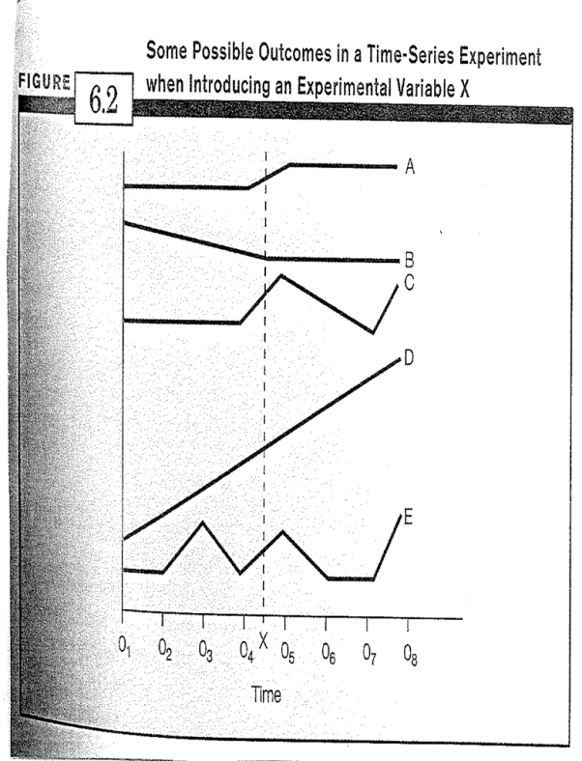

Test Markets
Real world testing of a new product or some element of the marketing mix using an experimental or quasi experimental design. Designed to provide information about:
- Estimates of market share and volume
- The effects that the new product will have on sales of similar products (if any) already marketed by the company. (Cannibalization rate)
- Characteristics of consumers who buy the product.
- Behaviour of competitors during the test (which can be projected to the release)
- Product weaknesses

Types of Test Markets
Traditional or standard test market: Testing through a firm’s regular channels of distribution.
- These tests take a long time (6 months +)
- Costly
- Tip-off the competition

Scanner or electronic test markets: Markets where scanner panel research firms have panels of consumers who carry scannable cards for use in buying particular products, especially those sold though grocery stores
- Permit to analyze the characteristics of those consumers who buy and those who don’t buy the test products
- Speedy
- Low Cost
- Some degree of security
- Can have unrepresentative sampling

Controlled test markets: Markets managed by research suppliers who ensure that the product is distributed through the agreed upon types and numbers of distributors. Distributors are paid to provide the required amount of shelf space for test products
- Enables companies to get their products into test markets more quickly
- Often supply more realistic levels of distribution
- Provide better monitoring of product movement

STMs (simulated test markets): Simulations of the types of test markets noted above.
- Conducted more quickly than the other two approaches
- Lowest cost
- Highly predictive results
- Combination of limited amounts of information and mathematical models

Costs of Test Markets
Direct Costs:
- Advertising expenses (commercials, ad agencies, media time, syndicated and customized research information and data analysis)
- Point-of-purchase materials
- Coupons and sampling
- Travel and set-up expenses
- Need for customized research

Indirect Costs:
- Possible diversion of sales from your other products
- Potentially bad press / public reaction if experiment fails
- Letting competitors know what your company is doing
- Falsely thinking the sample results are always representative of the population

Decision to Conduct Test Marketing
- Weigh the cost and risk of failure against the probability of success and associated profits.
- Consider the likelihood and speed with which competitors can copy your product and introduce it on a national basis.
- Consider the investment required to produce the product for the test market versus the investment required to produce the product in the quantities necessary for a national rollout.
- Consider how much damage an unsuccessful new product launch would inflict on the firm’s reputation with retailers

Steps in a Test Market Study
- Define the Objective: Share & volume estimates, characteristics of people purchasing the product, frequency and purpose of purchase, where sales are made, effect of new product sales on existing lines
- Select a Basic Approach: Traditional, scanner, controlled or simulated test markets
- Develop Detailed Test Procedures: How will you execute the study? Who will be involved? How long will it take and how much can you spend?
- Select Test Markets: Minimum of 2 and a control group for existing brands and 3 for new ones. Should be geographically dispersed and demographically representative (should cover at least 3% of the nation).
- Run test for at least 6 months, up to a year, depending on product re-purchase cycle
- To test media spending levels
  - Use minimum increment of 50% (up or down)
  - At least 4 TV and radio stations, a dominant local newspaper with Sunday supplement
  - TV spillover and spill-in less than 15%
- Execute the Plan: Test must be long enough to provide an adequate amount of repeat purchase cycles, but must also consider the speed of competitor reaction and the costs of running the tests.
- Analyze the Test Results: Focus on 4 areas:
- Purchase Data: Level of initial purchase and repeat rate
- Awareness Data
- Competitive Response
- Source of Sales: Which brands did the people who purchased the test product previously purchase?

Other Types of Product Tests
Rolling Rollout: A product is launched in a certain region rather than in one or two cities. Scanner data can provide information on how the product is doing in a few days resulting in the possible product launch in additional regions.

Lead Country Strategy: A product is tested in a foreign market before rolling it out globally. Colgate-Palmolive Company launched Palmolive Optims shampoo and conditioner in the Philippines, Australia, Mexico, and Hong Kong. Later, the products were rolled out in Europe, Asia, Latin America, and Africa.

