CHAPTER 8
PRIMARY DATA COLLECTION: OBSERVATION
ETHNOGRAPHY, SCANNED-BASED RESEARCH, AND OTHER OBSERVATION TECHNIQUES

Nature of Observation Research
Observation Research: The systematic process of recording patterns of occurrences or behaviors without normally communicating with the people involved.

Conditions for Using Observation
- The needed information must be either observable or inferable from behaviour that is observable. (E.g. If a researcher wants to know why an individual purchased a new Corolla instead of a Ford, observation research will not provide the answer)
- The behavior should be repetitive, frequent, or in some manner predictable. Otherwise, the cost of observation may make the approach prohibitively expensive.
- The behavior must be relatively short in duration (E.g. the entire decision making process of buying a new home over several months isn’t feasible).

Approaches to Observation Research
- Normal versus Contrived Situations: Is the setting made up by the researcher or are you observing a naturally occurring event?
  - Natural: Simple observation
  - Contrived: Researcher controls extraneous variables, and instructs the participants to do something. Less external validity
- Open versus Disguised Observation: Does the subject know the purpose of the research?
  - Open Observation: Process of monitoring people who know they are being watched. This may cause people to behave differently and the appearance, etc. of the interviewer may cause bias.
  - Disguised Observation: Process of monitoring people who do not know they are being watched
- Human versus Machine Observers: Can a machine better capture data – or not?
  - Some machines are cheaper, more accurate and more efficient, such as traffic counters, media habit records (Nielsen), electronic scanners, cameras, etc.
- Direct versus Indirect Observation: The book doesn’t freaking talk about anything else in this section except for:
  - Garbologists: Researchers who sort through people’s garbage to analyze household consumption patterns
- Structured vs. Unstructured: Researcher takes detailed notes or makes general observations.

Advantages of Observation Research
- You see what people actually do - rather than what they say they do
- Firsthand information is less prone to biases
- The observational data can be executed quickly and relatively accurately
- Electronic collection such as scanners is more efficient than manual counts
- Clients can also observe their customers along with the researcher

Disadvantages of Observation Research
- Only physical or behavior can be measured
- Can’t measure attitudes, beliefs, intentions, or feelings
- Not always a good representation of the general population
- Interpretation is somewhat subjective depending on observation type
- Data analysis is generally more qualitative than quantitative
- It can be expensive and time consuming if subjects not readily available
- Data can be time sensitive making predictive analysis tricky
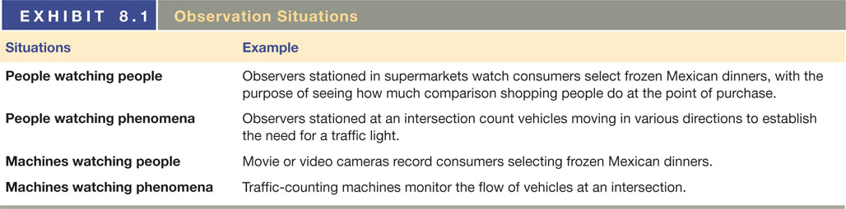

Human Observation
Ethnographic Research: Stems from anthropology. It is the study of human behavior in its natural context, involving observation of behavior and physical setting. It is a research method designed to explore cultural phenomena where the researcher observes society from the point of view of the subject of the study.

- Ethnographers directly observe the population they are studying. As “participant observers”, ethnographers can use their intimacy with the people they are studying to gain richer, deeper insights into culture and behaviour – in short, what makes people do what they do

- Advantages:
  - It is reality-based; it can show exactly how consumers live with a product, not just what they say about it or how they remember using it.
  - It can reveal unexpressed needs and wants and it can discover unexploited consumer benefits.
  - It can reveal product problems.
  - It can show how, when, where, and why people shop for brands.
  - It can show who in the family actually uses a product.
  - It can take advantage of consumers’ experience with the category and their hands-on creativity.
  - It can test new products in a real context.
  - It can reveal advertising execution ideas that derive directly from consumer experience.
  - It can form a better relationship with your consumers based on an intimate knowledge of their lifestyles.

Mystery Shoppers: People who pose as customers and shop at a company’s own stores or those of its competitors to collect data about customer-employee interactions and to gather observational data. They might also compare prices, displays, and the like.
- Major uses:
  - Monitor customer service & quality (services are variable)
  - Assess employee training

- Four basic levels:
  - Level 1: The mystery shopper calls the business with a script with questions and notes the experience.
  - Level 2: The mystery shopper visits the business and makes a quick purchase with little or no customer-employee interaction.
  - Level 3: The mystery shopper visits the business for a more involved experience to include a scripted scenario to gauge the customer-employee interaction. Level III usually does not involve a purchase - although detailed discussion about the product or services will likely occur.
  - Level 4: The mystery shopper visits the business with great knowledge about the products. This knowledge can be used to test the employees. A purchase (and/or issues related to the purchases) might likely be involved.

- Objectives of mystery shopping:
  - Enabling an organization to monitor compliance with product/service delivery standards, and specifications
  - Enabling marketers to examine the gap between promises made through advertising/sales promotion and actual service delivery
  - Helping monitor the impact of training and performance improvement initiatives on compliance with or conformance to product/service delivery specifications
  - Identifying differences in the customer experience across different times of day, locations, product/service types, and other potential sources of variation in product/service quality

One-Way Mirror Observations: Practice of watching behaviors and activities from behind a one-way-mirror
- Allows clients to observe the group discussion as it unfolds
- New product development managers and the like can note consumer’s reactions to various package prototypes as they are demonstrated by the moderator
- Clients can observe the degree of emotion exhibited by the consumers as he or she speaks
- Also used to observe children in psychology and testing toys

Audits: Examination and verification of the sales of a product

Machine Observation
- Traffic Counters
- Physiological Measurement Devices
- Electroencephalograph
- Galvanic Skin Responses
- Eye Tracking
- Facial Action Coding Service (FACS)
- Television Audience Measurement
- Portable People Meter
- Symphony IRI Consumer Network

Observation Research on the Internet
Internet Tracking:
- Modeling surfing patterns along with demographic and psychographic data to predict consumer behavior.
- Web site should mirror the customers’ buying process
- Click sequence / patterns should enhance predictive capability.
- comScore—tracks the Internet with a panel of over 2 million users
- Scraping the Web - Used to develop a cohesive message from thousands of conversation threads in newsgroups, chatrooms, listservs, message boards, Facebook, Twitter, etc. (E.g. Nielsen, Buzzmetrics)

Observation Research and Virtual Shopping
Advantages:
- Duplicates the distracting clutter of an actual market
- Can set up and alter the tests quickly
- Production costs are low after set up
- Very flexible

