Lecture 18, 19, 20, 21 and 22
Correlation
- Also called bivariate data
- Basic concepts
  - Correlation – relationship between 2 variables
  - Use a scatter plot
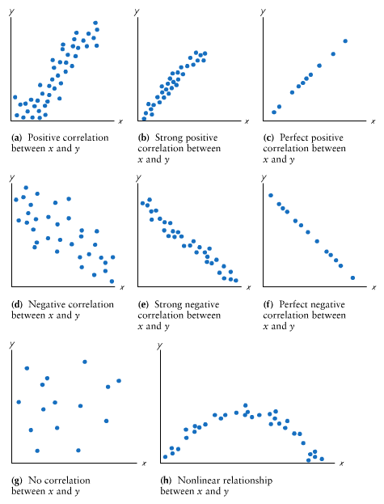
    - X and Y represent a one of the two variables used and are plotted together

  - Linear correlation coefficient (r) SAMPLE STATISTIC
    - Measures strength of correlation in a sample
    - Requirements
      - Sample data is random sample
      - Visual examination shows straight-line pattern
      - OUTLIERS REMOVED
    - Also, pairs of data must have bivariate normal distribution
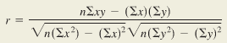
      - For and x, y must be bell shaped and vice versa

      - Round to 3 decimals
    - If VALUE FROM TABLE LESS THAN COMPUTED r VALUE, significant linear correlation
      - Write as “Since r=?, its absolute value does exceed ? so we conclude that there is a significant linear correlation between x and y.
    - Properties
      - -1 <= r <= 1
      - Value of r doesn’t change if all values for 1 variable converted to different scale
      - Value of r not affected by choice of x or y
      - r measures strength of linear association
    - interpreting r
      - value of r^2 is proportion of variation in y explained by linear association between x and y
      - “We conclude that r^2 of variation in y can be explained by linear association between x and y. This implies that 1-r^2 of variation in y can be explained by factors other than x.”
    - Common error
      - Correlation DOES NOT IMPLY CAUSALITY
        - Lurking variable – variable that affects but is not in study
      - Averages inflate correlation coefficient
      - Property of linearity
        - R=0 means there NO LINEAR RELATIONSHIP, but there can be others
- Beyond the basics
  - Hypothesis testing
    - Null = there is no significant correlation
    - Alternate = there is significant correlation
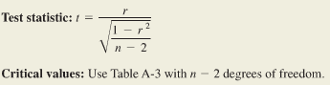
    - Method 1

      - If absolute value of t > critical value, reject null
        - Otherwise, say “there is not sufficient evidence to conclude that there is a significant linear correlation”
        - T is test stat, critical value is from table A3
    - Method 2
      - Test stat is r, critical value is from table A6
      - If absolute of r > critical value, reject null
  - Centroid
    - For given (x, y), point (x-bar, y-bar) is centroid

Regression
- Basic concepts
  - Association between x (independent variable) and y-hat (dependent variable)
  - Requirements
    - Paired sample (x, y) are random sample
    - Scatterplot shows straight-line pattern
    - Outliers are removed
  - Notes
    - For each x, y must be bell-shaped
    - For different values of x, y-values must have same variance
    - For different values of x, distribution of y-values have means on straight line
    - Y-values INDEPENDENT
  - How to solve
    - + episilon(i) REGRESSION EQUATION
    - Episilon is error term that shows how far each point is from the population regression line
      - Epsilon(i) ~ N(0, sigma(e))
      - Shows that…
        - Population regression points don’t line up
        - Concept of regression beyond simple linear regression
        - Two formal requirements
          - x,y ~ N(beta(0)+beta(1)*x, sigma(e))
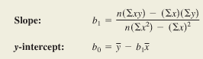
            - sigma is SD of error term, episilon is constant of all x
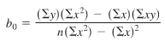

      - Round to 3 significant digits
- Beyond the basics
  - For predicting value y for x
    - No significant correlation = y-bar sample mean
    - Significant correlation = substitute x-value into regression equation
  - Guidelines
    - NO significance = don’t use regression
    - Stay in range of sample data (don’t calculate extremes)
    - Don’t use old data
    - Don’t make predictions of a population that’s different from sample data

  - Marginal change
    - Amount of change in a variable when other variable changes by one unit
    - SLOPE b1 IN REGRESSION EQUATION REPRESENTS MARGINAL CHANGE IN Y THAT OCCURS WHEN X CHANGES BY ONE UNIT
  - Outliers and influential points
    - Outliers are data points far outside other data
    - Influential points are points that strongly affect graph of regression line
      - Outliers that are horizontally far away from other points
  - Residuals and least-squares property
    - Residual is difference between observed sample y-value and y-hat (value predicted by regression equation)
      - Y – y-hat
    - Regression equation represents line that fits best according to least-squares property
      - When sum of squares of residuals is SMALLEST POSSIBLE
    - Residual plots
      - Scatterplot where y is replaced by y - y-hat
      - If there is NO PATTERN, regression equation is good representation
      - If there is A PATTERN, regression equation is not a good representation
Variation and Prediction Intervals
- Applications
  - Determine proportion of variation in y explained by association of x and y
  - Construct CI of predicted y-values (prediction intervals)
- Definitions
  - Total deviation – point that is vertical distance of y – y-bar
    - Distance between (x, y) and horizontal line passing through sample mean
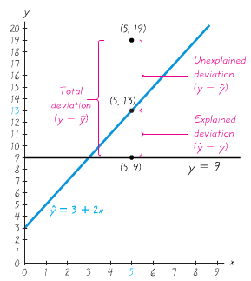
  - Explained deviation – vertical distance of y-hat – y-bar
    - Deviation b/c of using regression line
  - Unexplained deviation – vertical distance between y – y-hat
    - Deviation not from using regression line
  - Total deviation = explained deviation + unexplained deviation
  - Total variation = explained variation + unexplained variation
- Coefficient of determination
  - Amount of variation in y that is explained by regression line
  - R^2 = explained variation / total variation

- Prediction Intervals
  - Confidence interval estimate of predicted value of y
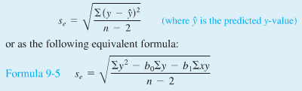
  - How to find

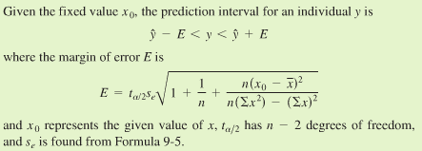
    - For an individual y

