- Stereochemistry
  - Isomers
    - Enantiomers
    - Diasteriomers
  - Absolute configuration (R & S)
  - Physical properties of enantiomers and diasteriomers
  - Resolution
- Intermolecular forces
  - Dipole-dipole
  - Hydrogen bond
  - Van der Waals

A.a- Isomers

Isomers : different compounds with the same molecular formula
- Constitutional Isomers: same molecular formula but different connectivity (different order) example : for C₄H₁₀, butane and 2-methylpropane
- Stereoisomers: atoms connected in the same sequence but differ in the arrangement of their atoms in space (ex. cis- and trans- isomers)
    - Enantiomers
    - Diasteriomers
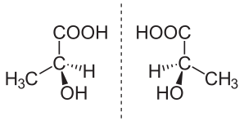
Enantiomer
- non-superposable mirror image (chiral)
- have at least one stereocentre (4 different substituents)
- Like right and left hands

Diasteriomer: all other stereoisomers that aren’t enantiomers
- cis- and trans- isomers (trigonal stereocentres)

Meso compound: achiral (has a superposable mirror image) ; same molecule but different (chair) conformation can be flipped to obtain same molecule (*popular for cis-isomers)

A.b- Absolute configuration
- naming system to differentiate between stereoisomers (Cahn-Ingold-Prelog)
  - R (clockwise)
  - S (counterclockwise)
- # of stereoisomers possible = 2^{n} ; n = # of stereocentres
  - n > 2 for diasteriomers

How to assign R + S configuration :
- Each of the 4 groups in the chiral centre is assigned a priority
  - highest atomic number (attached directly to chiral centre) = 1
  - lowest atomic number = 4
  - when priority cannot be assigned directly, continue down chain until point of difference is reached
  - if there is a double bond, break the bond and duplicate/triple its connecting atoms to assign priority, ex. C = O O-C–O-C
- Rotate formula so that group with lowest priority is directed away
  - or trick* : put hand in plane where lowest energy substituent lies and make circle on palm (substituent in back of plane of paper) or on back of hand (substituent in front of plane of paper) and form a circle in the 1-2-3 direction (observe orientation of circle from palm of hand point of view)
- Trace a path between groups 1-2-3
  - If clockwise, R ; if counterclockwise, S

A.c – Physical Properties of Enantiomers and Diasteriomers

Diasteriomers
- Have different properties from each other
  - Melting/boiling point m.p. & b.p.
  - Solubility
  - Chemical reactivity
- Basically two different compounds

Enantiomers
- Have identical physical properties, except two things :
- They react differently with other chiral molecules
- They rotate plane, polarized light in opposite directions
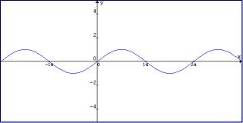
One photon (up/down movement)

Many photons unpolarized *polarizing filter* plain polarized light (PPL)

PPL [solution of a pure enantiomer] plane of polarization is rotated (α˚)

PPL [solution of a pure opposite enantiomer] same α ˚, opposite direction

*compounds that rotate light clockwise are dextrorotary – d (+)
*compounds that rotate light counterclockwise are levorotary – l (-)
angle rotation = α degrees (measured on machine) optical rotation
to compare with other samples, calculate specific rotation = [α]^{T}_{λ}
[α]^{T}_{λ} = 100 ⋅ α / l ⋅ c
α = observed rotation, l = length of cell (dm) – usually 1
T = temperature (˚C), c = concentration (g/100mL)
λ = wavelength usually 589 nm (sodium D line)

It is possible to measure samples of 100% pure enantiomers, but more often deal with mixtures of d (positive rotation) and l (negative rotation) enantiomers smaller α
Express as : optical purity = observed [α] / [α] of pure enantiomer x 100%
On a molecular level, this is controlled by an excess of one type of enantiomer over another.
  - Enantiomeric excess (ee)
  - For a mix of d & l isomers,
ee = ( | d-l | / d + l ) x 100%
*trick : make so that d + l = 100
ee = optical purity
In a mixture of equal amounts of d and l, [α] = 0, ee = 0, optical purity = 0
- several names : racemic mixture/racemate/dl mixture/± mixture

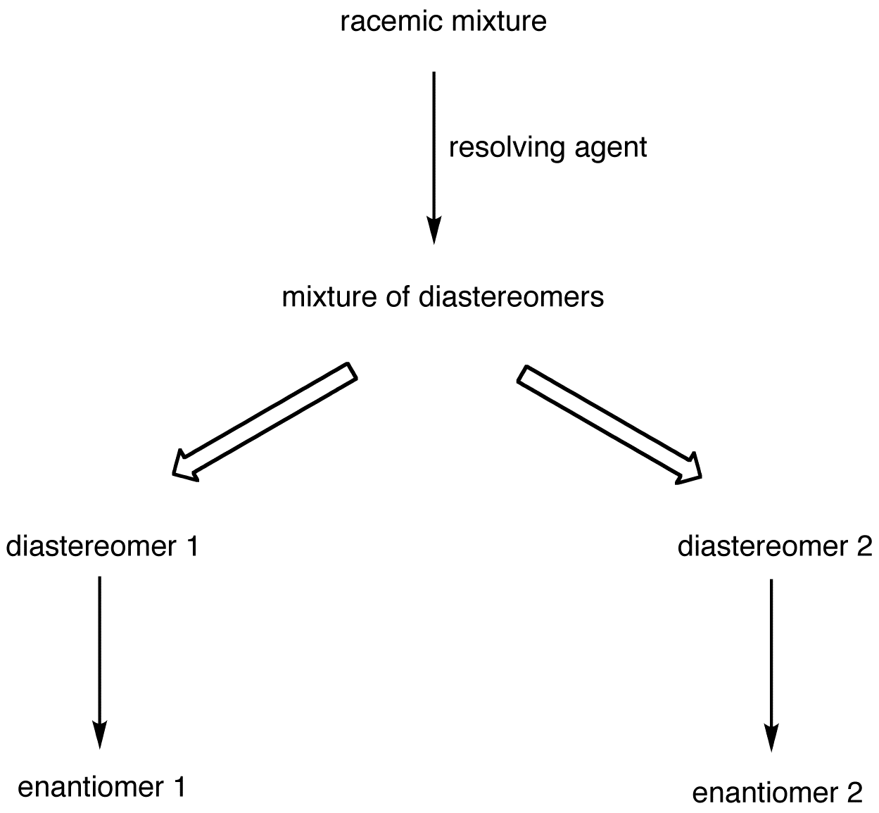
A.d- Resolution
- Method of separating two enantiomers
  - Temporarily make diasteriomers
- React mixture of two isomers with a different pure isomer
  - Separate them
- ex. by distillation
  - Regenerate enantiomers
- by chemical reaction

B- Intermolecular Forces
- attractive forces
- hold molecules together
- liquids & solids
- controls bulk properties:
  - melting point
  - boiling point
  - solubility
  - ‘feel’ of a substance (slippery, sticky, hard, soft)
  - interactions with other substances

a. dipole-dipole
- most molecules have dipoles (permanent dipole moment
- molecules orient to attract opposite dipoles (∂- ↔ ∂+)
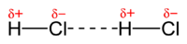
- strength of interaction depends on ∆E between atoms in bond and # of dipoles
  - big ∆E = big dipole
  - non-polar has little or no dipole
  - called the polarity of the bond
- as the polarity increases, get stronger intermolecular forces
  - higher boiling point
  - higher melting point
- medium in terms of intermolecular bond strength
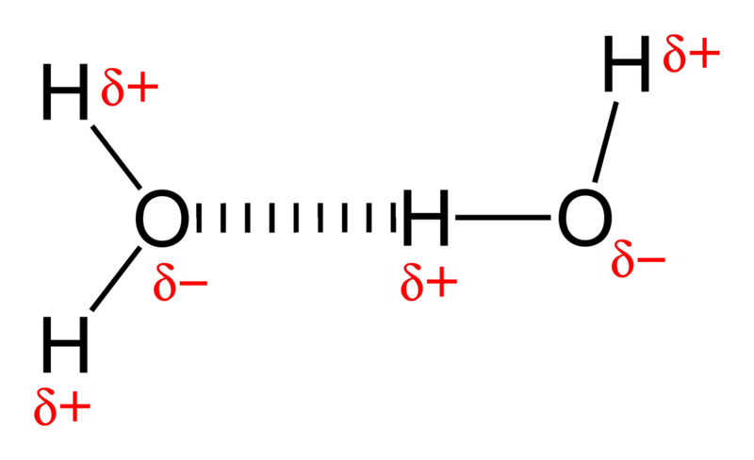
b. hydrogen bond
- not an actual bond but a strong dipole
- strongest type of intermolecular force
- strongest interaction when X – H ⋅⋅⋅ X –H aligned
  - if out of alignment, will have weaker interaction
- molecules that have no X-H bonds can still H-bond to other molecules that have X-H bonds (can accept H-bonds)
c. Van der Waals force
- important in hydrocarbons (C-H)
- non-polar
- result of small, temporary and random dipoles
A

A

++++++

- - - - - -
A

B
b
++++++

- - - - - -
- - - - - -

electron movement/dipole interaction
B

++++++

- - - - - -
++++++

- size of force depends on area of contact between A + B
- branching disrupts interactions
- in general, van der Waals forces give :
  - higher boiling point
  - higher melting point
- forces can sometimes ‘slip’ make for slippery substances

Intermolecular Forces & Properties
- H-bond > dipole-dipole > van der Waals
  - Based on surface of contact for Van der Waals
  - Once a dipole is introduced, it becomes predominant
  - Once an h-bond is introduced, it becomes predominant

Solubilities
- ‘like dissolves like’
  - to dissolve in a solvent, solute must have similar intermolecular forces
  - most of organics have lots of van der Waals
    - dissolve in organic solvents
    - are insoluble in water, except when…
- organic has lots of H-bond ability (relative to van der Waals surface)
  - methanol, ethanol, propanol and butanol are soluble in water ; atoms with more than 4 C are not soluble in water (too much van der Waals surface)
- charged organics (acids/bases) dissolve in water
  - an acid alone won’t dissolve in water, but when NaOH is added, it becomes a soluble ion

