Chemistry Mid-Term #1

Definitions
- Organic chemistry: study of molecules containing carbon (60%)
- Heteroatom: anything other than C,H ; O, N, Cl, Br, I, P, Si, S, B, F
- Electronegativity: ability of atom to attract e’s ; higher EN = better e attraction
- Ionic bond: atoms attracted by charge ; requires EN difference of 2
- Covalent bond: e’s shared between atoms ; ∆EN < 2 ; mix atomic orbitals to create molecular orbitals (bonds with C = covalent) ; represented by Lewis structures
- Orbital: region in space around atoms where probability of finding e’s is high ; has wave properties
- Molecular orbital: abbreviated M.O., made by mixing two atomic orbitals in phase (two positives or two negatives) ; creates a sigma (σ) bond ; called a bonding orbital ; lowers energy of the two atomic orbitals combined ; electron density between the two atoms ; putting electrons into σ orbital forms bonds
- Anti-bonding orbital: made by mixing two atomic orbitals out of phase (a positive and a negative) ; creates a sigma star (σ*) bond ; raises energy of the two atomic orbitals combined ; node in between atoms ; putting electrons into a σ* orbital forces atoms apart
- Hybridization: carbon can mix orbitals to make new orbitals for bonding
- σ bond: lies along the axis between atoms ; overlaps with sp^{n} orbitals or s orbitals ; determines 3-D shape of molecule ; drawn using lines (M.O.)
- π bond: above and below (still only one bond) the axis between atoms ; formed from p orbitals ; prevents rotations ; drawn by having two p orbitals (in phase) connected by a line

Concepts Learned:
- Nomenclature
- Lewis Structures
- Resonance
- Molecular shapes/LCAO method
- Conformations/Newman projections
- Chair/boat conformation
- Stereochemistry
  - Enantiomers
  - Diasteriomers
  - Absolute configuration (R & S)
  - Physical properties of enantiomers and diasteriomers
  - Resolution
- Intermolecular forces
  - Dipole-dipole
  - Van der Waals
  - Hydrogen bond

2- Lewis Structures
- Represent covalent bonds
  - e’s are represented by ⋅⋅ (non-bonding electrons/lone pairs)
  - bonds are represented by – (molecular orbitals)
- Carbon almost always has 4 bonds (can have less but never more -1 on midterm)
- Drawing Lewis Structures :
- Count total # of electrons
  - For each negative charge, add 1e ; for each positive, subtract 1e
- Draw molecule using single bonds
  - Each C is followed by atoms bonding to it, up to 4
- Count e’s used in each bond
  - 2 for each, so # bonds x 2 = # electrons in bonds
- Add remaining e’s to most electronegative first
  - Usually oxygen, nitrogen…
  - Stop when you get a full octet and move to the next electronegative
- Count formal charges
  - = (atomic group) – (# bonds) – (# non-bonded e’s)
  - tip : skip H
- Eliminate, when possible, two opposing formal charges by putting a negative charged atom’s extra electrons into bonds, forming double and triple bonds.

3- Resonance
- for compounds that can be drawn more than one way, differ in electron positions
- Drawing Resonance Structures:
- Repeat steps 1-5 of Lewis Structure
  - If given structure already drawn, still start from Step 1 (count total number of electrons in the shape 2 per bond)
- There are two (or more) possibilities to form double/triple bonds. Draw each separate possibility, ensuring that the C does not exceed 4 bonds.
  - Draw all of the contributing resonance structures, separating each by a double-headed arrow, ↔.
  - Move only electrons of multiple bonds and non-bonding electrons.
  - The actual structure is a blend of these structures. It is called the ‘resonance hybrid’.
  - To draw the resonance hybrid, in which the partial double bonds are indicated by a combination of a solid line and a dashed line.
- The energy of the resonance hybrid is lower than the energy of any contributing structure. (Resonance stabilizes a molecule/ion)
- The more stable a structure is by itself, the greater is its contribution to the hybrid. In general, the best structures will have:
- Full octets on all atoms
- Fewest formal charges
- Negative charges on electronegative atoms
- Positive charges on electropositive atoms
- Max separation of similar charges (++ or --)
- Min separation of opposite charges (+-)
- Therefore, 4 general cases for if the structure is insignificant:
- Forms with more than 2 charges
- Structures with positive and negative charges are ok, as long as the negative charge is on the most electronegative atom.
- Positive charges on electronegative atoms are ok if atom has a full octet.
- Broken double bonds (all connected by single bonds, like in original structure) are only significant when heteroatoms are involved.
4- Molecular shapes/LCAO Method
- 3 possibilities of molecular shapes:

- linear: all atoms are 180˚ apart (ex. H – C ≡ C – H)
- trigonal: all atoms are 120˚ apart (ex. 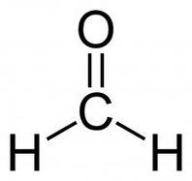 - formaldehyde)
- tetrahedral: 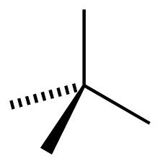formed by two V’s joined at the tip ; plane of each V is 90˚ to the plane of the other ; use hash to show to show ‘in back of plane’ and wedge to show ‘in front of plane’.

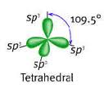
- Carbon can assume any of these geometries (hybridize orbitals to do this):
Tetrahedral:
    - sp³ orbitals formed by mixing 1 s and all 3 p orbitals
    - energy between s & p
    - when atom is surrounded by 4 ‘things’ (bonds or electron pairs)
Trigonal:
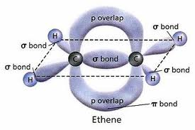
    - sp² orbitals formed by mixing 1 s and 2 p orbitals (one p orbital left)
    - π bond created between remaining p orbitals to prevent rotations
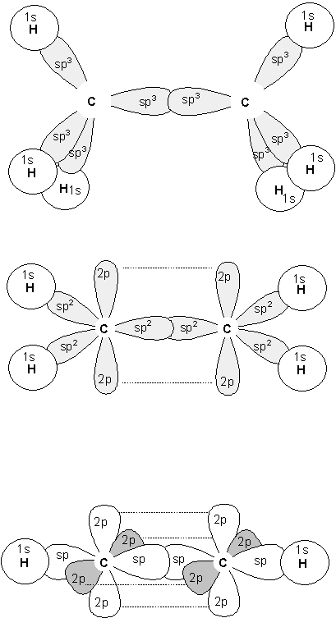
    - π bond is above and below the axis between atoms
    - when atom is surrounded by 3 ‘things’
Linear:
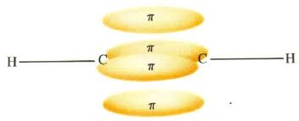
    - sp orbitals formed by mixing 1 s and 1 p orbital (2 p orbitals left)
    - two π bonds formed by overlap of p orbitals on each C
    - π bonds are 90˚ to each other
    - when atom is surrounded by 2 ‘things’

sp³ orbital in C₂H₆ sp² orbital and π bond in C₂H₄ sp orbital and π bonds in C₂H₂

- Alkanes have only C + H (single bonds) so all carbons are sp³
- Different types of line notation:

- Condensed structure ex. CH₃ – CH₂ – CH₃ for propane
- Lewis structure ex. 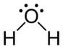 for H₂O (lone pairs included)
- Line structure ex. 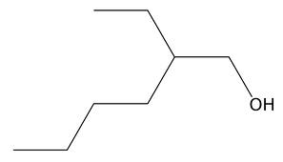 (heteroatoms are shown)

5- Conformations/Newman Projections
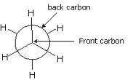
- Conformations are structures obtained by rotating σ bonds.
- Newman Projections facilitate viewing of these structures.
  - As if you are looking ‘down’ one of the bonds
- Two main types of conformers:
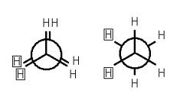
- Staggered conformation max separation of atoms ; lowest energy
- Eclipsed conformation
min separation of atoms (directly overlapping) ; highest energy

Butane conformers
- CH₃ – CH₂ – CH₂ – CH₃ (looking down this axis)
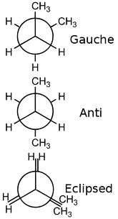
Gauche staggered: large groups are 60˚ apart (medium energy)

Anti-staggered: large groups are 180˚ apart (most stable – max separation of large groups)

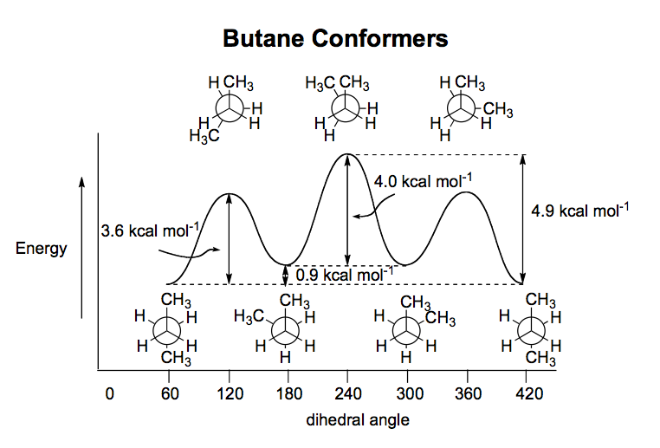
Eclipsed (2 types): 1- when H + CH₃ overlap each other, steric interaction increases energy of this conformer (less stable) ; 2- when large groups have min separation (overlap), steric interaction again highest energy

6- Chair/Boat Conformation
- Cyclohexane is the most stable of all rings because
  - it is a strain-free conformer
  - there is no eclipsing
  - all angles are 109.5˚
Chair conformation
*Will have to draw a chair conformer on the midterm
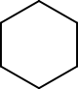

Top view rotate chair *no eclipsing
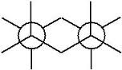

All staggered

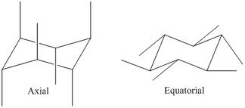

- Look at H’s on the Chair; 2 positions :
  - Axial position
    - Orientation (up/down) alternates
  - Equatorial position
    - Parallel to plane of ring

- Chairs can ‘flip’ :

⇔

When flipping a chair with substituents…
- Number the carbons in the original chair in clockwise order.
- Number the carbons in the flipped, keeping that:
  - The leftmost carbon remains the leftmost carbon (same number).
  - The rightmost carbon remains the rightmost carbon.
  - Number in clockwise order.
  - Whatever substituent is on top, stays on top.
  - Axial substituents become equatorial, and vice versa, on the appropriate carbon (same number as original chair).

- There is more space for groups in the equatorial position, therefore it has lower energy and is more stable (largest group must be equatorial)
- There is possibility of steric interaction for axial position. (not good)

