Lesson 4

Books of NT were all written in Greek
Jesus, Jew, spoke armaic
People around him spoke Armaic and Hebrew
books about him, they are all in greek
Jewish revelation taken over by Christianity and culture surrounding it
Culture was Hellenism
What is Hellenism:
It was blend of greek and orient that rose in wake of alexander the great conquest

Masedonian king
Before jesus, He was conquering more and more territory, spreading greek way of life
(greek way of doing business, learning, fighting war) = Hellenism
HELLADA: = Greece
Died in 30s
But was very influential, coronels that fought along him spread Hellenism
Hellenistic legacy very important at the time

Reaction to Hellenism
certain reaction against Hellenism in land of Palestine
But diff reaction among Jews outside of Palestine
And diff for Christians
In Palestine it was rejected because a Hellenistic ruler from Syria Hellenized jews by having zeus god statue in temple -> revolt from jews, reconsegration of temple
Rejection of Hellenism
- Jerusalem was important city at the time and jews there most were Hellenized
- But not the case in most land of Palestine
Also outside of Palestine people didn’t reject Hellenism
Example: Philo(jew) was impressed by it, he wasn’t a speaker of Hebrew
He had to order translation of Hebrew bible into greek THE SEPTUA
Philo and Hellenistic jews outside of Palestine were embraced by early Christian writers,

2nd important point Justine martyr

Hellenism is the blend of Greece and the Orient that arose in the wake of Alexander’s conquests and embraced all aspects of life.
Alexander the Great (356-323 BCE)
- King of Macedonia (Southeastern Europe) 336-323
- Overthrew the Persian Empire, carried Macedonian arms to India, and laid the foundations for the Hellenistic world of territorial kingdoms
- Educated by the philosopher Aristotle
The Generals
Some of Alexander’s generals founded the dynasties of the:
- Antigonids (ruled over Macedonia)
- Ptolemies (ruled over Egypt)
- Seleucids (ruled over Babylonia, Syria and Palestine)
They all contributed to the spread of Greek culture
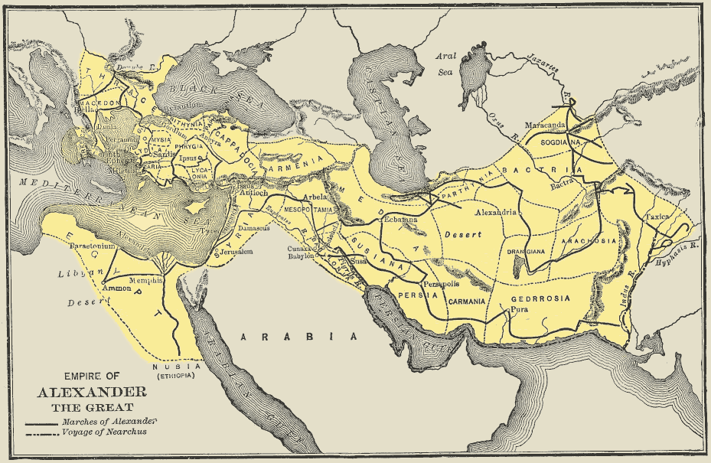

The Spread of Hellenism
- Hellenism included Greek education, ideals of administration, warfare, trade, commerce, sport, rhetoric, literature and philosophy.
- Hellenism was effectively spread by Roman emperor Augustus, who made Romans the patrons of Hellenism.
- There was a mixture of Roman and Greek unity after Augustus.

Hellenism and Judaism
- In Palestine, Hellenism was introduced as early as 332 BCE, when Alexander conquered the territory
- Palestinian Judaism was faced with either accepting or rejecting the Hellenistic way of life
- Antiochus IV Ephiphanes Hellenized Judaism to the point of placing a statue of Zeus in the temple in Jerusalem
- The Maccabean Revolt (168-164 BCE) ensued and attempted to re-establish the Jewish way
- Jerusalem was a highly Hellenized city, with many of its inhabitants being conversant in Greek
- Actual rejection of Hellenism in Palestine took place after 50 BCE and was completed in the Jewish wars of 66 and 135 CE
- In the diaspora, however, Hellenism was not rejected by Jews
Philo of Alexandria (20 BCE-50 BCE) is an example of a Hellenized Jew who did not speak Hebrew, but did speak Greek, lived in Egypt and was an admirer of Hellenism

Christianity and Hellenism
Unlike Palestinian Judaism, the first Christians (with some exceptions) did not reject Hellenism
- Many early Christian converts made by Apostle Paul were Greek-speaking Jews from the diaspora
- The Koine dialect of Greek was the natural vehicle for Christian proclamation
- The New Testament (NT) books were written in Greek
Paul was not adequately prepared philosophically to engage in dialogue with the real Gentiles (non-Jews)

Greek Philosophy
Unlike Greek and Roman religions, Greek philosophy promoted ethical teachings. It was similar to the teachings of Judaism and Christianity in this regard. It promoted virtue and happiness and spoke of a dissatisfaction with the actual human condition.
Christianity ended up allied with Greek thought.

Justin Martyr (100-165 CE)
Three main arguments regarding Greek philosophy:
- The Loan/theft Theory: The philosophers read or borrowed from Moses - hence the similarities between Christianity and philosophy philo like plato, Aristotle, stoic, had access to books of Hebrew bible, read pentatuc (5books), which is why you have similarities between Christianity and greek philo, and this argument was used by Philo (jew philo) who had tried to harmonize Judaism with greek philo, and then Justin found these arguments appealing, but today we can say that moses writings weren’t put together so this is impossible
- The Demon Theory: Distortions of the truth in Greek mythology are the works of demons, there is some truth in greek reli, which is seen in Judaism and Christianity but distorted through the work of demons (smarter than humans and more capable of cheating) interested in distorting the truth
The LogosTheory (logos spermatikos): The whole of the Logos (Word/Reason of God) is present in Jesus Christ, but portions (or seeds) of it are found among Jews and Greeks as well theory allows for fragments of truth among reli other than Christianity, logos fully present in one person (jesus, incarnate son of god) and fullness of logos is present in him, so Justin meant that greek philo and christinaity had similarities but are different as you find fragments of truth in greek you find fullness of truth in Christianity -> demonstrates that Christianity is valuable and not a superstition and should not be persecuted

Clip
One of earliest chirstian witter
2nd century
origanly a philo who embraced Christianity
defending it in front of roman authority who were persecuting it
to the point of being killed for Christian belief
he is important because he one of representatives of early Christianity
not shy to speak about greek philo
and ried to harmonize it with Christianity to show that it is not a weird and superstition belief, but could be considered equal to wha greek philosophers have said like Aristotle and plato

explaning how Christianity was born in this environment and how it embraced greek (lingua of circulation), this so they could share msg of jesus to larger audience
some jews converting to Christianity
but mot jews rejected its msg as he was considered the messiah

decided that best way was to book msg in greek cause,
proud of both greek and chirstian legacy (Justin)
he tried to work out the relationship between both
3 arguments (seen above with comments of clip)

MP3 CLIP LEGACY
Hellenism (greek ways) in Greco roman emprie and its link to Judaism and Christianity
Judaism rejected itin land of Judea
But not the case outside of Judea/Palestine
Father of Alexandria Hellenistic jew lived in time of jesus

Greek philo and moses
Scholars know its not the case that philo read moses
But it was their way to connect jewish theo with greek philo
Greek was like English today, helped Christianity

Schools talked about virtue and happiness
Christian talked about virtueness brought happiness
Also similarity between Socrates and jesus
Learn about stoics (group of philo who recommend virtue) learn about how some Christian have blended together number of elements of these philo with chirstian elements oftime
Despire similarities
You have compititon between
Why? They talked about the same issues, and Christian were trying to form and attract new believed in their church, specially in 2nd and 3rd century,
Celsus (philo), critical, Christianity philo for the uneducated, the writing were poorly written, authors didn’t know principles of rethorics,

Tortolian (CHRISTIAN), what does Athens have to do with Jerusalem
By Athens he meant philo thought
And Jerusalem chirstian thought
Do we as chirstians need philo language? What do we have to do with philo?
Protestant groups today still ask this question
As jesus was no philosopher
Important to know why Christians asked this? Its because it was born in that envrionemtn in greek schools, as well by adopting language and way of thiking chirstianism was allowed to spread message

MP3 on Justin Martyr first apology

Chapter 6. Charge of atheism refuted
main idea: chirstians accused of being ateist, and he refutes it by saying that If they were considered to be pagans they are atheist as they don’t believe in those gods, but as chirstians they are not atheist as they believe in god, they worship reason truth, confess 3 divine person in Christianity, trinity
Hence are we called atheists. And we confess that we are atheists, so far as gods of this sort are concerned, but not with respect to the most true God, the Father of righteousness and temperance and the other virtues, who is free from all impurity. But both Him, and the Son (who came forth from Him and taught us these things, and the host of the other good angels who follow and are made like to Him), and the prophetic Spirit, we worship and adore, knowing them in reason and truth, and declaring without grudging to every one who wishes to learn, as we have been taught.
Chapter 7. Each Christian must be tried by his own life
as crimminals they have to be judged, being a C dsnt mean we are criminals, don’t look at us as a group, some may be, but not all are, Christianity has nothing to do with criminality
This apology was addressed to emperor, wdk if it reached emperor tho

But some one will say, Some have ere now been arrested and convicted as evil-doers. For you condemn many, many a time, after inquiring into the life of each of the accused severally, but not on account of those of whom we have been speaking. And this we acknowledge, that as among the Greeks those who teach such theories as please themselves are all called by the one name Philosopher, though their doctrines be diverse, so also among the Barbarians this name on which accusations are accumulated is the common property of those who are and those who seem wise. For all are called Christians. Wherefore we demand that the deeds of all those who are accused to you be judged, in order that each one who is convicted may be punished as an evil-doer, and not as a Christian; and if it is clear that any one is blameless, that he may be acquitted, since by the mere fact of his being a Christian he does no wrong. For we will not require that you punish our accusers; they being sufficiently punished by their present wickedness and ignorance of what is right.
Chapter 8. Christians confess their faith in God
fact that C are not afraid of faith in god, they have hope that afterworld in kingdom of god they will live in world where there is no sin that will cause disturbance, basic msg
And reckon that it is for your sakes we have been saying these things; for it is in our power, when we are examined, to deny that we are Christians; but we would not live by telling a lie. For, impelled by the desire of the eternal and pure life, we seek the abode that is with God, the Father and Creator of all, and hasten to confess our faith, persuaded and convinced as we are that they who have proved to God by their works that they followed Him, and loved to abide with Him where there is no sin to cause disturbance, can obtain these things. This, then, to speak shortly, is what we expect and have learned from Christ, and teach. And Plato, in like manner, used to say that Rhadamanthus and Minos would punish the wicked who came before them; and we say that the same thing will be done, but at the hand of Christ, and upon the wicked in the same bodies united again to their spirits which are now to undergo everlasting punishment; and not only, as Plato said, for a period of a thousand years. And if any one say that this is incredible or impossible, this error of ours is one which concerns ourselves only, and no other person, so long as you cannot convict us of doing any harm.
Chapter 46. The Word in the world before Christ
what happened before coming of jesus, before incarnation of word of god into historical person JESUS, and he says that people lived before this and they had a part in this knowledge of logos, theory of logos, logos (important principle in greek philo) was always present in world, but was only known fullest in JESUS,
Chapter also deals with creed, early version of creed that martyr and c community: according to will of god, he was born of virgin, crucified etc, early form of creed, in 4th century creed of constantinaple, it is taken again
But lest some should, without reason, and for the perversion of what we teach, maintain that we say that Christ was born one hundred and fifty years ago under Cyrenius, and subsequently, in the time of Pontius Pilate, taught what we say He taught; and should cry out against us as though all men who were born before Him were irresponsible — let us anticipate and solve the difficulty. We have been taught that Christ is the first-born of God, and we have declared above that He is the Word of whom every race of men were partakers; and those who lived reasonably are Christians, even though they have been thought atheists; as, among the Greeks, Socrates and Heraclitus, and men like them; and among the barbarians, Abraham, and Ananias, and Azarias, and Misael, and Elias, and many others whose actions and names we now decline to recount, because we know it would be tedious. So that even they who lived before Christ, and lived without reason, were wicked and hostile to Christ, and slew those who lived reasonably. But who, through the power of the Word, according to the will of God the Father and Lord of all, He was born of a virgin as a man, and was named Jesus, and was crucified, and died, and rose again, and ascended into heaven, an intelligent man will be able to comprehend from what has been already so largely said. And we, since the proof of this subject is less needful now, will pass for the present to the proof of those things which are urgent.
Chapter 49. His rejection by the Jews foretold
he talks about jesus’ recjection by jews, emphasizes that it was foretold by prophets (scholars say that he reflects tension between jews and Christians, a tension that existed that dealth with opposition, a new reli movement ©) so justin says that prophets talked about this rejection (scolars do know tho that the tension was social)
And again, how it was said by the same Isaiah, that the Gentile nations who were not looking for Him should worship Him, but the Jews who always expected Him should not recognise Him when He came. And the words are spoken as from the person of Christ; and they are these I was manifest to them that asked not for Me; I was found of them that sought Me not: I said, Behold Me, to a nation that called not on My name. I spread out My hands to a disobedient and gainsaying people, to those who walked in a way that is not good, but follow after their own sins; a people that provokes Me to anger to My face. Isaiah 65:1-3 For the Jews having the prophecies, and being always in expectation of the Christ to come, did not recognise Him; and not only so, but even treated Him shamefully. But the Gentiles, who had never heard anything about Christ, until the apostles set out from Jerusalem and preached concerning Him, and gave them the prophecies, were filled with joy and faith, and cast away their idols, and dedicated themselves to the Unbegotten God through Christ. And that it was foreknown that these infamous things should be uttered against those who confessed Christ, and that those who slandered Him, and said that it was well to preserve the ancient customs, should be miserable, hear what was briefly said by Isaiah; it is this: Woe unto them that call sweet bitter, and bitter sweet. Isaiah 5:20

