CHAPTER 1:
Creating and Capturing Customer Value

def. Marketing: “Managing profitable customer relationships”
- Attracting new customers
- Keep current customers happy through continued satisfaction
- It’s not just a selling transaction, it’s building a relationship

The Marketing Process
Create value for customers and build Capture value from
customer relationships customers in return

Customer Needs, Wants and Demands
NEEDS
- These are not created by Marketers
- They are predetermined needs that we all have
- Physical Needs: food, clothing, warmth, safety
- Social Needs: belonging and affection
- Individual Needs: knowledge and self expression
WANTS and DEMANDS
- Wants satisfy needs, but are not always obtainable
- Vary from person to person and are influenced and shaped by our culture
- A want becomes a demand when you have the buying power
Ex. I NEED a phone but I WANT an iPhone.

Market Offerings
Customer needs/wants are satisfied by the market offerings.
i.e. Products, services, information, experiences.

Marketing Myopia
- Happens when a company focuses too much on the product
- They lose sight of the underlying needs and focus on the existing wants
- Their product is a tool to solve a problem
Ex. I need to make a hole, I don’t really need an electric drill, but just something that makes a hole.
Customer Value and Satisfaction
- The perceived value of a product and how it satisfies a need determines if a customer will buy it of not
- There is a fine line of where to set the expectations of a customer…
- Too high: the customer will be dissatisfied and switch to you competitor
- Too low: the customer may look you over

Exchange and Relationships
- Exchange is when one person offers something in return for their desired object.
- Marketing happens when people decide to satisfy through Exchange Relationships
- Exchange Relationships is a long-term bond that a seller and consumer have. A seller wants to strengthen this bond so the consumer continues buying his products.

Markets
- A market is a set of potential and actual buyers of a product.
Ex. Athletic market, urban market, hipster market, etc.
- A marketer manages his markets to produce a profitable return by nurturing a lasting relationship with the customer
- Sellers find the buyers, access their needs, and design their market offering around those needs.
- Marketers ask not only, “How do I reach the consumer?” but, “How will my consumer find me and fellow consumers?”
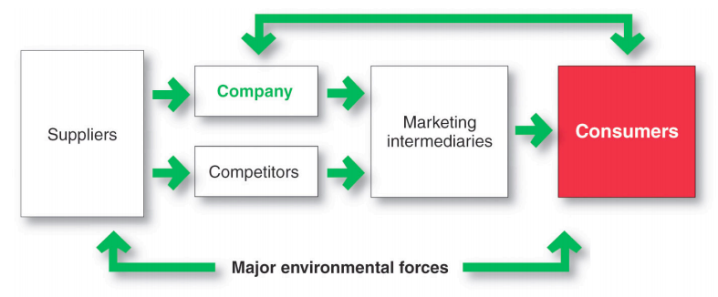
DESIGNING A CUSTOMER-DRIVEN MARKETING STRATEGY
A marketing strategy outlines who the customers are and how they will create value.
You have a product, what do you do now…?
- Market Segmentation
- Target Markets
- Value Proposition
- Market Management Orientations

Step 1: Market Segmentation
- Refers to dividing the markets into segments of customers
- You have to decide who you’re going to serve
- Look at what your product does…
- “Who can it serve?”
- “Can it be used for other things?”
- These questions will lead you to find different markets that have the potential to be interested in your product

Step 2: Target Markets
- Refers to which segments to go after
- You now know your options, which ones will you focus on?
- Your target market will be the people you think will most likely buy and get use from your product

Step 3: Value Proposition
- Refers to the set of benefits or values a company promises to deliver to customers to satisfy their needs
- Choose how your customer is going to see your product, especially in relation to others
- You are answering the customers’ question, “Why should I buy yours and not theirs?”

Step 4: Marketing Management Orientations
- In this step, you design a strategy to build a lasting relationship with your consumers
5 different strategies:

The Production Concept
- The idea that consumers will favor products that are widely available at a lower cost
- With this concept, one would focus on lowering production costs and having an efficient distribution system
Ex. Gum

The Product Concept
- The idea that people will prefer products of high quality, performance, and features
- This means one would focus on continually making improvement to their product
Ex. Online video games and their updates

The Selling Concept
- This is the idea that consumers won’t buy a product without a large selling or promotional offer
- This would require a lot of work in advertising
Ex. Cars or McDz trio
The Marketing Concept
- The marketer’s idea that achieving his goal is dependent on understanding the needs and wants of their target market and satisfying them better than competitors
- This requires a lot of ground work and requires you to fully understand your target audience and competitors
Ex. Tide says they understand fabrics (i.e. will take care of them) rather than just clean

The Societal Marketing Concept
- The idea that one should not only satisfy an immediate want and need, but also the long-term in the case of the individual and society
Ex. Sunchips degradable chip bags

Preparing an Integrated Marketing Plan and Program
- This is where you develop a program to deliver the intended value to the consumers
- It takes the marketing strategy and puts it in action
- The 4 Ps that make up the marketing mix are the tools used to implement the strategy

The 4 Ps
- Product: something that satisfies a need
- Price: what will it cost?
- Place: how/where it will be available
- Promotion: the merits of the product

Customer Relationship Management (CRM)
- This is potentially the most important concept of modern marketing
- This is the overall process of building and maintaining customer relationships through superior customer value and satisfaction

Relationship Building Blocks: Customer Value and Satisfaction
Customer Perceived Value
- This is what the customer believes you product is worth in comparison to its benefits and what the competition is offering
- The perceived value must not be lower than the price of the product. If it is, then the consumer will opt for the competition
Customer Satisfaction
- This is the balance of the product’s perceived performance and the buyer’s expectations
- If a customer expects more of a product that doesn’t deliver, they won’t be inclined to trust that company again

Customer Relationship Levels and Tools
There are different depths to the relationships a company will pursue…
- A common product (like soap) will rely on its advertising to create a relationship with customers known as a basic relationship.
- Products that are sold less often (like luxury cars) involve more personal relationships that are called full partnerships.

Relating with more Carefully Selected Customers
- Companies practice less mass advertising and more targeted advertising now
- This involves finding the “Angels” in a crowd and targeting them with promotions and services, while they discourage the “Demons” from going to their store
- Consumer-Generated Marketing: messages, ads, and other means of communication that boast a product created by consumers whether its invited or not.
Ex. Blog posts, Twitter posts, etc.

Partner Relationship Management
- This is working closely with partners both inside and outside of the company to bring better value and satisfaction to customers
- These partner can be: people in a different department, or people in an affiliated company

Customer Loyalty and Retention
- How satisfied a customer is will dictate what they tell their friends about your product and if they will continue buying that product
- Customer Lifetime Value: Not the individual purchases, but the purchases made over the customer’s lifetime.
- Share of Customer: The percentage of a customer’s buys that a company gets.
- Customer Equity: The combined customer lifetime values of all the company’s customers.

Building the Right Relationships

The Changing Marketing Landscape
- The Digital Age: Advances in computers and transport make for better customer research, product development, 24/7 marketing online.
- Rapid Globalization: Geographical and cultural distances have shrunk for greater market coverage, more options for purchasing and manufacturing, increased competition from foreigners.
- Ethics and Social Responsibility: Marketers need to take responsibility for the impact of their actions (i.e. Caring Capitalism: a way to differentiate)
- Not-for-Profit Marketing: Many non-profit organizing are realizing the importance of marketing (ex. Performing arts, government agencies, etc.)

MARKETING:
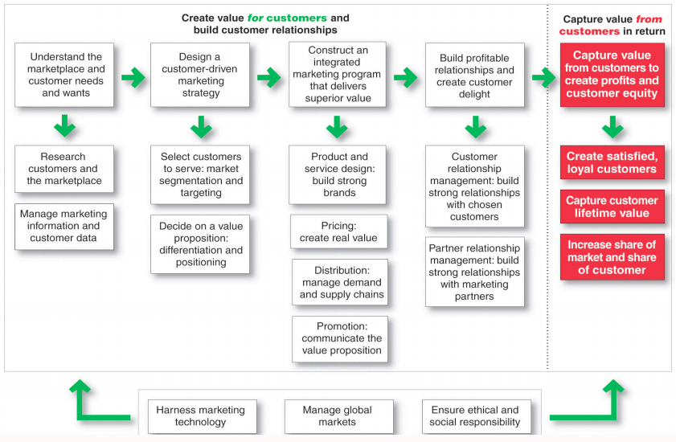
PUTTING IT ALL TOGETHER

CHAPTER 2:
Company and Marketing Strategy: Partnering to Build Customer Relationships

Strategic Planning
- Strategic Planning is the process of developing and maintaining a strategic fit between a company’s goals and capabilities and its changing market opportunities.
There are 4 steps:
- Mission Statement
- Setting Objectives and Goals
- Designing a Business Portfolio
- Planning Marketing and Other Strategies

Step 1: Mission Statement
- This describes the company’s purpose and what it wants to accomplish
- This is NOT a slogan
Ex. Canadian Tire’s Mission Statement: “to offer products and services to meet the everyday needs of Canadian families – today and tomorrow”

Step 2: Setting Objectives and Goals
- No matter what you’re doing, you want to have objectives and goals so you have a direction
- Business objectives: build profitable relationships, improve profits, etc.
- Marketing objectives: increase market share, create local partnerships, increase promotion, etc.

Step 3: Designing a Business Portfolio
- The business portfolio is the collection of business and products that make up a company
- To determine if you have a good portfolio, you must analyze it. One good method of doing so is the Growth Share Matrix
- The Growth Share Matrix is a portfolio planning method that divides a company into Strategic Business Units (SBUs) and evaluates them based on growth rate and market share
- SBU: a unit of the company that has a separate mission and objectives that can be planned separately from other company businesses (i.e. Company division, product line within a division, single product or brand)
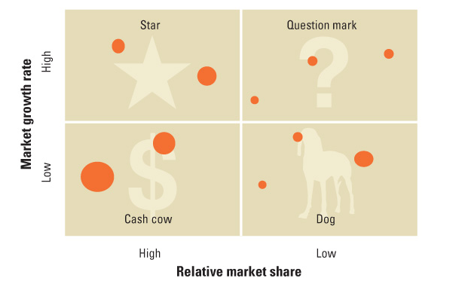

- Stars: High-growth and profit but need a lot of investment.
- Cash Cows: Little growth but high-profits. Need little investment.
- Question Marks: Low share in high growth markets. They require A LOT of money just to stay afloat.
- Dogs: Low growth and low share but generate enough cash to stay afloat.

Product/Market Expansion Grid
- This is another way of evaluating a business portfolio
- It aims to identify growth opportunities through:
Market Penetration
Market Development
Product Development
Diversification

Market Penetration
- Increasing sales of current products in a current market segment without changing the product
Ex. T Hos constantly sells the same thing to the same people

Market Development
- Identifying and developing a new market segment for a current product
Ex. T Hos finding new people to sell coffee to (i.e. Old people instead of students)

Product Development
- Altering or modifying a product for current market segments
Ex. T Hos offering flavored and iced coffee to the same students

Diversification
- The aim of growing a company by either starting up or acquiring businesses outside the company’s current products and markets
Ex. T Hos adding a gas station to their locations for both current and new customers

Downsizing
- Refers to the reduction of the business portfolio by eliminating products or business units that are not profitable or that no longer fit the company’s overall strategy
- Company growth is great, but sometimes you need to know when to pull out
- There are many reasons to abandon a product which include:
Change of environment
Company grew too fast and can’t handle it
Entering areas where it lacks experience

Planning Marketing: Partnering to build customer relationships
- Value Chain: The series of departments that carry out value-creating activities to design, produce, market, deliver, and support a firm’s products.
- Value Delivery Network: The company, suppliers, distributors, and ultimately customers who partner with each other to improve performance of the entire system.

Marketing Strategy and the Marketing Mix
- Marketing Strategy: The marketing logic that the business hopes to create customer value and achieve profitable customer relationships.
- This involves:
Market Segmenting and Targeting
Market Differentiation and Positioning

Market Segmentation and Targeting
- Market Segmentation: The division of markets based on different needs, characteristics, or behaviors which would require different products.
- Market Targeting: The process of evaluating market segments and deciding which to enter.

Market Differentiation and Positioning
- Market Positioning: Arranging a product to be in a clear, distinctive, and desirable place in relation to the competition in the target market’s minds.
- Market Differentiation: Actually differentiating the market offering to create superior customer value.

Developing an Integrated Marketing Mix
- Marketing Mix: The set of controllable tactical marketing tools (The 4 Ps) that the firm blends to produce the response it wants in the target market.
Price
Product
Place
Promotion
Price: list price, discounts, allowances, payment periods, credit terms, etc.
Product: variety, quality, design, features, brand name, packaging, etc.
Place: channels, assortments, locations, inventory, transportation, etc.
Promotion: advertising, personal selling, sales promotion, PR, etc.

The 4 Cs
- The 4 Ps are from the seller’s perspective. Looking from the consumer’s POV, we have the 4 Cs which represent the same concepts.

The 4 Ps | The 4 Cs
Product | Customer Solution
Price | Customer Cost
Place | Convenience
Promotion | Communication

SWOT Analysis
- Any good plan needs analyzing, Marketing is no exception
Strengths
Weaknesses
Opportunities
Threats
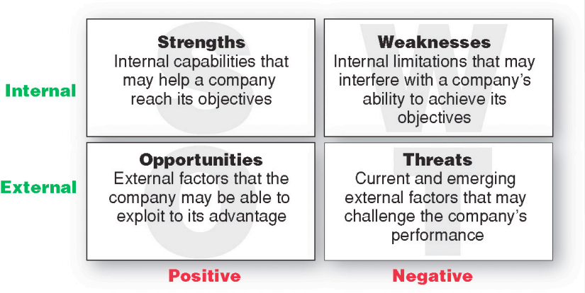
Analysis (SWOT)
- Finding opportunities
- Avoiding threats
- Understanding strengths
- Analyzing weaknesses

Planning
Marketing Plans include:
- Executive Summary
- Analysis of Current Situation
- Objectives
- Targets and Positioning
- Marketing Mix
- Budget
- Controls

Implementation
- Turns strategies and plans into marketing actions that accomplish strategic marketing objectives
- Good implementation is a challenge
- Marketing department organization
- Successful implementation depends on how well the company blends its people, organizational structure, decision and reward system, and company culture into a cohesive action plan that supports its strategies

Control
- Involves evaluating the results of marketing strategies and plans and taking corrective action
- Checks for differences between goals and performance
- Operating control, strategic control, marketing audit

Return on Marketing Investment (Marketing ROI)
- Marketing ROI: The net return from a marketing investment divided by the costs of the marketing investment. Marketing ROI provides a measurement of the profits generated by investments in marketing activities.

CHAPTER 3:
Analyzing the Marketing Environment

The Marketing Environment
- The marketing environment includes the actors and forces outside marketing that affect marketing management’s ability to build and maintain successful relationships with customers.

SWOT Analysis
- This allows us to see if we are properly serving our consumers
- The goal is to match the company’s strengths to attractive opportunities in the environment, while eliminating or overcoming the weaknesses and minimizing the threats

Microenvironment
- Consists of actors close to the company that affect its ability to serve its customers, the company, suppliers, marketing intermediaries, customer markets, competitors, and publics
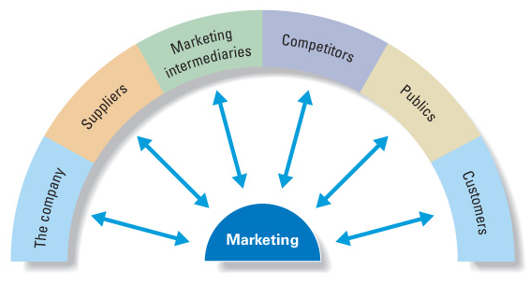
The Company
- Top management
- Finance
- R&D – Research and Development
- Purchasing
- Operations
- Accounting

Suppliers
- Provide the resources to produce goods and services
- Treated as partners to provide customer value

Marketing Intermediaries
- Help the company to promote, sell and distribute its products to final buyers
Ex. Coke sold in Subways
Types: Resellers, Distribution Firms, Marketing Services Agencies, Financial Intermediaries
Competitors
- Firms must gain strategic advantage by positioning their offerings against competitors’ offerings

Publics
- Any group that has an actual or potential interest in or impact on an organization’s ability to achieve its objectives
Ex. Financial publics, media publics, government publics, citizen-action publics, local public, general public, internal publics

Macro environment
- Consists of factors outside the company that affect its ability to serve political, natural, technological, demographic, environment, cultural
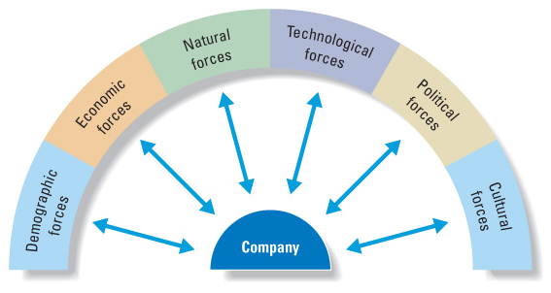
Demographic
- Demography is the study of human populations in terms of size, density, location, age, gender, race, occupation, and other statistics
- Important because it involves people, and people make up markets
- Trends include age, family structure, geographic population shifts, educational characteristics, and population diversity
Changing age structure of the population:
- Baby boomers: 1946-1964 [gma + gpa – spend $$$]
- Generation X: 1965-1976 [parents – tend to be cheaper, grew up poor]
High parental divorce rates
Cautious economic outlook
Less materialistic
Family comes first
Lag behind on retirement savings
- Millennials (Generation Y or Echo boomers): 1977-2000 [us]
Comfortable with technology
Includes Tweens (ages 8-12), Teens (13-19) & Young adults (20s)

Economic
- Economic environment consists of factors that affect consumer purchasing power and spending patterns
- Industrial economies are richer markets
- Subsistence economies consume most of their own agriculture and industrial output

Natural
- Natural environment involves the natural resources that are needed as raw material by marketers or that are affected by marketing activities
Trends:
Shortages of raw materials
Increased pollution
Increase government intervention
Environmentally sustainable strategies
Engel’s Law: As income rises…
- The percentage spent on food declines
- The percentage spent on housing remains constant
- The percentage spent on savings increases

Technological
- Most dramatic force in changing the marketplace
- Creates new products and opportunities
- Safety of new product always a concern

Political
- Political environment consists of laws, government agencies, and pressure groups that influence or limit various organizations and individuals in a given society
Legislation regulating business:
- Increased legislation
- Changing government agency enforcement
Increased emphasis on ethics:
- Socially responsible behavior
- Cause-related marketing

Cultural
- Consists of institutions and other forces that affect a society’s basic values, perceptions, and behaviors
- Core beliefs and values are persistent and are passed on from parents to children as well as reinforced by schools, churches, businesses, and government
- Secondary beliefs and values are more open to change and include people’s views of themselves, others, organization, society, nature, and the universe

How Do You React to These?
There are 3 different ways of reacting to changes in your environment:
- Uncontrollable: react and adapt as they happen
- Proactive: try to foresee or steer the changes the way you want
- Reactive: watching and reacting to forces
CHAPTER 5:
Managing Marketing Information to Gain Customer Insights

Customer Insights
- Fresh and deep insights into customers needs and wants
- Difficult to obtain
- Not obvious
- Customer’s unsure of their behavior
- Not derived from more information but better information and more effective use of existing information

Marketing Information Systems
- Marketing information system (MIS) consists of people and procedures for:
Assessing the information needs
Developing needed information
Helping decision makers use the information for customers
- MIS provides information to the company’s marketing and other managers and external partners such as suppliers, resellers, and marketing service agencies
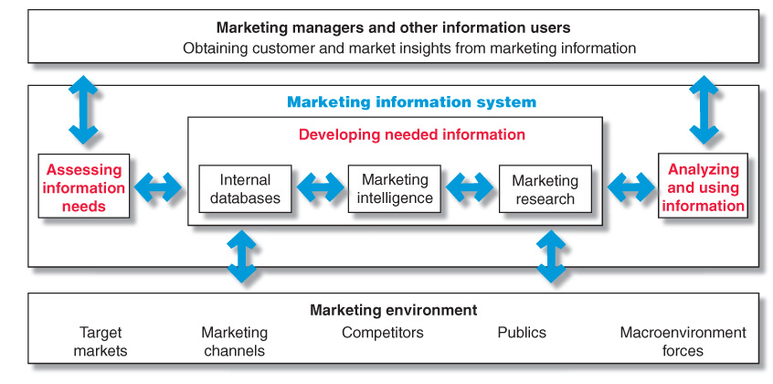
Internal Data
- Internal databases are electronic collections of consumer and market information obtained from data sources within the company network

Marketing Intelligence
- The systematic collection and analysis of publicly available information about consumers, competitors and developments in the marketplace

Marketing Research
- The systematic design, collection, analysis, and reporting of data relevant to a specific marketing situation facing an organization
- 3 kinds:
Exploratory
Descriptive
Casual

Developing a Research Plan
- Outlines sources of existing data
- Spells out the specific research approaches, contact methods, sampling plans, and instruments to gather data
Secondary data consists of information that already exists somewhere, having been collected for another purpose
Primary data consists of information gathered for the special research plan

Research Approaches
- Observational research involves gathering primary data by observing relevant people, actions and situations
- Ethnographic research involves sending trained observers to watch and interact with consumers in their natural environment
- Survey research is the most widely used method and is best for descriptive information – knowledge, attitudes, preferences, and buying behavior
Flexible
People can be unable or unwilling to answer
Gives misleading or pleasing answers
Privacy concerns
- Experimental research is best for gathering casual information – cause-and-effect relationships

Contact Methods

 | Mail | Telephone | Personal | Online
Flexibility | Poor | Good | Excellent | Good
Quantity of data collected | Good | Fair | Excellent | Good
Control of interviewer effects | Excellent | Fair | Poor | Fair
Control of sample | Fair | Excellent | Good | Excellent
Speed of data collection | Poor | Excellent | Good | Excellent
Response rate | Poor | Poor | Good | Good
Cost | Good | Fair | Poor | Excellent

Focus Groups
- 6 to 10 people with a trained moderator
- Challenges:
Expensive
Difficult to generalize from small group
Consumers not always open and honest

Sampling
- Sample is a segment of the population selected for marketing research to represent the population as a whole
Who is to be surveyed?
How many people should be surveyed?
How should the people be chosen?

Research Instruments
Questionnaires
- Most common
- Flexible
- Given In-Person or online or over the phone
- Wording of questions must be very carful
Close-end questions include all possible answers, and subjects make choices among them
- Provide answers that are easier to interpret and tabulate
Open-ended questions allow respondents to answer in their own words
- Useful in exploratory research

Implementing the Research Plan
- Collect information
- Process information
- Analyze information
- Interpret findings
- Draw conclusions
- Report to management

Analyzing and Using Marketing Information
- Customer Relationship Management (CRM) consists of sophisticated software and analytical tools that integrate customer information from all sources, analyze it in depth, and apply the results to build stronger customer relationships

Distributing and Using Marketing Information
- Information distribution involves entering information into databases and making it available in a time-useable manner
- Intranet provides information to employees and other stakeholders
- Extranet provides information to key customers and suppliers
CHAPTER 6:
Consumer Markets and Consumer Buyer Behavior

Model of Consumer Behavior
- Consumer buyer behavior refers to buying behavior of final consumers – individuals and households who buy goods
- Consumer market refers to all of the personal consumption of final consumers

Characteristics Affecting Consumer Behavior
- Culture is the learned values, perceptions, wants, and behavior from family and other important institutions like the school, government and the church
- Subculture are groups of people within a culture with shared value systems based on common life experiences and situations
- Social classes are society’s relatively permanent and ordered divisions whose members share similar values, interests, and behaviors
Measured by a combination of occupation, income, education, wealth, and other variables

Groups and Social Networks
- Membership groups are groups someone directly belongs to
- Aspirational groups are groups someone wants to be part of
- Reference groups are groups that serve to compare or reference oneself to in behavior or attitudes

Word-of-mouth influence and buzz marketing
- Opinion leaders are people within a reference group who exert social influence on others
- Also called influential or leading adopters
- Marketers identify them to use as brand ambassadors

Social Factors
- Family is the most important consumer-buying organization in society
- Social roles and status are the groups, family, clubs and organizations that a person belongs to that can define role and social status

Personal Factors
Age and Life Cycles according to RBC
- Youth: 18 and –
- Getting Started: 18-35
- Builders: 35-50
- Accumulators: 50-60
- Preservers: 60+

- Occupation affects the goods and services bought by consumers
- Economic situation includes trends in: Personal income, Savings, Interest Rates
- Lifestyle is a person’s pattern of living as expressed in his or her psychographics
- Look at a consumer’s activities, interests, and opinions to capture information about a person’s pattern of acting and interacting in the environment
- Personality and self-concept
Personality refers to the unique psychological characteristics that lead to consistent and lasting responses to the consumer’s environment
- Brand also have personalities, and consumers are likely to choose brands with personalities that match their own

Psychological Factors
- A motive is a need that is sufficiently pressing to direct the person to seek satisfaction
- Motivation research refers to qualitative research designed to probe consumers’ hidden, subconscious motivations
- Perception is the process by which people select, organize, and interpret information to form a meaningful picture of the world from three perceptual processes
- Selective attention: The tendency for people to screen out most of the information to which they are exposed to
- Selective distortion: The tendency for people to interpret information in a way that will support what they already believe
- Selective retention: The tendency to remember good points made about a brand they favor and forget good points about competing brands
- Learning is the change in an individual’s behavior arising from experience
- Belief is a descriptive thought that a person has about something based on:
Knowledge
Opinion
Faith
- Attitudes describe a person’s relatively consistent evaluations, feelings, and tendencies toward an object or idea

Decision Process
- Need recognition
- Occurs when the buyer recognizes a problem or need triggered by:
internal stimuli or external stimuli
- Information search
“Sources of Information”
  - Personal sources – family and friends
  - Commercial sources – advertising, Internet
  - Public sources – mass media, consumer organizations
  - Experiential sources – handling, examining, using the product
- Evaluation of alternatives
- How the consumer processes information to arrive at brand choices
- From a marketer’s perspective, it is important to highlight the features that are your product’s strengths in the information stage. If those features also benefit the consumer, this is where your product will stand out.
- Purchase decision
- The act by the consumer to buy the most preferred brand
- The purchase decision can be affected by: attitudes of others, unexpected situational factors
- Post purchase behavior
- The satisfaction or dissatisfaction that the consumer feels about the purchase
- Relationship between: Consumer’s expectations & product’s perceived performance
- The larger the gap between expectations and performance, the greater the consumer’s dissatisfaction
- Cognitive dissonance: the discomfort caused by a post-purchase conflict

Adoption Process
- Adoption process is the mental process an individual goes through from first learning about an innovation to final regular use
- Stages in the process include:
- Awareness
- Interest
- Evaluation
- Trial
- Adoption

Adoption Rates highly depend on…
- Relative advantage
- Compatibility
- Complexity
- Divisibility
- Communicability

CHAPTER 8:
Customer-Driven Marketing Strategy: Creating Value for Target Customers

MARKET SEGMENTATION

Market segmentation involves dividing the market into smaller groups with distinct needs, characteristics, or behaviors that might require separate marketing strategies or mixes.
Market targeting is the process of evaluating each market segment’s attractiveness and selecting one or more segments to enter.
Differentiation is actually differentiating the market offering to create superior customer value.
Positioning is arranging for a market offering to occupy a clear, distinctive, and desirable place relative to competing products in the minds of target consumers.

Segmenting consumer markets

Geographic Segmentation
- Divides the market into different geographical units such as nations, provinces, countries, cities, or neighborhoods

Demographic Segmentation
- Divides the market into groups based on variables such as age, gender, family size, family life cycle, income, occupation, education, religion, race, generation, and nationality

Age and Gender Segmentation
- Age and life-cycle stage segmentation is the process of offering different products or using different marketing approaches for different age and life-cycle groups
- Gender segmentation divides the market groups based on gender

Income and Psychographic Segmentation
- Income segmentation divides the market into different income groups
- Psychographic segmentation divides buyers into different groups based on social class, lifestyle, or personality traits

Behavioral Segmentation
- Behavior segmentation divides buyers into groups based on consumer knowledge, attitudes, uses, or responses to a product
Occasions
Benefits sought
User status
Usage rate
Loyalty status
- Occasion segmentation divides the market into groups according to occasions when buyers get the idea to buy, actually make their purchase, or use the purchased item
- Benefit segmentation divides the market into groups according to the different benefits that consumers seek from the product
- User status segments the marking into nonusers, ex-users, potential users, first-time users, and regular users of a product
- Usage rate divides the market into light, medium, and heavy product users
- Loyalty status divides the market by consumer loyalty: to brands, to stores, to companies

Multiple Segmentation
- Multiple segmentation is used to identify smaller, better-defined target groups
- Geodemographic segmentation is an example of multivariable segmentation that divides groups into consumer lifestyle patterns

Segmenting Business Markets
Business markets can be segmented into the same variables as consumer markets as well as:
- Customer Operating Statistics
- Purchasing Approaches
- Situational Factors
- Personal Characteristics

Segmenting International Markets
- Intermarket (cross-marketing_ segmentation divides consumers into groups with similar needs and buying behaviors even though they are located in different countries

Requirements for effective segmentation
- Measurable: the size, purchasing power, and profiles of segments can be measured
- Accessible: the market segments can be effectively reached and served
- Substantial: the market seems large or profitable enough to serve
- Differentiable: the segments are conceptually distinguishable and respond differently to different marketing mix elements and programs
- Actionable: effective programs can be designed for attracting and serving the segments

TARGET MARKETING
- Target market consists of a set of buyers who share common needs or characteristics that the company decides to serve
- To evaluate look at:
- Segment size and growth
- Segment structural attractiveness
- Company objectives and resources

Target Marketing Strategies
Undifferentiated (mass) marketing targets the whole market with one offer.
- Focuses on common needs rather than on what is different

Differentiated (segmented) marketing targets several different market segments and designs separate offers for each.
- Goal is to achieve higher sales and stronger position
- More expensive than undifferentiated marketing

Concentrated (niche) marketing targets a large share of one or a few segments or niches.
- Limited company resources
- Knowledge of the market
- More effective and efficient

Micromarketing is the practice of tailoring products and marketing programs to suit the tastes of specific individuals and local consumer groups.
Local marketing
Individual marketing
- Local marketing involves tailoring brands and promotion to the needs and wants of local consumer groups (i.e. cities, neighborhoods, stores)
- Individual marketing involves tailoring products and marketing programs to the needs and preferences of individual customers (also known as one-to-one marketing, mass customization, markets-of-one marketing)

Choosing a Target Market
Depends on:
- Company resources
- Product variability
- Product life-cycle stage
- Market variability
- Competitor’s marketing strategies

Socially Responsible Target Marketing
- Benefits customers with specific needs
- Concern for vulnerable segments (i.e. Children & alcohol, rigs, etc.)

DIFFERENTIATION AND POSITIONING
- Product position is the way the product is defined by consumers on important attributes – the place the product occupies in consumers’ minds relative to competing products
- Perceptions
- Impressions
- Feelings

Choosing a Positioning Strategy
- Identifying a set of differentiating competitive advantages upon which to build a position
- Choosing the right competitive advantages
- Selecting an overall positioning strategy
- Effectively communicate and deliver the chosen position to the market

Possible Competitive Advantages
- Product differentiation: differentiated on features, performance, or style and design
- Service differentiation: differentiated on speedy, convenient or careful delivery
- Channel differentiation: differentiation through the way they design their channel’s coverage, expertise, and performance
- People differentiation: hiring and training people better
- Image differentiation: perceived difference based on a strong, distinctive image conveying the product’s distinctive benefits and positioning

Differences to Promote
- Important
- Distinctive
- Superior
- Communicable
- Preemptive
- Affordable
- Profitable

Positioning Statement
- A positioning statement summarizes the company or brand positioning
- To (target segment and need) our (brand) is (concept) that (point of difference)

CHAPTER 9:
Products, Services, and Brands: Building Customer Value

What is a Product?
- Product is anything that can be offered in a market for attention, acquisition, use, or consumption that might satisfy a need or want
- Services are any activity or benefit that one party can offer to another that is essentially intangible and does not result in the ownership of anything
- Experiences represent what buying the product or service will do for the customer

Product and Service Classification
- Consumer products are products and services for personal consumption
- Classified by how consumers buy them
- Convenience products: consumer buys frequently (candy, newspaper)
- Shopping products: customer puts more thought into buying (cars)
- Specialty products: unique/rare (rolly, plastic surgery)
- Unsought products: didn’t know/plan (funeral services, life insurance)
- Industrial products: business product/needs further processing (parts)

Organization Marketing
- Consists of activities undertaken to create, maintain, or change attitudes and behavior of target consumers toward an organization

Person Marketing
- Consists of activities undertaken to create, maintain, or change attitudes and behavior of target consumers toward particular people

Place Marketing
- Consists of activities undertaken to create, maintain, or change attitudes and behavior of target consumers toward particular places

Social Marketing
- The use of commercial marketing concepts and tools in programs designs to influence individuals’ behavior to improve their well-being and that of society

Individual Product and Service Decisions
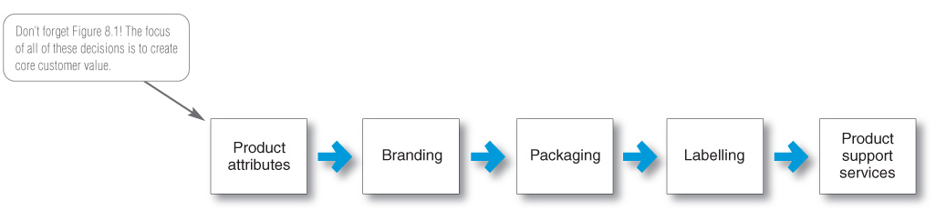

- Product attributes are the benefits of the product or service
- Quality
- Features
- Style and design

Product quality includes level and consistency:
- Quality level is the level of quality that supports the product’s positioning
- Total quality management (TQM) is an approach in which all the company’s people are involved in constantly improving the quality of products, services and business processes
- Conformance quality is the product’s freedom from defects and consistency in delivering a targeted level of performance

- Product features are a competitive tool for differentiating a product from competitors’ products
- Product features are assessed based on the value to the customer versus the cost to the company
- Style describes the appearance of the product
- Design contributes to a product’s usefulness as well as to its looks
- Brand is the name, term, sign, or design – or a combination of these – that identifies the maker or seller of a product or service
- Brand equity is the differential effect that the brand name has on customer response to the product and its marketing
- Packaging involves designing and producing the container or wrapper for a product
- Labels identify the product or brand, describe attributes, and provide promotion

Decision Process
- Need recognition: buyer recognizes a prob or need triggered by inernal or external stimuli
- Information search: sources of info (i.e. personal [fam] commercial [ads], public [media], experiemental [using prod]
- Evaluation of alternative: consumer processes choices and choses preferred brand
- Purchase descision: act of buying
- Post-purchase behavior: satisfied? Rlsp between expectations+performance

Pricing Strategies:
- Market-skimming pricing: high initial prices to get from ppl who will pay
- Market penetration pricing: low initial price 2 attract more ppl

Distribution Decisions
- Exclusive distribution: only certain outlets carry
- Exclusive dealing: sellers don’t sell competish

EXAM Q:
Macro impant
Segment
Target
Mark mix (4ps)

Psychographics use

