Acco 230 midterm

Chapter 1

- Identifies and records economic events of an organization and communicates to the interested users
- Internal users:
  - Managers, employees, and others who plan, organize, and run the company
- External users:
  - Do not work for the company
  - Investors, lenders and other creditors
  - Customers, employees, labour unions
  - Taxing authorities and regulators
- Financial statements
  - Income statements (statement of earning or statement of profit or loss)
    - Reports revenue and expenses for a specific period
    - Revenue – expenses- income tax expense= profit
- Statement of change in equity
- Change in components of equity
- Common shares + retained earning – dividends
- Statement of financial position
- Shows the assets, liabilities and shareholders equity and a specific point in time
- Assets = liabilities + shareholders equity
- Statement of cash flows
  - How money is obtained and used
  - Operating activities + investment activity +financial activity (common shares – notes payable –dividends)= net increase in cash

- Comparing IFRS and ASPE
- 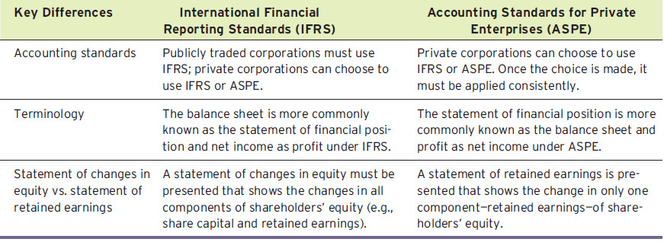
- Chapter 2

- Current assets

  - Examples include cash, short-term (trading) investments, accounts receivable, merchandise inventory, and prepaid expenses
- Non currents assets
  - Long-term investments
  - Property, plant, and equipment
  - Intangible assets and goodwill
  - Other assets
- Currents liabilities
  - Bank indebtedness
  - Accounts payable
  - Accrued liabilities
  - Bank loan/notes payable
  - Current maturities of long-term debt
- Non current liabilities
  - Bank loan/notes payable
  - Lease obligations
  - Pension and benefit obligations
  - Deferred income tax liabilities
- Working capital = current assets – current liabilities
  - Same as current ratio it is positive company will be able to pay back if its negative the company may have to take a loan to pay back
- Current ratio = (current assets / current liabilities)
  - Measures the short term ability to pay obligations (higher is generally better)
- Debt to total assets = total liabilities / total assets
  - Measures the company’s ability to survive over a long period (lower is better)
- Free cash flow – the cash remaining after operating activity adjusting for capital expenditure and dividends paid.
- Earning per share = Profit available to common shareholders/ Weighted average number of common shares
- Price-earning ratio = market price per share / earning per share
  - Measures the company operating success (higher is generally better)

- Chapter 3
- Accounting transaction
  - Not all transaction are recorded
  - They are only recognized when it changes something such as assets liabilities and shareholders equity
- Normal balance
  - Assets – debit
  - Liabilities – credit
  - Shareholders equity – credit
  - Common shares – credit
  - Retained earnings – credit
  - Revenues –credit
  - Expenses – debit (will decrease retained earning)
  - Service revenue – credit
  - Dividends – debit (will decease retained earning)
  - Equipment – debit
  - Accounts receivable – debit
  - Supplies - debit
  - Unearned revenue – credit
  - Accounts payable – credit
  - Common shares – credit
  - Salaries expenses – debit
  - Cash – debit
- Trail balance – is debits and credit in a chart where debit equal credits
- Posting is the process of transferring info from general journal to the general ledger accounts

- Chapter 4
- Accrual basis of accounting
  - Transactions are recorded when the work is done rather then when the money is received or paid
- Cash basis of accounting
  - Revenue is recorded only when cash is received
  - Expenses are recorded only when cash is paid
- Types of adjustment entries
  - Prepayments
    - Prepaid expenses: expenses paid in cash are recorded before being used (increase current assets) &(decrease non current assets such as buildings and equipment)
    - Unearned revenue: is revenue that is received before work is done
- Accruals
- Accrued revenues: revenues earned but not yet received in cash or recorded
- Accrued expenses: expenses incurred but not yet paid in cash or recorded
- Closing the books
  - Temporary accounts
    - All expenses accounts
    - All revenue accounts
    - Dividends accounts
- Permanent
- All asset accounts
- All liability accounts
- All shareholders equity accounts
- The closing process
  - Close revenue accounts:
- Debit each revenue account for its balance and credit Income Summary
  - Close expense accounts:
- Debit Income Summary and credit each expense account for its balance
  - Close Income Summary:
- Debit (or credit) Income Summary for the balance in the account and credit (debit) Retained Earnings
  - Close Dividends account:
- Debit Retained Earnings and credit Dividends account for the balance
- Chapter 5
- Sales revenue – cost of goods sold = gross profit
- Gross profit – operating expenses =profit (before income tax)
- Profit (before income tax) – income tax expenses = profit
- Inventory system
  - Beginning inventory + purchases = cost of goods available for sale
  - Ending inventory is beginning inventory of next fiscal year
- Perpetual system
  - Detailed records are kept for the cost of each product bought and sold
  - Updated constantly
  - Physical count is done at least once a year
  - Purchases are recorded and debits to merchandise inventory
  - They include all freight charges and applicable taxes
  - Less purchases returns, allowances and discounts
- Periodic system
  - Detailed records are not kept
  - Only done and the end of the accounting period
  - Cost of goods sold = beginning inventory + cost of purchases – ending inventory
- FOB shipping point
  - Ownership of good passes from seller to buyer when they are shipped
  - The buyer pays the freight charges and is responsible for the damages
- FOB destination
  - Ownership is transferred when the item(s) are received
  - The seller pays for the freight charges and is responsible for damages

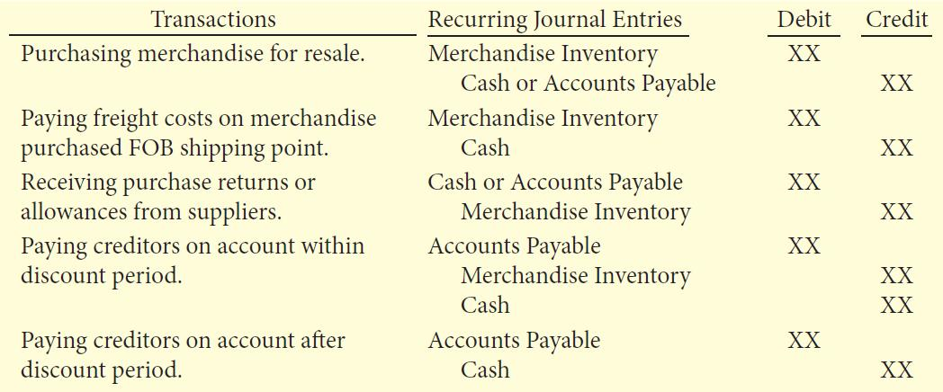
- Gross sales –sales return and allowance – sales discounts = net sales (use the same if for perpetual or periodic inventory system)

- Income statement presentation
  - Single step
    - All data is classified into two categories – revenue (includes operating and non operating revenues and gains) and expenses (includes cost of c=goods sold, operating expenses and non operating expenses and losses)
    - Income tax expenses is usually disclosed separately from other expenses
- Multiple step
- Shows several steps in determining profit or loss
- Net sales: sales return and allowance and sales discounts is subtracted from gross sales to give the net sales
- Gross profit: cost of goods sold subtracted from net sales to give you gross profit
- Profit from operations: operating expenses are deducted from gross profits to determine profit before operations
- Non-operation activities: the result of activities that are not related to operating are added (revenues) or subtracted (expenses) to determine profit before income tax
- Profit: income tax expenses is subtracted from profit before income tax to determine profit or loss
- Gross profit margin = gross profit / net sales (higher is generally better)
- Profit margin = profit /net sales (higher is generally better)
- Comparison of entries for inventory purchases 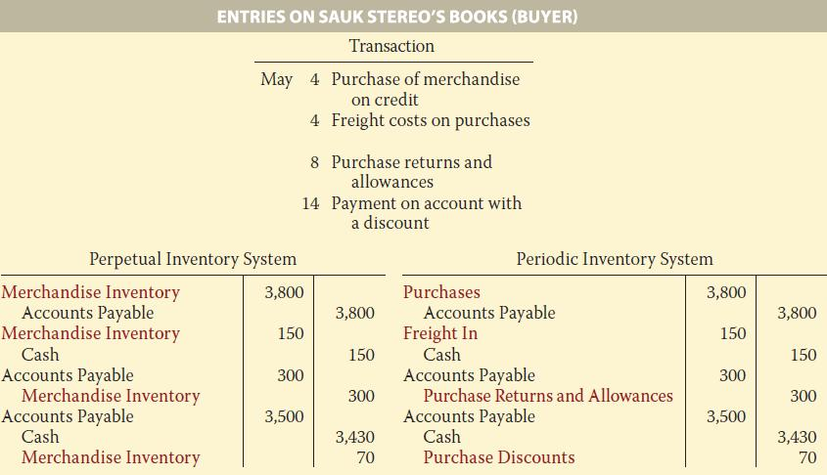
- Comparison of entries for sales 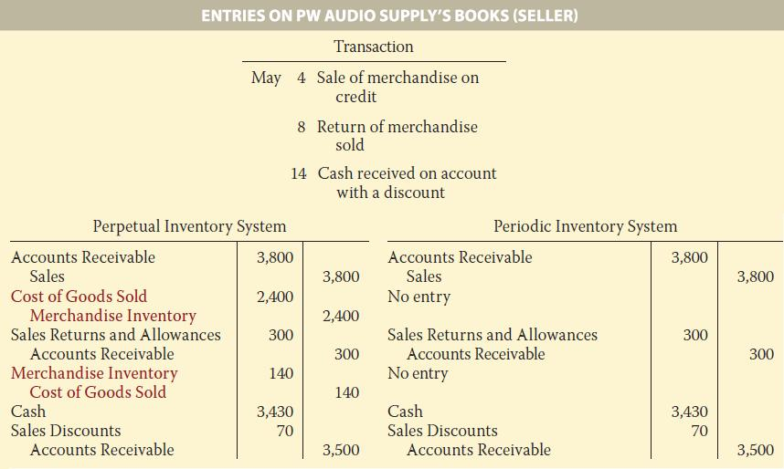
- Chapter 6
- Specific identification
  - Used in perpetual system only
  - Can only be used when actual cost of each item can be determined
- Cost formulas
  - FIFO- cost of first item purchased is the cost of first item sold
  - Average – cost is determined using a moving average of the cost of the items purchased
- Effects of inventory errors on the income statement 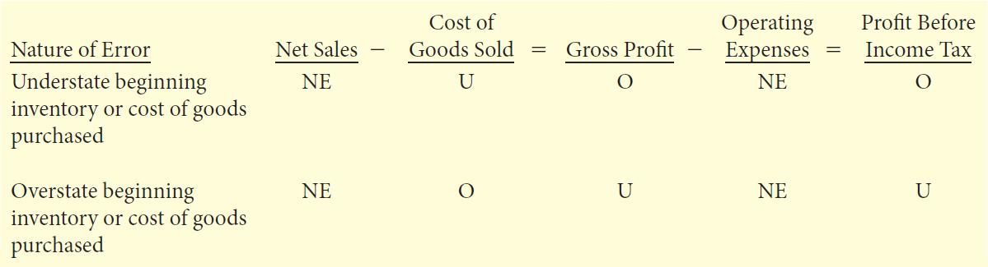
- Effects of inventory errors on statement of financial position 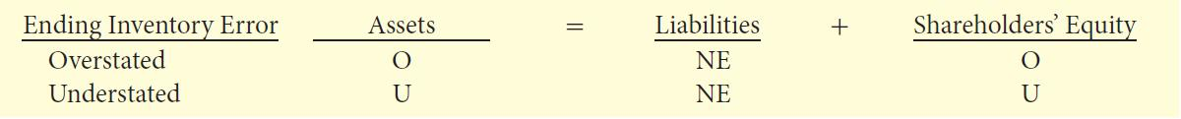

- Ending inventory will become the next years inventory
- Profit is added to retained earning
- Because the profit will be wrong between years but retained earing will be okay
- Because of the balancing between the errors
- But the retained earning for that year will be wrong
- Cant assume that because the ending inventory is wrong in one year that in the next year it is wrong unless its stated
- LCNRV rule
  - Example
  - Cost of ending inventory is 110000$\
  - Net Realizable Value 90000$
  - If cost > nrv
  - Have to do a write down
  - Debit cogs 20000
  - Credit merchandise inventory 20000
  - Means inventory is overstated

  - Cost 110000$
  - Nrv 120000$
  - They are at least equal
  - Cost< nrv
  - You don’t do anything
  - Because you cost is lower

- Inventory turnover ratio = cost of good sold (income statement) / average inventory (balance sheet)
- Day to day inventory = 365/ inventory turnover

- Chapter 7
- Fraud
  - Recording expenses as assets
  - Overstating useful lives of assets
  - Recording revenues that do not exist

- Internal control (the 5 primary components)
  - Control environment – it is the mangers responsibility to make sure that employees now that un ethical behavior will not be tolerated (butting there foot down)
  - Risk assessment – companies must identify and analyze various facts that create risk and determine how to mange these risk
  - Control activities – to reduce fraud management must think of way to reduce these activities
  - Information and communication – system must capture and record all information and report them to external parties.
  - Monitoring – internal control systems must be monitored periodically for their adequacy. And must be reported to management and the board of directors.

- Control activities
  - Authorization of transactions and activities – is when one employee is authorized to do something so you k now exactly who is to blame
  - Segregation of duties – different duties should be given to different individuals (making hard for fraud to take place)
  - Documentation – documenting transactions and activities (can also make employee sign it so you can see who is responsible for it)
  - Physical controls – such as locking warehouse of sensors on clothing
  - Independent checks of performance – check on employees work should be done by internal and external to watch employees unintentional and intentional
  - Human resource controls
- Conduct thorough background checks – check applicants background to avoid future fraud or theft
- Bonding of employees who handle cash – bonding mean having insurance protection, one way is that the insurance company screens all employees, second it will not hesitate to prosecute the offender
- Rotating employees duties and requiring employees to take vacations – this means that if only one employee is do the job to have him go on vacation to see if they are doing any fraudulent work.
- Limitation of internal control (can only be reasonable assurance only if the records are reliable)
  - The cost of the reasonable assurance should not exceed its expected benefit
  - Human element is to costly and will effect the costumers, therefor signs and sensors are a simple and effective way of doing so
  - Collusion (two or more people are working together) but can still defeat the internal control if the two employees collaborate
  - Size of business can also affect internal control because of the amount of works. Therefor managers or owners will have to over view everything
- Cash control
  - Cash is the most targeted thing for theft
  - Different types of money, Coins, currency, cheques, money orders
  - Money on hand or in bank
  - Debit card and bank credit card transactions (but not non-bank credit card transactions)
- Cash receipts
- In a business where over the counter work is done (allot of cash) there are other ways of having an effect on internal control such as inventory control which will go hand in hand with giving a certain amount of money to the cash (float) and inventory and floats are linked. (Deposit should only be done by authorized employees)
- Mail in receipts – when cheques are received there is a stub attached to it when a check is written this stub should be written and sent to the accountant
- Electronic receipts - electronic funds transfer (EFT) is cash, which is transferred over the Internet where no cash is handled.
- Cash payments
- Payments are more effective when payments are made by cheque or by electronic funds transfer, rather than in cash
- Good controls include:
- Dual signatures on cheques
- Segregation of duties different workers doing different things
- Use prenumbered cheques so that cheques can be counted and tracked
- The use of paying electronically instead of by cheque will help the fact that cheques and cash will be harder to get a hold of
- Use of a bank
  - The use of a bank
    - Lower the amount of money need to keep on hand
    - There are two records of transactions
- 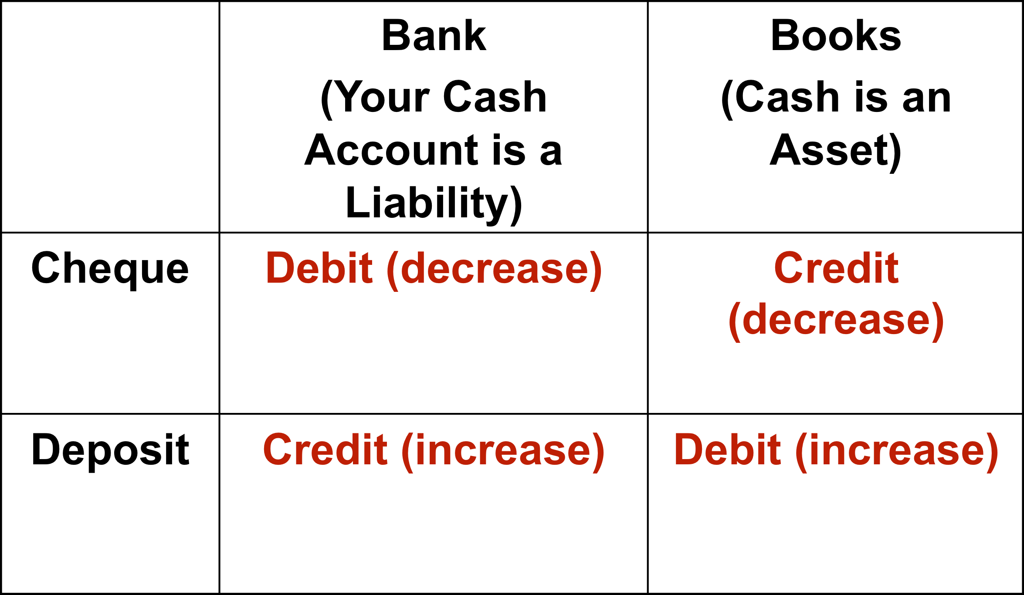

- Difference between company records and bank statement

  - Time lag
    - The time lag the there is between a company recording a transaction and when the bank records a transactions because of the processing time it takes for the bank transactions to go throw
    - The bank reconciliation procedures
      - Reconciling items per bank:
      - Deposits in transit
      - Outstanding cheese
      - Bank errors
      - Reconciling items per books:
      - Credit memoranda and other deposits
      - Debit memoranda and other payments
      - Book errors
- Reporting cash
  - Cash is recorded in the statement of financial position which is at a specific point in time
  - Cash is also recorded in a statement of cash flow which is during a period of time
  - Companies have a overdraft protection which is a deficit which is reported as a current liability called bank indebtedness
  - Cash that is held back by the bank such as gift cards are restricted because the money is there’s but hasn’t been used yet.
  - Banks make loans to companies which they force the company to keep a certain amount in the account which is called compensating balance
- Managing cash
  - For a business to survive it must have cash
- Increase the speed of collection on receivables
- Keep inventory levels low
- Delay payments of liabilities
- Plan the timing of major expenditures
- Invest idle cash
- Prepare a cash budget

- Chapter 8

- Accounts receivable

  - The term receivables is referred to as an amount which is owed to a company from other companies or customers
  - 3 types
    - Accounts receivables – is an amount owed by customer for work done
    - Notes receivables – formal credit instrument (written promise to pay)
    - Other receivables – interest receivable, loans and advances to employees, recoverable sales and income tax
- Accounts receivable subsidiary ledger
  - Subsidiary ledger is a group of accounts that share a common characteristic
  - It gives a detailed report the support the total amount
  - A control account is a general ledger account that summarizes the subsidiary ledger data
- Interest revenue
  - Is if a customer does not pay with in the 30 day usually there is an interest charged to the bill.
  - Which is recorded under interest revenue which increases accounts receivable

- Recording estimated uncollectible accounts
  - Some accounts receivable become uncollectible
  - Which are debited to an account called DAD BEDTS EXPENSE
  - It is recognized in the same period that the sales revenue is generated
- The allowance method
  - This method estimates the uncollectible accounts at the end of each period
  - The amount estimated is shown is and account called allowance for doubtful accounts
  - A contra asset account that is shown under accounts receivable
  - This is used because we don’t know which customer will not pay back
- 3 features of allowance method
- Recording estimated uncollectible accounts
- Any increase to allowance is recorded as bad debts expense
- Recording the write off of an uncollectible account
- The actual account are written off when the account is determined uncollectible
- This write off reduces the allowance for doubtful accounts
- Recording the recovery of an uncollectible account
- If a write off is later collected then the write off is reversed and the collection is recorded
- Recording estimated uncollectible accounts
- Bad debts expense is reported in the income statement as an operating expense
- The balance in the allowance for doubtful accounts is deducted from accounts receivable in the current assets section of the statement of financial position

- Estimating the allowance
  - Most companies use the percentage of receivable basis to determine the allowance
  - Estimate what percentage of receivables are likely to be uncollectible
  - Apply this percentage to total receivable
  - Apply this percentage to receivables classified according to the length of time they have been outstanding called aging the accounts receivable
- Recording the write off of an uncollectible account
  - Write off should on be done by management and not any one who has access to cash accounts or receivables to prevent any theft to hide accounts.
  - When a write off occurs the system is only effecting accounts receivable and allowance for doubtful accounts because the amount has already been recorded
  - It only effect the statement of financial position but the net realizable value remains unchanged
- Recording the recovery of an uncollectible account
  - To do so the write-off must be undone which is done in two steps
  - First you must revers the write off debiting accounts receivable and crediting allowance for doubtful accounts
  - The debit cash for the amount
  - And finally credit accounts receivable for the amount
- Notes receivables
  - Is an amount which is promised to be repaid which is called a promissory note to repay
  - Requires for interest to be paid
  - Extends for time period for more the 30 days
- Formula for calculating interest
    - Face value of note x annual interest rate x time in terms of years = interest

- Honoring and dishonoring notes receivable
  - Honoring
      - The note is paid in full on maturity date
      - Collection is recorded
- Dishonoring
      - Not is not paid at maturity date
      - Amount is transferred to accounts receivable if eventual collection is expected
      - Amount is transferred to allowance for doubtful account if it eventually not expected to be collected
- Statement presentation
- Statement of financial position
      - Short term receivables are reported in the current assets section of the statement of financial position
      - And following cash and short term investment if items are presented from most to least liquid
    - Income statement
      - Income statement related to receivable may include revenue generated from sales or services on account
      - In addition to bad debit expense would be reported in the operating expense
      - And the interest revenue would be report in the non-operating section
- Managing receivables
  - Determine to whom to extend credit to
      - Credit checks
- Establish a payment period
- The amount of time the customer has to pay
- Monitoring collections
- Prepare and update an accounts receivable aging schedule
- Evaluate the liquidity of receivables
- Liquidity is measured by how quickly certain assets can be converted into cash
- Accelerating cash receipts from receivables when necessary
- Receivables turnover = net credit sales / average gross receivables
      - Measures the liquidity of receivables
      - Higher is better
- Average collection period = 365 days/receivables turnover
      - Is the average amount of time that a receivable is outstanding
      - Lower is better
- Securitization
- Factoring

Chapter 9

- Property, plant, and equipment
  - Long lived resources
      - Are meant to be used by the company
      - Have a physical substance
      - Are not intended for sale to customers
- Provide benefits over many years
- Determining the cost of property plant and equipment
  - Recording the cost of a PPE
      - Purchase price, including taxes and duties, less discounts or rebates
      - Expenditure necessary to bring the PPE to point where it can be used buy the company (intended use)
- Types of expenditure
  - Operating expenses are expenses only in the current period
  - Capital expenditure are expenses that will benefit the companies future
- Land
  - Cost of land includes
    - Purchase price
    - Closing cost such as legal fees and titles
    - Plus any cost to prepare the land for its intended use
    - Less anything that is salvaged
    - Everything till the time that excavation is included in the cost of land
- Land does not have any depreciation, therefore is has unlimited life
- Land improvement
  - Coat of structural additions made to the land (ex, fences, parking lots, sidewalks)
  - These are accounted for separately from the land account because unlike land these improvements do depreciate over time and also need maintenance
- Building
  - All expenditures related to purchasing or construction of a building
  - Purchase price
  - Closing fees (legal fees, titles, insurance)
  - Cost required to make the building ready for its intended use
  - When a building is constructed
    - Contract price
    - Architect fees
    - Building permits
    - Excavation cost
    - Interest cost during building
    - Equipment
      - Purchase price
      - Freight charges and insurance during transit paid by the purchaser
      - Assembly, installation and testing
- Asset retirement cost
  - The cost of retiring a asset
  - These amounts are estimated in advance and are adjusted as time goes by
- Buying or leasing
  - Advantages of leasing
    - Reduced risk of negative impact of obsolescence
      - Companies can change the assets being leased if it goes out of date
- 100% financing
- Financing usually need a 20% down deposit for the assets which leasing does not so money is freed up
- Income tax
- If a property is leased it can only deduct the leasing amount from the income tax purpose
- Off-balance sheet financing
- Because the of leasing the is no liability for the item leased on the balance sheet just a rent expense where as if the item was bought the would be a liability (loan)
- Operating lease
    - Treated as a rental by leasing
    - Periodic payment (debit rent expense & credit cash)
- Finance leases
- Treated as a purchase by lessee (debut asset & credit liability)
- Periodic payment (debit liability and interest expense & credit cash)
- Depreciation
- Systematic allocation of the cost of property, plant and equipment over the asset’s useful life
- Factors in calculating depreciation
- Cost – purchase price plus all cost necessary to have the asset ready for use
- Useful life – how long the asset is expected to last
- Residual value – is the amount the company will receive at the end of its useful life
- Depreciation method
- Straight line
- Used by a majority of Canadian publicly traded companies
- Diminishing balance
- Depreciation rate = straight line rate x multiplier
- Unit of production method
- Is the amount of thing produced or the amount of km done for the machine or vehicle
- Other depreciation issues
- Significant components – maybe depreciated separately
- *Income tax -
- Impairments – when carrying amount of assets exceeds its recoverable amount
- Cost vs. revaluation model
- Revaluation model is allowed under IFRS
- Allows revaluation to fair market value
- Revising periodic depreciation
- Revision needed
- Capital expenditure during assets useful life
  - Capital expenditure is a major expense that will befit the future of the company and the PPE it is added tot eh PPE cost and the depreciation from that point on will have to be revised
- Impairment losses
  - Is the amount at which the book value is if that is lower then the depreciation amount must be revised
- Changes in estimated useful life or residual value
  - Management must revised the estimated useful life after every year because of wear and tear which means that depreciation is not enough
- Changes in the pattern in which the assets economic benefit are consumed
- If consumption is going to change then the method of depreciation must also change
- Change made in current and future years, but not in prior periods because that information was not known before
- Disposals of property, plant and equipment
- 4 steps must be followed in the retirement exchange or sale of PPE
  - Update depreciation – depreciation must be recorded of the entire period of which an item is available for use
  - Calculate carrying amount – carrying amount = cost –accumulated depreciation
  - Calculate the gain or loss –
    - Proceeds – carrying amount = gain or loss
    - Proceeds > carrying amount = gain credit
    - Proceeds < carrying amount = loss debit
- Record the disposal – remove cost of asset and accumulated depreciation
  - Cash XXX
Accumulated depreciation XXX
Asset XXX
gain on disposal XXX
- Intangible assets and goodwill
  - Intangible assets are the same as PPE where they are not intended for sale but befit the company’s future operation
  - Intangible assets = Patens, licenses.
  - They do not have any physical substance
  - Ex rights, privileges and competitive advantages
  - Accounting for intangible assets
    - Are recorded at cost plus what it take for it to be ready for its intended use
    - Intangible assets has a finite life
    - Therefore for amortization is cost minus useful life there for an estimated useful life must be calculated/ legal life
    - Intangible assets is amortization not depreciation
    - Useful life is usually shorter then its legal life (because new way of production will be developed)
    - Impairment (overstated) Carrying amount > recoverable amount (market value)
- Intangibles with finite lives
- Patents are exclusive right to something (right to produce for 20 years)
- Copyrights is life of the creator plus 50 years
- Intangibles with indefinite lives
    - Trademarks and trade names
    - Franchises contractual agreement to sell products or services
    - Licenses operating rights
- Goodwill
- When paying more then what something is worth
- Statement presentation of long lived assets
- Have an effect on 3 things statement of financial position, income statement, statement of cash flow.
- Statement of financial position
          - Reported as
            - PPE
            - Intangible assets
            - Goodwill
- Disclose cost and accumulated depreciation
- Income statement
- Depreciation expenses, gains and losses on disposals and impairment losses are include in the operating section
- Statement of cash flow
- Cash flow of purchase and sales of long lived assets are reported in the investing section
- Return on assets
- Measures over all profitability
- Measure the amount of profit generated by each dollar invested
- = (Profit /average total assets)
- Higher is better
- Asset turnover
- Measures how efficiently a company uses its assets
- How many dollar of sales are generated by each dollar invested
- = (net sales / average total assets)
- higher is better
- profit on margin revisited
- Together, profit margin and asset turnover explain the return on assets ratio:
- Profit margin x asset turnover = return on assest

Chapter 10

- Current liabilities
- Is a obligation resulting from past transaction
- Which must be paid on maturity date (usually one year)
- Types of current liabilities include:
- Bank indebtedness from (operating lines of credit(pre-approved))(money owed to the bank)
- Accounts payable and accrued liabilities
- Unearned revenue
- Notes or loans payable
- Sales taxes (QST & GST)
- Property taxes
- Payroll
- Current portion of non-current debt
- Operating line of credit
- Is a line of credit pre-authorized by the bank to a company
- When used it results in a bank indebtedness
- Sales taxes
- Sales taxes are collected by companies then sent to government so they are held a liabilities
- Gst , PST OR QST
- PROPERTY TAXES

- Payroll

- Short term notes payable
- Is a promised to pay back a loan in future or on demand
- Is separate from accounts payable because it is give a written document incase legal rights are need for collection
- If due in a year it is under current liabilities
- Current maturities of non current debt
- The portion of non-current (long-term) debt that is due within the current year or operating cycle should be classified as a current liability
- Non current liabilities
- Is an obligations to pay back a loan which will be pay back after one year or longer
- Includes long-terms notes, bonds and lease
- Maybe secured (means that there is capital at risk if payments aren’t made) unsecured (means there is no form of liabilities for the company to repossess if payments aren’t made)
- Fixed principal payments plus interest
- Is payment of a loan or no paid
- Which is a fixed value plus the interest of the left over amount of the loan
- Blended principal and interest payments
- Is a payment of a loan
- Is a fixed payment
- Which is interest of due amount minus fixed amount
- Which left over is the reduction of the principal amount
- Bonds payable
      - We look at it from the perspective of the company giving the bond
      - Is a promise to repay a specific amount at a fixed future date
      - A bond is used when the debt amount is to large for on single lender
      - May be secured or unsecured (debenture means unsecured)
      - Payable at maturity (term bonds on specific date) or in installments (serial bonds)
      - Bonds can be redeemed if they are bought back by the company
- Bond trading
    - Convertible bonds can be converted in to common shares at a stated price
    - Bonds can be traded on the stock market
- Terminology
- Face value: Amount of principal due at maturity
- Present value:
    - Value today of:
    - Bond face value to be received at maturity, and
    - Interest payments to be received periodically
- The value today is dependent upon when the amounts are to be received, and the market rate on interest
- Accounting for bond issues
- Can be issued at:
    - Face value
    - Bellow face value (discount)
    - Above face value (premium)
- Calculating the price of a bond using present value tables
- Issue price = the present value of all future cash inflows (discounted at market rate of interest)
- Face value – use Table 1 (PV of $1) to determine the factor to use to calculate the face value of bond
= PV factor x face value of bond
- Interest – use Table 2 (PV of an annuity of $1) to calculate the present value of bond interest
= PV annuity factor x periodic interest payment (payment calculated using coupon rate)
- Sum the two to arrive at the price of the bond

- Amortization of Bonds Premium or Discount
- 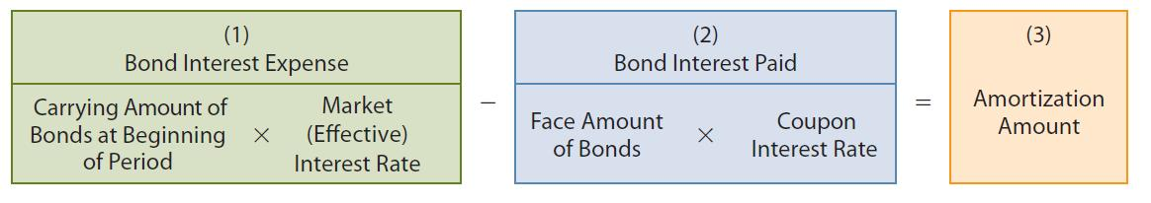
- Issuing bonds at face value
- Rate of interest is the same as the market value
- Issuing bonds at a discount
- This occurs when the investors pay less then the face value for the bond
- Done to make the bond more interesting
- Since the coupon rate is fixed the price of the bond must be lower so that the yield will be higher
- Using the present value table
- N= years x 2
- I = market rate x period
- Present value of face value received in n
- Present value of interest received of the period of months
- Amortizing the discount
- The discount amount is the amount that is amortized
- In the end the price of the bond always ends up at the face value
- Issuing bonds at a premium
- When the interest rate is higher then the market rate
- Then investors are going to be willing to pay more then what the bond is worth
- Using the present value table
- N= years x 2
- I = market rate x period
- Present value of face value received in n
- Present value of interest received of the period of months
- Amortizing the premium
- The premium is the amount amortized
- In the end the price of the bond always ends up at the face value
- Redeeming bonds at maturity
- At maturity the carry amount of the bond will be equal to the face value
- Redeeming bonds before maturity
- A company may decide to retire bonds before maturity to save on interest cost, and remove debt from the balance sheet
- Whens bonds are retired
  - Eliminate carrying amount
  - Record cash payment
  - Recognize gains (cost< carrying amount)/ loss (cost> carrying amount)
- Statement presentation
- Current liabilities
- Is generally reported as the first category in the liabilities section of the statement of financial position
- Non-current liabilities
- Are reported right after the current liabilities
- Measured and reported at amortized cost
- Uncertain liabilities
- Unsure of who is owed, when, and how much
- Provisions are uncertain as to timing or amount, but they know a charge will result
- Contingent liabilities is uncertain of what will happen
- In a result companies should recognize if more likely then not (IFRS) or in (ASPE) should be recognized if likely
- Analysis of debt obligations
- Liquidity ration measure the short term ability for a company to pay back it obligations
  - Current ratio
  - Inventory turnover ratio
  - Receivables turnover ratio
- Solvency ratio is the ability for a company to repay its long term obligation and to survive over a long period of time
- Debt to total assets
- Time interest earned
- Debt to total assets it measure how much the companies assets are financed by debt
- = total liabilities / total assets ( lower is better )
- Time interest earned is the ability of a company to pay its interest as it comes due
Profit +interest expense +income tax expense (EBIT)
Interest expense
- Higher is better
- Operating leases
- Is periodic rental usually short term
- Is done to avoid recording the liability
- But must be disclosed in the notes to the financial statement
Chapter 11

- The corporate form of organization
- Corporations – separate there owners from there company’s
- Owners are known as shareholders
- Purpose – profit (retail) or not-for-profit (fundraiser)
- Ownership – public or private
- Characteristics of corporation
- Separate legal existence - advantages
- Limited liability of shareholders (shareholder assets are not at risk if the company losses money) - advantages
- Transferable ownership rights - advantages
- Ability to acquire capital - advantages
- Continuous life - advantages
- Corporation management- advantages
- Government regulations - disadvantages
- Income tax- disadvantages
- Share issue considerations
- A corporation sells shares to generate money
- Can be divided in to different classes (common shares and preferred shares)
- Rights are given to different shares
- Voting – one share = one vote
- Dividends – is a payout amount to shareholders of the companies profit
- Liquidation –
- Authorized share capital
- Is indicated in its articles of incorporation
- Max amount of shares allowed to sell
- May be limited or unlimited
- Not recorded, disclosed only
- Issued shares (number of shares sold)
- The first time a company issues share its called initial public offering (IPO)
- Share price is set by the company
- Shares are usually issued for cash but it can sometimes be trade for assets such as land
- If its cash you Dr. cash and Cr. Common shares
- For land you Dr. land and Cr. Common shares

- Reacquisition of shares
- Companies can buy its own share on the open market
- Shares can be retired and cancelled or the can be kept in a treasury shares for later resale
- Reasons for reacquire shares
- To increase trades of there shares a company can buy or reacquire shares
- To reduce the number of shares available which will increase earning per share and return on common shareholders equity
- To buy out hostile shareholders
- To have additional shares to be offered to employees as bonus and stock plans
- Steps to record and reacquisition of shares
- Remove cost of shares from share capital account, based on the average cost per share
- Record the cash paid – cash is credit for the amount paid for the share
- Recording the gain or loss on reacquisition the gain or loss is the difference between the amount of the share at purchase minus the amount at which it was reacquired because the gain or lose is between a company and the owners and not between two companies it isn’t put on the income statement but is reduces or increases shareholders equity
- Reacquisition of shares
- Average cost of shares
Balance in common shares account
Number of common shares issued

- Below average cost
  - When the average cost > reacquired price
  - Debit common shares for the full amount, credit cash for the amount paid, and credit contributed capital- reacquisition of common shares
- Above average cost
  - When the average cost < reacquired cost
  - Debit common shares for the amount of the shares debit retained earning for the amount that was paid over the average past and credit cash for the full amount
- Preferred shares
- Share capital can consist of preferred shares and common shares
- Preferred shares have first dibs on dividends paid and at the event of liquidation
- But usually do not have the right to vote
- Recording is similar to common shares
- Convertible preferred shares are know to be able to change PS to CS at a specified ratio
- Redeemable/callable PF is the right to repurchase at a specific point in time and price
- Retractable PF is the right for the shareholder to sell is shares back at a specific point in time and price

- Dividends preference
- Dividends are paid in order of which preferred shareholders receive dividends before common shareholder s
- Cumulative is dividends pay to preferred shareholder plus all existing non paid dividends before common shareholders receive anything
- Non-cumulative is the opposite
- Dividends
- Is a pro rata (you get as much as you own) distribution of dividends from retained earning
- Cash dividends are most popular but also can be stock dividends
- Cash dividends
- For a cash dividend to happen a company must meet two-part solvency test
    - Must have enough cash to pay its up coming liabilities
    - The net realizable value of it assets must exceed its liabilities and share capital
- Three important dates in connection with dividends
- Declaration date – is the date of which the board of directors authorizes the cash dividends, the recording is debit cash dividends and credit dividends payable
- Record date - the date of who will receive a dividends , no entry
- Payment due – the date the dividends cheque is mailed, debit dividends payable and credit cash
- Stock dividends
- Is the distribution of stocks as a dividends
- Does not effect assets, liabilities, or shareholders equity because id decreases retained earning and an increase in shareholders equity
- Purposes and benefits of stock dividends
- Is to satisfy shareholders dividends
- Increase the marketability of its shares (when the number of shares go up the trading of shares increasing and entry of new investors) because the price of the share will decrease
- That the portion of shareholders equity has been reinvested and is unavailable for future cash dividends
- Stock split
- A stock split is the issuing of 100% more shares
- Where it increases the amount shares available which decreases the price of the stock but makes it more marketable
- Has no effect of share capital, retained earning or shareholders equity
- Example of a split is 2:1 split (meaning that if u own 1 share now you will have 2)
- Comparison of effects
- 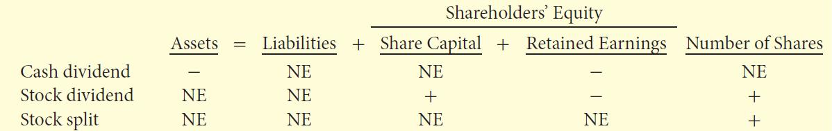

- Retained earning restrictions

- Balance in retained earning us generally available for dividends declaration
- Restrictions make a portion of RE unavailable for dividends
- Legal restrictions – the portion of treasury shares must be equal to the amount in retained earnings
- Contractual restrictions – if there are loan payments that must be made then dividends can not be made from retained earning so that the loan payments a secured
- Voluntary restrictions – if the board of directors decide that they will expand the company it is possible that dividends from retained earning will be held back to keep cash available
- Presentation of shareholders equity
    - Share holders equity transactions are reported in the statement of financial position and statement of change in equity
    - Shareholders equity is linked to retained earning there for it shows in the income statement
    - Contribution capital
- Share capital – preferred shares and common shares
- Additional contribution capital – the amount contributed from requiring and retiring shares
- Retained earning
- Is the cumulative profit or loss since incorporation
- Annual profit is added and the losses are deducted out of retained earning to see if the is a dividends paid or not
- Accumulated other comprehensive income
- Most revenues, expenses, gains, and losses are included in profit
- However, certain gains and losses bypass profit and are recorded as direct adjustment to shareholders equity
- Other comprehensive income (OCI) includes certain gains and losses:
- For example, revaluations of property, plant, and equipment using the revaluation model
- Accumulated other comprehensive income is the cumulative change in shareholders equity:
- Starts with opening balance and is increased (decreased) by other comprehensive income (loss) each period
- Comprehensive income (loss) includes profit and OCI
- 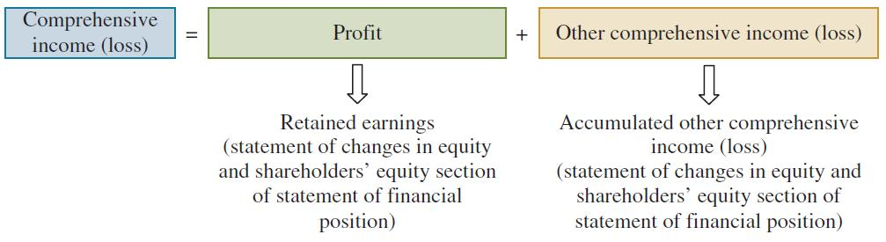
- statement of change in equity
- Discloses changes un total shareholders equity for the period
- Contributed capital
- Retained earning
- Accumulated other comprehensive income
- Statement of retained earning
- For private companies who have simpler share structures and few share transactions
- Shows the amount and change in retained earning during the period
- Add profit to opening balance minus if any cash dividends
- Measuring corporate performance
- Investors are interested in companies dividends record and earning performance
- Dividend record
- Payout ratio – measures the % of profit paid out as dividends
- Payout ratio – cash dividends / profit
- Higher is better if investors are looking for income
- Dividend yield
- Measures the profit generated by each share
- Dividend per share / market price per share
- Higher is better if investors looking for income
- Earning per share
- Measures the profit earned by each common share
- Profit available to common shareholders / weighted average number of common shares
- Not comparable between companies
- Profit available to common shareholders = profit – preferred shares
- Earning per share – complex capital structure
- When companies has securities that can be converted into common shared
- The additional common shares will result in a reduced (diluted) earning per share figure
- Basic EPS - Profit available to common shareholders / weighted average number of common shares
- Diluted EPS – hypothetical calculation as if all securities were converted into, or exchanged from common shares

- Return on common shareholders equity
- Measures the company’s profitability from the shareholders viewpoint
- It shows how many dollars were earning for each dollar invested
- Common shareholders’ equity:
= Total shareholders’ equity – legal capital of preferred shares
- Profit available to common shareholders / average common shareholders equity
- Higher is better

Chapter 13

- Reporting of cash flow
- Purpose of the statement of cash flow
- It helps users asses
- A companies ability to generate cash
- A companies needs in using this cash
- This is useful in determining
- Companies ability to generate future cash flow
- Investing and financing transactions during the period, and effect upon capital structure
- And for making comparisons with other companies
- Content of the statement of cash flow
- What is in the cash flow
- Definition of cash
- Cash can also include short term highly liquid investments that can be converted to cash within a short period (within 3 months)
- Classification of the cash flow
- Operating activity – includes
      - the cash effects of transactions that create revenue and expenses. They effect profit
- Investment activity – includes
      - Purchase and disposal of investments and long lived assets
      - Lending money and collecting the loans
- Financing activities – include
- Obtaining cash from issuing debt and repaying the amount borrowed
- Obtaining cash from shareholders and paying them dividend
- Significant noncash activities
- If it does not effect cash don’t report it in the cash flow
- They are reported in the notes of the financial statement
- Examples:
- Issue od debt to purchase assets
- Issue of share to purchase assets
- Conversion of debt to equity
- Exchange of property, plant and equipment
- 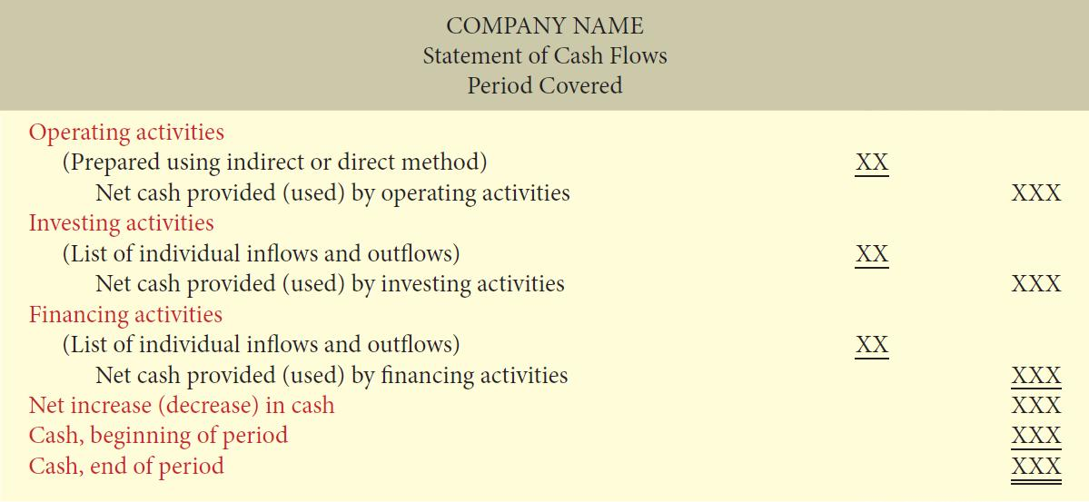

- Preparing the statement of cash flow
- Step 1: Prepare operating activities section
  - Determine the net cash provided or used by operating activities from accrual basis to cash basis
  - Indirect method
    - Easier to prepare
    - Reveals less information to competitors
    - Start with profit and deduct items not affecting cash to arrive at net cash provided (used) by operating activities
    - Example is depreciation it does not affect cash therefore it is added back to the operating activities. Same goes for bonds
    - 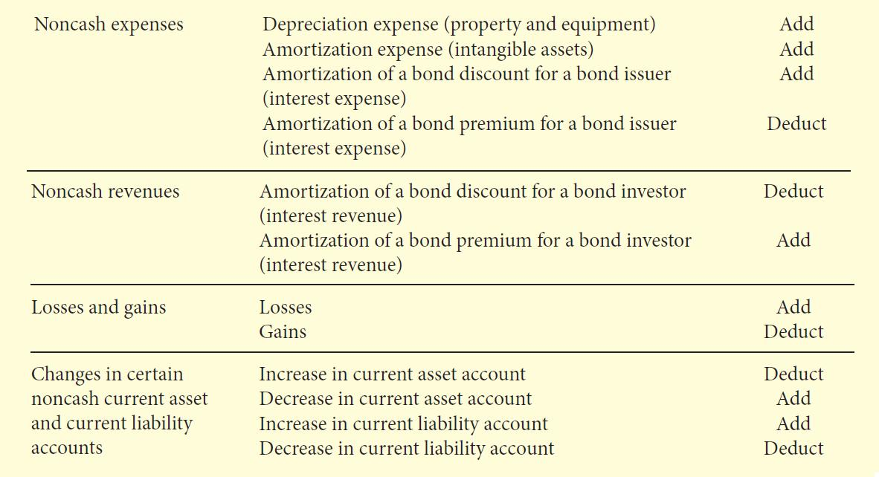
    - Direct method
- Standard setters prefer the direct method but allow the use of either method
- Details cash receipts and payments
- Similar to indirect method:
- Adjusts income statement from accrual basis to cash basis in order to arrive at net cash provided (used) by operating activities
- However, whereas indirect method adjusts total profit, direct method adjusts each individual revenue and expense account
Cash receipts from customers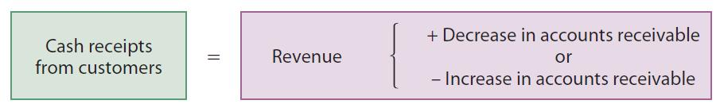
Cash payments to suppliers
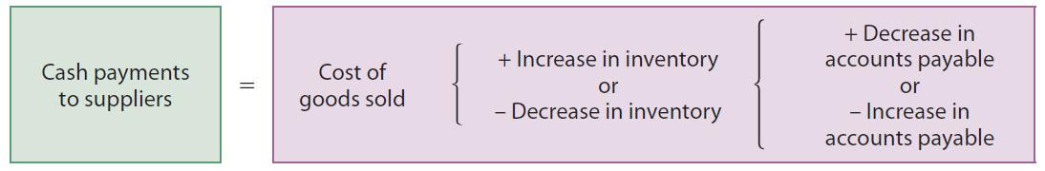
cash payments for operating expenses
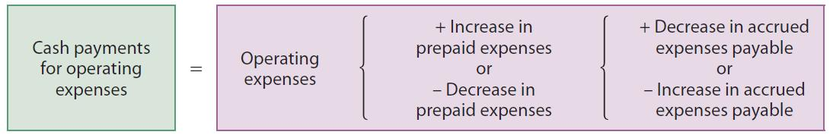

cash payments to employees
cash payments to employees = salaries expense +/- decrease/increase in salaries payable
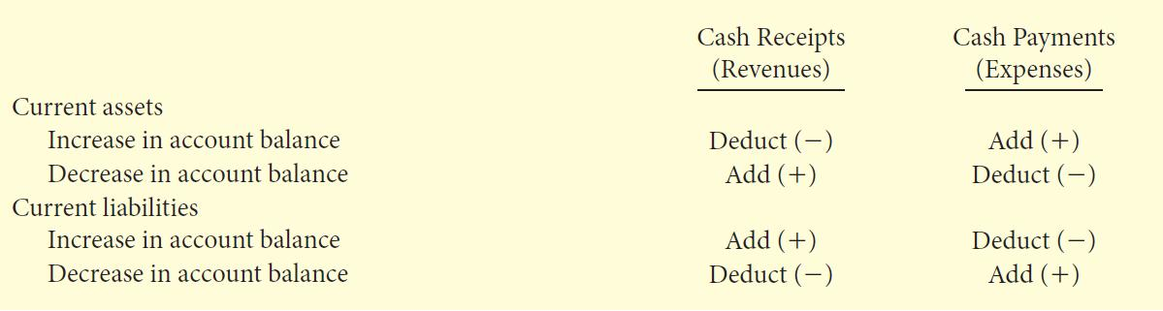

- Step 2: Prepare investing activities section
- Determine the net cash provided (used) by investing actives by analyzing change in non-current asset accounts
- Is reported the same way if using indirect or direct method
- Asset acquisitions are uses of cash; disposals are sources of cash (for the proceeds of disposition)
- Step 3: Prepare financing activities section
- Determine the net cash provided (used) by financing activities by analyzing changes in non-current liability and shareholders equity account
- Changes to notes, loans and bonds payable are analyzed to determine cause of change
- Step 4: Complete the statement of cash flows

