Motivated: moved to action/behavior or change in action/behavior

Motive: internal disposition to approach or avoid incentive

Incentive: environmental stimulus, attracts or repels

Push and Pull

motives push person into action toward end state

ex: hunger as a push toward food
  - Motives push train to destination
  - Biological needs and psychological needs

incentives pull person toward end state

ex: chocolate pulls person toward it
  - External tangible objects pull train to destination, end state
  - External incentives and goals

- Emotions as Motives

- Emotion: universal multi-channeled reaction by which person adapts to stimulus change
- ex: fear is adaptation to danger
- anger is adaptation to blocked or thwarted goal

- What motivates behavior?

- Events at end of motivation sequence or journey:
- consummatory (to complete) behavior is interaction with incentive, finalizes motivation sequence
- subjective feelings experienced during consummatory behavior

- psychological energy or mental energy—powers psychological endeavors for
- cathexis
- adaptation energy
- self-regulation or self-control
- information processing

- Physical
- material basis; glucose—powers muscles and brain
- brain has 2% of body’s weight but uses 25% of glucose

- Knowledge, Competence and Motivation

- Knowledge: how to perform behavior
- Competence: capable of doing behavior
- Motivation: impetus or reason for behavior
- all components necessary for behavior to occur

- Sources of Motivation

- location where behavior is motivated
- internal sources inside the person ex: hunger
- external sources outside person ex: food

- Internal

Biological attributes or variable—amount of food in stomach

ghrelin: hormone that stimulates hunger/eating

Psychological attributes or variable—degree of self-control

need to belong: characteristic that motivates person to affiliate with or be included by others

- Linking Biological and Psychological Variables

- Reductionism: explain mind’s psychological process in terms of activity of neurons in brain
  - Example: hunger sensations result from brain’s hypothalamus registering decline of glucose in brain

Emergence: refers to brain’s neural processes issuing forth psychological or mental events in consciousness
  - Brain registers low level of nutrients or glucose in blood stream from which emerges feeling of hunger

External sources

- External variables; incentives, goals
- Positive incentives motivate approach behavior
- Negative incentives motivate avoidance behavior
- As incentive or goal value increases, motivation increases

individual’s evolutionary past is shared by all humans

individual’s personal past belongs to him/her alone

evolutionary history: long-term past of humans that determines human nature; what all humans have in common as result of evolution

evolutionary psychology: link between evolutionary past and current behavior

personal history: person’s experiences since conception, determines his/her individual nature

person’s evolutionary history and personal history determine current motivations

Individual Differences

People motivated differently due to stable individual differences; psychological needs, personality traits

Agentic theory: people intentionally create circumstances of their lives to which they then react

products and producers of social systems

Combined Internal and External Sources Motivate Behavior

internal and external sources combine to motivate behavior

thirst increases motivation for water

size of water reward increases motivation

deprived of money (internal), men prefer heavier women (external)

when hungry (internal), value of money is greater (external)

strong motive for money (internal), more M&Ms eaten (external)

Motivation Sequence

Choice: select among motives to satisfy or incentives to attain

Instrumental behavior: satisfies motive or attains incentive

instrumental behavior or achievement behavior show strength of motivation in terms of;
  - Duration
  - Persistence
  - Frequency
  - Intensity

Emotion: from latin emovere; to move out

readiness to act consistent with aim of emotion

fear moves person away from danger toward safety

anger moves person to redress a wrong

Research in Motivation

- Research methods used to discover principles of motivation and emotion
- Research methods allow scientists to be highly confident that principles are valid

Experimental vs Correlational Research

Correlational variable: values measured by researcher

Experimental variable: values created by researcher

Dependent variable: behavior linked to above two variables

Correlational research: dependent variable or behavior is associated with correlational variable

Ex; persistence in solving problem is associated with level of achievement motivation

Experimental research: value of experimental variable determines dependent variable (behavior)

Ex: amount of incentive (dollars) determines degree of persistence in problem solving

Feasibility and Ethics

Feasibility of research and ethics involved determine whether to employ experimental or correlational research

Research in Natural Setting

- Correlational research could be used to investigate severe motivational conditions
  - Ex: does voluntary starvation increase attractiveness of all foods?
- could be used when high certainty desired
  - ex: does chocolate aroma that occurs below awareness increase desire for chocolate?

Research in Emotion

Create affect by:
- mood induction techniques involve self-statements
- happy and sad movies or music can alter moods
- emotions as result of natural or human phenomena
  - ex: floods, tornadoes, deaths

- Biological: Nature of body and brain affect motivation
- Psychological: Properties of mind affect motivation
- Environmental consists of;
  - Objective environment: material things affect motivation, e.g., money or university degree
  - Cognitive environment: mental representation of things affect motivation, e.g., subjective value of money or visualizing graduation

- Greek philosophers, from 1600 om

Aristotle’s Theory

- Causes of behavior: efficient causes trigger behavior—food triggers eating
- Final cause is purpose of behavior—eat to provide nourishment to body
- Formal causes refers to theory—human innately prefer sweets as aid to survival
- Material cause refers to role of brain in behavior—brain’s hypothalamus triggers hunger

Hedonism

pursue pleasure and avoid pain; motivation governed by hedonism

Socrates, Democritus, Epicurus for them hedonism meant pleasure is to exceed pain when averaged over long run

Later Philosophers

Hobbes;

incentive motivation: approach pleasing, avoid displeasing stimuli

Locke;

choice: small immediate versus large delayed reward, nearness of reward increases desire for it

Bentham;

principle of utility: things are beneficial if they increase happiness or decrease unhappiness

Sigmund Freud

Pleasure principle: pursue pleasure, felt as sudden decrease in tension

Reality principle: circumstances determine when to attain pleasure, postpone for greater pleasure later

Edward Lee Thorndike

Law of effect: satisfying consequences strengthen behavior, dissatisfying consequences weaken behavior

Today…

consequences refer to observables (reinforcers/punishers) rather than to subjective states

reinforcers increase behavior

punishers decrease behavior

Current Trends

- Impulsiveness: tendency to choose immediate reward, influenced more by nearness of reward
- Self control: tendency to choose delayed rewards, influenced less by nearness of reward
- Benefits of self-control: higher grades, less alcohol use, better adjustment, better interpersonal relationships
- Positive psychology: science that investigates what promotes maximal functioning of people, groups, institutions

study the conditions that produce happiness

Evolution and Motivation

Evolutionary past helps determine what currently motivates people today

Charles Darwin

Theory or evolution: changes in frequency of physical and psychological traits explained by principles of variation and selection

Principle of variation: amount or value of particular trait varies in frequency in population

Principle of selection: environment selects traits that aids survival, trait increases in frequency

leads to population thinking

population thinking: view emphasizing uniqueness of each individual and individual differences; people differ in strength of their psychological needs and level of personality traits

Herbert Spencer

- Pleasure selects for behaviors that aid survival
- Pain eliminates behaviors that are harmful to survival
- Pleasure motivates eating, drinking, sex
- Remove pleasure of behaviors, result is uninhabited planet

Instinct

inherited impulses, result in specific patterns of behavior

some motivated behaviors appear to be instinctive

ex: sucking, crying, smiling, emotional

Current Trends

purpose of instinctive smiles and laughs is to help children master social environment

smiles/laughs are positive responses to incongruities and reinforce exploration of environment

laughter acts as social lubricant for people

Unconscious Motivation

inaccessibility to one’s motives

being unaware of sources of one’s motivation

Freud’s Concious-Unconcious Distinction

uses analogy of two rooms to explain unconscious, preconscious, and conscious

unconscious: area of mind that is not open to inspection, analogous to large room that contains repressed impulses, instincts, desires
- preconscious: area of mind that is accessible to inspection and is analogous to a small room containing thoughts, feelings, sensations
- conscious: area of mind that is currently being inspected and is analogous to having attracted the eye of the conscious in the small room

repression: censor prevents instinctual impulses from entering small room
  - from reaching pre-conscious

- Motivational Instincts and Unconscious

- according to Freud, instincts originate in body and exert pressure
- aim of instinct is to be satisfied through interaction with object
- main Freudian instincts: sex, death, ego preservation

- Satisfying Unconscious Impulses

- instincts can be satisfied;
  - joke, dreams—manifest (actual) content and latent (meaning) content

Current Trends

research on how a goal is activated when person is unaware of source of activation

automaticity: external events control one’s mental process but without the person’s awareness

Internal Sources of Motivation

motivation for behavior begins inside organism or person as in the case of drive or need

Drive Concept

mechanism—how we do something or means by which act is performed

drive—stimulus that induced behavior and keeps behavior going even if stimulus is now absent

Psychological Needs

- needs inherent characteristic, indicates psychological deficit
- person lacking some necessary ingredient

primary or viscerogenic: Murray’s psychological needs

secondary or psychogenic Murray postulated 22 psychological needs

achievement—accomplish tasks, surpass self and others

affiliation—approach others, win affection, remain loyal

autonomy—independent and free, resist coercion

dominance—control environment, influence others

order—put things in order, organize, neat and clean

understanding—ask questions, analyze, enjoy logic, use reason

danger of creating too many psychological needs so that needs lose their explanatory power

solution is to arrange needs in hierarchy so that lower order needs derived from higher needs

existential concern—basic psychological need shared by all people

one’s own death, isolation, self-identity or self-insight, freedom or free will, meaning of life

External Sources of Motivation

Incentives: stimuli attract or repel

Tolman & Honzik—food incentive, maze errors decrease; removed food incentive, maze errors increase

motivation depends on both internal and external sources
  - hunger and food combine to motivate behavior

- Warden’s Incentive Drive Link

- Incentive drive: incentive (water) links with drive (thirst) to motivate behavior
- increased hunger drive increases electrified grid crossings for food incentive
- delayed food incentive decreases electrified grid crossings in hungry rats

- Lewin’s Field Theory

- uses internal and external sources to develop idea of psychological force as motivation
- psychological force: motivation depends on valence of objects in life space (personal environment), psychological tensions, psychological distance

- Psychological force= valence of goal; tension in person / psychological distance between person and goal

- Temporal motivation theory: way to explain how incentive value decreases with incentive delay
- delayed incentives have less value or are less motivation than near incentives

Brief History of Emotion

description of emotion shifted from outward physiological movement of person to movement that occurs within person

Emotion as Subjective Feeling

personal feelings of affect that arise in consciousness

feelings of bodily symptoms

feelings that flood consciousness

Basic Emotions

early Greeks to Descartes to James considered basic emotions; love, hate, joy, sad, hope

cognitive interpretations of stimulus changes determine emotions

Emotion as Motive for Action and Thought

emotions serve as impulses for action and thought

action readiness: impulse for action of emotion-relevant behavior

motor explosion: nonadaptive response during an emotion ex jump for joy

Accompaniments of Emotion

physiological arousal has long been viewed as accompaniment of emotion—heart rate

Bacon and Descartes noted that emotions involved physiological accompaniments

Physiological Arousal

arousal serves as either basis of action or information for qualitative feel of an emotion

Bacon & Decartes

- Fear: Paleness, tremble, hair erection, startle, screech
- Grief: Sigh, sob, groan, tears, distorted face, grind teeth
- Joy: Vigor of eyes, sing, leap, dance, at times tears
- Anger: Paleness, blush, tremble, foam at mouth
- Lust: Flagrancy in eyes, priapism
- Love: Pulse is fuller and stronger, heat in breast
- Hate: Pulse feeble, quick; cold, heat alternate in breast
- Sadness: Pulse feeble, slow; constriction around heart

- Facial expressions have long been viewed as accompaniments of emotion
- Expressions as indicator of emotional feelings
- Expressions as signals used to satisfy one’s social motives

- Toppling of initial dominoes represents evolutionary history, which topples later dominoes that represent personal history
- 10th or last domino represents motivated behavior in present

- Evolutionary History and Personal History

- Evolution created human body and human nature

- Human nature: behavioral, motivational, emotional characteristics that people have in common in spite of environmental and cultural differences

- Universal motives: shared human motives due to evolution
- Hereditary—nature and experience—nurture
- Purely hereditary; eye color, blood type etc… can’t be changed
- contribute to motivation of behavior just like length and width contribute to area of rectangle

- Experience and Motives

- Innate behaviors are instinctive, not taught
- Current behaviors result of interaction between innate tendencies and experience

- Evolutionary Psychology

- Area of study that analyzes human motivation in terms of evolution
- Psychological mechanisms evolved to solve problems of adaptation

- Universal Motives

- Universal biological and social needs and incentives that exist in societies in the world over
- Universals may be motives and valued incentives that are common throughout the world

- Categories of Universal Motives

- Aesthetics: art, hygiene, music, standards of beauty
- Control of environment: fire, shelter, tools
- Emotions: anger, contempt, disgust, fear, happy, sad
- Facial expressions: for emotion, communication, modify
- Fears: loud noises, snakes, strangers in childhood
- Goal setting: predict and plan for future
- Self concept: self as subject, object, different than others
- Sexual interactions: attraction, sexual jealousy, regulation
- Social milieu: live in social unit, rights, obligations

- Inherited Structures for Behavior, Motives, Emotions

- Genes: DNA segments that provide info to build brain and body from one generation to the next
- brain and body disposed to react in certain ways ex: universal motive

- Universal Motives of Sex, Fear, Food, and Music

- Motives shared by all humans
- Universal motives determine commonality of what motivates us

- Selecting a Mate

- Sexual selection: one sex selects individual from other sex for mating based on some trait of latter
- Physical attractiveness is one characteristic of mate value

- Mate value: one person’s characteristics that makes him or her desirable to another person as a partner

- Some items from Mate Value Inventory

- Attractiveness, ambitious, desire for children, sense of humor, financially secure, responsible, sociable, faithful, loyal etc...
- People with higher physical attractiveness are better at attracting mates and have more sexual experiences
- Tend to believe them more, make more money over life period

- Good Gene Hypothesis

- Beauty signals that person has good genes for intelligence, good immune system, healthy babies, good parenting
- People select partners with high mate value OR
- People do NOT select partners with low mate value
- Haven’t figured this out…

- Universality of Beauty and Health

- Standards of beauty are the same the world over: averageness, symmetry, sexual dimorphism (feminine, masculine)

- Sex Differences in Long-term Mate Selection

- Women select mates to increase chance of survival of their few offspring
- Men select mates to increase chance of producing many offspring

- Characteristics of Long-term Mates

- Women prefer mates who have good financial prospects, are ambitious and industrious
- These traits are needed to raise a family successfully

- Men prefer mates who have good looks, which is indicative of fertility
- Fertility is a trait that is needed to produce many children

Maintaining Relationships

By pleasure of sex, guarding against poaching, jealousy

Function of Sexual Pleasure

- Rewards sexual behavior
- Development of romantic love
- Promotion of pair-bonding
- Boost chances of pregnancy

Guarding Relationships

Mate poaching: an attempt to attract a person who is already in a relationship

60% of men and 40% of women reported attempts at poaching

Jealousy

- A negative emotion triggered by possible loss of one’s mate
- Men report greater distress from sexual infidelity than do women
- Women report greater distress from emotional infidelity than do men

Biosocial Theory

- This stresses the interaction between social experiences and evolved sex differences in strength and reproductive capacity

Structural powerless hypothesis: explanation of why women prefer good financial prospects, ambition, industriousness in their men

- Women have less economic opportunity ex: powerless to attain financial resources and so prefer men who have greater financial resources

Fear as a Universal Motive

- Fear is the motive for escaping or avoiding dangerous stimuli or circumstances
- Fear results from interaction of evolutionary history and personal history
- Fear resides in the amygdala, hippocampus

Survival Value

- Fear evolved to motivate escape and avoidance responses to dangerous stimuli or circumstances

Preparedness

Degree of readiness to learn to fear some stimuli compared to other stimuli

Contraprepared: fears learned with difficulty

Prepared: fears that occur full-blown without prior experience, innate fears, or fears learned quickly

Preparedness and Observational Fear Conditioning

- Observing monkey did NOT become disturbed to snake or flower when model monkey acted calmly
- Observing monkey became disturbed to snake but only when observing monkey acted fearfully
- Monkeys are prepared to fear snakes, not flowers
- Conditioned heart rate acceleration occurs to snakes but not flowers
- Spider and snake stimuli presented below awareness increase arousal, which is indicative of fear

Liking and Preference for Foods

- Evolutionary history and personal history combine to determine food liking and preference

- Omnivorous to be able to eat a variety of foods, eat food from one’s locale

- Food neophobia is a tendency to avoid novel foods and to prefer familiar foods
- Evolutionary significance is that it protects person from eating substances that cause illness or death

Innate preference and aversion for substances

- Babies prefer sweets and shun sour and bitter stimuli
- Facial expressions of very young infants indicate preference
- Signal what it tasted—sweet, sour, bitter
- Babies indicate by their expressions their likes and dislikes

Early Experiences Interact with Innate Preferences

Mother drinks carrot juice while pregnant or nursing

Infants experienced carrot flavor by swallowing amniotic fluid or drinking mother’s breast milk

Experiences increased infant’s preference for carrot-flavored cereal

Fat Preference

Humans prefer fat in foods, “fast foods” often contain high fat content

Universal Appeal of Music

Evolutionary psychology maintains function of psychological mechanisms is to solve problems of survival

What is survival value of music—survival benefits of music not obvious

Possible Evolution of Music

Music may promote group cohesion, listen together

Regulates mood, pleasurable to listen to

By-product in evolution of other motives

Benefit of sexual selection, musicians may have higher mate value

Music in human culture for over 30,000 years, different forms world wide

Responding to music is innate

Infants enjoy music

Prefer consonant music to dissonant (unpleasant) music; infants orient toward consonant music when given the choice

Alcohol

- Ethanol is the alcohol in a drink
- In low amounts produces euphoria and releases social inhibitions
- Bi phasic effect; at the beginning you feel good, can look inhibitions, after drinking for a while it becomes a depressant

Nicotine

- Psychoactive drug in tobacco
- Reported as mood enhancing and relaxing
- Acts similar as amphetamines on the brain

Amphetamines

- From kat plant or produced artificially
- Stimulant
- Produces alertness, euphoria, feelings of well-being
- Methamphetamine derived from amphetamine and produces a greater psychoactive effect
- Ritalin before exams, ADHD ADD medicine
- Can be dangerous to take, if you do not have ADD

Cannabis

- Tetrahydrocannibol (THC) from hemp (cannabis) plants is psychoactive component
- THC contained in marijuana and hashish
- Smoking marijuana produces euphoric, relaxed, drowsy feelings

Cocaine

- Cocaine hydrochloride is odorless white powder processed from coca paste
- Produces an increased sense of energy, mental acuity, sensory awareness

Opiates

- Drug processed from the sap of the seeds of opium poppy plant
- Types opiates are codeine, morphine, heroin
- “rush”, elevated mood, euphoria, decreased anxiety
- does not cross brain barrier well
- one of break down products of heroin is codeine—not as strong, bi product

Extent of drug use

Frequency of use in descending order:

- Caffeine, alcohol, cigarettes
- Cannabis or marijuana
- Cocaine, ecstasy, amphetamine, methamphetamine
- Heroin

Characteristics of Addiction

- Addiction is an intense craving, seeking out, and use of particular drug
- Voluntary drug use results in either quitting, using occasionally, or compulsive involuntary use
- Becomes what you live for, brain is biologically altered

Craving

- Feeling an overpowering, uncontrollable urge for the drug the person is using
- Desire for pleasure that a drug brings
- Craving is a desire for the relief of unpleasant withdrawal feelings

Tolerance and Withdrawal

- Tolerance: body habituates to effects of drug
- withdrawal syndrome: drug-opposite effect characterized by unpleasant feelings that results form drug abstinence
- addiction: dependence, intense craving, seeking out, and using a drug
- hits reward circuits—dopamine circuits; allow us to go back and have us learn things, make us feel good…system takes over

Initiation into Drug Use

Process by which individuals progress from drug experimentation to habitual drug use

Genetic Disposition

- Genetics of addiction—genetically related individuals similarly vulnerable to drug experimentation and addiction
- Differences within cultures, genetics attributions
- Higher probability to addiction if parent was, does not necessarily mean you will have the addiction as well

Personality Disposition

- “addictive personality”

- some nervous systems, such as in ones with ADD, have higher desire for risk, extreme

- Level of personality traits that are associated with drug experimentation, use, and finally addiction
- High sensation seekers enjoy the greater stimulation that psychoactive drugs provide

- Impulsiveness: increased sensitivity to drug effects, low awareness of negative drug consequences
- Higher tendency to drug use

- Person’s level of impulsiveness measured by Barratt Impulsiveness Scale

- Reward deficiency syndrome: brain’s pleasure center is less sensitive to dopamine
- Since it does not work as well, they will take drugs to attempt for it to function properly, feel good

- Dopamine: brain chemical related to pleasure

- Lower sensitivity makes individuals more likely to turn to drugs for pleasure

Theories of Drug Addiction

- Role of reinforcement process
- Positive reinforcers, psychoactive drugs produce pleasure
- As negative reinforcers, psychoactive drugs reduce general discomfort and agony of withdrawal

Discovery of Pleasure Centers in the Brain

- 1953 James Olds implanted electrodes in hypothalamus of rat’s brain
- rats behaved repeatedly in order to stimulate electrode presumably for the pleasure provided
- neurons activated in pleasure centers from brain
- feelings of pleasure emerge in consciousness from activated neurons

- incentive—a bullet, key something in which is powerful enough to change situation
- economics, social, moral
- dose response—using different levels to see where incentives will come out of

Drugs and Natural Incentive Effects

- Drugs do not operate like natural incentives—only pleasurable when they reach the brain’s pleasure areas
- Artificially done

Neurons and Neurotransmitters

Neurons: specialized cells that conduct electrical impulses
- Electrical impulses are the way of communicating among neurons in the brain
- Individual neurons are separated by gaps known as synapses
- Each neuron can have thousands of connections to other neurons, communicate with one another

Neurotransmitters: chemicals that allow neurons to communicate across synapses
- After communicating, neurotransmitters reabsorbed (reuptake) into neurons
- By taking drugs, body loses function
- Ex: cocaine, body stops producing dopamine as it is tricked in thinking dopamine is going into body
- Drugs fill in caps, can bine to receptor, fires next neuron, feels good

not coming from neuron itself, tricking the body

body craves it more as the body is no longer producing the dopamine
- antidepressants stop re-up of neurons
- can stay in synaptic cleft longer, alleviate depression, tricking body into it getting serotonin

Common Brain Pathway

Mesolimbic dopamine system: neurons in middle of brain linked to pleasure, especially the nucleus accumbens and ventral tegmental area

Dopamine is the major neurotransmitter there
  - Psychoactive drugs stimulate neurons or influence dopamine that is already there in those areas
  - Psychoactive drugs travel to synapses of mesolimbic dopamine system
  - From the increased activity of neurons in that area, there emerges feelings of pleasure and euphoria

Blocking Drug Effects

Antagonists: drugs that have the ability to inhibit effects of neurotransmitters like dopamine

Naltrexone is an antagonist, can inhibit effects of psychoactive drugs

Opiates can’t stick to neurotransmitters as antagonists are working against them, are stronger
  - Can reduce urge to drink alcohol, reduce reinforcing effects of alcohol

- When alcohol dependent individuals take naltrexone for six consecutive days, it reduces their urge for alcohol and reduced drinking

- Psychological Theories

- Explain drug craving, pleasure, drug withdrawal
- Do not use brain processes as explanatory concepts

Opponent Process Theory

- Psychoactive drugs produce euphoria, known as process A
- An opponent reaction or drug-opposite reaction, known as process B, occurs in response to process A
- Process A declines as drug wears off
- Opponent process B remains strong
- Drug opposite effects of B are responsible for withdrawal symptoms

Incentive Sensitization Theory

Incentive sensitization theory: craving depends on drug’s incentive value and its hedonic value

Incentive value refers to drug’s ability to create wanting or craving—increases

Hedonic value refers to actual pleasure derived from using a drug—remains constant, or declines slightly

Repeated experiences of drug use

Conditioning Theories

Explain how actual drug stimuli and drug-associated stimuli evoke craving, euphoria, and withdrawal

Classical Conditioning

- Unconditioned stimulus (drug) unconditioned response (pleasure)
- Conditioned stimulus (drug-associated) repeatedly predicts the unconditioned stimulus (drug)
- Eventually, conditioned stimulus evokes a conditioned response that may resemble unconditioned response

Conditioned Compensatory vs. Drug-like Responses

Conditioned compensatory response model the conditioned drug response is opposite of the unconditioned drug response
  - Conditioned response compensates for forthcoming unconditioned drug response
  - Compensation effect is opposite of drug effect
  - If unconditioned response is pleasure, then conditioned compensatory response is withdrawal agony

Conditioned druglike response model: the conditioned drug response resembles the unconditioned response
  - If the unconditioned response is pleasure, then the conditioned druglike response is also pleasure

Events That Lead to Drug Relapse

Drug relapse taking drugs again after having abstained or having reduced one’s drug dependency
- Conditioning theories can explain drug relapse following drug abstinence

- Priming: reinstatement of a strong drug craving with a single dose of alcohol, nicotine, cocaine, or heroin
- The first drink of alcohol increases the desire for a second drink or the first cigarette increases the desire for a second cigarette

Priming with a Conditioned Stimulus

- A conditioned stimulus can prime a strong craving for a drug like alcohol, nicotine, cocaine, or heroin
- Stimuli associated with smoking primes a desire for a cigarette, e.g., bar scene or sight of cigarette pack

Stress and Drug Cravings

The use of psychoactive drugs alleviates stress

Comorbidity: people who are stressed or who are in distress are more likely to use drug

- Self-medication hypothesis: individuals stressed from PTSD take psychoactive drugs to reduce negative feelings that are evoked by traumatic memories

Drug use is motivated by escaping from drug lows or pursuing drug highs

Positive Reinforcement

- Psychoactive drugs make a person feel good
- Positive reinforcement is the good feeling the drug provides, which strengthens a person’s drug use

Negative Reinforcement

- Psychoactive drugs make a person feel less bad
- Negative reinforcement is the reduction of bad feelings from drug withdrawal
- Negative reinforcement strengthens drug use

Affective model of negative reinforcement

individuals are motivated to use drugs to reduce actual or anticipated negative affect that results from the withdrawal of drugs

Cognition and Addiction

Individuals can cognitively decide whether to expose themselves to drug stimuli

Motivation for change: stopping psychoactive drug use occurs in stages: a person willfully contemplates, prepares, executes, and maintains change

Behavioral Addictions

Rather than a drug, behavior itself becomes addictive

Exercise and gambling can become addictive

Negative addiction: behavior like drug use that is harmful to health

Positive addiction: compulsive behaviors that benefit health
  - Good feelings (runners high)
  - Endorphins

Reinforcers

- Positive reinforcer from exercise is improved physical, mental health, and goal achievement
- Exercise high is positive reinforcer characterized by euphoria and mood improvement
- Negative reinforcer from exercise is relief of stress and tension (negative—taking away)

Change in cognition

Exercise Tolerance

- Decline in euphoria from exercise that is the result of physical conditioning, resembles drug tolerance
- Person must exercise more or more frequently to experience the same level of positive feelings

Withdrawal

- Abstention from exercise results in depression, anxiety, and irritableness
- Exercise withdrawal resembles drug withdrawal

Addiction

Crave, pursue activity, and exercise in spite of adverse consequences, exercise dependence

Endorphins and Exercise-Induced Euphoria

- Endorphin-exercise connection: strenuous exercise releases endorphins in neurons linked with pleasure neurons, e.g., mesolimbic dopamine system
- Endorphins: neurotransmitters located in brain’s pain pathway, they reduce pain and stress

Gambling Addiction

- Legalization of gambling has led to an increase in associated problems
- Gamblers seek opportunities to gamble and are not sensitive to negative financial and social consequences

Gambling Priming

- The urge to gamble can be primed by gambling-associated stimuli

advertisements, paycheck, sights, sounds of gambling in casino (Slots)

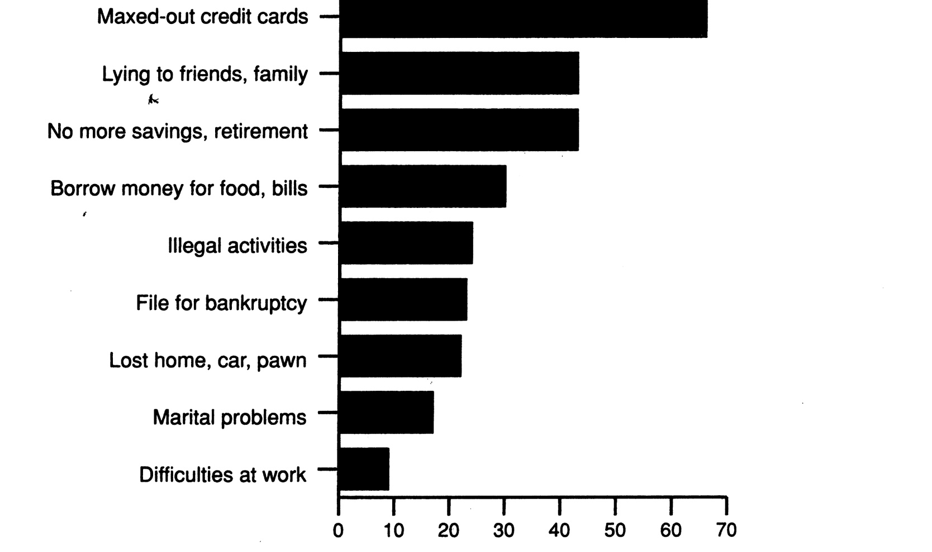

negative behaviors attest to addictive nature of gambling

Dopamine and Gambling

- Mesolimbic dopamine system linked to pleasure of gambling
- Dopamine antagonist (naltrexone) implicated in reduction of gambling pleasures

Video: Steven Levitt : The freakonomics of McDonalds

- Crack cocaine’s influence on inner city gangs
- Highly addictive, short high, expensive
- Comparison of gang to mc donalds
- Organization—hierarchy
- Salaries
- Local leader—franchise owner
- Compared to war zone
- “compensating differential”—war, paid more

- Internal Factors of Body Regulation

- Homeostasis: maintain constant internal body conditions

- to restore constancy following offset disturbances
- ex: sweat when hot, shiver when cold—restore internal body temperature to set point

- Negative Feedback System

- Self-correcting process, reduces discrepancy between desired state and actual state

- Ex: relationship between household thermostat setting, actual temperature, actions of furnace or AC
- Hypothalamus sending messages to pituitary gland

- When it does not hit set point, creates a deviation—physiological need is created
  - Needing food or water

- Needs and drives

- Physiological need: discrepancy between set point and actual physiological state
- hunger, measures glucose—hypothalamus determines blood glucose is too low, feelings in stomach due to past experiences to intake food
- iron, can’t breathe without—hemoglobin

- creates a physiological drive, seek out to get back homeostasis balance

- alliesthesia: change in a person’s internal physiological state determines whether stimulus is judged pleasant or unpleasant
- idea that there is more than one homeostasis balance
- stimuli and behaviors that restore balance feel pleasant, while those who disrupt feel unpleasant

- Thermoregulation

- Raised body temperature causes “Warm” sensations, pleasant to get cooler
- Vise versa for lowered body temp

Cellular Thirst

from loss of intracellular or extracellular fluids

intracellular fluid: water within body’s cells

thirst occurs from loss of water within cells when water is drawn out due to higher salt concentration in extracellular fluid

- Extracellular fluid: water that provides an external environment around cells
- thirst occurs from loss of extracellular fluids due to evaporation from skin, sweating, urinating, exhaling

- Thirst Sensations

- Intracellular or extracellular water loss produces local thirst sensations—dry mouth, throat
- General thirst sensations—thirsty, tired, weary

- Water Deprivation and Hedonics of Drinking

- When thirsty, drinking is pleasant—alliesthesia
- Cooler water more pleasant as it restores core body temp sooner
- Pleasantness of water determines how much is drank

- Inhibitors of thirst

- Must eventually stop or inhibit drinking
- Receptors in mouth, stomach, intestines monitor water intake, provide signals to inhibit drinking
- Feed back loop—back to hypothalamus

- Body’s Energy Requirements

- Body and brain require energy is order to work
- Energy comes from food and measured in calories
- Calorie: unit of heat energy necessary to raise water temperature one degree Celsius

Metabolism

Resting metabolism: energy for maintenance of body and brain when person is inactive, at rest

Thermic effect: energy used to digest, absorb, and store food

Physical activity: energy used for voluntary activity and spontaneous activity

- Energy Storage and Use

Energy homeostasis: balance between energy input gained from food minus energy output for metabolism, thermic effect, and physical activity
- Homeostasis energy input = energy output

- Energy comes from glucose—simple sugar obtained from carbs
- Excess glucoseglycogen—glucose molecules linked together for storage in liver and muscles

- Energy homeostasis occurs on a short-term basis and a long-term basis

Decline in glucose in blood initiates hunger, eating

Rise in glucose in blood inhibits hunger, eating

Set Point Model and Long-term Regulation

Set point model: body fat level set at a specific value
- Discrepancy below set-point value triggers hunger
- Dieting lowers metabolism so as to maintain set point
- High calorie meals increase thermic effect so as to burn more calories in order to maintain set point
- Below set point—triggers hunger
- Hunger is a mechanism, something triggers it
- Feel its effects, chemical changes

Carrying cost: energy used to carry one’s weight

Greater for a heavy than light person when engaged in various activities

Energy Reservoir Model and Long-term Regulation

level of fat stored is analogous to the amount of water in reservoir

- level of stored fat depends on amount of energy input and amount of energy used
- small amount eaten, metabolism decreases in order to conserve level of fat—analogous to conversing water in reservoir
- energy expenditure is high, such as exercise, fat level declines—analogous to using a lot of water and reservoir level drops

Hunger Sensations

inform a person that he or she is running low on energy

Sensations Indicating Energy Depletion

hunger, desire to eat, amount, fullness vary with time since last meal, since energy was used during time interval

Ratings of Hunger and Related Sensations

Rate the intensity of your hunger and related sensations that you feel right now:

- Hunger: Not at all hungry = 0 --- 9 = As hungry as I have ever felt
- Desire to eat: Very weak = 0 --- 9 = Very strong
- How much could you eat: Nothing at all = 0 --- 9 = A large amount
- How full is your stomach: Not at all = 0 --- 9 = Very full

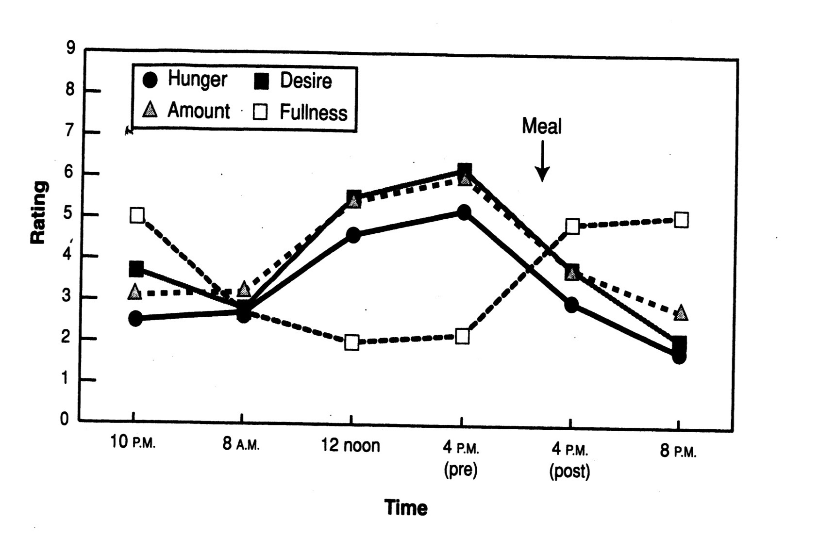

ratings of hunger, desire to eat, amount expected to eat increased with hours of deprivation and decreased with eating; ratings of stomach fullness showed reverse trend

Hunger Indicates Size of Energy Stores

- Number of calories in stomach predicts hunger and size of next meal—after 3 or 4 days without food, hunger sensations cease

Feedback Mechanisms for Satiety

Hunger motivates eating

Satiety: hunger gratified, feel content, replenished energy stores, inhibits eating

Hunger/satiety feedback mechanism based on several factors

feeling “full”—inhibits further eating

calorie detectors—amount of food energy in stomach inhibits further eating, calories eaten determines how full person is; high calorie meals produce feeling “full” sooner

hormones—critical for energy homeostasis; CCK, leptin, ghrelin
  - Cholecystokinin (CCK): short-term inhibitor of hunger and eating, released from upper part of small intestine
  - Leptin: released by adipose (fat) tissue associated with long-term energy conservation and expenditure
    - decreased leptin linked with energy conservation and increased leptin with energy expenditure
  - ghrelin: hormone released from stomach
    - rises before meal time, declines rapidly after eating

- Food Characteristics and Eating

- Fat, sugar, experience with food all determine how much person enjoys eating

- cephalic responses: physiological reactions to sight and aroma of food
- sight and aroma of food increases hunger, salivation secretion of gastric juice, insulin

- Palatability and amount of food

- Palatability: hedonic value of food
- appetizing, delicious, pleasurable to eat
- based on variety, texture, temperature, aroma, flavor, appearance
- more food given, more food will eat
- possible reason for being overweight is that people given portions larger than necessary to maintain energy homeostasis

- Sensory specific Satiety

- decrease in response to sensory characteristic of food; flavor, texture
- sensory specific satiety resembles stimulus habituation, leads to decreased liking and consumption of particular food

- Food Preferences

- Humans have both innate preferences and learned preferences for certain foods
  - innate; infants prefer sweet and reject bitter and sour
    - rats and humans have innate salt preference when deprived of salt
  - conditioned; mere exposure effect—repeated food tastings increases liking for that food
    - food eaten when more hungry is preferred to food that is eaten when less hungry
    - food with higher energy content (more calories) preferred to food with lower energy content
    - pleasant digestive consequences of food increase liking for that food, vice versa
    - taste aversion—strong dislike for particular food due to association of taste and smell with nausea

- Boundary Model of Eating

- person sets boundaries of when to start and stop eating
- boundaries define zone of biological indifference
- boundaries are under cognitive control
- zone of biological indifference is between hunger boundary (eat when below) and satiety boundary (stop eating when above)
  - narrowest for normal eaters
  - wider for restrained eaters
  - widest for anorexics
- restraint: cognitive effort that is used to resist urge to eat
- revised restraint scale measures cognitive effort used in dieting
  - when cognitive restraint released, dieters overeat or may binge on food
  - various events cause release of cognitive restraint

- Stress Induced Eating

- Caused by failure releases cognitive restraint
- Comedy or horror film produces stress and overeating results
- Restrained eater ate more popcorn while viewing comedy or horror film than non-restrained eaters did

- Hunger Boundary

- lower boundary of zone of biological indifference determines extent of hunger necessary before person begins eating

- Physiological Pressures

- Restrained eaters resist physiological pressures to eat that hunger produces
- Palatable food intensifies pressure of hunger
- Dieters have stronger cephalic responses to palatable food than non dieters do

Internal Cues and Eating Disorders

Anorexia nervosa: condition, usually young women, typified by extreme weight loss (less than 85% of normal body weight), distorted body image, trouble distinguishing when hungry or full

very high cognitive control for not eating

Refeeding syndrome: people with anorexia have adverse reaction to eating that results from body’s lost ability to digest food

incentive value of handling food is high

incentive value of eating is low

Arousal and Performance

Arousal refers to mobilization or activation of energy for and during behavior

Arousal increases vigor of behavior, affects efficiency of behavior

Categories of arousal:

physiological

brain

psychological

Physiological Arousal

Physiological arousal: bodily changes that correspond to feeling energized

Sympathetic nervous system: increases heart rate, muscle tension, perspiration

Brain Arousal

brain areas receiving more blood, glucose, oxygen more active, use more energy

positron emission tomography (PET) and functional magnetic resonating imaging (fRMI) measure blood flow, glucose use, oxygen in active brain areas

Psychological Arousal

subjective experience regarding how activated or energized person feels

energetic arousal: positive feeling

tense arousal: negative feeling

scale measuring energetic and tense arousal Thayer’s Activation-Deactivation Checklist

higher score on scale, greater degree of energetic and tense arousal

energetic arousal results from brisk short walk

tense arousal higher prior to exam

Sources of Arousal

High midday, low in morning and night

Caffeine boosts energetic arousal

Tense arousal stems from evaluation anxiety during exams, sports competition, social situations

Collative Variables

stimulus characteristics; ex: stimulus novelty, complexity, incongruity

novelty: stimulus new or different

incongruity: single element in array conflicts with other elements in array or with prior elements

Tasks

Degree of arousal or energization to begin work on task depends on:

severity of need to complete task

incentive value of task

likelihood of successfully completing task

Arousal Performance Relationships

Performance efficiency depends on:

task difficulty

intensity of arousal

Arousal and Behavior

Some tasks, arousal increases behavioral efficiency, and some decrease

anxiety increased, decrease in number of successful basketball free throws

reaction speed increased with increase in caffeine

Yerkes-Dodson Law

Inverted u arousal relationship: stimulation or arousal increases, performance increases, levels off, then declines

arousal interacts with task complexity: low arousal for best performance on difficult tasks;

high arousal for best performance on easy tasks

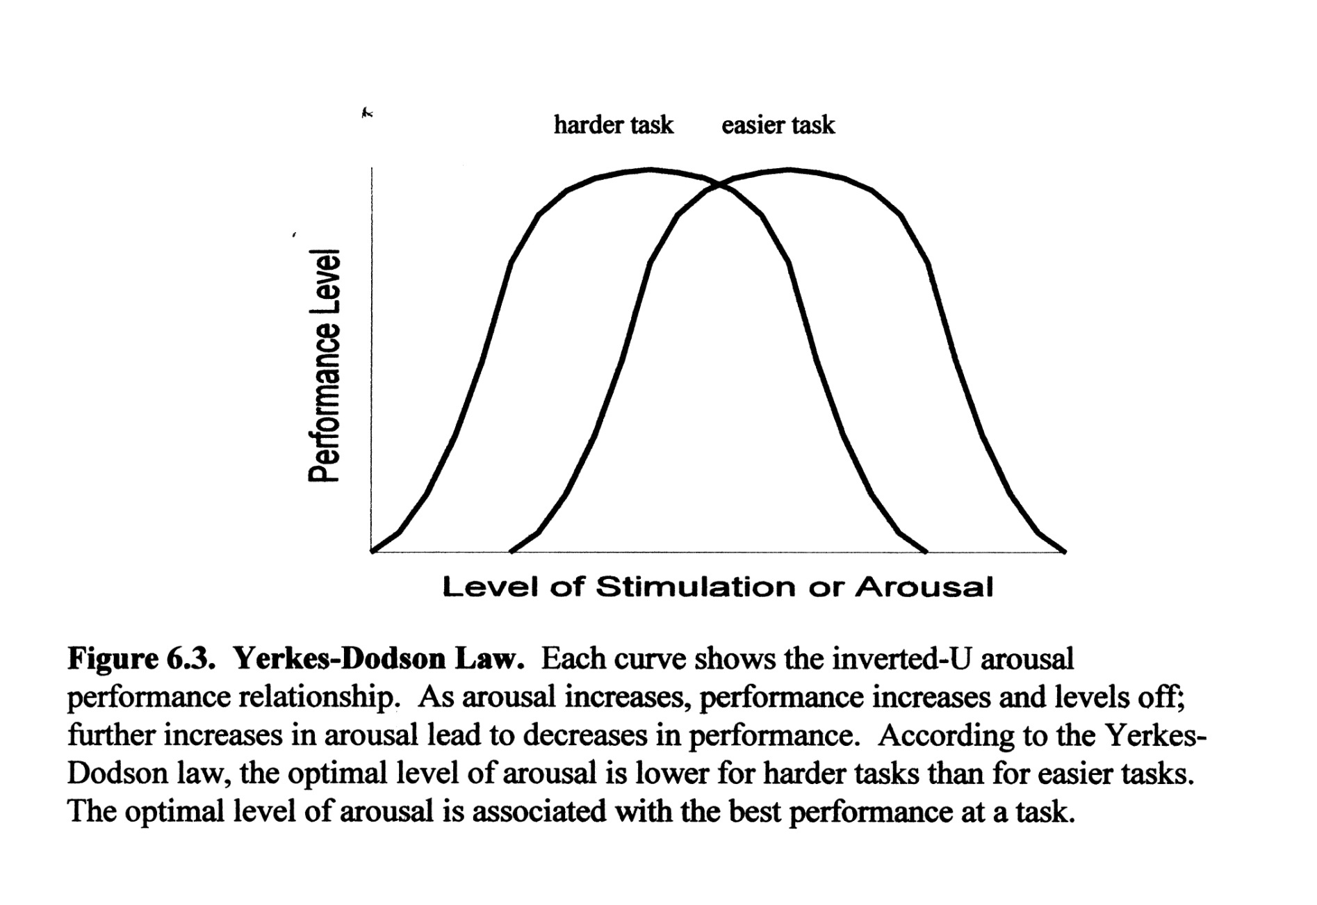

Zones of Optimal Functioning

idea in sports psychology that each individual has his/her own inverted U-curve

athletic performance best when athlete is at optimal of own curve

Theories about Arousal Performance Relationship

Hull-Spence Drive Theory

- Arousal increases strength of all responses
- Easy tasks—correct response is stronger than incorrect response
- Arousal magnifies this difference so that person performs even better during high arousal
- Complex tasks—correct response may be weaker than incorrect one
- Arousal magnifies difference, person performs even worse during high arousal, since incorrect response becomes even stronger

Cusp Catastrophe Model

- Cognitive and physiological arousal interact to suddenly change performance
- Higher levels of cognitive arousal, increases in physiological arousal result in optimal performance (cusp)
- Further increases shatter performance (catastrophe)
- Tonic immobility: freezing of behavior in dangerous situation
- Freezing has survival value in animals, since predators do not attack immobile prey
- Freezing bad for humans if it prevents escape from dangerous situations

Cut Utilization Hypothesis

- Increased arousal, less attention given to cues that are relevant to task being performed
- Complex tasks, many relevant cues, potentially ignored
- Performance declines from ignoring relevant cues

Stimuli

Cue function of stimulus determines type of response

arousing function of stimulus determines intensity of response

ex: upon hearing one’s name, person responds to caller, becomes aroused or energized as well

Cool memory system: localized in hippocampus, works best under low arousal

Ex: remembering location of textbooks

Hot memory system: localized in amygdala, works best under high arousal

Ex: remembering first kiss

Processing Efficiency Theory

anxiety expressed as worry takes up working memory capacity and interferes with problems solving, ex: math

Being evaluated, as occurs in many aspects of life, produces anxiety

Anxiety, in turn, influences how efficiently information is processed

Trait vs State Anxiety

Trait anxiety: to be set to respond negatively and with worry to environment

State anxiety: feelings of apprehension and worry in reaction to actual environmental situation

How does anxiety affect the size of one’s math memory span vs verbal memory span?

- As math anxiety increased, Computation memory size decreased, Listening memory was unaffected

Arousal and Affective Valence

Affective valence: negative and positive feelings

Positive affective valence: content, happy, ecstatic

Negative affective valence: down, sad, depressed

how a person feels depends on level of arousal

Variation in Affective Valence

Arousal is not neutral, is tinged with affective valence

Affective valence depends on intensity of arousal

Optimal Level of Stimulation Theory

Optimal level of stimulation theory: describes relationship between level of stimulation (arousal) and associated affective valence

Effects emotions

as arousal increases, pleasantness of affective valence increases, levels off, and then decreases

low arousal can be boring

high arousal can be distressing

moderate arousal corresponds with feeling best

person’s affective valence depends on level of stimulation and arousal

level of stimulation and arousal increases to moderate level, affective valence increases

further increases in stimulation, produce negative affective valence

very low and high arousal have negative valence

When arousal is too low

Sensory deprivation: reducing sensory stimulation from touch, sound, light to lowest level possible

Boring, aversive

Hedonic Reversal

eventual liking of stimuli, initially painful or feared

initially too hot, people learn to like chili peppers

people come to enjoy suspenseful feeling derived from watching scary movies

Stimulus Complexity and Affective Valence

- Liking of various stimuli depends on complexity level of those stimuli
- Dependency follows inverted-U relationship expressed in optimal level of stimulation theory

Liking Increases, Decreases with Complexity

Stimuli like house facades, poems, music vary in complexity

As their complexity increases, liking increases, but decreases with further increases in complexity

rated subjective complexity of music increased, liking for that music increased, leveled off, then decreased

Experiences, Complexity and Liking

- Repeated exposure decreases perceived or subjective stimulus complexity
- Repeated exposure decreases, liking of simple stimuli, move away from optimal complexity level
- Repeated exposures increases liking of complex stimuli, because they move toward their optimal complexity level

Musical grammar processor: primitive mechanism that stimulates musical notes for musical enjoyment

Processor works same way each time, sealed off from memory

Consequently, no habituation of enjoyment when you listen to favorite music

Incongruity Resolution in Music, Humor, Suspense

Schema: knowledge structures of environment regularities

Ex: script, plan, diagram

new info understood when assimilated or fits into schema

congruous events expected, incongruous unexpected

incongruous can be assimilated into schema, thereby resolved, understood, comprehended

schema incongruity model: describes relationship between incongruity-resolution & affective valence

increases in stimulus incongruity increases arousal

according to schema incongruity model, successful assimilation of incongruous info into schema produces positive affect

unsuccessful assimilation of incongruous info produces negative affect

Music

Defined as patterned sound that person can “keep time to”

Music alerts arousal, induces positive or negative affect

May evoke goose bumps or shivers known as chills

People listen to music for many different reasons

Ex: change mood

Most frequent reason enjoyment, least frequentlearning about music

Incongruity Resolution and Music Appreciation

Enjoyment of music comes from assimilating pieces of music into activated musical schemas

Later notes may vary in pitch or loudness, still assimilated into prevailing music schema, hence enjoyed

Incongruity Resolution and Humor

- Joke punch line initially incongruous from joke stem
- Punch line is resolved when it is assimilated into an alternative schema imbedded in the joke stem
- Assimilation or resolution triggers humor

Resolution of Suspense

- Theory of suspense enjoyment: resolution of suspense and subsequent enjoyment depends on
- Possibility of harm to protagonist
- Protagonist must be a likable character
- Viewer or reader must feel physiological arousal
- Protagonist avoids danger, is safe

Choke

-choking: poor performance, worst performance than expect, than skil level dictates

already done well, and do worse

can’t pull out what you know,

body reaction, mind races

problematic, use parts of brain that we need to think

think too much of what we’re doing

know how to do it, tihkning can be detrimental

malfunction of prefrontal cortex, part that is most developed in evolution

stressful situations, doesn’t work as well

get too involved, trying to control outside of conscious awareness

stereotypes impact on performance

-situation allows for interpretation;

-past experiences, own personal nervous system, environment, ideas we hold about life

-then, stress response (cognitive side)

-response without thinking, what saves us

-fight or flight

stress: a change that has to be taken care of

can get stress out biologically from 2 very different situations

ex: tiger going after us, someone cutting us off in traffic

Demands, Strain Coping & Stress

Demands—requirements of environment which motivate behavior, require action

Also the way we think leads to stress

Strain: reaction that occurs when person’s resources are beginning to be inadequate to meet demands

Too high, don’t have adequate resources for event

Coping: behavior that is motivated to meet life’s demands and consequences of demands

Stress: reaction after excessive strain that resulted when coping resources became inadequate

Stress Characteristics

1-physical symptoms;
  - allergies, cold, flu, headache, indigestion

2-psychological symptoms
  - anxiety, negative mood, boredom, depression, feel helpless or hopeless, negative mood, irritable

3-behavioral symptoms
  - alcohol, nicotine, drugs, coffee, tea, eating poorly, resting badly, (not enough rest, or too much), fill time passively (watch tv, sit and stare)

Characteristics of Stressors

- Life demands have several characteristics that determine whether they will be a source of stress
- Usually negative events—source of stress, positive events—are not

Negative Life Events as Stressors

Same domain effect: negative life demands produce distress, or stress (negative valence)

Positive life demands—produce eustress or good stress (positive valence)

Predictability and Controllability of Life Events

Predictable stressors preferred over unpredictable stressors

Explained by 2 hypothesis;

1-Preparatory response Hypothesis

-predictive stimulus, allows for preparation

ex: knowing the date of the exam allows for studying

2-Safety Hypothesis

-safe intervals predict stressor is not coming, unsafe intervals predict stressor is coming

-person relaxes during safe intervals, feels anxious during unsafe ones

ex: knowing exam date follows a student to relax, not forthcoming, become anxious during interval that predicts exam

Stressor-Stress Relationship

-stress increases with increases in the accumulation of stressors and with magnitude of stressors

-weak positive relationship

Determining the Impact of Stressors

Life change unit: measure of amount of adjustment or coping that demand requires

-college student life events scale
  - Quantitative measure of life change units for demands faced by students
  - Measures duration of tension, worry, anxiety, irritability, or depression produced by each demand

-undergrad stress questionnaire
  - Provides items already rated for their severity of stressfulness

Stressor Magnitude and Stress

-traumatic events that threaten a person with death or serious injury result in an acute stress disorder, later on posttraumatic stress disorder

acute stress disorder: fear and helplessness reaction to traumatic event, threatens death or serious injury but subsides in 4 weeks

posttraumatic stress disorder (PTSD): acute stress disorder, over 4 weeks

-distressing recollections, physiological reactivity, social impairment, avoid reminders of original traumatic event

Cumulative Effects of Stressors

-life demands accumulate, becomes stressors, produce stress

-traumatic stressors can also accumulate, increase likelihood of PTSD

Video: http://www.ted.com/talks/kelly_mcgonigal_how_to_make_stress_your_friend.html
- Kelly McGonigal: How to make stress your friend

-study; recorded stress levels, asked if it was harmful for health

-if you believe it is harmful, it will be

-those who did not view it as harmful, did not die, were less likely to die

-change mind about stress, change body

-view as sign that boy is energized, preparing for stressful event

-pounding heart—action, breathing faster—more oxygen to brain

-less stressed, more confident, physical stress response changed

-blood vessel remained the same, almost as to what happens in moments of joy

-stress makes you social

-oxytocin—released when you come into physical contact with others

-crave physical contact, enhances empathy, helps you care and support those around you

-it is a stress hormone, as much as stress response as adrenaline

-stress response is making you reach out

-acts on body, protect cardiovascular system from stress

-natural inflammatory, helps keep blood pressure down

-helps heart cells regenerate due to stress related damage

-human connection, its resilience

-study; adults

-asked stress in past year, how much time spent helping out close ones

-used records to find out who died

-financial, family crisis increased by 30%

-not true for everyone, those who spent time caring for others showed zero increase in stress

-how you act and think can change your experience with stress

-caring created resilience

-stress gives access to the heart, giving strength and energy

-can trust yourself to handle life challenges

Racism as a Stressors

-various types of racism experienced by African Americans, other minorities results in stress and various psychiatric symptoms

types of racism;

-cultural: practices of one group imposed on another

-institutional: policies ingrained in organization

-individual: experienced personally

-collective: entire organization discriminates

Bodily Effects of Stress

-psychologically, also physically

-weaken immune system, increases possibility of diseases

Physical Effects of Stressors

General adaptation syndrome: body’s physiological reaction to all stressors occurs in 3 stages

1-alarm

2-resistance

3-exhaustion (adaptation energy depleted)

-public speaking, job interviews can cause stress—increase heart rate, stress hormone levels

Stressors and Psychophysiological Disorders

Psychophysiological or psychosomatic disorders: asthma, headaches, heart disease, hypertension, ulcers

-stress also worsen existing medical diseases

-anger can interact with chronic risk factors (high cholesterol, high blood pressure), increase likelihood of heart attacks

Stressors and Immune System

Psychoneuroimmunology: study of relationship between psychological stressors, strength of immune system, disease

Immune system: body’s defense against invading microorganisms, such as bacteria, viruses, which can cause diseases

Stressor Effects on Immune System

Stressors reduce effectiveness of IS, ability fighting off negative effects of bacteria, virus

Open Window Hypothesis—few hours after strenuous exercise immune system is weak, providing open window for germs to infect body

Mild exercise strengthens immune system compared to little or too much

Stressors, Immune System, Common Cold

Psychological stressors can downgrade immune system, increase likelihood that cold virus will result in a cold

Variables Moderating Impact of Life Events

Stressor moderating variables stress

Moderator variables: environment or person characteristics, alter relationship between the stressor and stress

alter impact of stressors

level of life changes or stressors increase, level of stress increases

increase in stress significantly less for individuals who possess moderator variables

Appraisal and Stress

Primary appraisal: judge if life event or demand is relevant benign, positive, or stressful for person

Secondary appraisal: make inventory of appropriate resources to cope with demand

Appraisal as a Moderator—how an event is appraised determines how stressful it will be

Coping and Behavior

- Coping refers to how a person manages or deals with life events or stressors

Problem focused coping: identify problem clearly, consider potential solutions for problem

Emotion focused coping: managing distress person feels; ex: coping with disappointment

appraisal and subsequent coping is a process, not a static event

Social Support as a Moderator

Buffering hypothesis: social support buffers or protects person from harm of a potential stressor

social support also buffers immune system and physical health against stressors

Personality Differences as Moderator Variables

Characteristics of a person moderates the effects of the stressor or of the stress:
  - Tendency to procrastinate
  - Sense of humor
  - Hardiness

Those who procrastinate experience more stress at end of semester

Sense of humor—individual difference characteristic, involves being inclined to smile, laugh, be amused

can help with stressor appraisal and reduce impact of stress

Hardiness: personality trait that lets a person;

- See life events as challenging
- Feel in control of those events
- Be committed to various activities

Drives and Needs as Internal Sources of Motivation

- Internal state that push a person into action to satisfy drive or need

Ex: hunger drive pushes animal to search for food, need for affiliation pushes person to seek and interact with others

Interaction of Push and Pull Motivation

behavior depends on interaction between internal motive and external incentive

strength of incentive goes hand in hand with strength of motive

Physiological Needs and Psychological Drives

Psychological need: deficit of some psychological entity

Psychological needs have no material existence

Physiological need: internal body condition has deviated from physiological set point, a deficit

physiological need pushes organism into action in order to satisfy the need

schemas—how we view the world, stuck in subconscious schemas and belief systems

Hull’s Drive Theory

Drive: persistent internal pushing action of physiological need

- Drive energizes behavior toward need satisfaction
- Drive has a unique feel that is used to guide behavior

rats’ running time increases after deprivation shifts from 22 to 2 hours and decreases after a shift from 2-22 hours

Characteristics of Psychological Needs

deficit between person’s desired set-point and his/her current level of satisfaction derived from incentive or behavior

Chronic or Temporary Psychological Needs

Psychological needs are chronic and preexisting

OR

Psychological needs are dormant until activated

Reintegration: process by which stimulus activates psychological need

Using Needs to Explain Behavior

To show that a need motivates behavior requires;

- psychologists measure intensity of a need with a valid psychological scale or questionnaire
- compute correlation between need-scale scores and behaviors that function to satisfy need
- correlation should be statistically significant

Maslow’s Theory of Needs

Consists of global view of motivation, involves five categories of needs;

Hierarchy of needs: arranged in hierarchy of potency;

Physiological

Safety

Belonging

Esteem

Self-actualization

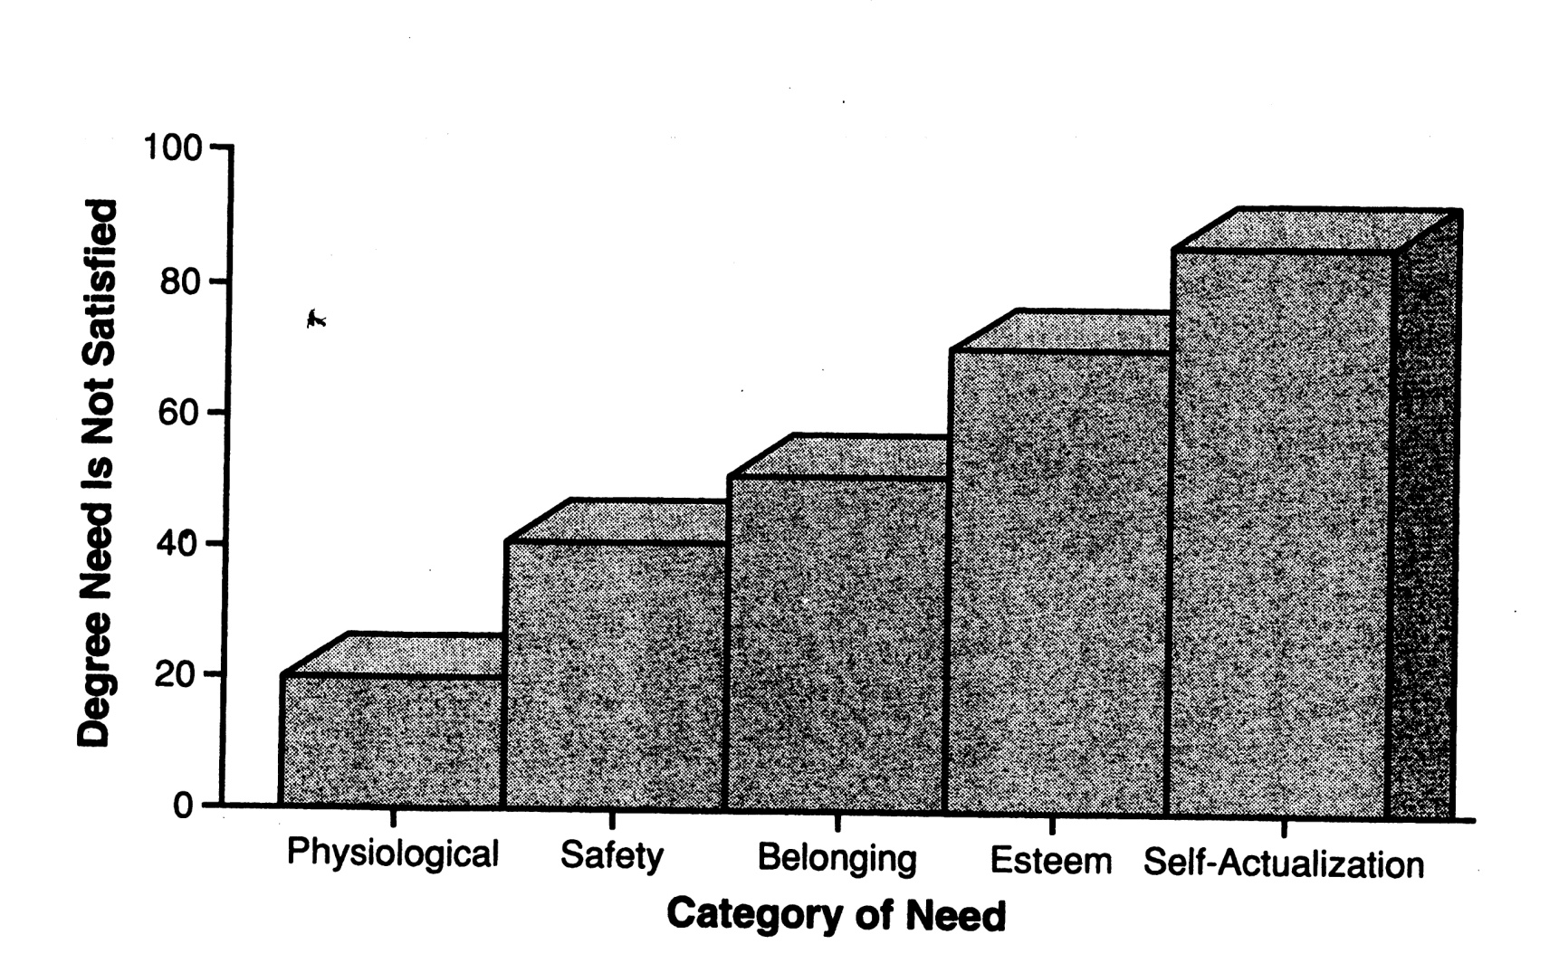

- A person works to satisfy these needs in hierarchical fashion, with the most time spent on the most potent need, which is lowest in the hierarchy, then working up the hierarchy . As a lower-order need becomes satisfied the next need becomes more potent.

Belongingness: social relationships with friends, lovers, family members

Esteem: through achievement and competence, person gains self-respect and respect to others

Self-actualization: fulfill and utilize one’s abilities and talents to the fullest in the area one chooses

Need satisfaction inventory measures the extent each need in Maslow’s hierarchy is satisfied

contains 50 statements

Some Important Psychological Needs

Number of psychological needs of current interest to psychologists:

- Achievement, power, cognition
- Esteem, relatedness (affiliation, belonging)
- Autonomy, competence

Achievement Motivation

- Need to achieve
- Need to avoid failure
- Also involves the probability of success at a task and the incentive value of succeeding at a task

video: dan pink—puzzle of motivation

candle problem—candle, thumbtack, matches

power of incentives

norms of how long it takes to solve

separate groups, offered $ (motivators)

took them 3.5 mins longer, those who were offered $

incentive dulls thinking and creativity

”mismatch between what science knows and what business does ”

tacks out of box, took less them for those who had incentive

clear route to destination

Need to Achieve and Need to Avoid Failure

Need to achieve: disposition to engage in task-oriented or achievement behavior

also known as motive to achieve success (Ms)
  - Characterized by doing a task well and with high internal standard of excellence

Motive to avoid failure: (MAF) tendency to inhibit achievement behavior so as not to fail

characterized by anxiety and fear of failing a task

Various psychological tests measure the need to achieve and the need to avoid failure

Projective test: unstructured stimuli designed to activate a person’s currently strong motives

Thematic Apperception Test (TAT) more structured projective test consisting of pictures designed to activate many psychological needs

In a person’s reply, look for;

  - Competition with a standard of excellence
  - Unique accomplishment
  - Long-term involvement with a project or task

strength of responses to a TAT depends on;
  - Strength of psychological need (MS or MAF)
  - Intensity of TAT picture’s force for activating the need

Achievement Motive Scale

short questionnaire, designed to measure motive to achieve success (MS), motive to avoid failure (MAF)

Achievement behavior;

increases with high need to achieve MS>MAF

decreases with high need to avoid failure MAF>MS

increases with increases in probably of task success, easy tasks high probability (PS)

increases with increases in incentive value of task success= (1-PS); easy tasks have low incentive value; as PS increases, incentive value (1-PS) decreases

tasks have medium probably of success (.5) preferred by individuals with high motive for success (MS>MAF), avoided by people with high motive to avoid failure (MAF>MS)

MS>MAF individuals persist longer at task

Achievement Goal Framework

Achievement theory involves;
  - Mastery and performance goals combined with approach and avoidance behavior

Mastery goals: absolute or personal standards which involve accomplishments, improvement, or greater understanding of a task
  - Approach—intent toward self-improvement, mastering material
  - Avoidance of goal—fear of being unable to master material

Performance goals: relative standards, involved comparison with others as in surpassing or outperforming others
  - Approach—intent of outperforming others
  - Avoidance of goal—fear of doing worse than others

Power motive: psychological need for power—influence others, be in charge, high status

TAT pictures can be used to activate andmeasure need for power

Characteristics of Need for Power

Running for office; mayor, governor, president

Professions; teacher, executive, psychologist

Write letters to editor

Own trappings of power; fancy car

Exploit others

Expressing Need for Power

High need for power successful occupations
  - Allow for legitimate exercise of power

Need for cognition: understand one’s situation and experiences by thinking about them

Attitude polarization: one’s opinion about an issue becomes more extreme after thinking about it

high need for cognition individuals less likely to change attitudes since they think about both sides of an issue; ex: less subject to attitude polarization

Self-esteem, Relatedness, Autonomy, Competence

- Satisfying psychological need is a great experience, which are linked to satisfying psychological needs of self-esteem, relatedness, autonomy, competence

Self-esteem: worthy of yourself, good as others

Relatedness: intimate contact with people you care for, who care about you

Autonomy: you cause your own actions, rather than at the mercy of external forces, pressures

Competence: capable and effective in your actions, not incompetent

Need for Affiliation and Intimacy

- Used interchangeably with need for relatedness or need to belong
- Affiliation motive—establish, maintain, restore positive social relationships

can measure need with TAT cards

makes statements about loneliness, ways of preserving social relationships

Intimacy motive: emphasizes positive feelings which exist between individuals
  - Does not emphasize alleviation of anxiety which stems from absence of a relationship

social interaction; positive affect ratings were higher for students with a high intimacy motive compared to students with a low intimacy motive. No differences exist between affect scores during nonsocial interactions

Self-Determination Theory: needs of autonomy, competence, belonging—innate and motivate behavior
  - needs serve as basis for freely chosen experiential activities

Consequences of Unfulfilled Needs

Psychological needs not satisfied, psychological ill health is the consequence

Balanced Psychological Needs

Balance hypothesis: psychological health, greatest when there is a balance in the satisfaction of psychological needs; is lower if one need is highly satisfied while other is not
  - positive affect and satisfaction with life is greater for individuals who have achieved a balance in the satisfaction of their needs for autonomy, competence, relatedness
  - measured by satisfaction with life scale

Motivation without Awareness

- aware of their behavior, may not be aware of sources of motivation for the behavior
- behavior is known, motive is now

Reflexology: theory that all human action consists of reflexive actions to external stimuli
  - human action is not in response to thought or intention, but instead to stimuli in environment

Automotive Hypothesis: non-conscious activation of motives and behavioral intentions
  - environmental stimuli can activate motives, goals, accompanying behavioral strategies
  - not aware of source of activation

Priming Achievement Behavior

- high performance goals primed non-consciously—participant solves anagrams that have solutions like win, compete, succeed
- primed goal affects subsequent achievement behavior for different puzzle solving task

Priming of Action

- move toward rudeness, primed non-consciously
- primed motive increases likelihood of interrupting another person
- stereotype of elderly primed non-consciously—person walking slower as if very old

Imperceptive Effects of Mimicry

- Being mimicked without being aware of it—increases person’s liking of the mimicker
- Mimicking increases smoothness of social interaction

- Temperament and personality are real, differ from person to person—determines what is motivating from one person to the next

Temperament: differences in emotionality, result from genetically inherited characteristics

Ex: different breeds of dogs have different temperaments

beagles, terriers more sociable than basenjis and Shetland sheepdogs

personality: behavioral consistencies, result from interaction between temperament and social experiences

dog’s temperament interacts with rearing

sociability in dogs parallels extraversion in humans

personality traits: specific dimensions in behavioral consistency across time and relevant situations

categories, also causes of behavior

cause people to react differently to different situations

cause people to approach and avoid different situations

determine how people react to situations; positively, negatively

determine choice of situations and altering of situations; ex: approach, avoid, modify situation

biological reality; grounded in material world—traits are not fictional intervening variables

Five-Factor Model—divides personality into 5 traits:

openness to experience

conscientiousness

extraversion

agreeableness

neuroticism

sensation seeking: personality trait, defined by seeking of varied, novel, complex, intense sensations and experiences

trait includes willingness to take various risks for the sake of such sensations and experiences

4 components of sensation seeking;

thrill and adventure seeking

experience seeking

disinhibition

boredom susceptibility

Operational Definitions

Operational definition: psychological construct, defined by procedure used to measure it

traits defined by procedures used to measure them ex: personality scales

40 item mini-marker set measures—operationally defines big-five personality factors

Human traits to describe yourself accurately as possible

Sensational Seeking Scale

defines a person’s level of sensation seeking

Psychophysiology and Neuropsychology

Psychophysiologypersonality traits correlated with physiological variables

Neurophysiologypersonality traits correlated with brain and neurotransmitter activity

Monoamine oxidase (MAO): brain enzyme, marker for sensation seeking, correlated negatively with scores on the sensation seeking scale

Behavioral Genetics

Closer genetic relationship between individuals, stronger the correlation between their personality traits and their level for sensation seeking

identical twins, more alike than fraternal twins in big-five personality traits and in sensation seeking, even when apart –no difference for thrill and adventure seeking

Personality Traits Affect Motivation

real, determine how people react and select or alter situations

trait-environment interaction: how a person reacts to a situation depends on the amount of a personality trait he/she possesses

trait-environment correlation: situation or activity person selects depends on amount of personality trait he/she possesses

Effects of Extraversion on Motivation

Extraverts;
- easier to put into a good mood in comparison to introverts
- more satisfied with their social relationships
- more sensitive to humor stimuli
- participate in social activities more
- chose to be at group study table in library, participate in team sports

channeling hypothesis: personality traits channel or convey how psychological motives are represented and satisfied

level determines how a person’s affiliation motive is satisfied; affiliation motive is satisfied by volunteer work for extraverted women

also determines how a person’s power motive is satisfied; satisfied by women graduates of Radcliffe entering high impact careers which allow them to interact with people

Effects of Neuroticism on Motivation

Neuroticism—personality trait that rangers from non-emotional (calm, contented) to emotional (anxious, quickly roused)
  - highly neurotic are easier to put in a bad mood
  - experience more negative moods in various aspects of life
  - more likely to drink to cope with negative social interactions
  - more likely to engage in risky behaviors to cope
  - choose to increase solitary drinking with increases in number of negative interpersonal exchanges they experience, those with low neuroticism not affected

Effects of Conscientiousness on Motivation

- high levels of conscientiousness;
  - being competent
  - orderly
  - achievement striving
  - self-disciplined
  - correlates positively with GPA, healthy life-style behaviors

Effects of Agreeableness on Motivation

- being trusted, compliant, helpful
- more likely to help stranded motorist who is a friend or sibling—no difference in helping stranger

Effects of Multiple Traits on Motivation

Several personality traits can combine to affect motivation of behavior

Internet Usage

Low agreeableness, conscientiousness, and extraversion—use more

High conscientiousness—use for academic purposes

Prejudice

Selection hypothesis: level of individual’s personality trait determines type of contact with other group members

selection hypothesis is an instance of trait-environment correlation

- high in openness-to-experience seek more contact with minority group members
- high in openness and agreeableness—positive attitudes toward minority group members from quality of contact

Happiness and the Big Five Personality Traits

happy students lower on neuroticism and higher on extraversion and agreeableness

extraverts gain greater positive affect from their social interactions

no difference in conscientiousness and openness individuals

Effects of Sensation Seeking on Motivation

- sensation seeking determines how a person reacts to a situation or event, determines situations and activities person chooses

Sensation Seeking-Environment Interaction

- high sensation seekers enjoy more intense sensations and experiences

high sensations more likely to;

choose to engage in risky sports, activities

unusual stimuli, situations

things out of the ordinary

more susceptible to boredom

Self as a Motivational System—how one views themselves in the future, determines what motivates them now

self-concept: person’s knowledge about self, organized into a schema from which info about the self can be retrieved and evaluated

Motivation Regarding Self-Knowledge

Self-enhancement: learn positive things about self

Consistency: learn info that is consistent with current self-knowledge

Appraisal: info about self, accurate but also enhancing and consistent with self

Possible Selves as Incentives

- person motivated to aspire to a possible self, more valued than current self
- positive incentive for which a person thrives

self esteem is the outcome of a self-evaluation process, resulting negative or positive judgment

self esteem = success/pretentions (possible selves)

more success, higher self-esteem

depends on the contingencies of self-worth—domains in people’s lives that they consider important for their self-esteem

high self esteem results form successes in domains of contingent self-worth, and vise versa.

endeavors outside domains have no effect on self-esteem

Domains of Contingencies of Self-Worth

other’s approval: opinion, acceptance by others

appearance: physical looks of face and body

competition: outperforming others in competitive tasks

academic competence: high grades, do well in school

family support: approval, acceptance, care of family

virtue: follow ethical principles or abide by moral code

god’s love: belief one is loved by God, feeling of religiosity

measured by Contingencies of Self-Worth Scale

low and high academic-contingent self-worth; acceptance and rejection letters only affected students with high academic-contingent self-worth

- Extrinsic Motivation and Incentive Value

- axioms of wanting more;

to have more of something desirable is good, have less of it is bad

to have something undesirable is good, to have less of it is good

Reinforcers and Punishers vs. Incentives

- refer to good and bad behavior consequences
- reinforcers: behavioral consequences that select behavior increase frequency of behavior
- punishers: behavior consequences that deselect behavior decrease frequency of behavior
- incentives: anticipated external stimuli, motivate behavior to occur
  - positive ones—motivate approach behavior; behavior to attain incentive
  - negative ones—motivate avoidance behavior; behavior to prevent incentive from occurring

Past vs. Future

- Reinforcers and punishers are actual consequences of behavior
- Positive and negative incentives are anticipated consequences

- Outcome of Anticipated
- Behavior: Outcomes of Behavior:
- Past Events Future Events
- Positive
- Stimulus Reinforcer Positive Incentive
- Negative Punisher Negative Incentive
- Stimulus

Objective and Subjective Incentive Value

Incentive value: attractiveness of an incentive based on objective properties ex: number, amount

Utility: subjective value of incentive, based of satisfaction, pleasure, usefulness

Fechner’s Law—relationship between objective and subjective incentive value (utility), equal increases in objective value produce smaller and smaller increases in subjective value (utility)

As dollar amount increases, utility increases, in smaller and smaller amounts

Incentives as Losses and Gains

Anticipated gainspositive incentives

Anticipated lossesnegative incentives

Losses loom larger than gains: loss of something more dissatisfying than gain of it

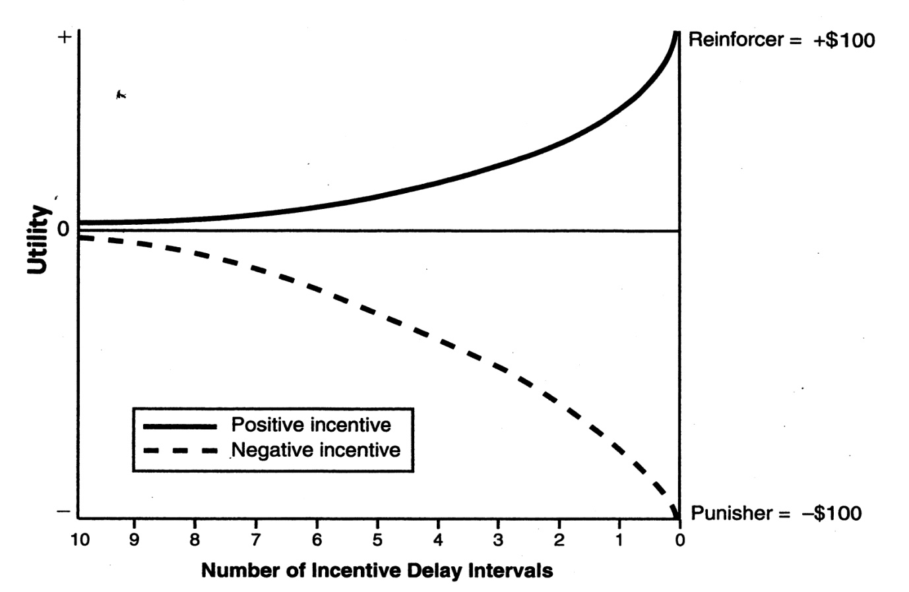
- At same incentive delay interval, subjective value of incentive loss is greater than subjective value of an incentive gain
- The values of both a positive incentive (+$100) and a negative incentive (-$100) increase as their delay intervals decrease. When the incentives are reached (zero delay), the positive incentive equals the reinforcer (gain $100), and the negative incentive equals the punisher (lose $100). The absolute subjective value or utility is greater for the negative than for the positive incentive

Buyer and Seller Experiments

Willingness-to-accept or sell price represents incentive loss

Willingness-to-pay or buy represents incentive gain

Sell prices are greater than buy prices since losses loom larger than gains

Factors that Affect Incentive Value

valuable incentives described by more, bigger, better

less valuable incentives by less, smaller, worse

incentive amount: quantity or number of incentives increases their value

incentive value increases, motivation increases

Rate of Reinforcement--as it increases, rate of responding increases

Given choice, animal or human chooses activity which has the higher rate of reinforcement

Melioration: shift toward an activity, more lucrative or provides a greater rate of reinforcement

Contrast Effect—motivational impact of an incentive dependent on how it compares to prior or other incentives

Positive incentive contrast—upward shift in incentive value, motivated behavior increases

Negative incentive contrast—downward shift in incentive value, motivated behavior decreases

Law of hedonic contrast: subjective feelings that accompany incentive contrast

positive contrast produces pleasant feelings

negative contrast produces unpleasant feelings

contrasted incentives must be in the same category as incentives they are compared with

Temporal Motivation Theory—how far an incentive is situated in the future determines the value or utility of that incentive

integrates how incentive utility changes temporally (with time)

utility based on the value of the expected incentive and delay of incentive

Utility = (expected incentive value)/(1+delay interval)

incentive delay interval is time when the incentive becomes available

Delay discounting: process by which a future incentive is represented in the present at a marked down value—ex: $10 delayed by one month, discounted to be worth $1 at the moment

person decides between incentives based on their discounted values

preference reversal: change in preference from one incentive to another, due to a change in discounted values based on changes in the incentive-day intervals

shorter-delay intervals, larger incentive preferred over smaller incentive

ex: $50 dollar in 8 weeks, preferred over $25 now

delay lengthens by 4 weeks, preference reverses, smaller incentive preferred

ex: $25 now preferred to $50 in 12 weeks

Procrastination—delay in goal-directed behavior, despite knowing that one will be worse off as a result

ex: delay work on a paper, knowing lower grade will be the result

people differ in extent that they procrastinate

general procrastination scale measures the trait tendency of individuals to procrastinate

Origins of a Goal

- Goals enter subconsciousness from various sources
- Goal is selected from consciousness and acted on

Incentives vs Goals

Incentives—potential sources of motivation

Goal is the incentive a person selects, commits to, acts on, incentive to be achieved

goal then achieved, displaced by another goal, or abandoned

goals are more important, complex, cognitive, usually single occurrences

From Incentives to Goals

factors that determine if incentive is chosen as goal:
  - Value of incentive or potential goal
  - Probability of achieving goal
  - Amount of effort required to achieve goal

Future Orientation of Goals

- Future goals are visualized in the present
- Negative goal features are discounted more steeply than positive goal features are discounted
- Negative goal gradient is steeper than positive goal gradient
- The tendency to approach positive goal features and to avoid negative features increases as a goal draws closer
- Changes in the strength of an approach tendency are slower than changes in an avoidance tendency
- At distant intervals, the approach tendency is stronger while at nearer intervals the avoidance tendency is stronger

Leve lf Aspiration

Person’s desire:
  - To excel
  - To do better the next time
  - To do better than others

Association of Goals with Affect

Affect: subjective valence of an emotion

goals that produce positive affect are approached

goals that produce negative affect are avoided

Goals that Satisfy Needs

goals which satisfy physiological needs have positive valence, determines psychological demand for goals

valence is the subjective value of a goal or attractive of it, how much it is desired

Goal Setting for Evaluating Self-Efficacy

Self-efficacy: belief in one’s capability of successfully performing specific task or achieving specific goal
- Success and failure can raise and lower it
- Can raise or lower goal motivation

Environmentally Activated Goals

Stimuli associated with goal-achivement behavior can activate goal

Ex: sight of textbook reminds person of future exam with a goal to prepare for exam

Committing to a Goal

Goal commitment: process by which a person becomes set to achieve goal

willingness and persistent determination to expend time, effort in goal pursuit

commitment increases, goal achievement increases

increase goal commitment by;
  - Telling someone about your goal
  - Publicly announcing one’s goal increase of dopamine, not necessarily true—when you are reinforced, ex telling everyone you quit—feel like you’ve done it but you haven’t yet, give up

Negative Feedback loop—discrepancy in the loop is the distance between current-state and goal-state

Feedback—info about progress toward goal, whether achievement behavior is affective

Goal-achievement strategies/achievement behavior reduce discrepancy

No discrepancygoal is achieved

Feedback & goal achievement

Goal Thoughts

Respondent thoughts (in relation to conditioning—Pavlov): fantasies about a goal intrude into awareness

Operant thoughts: mental plans about how to achieve one’s goal before putting plans into action

Subgoals (proximal goals): similar to rungs in a ladder, reach the top (final or distal goal)

increase motivation, temporarily closer than a person’s final goal is

increase self-efficacy

provides feedback toward achieving final goal

Achievement Behaviors

A goal is accompanied by the knowledge that is necessary to execute achievement behaviors

Perception-behavior link: goal elicits appropriate achievement behavior, goal and behavior have been associated together in the past

Motivated preparation: valence of goal—positive or negative—determines type of achievement behavior that is activated; approach or withdraw

Achievement valence: satisfaction derived from achieving a goal

dissatisfaction results when person fails to achieve goal

Failure

can occur if goal is too high

following success—next goal scaled up

following failure—next goal scaled down

Exceptions to effect of failure;
- Person high in self-efficacy increases effort following failure
- Person low in self-efficacy decreases effort following failure

VIDEO : Operant conditioning: Schedules of reinforcement

Continuous reinforcement loses its effect, getting it every time, loses it’s power

need to change ratio of how often you do it

ratio—amount of responses

interval—time

fixed-ratio

always the same; 10:1

high rate of behavior

variable-ratio

powerful, don’t know when it will happen, will work harder

can also be fixed, but randomized presentation of reward
- the way you work is different, reward can be the same as fixed
- number of responses in order to get reward changes, fixed-ratio which changes

slot machine

fixed-interval

pay cheque every 2 weeks if he sells 5 cars

depends on time, less incentive, less motivation to sell more

variable-interval

responses reinforced after interval or time has passed

gets a bonus if he interacts with someone, doesn’t know when boss will be around

- Cost to achieving a goal or satisfying a need, resources required

- Various Motivational Costs for typing a paper for class

- Responses costs—number of key strokes
- Time costs—took 1 hour to type paper
- Physical energy costs—number of calories burned
- Psychological energy costs—stay on task of typing
- Opportunity costs—gave up watching TV

- Response and Time Costs

- Response costs—number of discrete behaviors necessary to complete a task or achieve a goal ex: key strokes in writing a paper

- Fixed ratio schedule of reinforcement: number of responses that are required for one reinforce
- ex: ratio of 10 to 1

- time costs—refer to length of time to complete a task or accomplish a goal
- ex: university degree after 4 years of study

- Physical Energy Costs—utilizing oxygen and glucose in order to accomplish a task or achieve a goal
- calorie is a unit of physical energy
- abstract concept which refers to effort to maintain self-control (not giving into temptation) and energy for decision making, control of attention, info processing
- self control linked to muscular energy; reduced with use, strength returns with rest

- Opportunity Cost
- Alternative activities a person gives up to engage in the current activity, e.g, by being in class you gave up the opportunity to visit friends
- Regret is emotion experienced when reflecting on rejected opportunities
- Regret depends on value of rejected opportunities

- choice overload: demotivating effect of too many choices in decision-making process
- cannot make up their mind to come to a decision, too many choices

- Motivation Resource

- means by which motivational costs are met for need satisfaction and goal achievement

- Response Resources

- reflex reserve: reinforcement builds up a storehouse of responses available for earning future reinforcers
- rat uses its reserve of responses during extinction procedure, responding eventually stops, but greater reserve implies longer responder

- learned industriousness: rewarding industriousness, persistence acquired ability to sustain effort in the face of intermittent reinforcement and accumulation of fatigue
- industrious person persists longer, works harder, expends greater effort toward completing goal

- grit: individual difference characteristic, refers to perseverance and passion for long-term goals

- Physical Energy Resources

- available glucose and glycogen
- more glucose—more physical and mental tasks can be accomplished

- Psychological Energy Resources

- no physical basis
- resembles muscle energy, used for self-control and control of one’s attention

- spend motivation resources like money, aim to accomplish most by spending the least

- demand law: demand schedule refers to quantity of goods a person is willing to purchase (demand) at various prices
- price raisedless is bought (demanded)
- price loweredmore is bought (demanded)

- Skinner box—demand refers to number of reinforcers animal demands at various lever press prices set by a fixed ratio schedule of reinforcement
- FR requirements increase, demand for reinforcers decreases

- Elasticity

- demand changes as the price of the incentive or reinforce changes
- change in demand is not equal for all reinforcers
- change in demand is elastic, it is variable

- elastic demand: cost goes up, demand goes down steeply, responding decreases
- occurs for goods or services with low utility
- ex: luxuries like soft drinks, water bottles

- inelastic demand: cost goes up, demand goes down slightly, responding increases
- goods or services with high utility
- ex: gas, degree

- substitution effect: increase in price of one reinforce leads to increased demand for a different reinforce to replace original one
- ex: if requirements for elective course become too high, switch to another elective

- Achieved for highest goals, but with least expenditure of motivation resources as possible
- Principle of least effort: given choice between two equally valued incentives—select incentive requires the least effort
- Law of less work: choose less laborious behavior sequence which leads to reinforce

- Romantic Love

- Investment model: longevity of romantic relationships depend on rewards, costs, alternatives and investments
  - Enduring romantic relationships
    - high rewards
    - low costs
    - few alternatives or substitutes
    - high investments (things lost if break-up occurs)

- Characteristics and Categories of Emotions

- Emotion: functional reaction to stimulus change

reactions occur along various channels or dimensions

reactions operate in synchrony for purpose of adaptation to stimulus change

- Emotion Channels

Channels are dimensions along which emotions are expressed;

Affect—private subjective experience

Facial—expressions register on face

Physiological—heart rate, muscle tension, electro dermal changes, respiration, skin temperature

Behavior—motivated by emotions

Brain processes underlie all channels and behavior

response coherence postulate: emotion channels are associated together

channels change together, synced

Methods for Uncovering Basic Emotions

How categories of emotions were derived;

- Analysis of word meaning

seven categories of emotion based on emotion words: joy, love, surprise, sadness, dear, anger, disgust

emotion prototype: most representative common meaning of all words within an emotion category
- Theory of evolution

emotions classified by ability to aid species survival, categories similar but different names

category of exploration (expectancy, curiosity)
- Facial expressions

each emotion characterized by unique facial expression

guilt, shame—blushing

love—smiling, leaning toward partner, head nods

Characteristics of Affect

- Refers to private subjective feelings which enter into consciousness during an emotion

Private Affective Experience

Qualia: primitive subjective experience of affect

affective experiences that are not fully describable

ex: describe what strawberry tastes like, describe what love or disappointment feels like

Affect Emerges from Brain

Epileptic aura: psychological changes that precede seizures, involve emotional feelings

seizures for auras occur in limbic system

occur for a range of emotions, have accompanying facial expressions

emotional education: process by which children learn to label feelings

people label situations and child’s facial expressions, attach labels to child’s affective feelings

Intensity and Duration of Emotions

emotions can vary in intensity (anxiety to terror) , length, valence (positive or negative)

law of change: greater stimulus changes produce stronger emotions

gun pointed at person more intense stimulus, will produce stronger emotions

law of emotional momentum: emotion stimulus which someone does not adapt to, repeatedly gives out the same emotion

honeymoon effect: high passion occurring in early marriage

passion declines with length of marriage due to habituation of partner

Function of Arousal

Physiological arousal: heart rate, blood pressure, electrodermal (skin), responses (perspiration), muscle tension, respiration

James-Lange Theory: specific emotion occurs when we become aware of body’s unique accompanying pattern of physiological arousal
- feeling aroused due to emotion
- emotion stimulusphysiological responsesaffect

assume each specific affective feeling has unique profile of aroused physiological responses associated to it, no evidence that each subjective emotional experience has a unique physiological profile associated with it

- research evidence indicates that discrete affective experiences cannot be fully differentiated on visceral (physiological) activity alone
- large differences between positive and negative emotions

affect programs: brain maps which correspond to emotional experiences and associated behaviors

when researching critical intensity, emotional experience emerges in consciousness

cognitive arousal theory: affect depends on interpretation of one’s physiological arousal as based on information taken from emotion situation

arousing stimuli (gun, snake) produce greater physiological arousal than others (view of gun, mushroom)

excitation transfer: experiments in which physiological arousal induced from one source influences emotional experience and behavior induced from another source

male physiological arousal increased by running

arousal increased attraction for attractive women, decreased attraction for unattractive ones

Cannon’s Theory: physiological arousal is organism’s preparedness for emergency response of fight/flight

discrete emotions prepare organism for specific emergency responses, such as fight or flight

action readiness is the preparedness to execute a behavior associated with a specific emotion

Moods

Mood is a subjective experience similar to an emotion

more in background of consciousness while emotion is the focus

longer and more intense than emotions, less aware of stimulus

good or bad mood, negative vs positive affect

negative affect—afraid, scared, nervous, jittery, irritable, hostile, guilty, ashamed, upset, distressed

positive affect—active, alert, attentive, determined, enthusiastic, excited, inspired, interested, proud

positive mood higher midday, lower in morning and night, negative mostly constant over entire day

positive mood increases from Sunday to Monday

negative mood increases from Saturday to Monday, decreases to Saturday

Seasonal Variation—mood varies with seasons of the year

Seasonal affective disorder: mood extremely low in winter, some also in summer

Appraisal of the Emotion Event

- how people react emotionally to a situation depends on how they appraised that situation
- different appraisals same event different emotions
- same appraisal different events same emotions
- appraised outcome produces involuntary unfolding of emotion

appraisal of emotion stimulus can begin prior to awareness

involvement of amygdala, negative features receive more emphasis during initial appraisal process

appraisal prior to and with awareness results in unfolding of emotion, along its various channels

Characteristics of Emotion Situation

situation determines or defines an emotion

situational definition: stimulus and its context determine the emotion

prediction or onset of stimuli evoke either positive or negative emotions

positive stimuli evoke positive emotions

loss of positive stimuli evoke negative emotions

negative stimuli evoke negative emotions

loss of negative stimuli evokes positive emotions

Separation of Emotion and Cognition

emotions can occur automatically, can result from primitive appraisal process than can be below the level of awareness

Appraisal without Awareness

stimuli presented in succession below level of awareness can elevate mood

Priority of Negative Stimulus Appraisal

below awareness, negative elements appraised little earlier than positive elements are

avoidance behavior associated with negative elements

approach behavior associated with positive elements

Appraisal Dimensions

various dimensions used for stimulus appraisal;
  - expectedness—extent situation was expected
  - unpleasantness—extent situation was pleasant/unpleasant
  - goal hindrance—extent situations help or hinder goal
  - unfairness—extent situation unjustified, underserved
  - external causation—who was responsible
  - coping ability—capability of coping
  - immorality—persona responsible act unethically or not
  - self-consistency—extent situation affected self-esteem

Amygdala and Emotion-Stimulus Processing

- limbic system in brain is responsible for emotion
- amygdala part of system, rapidly and crudely processes fear-relevant stimuli, alerts cortex, does further appraisal of stimulus

facial expressions are synched with other channels of emotion expression, coordination is necessary to effectively deal with environmental demands that people encounter

expression feeling link—association between facial expression and emotional feelings (affect); occur jointly in reaction to emotion-inducing event

efference hypothesis: brain circuits sending information to facial muscles to generate an expression related to the emotion

Innateness of Facial Expressions of Emotion

facial expressions are innate, are fine-tuned through experience

infant expressions are true to their subjective feelings

deaf and blind children exhibit facial expressions of emotions in appropriate ways

those of blind children are less refined, lack practice, have no feedback

Universality of Facial Expression of Emotion

Emotion recognition: studies show that expressions of emotion are recognized similar the worlds over

members identify expressions more accurately for own cultural group than other ones

Function of Facial Expression

- readout hypothesis: conveys individual’s emotional feelings to another individual
- behavioral ecology hypothesis: serve use to one’s social motives, influence others

for when one is alone, reactions to an imaginary person

expressions need not vary with the degree of affect, but vary whether one is alone or with others

- one hypothesis is that fear expression resembles baby faces, thus inhibiting aggression
- angry face resembles mature face, signals attack
- participants rated fear and anger faces for baby features: babyish/mature, eye size, submissive/dominant

fear resembled baby face, larger eyes, showed greater submissiveness

anger resembled mature faces, smaller eyes, less submissiveness

Display Rules for Facial Expression

Display rules: learned social conventions that specify what voluntary facial expressions are to be exhibited in a specific situation

people differ in extent they feel rules should be followed

amplify: intensify or exaggerate expression of feelings

not inhibit: express feelings naturally

deamplify: reduce intensity of expression of feelings

qualify: express feelings, add expression; ex a small

neutralize: show neutral face, not indicative of any feeling

mask: show different expression when what you are feeling

Motivating Function of Emotions

- emotions motivate behavior toward some designated end, which is the goal/aim of emotion
- action readiness: state of preparedness for a course of behavior to achieve the aim/goal of an emotion
- each unique emotion has own aim/goal
- emotion motivates people to achieve the aim/goal of that emotion

Examples of the goals of some emotions;

joy—reward for achievement, eating, drinking, sex

fear—escape from danger, attend to danger stimulus

anger—remove obstacles blocking goal

shame—maintain respect of others, self-esteem

pride—reinforce achieving socially valued behaviors

Emotions as Motives for Cognitive Activity

Cognitive signaler: emotional feeling influences a person’s future cognitive appraisal

Appraisal tendency hypothesis: each emotion has a unique influence on people’s judgments

Motivational Nature of Postive Emotions

- most emotions are negative, humans behave to reduce negativity
- when negativity disappears, motivation ceases
- positive emotions serve as positive reinforcers—maintain the behavior that produced them

undoing hypothesis: positive emotion more quickly removes negative emotion than letting it fade out on its own

broaden-and-build theory: maintains positive emotions enlarge the availability of thought-action links

positive emotions broaden the scope of attention

subjective well being: also known as happiness, pleasant feeling a person tries to achieve

satisfied with life, experiences positive affect, less frequent negative affect

subjective happiness scale measures well being

Set Point of Happiness

level of happiness to which a person consistently returns, resembles a thermostat setting

not at zero, people on average are a little bit happy

happiness increases achievement behavior, predicts marital success

hedonic treadmill: increases in happiness are temporary, happiness returns to set point level

treadmill resembles walking up a down-escalator

normal, part of everyday life

problem with sorting out 3 conversations and decoding the structure of them

1.”What Happened” Conversation

- disagreement on what happened/should have happened
- who said what, who did what
- who is right, who meant what, who’s to blame

The Blame Frame

- talking about fault is similar to talking about truth
- distracts us from exploring why things went wrong, and how we can correct them going forward
- focus instead on the contribution system

2. The “Feelings” Conversation

- are feelings valid/appropriate, should we acknowledge or deny them
- what about the other person’s feelings, are they angry or hurt?
- What should we do with our emotions, when strong feelings arise what do we do
- Telling someone how you feel, can feel vulnerable, uncomfortable
- Feelings are at the core of every difficult situation
- Understanding, talking and managing feelings is a human challenge, not easy and nor risk free
- Does not always make sense to talk about feelings

3. The “Identity” Conversation

- conversation we have with ourselves about what a situation means to us
- internal debate—competent/incompetent; good/bad
- impact on self-image, self-esteem, future, well-being
- if we feel balanced or anxious during conversation
- most subtle, most challenging
- about who we are, how we see ourselves

Move toward a learning conversation

instead of persuading to get your way, understand other’s point of view

explain your own, share and understand feelings

work together to find a way to manage problem

makes it more likely that other person with be open to persuation

invite other people into conversation

Conversation

- spend most of our time, make assumption
- truth assumption—that we are always right, but we are not
- difficult conversations are almost never about getting facts right
- are about conflicting perceptions, interpretations, values
- not about what is true, but what is important
- interpretations and judgments are important to explore
- trying to figure out who is right and who is wrong is a dead end

move away from delivering messages and towards asking questions, explore how each person is making sense of world

Intention Invention

- what you think of one’s intention will affect how you think about that person and the conversation you hold
- assume we know intentions of others when we do not, as they are invisible
- make assumptions about other people’s behavior
- people’s intentions are complex and mixed

NEED TO….

- shift toward learning stance; stop arguing about who is right or wrong, explore one another’s stories, disagreeing is okay
- we argue and it does not help—we think they are the problem; selfish, naïve, controlling, irrational
- need to understand we have different information, know ourselves better than anyone else can, different interpretations, apply different implicit rules, our conclusions reflect self-image

- need to move from certainty to curiosity, ask yourself what information the other person may have, listen, do not accept or reject
- hold view as a hypothesis, share impact on you, inquire about their intentions
- do not pretend you do not have assumptions, some defensiveness is inevitable—listen for feelings

distinguish blame from contribution, seek understanding rather than judgement

feelings are too painful and powerful to remain peacefully bottled

will be heard one way or another, whether leaks or bursts

provoke argument instead of sharing feelings

affects tone of voice, body language, facial expression

sarcastic, aggressive, impatient, unpredictable, defensive

A way out of the feelings bind…

- need to sort out what your feelings are

recognize that good people can have bad feelings

learn that your feelings are as important as theirs
- need to negotiate with your feelings

negotiate with feelings, will not remain static

feelings are based on our perceptions, which are negotiable
- need to share feelings (not attributions or judgments)

don’t evaluate, just share

end up in a struggle if they think you are over reacting

express you feelings without judgment, attribution or blame

how I feel…

sense of who we are in the world may be disrupted

our identity is the story we tell of ourselves

anxiety results not only fro having to face other people, but having to face ourselves

3 Core Identities

- Am I competent?
- Am I a good person?
- Am I worthy of love?

no quick fix

We are vulnerable because;

all-or-nothing; either competent or incompetent, good or bad, worthy of love or not

denial—sticking to purely positive identity leaves no place in our self-concept for negative feedback

exaggeration—we exaggerate, we act as if other person’s feedback is only feedback we have about ourselves

Ground your Identity

Ask yourself;

- What about my identity feels at risk?
- What does this mean to me?
- What would it feel like if what I feel is true?
- What are you really afraid of?
- What’s the downside?
- What if they reject me?
- What if they laugh?

ABOVE ALL CHECK FOR “EMOTION COMMOTION

3 Basic Steps for Success in Conversations

Nancy McFadden suggest in relation to disagreements ;

- Stay on topic
- Repeat the topic ever time someone strays
- Agree to Disagree

- learning to accept and cooperate with wisdom that disagreement is merely a communication skil, and not cause for converting others, or being converted

All or Nothing Thinking
- look at things in absolute, black and white
- either dieting or not, small indulgences will destroy whole day’s efforts

Overgeneralization
- view one or two negative events as a never ending patter of defeat

Mental Filter
- dwell on negatives, ignore the positives

Discounting the Positive
- twist positives into negatives

Jumping to Conclusions
- jump to conclusions that are not warranted by facts
- fortune telling—predict that things will turn out badly
- mind-reading: assume that someone doesn’t like you or is looking down on you

Magnification or Minimization
- blow things way out of proportion (magnification), or shrink them in your ,mind’s eye (minimization)—“binocular effect”

Emotional Reasoning
- reason for how you feel “feel like an idiot, therefore I am one”

“Should Statements”
- beat up on yourself or others with should/shouldn’t/must
- direct against yourself, lead to guilt and depression
- those directed to others lead to frustration, resentment, anger

Labeling and Mislabeling

- labeling is an extreme form of overgeneralization
- label entire self based on some flaw or shortcoming
- instead of saying “I made a mistake” you tell yourself “I’m stupid”
- mislabeling—describe an event or problem with language that is highly colored and emotionally loaded—“not being able to eat that pie is killing me”

Personalization and Blame
- blame yourself (personalization) or others (blame) in judgmental way
- self-blame is usually associated with feelings such as inadequacy, guilt, shame, depression
- other blame is usually associated with feelings of frustration, resentment, anger

