Pain medication

Prescription drugs
• $300 billion per year (U.S.)
• Requires doctor’s prescription

Over the counter - OTC
• $25 Billion per year (U.S.)
• No prescription required
• Some are “behind the counter”

OTC vs. prescription
• OTC drugs most commonly used
• Cheaper than prescription
• Cost is visible
• Spend 10X more money on
prescription drugs

Top OTC meds (North America 2008)
• Cough and cold $4.1 billion
• Pain reliever $2.7 billion
• Antacid $1.4 billion (Heartburn/ulcers)
• Toothpaste $1.2 billion
• Laxative $0.8 billion

Important considerations when buying
• Safety
• Indications
• Counter-indications

Safety
• Dose makes the drug
- Huge safety factor on OTC meds
- Directions are often written on the box; dose is
Based on your body size

Safety
• Dose makes the poison
- labels have indications of what the drugs are used for
- Warnings

Side effects
• ALL drugs have side effects
• Effect – what is it?
– Info is easy to find
– Label or box
– Google
• Incidence – how common is it? (How often do things
Go wrong?)
– Info is difficult to find
• Need both to evaluate risk

Indications
• What to use for?
• Many people take the wrong drug (buy it for something
Its not going to work for.. Waste money)
• Many people take drugs unnecessarily
Counter indications
• When you should NOT use (cases when you should
Not take the drug)
– Conditions (interactions with medical history)
– Drug combinations (mixing OTC meds and prescription)
– Foods (food combos)
– “Natural” remedies (contain biologically active substances )

Pain relievers most common OTC drug (Consumed the most)
• $2.7 billion per year (North America)
• 50 billion tablets (North America)
• 35,000 tonnes/year
• 1200 dump trucks

Aspirin – one of World’s most popular drugs
• 1. Alcohol
• 2. Caffeine
• 3. Aspirin
• 4. Nicotine?

Salix (Family of plants that includes:)
• Genus (family)
– Willow
– Poplar
– Beech
– Wintergreen
• Contain poisons called Salicylates
(naturally prevents insects)
- Sumerians used willow leaves for pain
2,200 BC
- Egyptians used willow for inflammation (redness/swelling)
- Hippocrates used willow bark for
Childbirth

Knowledge of herbs was lost during the dark ages due to the
Banishing of witchcraft

Rediscovered by Edward Stone 1702- 1768
- Rector in church of England
- Described treatment for ague in 1763
- Discovered what was already known; that willow could
Be used for pain and fever
Doctrine of signatures
The taste of willow was similar to quinine so Stone believed that willow could cure fever, he used the doctrine of signatures to rationalize that:
• Association between disease and cure
– People who live near swamps get malaria
– People with malaria have fever
– Treat malaria with quinine
– Quinine is bitter
– Willow bark is bitter (taste)
– Willows grow in swamps
• Willow bark will cure fever!!!

(although the logic is wrong, he did rediscover that willow bark could cure fever)

April 25, 1763
• “As this tree delights in a moist or wet soil,
where agues chiefly abound, the general
maxim that many natural maladies carry
their cures along with them or that their
remedies lie not far from their causes was
so very apposite to this particular case that
I could not help applying it; and that this
might be the intention of Providence here,
I must own, had some little weight with
me”

Willow bark for fever
• Dried bark
• Ground to a powder
• Given for fever

Salicin
• Henri Leroux 1829. Chemist isolated the substance in willow that was responsible for reducing fever. He took 1.5 kg of willow bark and extracted 30g of Salicin which was the active compound/treatment for pain.

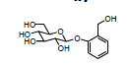

Chemical structures
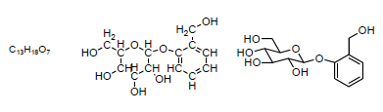
- Fossils provide evidence of past life
- Oil contains molecular fossils
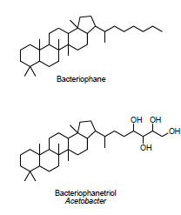

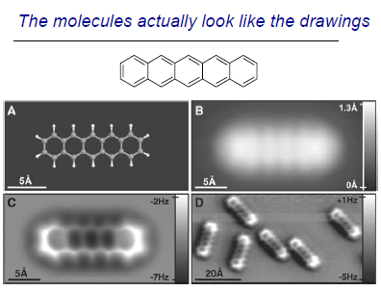

Need to use a lot of bark to obtain a little bit of Salicin (active substance)

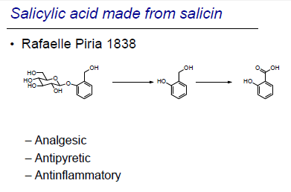
• Rafaelle Piria 1838 created Salicylic acid made from salicin. About 100 years after stone
Basic skeleton of the chemical structure is the same
Analgesic (reduce pain)
Antipyretic ( reduce fever)
Antiflammatory (reduce swelling)

Can manufacture in a larger amount of salicic acid (synthetic) from oil rather than willow bark
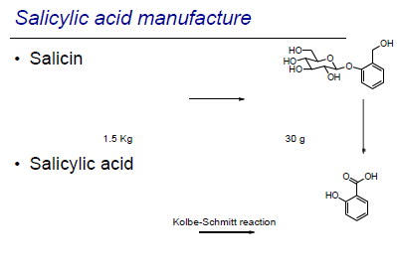
Kolbe-Schmitt reaction
If you take tar and expose it to steam could be used to create natural gas

Problem was when you extract gas from the coal you will get waste product coal tar
The waste is expensive

William Perkin found that you could take the coal tar and convert it to create a dye called "mauve" which was purple
Could not wear colour clothes before the discovery of mauve

Could create large amounts of Salicylic acid from coal tars
Which was more efficient because you could create a lot more product from the synthetic source than from the natural source

Salicylic acid made and sold by dye
companies
Bayer started as a dye company

Salicylic acid was a drug with problems
– Analgesic
– Antipyretic
– Antinflammatory
– Bitter taste
– Stomach irritation

Felix Hoffmann 1868 - 1946
• His Father had arthritis
– Took salicylic acid
for pain
– Suffered from
stomach problems (from taking salicylic acid
Chronically over a long period of time)
- Hoffman wanted to make small changes to the structure, looked at the effect of the change based On its properties
- He found that he made a compound that didn’t have bitter taste or cause stomach problems.(Modified the structure to get rid of the bad properties of salicylic acid). Unfortunately it no
- Longer was useful for pain. Changed the OH to a more complex acetasalicylic acid
- Found that a modified substance worked even better than natural substances.

Process of drug optimization
Salicylic acid
Taste less bitter
No stomach irritation
Not effective for pain

August 10, 1897 was the first time he created "asprin" (as we know it today) he made a material better that was better than the natural substance because it was engineered to keep the good properties

Salicylic acid Acetasalicylic acid
August 10, 1897
August 10, 1897

Hoffmann used a biological assay
Aspirin was trademarked
Bayer’s first drug sales were heroin
Bayer Aspirin marketed with heroin ( claiming it was a "less addictive form of morphine)
Aspirin initially sold as a powder

Aspirin tablets became more popular
- Convenient way of ingesting and regulating dose

Aspirin marketing
- Counterfeit marketing is less of a problem today due to the internet

Aspirin and A.S.A.
• Acetasalicylic acid (A.S.A.) is the Generic name of the material
Only the bayer company can sell "asprin", any company can sell A.S.A

• Benefits
– Pain
– Fever
– Inflammation
– Reduce heart attack
risk

• Side effects
– Tinnitus
– Stomach irritation
– Blood clotting

A.S.A. effective for muscle pain
A.S.A. not effective for visceral pain (internal/after surgery)

Works by blocking the Prostaglandins
Prostaglandins are local hormones
• Produced and “used” in same cell
• Exist for short times
Prostaglandin related with the generation of pain, stops the body from producing prostaglandin hormones (that triggers the feeling of pain)

Prostaglandin biosynthesis
arachadonic acid
Cyclooxygenase (single molecule that acts as a machine by converting one thing to another)

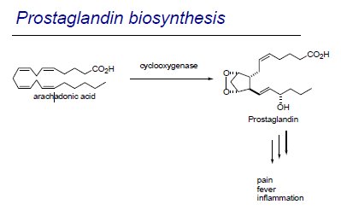
Aspirin and Heart disease
One Aspirin tablet every 2 days for 5 years
Lowers the risk of heart attack
Prostaglandins and blood clotting
Aspirin to prevent heart attack
Early ads claimed Aspirin does not affect
heart
Aspirin now advertised for heart protection

A.S.A. and cancer?
Connection between prostaglandins and tumours. However
It has not been shown to work

A.S.A. in the news
Can be used for a variety of uses such as:
Homemade explosives ( Aspirin was used to construct the device)
Petric acid has a Structure related to TNT and can be made from A.S.A

Side effects of A.S.A.
• Death
– More than 60 tablets at once (suicide/intentional)

Ringing in the ears (typically unintentional)
• Tinnitus
– More than 10 tablets
– Warning of salicylism (aspirin poisoning)

Stomach irritation – excess HCl (long term use)
Mucus protects the stomach from HCl
Prostaglandins help to protect the Stomach are effected by A.S.A
Production of this mucus Is by prostaglandins:
• Decrease acid production
• Increase mucus production
Can cause stomach irritation,

Bufferin (developed to counter the stomach irritation of A.S.A)
• Contains an antacid
- Does not work because it tries to lower the acidity because it’s basic. Acid levels have nothing to do with prostaglandin production.
- Water is the best fix for stomach irritation

– MgSO4 (gypsum)
• Pills dissolve quickly
Plastic coating on A.S.A. tablets

Reye syndrome and influenza
Doctors noticed that children with chicken pox who had taken Aspirin sometimes got Reye syndrome. Doctors thought prescribing Aspirin for children will cause the problem

Children’s aspirin no longer available because it is the same dose as other aspirin brands sold for adults
A.S.A. not in last 3 months of pregnancy (easy delivery if you stop taking it)
• Prostaglandins important for birth

Regular and extra strength
They are the same other than mg dose, extra strength is usually cheaper

Tablets and caplets and gelcaps
- Doesn’t matter which one you take, they are equally effective (personal preference)

Anacin has caffeine for headaches
• A.S.A. 325 mg
• Caffeine 32 mg

Name brand vs generic
- They are the same, only difference is price
- "quality often costs more" (People associate name brands and quality)
- Generic drugs are the same quality as name brands
• Same chemical substance
• Same dosage
• Equivalent bioavailability
– Same amount of drug enters the body
*ALWAYS BUY GENERIC*

Bioavailability – The amount of drug that gets into the body
• Same chemical substance
• Same dosage
• Must have equivalent bioavailability
– Same amount of drug enters the body
Use name brand to find the generic

A.S.A. Summary
Benefit
Reduced Pain
Reduced blood clotting
Reduced Fever
Prevent heart attack
Reduced inflammation

Side Effects
Stomach irritation
Rye syndrome (maybe)

Price per 100 tablets:
Bayer aspirin $ 9.49
Bayer aspirin (extra strength)$ 9.99
Bufferin $12.49
Bayer coated aspirin $15.82
Anacin $11.49
Bayer Aspirin Low Dose $17.99
Generic A.S.A. $2.50

