ADM 1300
Lecture 2

- Management: The process of achieving organization goals through people and other resources
  - Process (series of activities and operation)
  - Involves assembling and using resources
    - Human, financial, information
  - Involves acting in a goal-directed manner to accomplish tasks
    - Activity towards a goal
    - Activity with purpose and direction
  - Activities are carried out by organizational setting
    - People with different structures, intentionally structured and coordinated
- Top management: (chief executive officer, chief financial officer, premier, mayor)
  - Develop long range plans for the organization
  - Inspire executives and employees to achieve their vision for the company’s future
- Middle management: (Regional manager, division head, dean)
  - Focus on specific operations, products, or customer groups within an organization
  - Responsible for developing detailed plans and procedures to implement the firm’s strategic plans
- Supervisory management: (supervisor, department chairperson, program manager)
  - Implement plans by made by middle management
  - Responsible for non-manager employees
  - Motivate employees to complete daily, weekly, and monthly goals
- Managers do:
  - Getting the most outputs with the least inputs
    - Efficiency- do things right
  - Completing activities so organization goals are achieved
    - Effectiveness- do the right things
  - Not always attributed to money
  - To manage effectively and efficiently, you must get the best out of people
    - May require different management styles
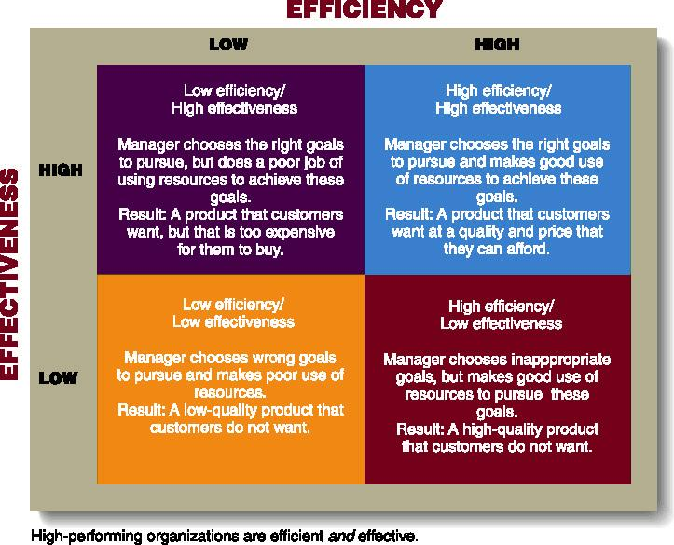

- Managerial Functions
  - Planning
    - The process of looking forward to future events and to decide on course of action for achieving future goals
  - Organizing
    - The process of blending human and material resources through a formal structure of tasks and authority
  - Directing
    - Guiding and motivating employees to achieve goals
  - Controlling
    - The function of assessing an organization’s performance against it’s goals
    - Four basic steps:
      - Setting performance standards
      - Monitor performance
      - Compare performance with standard
      - Make corrections if needed
- Management functions
  - Planning
    - Defining goals
    - Establishing activities
    - Developing sub-plans
      - To coordinate activities
  - Organizing
    - Determining
      - What needs to be done
      - How it will be done
      - Who will do it
  - Directing
    - Directing and motivating all involved parties and fix any problems
  - Controlling
    - Monitoring activities and make sure they are completed as planned
  - Lead to organization’s stated purpose
- Skills needed for managerial success
  - Technical skills
    - Manager’s ability to understand and use the technique, knowledge, tools and equipment of a specific department or area to study
  - Human skills
    - Interpersonal skill that enables a manager to work effectively with and through people
  - Conceptual skills
    - Ability to see the organization as a unified whole
    - To understand how each part of the organization interact with each other

- Importance of planning
  - Different types and levels of planning
  - Organizations should have comprehensive planning framework
    - Each step should fit in overall plan
      - Broad/long range planning: mission statement, objectives and goals
      - Narrow/short-range planning: functional plans for specific employees/areas
  - Plans will out line the steps the company will make to achieve goals
- 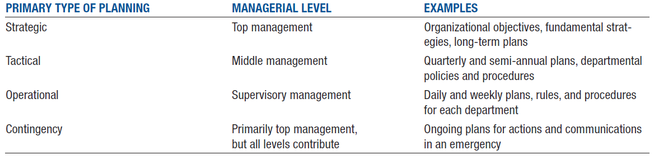
- Steps in the strategic planning process
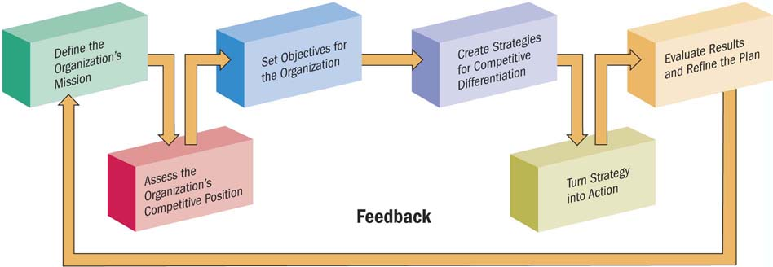

- SWOT
  - Strengths
  - Weaknesses
  - Opportunities
  - Threats
    - A firm can develop the best strategy by accessing each factor 1 by 1
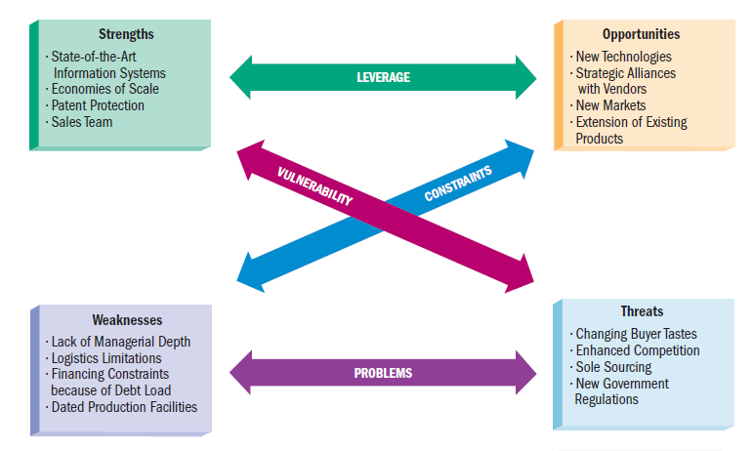
- Managers as decision makers
  - Decision making:
    - Process of seeing a problem or opportunity
    - Accessing possible solutions
    - Selecting and carrying out the best-suited solution
    - Assessing the results
  - A programed decision
    - Simple, common and frequently-occurring problems that already have a solution
  - A non-programed decision
    - Complex and unique problem or opportunity with results important to the organization
- Managers as leaders
  - Leadership
    - The ability to direct or inspire people to meet goals
  - Involves use of influence or power
  - Three common traits:
    - Empathy
    - Self-awareness
    - Objectively in dealing with others
  - Leadership styles
    - Autocratic
      - Leader-centered: make decision alone without consulting employees
      - Strong and powerful
      - No attempt to find out what problems
      - People working for them feel ineffective
      - Motivation- threat job
        - Fast decisions
        - Discourage employees

    - Democratic
      - Involves employees in decisions, delegating assignments, and ask them for suggestions
    - Free-rein
      - Involves minimal supervision
        - Leaves decision making to employees
    - Persuasive
      - Not as authoritative
      - Better way to get things done
      - Strong central authority
      - Communication one way
      - Better relationship with employees
      - May not have full support from employees
    - Consultative
      - Communication 2 way
      - Employee feels more valued
      - Manager prepared to consult
      - Staff input can improve
      - Time to consult can slow down decision
    - Participative
      - Part of the action
      - Employees involved in management decisions
      - Motivation and commitment
      - Employees gain confidence
      - Communication can be too informal
    - Laissez-faire
      - Responsibility & control
      - Can work well with creative highly qualified staff
      - Risk of disorganized time and money
      - Let employees decide
    - Contingency
      - Plans of action managers take in emergency situations
- Organizational structures
  - Organization
    - A structured group of people working together to achieve common goals
  - Three key elements:
    - Human interaction
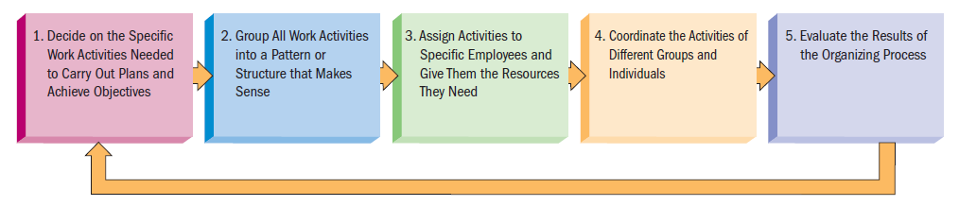
    - Goal-directed activities
    - Structure

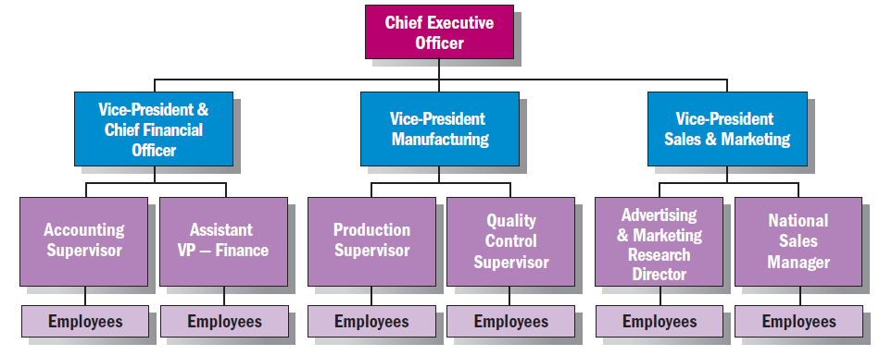
-

- Departmentalization
    - Process of dividing work activities into units within the organization
  - Product
    - Organized based on goods and services the company offers
  - Geographical
    - Organized by geographical regions within a country
    - Or by region throughout the world (for multinational)
  - Customer
    - Organized by different types of customers the organization serves
  - Functional
    - Organized by business functions
      - Finance
      - Marketing
      - Human resources
      - Production
  - Process
    - Organized by work processes necessary to complete production of goods or services
- Types of organizational structures
  - Line organizations
    - Oldest and simplest form
    - Direct flow of authority from CEO to employees
  - Line-and-staff
    - Combines line departments and staff departments
    - Line departments participate in decisions that affect the core operations of the organization
    - Staff departments lend specialized technical support
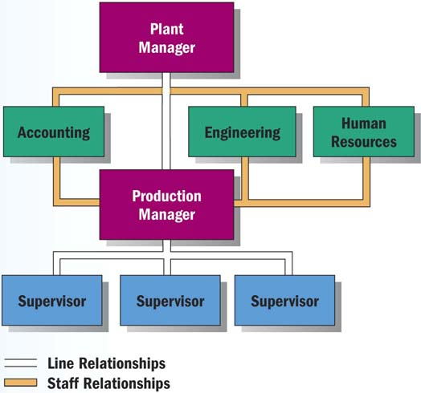

- Matrix organizations
  - Project management structure that links employees from different parts of the organization to work together on specific projects
  - Employees report to both a line manager and project manager
  - Advantages
    - Flexibility in adapting to changes
    - Focus on major problems or products
    - Outlet for employees’ creativity and initiative
  - Disadvantages
    - Integrated skills of many specialists into a coordinated team
    - Team member’s permanent functional managers must adjust employee’s regular workload

Lecture 3
- Small business
  - An owner managed business with fewer than 100 employees
  - 2.3 million in Canada
  - 97.7% of all employer businesses in Canada are ‘small’
  - Account for 2/3 employment in 4 industries
    - Non-institutional healthcare
    - Food and accommodation
    - Construction
    - Other services
- Entrepreneur(s)
  - People who recognize and seize opportunity
- Entrepreneurship
  - The process of identifying an opportunity in the marketplace
    - Assessing the resources necessary to capitalize on that opportunity
- Entrepreneurial process
  - Identifying opportunities
    - Idea generation
    - Screening:
      - Idea creates or adds value
      - Idea provides a sustainable competitive advantage
      - Idea is marketable and financially viable
      - Idea has low exit costs
    - Develop the opportunity
  - Access the necessary resources
- Forms of business ownership
  - Sole proprietorship (SPs)
    - Simplest form of business
    - Available to any individual who is legally able to enter into a binding contract
    - Under provincial and municipal jurisdiction
    - Filing a name is not required
    - Owned and operated buy one person
    - Advantages
      - Ease of start and end
      - Cheap
      - Pride of ownership
      - No special taxes
      - No government regulation
      - Flexibility and control
    - Disadvantages
      - Unlimited liability
      - Limited growth
      - Limited financial resources
      - Limited skills pool
      - Limited lifespan
  - Partnership
      - An arrangement whereby two or more people combine some or all resources in a business undertaking with a view to share profits among partners
      - Provincial laws require they register its name and give information about all partners
    - General
        - Joint liability- liable for equal shares in debts
        - Each partner is liable for full amount
        - Each member can bind the partnership without consent to the other
      - Partners are equal
      - Complete sharing
      - Same responsibilities
      - Same profit
    - Limited
      - Composed of one or more general partners who conduct the business
      - One or more partners who contribute an amount in actual cash (special or limited partners)
        - Silent partner
          - Known to the public, not actually involved
        - Secret Partner
          - Not known to the public, active management role
        - Nominal Partner
          - Name used for public relations, not actually involved (besides money investment)
        - Dormant Partner
          - Unknown to public nor involved
    - Joint venture
      - Partnership established for a specific project or for a limited amount of time
    - Advantages
      - Ease of organization
      - More financial resources
      - Shared management
      - Faster decision making
      - Combined knowledge and skills
      - Fewer regulatory controls
    - Disadvantages
      - Unlimited liability
      - Division of profits
      - Disagreements among partners
      - Life of a partnership
  - Corporation
    - Recognized as a separate legal entity under the law
    - A corporation incorporated under the laws of Canada can carry on business in all parts of Canada (federally incorporated business)
      - 150 of 200 largest corporations in Canada
      - A federal company cannot be prevented by the provincial government from exercising the powers that have been that have been validly conferred on the company by federal authority (doing business in a province)
    - Governance of a corporation is a responsibility of a board of directors
    - Ownership is through stocks or shares- either ‘preferred’ shares or ‘common’ shares (typically ‘voting’ shares)
    - Under federal laws
    - Under provincial laws
      - Private corporation
        - Right to transfer shares is restricted
        - Number of shareholders limited to 50
        - May not sell shares or debentures (bonds or debt instruments) to the public
      - Public corporation (most “family businesses”)
        - Sell shares to the public on a stock exchange
        - Stricter regulations for filing financial reports
          - Must follow certain audit procedures
        - Must file a prospectus if shares are sold to the investing public
      - Subsidiary Corporation
        - One that has majority of it’s stocks owned by another company known as parent company
      - Holding company
        - A corporation that controls one or more corporation through ownership of their common stock
    - Advantages
      - More money for investment
      - Size
      - Perpetual (lasting) life
      - Separation of ownership/management
      - Limited liability
    - Disadvantages
      - Initial cost
      - Paperwork
      - Two tax returns
      - Double taxation
      - Termination difficult
    - Crown corporations
        - Export Development Corporation (Areas where the risk involved would make it necessary for a private sector organization to change an unaffordable price)
        - Via Rail
      - A “for profit” organization owned and operated by the federal, provincial, and local government
        - To provide a service
      - Operate in areas where the private sector either could not or would not operate because of high infrastructure or other costs
        - Mail delivery
        - Atomic energy (Areas where return on investments occur in the long-term)
        - Business Development Bank (Areas where a service is intended to make all businesses more profitable)
    - Cooperatives
        - The Farmers COOP (Co-op)
        - Gay Lea- A Co-op of Ontario dairy farmers
        - Ocean spray- A co-op of cranberry farmers
      - An organization composed of individuals or small businesses that have banded together to reap the benefits of belonging to a larger organization
      - Expected to operate without a profit
      - Pass savings on to members
        - Co-op buys in bulk
        - Advertisement efforts are pooled
    - Non-profit
        - Universities
        - Hospitals
        - Charities
      - Focus more on providing a service than profit
      - Not owned by a government entity
      - Funded through private donations and grants by government
  - Family business
    - 2/3 of Canadian business enterprises are controlled by families
    - Approx. 10,000 business in Canada with two or more generations as owners or managers
    - Control about 1/3 of the 100 largest companies in Canada
    - Founder or family members are in executive positions
    - Family members hold sufficient shares to make decisions and control operations
    - Approx. 25 % of fam. Businesses survive the founder’s demise
      - 10% survive beyond 2 generations
      - 3% beyond the 3rd generation
- Corporate expansions
  - Mergers
    - Two or more companies join to form one company
      - Vertical merger
        - Firms merge that are involved at different levels of the same business (Chrysler and a steel company)
      - Horizontal merger
        - Firms at the same level of business merge (Chrysler and Daimler Benz)
      - Conglomerate merger
        - The merger of two firms in unrelated industries
  - Acquisition
    - One company purchases another by buying most of its stocks
    - Acquired company may become a subsidiary company or assets may be merged
    - Buying company gains control of acquired company’s assets and are responsible for liabilities
  - Leveraged buy-out
    - A group of investors borrows money from bank or other lending institutions to acquire a company
      - Using the assets of acquired company as security for repayment of the loan
  - Friendly V.S. hostile takeover
    - Corporate raider offers to buy some or all of the company’s stock at a premium over it’s current price
    - Friendly
      - Both groups agree
    - Hostile
      - When the second company does not wish to be taken over
    - Attempt to fend off a hostile takeover
      - Ask shareholders not to sell to the raider
      - File a lawsuit
      - Poison pill
        - Allow shareholders to buy more shares of stocks at prices lower than the market value
      - Shark repellent
        - Requiring a large majority of shareholders to approve the takeover
      - White knight
        - A more acceptable firm that is willing to acquire the threatened company
- Canadian private sector
  - Canadian businesses have shifted from a system of enterprises to a corporate system
  - Sole proprietorships
    - Majority in 1950s
    - Lowered significantly in 1980s
    - Dominated by Corporations today
  - Partnerships
    - Not a lot back in 1950s
    - Lowered significantly to barely any in 1980s
    - Almost none today
  - Corporations
    - 2nd most back in 1950s
    - Increased significantly in 1980s
    - Dominating, almost taking over today
  - Co-operatives
    - Barely any in 1950s
    - Lowered to almost none in 1980s
    - Lowered even more to rare today

Lecture 4
- Scientific Management (Frederick Taylor)
  - The systematic study of the relationship between humans and tasks to redesign the work for higher efficiency
    - Taylor sought to reduce the time a worker spent on each task by optimizing the way each task was done
    - Simplifying the jobs to allow training in specialized sequence of motions in the ‘best’ way
  - Principles to increase efficiency
    - Replace usual ways of work methods with methods based on scientific study of the way the job is performed now and determine new ways to do it
      - Codify new methods into rules
    - Select workers whose skill matches rules set step 1
      - Train and develop each worker
      - Cooperate with the workers to ensure the developed methods are being followed
    - Establish a fair level of performance and pay for higher performance
    - Studycodifyselect & trainReward
  - Problems
    - Managers often implement only the increase output side of Taylor’s plan
      - They did not allow workers to share an increased output
      - Specialized jobs became boring and dull
      - Workers end up distrusting Scientific management
    - Workers could purposely underperform
    - Management responded with increased use of machines
- Scientific Management (Frank and Lillian Gilbreth)
  - Refined Taylor’s methods
    - Made many improvements to time and motion studies
  - Time and motion studies
    - 1. Break down each action into components
    - 2. Find better ways to perform it
    - 3. Reorganize each action to be more efficient
  - Gilbreths also studied fatigue, lighting, heat, and other worker problems
- Gilbreths VS Taylor
  - Gilbreths’ studies were more focused on how a task was done
    - And how to best eliminate unneeded, fatigue steps in process
  - Gilbreths’ version had a more developed view of the worker and his/her interests VS Taylor’s
  - Gilbreths used photography as a means to study human motion in completing tasks (micro motion films)
- Administrative management (Max Weber)
  - Bureaucracy
    - Formal system of organization and administration to ensure effectiveness and efficiency
    - Developed 5 principles of bureau
      - A manager’s formal authority derives from his/her position
      - People should occupy positions because of performance, not social networks/connections
      - The authority, responsibility of each position relative to every other position should be made clear
      - Positions should be arranged hierarchically
      - Managers must create a well defined system of rules standard operating procedures, and norms
    - Authority
      - Power to hold people accountable for their actions
    - Performance
      - Position in firm should be held based on performance instead of social connections
    - Position duties are clearly identified
      - People should know what is expected of them
    - Line of authority
      - Should be clearly identified
        - Workers know who reports to who
      - Rules, Standard Operating Procedures (SOPs), and norms
        - Used to determine how the firm operates
          - Sometimes, these lead to ‘red tape’ and other problems
- Administrative management (Henri Fayol)
  - Hypothesized that administrative activities can be divided into 6 groups:
    - 1. Technical operations (productions/manufacturing)
    - 2. Commercial Operations (purchases/ sales)
    - 3. Financial operations (funding/ controlling capital)
    - 4. Security operations (protecting property & persons)
    - 5. Accounting operations (stock-taking, costing)
    - 6. Administrative operations/ managerial activities
      - ‘Foresight, organizing, commanding, coordinating, controlling’
  - Fayol developed a set of 14 principles
    - 1. Division of labour
      - Allows for job specialization
        - Firms can have too much specialization leading to poor quality and worker involvement
    - 2. Authority and responsibility
      - Both formal and informal authority resulting from special expertise
    - 3. Unity of Command
      - Employees should have only 1 boss
    - 4. Line of authority
      - A clear chain from top to bottom of the firm
    - 5. Centralization
      - The degree to which authority rests at the very top
    - 6. Unity of direction
      - One plan of action to guide the organization
    - 7. Equity
      - Treat all employees fairly with justice and respect
    - 8. Order
      - Each employee is put where they have the most value
    - 9. Initiative
      - Encourage innovation
    - 10. Discipline
      - Obedient, applied, respectful employees needed
    - 11. Remuneration (Rewarding) of personnel
      - The payment system contributes to success
    - 12. Stability of tenure (contract)
      - Long-term employment is important
    - 13. General interest over individual interest
      - The organization takes precedence (majority/ priority) over individual
    - 14. Esprit de corps
      - Share enthusiasm and devotion (care) to organization
- Behavioral management (Mary Parker Follett)
  - Suggested that workers help analyze their jobs for improvement
  - The Worker knows the best way to improve the job
  - If workers have the knowledge of the task, they should control the task
- Hawthorne studies (Elton Mayo)
  - Examined the physical and environmental influences of the workplace
    - Brightness of the light
    - Humidity
  - Later examined the psychological aspects
    - Breaks
    - Group pressure
    - Working hours
    - Managerial leadership
  - 4 general conclusions
    - The aptitude (skill) of individuals are imperfect predictors of job performance
    - The informal organizations affect productivity
    - Work-group norms (standards) affect productivity
    - The workplace is a social system
- Theory X&Y (Douglas McGregor)
  - Theory X
    - Assume the average worker is lazy, dislikes work, and will do as little as possible
      - Managers must closely supervise
        - Control through reward and punishment
  - Theory Y
    - Assume workers are not lazy, want to do a good job and the job itself will determine if the worker likes the work
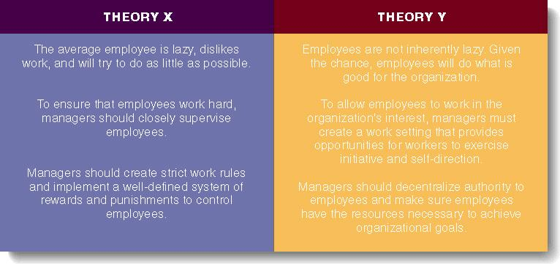
      - Managers should allow worker great latitude
        - Create an organization to stimulate the worker

Management Science
- Uses rigorous (difficult/ demanding) quantitative techniques to maximize resources
  - Quantitative management
    - Utilizes linear programming, modeling, simulating systems
  - Operations management
    - Techniques to analyze all aspects of the production system
  - Total Quality Management (TQM)
    - Focuses on improved quality
  - Management Information Systems (MIS)
    - Provides information about the organization
Organization- Environment theory
- Considers relationships inside and outside the organization
  - The environment consists of forces, conditions, and influences outside the organization
- Systems theory considers the impact of stages:
  - Input: acquire external resources
  - Conversion: inputs are processed into goods and services
  - Output: finished goods are released into the environment
What is business?
- Business
  - All profit-seeking activities and enterprises that provide good and services necessary to an economic system
  - Profits: rewards for businesspeople who take the risk involved to offer goods and services to customers
- Factors of production
  - Natural resources
  - Capital
  - Human resources
  - Entrepreneurship
- Private enterprise system
  - Capitalism
    - Adam Smith
    - Invisible Hand
      - A natural phenomenon that guides free markets and capitalism through competition for scarce resources
  - Economic system
    - Determines business ownership, profits and resources
  - Firms rewarded for their ability to serve the needs of the customers
  - Minimizes government intervention
  - Competition
    - The battle among businesses for consumer acceptance

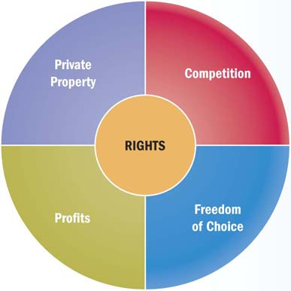
- Basic rights within a private enterprise system

Today’s business work force
- Reliable workers dedicated to promoting strong ties with customers and partners
- Capable of efficient, high quality production
- Able to compete in global markets
- Technically savvy and innovative (advanced)
Changes in the work force
- Aging of the population
    - Shrinking in the labour pool
  - Many baby boomers are hitting the peak of the careers
    - Generation X and Y are launching their careers
  - More generations mixing in the workplace than ever before
  - Technology has intensified the hiring challenge by requiring workers to have ever-more advanced skills
- Increasingly diverse workforce
  - 2/3 of Canada’s population growth is from international immigration
    - Particularly from Asia
  - Employee teams with individuals of different genders, ethnic backgrounds, cultures, religions, ages, and physical and mental abilities are more effective
The 21st century manager
- Vision
  - Ability to recognize marketplace needs and what an organization must do to satisfy them
  - Companies today look for managers who are intelligent, highly motivated people with the ability to create an support a vision for the organization

- Critical thinking and creativity
  - Critical thinking: Ability to analyze and access information to pinpoint problems or opportunities
  - Creativity: capacity to develop novel solutions to perceived organizational problems
- Ability to lead change
  - Guide employees and organizations through changes
  - Mangers must be comfortable with tough decisions in fluctuating conditions
  - Factors that require organizational change can come from external and internal sources
Economics
- Studies of the choices people and government make when dividing scarce resources
  - Demand
    - Willingness and ability of buyers to purchase goods and services
  - Supply
    - Willingness and ability of sellers to provide goods and services
Microeconomics
- Forces of supply and demand
  - Study of small economic units
    - Individual consumers
    - Families
    - Businesses
- Factors driving demand
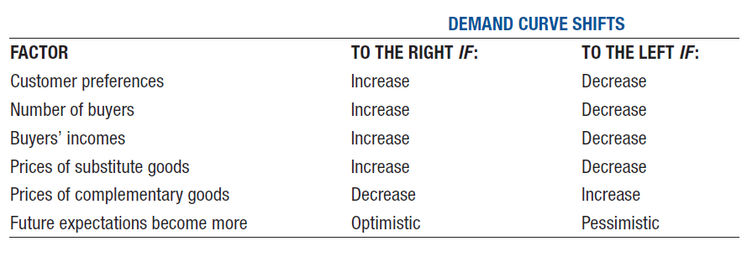
  - Demand curve- a graph of the amount of a product that buyers will purchase at different prices
- Factors Driving Supply
  - Factors of production play a central role in the overall supply of goods and services
  - A change in the cost or the availability of any of these inputs can shift the entire supply curve
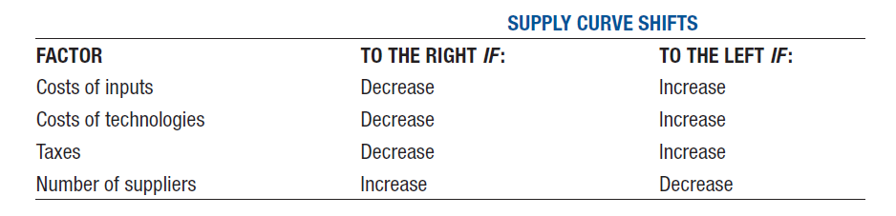

- Supply curve
  - A graph that shows the relationships between different prices and the amount of goods that sellers will offer for sale, regardless of demand
How demand and supply interact
- Supply and demand curve meet at equilibrium price
- Buyers and sellers make choices that restore the equilibrium price
- Changes affect both demand and supply
Macroeconomics
- Issues for entire society
  - Political, social, and legal conditions differ in every country
  - Economies generally classified in one of three categories:
    - Private enterprise system (capitalism or market economy)
    - Planned economies: Socialism, communism
    - Mixed market economy (combination of two)
Capitalism
- The private enterprise system and competition
  - Businesses meet needs and demands of consumers and are rewarded through profit
  - Government favours a hands-off approach
  - Marketplace competition regulates economic life
  - Four degrees of competition
    - Pure competition
    - Monopolistic
    - Oligopoly
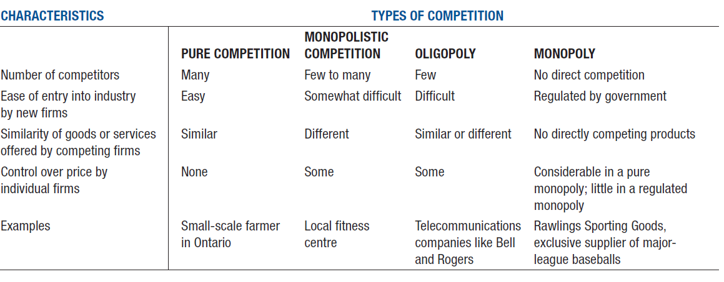
    - Monopoly

Evaluating economic performance
- An economic system should provide a stable business environment and sustained growth as benefits for its citizens
  - Business decisions and consumer behavior differ at various stages of the business cycle
    - Prosperity
      - Unemployment low
      - Consumer confidence/purchasing high
      - Business expanding
    - Recession
      - Cycle of economic contractions that lasts for six months or longer
      - Consumers careful about purchases
      - Business slow production/expansion
    - Depression
      - Extended recession
    - Recovery
      - Declining unemployment
      - Increasing business activity
      - Renewed consumer confidence
Global economic challenges
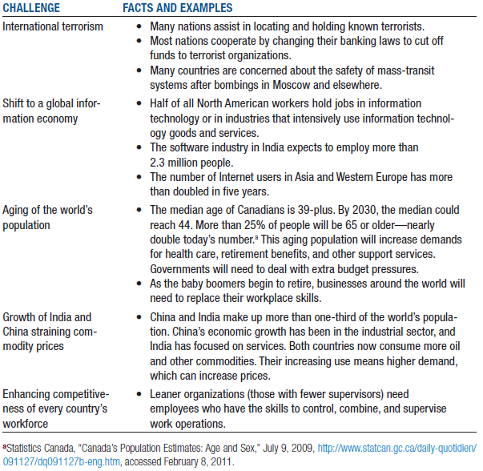

Why nations trade
- Boosts economic growth
- Expands market
- More efficient production systems
- Less reliance on the economies of the home nations
- Exports
  - Domestically produced goods and services sold in other countries
- Imports
  - Foreign goods and services purchased by domestic customers

International sources of factors of production
- Decisions to operate abroad depend upon availability, price, and quality of:
  - Labour
  - Natural resources
  - Capital
  - Entrepreneurship
- Companies doing business overseas should make strategic decisions

Additional Environmental factors to which companies are exposed
- New social and cultural practices
- Economic and political environments
- Legal restrictions
- Companies can expand their market, seek growth opportunities in other nations
  - Make their production and distribution systems more efficient
  - Reduce their dependence on the economies of their home nations
Exchange rates
- Currency rates are influenced by:
  - Domestic economic and political conditions
  - Central bank intervention
  - Balance-of-payments position
  - Speculation over future currency values
- Values fluctuate (alter), or ‘float’ depending on supply or demand
- National governments can deliberately influence exchange rates
- Business transactions are usually conducted in the currency the region where they happen
- Rates can quickly create or wipe competitive advantages

International trade barriers

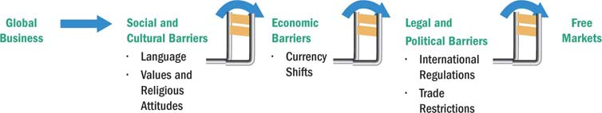
Social and cultural differences
- Language
  - Potential problems include:
    - Mistranslation
    - Inappropriate messaging
    - Lack of understanding of local customs
    - Difference in taste
- Values and religious attitudes
  - Differing values about:
    - Business efficiency
    - Employment levels
    - Importance of regional differences
    - Religious practices
      - Holidays
    - Values about issues such as interest-bearing loans
Economic differences
- Infrastructure
  - Basic system of a country’s communication, transportation, and energy facilities
- Currency conversion and shifts:
  - Fluctuating values can make pricing in local currencies difficult
  - Affect decisions about market desirability and investment opportunities

Political and legal differences
- Political climate
  - Stability is a key consideration
- Legal environment
  - Canadian law
  - International regulations
  - Country’s law in which trade is planned
  - Climate of corruption
- International regulations
  - Treaties between Canada and other nations
  - Tariffs
    - Taxes imposed on imported goods
  - Enforcement issues
Types of trade restrictions
- Tariffs: Taxes, surcharges, or duties on foreign product
  - Revenue tariffs generate income for the government
  - Protective tariffs raise prices of imported goods to level the playing field for domestic competitors
- Nontariff barriers
  - Quota
    - A limit set on the amounts of particular products that can be imported
  - Dumping
    - Selling products in other countries at prices below production costs or below typical prices in the home market
  - Embargo
    - A total ban on importing specific products or a total stop to trading with a particular country
  - Exchange control
    - A restriction on important certain products
    - Restriction against certain companies to reduce trade and the spending of foreign currency
      - Through central banks or government (national policy)
Going global
- Determining which foreign market(s) to enter
- Analyzing the expenditures required to enter a new market
- Deciding the best way to organize the overseas operation

Levels of involvement
- Risk increases with the level of involvement
- Many companies employ multiple strategies
- Exporting and importing are entry-level strategies
  - Importing is the process of bringing in goods produced abroad
  - Exporting is the act of selling home goods overseas

Countertrade and franchising
- Countertrade
  - A barter agreement whereby trade between two or more nations involves payment made in the form of local products instead of currency
- Franchising
  - A contract-based agreement in which a franchisee can produce and/or sell franchisor’s product under the company’s name if the franchisee agrees to the operating terms and requirements
- Foreign licensing agreement
  - An international agreement in which one firm allows another firm to produce or sell its product, or use its trademark, patent, or manufacturing processes, in a specific geographical area, in return for royalties and other compensation
- Subcontracting:
  - An agreement that involves hiring other companies to produce, distribute, or sell goods and services

Offshoring and international direct investment
- The relocation of business processes to lower-cost overseas locations
  - Not initiating business but gaining cost savings to stay competitive
  - Extremely controversial
- The ultimate level of global involvement is direct investment
  - Directly operating production and marketing in a foreign country
  - Acquisition (purchase firm from host country)
  - Joint venture (Partnership between companies)
  - Overseas division (set up office overseas)

Lecture 5
Ethics and social responsibility
Decision-making

Ethics and Ethical behavior
- Ethics
  - Beliefs about what is right and wrong
    - Good or bad
- Ethical behavior
  - Behavior that conforms to individual beliefs and societal norms about what is right and good

Business ethics
- The study of business situations, activities, and decisions where issues of right and wrong are addressed
- Rules, standards, codes, or principles which provide guidelines for moral right behavior and trustfulness in specific situations
- Application of business activity in ethics
  - Study of morals and principles of what is right or wrong in human behavior
- Beliefs that determine what is acceptable (and what is not) in business
- Applies a group’s standard of right and wrong to the decisions and actions of business organizations, managers, and employees

Common themes emerging from definitions of business ethics
- Right and wrong
- Moral statements
  - The means by which individuals judge their actions and the actions of others based upon accepted behavior in society
- Value judgments
  - Subjective evaluations of what is considered important
    - Based on how managers intuitively feel about the goodness or rightness of various goals

Basic approaches to ethical decision-making
- Utilitarian Approach
  - An approach the focuses on the consequences of a decision
    - The intention is to make a decision that results in the greatest food for the greatest number
- Moral rights approach
  - An approach that focuses on the examining of moral standings of actions independent of their consequences
    - Some things are just ‘right’ and some things are just ‘wrong’ regardless the consequences
- Universal approach
  - Choosing a course of action you believe can apply to all people under all situations
    - Treat others the way you want to be treated
- Justice approach
  - Focuses on how equitably (fairly) costs and benefits of actions are distributed
- Procedural justice
  - Impartial (fair) applications of rule and procedure
- Corrective justice
  - Appropriate compensation for wrongdoings that are suffered
- Retributed justice
  - The punishment should fit the offence (crime/fault/sin)
- Distributive justice
  - Concern for how all stakeholders are treated

Influences on ethical behavior
- Individual morals
- Education
- Media
- Union contracts
- Competitive behavior
- Professional associations

Business ethics
- 2 branches of ethics
  - Descriptive ethics
    - Describing, characterizing, and studying morality
      - “What is”
  - Normative ethics
    - Supplying and justifying moral systems
      - “What should be”
Making ethical judgments
- Ethical dilemmas
  - Situations where a decision must be made between two equally valid but mutually exclusive courses of action

Corporate Social Responsibility (CSR)
- Degree of moral obligation that may be ascribed (recognized) to corporations beyond simple obedience to the laws of state
- An organization’s obligation to maximize its positive impact and minimize its negative effects in being a contributing member to society
- Intelligent and objective concern for the welfare of society that restrains individual and corporate behavior from ultimately destructive activities, no matter how immediately profitable, and leads in the direction of positive contributions to human betterment, variously as the latter may be defined

CSR definitions
- The way a corporation achieves a balance among its economic, social, environmental responsibilities in its operations so as to address shareholder and other stakeholder expectations
- “The capacity of a corporation to respond to social pressures
CSR: philosophical arguments
- Can a corporation of social responsibilities
- Can a corporation be morally responsible for its actions
For CSR
- Must satisfy society’s needs
- CSR prevents public criticism and government regulation
- Business and society are interdependent (reliant)
- Good for the bottom line
- Investors and consumers support CSR
- Addressing social problems can become financial opportunities
- Business should take long term CSR approaches
- Social services improve public image and goodwill
- Business can solve problems as well as government
- Proactive (upbeat) approach is better than reactive (responsive)
- Businesspeople are also concerned citizens
Against CSR
- Profit maximization is the primary objective of business
- Business is responsible to shareholders
- Social policy is role of government
- Businesses lack training in social issues
- CSR would give too much power to business
- Business involvement in social matters increases cost
- No reliable guidance in CSR matters
- Business can not be held accountable unlike social institutions
- There is dividend support in business community for social involvement

Areas of social responsibility
- Natural environment
  - Every sector of business in every country leaves an environmental footprint
  - Issues:
    - Ozone depletion
    - Global warming
    - Freshwater quantity and quality (decreasing)
    - Deforestation
    - Solid and hazardous waste
    - Land degradation
    - Acid rain
    - Air pollution
    - Energy inefficiency
    - Production of toxic substances
  - Responses of governments in Canada
    - Canadian Environmental Protection Act (federal)
    - Air quality legislation (provincial)
    - Water quality legislation (federal)
      - Canada water act
      - Fisheries act
      - Canada shipping act
      - Dominion water power act
    - Land related legislation
  - Exxon Valdez Oil spill
    - CERES organization was formed
    - Developed ten principles that have been advanced as models for businesses to express and practice environmental sensitivity
      - Protection of the biosphere
      - Sustainable use of natural resources
      - Reduction and disposal of waste
      - Energy conservation
      - Risk reduction
      - Safe products and services
      - Environmental restoration
      - Informing the public
      - Management commitment
      - Audits and reports
- Customers
  - Rights of customer
    - Safe products
    - Product information
    - Be heard
    - Choose
    - Be educated about the purchase
    - Courteous service
  - Advertising
    - Truth
    - Counterfeit brands
    - Stealth advertising
    - Morally objectionable advertising
- Employees
  - Legal and social commitments
- Investors
  - Improper financial management
  - Misrepresentation of finances

Lecture 6
Human Resources Management- Motivation
- Includes all activities used to attract and retain employees and to ensure they perform at a high level in meeting organization goals
  - Strategic Human Resources Management: process by which managers design the component of HRM system process to be consistent with:
    - Each other
    - Other elements of the organizational architecture
    - The organization’s strategy and goals
Components of a HRM
- Recruitment and selection
- Training and development
- Performance appraisal
- Pay and benefits
- Labour relations
  - Before doing any of these, human resource planning and job analysis must be down
Human Resource Planning
- Includes all activities that managers use to forecast their current and future human resources needs
- Demand forecasts and supply forecasts
- Outsourcing
  - Flexibility (fills an immediate and temporary need)
  - Cheaper than hiring an employee (no benefits)
Job Enlargement, Job Design, Job Specialization
- Job Enlargement
  - Increasing the scope of the job through extending the range of duties and responsibilities
- Job Design
  - Organizing tasks, duties and responsibilities into a unit of work
- Job Specifications
  - The degree to which tasks are separated into separate jobs
Job analysis
- Process of identifying the task, duties and responsibilities that make up a job (job description) and the knowledge, skills, and abilities needed to perform a job (job specification)
Identifying and selecting competent employees
- Job analysis
  - An assessment that defines a job and the behaviors necessary to perform the job including knowledge, skills, and abilities
    - Requires conducting interviews, engaging in direct observation, and collecting the self reports of employees and their managers
- Job description
  - A written statement of what the job holder does, how it is done and why it is done
- Job specifications
  - A written statement of the minimum qualifications that a person must possess in order to perform a given job successfully
From planning to a HRM system
- Human resources planning provides a supply forecast and demand forecast
- Job analysis provides a measure of what the jobs are and what knowledge, skills, and abilities are needed to actually do the job
  - With this information, the HRM system begins
Components of a HRM System
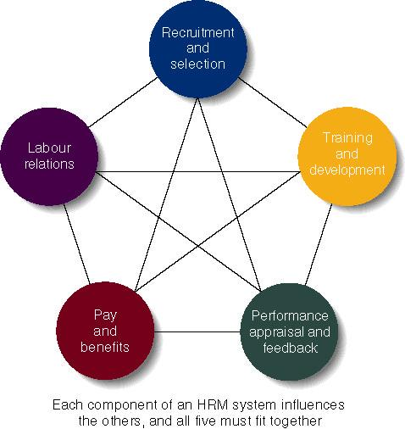
External Recruitment
- Managers look outside the firm for people that have not worked at the firm before
- Sources:
  - Advertisement
  - Open houses
  - Informal networks
  - Employment agencies
- Advantages:
  - Large applicant pool
  - Hire people with the necessary skills, knowledge, and abilities
  - New ideas and latest technology
- Disadvantages
  - Lowering moral of current employees
  - High costs
  - Performance of new recruits is nebulous
Internal Recruitment
- Managers look inside the firm at existing employees to fill the vacancy
- Sources:
  - Employees looking for lateral moves
  - Employees looking for promotion
- Advantages:
  - Employees already familiar with the organization
  - Managers already know internal candidates
  - Boost level of employee morale and motivation
  - Less time-consuming and less expensive
- Disadvantages:
  - Limited pool of candidates
  - Candidates set in organization’s ways
  - No new ideas

Identifying and selecting competent
- Types of selection devices
  - Application forms
  - Written tests
  - Performance simulations
  - Interviews
  - Background investigations
  - Physical examinations
Selection process
- After a pool of applicants are identified, candidates’ qualifications related to the job requirements are determined:
  - Background information: includes education, prior employment, etc.
  - Interview: almost all firms use one of two types:
    - Structured interview: managers ask each person the same job-related questions
    - Unstructured interview: held like a normal conversation
  - Testing: includes testing of ability, personality, physical ability, and performance
    - Ability test- assess if applicant has right skills for the job
    - Personality test- seek traits relevant to job performance
    - Physical ability test- assess whether applicant has physical ability to do task
    - Performance tests- measure job performance
      - Ex. Typing speed test
  - References:
    - Outside people provide candid information about candidate
Selection Tools: Reliability & Validity
- Must be reliable and valid
  - Reliability- the degree to which the tool measures the same thing each time it is used
    - Scores should be close for the same person taking the same test over and over again
  - Validity- does the test measure what it is supposed to measure?
  - Managers have an ethical and legal duty to develop good selection tools
Identifying and selecting competent employees
- Validity (of prediction):
  - A proven relationship between the selection device used and some relevant criterion for successful performance in an organization
    - High test scores equate to high job performance, low scores to poor performance
- Reliability (of prediction)
  - The degree of consistency with which a selection device measures the same thing
    - Individual test scores obtained with a selection device are consistent over multiple testing instances
Training and development
- Training; teach organizational members how to perform current jobs
  - Help worker’s acquire skills to perform effectively
- Development: build worker’s skills to enable them to take on new duties
  - Training used more often lower levels of firms, development is common with managers
  - A needs assessment should be taken first to determine who needs which program and what topics should be stressed
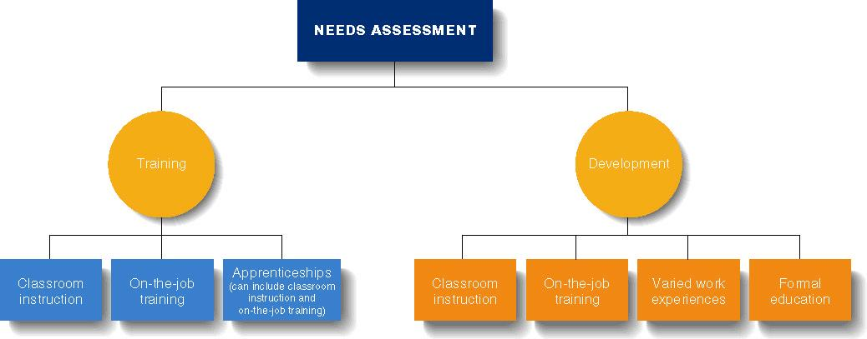

Types of training:
- Classroom Instruction: workers acquire skills in classroom
  - Includes use of videos, role-playing, simulations
- OJT: Learning occurs in the work setting as worker does the job
  - Training given by co-workers and can be done continuously
- E-training: online training helps employees keep up with skills and new products
  - Includes online text, live presentations, slide shows, taped lectures, and video on demand
Types of development
- Varied work experiences- Top managers must build expertise in many areas
  - Workers identified as possible top managers given many different tasks
- Formal education- tuition reimbursement is common for managers taking classes for MBA or similar
- Whatever training and development efforts used, results must be transferred to the workplace
Performance Appraisal & Feedback
- Performance appraisal- the evaluation of an employee’s job performance and contributions to the organization
- Performance feedback- process through which managers share performance appraisal information with their subordinates and develop a plan for the future
Steps in the performance appraisal process
- Establish performance standards
- Communicate the standards
- Evaluate performances
- Review results with employee
- Take corrective action
- Plan for the future

Evaluating performance
- Graphic Rating Scale: Performance is assessed along one or more continua with specified intervals
  - Rating quality
- The behaviorally anchored rating scales (BARS): Performance is assessed along a scale with clearly defined scale points containing examples of specific behaviors
  - Ex. Sometimes listens but rarely does well, always listens but occasionally do well, always listens and always does well, always listens and always does well and often does extra, always. Listen, do well, and do extra.
- The behavioral observation scale (BOS)- Performance is assessed in terms of the frequency with which specific behaviors are performed
  - Almost never- Almost always
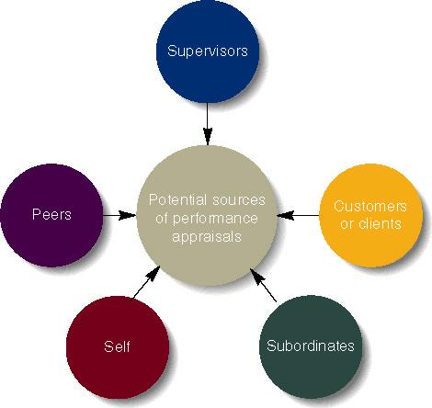

Effective feedback
- Be specific and focus on correctable behavior. Provide a suggested improvement
- Focus on problem-solving and improvement, not criticism
- Express confidence in worker’s ability to improve
- Use formal and informal feedback
- Treat subordinates with respect and praise achievements
- Set a timetable for agreed changes
Pay and Benefits
- Pay level: how the firm’s pay incentives compared to other firms in the industry
  - Managers can decide low or high relative wages
- Pay structure: cluster jobs into categories based on importance, skills, and other issues
- Benefits: offered to employees in addition to their pay and are considered part of the compensation package
  - Some are required by law (social security, workers comp)
  - Others are provided at the employers option (extended health insurance, dental insurance, pension plans, life insurance, flexible working hours, daycare, wellness programs)
Retaining Competent and high performance employees
- Types of compensation
  - Base wage or salary
  - Wage and salary add-ons
  - Incentive payments
  - Skill-based pay
    - A pay system that rewards employees for their job skill and competencies they can demonstrate
Motivation
- The processes that account for an individual’s willingness to exert high levels of effort to reach organizational goals, conditioned by the effort’s ability to satisfy some individual need
  - Effort: a measure of intensity or drive
  - Direction: toward organization goals
  - Need: personalized reason to exert effort
- Motivation works best when individual needs are compatible with organizational goals
- Motivation process:
  - Unsatisfied need
  - Tension
  - Effort
    - Intensity
    - Direction
    - Persistence
  - Satisfied need
  - Tension reduction
Early theories of motivation
- Maslow’s Hierarchy of Needs Theory
  - Needs were characterized as five levels:
    - Individuals must satisfy lower-order needs before they can satisfy higher order needs
    - Satisfied needs will no longer motivate
    - Motivating a person depends on knowing at what level that person is on the hierarchy
      - Low- order (external): physiological, safety
      - Higher-order (internal); social, esteem, self-actualization
- McGregor’s Theory X and Y
  - Theory X
    - Employees have little ambition, dislike work, avoid responsibility, and require close supervision
  - Theory Y
    - Employees can exercise self-direction, desire responsibility, and like to work
  - Motivation is maximized by participative decision making, interesting jobs, and good group relations
- Herzberg’s motivation- hygiene theory
  - Job satisfaction and job dissatisfaction are created by different factors
    - Hygiene factors: extrinsic (environmental) factors that create job dissatisfaction
    - Motivators: intrinsic (psychological) factors that create job satisfaction
  - Attempted to explain why job satisfaction does not result in increased performance
    - The opposite of satisfaction is not dissatisfaction, but rather no satisfaction
- McClelland’s Three-needs Theory
  - Three acquired (not innate) needs-achievement, power, and affiliation- are major motives in work
    - Need for achievement (nAch)- the drive to succeed and excel in relation to a set of standards
    - Need for power (nPow)- The need to make other behave in a way that they would not have behaved otherwise
    - Need for Affiliation (NAff)- the desire for friendly and close interpersonal relationship
Contemporary theories of motivation
- Goal setting theory
  - The proposition that specific goals increase performance and that difficult goals, when accepted, result in higher performance than do easy goals
    - Working toward a goal is a major source of job motivation
    - The specificity of the goal itself acts as an internal stimulus

  - Factors that influence the Goal-performance relationship:
    - Feedback
    - Goal commitment
    - Self-efficacy
    - National culture
- Reinforcement theory
  - The theory that behavior is a function of its consequences
    - Reinforcers- Consequences immediately following a behavior that increase the probability that the behavior will be repeated
- Job Design Theory
  - How tasks can be combined to form complete jobs
  - Factors influencing job design:
    - Changing organizational environment/structure
    - The organization’s technology
    - Employee’s skills, abilities, and preferences
  - Job enlargement
    - Increasing the scope (number of tasks) in a job
  - Job enrichment
    - Increasing responsibility and autonomy (depth) in a job
- Job Characteristics Model (JCM)
  - A framework for designing motivating jobs
    - Five primary job characteristics:
      - Skill variety: how many skills and talents are needed?
      - Task identity: does the job produce a complete work?
      - Task significance: how important is the job?
      - Autonomy: how much independence does the jobholder have?
      - Feedback: do workers know how well they are doing?
- Equity theory
  - Proposes that employees perceive what they get from a job situation (outcomes) in relation to what they put in (inputs) and then compare their inputs-outcomes ratio with the inputs-outcomes ratios of relevant others
    - If ratios are perceived as equal then a state of equity (fairness) exists
    - If ratios are perceived as unequal, inequity exists and the person feels under- or over- rewarded
    - When inequities occur, employees will attempt to do something to rebalance the ratios (seek justice)
  - Employee responses to perceived inequities:
    - Distort own or others’ ratios
    - Induce others to change their inputs or outcomes
    - Change own inputs (increase or decrease efforts) or outcomes (seek greater rewards)
    - Choose a different comparison (referent) other (person, systems, or self)
    - Quit their job
  - Distributive justice
    - Perceived fairness of the amount and allocation of rewards among individuals (who received what?)
  - Procedural justice
    - Perceived fairness of the process used to determine the distribution of rewards (how who received what)
- Expectancy theory
  - Individuals act based on the expectation that a given outcome will follow and whether that outcome is attractive
  - Key to the expectancy theory is understanding and managing employee goals and the linkages among and between effort, performance, and rewards
    - Effort: employee abilities and training/development
    - Performance: valid appraisal system
    - Rewards (goals): understanding employee needs
- Expectancy relationships
  - Expectancy (effort-performance linkage)
    - The perceived probability that an individual’s effort will result in a certain level of performance
  - Instrumentality
    - Perception that a particular level of performance will result in attaining a desired outcome (reward)
  - Valence
    - The attractiveness/importance of the performance reward (outcome) to the individual

Lecture 7
Communication and teamwork
- Communication
  - Ability to share ideas and feelings
  - Two-way process by which information is exchange between individuals, including behavior, verbal or nonverbal that is perceived by another
  - Two-way process in which the communicators try to achieve a shared meaning
Characteristics of communication
- No direct mind-to-mind contact, so we must share feelings and experiences through a physical process
- Only inference is possible, so we never know for sure
- Communication is a dynamic process- no obvious beginning and end, and a means through which we bring definition to the world around us
- Communication is interactive, a reciprocal process
- Inevitable (unavoidable)
- Communication permits the transmission of knowledge between persons, and also between generations
- Symbolic, expressing things, processes, ideas
- Does not mean understanding
- Has consequences
- Self-reflective, rooted in our ability to think about ourselves and to reflect on our past, present and future
- The brain is an open system- we can learn and we never stop learning
- Contextual- time, place, and prescriptive regarding the type of behavior preferred or prohibited
Importance of communication to management
- Management is getting things done through other people
- Everything a manager does involves communication (managers spend 75% of their time communicating)
- For the manager, communication facilitates control, motivation, the expression of emotions, and the transfer of information/meaning
The communication process:
- Consists of 2 phases
  - 1. Transmission phase: information is shared by 2 or more people
  - 2. Feedback phase: a common understanding is assured
- Starts with the sender who wants to send the information
  - Sender must decide on a message to send
  - Sender also puts the message into symbols or language, a process called encoding (constructing the message)
    - Noise: anything harming the communication process
- Messages are transferred over a medium to a receiver
  - Medium: pathway the message is transmitted on (phone, letter)
  - Receiver: person getting the message
- Receiver next decodes the message
  - Decoding allows the receiver to understand the message (interpreting the message)
  - A critical part, can lead to misunderstanding
- Feedback is started by receiver and states the message is understood or that it must be re-sent
Communication issues
- Encoding of messages could be done verbally or non-verbally
  - Verbal: spoken or written communication
  - Non-verbal: facial gestures, body language, dress.
- Sender and receiver communicate based on their perception
  - Subjective perception can lead to biases and stereotypes that hurt communication
  - Effective managers avoid communicating based on a pre-set belief
Nonverbal communications
- In a normal two-way communication, verbal components carry less than 35% of the social meaning of the situation
- We believe that non-verbal messages over verbal messages when the 2 contradict each other
- Nonverbal communication is often the foundation of our first impressions
- Communication in any form other than words that can produced shared meaning and elicit a response
- Embraces the intentionality and ‘unintentionality’ of messages during the encoding and decoding stages
Verbal Vs. Nonverbal
- Verbal
  - Based on culturally agreed upon set of symbols
  - Usually deliberate
  - Learned later in life
  - Come in an orderly sequential way
  - Has a definite ending point
- Nonverbal
  - Based on culturally agreed upon set of symbols
  - Often governed biologically/ involuntarily
  - Learned earlier in life
  - Do not come in an orderly sequential way, but simultaneously from a multiple of channels
  - Continuous process, never ending

Nonverbal communication characteristics and functions
- Characteristics
  - Without talking and any form of formal training it is possible to get an idea about how others are feeing
  - All behavior has communicative value
  - Nonverbal messages are primarily attitudinal
  - Ambiguous- over 700,000 different physical gestures, facial expressions, and movements
- Functions
  - Repeating
  - Substituting
  - Complementing
  - Regulating
  - Contradicting
  - Deception and leakage
Categories of nonverbal communication
- Time
- Space
- Silences
- Facial expressions
- Posture
- Gesture
- Eye contact
- Touch
- Dress
- Paralanguage
  - Voice quality
  - Volume
  - Pitch variation
  - Tempo
- Chronemics
  - The use of time in the midst of communication
- Proxemics
  - The use of space
- Material possessions (artifacts)
  - Style of dress
  - What ‘stuff’ do you have
    - Clothes
    - Jewelry
    - Trinkets
- Chromatics
  - Communication through colors- send intended or unintended messages in some cultures
  - Red- happiness or good luck
  - Green?
  - Gift of yellow roses in Chile= I don’t like you
- Smell
  - Cologne- a sign of respect or disrespect?
- Oculesics
  - The role of eyes
  - Can convey trust or aggression
- Haptics
  - Touch- conveys intimacy of the relationship (Brazil Vs. North America differs in respect)
- Kinesics
  - Body language
  - Fidgeting, gestures, facial expressions, posture
    - Crossing arms
    - Crossing feet
    - Opening jacket
    - Slouching
    - Leaning
    - How you greet
    - How you eat
Dangers of ineffective communication
- Managers spend most of their time communicating so both they and the subordinates must be effective communicators
  - To be effective:
    - Select an appropriate medium for each message
      - There is no ‘best’ medium
    - Consider information richness: the amount of information a medium can carry and the extent to which the medium enables the sender and the receiver to reach a common understanding
      - Medium with high richness can carry much information to aid understanding
Directions of communications within organizations
- Downward communication
  - Goals, objectives, directions, decisions, and feedback
- Upward communication
  - Information, suggestions, questions, problems
- Lateral communication
  - Information exchange- formal and informal- that assist or affect coordination
Informal communication channels- aka the grapevine
- Tend to operate more often in the lateral than in the vertical direction
- Information flows extremely fast
- Carry work-related as well as non-work related information
Barriers to effective communication
- Interpersonal barriers
  - Selective perception
  - Frames of reference
  - Individual differences
  - Emotions
  - Language
  - Nonverbal cues
- Organizational barriers
  - The hierarchical structure
  - Differences between level of authority
- Cultural Barriers
  - Culture cannot exist without communication and human communication occurs within a cultural context
    - Ethnocentrism
    - Stereotyping
    - Cultural distance
Groups Vs. Teams
- Groups:
  - Two or more people with a common relationship
- Teams:
  - Small number of people with complementary skills who are committed to a common purpose, performance goals, and approach for which they hold themselves mutually accountable
Groups teams
- Teams
  - Shared leadership
  - Shared accountability
  - Development of purpose/mission
  - Continuous problem solving
  - Effectiveness is measured in terms of the team’s outcomes and goals
Types of teams
- Problem- solving
  - 5-12 employees from the same department who meet for a few hours each week to discuss ways of improving quality, efficiency, the work environment
- Self-managed
  - 10-15 employees performing highly related or independent jobs, taking on many of the responsibilities of their former manager
- Cross functional
  - Employees from about the same hierarchical level, but from different work areas, who come together to accomplish a task
- Virtual
  - Use computer technology to tie together physically dispersed members in order to achieve a common goal
  - 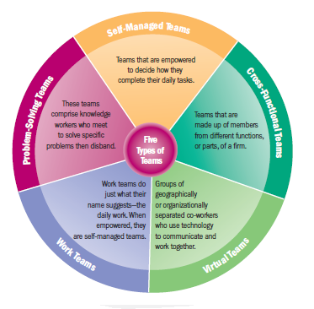
Stages of group and team development
- Five stage model
  - Forming
    - Considerable uncertainty about team’s structure, purpose, and leadership
  - Storming
    - Intragroup conflict; resistance to the constraints imposed on individuality; who will control the team?
  - Norming
    - Close relationships develop; team cohesiveness; strong sense of team identify and camerderie
  - Performing
    - The team is now fully functional and accepted
  - Adjourning
    - Group disbands
- Punctuated equilibrium model
  - Phase 1- first meeting sets the team’s direction followed by a period of intertia (stands still or follows a particular direction)
  - Phase 2- recognition that work needs to be done followed by a burst of changes to old patterns, setting a new direction, ending with a final burst of activity to finish its work
Five-stage model VS. PEM
- Forming + storming + low performing = PEM Phase 1
- Storming + high performing +adjournment= PEM Phase 2

Respect in generations
- Generation 9/11
  - 1991- now
    - Be supportive and positive when communicating with them
    - Speak to them as adults, not children
    - Try to understand and be sensitive to how technology fits into their work and social lives
- Millennials
  - 1987-1990
    - Communicate job instructions clearly and be specific
    - Give them challenges whenever the opportunity presents itself
    - Try to accommodate differing schedules by being as flexible as possible
- Generation X
  - 1965-1976
    - When assigning tasks, give them clear and precise instructions and deadlines
    - Listen closely to their ideas
    - Understand that if they seem impersonal at times, they may be trying to be more efficient
- Baby boomers
  - 1946-1964
    - Remember their strong work ethic, and try to a reasonable and compromising approach to them
    - Let them know they are needed and valuable when appropriate
    - Treat them with respect and clearly explain your point of view
- Traditionals
  - 1930-1945
    - Respect their values and beliefs which may be more conservative than yours
    - Try to find the positive qualities of their generation
    - Teach instead of being dismissive, explain instead of being impatient and respect their significant experience

Lecture 8

Marketing: a group of activities designed to expedite transactions by creating, disturbing, pricing, and promoting goods, services, and ideas

Marketing creates utility- the ability of a product to satisfy human wants and needs
- Place utility
  - Making the product available where the buyer wishes to buy it
- Time utility
  - Making the product available when the buyer wishes to buy it
- Ownership utility
  - Created by transferring ownership of the product to the buyer
- Form utility
  - Created through the production process: transforming raw materials or inputs into a form the buyer wants
Developing a market strategy
- Market strategy
  - A plan of action for developing, pricing, distributing, and promoting products that meet the specific needs of customers
- Two key ingredients
  - Target market
  - Marketing mix
Target market and market segmentation
- A market- a group of people who have a need, purchasing power, and the desire and authority to spend money on goods, services, and ideas
  - Ex. Purchasers of automobiles
- A target market- more specific group of consumers on whose needs and wants a company focuses its marketing efforts
  - Purchasers of Ford F150 pick-up trucks Vs. purchasers of the Lotus Elite
- Target market requires market segmentation
- Total market approach- firms try to appeal to everyone and assume all buyers have similar wants and needs
  - Sugar, flour, salt, heating oil
- Market segmentation- dividing the total market into groups of people who have relatively similar needs and wants
  - Concentration approach to market segmentation- developing one marketing strategy for a single market segment
    - Jaguar, lotus, Patek Philippe, Rolex, Omega, Gucci
  - Multi-segment approach- aiming marketing efforts at one or more segment in a similar product market and developing a marketing strategy for each
    - Bicycles: racers, commuters, children
Market segmentation
- Demographic
  - Age, sex, race, ethnicity, income, education, occupation, family size, religion, social class
- Geographic
  - Climate, terrain, natural resources, population density
- Psychographic
  - Personality characteristics, motives, lifestyles
- Behavioristic
  - Consumer’s behavior towards the product

Marketing mix
- Four marketing activities
  - Product
  - Price
  - Promotion
  - Distribution
- Target market is the central focus
Product
- A good, service, idea, or some combination thereof that represents a complex mix of tangible and intangible attributes that provide satisfaction and benefits
- Can be consumer products or industrial products

Developing new products:
- Idea development
- Screening new ideas
- Concept testing
- Business analysis
- Prototype development
- Product testing and test marketing
- Commercialization

Classifications of consumer products
- Convenience products
  - Bought frequently
  - For immediate consumption without lengthy search
- Shopping products
  - Purchased after buyer has compared competitive products
- Specialty products
  - Products that the buyer searches for and makes a special effort to obtain
The life cycle of product
- Introduction
- Growth
- Maturity
- Decline

Product identification
- Branding- process of naming and identifying products (The use of symbols to communicate the quality of a particular product)
  - Brand- a name, term, symbol, or design that identifies a product and distinguishes from other products
  - Brand name- the part of the brand that is a distinctive design: the Mercedes star, the jaguar leaper, golden arches at McDonald’s
  - Trademark- a legally registered brand
  - Manufacturer’s brand- initiated and owned by the manufacturer from the point of production to the point of purchase (Kellog’s, Sony, Life Brand)
  - Private distributor brand- owned and controlled by a wholesaler or retailer (Kenmore, president’s choice, life brand
Types of brands
- National Brands
  - Proctor and gamble’s ivory shampoo
  - Produced and distributed by manufacturer
- Licensed brands
  - Olympic logo, Harley Davidson’s logo
  - Right to place their name on licensed brands
- Private brands
  - Sears’ Craftsman tools, Kenmore appliances
  - Wholesalers

Price
- The value placed on an object exchanged between a buyer and a seller
- Pricing objectives
  - Goals that producers hope to attain in pricing products for sale
    - Profit maximizing
    - Market share
- Cost-oriented pricing
  - Taking costs into account as “mark-up”
    - Markup/sale price= markup %
- Breakeven analysis
Breakeven
- The point where revenue from sales covers all costs
  - Variable cost
    - Change according to the level of production
      - Material input, direct labour
  - Fixed cost
    - All expenses that remain the same no matter how many products are made or sold
      - Factory rent, business insurance
- BE= TFC/ Price of 1 unit - Variable cost of one unit

Pricing strategies
- New-product strategies
  - Price skimming
    - Charging the highest possible price that buyers who want the product will pay
  - Penetration pricing
    - A low price designed to help a product enter the market and gain market share rapidly
- Psychological pricing strategies
  - Odd/even
    - $9.99 Vs. $10.00
  - Prestige pricing
    - High prices connote (=) high quality
- Price discounting
  - Quantity discounts
  - Seasonal discounts
  - Promotional discounts
Distribution
- Making products available to customers in the quantity desired
- Physical distribution activities
  - Producers
    - Inventory planning and control
      - Transportation
        - Warehousing
          - Materials handling
            - Customers
- Two key intermediaries
  - Wholesalers- buy from producers or other wholesalers and sell to retailers (usually do not sell in significant quantities directly to consumers
  - Retailers- buy products from wholesalers and sell them to consumers for home and household use, rather than for resale
Marketing channels for consumer products
- Producer Consumers
- Producer retailers (middlemen) consumers
- Producer wholesalers (middlemen) retailers (middlemen) consumers
- Producer agents (middlemen) wholesalers (middlemen) retailers (middlemen) consumers
Intensity of market coverage
- Intensive distribution
  - Makes a product available in as many outlets as possible (Caramilk chocolate bars)
- Selective distribution
  - Uses only a small portion of all available outlets to expose products (Black and decker)
- Exclusive distribution- exists when a manufacturer gives a middleman the sole right to sell a product in a defined geographic territory (Jaguar, Rolls Royce)
The promotion mix
- Publicity
  - Non-personal communication transmitted through the mass media but not paid for directly from the firm
  - Principle publicity mechanisms
    - News release
    - Feature articles
    - Captioned photographs
    - Press conferences
    - Interviews
- Sales promotion
  - Direct inducements offering added value or some other incentives for buyers to enter into an exchange
  - Intended to:
    - Stimulate demand
    - Stabilize sales
    - Inform, remind, and reinforce customers
  - Major tools
    - Point-of-purchase displays
    - Premiums
    - Sampling and demonstrations
    - Coupons
    - Consumer contests and sweepstakes
    - Refunds
    - Trade shows
- Personal selling
  - Direct, two-way with buyers and potential buyers
  - Most flexible of the promotion methods
- Advertising
  - Paid form of non-personal communication transmitted through a mass medium
  - All advertising possess 4 basic features
    - Verbal and/or visual message
    - Sponsor who is identified
    - Delivery through at least one medium
    - Payment by the sponsor to the media carrying the message
  - Print media
    - Newspapers
    - Magazines
    - Direct mail
    - Outdoor advertising
  - Electronic media
    - Television
    - Radio
    - Internet marketing
Promotion
- Persuasive form of communication that attempts to expedite a marketing exchange by influencing individuals, groups, and organizations to accept goods, services, and ideas
- Objective is to communicate directly or indirectly with individuals or groups or organizations to facilitate exchanges

Push and pull strategy
- Pushing: producer wholesaler retailers consumers
- Pulling: Producer consumer retailers wholesaler producer
The marketing process
- A multistep process
- Conduct research
- Identify a target market
- Design a product to meet the need based on research, then conduct product testing
- Determine a brand name and design a package
- Set a price
- Select a distribution system
- Design a promotional program

Lecture 9
Production and operations management
- Production
  - Use of resources, such as workers and machinery, to convert material into finished goods and services
- Production and operations management
  - The process overseeing the production process by managing the people and machinery that convert materials and resources into finished goods and services
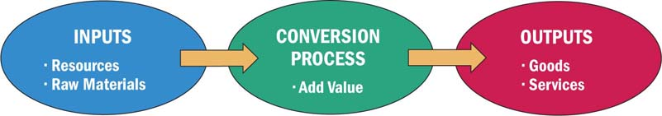

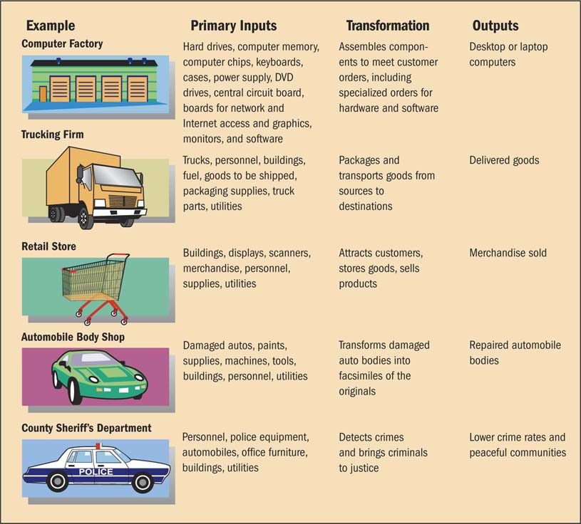
The strategic importance of production
- Production is a vital function necessary for generating money to play employees, lenders and stockholders
- Effective productions and operations management can:
  - Lower a firm’s cost of production
  - Boost the quality of the goods and services
  - Allow it to respond dependably on customer demands
  - Enable it to renew itself by providing new products
Mass, flexible, and customer driven production
- Mass production
  - A system for manufacturing products in large quantity by using effective combinations of employees with specialized skills, mechanization, and standardization
- Flexible production
  - More cost-efficient for producing smaller runs
  - Uses information technology, programmable equipment, and skilled people
- Customer-driven production
  - Assesses customer demands in order to make the connection between products manufactured and products bought
Production Processes
- Analytic production system
  - Reduces a raw material to its component parts in order to extract one or more marketable products
- Synthetic production system
  - The reverse of an analytic system; combines a number of raw materials or parts or transforms raw materials to produce final products
- Continuous production process
  - Generates finished products over a long period of time
- Intermittent production process
  - Generates products in short production runs, shutting down machines frequently or changing their configurations to produce different products
Technology and the production process
- A robot is a reprogrammable machine capable of performing a variety of tasks that require the repeated manipulation of materials and tools
- Computer-Aided Design (CAD) Process used by engineers to design parts and entire products on the computer
  - Engineers who use CAD can work faster and with fewer mistakes than those who use traditional drafting systems
- Computer-Aided Manufacturing (CAM)
  - A computer tool that a manufacturer uses to analyze CAD output and the steps that a machine must take to produce a needed product or part
- Flexible Manufacturing System (FMS)
  - A production facility that workers can quickly change to manufacture different products
- Computer-Integrated Manufacturing (CIM)
  - An integrated production system to uses computers to help workers design products, control machines, handle materials, and control the production function

Location decision
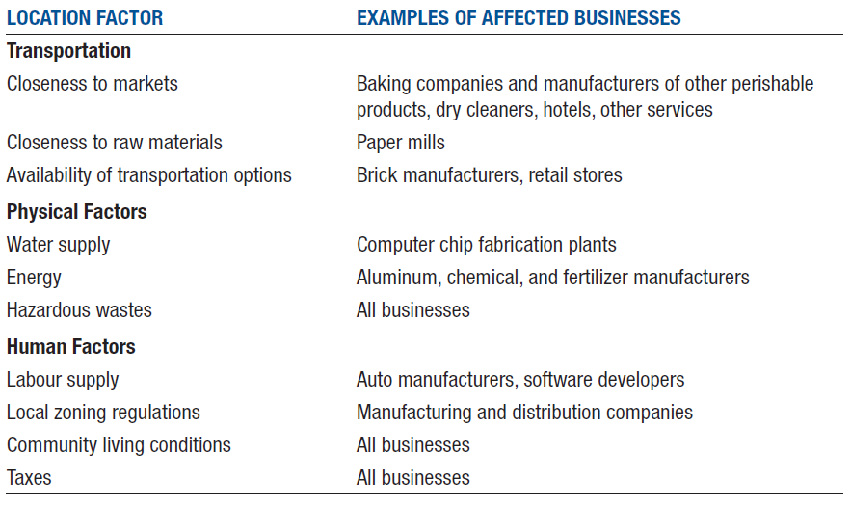

Job of production managers
- Supervise the work of people and machinery to convert outputs (materials and resources) into finished goods and services
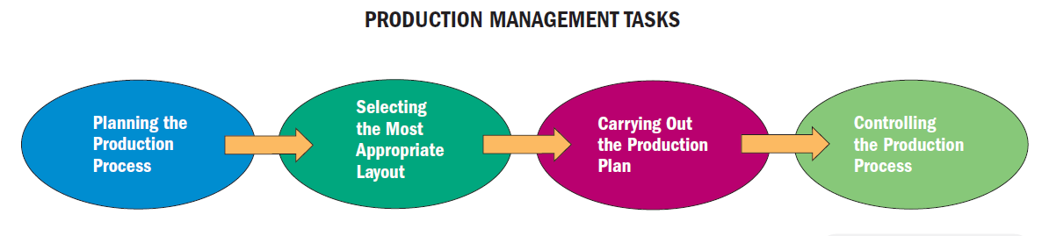

Planning the production process
- Choose what goods or services to offer to customers
- Convert original product ideas into final specifications
- Design the most efficient facilities to produce those products
- In a traditional manufacturing organization, each production manager has a specific area of authority and responsibility
- Organization are moving toward team-oriented structures, where team members are assigned to specific projects, with all members reporting to the production manager

Selecting the facility layout
- Process layout groups machinery and equipment according to their functions
- Facilities production of a variety of nonstandard items in relatively small batches
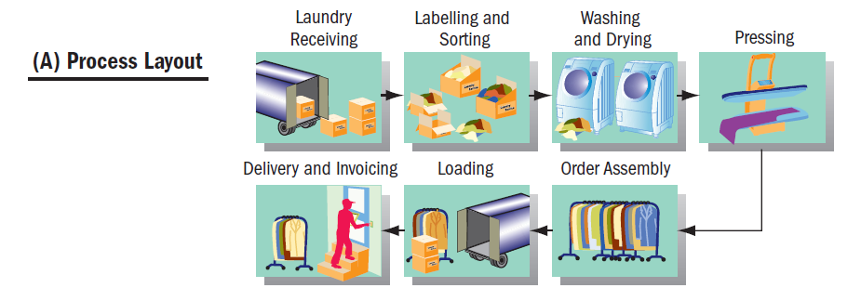

- Process layout lets up production equipment along a product-flow line and the work in this line moves along this line past workstations
- Efficiently produces large numbers of similar items

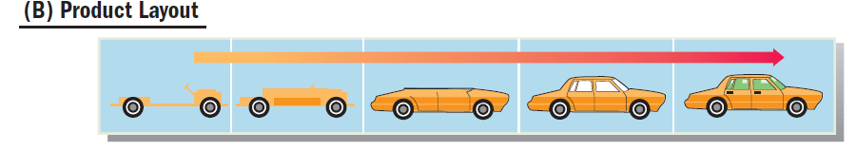

- A fixed-position layout places the product in one spot, and workers, materials, and equipment come to it
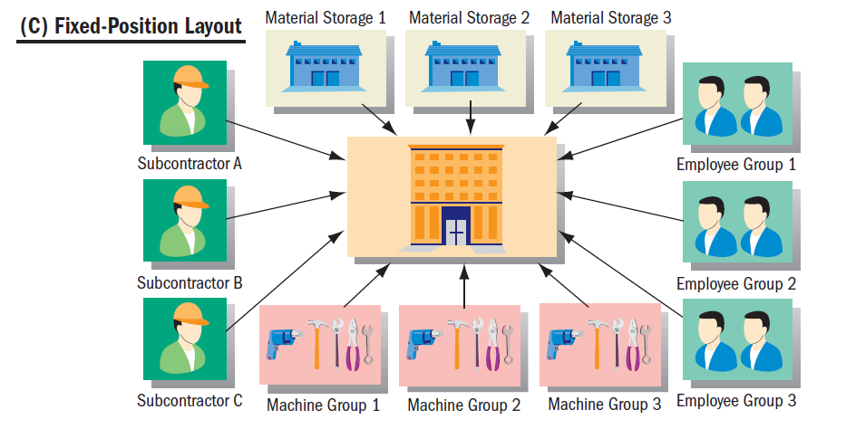
- Customer-Orientated layout arranges facilities to enhance interactions between customers and its service
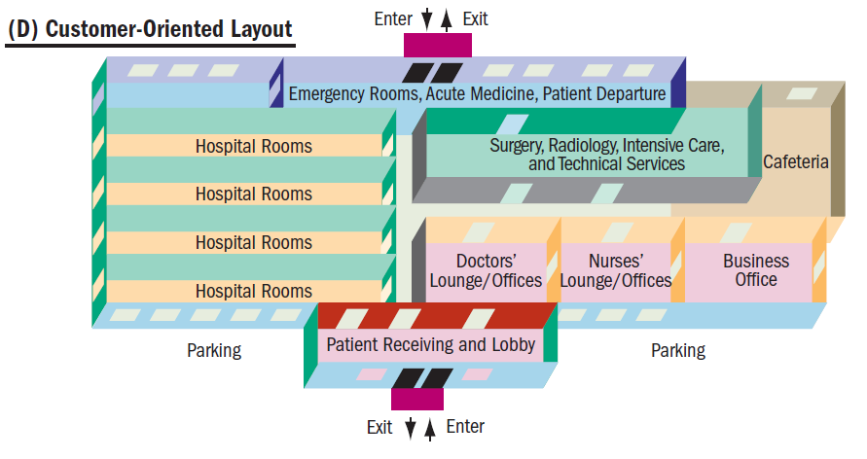
Carrying out the production plan
- Make, buy, or lease decision
  - Choosing whether to manufacture part in-house, buy it from an outside supplier, or lease it
    - Factors in the decision includes cost, availability of reliable outside suppliers, duration of the firm’s supply needs, and the need for confidentiality
  - Selection of suppliers
    - Based on comparison of quality, prices, dependability of delivery, and services offered by competing companies
Inventory Control
- Inventory control: A function that balances the costs of carrying inventory with the need to have stock on hand to meet demand
  - Perpetual inventory
  - Vendor-managed inventory
- Just-in-time (JIT) system
  - A broad management philosophy that reaches beyond the narrow activity of inventory control to influence the entire system of production and operations management
- Materials requirement planning (MRP)
  - A computer-based production planning system that ensures a firm has all the parts and material it needs to produce its output at the right time and place and in the right amounts
Controlling the production process
- Production control
  - Creating well-defined procedures for coordinating people, materials, and machinery to provide the greatest production efficiency
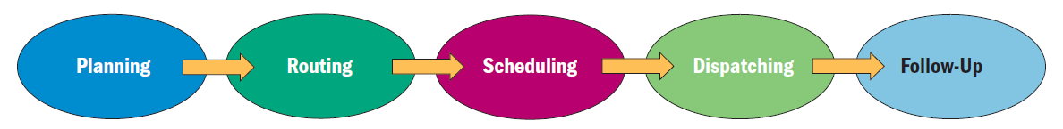

Importance of quality
- Quality: The state of being free of deficiencies or imperfection
  - Poor quality can account in a 20% loss in revenue
- Benchmarking
  - Process of looking at how well other companies perform business functions or tasks and using their performance as a standard for measuring another company’s performance
- Quality Control
  - Measuring output against quality standards
    - Many companies evaluate quality using the Six Sigma Concept
ISO Standards
- International Organization for Standardization (ISO)
  - An international organization whose mission is to develop and promote international standards for business, government, and society
    - Aim is to improve and encourage global trade and cooperation
  - Started in 1947
  - Representatives from 163 nations
  - ISO 9000 is a series of standards that sets requirements for quality processes
    - ISO 14000 series set standards for operations that minimize harm for the environment

Lecture 10
Accounting and financial statements
- Accounting
  - The recording, measurement, and interpretation of financial information
  - Not bookkeeping
Accounting Vs. Bookkeeping
- Accounting
  - Recording, classifying, summarizing, and interpreting of financial transactions to provide management and other interested parties with the information
    - Managerial accounting- focused on internal operations
    - Financial accounting- focuses on preparing financial statements for persons inside and outside the company
- Bookkeeping
  - Recording transactions (in journals, ledgers)
Generally accepted accounting principles
- Agreed upon practices
- Revenue recognition
  - Revenues are recorded for the accounting period in which sales are completed and collectible (or collected)
  - The earnings cycle must be completed and this occurs when:
    - The sale is complete and the product has been delivered
    - The sale price to the customer has been collected or is collectible (accounts receivable)
- Matching
  - Expenses will be matched with revenues to determine net income for an accounting period
- Full disclosure
  - Financial statements should include not just numbers, but also interpretations and explanations by management so that external users can better understand information contained in the statements
The accounts of accounting
- Assets: things of value owned by the firm
  - Cash
  - Accounts receivable (money owned by customers)
  - Inventory
  - Investments
  - Buildings
  - Vehicles
  - Equipment
  - Patents & copyrights (intangible assets)
- Liabilities: debts owed by the firm to others
  - Accounts payable (money owed to the others for merchandise purchased on credit but not yet paid
  - Interest payable (on debt instruments or loans)
  - Bonds payable (long-term loans to the business)
  - Notes payable (short-term loans from the bank)
  - Taxes payable
  - Salaries payable
- Owners’ equity (or Shareholders’ equity): the amount owners (or shareholders) invest in the business plus accumulated profits less dividends or other withdrawals of profits
  - Cumulative amount of all the owners have invested in the company plus all profits (and losses) that have accumulated since the business commenced
  - Always equal the book value of the assets- liability
  - In a partnership, it’s called partners’ equity or capital
  - In a sole proprietor ship, it’s called owners’ equity or capital
  - In a corporation, it’s called shareholders’ equity
    - Common stock
    - Retained earnings (accumulated profit remaining)
  - Not Cash
- Revenue accounts: where income from all sources are recorded
  - Sales, rentals, commission, royalties, and other sources
- Cost of goods sold accounts
  - Used when a company sells products (not services)
  - Shows all the costs of selling the products that were recorded in the sales (revenues) account
    - Transportation costs
    - Storage
    - Packaging and purchases of goods for resale
    - Cost of manufacturing the goods sold (if a manufacturer)
- Expense accounts: where expenses of running a business are recorded
  - Rent
  - Insurance
  - Salaries and wages
  - Utilities
  - Advertising
The fundamental accounting equation
Assets (Things of value that a firm owns)= Liabilities (A firm’s debts and obligations) + Owners’ equity (the difference between a firm’s assets and it’s liabilities)

Double entry bookkeeping: the strange language of accountants and bookkeepers
- Developed in medieval Italy
- Recognizes that every financial transaction has 2 sides: the money must come from somewhere and go to somewhere
- Respects the balancing of the fundamental accounting equation
- Uses debits and credits
  - Two types of entry used to record a transaction and they are opposites: one will increase and the other will decrease an account balance
  - 2 basic types of accounts:
    - Typically having a debit balance (those the company owns or receives. Ex. Assets)
    - Typically having a credit balance (those the company owes or pays. Ex. Liabilities, equity)
  - Debit entry will increase an account with a debit balance, but decrease an account with a credit balance
  - Credit entry will increase an account with a credit balance, but decreases an account with a debit balance
    - Debits
      - Increases debit balance or decreases credit balance
      - Increase an asset account
        - Purchase equipment
      - Decrease a liability account
        - Paid for the equipment
      - Decrease an equity account
        - Distributed dividends
      - Decrease a revenue account
        - Recorded sales returns
      - Increase an expense account
        - Paid the utility bill
    - Credits
      - Increases credit balance or decreases debit balance
        - Increases liability account
          - Purchase equipment on credit
        - Decrease an asset account
          - Paid for the equipment in cash
        - Increase an equity account
          - Sold shares of stock or invested money in the company
        - Increase a revenue account
          - Recorded sales
        - Decrease an expense account
          - Overpaid the utility bill
- A T-account
  - Ledger
    - Collection of T-Accounts
  - Journal
    - A repository of (more or less) every financial transaction undertaken by the business
  - Posting
    - Transferring the journal entries to the T-accounts in the general ledger
- The accounting cycle
  - 1. Examining source documents
  - 2. Recording transactions (in the journal)
  - 3. Posting transactions (in the ledger)
  - 4. Preparing financial statements
The financial statements
- Two best-known examples of financial statements are:
  - The income statement
    - Displays revenues, expenses, and profit (or loss) resulting from operations
    - Relates to activities over a period of time
      - “Statement of income for the period ended… “
  - The balance sheet
    - Display assets, liabilities, and owners’ equity depicting the financial position
    - A “snap shot” of financial position at a given moment
      - “Balance sheet as of December 31st, 20XX”

The income statement- intricacies
- Income statement formulae:
  - Beginning inventory + purchases – Ending inventory = cost of good sold
  - Revenue – Cost of good sold= Gross margin (gross profit)
  - Gross margin – Operating costs = Net income (profit) before taxes
  - Net income before taxes - Income taxes = Net income (profit)
- Net income gets added to the accumulated profits from previous years
  - Recorded in the balance sheet account called “retained earnings” for a corporation or “capital” for a sole proprietorship
The balance sheets- intricacies
- Balance sheet formula- the fundamental accounting equation
  - Assets = Liabilities + owners’ equity
- Layout:
  - Current assets
  - Fixed assets
  - Other assets
  - Current liabilities
  - Long-term liabilities
  - Shareholders’ equity
- Working capital= current assets- current liabilities
- If a firm has no debts, then assets=owners’ equity (the owners own everything)
- If a firm has debts, then assets – liabilities= owners’ equity (owners own everything except the amount due others)
  - Assets= liabilities + owners’ equity
Balance sheets intricacies- depreciation
- Assets do not last forever, but some are expected to last longer than others
- Assets that are consumed within one accounting cycle are conventionally expensed:
  - Office supplies
  - Rent
- Assets expected to last longer than one accounting cycle are depreciated- the cost of the asset is amortized (or spread or allocated) over its useful life and recorded systematically as “depreciation expense”
  - Not cash
  - Many methods of calculating depreciation expense
    - Straight-line
    - Units of production
    - Declining balance
  - As depreciation is expensed each year, it is accumulated in a “contra-asset account” (accumulated depreciation) and the net book value of the asset is expressed “net of accumulated depreciation”

Financial statements- comparative
- Both income statement and the balance sheet can display account figures for 2 years.
  - These statements are called comparative balance sheets and income statements

Working capital is defined as the difference between current assets and current liabilities

Financial ratio analysis
- Facilitates the analysis if financial statements
- Ratios are not useful in and of themselves
- To be useful and informative, ratios must be compared against something
  - Standard ratios for the industry that the firm is in
  - Ratios of a competitive firm (competitor)
  - Year-over- year ratios of the same company
- Ratios can also be useful in forecasting cash requirements or in preparing a budget
Ratio analysis – Types of financial Ratios
- Profitability ratios
  - Measure how much operating income or net income a company is able to generate relative to its assets, owners’ equity, and sales
    - Profit margin= Net earnings (net income)/ gross operating revenue (gross sales)
    - Return on assets= net earnings (net income)/ total assets
    - Return on equity = net earnings (net income)/ total shareholders’ equity
- Asset utilization ratios
  - Measure how well a firm uses its assets to generate each $1 of sales
    - Receivables turnover= gross sales/ accounts receivable
    - Inventory turnover= gross sales/ ending inventory
- Liquidity ratios
  - Measure the speed with which a company can turn its assets into cash to meet debt obligations as they fall due
    - Current ratio= current assets/ current liabilities
    - Quick ratio= current assets- inventory (ending)/ current liabilities
  - Long term solvency
    - Debt-to-owners’ equity = total debt/ total owners’ equity (net assets)
  - Liquid and risk
    - Bankruptcy occurs when a company is unable to pay its debts when they fall due
    - The lower the degree of liquidity, the greater the risk
    - Solvency concerns the financial risk that is evident in the company
- Debt utilization ratios
  - Measures how much debt a company is using relative to other sources of capital (investing more money in equity, selling shares)
    - Leverage
      - Debt to total assets= total debt/ total assets
      - Times interest earned= income before incomes and taxes (net profit from operations)/ interest expense
- Per share data
  - Measures how much earnings or dividends are being earned for every share held
    - Earnings per share= net income (net profit)/ number of shares outstanding
    - Dividends per share= total dividends paid/ number of shares outstanding
Exchange rates
- What buyers are willing to pay for a given currency is referred to as the foreign currency exchange rate
- Many factor influences a nation’s currency including the money supply, interest rates, and economic conditions
- If $1.00 Canadian can buy only $0.85 USD then the exchange rate for the Canadian dollar would be $0.85 USD
- If $1 Canadian can buy $1.15 USD then the exchange rate for the Canadian dollar would be $1.15 USD
- Weak currencies are those for which their value changes frequently
- The generally most affected accounting principle most affected by fluctuations in foreign currency will be the full disclosure principle
- When purchasing an asset using foreign currency, one adjustment is made to reflect the cost of the asset in Canadian dollars and this becomes the asset’s historical cost
Breakeven analysis
- Occurs when total revenue= total cost
- Involves a manufacturing concern, but the principles can be applied to all businesses
- Two main types of costs:
  - Fixed cost
    - Remain the same regardless of how many items you sell
      - Rent, insurance, property tax, interest expense
  - Variable costs
    - Vary depending on the number of units of profit sold
      - Direct labour, direct materials
- At breakeven:
  - TR=TC
  - Price x # of units sold= TFC+ (VC x # of units sold)
  - P x X - V x X= TFC
  - (P-V) x X= TFC
  - X= TFC/ (P-V)
    - X= # of units sold to break even
    - P= selling price
    - V= variable cost
    - TFC= total fixed cost

Lecture 11
Managing Cross-culturally
How to approach C/C Management
- Parochial managers: (Ignorance)
  - Management practices and the world is viewed from the point of view of their OWN cultural perspective only.
    - My way is the ONLY way!
- Ethnocentric managers: (Sense of Superiority)
  - Acknowledge cultural differences, but believe that their own culture, value system, and ways of doing things is the best. Diversity is resisted.
    - There are certainly other cultures, but mine is superior!
- Geocentric Managers: (Diversity offers value)
  - Best fit or contingency approach will be adopted by managers
    - There are other cultures and in order to build a sustainable competitive advantage, I need to be willing to learn, flexible, and be culturally sensitive
What is culture?
- The collection of:
  - Learned & shared values, enduring beliefs and attitudes
  - Which are seen as relatively permanent perceptual framework
    - Influences individuals’ behavior/customs within a society
    - And the set of symbols that distinguish a society’s orientation as per above
- Universal (Etic)
  - Ethnology – common biological basis for human behavior
    - VS
- Culturally Specific (Emic) Behaviors
  - Cultural anthropology- study of human relations in specific contextual contexts
What are the different Models for understanding national culture
- Historical social models
  - The Euromanagement study
  - South East Asian Management
- Single Dimension Models
  - Context: High and low context cultures (Hall)
  - Time: Monochronic and Polychronic cultures (Lewis)
  - Trust: Fukuyama’s Analysis of trust
- Multiple Dimension Models
  - Hofstede
  - Kuckhohn & Strodtbeck
  - Hampden-Turner & Trompenaars (7 Dimensions)
Historical Social models
- The Euromanagement study
  - Common characteristics between European Managers:
    - Capacity to manage diversity
    - Orientation toward people
    - Social responsibility
    - Degree of informality
- South East Asian Management
  - These Models of culture explore:
    - Confucianism (moral and religious systems)
    - Role of mandarins (means to command)
    - The Taipans (supreme ruler of big boss)
    - The role of religion (taken seriously)
Single Dimension Models of National Culture
- Context= directness
- High and Low Context Cultures (Hall)
  - How individuals in a society seek information/knowledge
    - High context cultures: Information and knowledge obtained from contextual aspects of personal information networks (e.g., apparent social status, nonverbal)
      - Ex: Asians, Latin Americans
      - Usually rely on less verbal communication and more on non-verbal communication
      - More aware of their surroundings
      - Indirect and allusive messages are seen as effective communication
      - Face-saving and harmony are values held in highest esteem
    - Low Context cultures: information and knowledge obtained from a research base (which often means primary research, like directly inquiry to a respondent)
      - Ex: Germans, Swiss, North Americans
      - More oblivious (unaware) to surroundings and environment
      - Believe that everything worth being communicated has to be verbally stated and stated well
      - Confront conflict openly and explicitly
      - Avoid vagueness and ambiguity and get to the point
      - Crisp, precise, and direct messages are hallmarks of effective communication
  - Monochronic and Polychronic Cultures (Lewis)
    - Monochronic Cultures
      - Focused, concentrate on one thing at a time within a set timescale
      - Time recognized as a scarce resource with an opportunity cost
        - Ex: Germans, Finnish, and some North Americans
    - Polychronic Cultures
      - Multitask, and often in an unplanned and opportunistic sequence
      - Time schedules and punctuality not particularly important
      - Planning, schedules, and appointments perceived as artificial constructs
        - Ex: Polynesians, Latin Americas, Arabs
  - Fukuyama’s Analysis of Trust
    - An analysis of the relationship between trust, social capital, and the development of organization and management
    - Low trust vs. High trust societies
      - High trust
        - More flexible workplace organized on group oriented basis
        - More responsibility delegated to lower levels of the organization
          - Ex: USA, Canada
      - Low trust
        - More bureaucratic, hierarchical
        - Familistic Societies: Strong families, but weak bonds of trust among people unrelated to one another
          - Ex: France, Spain, Italy, Japan
Multiple Dimension Models of National Culture
- Hofstede’s Five Dimensions
- Collectivism VS. Individualism
  - The extend to which people define themselves as autonomous (independent) individuals or members of groups
    - Individual societies: Members primarily concerned with looking after themselves and their immediate families (North America/ Western Culture)
    - Collective societies: Members put emphasis on groups (Asian, Latin, African cultures). Decision making typically occurs by consensus (agreement)
- Power distance
  - How a society deals with the fact that people are unequal in a social and status sense
  - The extend to which a society accepts that power in society’s institutions and organizations is distributed unequally
    - Large Power distance: greater acceptance of unequal power (Japan, China)
    - Small Power Distance: people want power to be shared equally (USA, Canada)
- Uncertainty avoidance
  - How society copes with uncertainty and deals with risk
  - People’s conscious avoidance of ambiguous and uncertain situations
    - High uncertainty avoidance: characterized by intolerance behaviors and ideas that deviate from the norm
- Femininity Vs. Masculinity (Quality of live VS. Career Success)
  - The gender stereotypical leaning of a society and the degree of which society allows overlap between roles of men and women
    - Masculine Society: Social values such as aggressiveness, acquisition of money and material possessions; gender-based roles clearly differentiated
    - Feminine Society: Social values such as nurturing sympathy for the disadvantaged
- Time Orientation (Confucian Dynamism)
  - Employee’s devotion to the work ethic and their respect for tradition
    - Confucian Dynamism
- Kluckhohn & Strodbeck
- Individual selves: How people see themselves
  - A mix of good and evil, with change possible?
    - Impossibly evil?
    - Intrinsically good?

- World: Peoples’ relationship to the world
  - Dominant over nature?
  - Subjugated (Dominated) to it (fatalistic)?
  - In harmony?
- Human relationships: Individualism or Collectivism
  - Individual decision-making or group decision-making?
- Activity: doing or being
  - Doing: Hard work ethic to succeed
  - Being: work enough to survive, live for the moment as it is
- Time: Present, Past, & Future
  - Past-Oriented: History, tradition, customs
  - Present-Oriented: collective wisdom to make plans, justify traditions
- Space
  - Need for privacy
- Trompenaars
  - THREE Universally shared social problems addressed by Seven Fundamental Dimensions of Culture:
    - 1. Relationship with other people
      - a. Universalism Vs. particularism
      - b. Collectivism Vs. individualism
      - c. Neutral Vs. affective
      - d. Diffuse Vs. specific
      - e. Achievement Vs. Ascription
    - 2. Relationship to time
      - Monochronic Vs. Polychronic
    - 3. Relationship with nature
      - Inner- Vs. Outer-directed

