Cardiovascular Physiology 1
- Describe the primary function of the cardiovascular system.
The Transport of Materials to different parts of the body
- entering the body- oxygen nutrients and water
- moveing cell to cell- wastes, hormones, stored nutrients and defense mechanisms
- leaving body- waste, heat, carbon dioxide
- Identify components of the circulatory system, including the heart, blood vessels, and blood. Describe the division of the system into the pulmonary and systemic circulations.
Heart- Generates movment of blood
Blood vessels- pathways for the blood
Blood- comprised of plasma (58%) and Red blood cells (42%)
- Systemic circulation- carries oxygenated blood away from the heart to the body and then back to the right atrium.
- Pulmonary circulation is the half portion of the cardiovascular system that carries deoxygenated blood away from the heart to the lungs and returns oxygenated blood back to the heart

- Track the circuit traveled by the blood, from its ejection into the aorta, back to the left ventricle.
Blood leaves through the left ventricle to the aorta, the aorta leads to smaller arteries and capillaries. Oxygen in the blood diffuses into the tissues of the body, blood moves to the vena cavae and re enters the heart through the right atrium. Deoxygenated Blood moves from the right atrium through the tricuspid valve into the right ventricle and leaves through the pulmonary artery and to the lungs where it becomes oxygenated again, the oxygenated blood flows back from the lungs through pulmonary veins, into the left atrium and then the left ventricle.
- Describe how blood flow driven by pressure created by ventricular contraction is impeded by the resistance offered by narrow blood vessels, according to the relation F = ΔP / R.
The radius of a blood vessel is the major determinant of blood flow due to resistance being proportional to L/r^4 so if the radius of a blood vessel is shroken by ½ then the flow rate shrinks by 1/16th
- Describe how blood viscosity, vessel length and vessel radius determine resistance (R = 8Lη / π r⁴).
If the length of a tube is longer it takes more pressure and a longer maount of time to move the liquid
If the viscosity of a substance is higher it will move slower in the tube
If the radius of a tube is shrunk in ½ it is proportional to it diminishing by 1/16th

- Know that a 2-fold change in vessel radius results in a 16-fold change in resistance and explain how this affects flow rate..
This will decrease Flow Rate
Differentiate between flow rate and velocity of flow.
Flow rate- Volume of blood that passes point in given time (litters/minute)
Velocity of flow- distance travelled in a given time V= Flow rate/ CS Area

Cardiovascular physiology 2

- Describe the anatomy of the heart, and know the names, location, and one-way-flow function of the valves.
Base- wide top of heart
Apex- point of heart
Pericardium- membranous sac enclosing heart
Pericardial fluid- lubricates the heart so it doesn’t stick
Valves- semilunar valves only open into pulmonary trunk and aorta
Atrioventricular valves open into ventricles from atrium

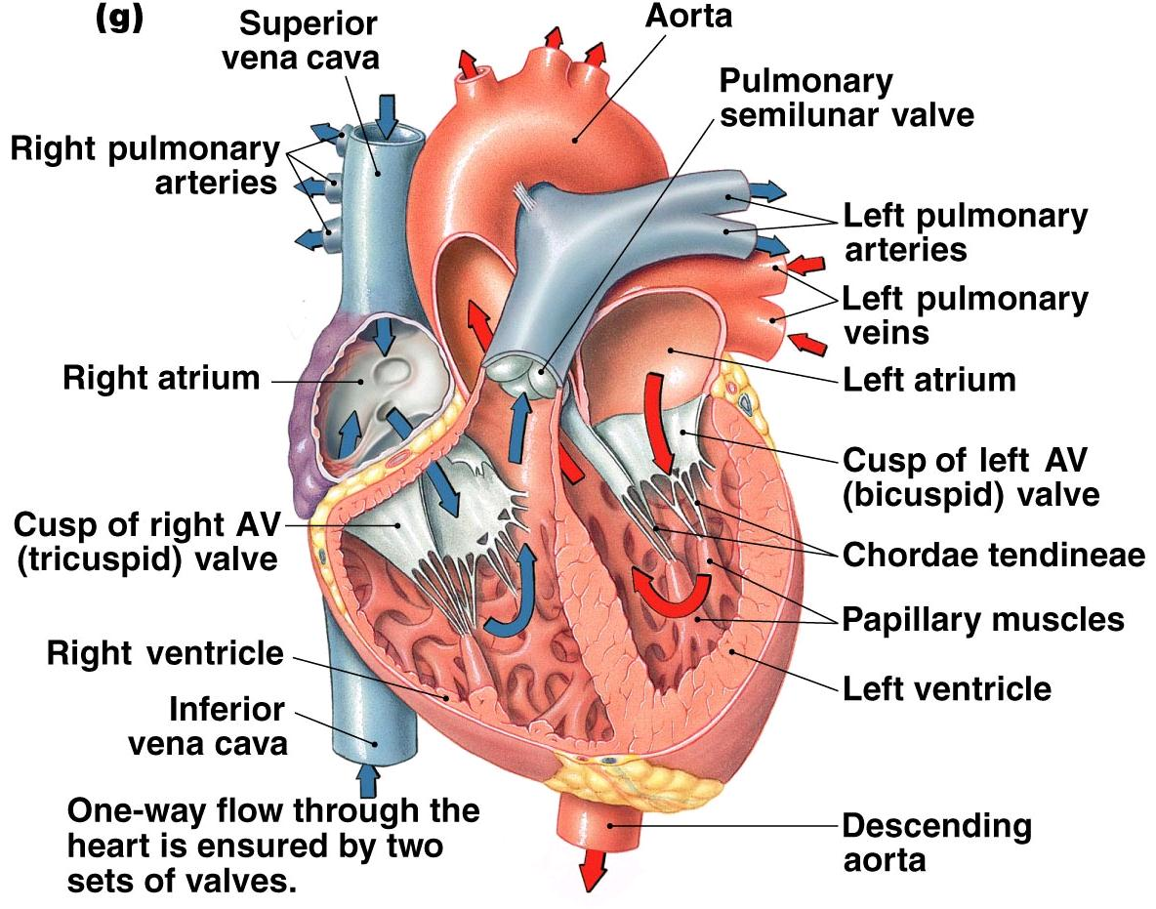

- Identify the pulmonary circulation as a low resistance, low pressure system compared to the systemic circulation.
- Describe action potentials in pacemaker cells and contractile cells. Compare these with skeletal muscle.
- Action Potentials in pacemaker and contractile cells are much longer then skeletal muscle cells and can last up to 250 ms.
- The refractory period lasts about as long as the twitch which prevents tetanus of contraction
-
- Describe excitation contraction coupling and relaxation in cardiac muscle.
Excitation contraction coupling:
- action potential in near cell sends ions through gap junctions
- the membrane becomes depolarized to threshold and an action potential is initiated
- action potential spreads into t-tubules
- voltage gated ca2+ channels open, ca enters the cell and creates a release of more ca2+ from the sarcoplasmic reticulum
- this initiates a crossbridge cycle which causes the cell to contract

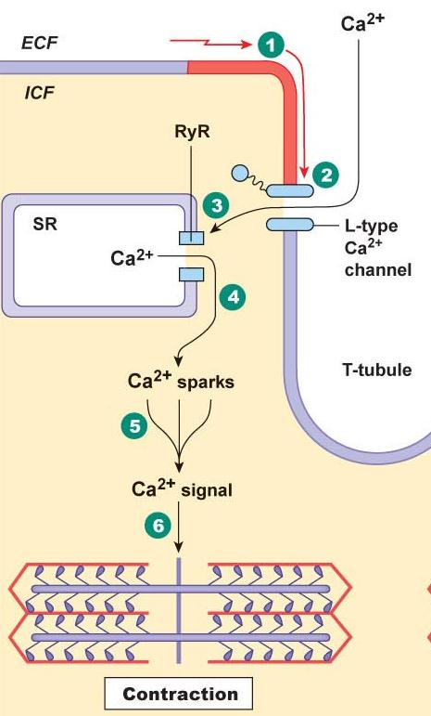
Relaxation-
- Membrane is repolarized
- Ca2+ cnanels close
- Ca dissociates from troponin
- Ca either pumped back into SR or leaves in an exchanger
- Na/k pump maintains potential
- Describe the effects of sympathetic nerve stimulation (and circulating epinephrine) on ventricular contractility.
- in sympathetic stimulation norepinephrine and epinephrine bind to beta-adrenergic receptors on cardiac myocytes
- this increases Ca2+ entry and the amount of Ca in the SR
- so this means more ca can enter the cell and more is released from the SR
- so then more Ca can bind to troponin which causes more cross birdges to be formed and a stronger contraction
Describe the effect of sympathetic and parasympathetic activity on heart rate.
- Sympathetic Stimulation causes a depolarized minimum potential and an increased slope of the pace maker potential. This causes an increased heart rate
- Parasympathetic stimulation causes a hyperpolarized minimum potential and a decreased slope of the pacemaker potential. This causes a decreased heart rate

Cardiovascular Physiology 3

- Describe how pacemaker cells in the sinoatrial (SA) node produce spontaneous action potentials in a rhythmic fashion, and how this results in the propagation of action potentials throughout the heart (SA node → atria → AV node → bundle of His → bundle branches → Purkinje fibres → ventricular muscle walls).
- SA node fires an action potential and depolarization spreads across adjacent cells
- Rapid conduction through the intermodal pathway connects the SA and AV nodes but Slow conduction through the atria.
- The AV nodes send a signal to the AV bundles to the apex of the heart
- These are connected to purkinjee fibers which send a rapid signal throughout the apex so all parts of it contractile nearly simultaneously

- Explain why at any given time during heart electrical activity, some parts of the heart are depolarized and other parts are not. Describe how these differences can be recorded from the body surface as electrocardiograms (ECG's).
- Identify the ECG as a useful diagnostic tool because it has particular features (P wave, QRS complex, T wave) that serve to mark the timing and quality of particular cardiac electrical events and explain what the P, QRS and T-waves represent.
P wave- atrial depolarization
QRS wave- ventricular depolarization
T wave- ventricular repolarization
- Describe the sequence of events constituting a cardiac cycle (as summarized in Figure 14-24 pg 496),
Ventricular filling isovolumetric contraction ventricular ejection isovolumetric relaxation ventricular filling
the difference between systole and diastole, and when and why the valves open and close.
Systole- force of blood flow from heart into the arteries
Diastole- force of the heart relaxing as blood flows back into the heart
- Define cardiac output (CO) and its relation to stroke volume (SV) and heart rate (HR). Be able to calculate CO and identify its value in an average person.
Cardiac output- volume of plod pumped by each ventricle each minute (CO= HR X SV) the average value for a person is 5l/min

- Define stroke volume, and be able to calculate it.
Stroke volume- volume of blood ejected from ventricle during systole (sv= EDV- ESV)
- EDV- end diastolic volume- amount of blood in ventricle after diastole
- ESV- end systolic volume- volume of blood ejected from ventricle during systole
List important factors determining stroke volume, and describe Starling's Law of the Heart (Frank-Starling
Stroke volume is determined by
- EDV (preload)
- Sympathetic input to ventricles
- Arterial pressure (afterload)
Frank sterling’s law of the heart states that the more blood that is put in to the ventricle, the more the muscle fiber is stretched, the more force it contracts and the more blood is pumped out

Cardiovascular Physiology 4

- Compare the structures (walls, dimensions) of arteries, arterioles, capillaries, and veins.
Arteries:
- diameter of 4.0mm
- wall thickness of 1.0 mm
- outer structure contain smooth muscle fiber
- also contain layers of fibrous tissue, endothelium and elastic tissue
Arterioles:
- diameter of 30.0 um
- wall thickness of 6.0 um
- mainly consist of smooth muscle
- also contain endothelium
Capillary:
- diameter of 8.0 um
- wall thickness of 0.5 um
- only contain endothelial tissue
veins:
- diameter of 5.0 mm
- wall thickness of 0.5mm
- contain mainly elastic and smooth muscle
- also contain fibrous tissue and endothelium

- Relate the structure of arteries, arterioles and capillaries to their respective functions.
Arteries: transport blood away from the heart (only oxygenated blood besides the pulmonary artery
- have low resistance vessels with large diameter and be stretched very easily

- Define arterial systolic pressure, diastolic pressure, pulse pressure, and mean pressure.
Arterial systolic pressure- highest pressure during ventricular ejection
Diastolic pressure- lowest pressure during ventricular relaxation
Pulse pressure- systolic pressure- diastolic pressure
Mean arterial pressure- average arterial pressure during a single cardiac cycle (MAP= dp + 1/3 (SP-DP)
- Explain the measurement of arterial blood pressure and give the range of values that are considered normal for blood pressure.
A sphygmomanometer is used to measure blood pressure where a cuff is wrapped around your upper arm and is measured in terms of mm of mercury. Systolic pressure is measured from the first beat of your heart and diastolic is measured when you can no longer hear the pulse
- normal blood pressure is considered 120/80 mm Hg
- Recognize that the branching of arteries into narrow arterioles results in high resistance to blood flow through the narrow arteriolar vessels.
- Describe how changes in arteriolar radius (constriction, dilation) control the flow of blood to downstream capillary beds in tissues (remember F = ΔP / R).
Resistance to blood flow increases as you decrease the radius of your arterioles and arteries which means less blood will flow to your tissues if the arteries are constricted and more blood will flow if they are dialated

- Describe how the radius of arterioles is controlled by local factors, circulating hormones, and autonomic nervous activity.

Identify the arterioles as the vessels where the greatest drop in
mean blood pressure occurs (Figure 15-6 pg 514).

RESPIRATORY PHYSIOLOGY 1

- Distinguish between cellular respiration and external respiration.
- List the functions of the respiratory system.
- Draw a diagram of the respiratory system and identify the following parts: pharynx, larynx, trachea, bronchi, bronchioles, alveoli, lungs, diaphragm.
- Describe how the cilia, mucus and phagocytes serve as protective mechanisms.
Mucus entraps microorganisms, and so helps protect the reproductive, digestive, respiratory and urinary systems. An enzyme in mucus called lysozyme kills bacteria - you find lysozyme in tears and saliva too.
Other general defenses include the cilia that move the mucus in our breathing system up to the pharynx where it is swallowed.

- Briefly describe the structure and function of the alveoli, alveolar cell wall, type I cells and type II cells.
- Alveoli- involved in gas exchange
  - elastic fibers wrap around them
  - capillaries complete surround them and this is where exchange takes place

- type 1 cells- gas exchange
  - flat epithelial cells one layer thick (very easy for oxygen to pass through)
- type 2 cells
  - smaller and thicker
  - secrete a chemical important of your lungs (surfactant)
  - below a thin layer of water
- alveolar cell wall

- Explain the relationship between the lungs, the pleura, and the chest wall.
- Explain how cystic fibrosis affects lung function.
List the five major steps of respiration and draw a simple diagram such as figure 17-1 (pg. 570) to illustrate these steps.

RESPIRATORY PHYSIOLOGY 2

- State Dalton's and Boyle's Laws for gases
Dalton’s law- total pressure in a gas mixture is the sum of the pressure of each gas
Boyles law—increasing container volume decreases gas pressure or decreasing container volume increases gas pressure (P1V1 =P2V2)
- this is how your lungs work
- Define ventilation and explain the bulk flow equation for air flow into and out of the lungs F= (P_{atm} - P_{alv})/R.
Air flows from region of high pressure to low pressure
- (air pressure- alveolar pressure)/ resistance
- p atm > p alv if we want air to flow into lungs (backward if we want it out)
- Distinguish between alveolar and intrapleural pressures and explain the importance of having a negative intrapleural pressure.
Because if you have negative intrapleural pressure the lungs will be stuck to your chest wall.
- Describe what happens during pneumothorax.

- Explain how Boyle's law applies to ventilation.
- Describe the sequence of events that occurs during inspiration and expiration (figures 17-8, 17-9 pg.581-582).
INSPIRATION
- increased lung volume
- decrease P alv
- air flows into lungs
EXPIRATION
- DECREASED LUNG VOLUME

List the major muscles that play an active role in relaxed (quiet) inspiration; in forced inspiration; and in forced expiration.

